

800-TagniFi

www.tagnifi.com

Abstract

Designed for business valuation professionals, TagniFi’s Quarterly Economic Update provides timely economic data to satisfy Revenue Ruling 59-60.

Quarterly Economic Update

For the 3rd Quarter of 2019

# Summary

Real GDP continued to slow, but exceeded expectations in the 3rd quarter, despite concerns over ongoing trade tensions, the resulting tariffs, and shortages of skilled manufacturing labor. Personal and government spending remained robust. Additionally, the Federal Reserve has cut target interest rates twice throughout the quarter, creating favorable conditions for equity markets.

Oil prices rose slightly during the 3rd quarter as tensions mounted in the Middle East. The rising prices were moderated by growing U.S. production and stockpiles combined with decreased demand from China. Additionally, Saudi output recovered faster than expected from the mid-September oil field attack, preventing a spike in globally traded crude prices. Crude oil prices[1] ended the quarter at $56.95 per barrel in September, up 4.0% from the previous quarter. Prices for crude oil were 18.9% lower than last September.

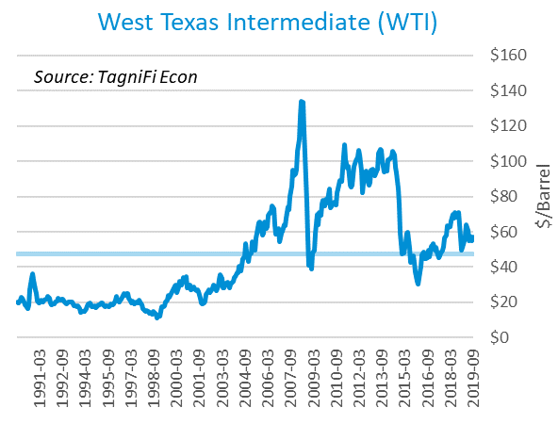

The U.S. dollar index[2] continued to rise, up 2.56% from the 2nd quarter and 4.11% since the 3rd quarter last year. The dollar gained momentum in August and September as a result of weakening global economies and aggressive monetary policy easing overseas. A notable factor was a drop in the value of the British pound amid Brexit uncertainty.

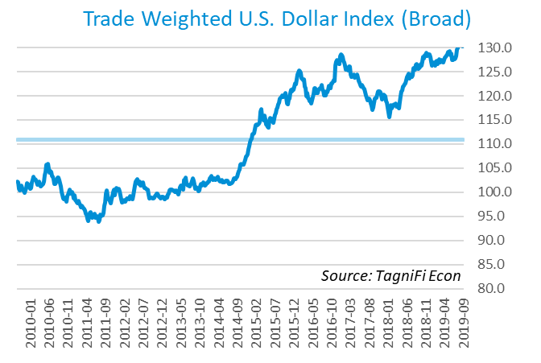

# Economic Highlights

* Real GDP grew at an annual rate of 1.9% in the 3rd quarter, decelerating by 0.1% from the previous quarter, yet exceeding economists’ expectations.
* Oil prices rose, with WTI crude up to $56.95 per barrel in September.
* The U.S. dollar index climbed 2.56% in the 3rd quarter and 4.11% since the same period last year.
* In September, the Federal Reserve cut the federal funds target rate to a range of 1.75 to 2.00 percent. Two target rate cuts totaled 50 basis points in the third quarter.
* Interest rates declined during the quarter with the 10-year U.S. treasury yielding 1.68% and the 30-year U.S. treasury yielding 2.12%.
* Consumer inflation cooled slightly to 1.73% during the quarter.
* The housing market slid two months out of the last three, with new housing starts down to 1.26 million in September but up 2.1% since last quarter.
* The U.S. labor market remained strong. The unemployment rate edged down to end the quarter at 3.5% with steady labor market participation.
* U.S. capital markets had a volatile quarter but finished steady with the S&P 500 and the Dow Jones Industrial Average each up 1.2% over the quarter.

# Business Activity

According to the Bureau of Economic Analysis (BEA), real gross domestic product (GDP)[3] for the 3rd quarter of 2019 grew at an annual rate of 1.9%, below both last quarter’s 2.0% rate and the 30-year average rate of 2.5%. Still, the growth rate exceeded economists’ expectations as continued personal consumption spending and government spending outweighed declining domestic business investment and a worsening trade deficit.

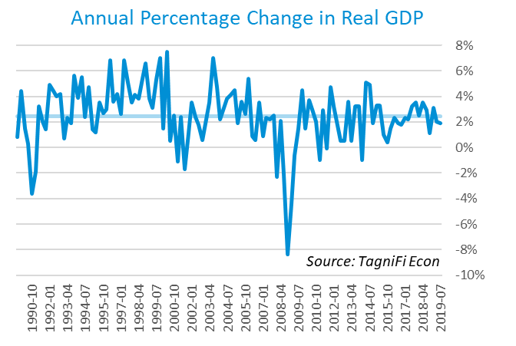

Personal and government consumption expenditures drove real GDP growth in the 3rd quarter, particularly personal spending on durable and nondurable goods as well as federal nondefense spending. Gross domestic private investment, led by nonresidential fixed investments, tempered the 3rd quarter rise in real GDP. Growth in exports was offset by a larger gain in imports.

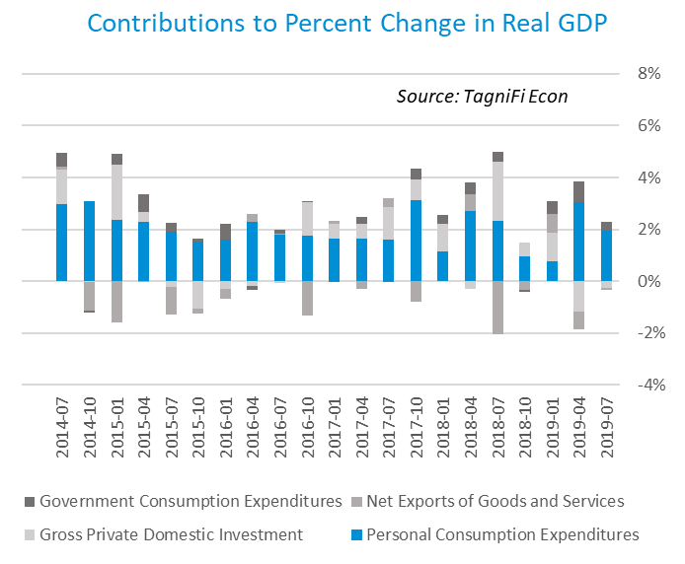

As of June, the Industrial Production Index[4] stood at 109.52, edging up 0.2% for the 3rd quarter of 2019. Warm weather increased demand for air conditioning, boosting utilities output. Manufacturing production decreased, especially in automobiles, due to a strike at General Motors as well as broader uncertainty over U.S.-China trade relations. The Industrial Production Index was 0.1% lower than the same period last year.

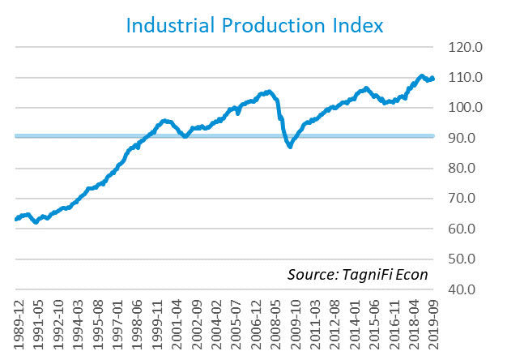

# Interest Rates

Long-term treasury bond yields continued to fall in the 3rd quarter 2019 as investors fretted over soft inflation and uncertain trade conditions. The U.S. treasury yield curve[5] ended the 3rd quarter partially inverted, with 3-month treasury bonds yielding 1.88% and the 10-year treasury yielding 1.68%. The annual yield on the 30-year treasury ended the quarter at 2.12%. The 2-year yield outpaced the 10-year yield for part of August, a condition widely regarded as an indicator of impending economic recession.

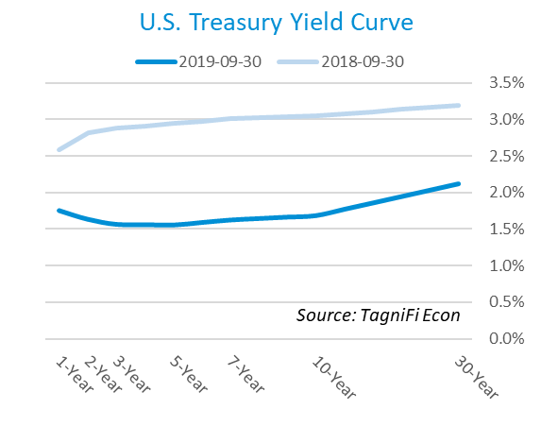

In September, the Federal Reserve lowered the federal funds target rate to a range of 1.75 to 2.00 percent, the second target rate cut in the 3rd quarter. The decision came amid mixed opinions on global economic softening and cooing domestic inflation. The effective federal funds rate[6] as of September 30th was 2.04%.

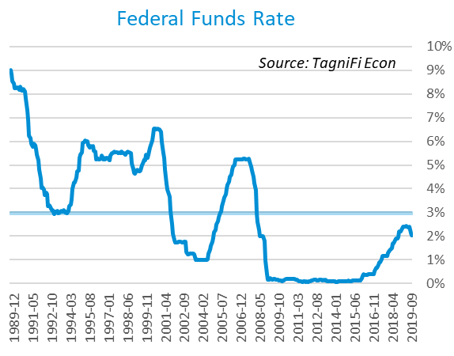

The yield on the 10-year U.S. treasury[7] fell 0.32 percentage points throughout the 3rd quarter to end September at 1.68%. This is below the average yield of 4.56% over the last 30 years and the 3.05% yield from the same period last year.

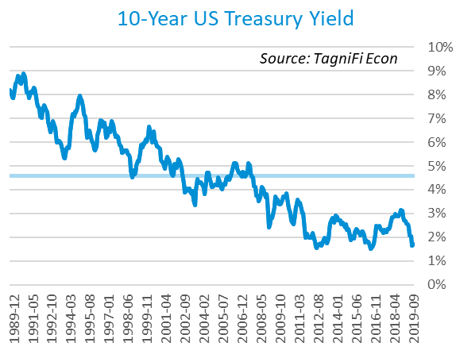

Corporate bond yields also decreased this quarter, with the Moody’s Baa Corporate Bond Yield Index[8] ending the 3rd quarter at 3.91% compared to 4.46% for the 2nd quarter. Rates were below both the 4.88% yield from the same period last year and the index’s average yield of 6.92% for the last 30 years.

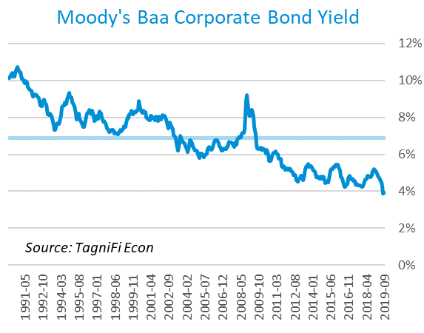

# Employment

In the 3rd quarter of 2019, the U.S. unemployment rate fell to its lowest level since December 1969. Total nonfarm payrolls[9] increased by 2.2 million over the same period last year as underwhelming initial estimates were revised significantly higher in November’s jobs report.

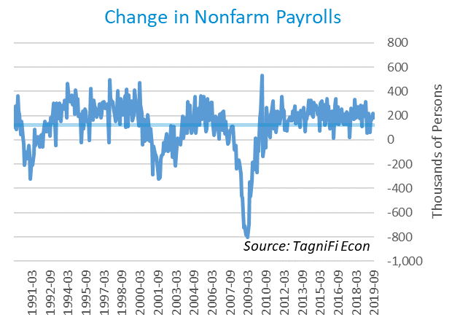

The unemployment rate[10] ended the 3rd quarter down slightly at 3.5% with steady labor force participation. The rate was down 0.2% from the same period a year ago and remained well below the 30-year average unemployment rate of 5.9%. The unemployment rate has been falling steadily since the Great Recession.

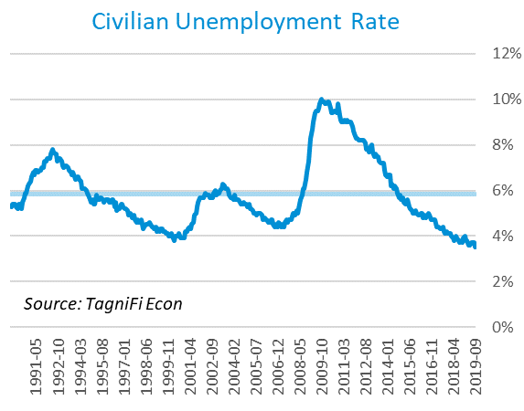

# Inflation

Inflation decelerated during the 3rd quarter due largely to lower energy prices, especially those for gasoline. The Consumer Price Index (CPI)[11] has increased by 1.73% since last September. According to Federal Reserve Bank of New York’s Survey of Consumer Expectations, inflation expectations fell to 2.5% for the one-year horizon and 2.4% for the three-year horizon in September.

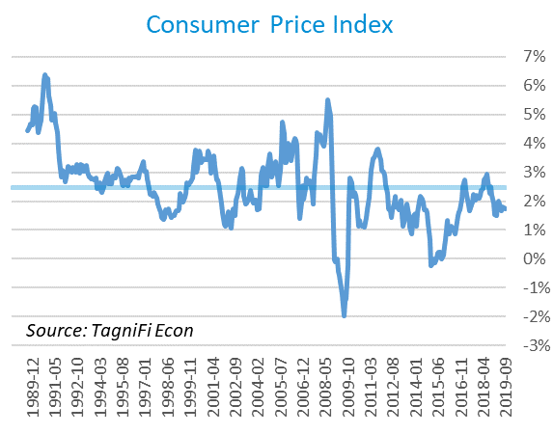

Prices at the producer level fell over the 3rd quarter, with September prices down for both goods and services. The Producer Price Index (PPI)[12] was 2.65% lower in September compared to the same period last year, falling well below the 30-year average of a 2.11% annual increase.

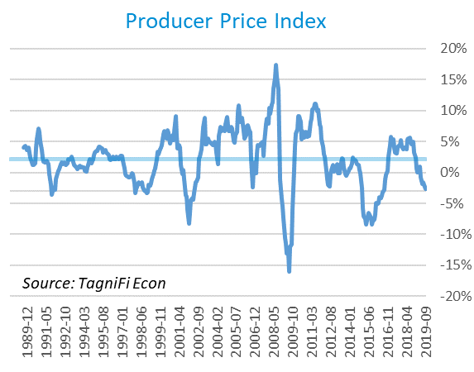

# Housing

During the 3rd quarter, the housing market continued to show signs of instability. New home starts[13] fell in two of the last three months, sliding to 1.26 million in September. Still, total housing starts were up 2.1% over last quarter. Single-family home starts have been rising for four straight months, while building permits dropped 2.7% in September from their 12-year high. Although lower interest rates have boosted the housing sector in recent months, labor shortages continue to constrain growth. The current level is well above the lows seen in 2009 when only 0.5 million new homes were built yet continues to fall below the 30-year average of 1.30 million units per month.

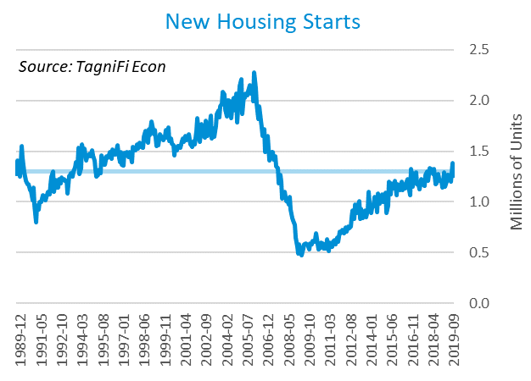

The cost of financing for would-be homebuyers continued to decline during the 3rd quarter as the 30-year fixed-rate mortgage[14] slipped to 3.64% despite a late-September rise. The Fed announced two target rate cuts in the 3rd quarter totaling 50 basis points.

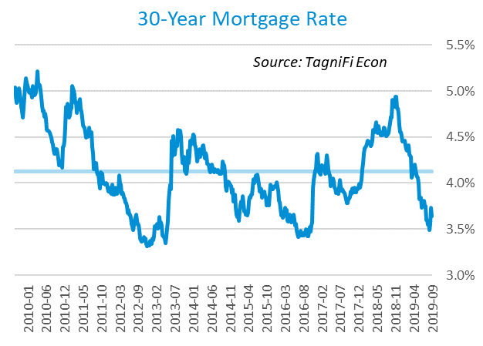

The S&P Case-Shiller Home Price Index (20-city)[15] for August 2019 increased by 2.1% over the year, the lowest rate of growth since August 2012, with mixed results among the 20 cities included. Last August, home prices were increasing at a 5.6% annual rate. The 20-city composite lagged the national index. Overheated markets and new tax laws limiting homeownership-related deductions may be constraining growth in some areas.

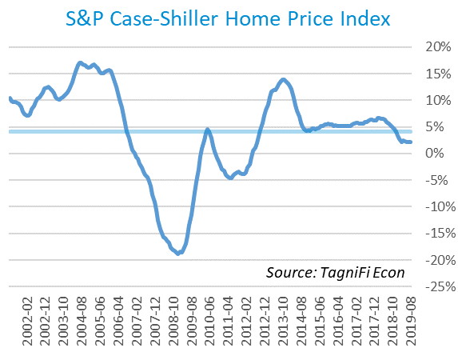

# Consumer Spending

The level of Personal Consumption Expenditures (PCE)[16] rose by 3.95% from September 2018 to September 2019. Increased spending on motor vehicles and healthcare contributed to the recent expenditure gain. Still, September’s gain fell below both the 30-year average level of 4.83% and the 5.16% level from the same period a year ago.

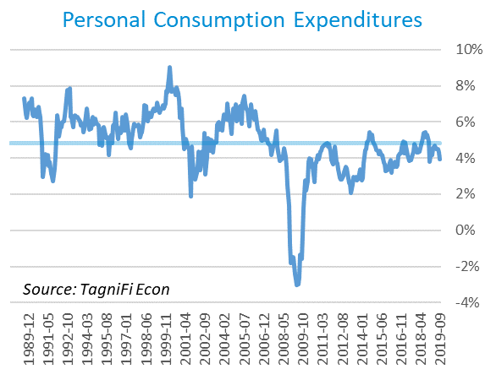

Automotive companies reported 17.2 million autos and light trucks sold[17] in September, up 0.2 million units from August yet down 0.1 million over the year. September sales were 1.9 million units above the 30-year average of 15.3 million units per month.

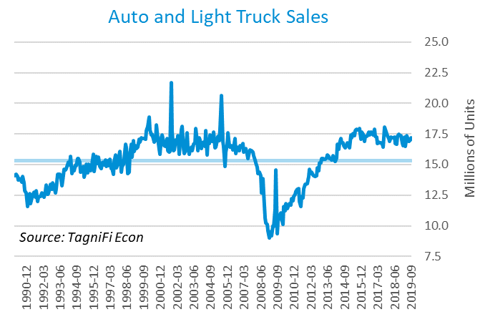

The consumer sentiment[18] index ended September at 93.2, rebounding slightly from a drop of over 8 points in August. The rally came despite an increase in worries over the impact of tariffs on inflation and unemployment. September’s consumer sentiment reading was below its level of 100.1 one year prior yet above the 30-year average of 87.5.

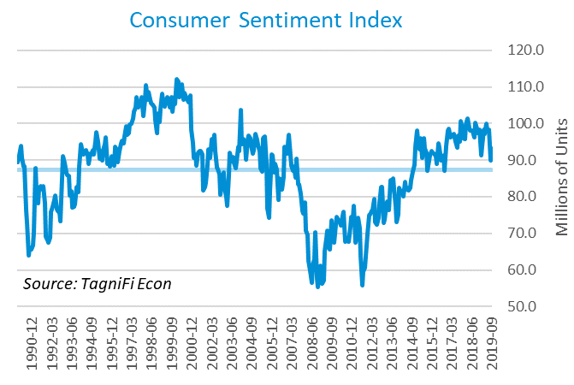

# Capital Markets

U.S. stock indices widely rebounded in September of 2019 after decreases in August. Strong tech sector performance and better-than-expected economic data from China relieved investor anxiety at the end of the quarter. Additionally, the central bank made policy moves to support economic growth throughout the quarter. However, concerns still loomed over the weakening global economy, escalating tensions between the U.S. and China, and mounting presidential impeachment pressures. The S&P 500 closed the quarter at 2,976.74, up 1.2% from the previous quarter and 2.2% from the same period last year. The Dow Jones was up 1.2% in the 3rd quarter and 1.7% over the year. However, the NASDAQ Composite ended the quarter down 0.1% and the year down 0.6%.



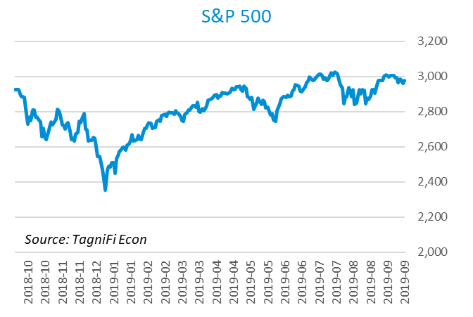

Stock market volatility[19] ended the 3rd quarter at 16.24, up 7.7% since last quarter but below the 10-year average of 17.09. August spikes in the volatility index, a proxy for investor anxiety derived from tracking options prices on S&P 500 stocks, reflected escalating trade tensions with China and recession concerns over inversion of the treasury yield curve. The volatility index reached a seven-month high of 24.59 in August; however, the tumult alleviated in September, with the volatility index decreasing throughout the month.

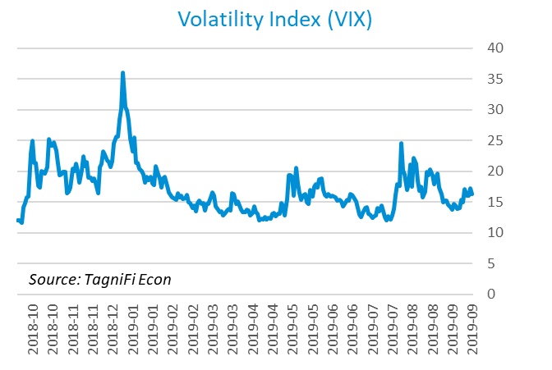

# Outlook

The U.S. Federal Open Market Committee is projecting real GDP growth[20] to slow steadily to 1.85% by 2022. They expect growth in Personal Consumption Expenditures (PCE)[21] to accelerate to 2.10% by 2022. Their forecast for the unemployment rate[22] is a gradual climb to 3.85% by 2022.



# About This Report

The *Quarterly Economic Update* is a free publication sponsored by TagniFi. You are free to share this report and include its contents in the economic outlook section of your valuation reports as required by *Revenue Ruling 59-60*. Please forward this free report to a colleague to help us spread the word about TagniFi.

# About TagniFi

TagniFi helps business valuation professionals automate the guideline public company method. With TagniFi for Excel, simply enter the valuation date and tickers into your Excel model then watch the data populate your guideline public company analysis within seconds. All TagniFi data passes through hundreds of quality checks to ensure that you are using the industry’s most accurate data in your valuation reports. For more information on TagniFi, please visit [www.tagnifi.com](http://www.tagnifi.com).

1. *U.S. Energy Information Administration, Crude Oil Prices: West Texas Intermediate (WTI) – Cushing, Oklahoma [MCOILWTICO], retrieved from FRED, Federal Reserve Bank of St. Louis;*[*https://fred.stlouisfed.org/series/MCOILWTICO*](https://fred.stlouisfed.org/series/MCOILWTICO)*, Nov 2, 2019.*
2. *Board of Governors of the Federal Reserve System (US), Trade Weighted U.S. Dollar Index: Broad [TWEXB], retrieved from FRED, Federal Reserve Bank of St. Louis;*[*https://fred.stlouisfed.org/series/TWEXB*](https://fred.stlouisfed.org/series/TWEXB)*, Nov 2, 2019.*
3. U.S. Bureau of Economic Analysis, Real Gross Domestic Product [GDPC1], *retrieved from FRED, Federal Reserve Bank of St. Louis;*[*https://fred.stlouisfed.org/series/GDPC1*](https://fred.stlouisfed.org/series/GDPC1)*, Nov 2, 2019.*
4. Board of Governors of the Federal Reserve System (US), Industrial Production Index [INDPRO], *retrieved from FRED, Federal Reserve Bank of St. Louis;*[*https://fred.stlouisfed.org/series/INDPRO*](https://fred.stlouisfed.org/series/INDPRO)*, Nov 2, 2019.*
5. Board of Governors of the Federal Reserve System (US), 1-Year to 10-Year Treasury Constant Maturity Rate [IDGS1 – IDGS30], *retrieved from FRED, Federal Reserve Bank of St. Louis;*[*https://fred.stlouisfed.org*](https://fred.stlouisfed.org/series/DGS1)*, Nov 2, 2019.*
6. Board of Governors of the Federal Reserve System (US), Effective Federal Funds Rate [FEDFUNDS], *retrieved from FRED, Federal Reserve Bank of St. Louis;*[*https://fred.stlouisfed.org/series/FEDFUNDS*](https://fred.stlouisfed.org/series/FEDFUNDS)*, Nov 2, 2019.*
7. Board of Governors of the Federal Reserve System (US), 10-Year Treasury Constant Maturity Rate [DGS10], *retrieved from FRED, Federal Reserve Bank of St. Louis;*[*https://fred.stlouisfed.org/series/DGS10*](https://fred.stlouisfed.org/series/DGS10)*, Nov 2, 2019.*
8. Moody’s, Moody’s Seasoned Baa Corporate Bond Yield [BAAS], *retrieved from FRED, Federal Reserve Bank of St. Louis;*[*https://fred.stlouisfed.org/series/BAA*](https://fred.stlouisfed.org/series/BAA)*, Nov 2, 2019.*
9. U.S. Bureau of Labor Statistics, All Employees: Total Nonfarm Payrolls [PAYEMS], *retrieved from FRED, Federal Reserve Bank of St. Louis;*[*https://fred.stlouisfed.org/series/PAYEMS*](https://fred.stlouisfed.org/series/PAYEMS)*, Nov 2, 2019.*
10. U.S. Bureau of Labor Statistics, Civilian Unemployment Rate [UNRATE], *retrieved from FRED, Federal Reserve Bank of St. Louis;*[*https://fred.stlouisfed.org/series/UNRATE*](https://fred.stlouisfed.org/series/UNRATE)*, Nov 2, 2019.*
11. U.S. Bureau of Labor Statistics, Consumer Price Index for All Urban Consumers: All Items [CPIAUCSL], *retrieved from FRED, Federal Reserve Bank of St. Louis;*[*https://fred.stlouisfed.org/series/CPIAUCSL*](https://fred.stlouisfed.org/series/CPIAUCSL)*, Nov 2, 2019.*
12. U.S. Bureau of Labor Statistics, Producer Price Index for All Commodities [PPIACO], *retrieved from FRED, Federal Reserve Bank of St. Louis;*[*https://fred.stlouisfed.org/series/PPIACO*](https://fred.stlouisfed.org/series/PPIACO)*, Nov 2, 2019.*
13. U.S. Bureau of the Census, Housing Starts: Total: New Privately Owned Housing Units Started [HOUST], *retrieved from FRED, Federal Reserve Bank of St. Louis;*[*https://fred.stlouisfed.org/series/HOUST*](https://fred.stlouisfed.org/series/HOUST)*, Nov 2, 2019.*
14. Freddie Mac, 30-Year Fixed Rate Mortgage Average in the United States [MORTGAGE30US], *retrieved from FRED, Federal Reserve Bank of St. Louis;*[*https://fred.stlouisfed.org/series/MORTGAGE30US*](https://fred.stlouisfed.org/series/MORTGAGE30US)*, Nov 2, 2019.*
15. S&P Down Jones Indices LLC, S&P/Case-Shiller 20-City Composite Home Price Index [SPCS20RSA], *retrieved from FRED, Federal Reserve Bank of St. Louis;*[*https://fred.stlouisfed.org/series/SPCS20RSA*](https://fred.stlouisfed.org/series/SPCS20RSA)*, Nov 2, 2019.*
16. U.S. Bureau of Economic Analysis, Personal Consumption Expenditures [PCE], *retrieved from FRED, Federal Reserve Bank of St. Louis;*[*https://fred.stlouisfed.org/series/PCE*](https://fred.stlouisfed.org/series/PCE)*, Nov 2, 2019.*
17. U.S. Bureau of Economic Analysis, Light Weight Vehicle Sales: Autos and Light Trucks [ALTSALES], *retrieved from FRED, Federal Reserve Bank of St. Louis;*[*https://fred.stlouisfed.org/series/ALTSALES*](https://fred.stlouisfed.org/series/ALTSALES)*, Nov 2, 2019.*
18. University of Michigan, University of Michigan: Consumer Sentiment [UMCSENT], retrieved from FRED, Federal Reserve Bank of St. Louis; <https://fred.stlouisfed.org/series/UMCSENT>, Nov 2, 2019.
19. Chicago Board Options Exchange, CBOE Volatility Index: VIX [VIXCLS], retrieved from FRED, Federal Reserve Bank of St. Louis; <https://fred.stlouisfed.org/series/VIXCLS>, Nov 2, 2019.
20. Federal Reserve Bank of St. Louis, FOMC Summary of Economic Projections for the Growth Rate of Real Gross Domestic Product [GDPC1CTM], *retrieved from FRED, Federal Reserve Bank of St. Louis;*[*https://fred.stlouisfed.org/series/GDPC1CTM*](https://fred.stlouisfed.org/series/GDPC1CTM)*, Nov 2, 2019.*
21. Federal Reserve Bank of St. Louis, FOMC Summary of Economic Projections for the Personal Consumption Expenditures Inflation Rate, Central Tendency, Midpoint [PCECTPICTM], *retrieved from FRED, Federal Reserve Bank of St. Louis;*[*https://fred.stlouisfed.org/series/PCECTPICTM*](https://fred.stlouisfed.org/series/PCECTPICTM)*, Nov 2, 2019.*
22. Federal Reserve Bank of St. Louis, FOMC Summary of Economic Projections for the Civilian Unemployment Rate, Central Tendency, Midpoint [UNRATECTM], *retrieved from FRED, Federal Reserve Bank of St. Louis;*[*https://fred.stlouisfed.org/series/UNRATECTM*](https://fred.stlouisfed.org/series/UNRATECTM)*, Nov 2, 2019.*