

800-TagniFi

www.tagnifi.com

Abstract

Designed for business valuation professionals, TagniFi’s Quarterly Economic Update provides timely economic data to satisfy Revenue Ruling 59-60.

Quarterly Economic Update

For the 4th Quarter of 2019

# Summary

Real GDP grew modestly during the 4th quarter, meeting economists’ expectations. Continued sluggishness in business investment held back growth, but personal and government spending continued to increase. The Federal Reserve cut target interest rates once more in the 4th quarter, for a total of three times throughout the year, lowering debt costs amid a trillion-dollar federal budget deficit.

Oil prices rose during the 4th quarter as U.S. crude oil inventories dropped faster than expected. Strong stock market performance, reflecting optimism for a U.S.-China trade deal, also helped bolster oil prices. Crude oil prices[1] ended the quarter at $59.88 per barrel in December, up 5.1% from the previous quarter. Prices for crude oil were 20.9% higher than last December.

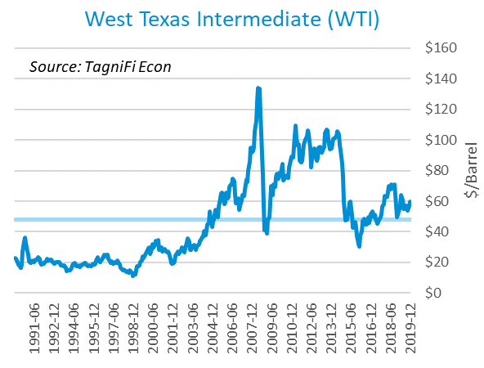

The U.S. dollar index[2] declined at the end of 2019, down 1.19% from the 3rd quarter, yet up 0.48% compared with the 4th quarter last year. The dollar weakened as U.S. economic growth slowed relative to other global economies. Progress in the U.S.-China trade war, U.S.-Canada-Mexico trade negotiations, and Brexit dealings in Europe have strengthened economic prospects outside U.S. borders.

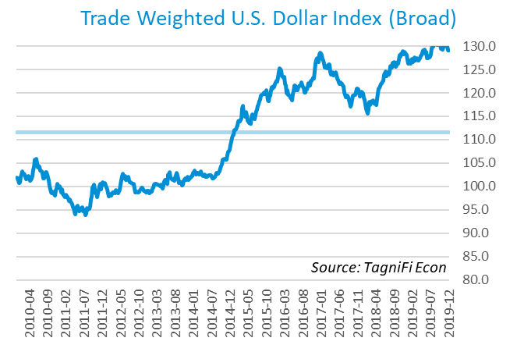

# Economic Highlights

* Real GDP grew at an annual rate of 2.1% in the 4th quarter, holding steady from the previous quarter, in line with economists’ expectations.
* Oil prices rose, with WTI crude up to $59.88 per barrel in December.
* The U.S. dollar index fell 1.19% in the 3rd quarter but rose 0.48% compared with the same period last year.
* In December, the Federal Reserve held the federal funds target rate stable at a range of 1.50 to 1.75 percent, after one target rate cut of 25 basis points earlier in the 4th quarter.
* Bond rates rebounded during the quarter with the 10-year U.S. treasury yielding 1.92% and the 30-year U.S. treasury yielding 2.39%.
* Consumer inflation accelerated to 2.29% during the quarter.
* The housing market grew for each of the last three months, with new housing starts up to 1.61 million in December, up 27.0% over the previous quarter.
* Job gains underperformed economists’ expectations, but the unemployment rate ended the 4th quarter at 3.5%, matching last quarter’s 50-year low.
* U.S. capital markets surged in the 4th quarter with the S&P 500 up 8.5% and the Dow Jones Industrial Average up 6.0% over the previous quarter.

# Business Activity

According to the Bureau of Economic Analysis (BEA), real gross domestic product (GDP)[3] for the 4th quarter of 2019 grew at an annual rate of 2.1%, matching last quarter’s rate, yet below the 30-year average rate of 2.5%. Over the entire year, real GDP rose 2.3%, the lowest in three years, continuing a trend toward slow but steady advancement for the U.S. economy.

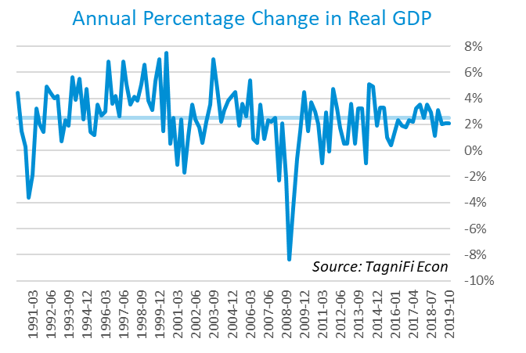

Net exports and personal consumption expenditures led real GDP growth in the 4th quarter, particularly personal spending on services. Other contributors to real GDP gains were federal spending, especially for defense, state and local government spending, and spending on durable and nondurable goods. Gross domestic private investment, particularly for nonresidential structures and industrial equipment, tempered the 4th quarter rise in real GDP. Moderate growth in exports was reinforced by declines in imports, as the U.S. decreased its global trade imbalance.

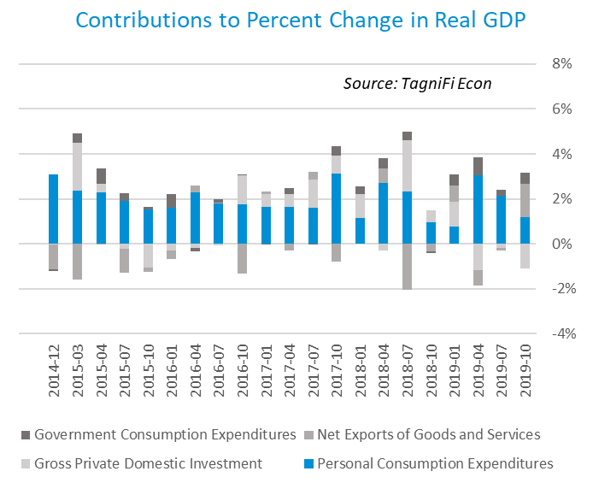

As of December, the Industrial Production Index[4] stood at 109.43, virtually unchanged for the 4th quarter of 2019. Unusually warm December weather decreased demand for heating, dampening utilities demand. Manufacturing production edged up as declining motor vehicle production was offset by increases in other durable goods along with food and beverages. The Industrial Production Index was 1.0% lower at the end of 2019 than one year prior.

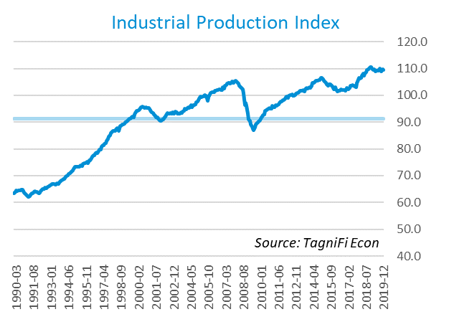

# Interest Rates

Long-term treasury bond yields began to rebound in the 4th quarter 2019, but remained decidedly lower over the year. Optimism over U.S.-China trade relations and global economic strengthening fueled late-2019 yield increases. The U.S. treasury yield curve[5] ended the 4th quarter with its mid-year inversion almost completely corrected. The 1-year and 2-year annual treasury yields were down slightly over the quarter, ending December at 1.59% and 1.58%, respectively. The benchmark 10-year treasury yielded 1.92% annually at the close of the last trading day of 2019, while the 30-year treasury ended the year at 2.39%.

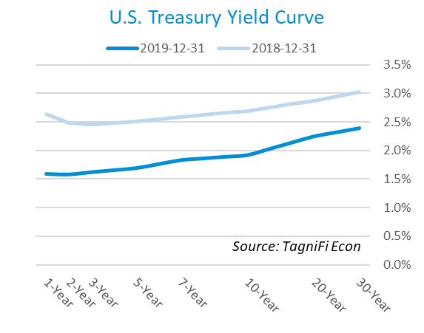

In December, the Federal Reserve held the federal funds target rate steady at a range of 1.50 to 1.75 percent, after cutting target rates three times during the year. The unanimous decision reflected confidence in current monetary policy’s ability to maintain economic expansion, a strong labor market, and modulated inflation. The effective federal funds rate[6] as of December 31st was 1.55%.

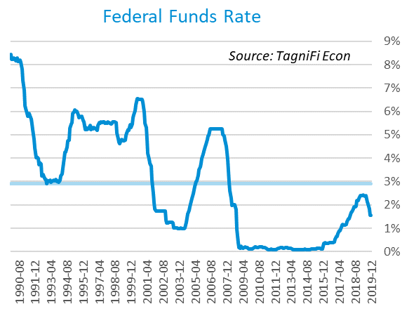

The yield on the 10-year U.S. treasury[7] rose 0.24 percentage points throughout the 4th quarter to end December at 1.92%. This is below the average yield of 4.51% over the last 30 years and the 2.69% yield from the same period last year.

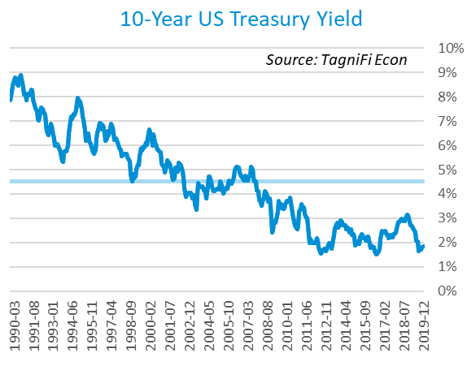

Corporate bond yields edged down this quarter, with the Moody’s Baa Corporate Bond Yield Index[8] ending the 4th quarter at 3.88% compared to 3.91% for the 3rd quarter. Rates were below both the 5.13% yield from the same period last year and the index’s average yield of 6.87% for the last 30 years.

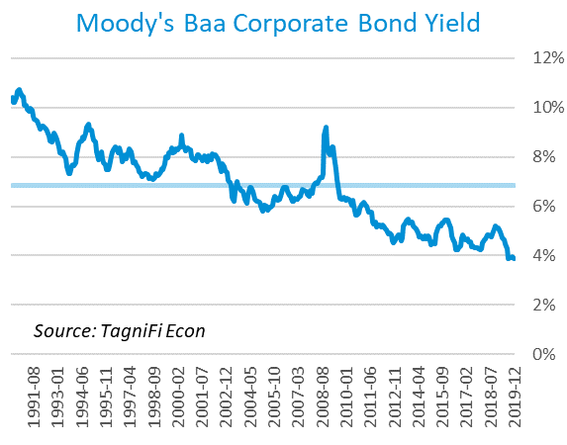

# Employment

Through the 4th quarter of 2019, the U.S. unemployment rate remained near its lowest level since December 1969. Growth in total nonfarm payrolls[9] fell short of economists’ expectations for the 4th quarter, as initially strong October and November estimates were revised downward. Still, U.S. jobs increased by 2.1 million compared with the previous year.

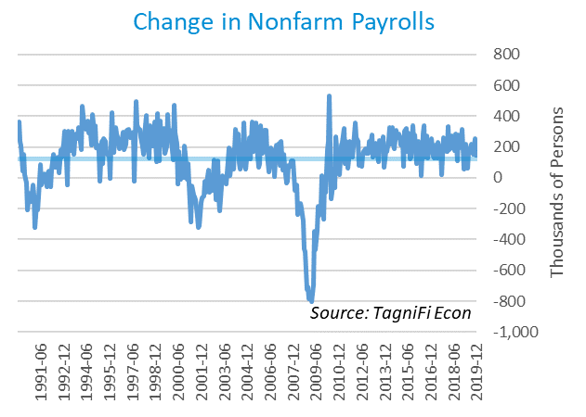

The unemployment rate[10] ended the 4th quarter at 3.5%, matching the previous quarter’s 50-year low, with steady labor force participation. The rate was down 0.4% from the same period a year ago and remained well below the 30-year average unemployment rate of 5.8%. The unemployment rate has been falling steadily since the Great Recession.

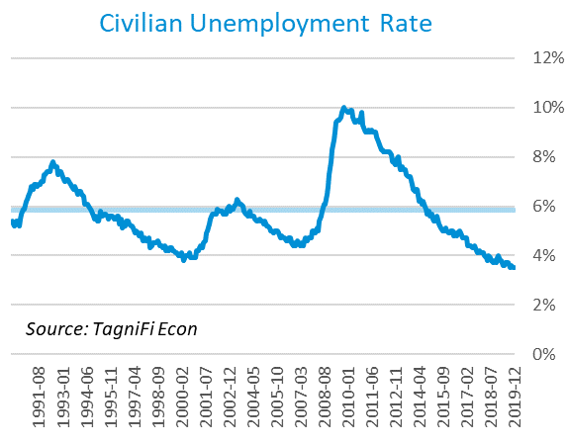

# Inflation

Inflation accelerated during the 4th quarter due largely to higher prices for shelter, energy, and medical care. The Consumer Price Index (CPI)[11] has increased by 2.29% since last December. According to Federal Reserve Bank of New York’s Survey of Consumer Expectations, inflation expectations inched up in December to 2.5% for the one-year horizon and held at 2.5% for the three-year horizon.

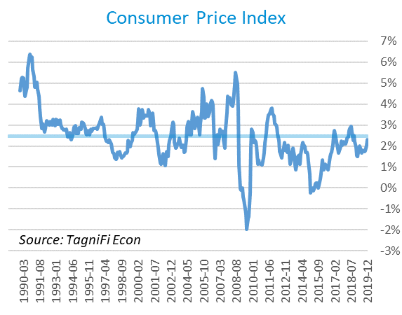

Prices at the producer level rose slightly over the 4th quarter, with December prices up for goods, especially energy, and unchanged for services. The Producer Price Index (PPI)[12] for all commodities was 0.90% lower in December compared to the same period last year, falling well below the 30-year average of a 2.06% annual increase.

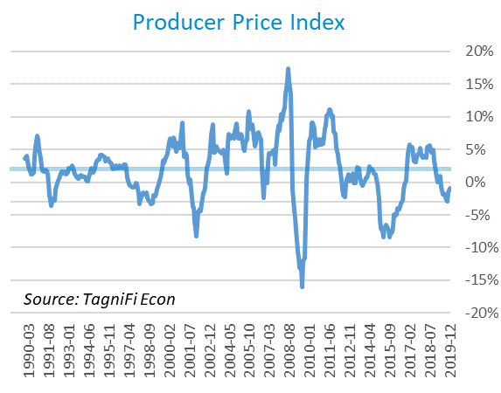

# Housing

During the 4th quarter, the housing market rebounded, with new home starts[13] rising for three consecutive months to reach a 13-year high of 1.61 million in December. Total new housing starts were up 27.0% over last quarter. Single-family home starts jumped 11.2%, reflecting gains in the Midwest and South. Despite these strong gains, building permits dropped 3.9% in December. Lower interest rates and tight inventories are credited for the jumpstart to the housing sector in recent months, while shortages of lots and labor continue to plague the sector. New home starts throughout the 4th quarter of 2019 exceeded the 30-year average of 1.30 million units per month.

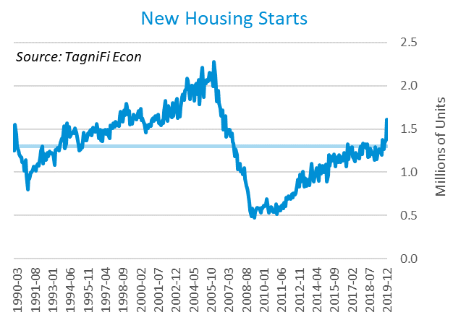

The cost of financing for would-be homebuyers rose slightly during the 4th quarter as the 30-year fixed-rate mortgage[14] inched up to 3.74% to end 2019. The Fed announced one target rate cut of 25 basis points in the 4th quarter.

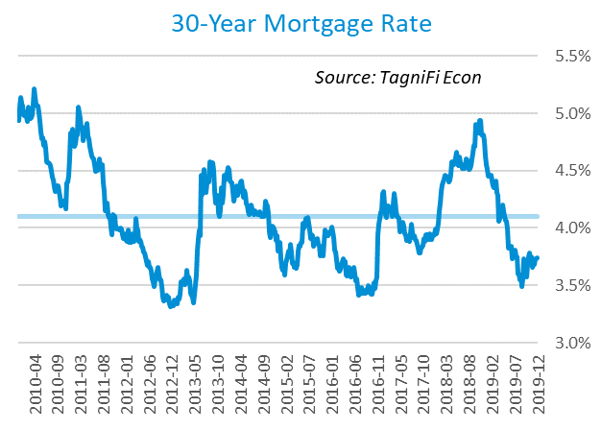

The S&P Case-Shiller Home Price Index (20-city)[15] for November 2019 increased by 2.5% over the year, with the largest gains in Southern and Southwestern cities. Last November, home prices were increasing at a 4.5% annual rate. The 20-city composite lagged the national index. Home inventories were near record lows, especially for starter homes, fueling the late-2019 rebound in prices.

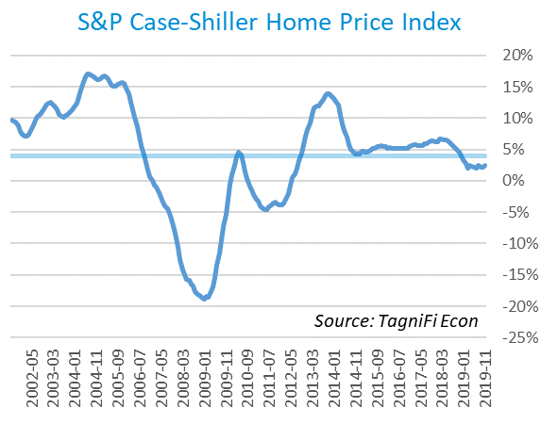

# Consumer Spending

The level of Personal Consumption Expenditures (PCE)[16] rose by 4.98% from December 2018 to December 2019. Increased spending on healthcare and prescription drugs led the recent expenditure growth. December’s increase outpaced both the 30-year average level of 4.81% and the 3.50% level from the same period a year ago.

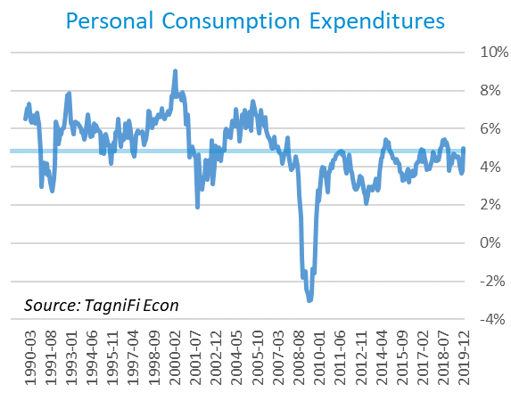

Automotive companies reported 16.7 million autos and light trucks sold[17] in December, down 0.4 million units from November and 0.7 million over the year. December sales were 1.4 million units above the 30-year average of 15.3 million units per month.

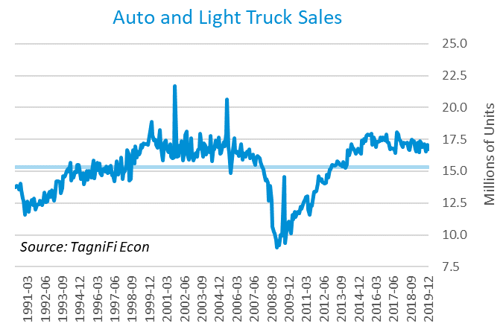

The consumer sentiment[18] index ended the 4th quarter at 99.3 after rising in all three months of the quarter. December’s advance primarily reflected rising sentiment among higher-income households, and came despite the impeachment trial of President Trump. December’s consumer sentiment reading was above its level of 98.3 one year prior and well above the 30-year average of 87.6.

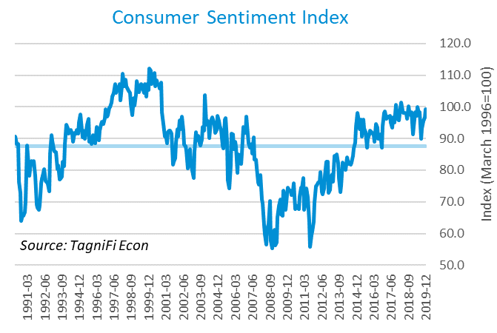

# Capital Markets

U.S. stock indices posted widespread gains during the 4th quarter of 2019, pushing annual growth to 6-year highs for the S&P 500 and NASDAQ Composite. Advancement toward a U.S.-China trade deal late in the year eased investors’ trade concerns. Also contributing to stock growth were three Federal Reserve rate cuts throughout the year and high consumer sentiment, despite slowing growth and a looming impeachment trial. The S&P 500 closed the quarter at 3,230.78, up 8.5% from the previous quarter and 28.9% from the same period last year. The Dow Jones was up 6.0% in the 4th quarter and 22.3% over the year. The NASDAQ Composite experienced double-digit growth in the 4th quarter at 12.2% and ended the year up 35.2%.



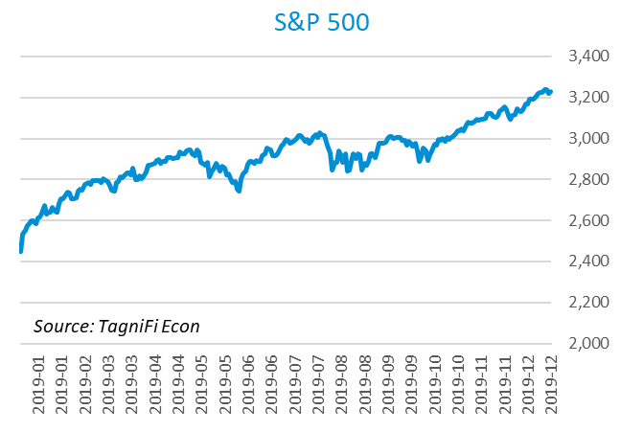

Stock market volatility[19] ended the 4th quarter at 13.78, down 15.1% since last quarter and below the 10-year average of 16.86. The volatility index, a proxy for investor anxiety derived from tracking options prices on S&P 500 stocks, dipped to a 15-month low of 11.54 in November despite mixed signals on U.S.-China trade talks, and reversed its usual negative correlation with stock market performance. Policy easing by the Fed and signs of growth in other developed economies across the globe helped to maintain investor calm through the 4th quarter.

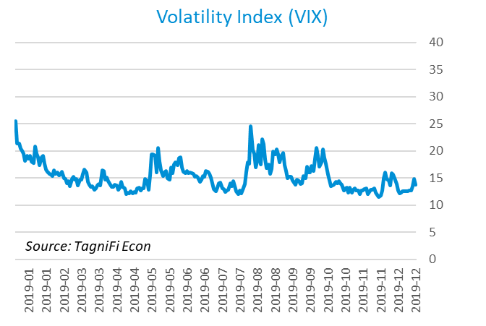

# Outlook

The U.S. Federal Open Market Committee is projecting real GDP growth[20] to slow steadily to 1.90% by 2021 and 2022. They expect growth in Personal Consumption Expenditures (PCE)[21] to accelerate to 2.10% by 2022. Their forecast for the unemployment rate[22] is a gradual climb to 3.75% by 2022.



# About This Report

The *Quarterly Economic Update* is a free publication sponsored by TagniFi. You are free to share this report and include its contents in the economic outlook section of your valuation reports as required by *Revenue Ruling 59-60*. Please forward this free report to a colleague to help us spread the word about TagniFi.

# About TagniFi

In July 2015 we released our first dataset, TagniFi Fundamentals, because we thought investors and finance professionals needed a better solution for financial data. Since then our mission has remained the same: to serve our clients with the best financial data available at a reasonable price. We do this by developing innovative solutions to leverage tagged financial statements which allow us to deliver better, faster and more detailed data at a fraction of the cost.

Today TagniFi is a platform of financial data aimed at making our clients more productive and prosperous. We're helping clients in all corners of finance make better decisions with better data. We relentlessly focus on quality and the trust we've earned from our clients is our greatest asset. Our growth is centered around our clients' needs as we look to expand our platform with new data. Referrals from our existing clients is the ultimate compliment so we choose to invest in our product, not flashy marketing campaigns.For more information on TagniFi, please visit [www.tagnifi.com](http://www.tagnifi.com).

How TagniFi Automates Business Valuation

TagniFi’s financial data platform empowers business valuation professionals to quickly and easily build highly accurate financial models with full transparency—and within seconds.

**Public Comps**  
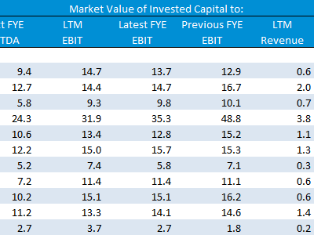Search for public companies with TagniFi Web. Simply enter your valuation date and ticker symbols in Excel to run a guideline public company method. Your Excel model populates instantly with the financial statements, analyst estimates, interest rates and economic data for your valuation date.

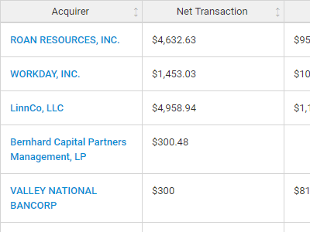**Transaction Comps**  
Search for public and private M&A transactions with TagniFi Web. Run your transaction comps within seconds by pasting the Deal ID into your Excel model. Every deal disclosed in an SEC filing (8-K, 10-K, or 10-Q) is available for your analysis. Choose from over 90 fields of data available for every deal.

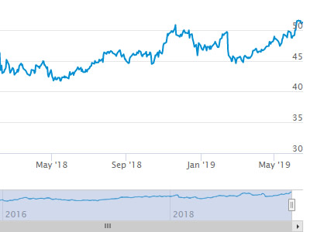

**Historical Beta and Volatility**Calculate historical beta and volatility as of your valuation date automatically. Simply enter the tickers and valuation date in Excel - TagniFi does the rest. In addition to beta and volatility, there are over 40 Excel models available in the Model Library to help with your valuation report.

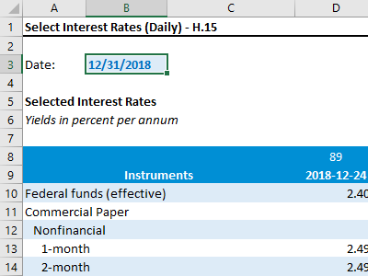**Interest Rates and Economic Date**Automate the interest rates and economic data in your valuation report using the TagniFi Excel plugin. Choose from over 200,000 time series available. All data in this *Quarterly Economic Update* is from the TagniFi platform. Use economic and interest rate date for your own valuation models with the TagniFi Excel plugin.

1. *U.S. Energy Information Administration, Crude Oil Prices: West Texas Intermediate (WTI) – Cushing, Oklahoma [MCOILWTICO], retrieved from FRED, Federal Reserve Bank of St. Louis;*[*https://fred.stlouisfed.org/series/MCOILWTICO*](https://fred.stlouisfed.org/series/MCOILWTICO)*, Feb 2, 2020.*
2. *Board of Governors of the Federal Reserve System (US), Trade Weighted U.S. Dollar Index: Broad [TWEXB], retrieved from FRED, Federal Reserve Bank of St. Louis;*[*https://fred.stlouisfed.org/series/TWEXB*](https://fred.stlouisfed.org/series/TWEXB)*, Feb 2, 2020.*
3. U.S. Bureau of Economic Analysis, Real Gross Domestic Product [GDPC1], *retrieved from FRED, Federal Reserve Bank of St. Louis;*[*https://fred.stlouisfed.org/series/GDPC1*](https://fred.stlouisfed.org/series/GDPC1)*, Feb 2, 2020.*
4. Board of Governors of the Federal Reserve System (US), Industrial Production Index [INDPRO], *retrieved from FRED, Federal Reserve Bank of St. Louis;*[*https://fred.stlouisfed.org/series/INDPRO*](https://fred.stlouisfed.org/series/INDPRO)*, Feb 2, 2020.*
5. Board of Governors of the Federal Reserve System (US), 1-Year to 10-Year Treasury Constant Maturity Rate [IDGS1 – IDGS30], *retrieved from FRED, Federal Reserve Bank of St. Louis;*[*https://fred.stlouisfed.org*](https://fred.stlouisfed.org/series/DGS1)*, Feb 2, 2020.*
6. Board of Governors of the Federal Reserve System (US), Effective Federal Funds Rate [FEDFUNDS], *retrieved from FRED, Federal Reserve Bank of St. Louis;*[*https://fred.stlouisfed.org/series/FEDFUNDS*](https://fred.stlouisfed.org/series/FEDFUNDS)*, Feb 2, 2020.*
7. Board of Governors of the Federal Reserve System (US), 10-Year Treasury Constant Maturity Rate [DGS10], *retrieved from FRED, Federal Reserve Bank of St. Louis;*[*https://fred.stlouisfed.org/series/DGS10*](https://fred.stlouisfed.org/series/DGS10)*, Feb 2, 2020.*
8. Moody’s, Moody’s Seasoned Baa Corporate Bond Yield [BAAS], *retrieved from FRED, Federal Reserve Bank of St. Louis;*[*https://fred.stlouisfed.org/series/BAA*](https://fred.stlouisfed.org/series/BAA)*, Feb 2, 2020.*
9. U.S. Bureau of Labor Statistics, All Employees: Total Nonfarm Payrolls [PAYEMS], *retrieved from FRED, Federal Reserve Bank of St. Louis;*[*https://fred.stlouisfed.org/series/PAYEMS*](https://fred.stlouisfed.org/series/PAYEMS)*, Feb 2, 2020.*
10. U.S. Bureau of Labor Statistics, Civilian Unemployment Rate [UNRATE], *retrieved from FRED, Federal Reserve Bank of St. Louis;*[*https://fred.stlouisfed.org/series/UNRATE*](https://fred.stlouisfed.org/series/UNRATE)*, Feb 2, 2020.*
11. U.S. Bureau of Labor Statistics, Consumer Price Index for All Urban Consumers: All Items [CPIAUCSL], *retrieved from FRED, Federal Reserve Bank of St. Louis;*[*https://fred.stlouisfed.org/series/CPIAUCSL*](https://fred.stlouisfed.org/series/CPIAUCSL)*, Feb 2, 2020.*
12. U.S. Bureau of Labor Statistics, Producer Price Index for All Commodities [PPIACO], *retrieved from FRED, Federal Reserve Bank of St. Louis;*[*https://fred.stlouisfed.org/series/PPIACO*](https://fred.stlouisfed.org/series/PPIACO)*, Feb 2, 2020.*
13. U.S. Bureau of the Census, Housing Starts: Total: New Privately Owned Housing Units Started [HOUST], *retrieved from FRED, Federal Reserve Bank of St. Louis;*[*https://fred.stlouisfed.org/series/HOUST*](https://fred.stlouisfed.org/series/HOUST)*, Feb 2, 2020.*
14. Freddie Mac, 30-Year Fixed Rate Mortgage Average in the United States [MORTGAGE30US], *retrieved from FRED, Federal Reserve Bank of St. Louis;*[*https://fred.stlouisfed.org/series/MORTGAGE30US*](https://fred.stlouisfed.org/series/MORTGAGE30US)*, Feb 2, 2020.*
15. S&P Down Jones Indices LLC, S&P/Case-Shiller 20-City Composite Home Price Index [SPCS20RSA], *retrieved from FRED, Federal Reserve Bank of St. Louis;*[*https://fred.stlouisfed.org/series/SPCS20RSA*](https://fred.stlouisfed.org/series/SPCS20RSA)*, Feb 2, 2020.*
16. U.S. Bureau of Economic Analysis, Personal Consumption Expenditures [PCE], *retrieved from FRED, Federal Reserve Bank of St. Louis;*[*https://fred.stlouisfed.org/series/PCE*](https://fred.stlouisfed.org/series/PCE)*, Feb 2, 2020.*
17. U.S. Bureau of Economic Analysis, Light Weight Vehicle Sales: Autos and Light Trucks [ALTSALES], *retrieved from FRED, Federal Reserve Bank of St. Louis;*[*https://fred.stlouisfed.org/series/ALTSALES*](https://fred.stlouisfed.org/series/ALTSALES)*, Feb 2, 2020.*
18. University of Michigan, University of Michigan: Consumer Sentiment [UMCSENT], retrieved from FRED, Federal Reserve Bank of St. Louis; <https://fred.stlouisfed.org/series/UMCSENT>, Feb 2, 2020.
19. Chicago Board Options Exchange, CBOE Volatility Index: VIX [VIXCLS], retrieved from FRED, Federal Reserve Bank of St. Louis; <https://fred.stlouisfed.org/series/VIXCLS>, Feb 2, 2020.
20. Federal Reserve Bank of St. Louis, FOMC Summary of Economic Projections for the Growth Rate of Real Gross Domestic Product [GDPC1CTM], *retrieved from FRED, Federal Reserve Bank of St. Louis;*[*https://fred.stlouisfed.org/series/GDPC1CTM*](https://fred.stlouisfed.org/series/GDPC1CTM)*, Feb 2, 2020.*
21. Federal Reserve Bank of St. Louis, FOMC Summary of Economic Projections for the Personal Consumption Expenditures Inflation Rate, Central Tendency, Midpoint [PCECTPICTM], *retrieved from FRED, Federal Reserve Bank of St. Louis;*[*https://fred.stlouisfed.org/series/PCECTPICTM*](https://fred.stlouisfed.org/series/PCECTPICTM)*, Feb 2, 2020.*
22. Federal Reserve Bank of St. Louis, FOMC Summary of Economic Projections for the Civilian Unemployment Rate, Central Tendency, Midpoint [UNRATECTM], *retrieved from FRED, Federal Reserve Bank of St. Louis;*[*https://fred.stlouisfed.org/series/UNRATECTM*](https://fred.stlouisfed.org/series/UNRATECTM)*, Feb 2, 2020.*