800-TagniFi
www.tagnifi.com
Abstract
Designed for business valuation professionals, TagniFi’s Quarterly Economic Update provides timely economic data to satisfy Revenue Ruling 59-60.
Interim Economic Update
Interim Update: 1st Quarter of 2020

Economic Impact of the Novel Coronavirus
An outbreak of a novel coronavirus named COVID-19, a respiratory virus capable of causing pneumonia, spread outward from its epicenter of Wuhan, China beginning in January 2020. As of February 29th, 85,403 cases and 2,924 deaths had been reported in more than 50 countries. The virus, while not highly deadly, has incited global fear as it is extremely contagious and poses a high risk to certain segments of the population including the elderly and those with pre-existing health conditions. Governments and healthcare systems’ primary responses to the novel coronavirus, which lacks established treatments or immunizations, have been widespread quarantines and travel bans.
The outbreak is expected to slow global economic output, most notably in China. Kristalina Georgieva, managing director of the International Monetary Fund (IMF), anticipates growth will slow worldwide this year by 0.1 percentage points and in China by 0.4 percentage points. Additionally, the Chinese government’s focus on containing the virus is expected to delay work on the anticipated Phase 2 of U.S.-China trade negotiations.
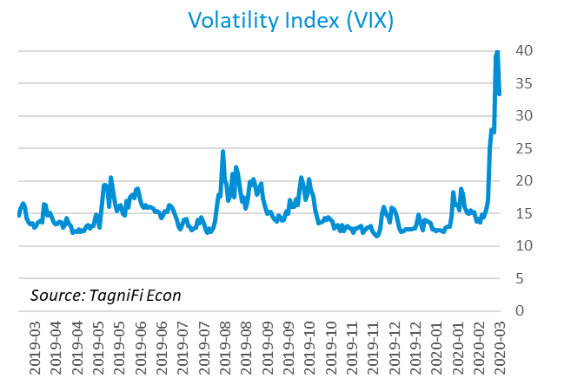
Partly in response to these emerging threats, the stock market dropped on Monday, February 24th by more than 3%, with the largest declines for companies in the travel industry and those with supply chains heavily reliant on China and South Korea, another country hard-hit by the virus’s spread. The slide continued throughout the week, with the Dow Jones Industrial Average falling 3,583.05 points and closing 12.4% lower on Friday, February 28th, than the previous Friday. The S&P 500 was down 11.5% over the same period. The volatility index, a proxy for investor anxiety derived from tracking options prices on S&P 500 stocks, closed at 39.16 on Thursday, February 27th, more than 1.5 times its level one week prior. In the course of the selloff, the market demonstrated an appetite for safer investments, pushing long-term treasury bond prices up and yields down. The Chairman of the Federal Reserve, Jerome Powell, indicated that the Fed would “act as appropriate” to mitigate the nation’s economic effects of the coronavirus outbreak. On Tuesday, March 3rd, the Fed cut target interest rates by 50 basis points to a range of 1.0% to 1.25% in response to the risks posed by the novel coronavirus to economic stability; it was the first emergency rate cut in over 11 years.

About This Report
The Quarterly Economic Update is a free publication sponsored by TagniFi. You are free to share this report and include its contents in the economic outlook section of your valuation reports as required by Revenue Ruling 59-60. Please forward this free report to a colleague to help us spread the word about TagniFi.

About TagniFi
In July 2015 we released our first dataset, TagniFi Fundamentals, because we thought investors and finance professionals needed a better solution for financial data. Since then our mission has remained the same: to serve our clients with the best financial data available at a reasonable price. We do this by developing innovative solutions to leverage tagged financial statements which allow us to deliver better, faster and more detailed data at a fraction of the cost.
Today TagniFi is a platform of financial data aimed at making our clients more productive and prosperous. We're helping clients in all corners of finance make better decisions with better data. We relentlessly focus on quality and the trust we've earned from our clients is our greatest asset. Our growth is centered around our clients' needs as we look to expand our platform with new data. Referrals from our existing clients is the ultimate compliment so we choose to invest in our product, not flashy marketing campaigns.For more information on TagniFi, please visit www.tagnifi.com.
How TagniFi Automates Business Valuation
TagniFi’s financial data platform empowers business valuation professionals to quickly and easily build highly accurate financial models with full transparency—and within seconds.

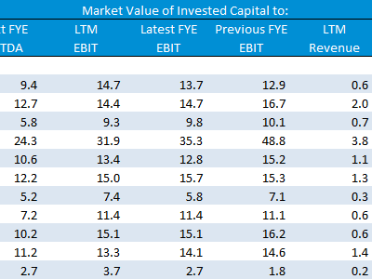
Public Comps
Search for public companies with TagniFi Web. Simply enter your valuation date and ticker symbols in Excel to run a guideline public company method. Your Excel model populates instantly with the financial statements, analyst estimates, interest rates and economic data for your valuation date.

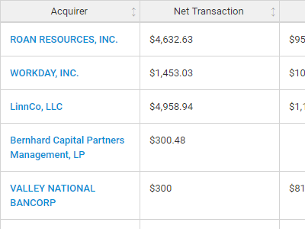
Transaction Comps
Search for public and private M&A transactions with TagniFi Web. Run your transaction comps within seconds by pasting the Deal ID into your Excel model. Every deal disclosed in an SEC filing (8-K, 10-K, or 10-Q) is available for your analysis. Choose from over 90 fields of data available for every deal.
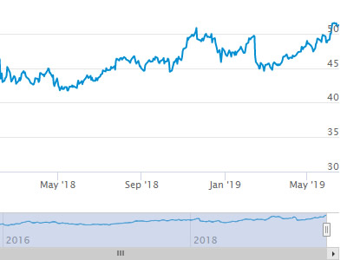
Historical Beta and Volatility
Calculate historical beta and volatility as of your valuation date automatically. Simply enter the tickers and valuation date in Excel - TagniFi does the rest. In addition to beta and volatility, there are over 40 Excel models available in the Model Library to help with your valuation report.

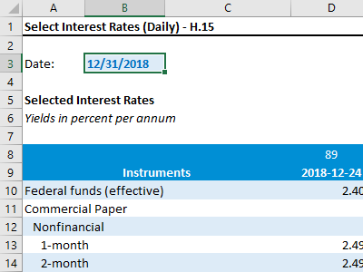
Interest Rates and Economic Date
Automate the interest rates and economic data in your valuation report using the TagniFi Excel plugin. Choose from over 200,000 time series available. All data in this Quarterly Economic Update is from the TagniFi platform. Use economic and interest rate date for your own valuation models with the TagniFi Excel plugin.

S&P Dow Jones Indices LLC, Dow Jones Industrial Average [DJIA], retrieved from FRED, Federal Reserve Bank of St. Louis; https://fred.stlouisfed.org/series/DJIA, Mar 1, 2020.
Chicago Board Options Exchange, CBOE Volatility Index: VIX [VIXCLS], retrieved from FRED, Federal Reserve Bank of St. Louis; https://fred.stlouisfed.org/series/VIXCLS, Mar 1, 2020.

