QUARTERLY ECONOMIC UPDATE

For the 1st Quarter of 2020

Abstract

Designed for business valuation professionals, TagniFi’s Quarterly Economic   
Update provides timely economic data to satisfy Revenue Ruling 56-60.

# Summary

In the 1st quarter of 2020, the U.S. economy has suffered widespread ramifications of the global COVID-19 pandemic. Worldwide restrictions on in-person gathering and economic activity, along with the resultant job losses and disruptions to global supply chains, began to seriously impact the world economy in February and the U.S. economy in March. GDP and employment dropped suddenly during the last month of the quarter. Capital markets reflected pervasive anxiety. Federal and state governments, along with the central bank, passed measures to buffer the economy and citizens from the ensuing fallout. The Federal Reserve cut target interest rates to nearly zero and enacted large-scale quantitative easing measures. Congress passed a relief bill worth $2.2 trillion to soften the impact on American businesses and citizens. The full impact of the pandemic remains to be seen.

By the end of the 1st quarter of 2020, 186,800 U.S. cases and 3,890 deaths had been reported from COVID-19[1]. The viral disease has continued to spread exponentially, and as of May 1, 2020 there were 1,096,706 confirmed cases and 64,066 related deaths in the U.S., with 12 states reporting more than 25,000 cases. In March, states began making emergency declarations and instituting protective measures to slow the spread of COVID-19, mitigating the impending overwhelm of the U.S. healthcare system.

Below is a summary timeline of COVID-19 events in the U.S.:

|  |  |
| --- | --- |
| January 8-9, 2020 | CDC issues official health advisory and travel health notice for travelers to Wuhan City, Hubei Province, China |
| January 17, 2020 | CDC enacts enhanced health screening for individuals traveling into the U.S. from Wuhan City, Hubei Province, China |
| January 21, 2020 | First confirmed case of COVID-19 in the US announced by Washington State Department of Health |
| January 30, 2020 | WHO declares “public health emergency of international concern” |
| January 31, 2020 | Secretary Azar of Health and Human Services declares a public health emergency in the United States |
| January 31, 2020 | White House bans foreign nationals from entering the U.S. if they were in China in the previous 2 weeks |
| February 2, 2020 | State Department issues an official warning against traveling to China |
| February 8, 2020 | First recorded death of an American citizen from COVID-19 in Wuhan City, Hubei Province, China |
| February 28, 2020 | World stock markets record largest 1-week decline since 2008 financial crisis |
| February 29, 2020 | Washington State announces first Declaration of Emergency and first announcement of confirmed COVID-19 death occurring in the U.S. |
| March 3, 2020 | FOMC announces unscheduled decision to lower Federal Funds Rate by 50 basis points to 1% to 1.25% |
| March 9, 2020 | S&P 500 declines trigger first of several 15-minute market-wide “circuit-breaker” trading halts |
| March 11, 2020 | WHO declares COVID-19 pandemic |
| March 11, 2020 | White House bans travel from 26 European countries |
| March 13, 2020 | U.S. declares National Emergency |
| March 15, 2020 | FOMC holds a second unscheduled meeting, announces it will lower Federal Funds Rate by 100 basis points to 0% to 0.25%, expand discount window credit and reduce of reserve requirements to 0%, and coordinate with Bank of Canada, Bank of England, Bank of Japan, the ECB, and the Swiss National Bank for U.S. dollar liquidity |
| March 16, 2020 | White House issues guidelines for the public to limit gathering, discretionary travel, and eating or drinking out |
| March 16, 2020 | Federal Reserve Board decreases discount rate to 0.25% |
| March 17, 2020 | White House invokes the Defense Production Act for ventilators and personal protective equipment (PPE) |
| March 18, 2020 | Families First Coronavirus Response Act signed with provisions for nationwide paid sick leave, tax credits, free COVID-19 testing, expansion of food assistance and unemployment benefits, and increase in Medicaid funding |
| March 19, 2020 | California issues first “Stay at Home” order |
| March 20, 2020 | U.S. Treasury and IRS officially move Tax Day to July 15,2020 |
| March 23, 2020 | Federal Reserve enacts quantitative easing measures and announces $300 billion in new credit programs |
| March 27, 2020 | Coronavirus Aid, Relief, and Economic Security (CARES) Act signed, the largest single spending bill in the history of the United States at $2.2 trillion |
| April 2, 2020 | Confirmed COVID-19 cases total more than 1 million worldwide |
| April 3, 2020 | SBA Announces Paycheck Protection Program” loans |
| April 9, 2020 | Federal Reserve Announces $2.3 trillion in additional loans to support the economy |
| April 10, 2020 | Global deaths from COVID-19 passes 100,000 |
| April 15, 2020 | Paycheck Protection Program funding exhausted |
| April 15, 2020 | Confirmed COVID-19 cases total more than 2 million worldwide |
| April 16, 2020 | Federal Reserve opens Paycheck Protection Program Liquidity Facility |
| April 16, 2020 | White House releases guidelines for easing social distancing restrictions |
| April 21, 2020 | First confirmed COVID-19 death in the U.S. revised to February 6, in California |
| April 24, 2020 | Paycheck Protection Program and Health Care Enhancement Act signed with additional funding |
| April 28, 2020 | U.S. becomes first country with 1 million confirmed cases of COVID-19 |
| April 28, 2020 | White House invokes Defense Production Act to require continued operation of meat and poultry processors following outbreaks of COVID-19 at some facilities |
| April 30, 2020 | Federal Reserve Expands Access to Paycheck Protection Program Liquidity Facility |

The Philadelphia Fed’s coincident index of economic activity in the U.S. fell 0.2% in the 1st quarter and 0.5% in March 2020. Over the quarter, state coincident indexes[2] showed increased economic activity in 18 states, decreased activity in 29, and stable levels in 3. In March, coincident indexes increased in 12 states, decreased in 34 states, and remained stable in 4. Coincident indexes reflect unemployment, payroll employment, manufacturing hours, and wages and salaries. The strong influence of unemployment estimates suggests that the calculations for March could skew higher than reality, as unemployment data referenced the week ending March 12, prior to “Stay at Home” orders taking effect in U.S. states.



The U.S. dollar index for goods and services[3] rose throughout the 1st quarter of 2020, up 7.07% from the end of last year and 6.75% compared with the 1st quarter a year ago. Demand for the dollar ballooned during March as tumbling equity markets led investors to diversify portfolios. The growth tempered in late March as the Federal Reserve expanded access to dollar loans for foreign central banks in its efforts to mitigate the most immediate economic consequences of the COVID-19 pandemic.

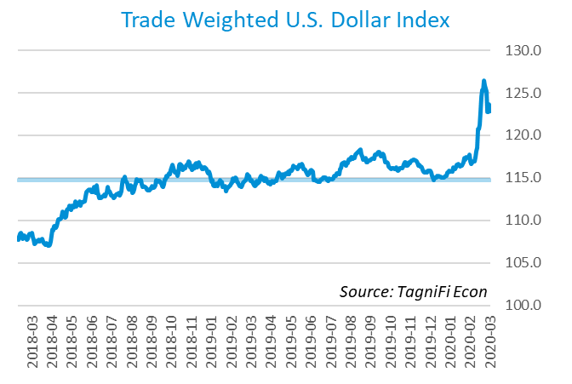

# Economic Highlights

* Real GDP fell at an annual rate of 4.8% in the 1st quarter, down from 2.1% growth in the previous quarter.
* Oil prices dropped by more than half, with WTI crude down to $29.21 per barrel in March.
* The U.S. dollar index rose 6.75% in the 1st quarter and 7.07% compared with the same period last year.
* In March, the Federal Reserve lowered the federal funds target rate to a range of 0.00 to 0.25 percent in two unscheduled decisions.
* Bond yields fell during the quarter, with the 10-year U.S. treasury yielding 0.70% and the 30-year U.S. treasury yielding 1.35%.
* Consumer inflation decelerated to 1.52% during the quarter.
* New housing starts fell 24.0% over the quarter, to 1.22 million in March.
* Unemployment rose to a 3-year high of 4.4%, and payroll employment dropped 701,000 in March.
* U.S. capital markets suffered a tumultuous March, ending the 1st quarter with the S&P 500 down 20.0% and the Dow Jones Industrial Average down 23.2%.

# Business Activity

According to the Bureau of Economic Analysis (BEA), real gross domestic product (GDP)[4] for the 1st quarter of 2020 fell at an annual rate of 4.8%, down from last quarter’s growth of 2.1% and well below the 30-year average rate of 2.4%. The 1st-quarter drop in GDP partly reflected drastic changes in economic activity resulting from the COVID-19 pandemic, as most state governments restricted in-person activities in the second half of March. Since the 1st quarter last year, real GDP rose 0.3%, a ten-year low.

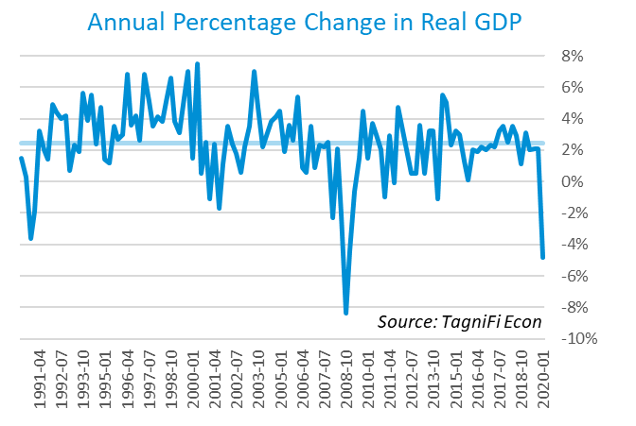

Declines in personal consumption and nonresidential investment led the drop in real GDP in the 1st quarter, particularly personal spending on services such as health care, food services and accommodations. Moderating the contraction in GDP were sharply lower imports, which more than offset a concurrent decrease in exports; personal spending on nondurable goods, particularly food and beverages; and government consumption.

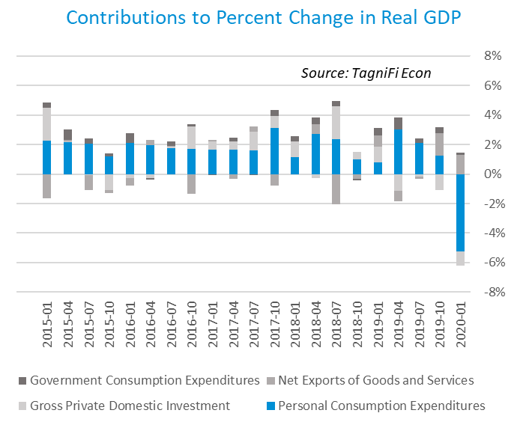

As of March, the Industrial Production Index[5] stood at 103.66, down 5.4% over the first quarter of 2020. Manufacturing shutdowns in March due to the COVID-19 pandemic propelled the decline, particularly motor vehicle and parts manufacturing. Utilities and mining production also decreased. The Industrial Production Index was 5.5% lower in March 2020 than one year prior.

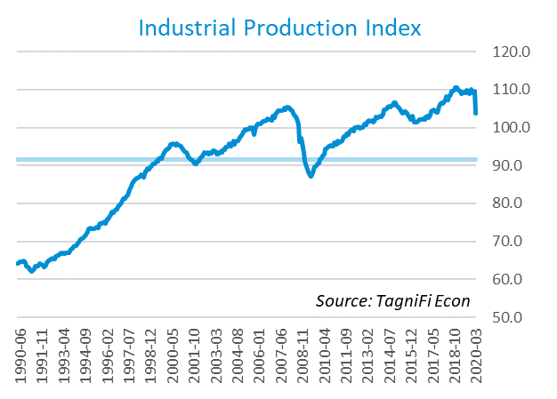

# Interest Rates

Short- and long-term treasury bond yields[6] fell sharply in the 1st quarter of 2020, ending the quarter at historic lows as U.S. debt overtook riskier investments in the wake of the economic fallout wrought by the COVID-19 crisis. The 1-year and 2-year annual treasury yields ended the quarter at 0.17% and 0.23%, respectively. The benchmark 10-year treasury yielded 0.70% annually at the end of March 2020, while the 30-year treasury yielded 1.35%.

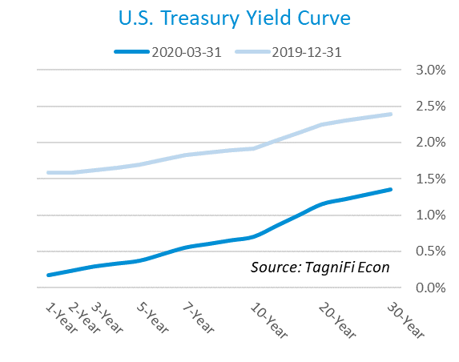

In March, the Federal Reserve dropped the federal funds target rate to a range of 0.00 to 0.25 percent in two unscheduled decisions. The Fed also unveiled a $700 billion quantitative easing program to bolster the US economy against the effects of the global pandemic. The effective federal funds rate[7] as of March 31st was 0.65 %.

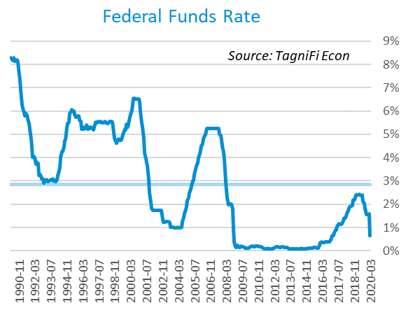

The yield on the benchmark 10-year U.S. treasury[8] dropped 1.22 percentage points throughout the 1st quarter to end March at 0.70%. This is below the average yield of 4.45% over the last 30 years and the 2.41% yield from the same period last year.

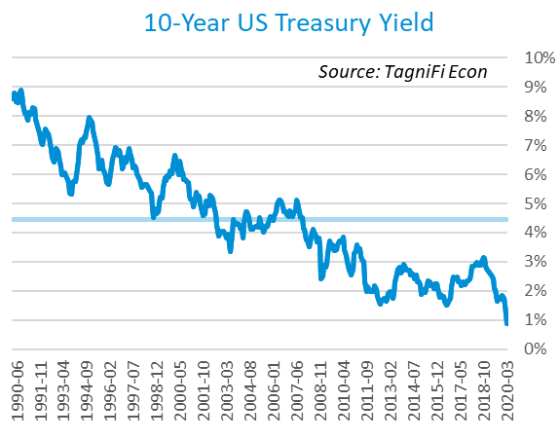

Corporate bond yields increased this quarter, with the Moody’s Baa Corporate Bond Yield Index[9] ending the 1st quarter at 4.29% compared to 3.88% for the 4th quarter. Rates were below both the 4.84% yield from the same period last year and the index’s average yield of 6.82% for the last 30 years.

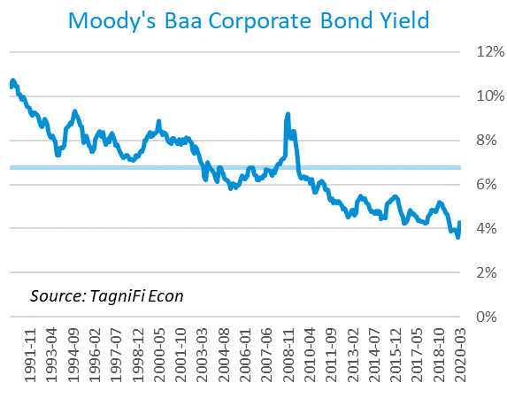

# Employment

The U.S. unemployment rate rose from its historic low during the 1st quarter of 2020, and the surge is expected to continue in the spring. Total nonfarm payrolls[10] began to tumble in March, falling 701,000, primarily in leisure and hospitality and other service industries. The job count fell faster than economists’ expectations even before states declared emergencies and ordered nonessential businesses to cease activities requiring people to gather. Payrolls were still up 1.5 million from the previous March, but losses are expected to accelerate in coming monthly reports.

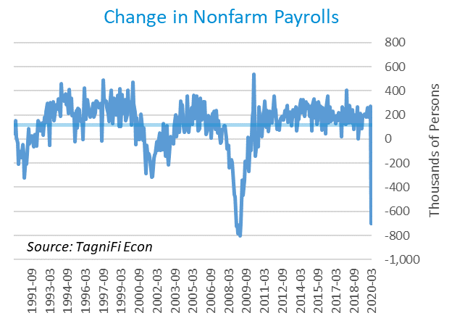

The unemployment rate[11] ended the 1st quarter at 4.4%, a 3-year high, while the labor force participation rate fell. The rate was up 0.6% from the same period a year ago but still below the 30-year average unemployment rate of 5.8%. Unemployment data for March reflects the week ended March 12, just the beginning of widespread layoffs in the U.S. due to the COVID-19 crisis. Weekly unemployment claims[12] data show a jump of more than 10 million filings for unemployment insurance over the last two weeks of March.

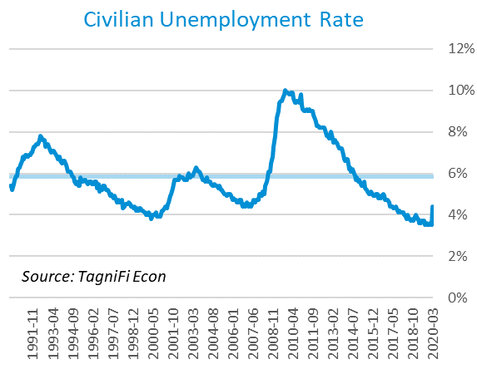

# Inflation

Inflation cooled during the 1st quarter due primarily to plummeting gasoline prices, along with airline fares, apparel, and lodging away from home. Still, the Consumer Price Index (CPI)[13] has increased by 1.52% since last March. According to Federal Reserve Bank of New York’s Survey of Consumer Expectations, inflation expectations[14] held steady in March at 2.5% for the one-year horizon and inched down to 2.4% for the three-year horizon.

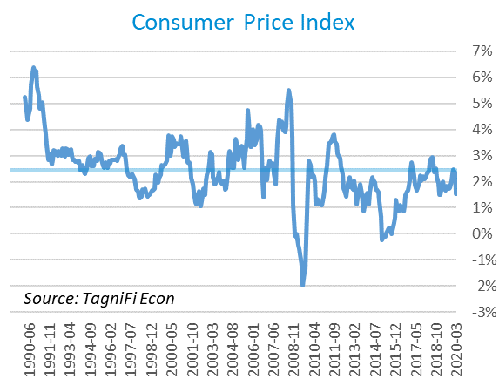

Prices at the producer level fell over the 1st quarter, with March prices down for goods, especially energy and other fuels. The Producer Price Index (PPI)[15] for all commodities was 3.49% lower in March compared to the same period last year, falling well short of the 30-year average of a 2.02% annual increase.

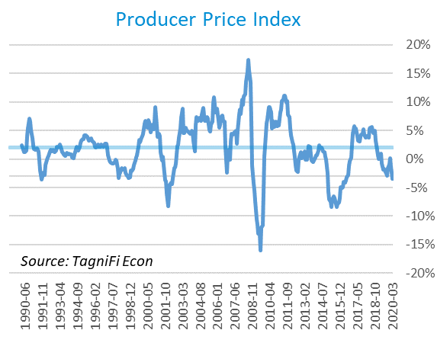

Oil prices tumbled by more than half during the 1st quarter, with U.S. crude oil[16] reaching a 16-year low. Demand for oil dwindled worldwide throughout the 1st quarter as the growing COVID-19 pandemic led to widespread cessation of business and personal travel as well as daily commutes and activities. Crude oil prices ended the quarter at $29.21 per barrel in March, down 51.2% from the previous quarter. Prices for crude oil were 49.8% lower than last March.

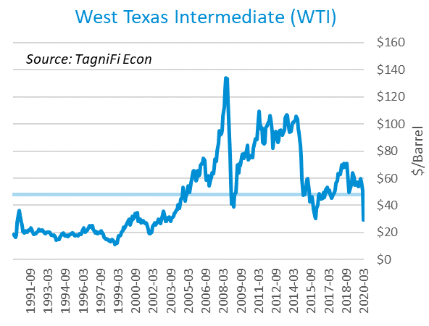

# Housing

During the 1st quarter, the housing market also felt the effects of nonessential business restrictions and economic contraction, with new home starts[17] dropping to 1.22 million in March. Total new housing starts were down 24.0% over last quarter. Single-family home starts were 17.5% lower and apartment and condo starts, 32.1% lower in March. Additionally, new construction permits fell 6.8% in March, foreshadowing continued declines in homebuilding. New home starts in the 1st quarter of 2020 slipped below the 30-year average of 1.30 million units per month.

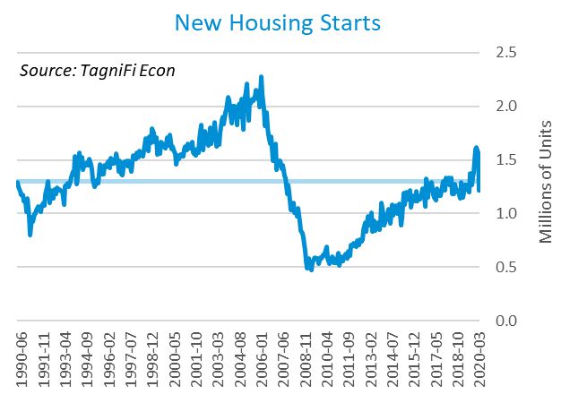

The cost of financing for would-be homebuyers declined during the 1st quarter as the 30-year fixed-rate mortgage[18] slid to 3.50% to end March 2020. The Fed announced two target rate cuts totaling 150 basis points in unscheduled decisions during March.

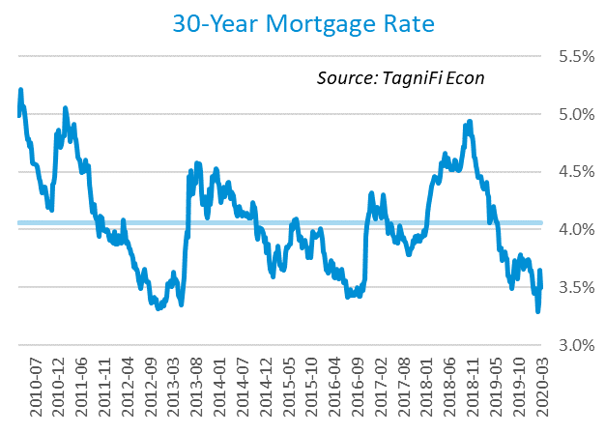

The S&P Case-Shiller Home Price Index (20-city)[19] for February 2020 increased by 3.4% over the year, with the largest gains in Western and Southern cities. Prior to the spread of COVID-19 in the U.S., home prices were advancing on robust demand, short supply and low mortgage rates; however, demand has since slackened due to the economic effects of the COVID-19 pandemic. Last February, home prices were increasing at a 2.8% annual rate. The 20-city composite lagged the national index.

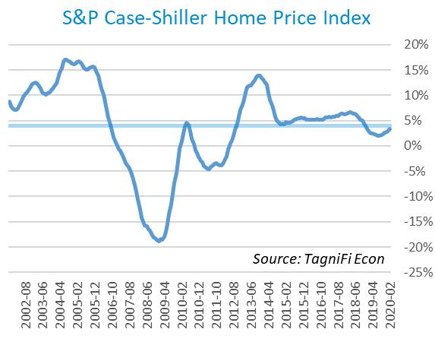

# Consumer Spending

The level of Personal Consumption Expenditures (PCE)[20] fell by 7.55% in March—the steepest monthly drop on record—and 3.77% from the previous March. Spending fell most sharply on healthcare, hospitality, recreation, motor vehicles, apparel, and transportation as stay-at-home orders took effect and incomes decreased. March’s annual drop contrasted with both the 30-year average over-the-year increase of 4.77% and the 4.21% level from the same period a year ago.

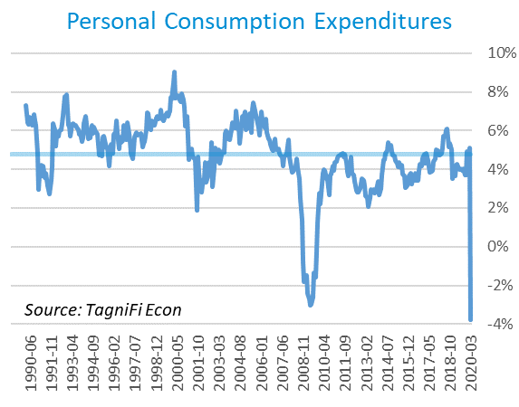

Automotive companies reported 11.4 million autos and light trucks sold[21] in March, down 5.4 million units from February and 5.9 million over the year. March sales were 4.0 million units below the 30-year average of 15.3 million units per month.

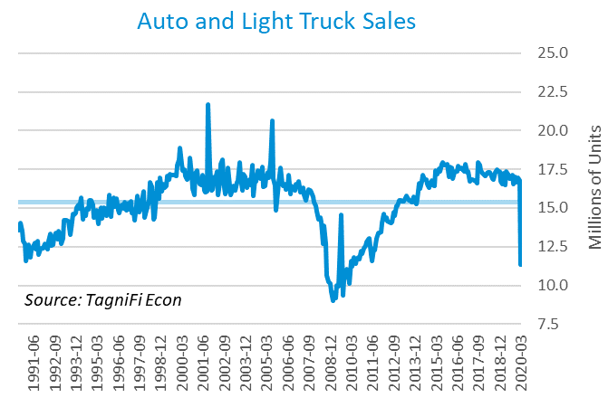

The consumer sentiment[22] index ended the 1st quarter at 89.1, the lowest level in approximately 3.5 years, after an 11.8% drop in March cancelled out gains earlier in the quarter. March’s decline was slightly larger than economists’ expectations as the COVID-19 outbreak grew to a global pandemic. Although March’s consumer sentiment reading was well below its level of 98.4 one year prior, it was still above the 30-year average of 87.6.

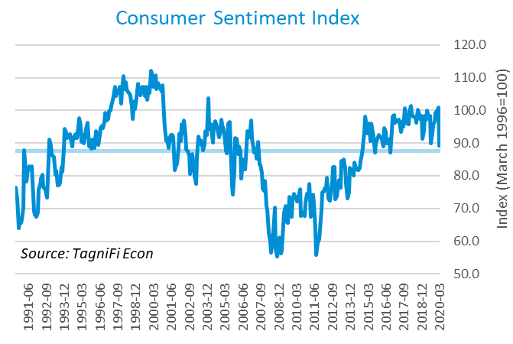

# Capital Markets

In March, the U.S. stock market suffered its worst month since October 2008, with the S&P 500 enduring its worst quarter since the end of 2008 and the Dow Jones Industrial Average weathering its worst quarter ever. Uncertainty about the extent and duration of economic devastation brought on by the COVID-19 pandemic, coupled with progressively more severe investor and consumer expectations, led to turmoil in U.S. capital markets, which had previously been gaining steam. The S&P 500 closed the quarter at 2,584.59, down 20.0% from the previous quarter and 8.98% from the same period last year. The Dow Jones Industrial Average fell 23.2% in the 1st quarter and 15.5% over the year. The transportation sector has been particularly hard-hit by the virus’s disruption, and the Dow Jones Transportation Index tumbled 29.1% in the 1st quarter and 25.7% over the year.



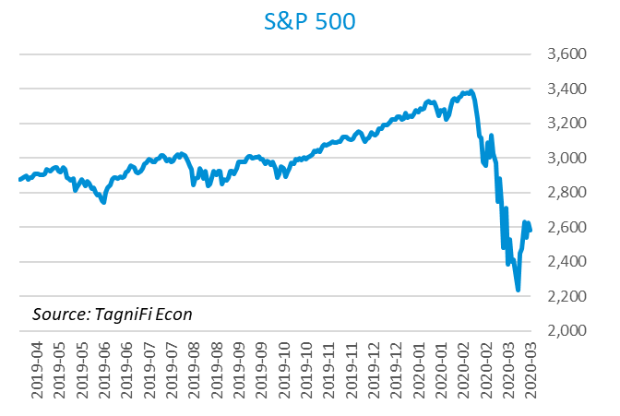

Stock market volatility[23] ended the 1st quarter at 53.54, up 288.5% since last quarter and well above the 10-year average of 17.13. The volatility index, a proxy for investor anxiety derived from tracking options prices on S&P 500 stocks, spiked to an all-time high of 82.69 in mid-March amid fear of severe impacts on global supply chains from the COVID-19 pandemic and widespread uncertainty about the potential breadth of the pandemic’s repercussions.

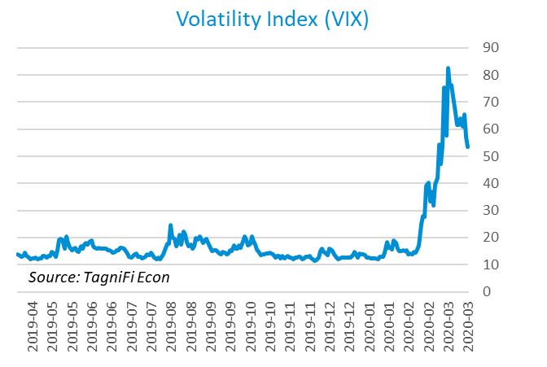

# Outlook

The U.S. Federal Open Market Committee’s scheduled March meeting was cancelled amid the COVID-19 pandemic. The FOMC convened twice in March to release unscheduled decisions lowering target rates and enacting broad fiscal policies to buffer the economy from the effects of the COVID-19 crisis. The FOMC has not issued new economic projections in the first quarter of 2020. In December 2019, the FOMC was projecting real GDP growth[24] to slow steadily to 1.90% by 2021 and 2022. They expected growth in Personal Consumption Expenditures (PCE)[25] to accelerate to 2.10% by 2022. Their forecast for the unemployment rate[26] was a gradual climb to 3.75% by 2022. Since that time, the effects of the current global pandemic have thrown the nation into a state of economic uncertainty.



# About This Report

The *Quarterly Economic Update* is a free publication sponsored by TagniFi. You are free to share this report and include its contents in the economic outlook section of your valuation reports as required by *Revenue Ruling 59-60*. Please forward this free report to a colleague to help us spread the word about TagniFi.

# About TagniFi

In July 2015 we released our first dataset, TagniFi Fundamentals, because we thought investors and finance professionals needed a better solution for financial data. Since then our mission has remained the same: to serve our clients with the best financial data available at a reasonable price. We do this by developing innovative solutions to leverage tagged financial statements which allow us to deliver better, faster and more detailed data at a fraction of the cost.

Today TagniFi is a platform of financial data aimed at making our clients more productive and prosperous. We're helping clients in all corners of finance make better decisions with better data. We relentlessly focus on quality and the trust we've earned from our clients is our greatest asset. Our growth is centered around our clients' needs as we look to expand our platform with new data. Referrals from our existing clients is the ultimate compliment so we choose to invest in our product, not flashy marketing campaigns.For more information on TagniFi, please visit [www.tagnifi.com](http://www.tagnifi.com).

How TagniFi Helps Business Valuation Teams

TagniFi’s financial data platform empowers business valuation professionals to quickly and easily build highly accurate financial models with full transparency—and within seconds.

**Public Comps**  
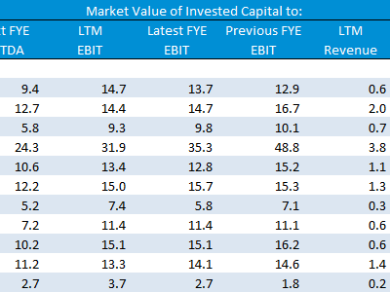Search for public companies with TagniFi Web. Simply enter your valuation date and ticker symbols in Excel to run a guideline public company method. Your Excel model populates instantly with the financial statements, analyst estimates, interest rates and economic data for your valuation date.

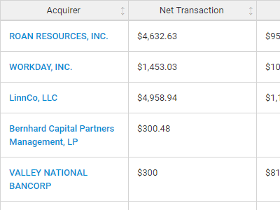**Transaction Comps**  
Search for public and private M&A transactions with TagniFi Web. Run your transaction comps within seconds by pasting the Deal ID into your Excel model. Every deal disclosed in an SEC filing (8-K, 10-K, or 10-Q) is available for your analysis. Choose from over 90 fields of data available for every deal.

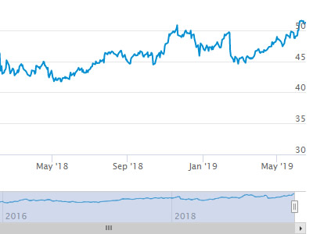

**Historical Beta and Volatility**Calculate historical beta and volatility as of your valuation date automatically. Simply enter the tickers and valuation date in Excel - TagniFi does the rest. In addition to beta and volatility, there are over 40 Excel models available in the Model Library to help with your valuation report.

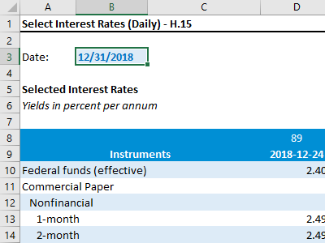**Interest Rates and Economic Data**Automate the interest rates and economic data in your valuation report using the TagniFi Excel plugin. Choose from over 200,000 time series available. All data in this *Quarterly Economic Update* is from the TagniFi platform. Use economic and interest rate data for your own valuation models with the TagniFi Excel plugin.

1. *Coronavirus Locations: COVID-19 Map by County and State, retrieved from USAFacts,* [*https://usafacts.org/visualizations/coronavirus-covid-19-spread-map/*](https://usafacts.org/visualizations/coronavirus-covid-19-spread-map/)*, May 2, 2020*
2. *State Coincident Indexes, retrieved from the Federal Reserve Bank of Philadelphia,* [*https://www.philadelphiafed.org/-/media/research-and-data/regional-economy/indexes/coincident/2020/coincidentindexes0320.pdf*](https://www.philadelphiafed.org/-/media/research-and-data/regional-economy/indexes/coincident/2020/coincidentindexes0320.pdf)*, May 2, 2020*
3. *Board of Governors of the Federal Reserve System (US), Trade Weighted U.S. Dollar Index: Broad, Goods and Services [DTWEXBGS], retrieved from FRED, Federal Reserve Bank of St. Louis;* [*https://fred.stlouisfed.org/series/DTWEXBGS*](https://fred.stlouisfed.org/series/DTWEXBGS)*, May 1, 2020.*
4. U.S. Bureau of Economic Analysis, Real Gross Domestic Product [GDPC1], *retrieved from FRED, Federal Reserve Bank of St. Louis;*[*https://fred.stlouisfed.org/series/GDPC1*](https://fred.stlouisfed.org/series/GDPC1)*, May 1, 2020.*
5. Board of Governors of the Federal Reserve System (US), Industrial Production Index [INDPRO], *retrieved from FRED, Federal Reserve Bank of St. Louis;*[*https://fred.stlouisfed.org/series/INDPRO*](https://fred.stlouisfed.org/series/INDPRO)*, May 1, 2020.*
6. *Selected Interest Rates Instruments, Yields in percent per annum, retrieved from FRED, Federal Reserve Bank of St. Louis;* [*https://fred.stlouisfed.org/release/tables?rid=18&eid=289&od=2020-03-31#*](https://fred.stlouisfed.org/release/tables?rid=18&eid=289&od=2020-03-31)*, May 1, 2020.*
7. *Board of Governors of the Federal Reserve System (US), Effective Federal Funds Rate [FEDFUNDS], retrieved from FRED, Federal Reserve Bank of St. Louis;*[*https://fred.stlouisfed.org/series/FEDFUNDS*](https://fred.stlouisfed.org/series/FEDFUNDS)*, May 1, 2020.*
8. Board of Governors of the Federal Reserve System (US), 10-Year Treasury Constant Maturity Rate [DGS10], *retrieved from FRED, Federal Reserve Bank of St. Louis;*[*https://fred.stlouisfed.org/series/DGS10*](https://fred.stlouisfed.org/series/DGS10)*, May 1, 2020.*
9. Moody’s, Moody’s Seasoned Baa Corporate Bond Yield [BAAS], *retrieved from FRED, Federal Reserve Bank of St. Louis;*[*https://fred.stlouisfed.org/series/BAA*](https://fred.stlouisfed.org/series/BAA)*, May 1, 2020.*
10. U.S. Bureau of Labor Statistics, All Employees: Total Nonfarm Payrolls [PAYEMS], *retrieved from FRED, Federal Reserve Bank of St. Louis;*[*https://fred.stlouisfed.org/series/PAYEMS*](https://fred.stlouisfed.org/series/PAYEMS)*, Feb 2, 2020.*
11. U.S. Bureau of Labor Statistics, Civilian Unemployment Rate [UNRATE], *retrieved from FRED, Federal Reserve Bank of St. Louis;*[*https://fred.stlouisfed.org/series/UNRATE*](https://fred.stlouisfed.org/series/UNRATE)*, Feb 2, 2020.*
12. *U.S. Employment and Training Administration, Continued Claims (Insured Unemployment) [CCSA], retrieved from FRED, Federal Reserve Bank of St. Louis;* [*https://fred.stlouisfed.org/series/CCSA*](https://fred.stlouisfed.org/series/CCSA)*, May 2, 2020.*
13. U.S. Bureau of Labor Statistics, Consumer Price Index for All Urban Consumers: All Items [CPIAUCSL], *retrieved from FRED, Federal Reserve Bank of St. Louis;*[*https://fred.stlouisfed.org/series/CPIAUCSL*](https://fred.stlouisfed.org/series/CPIAUCSL)*, May 2, 2020.*
14. *Survey of Consumer Expectations, retrieved from Federal Reserve Bank of New York,* [*https://www.newyorkfed.org/microeconomics/sce#indicators/inflation-expectations/g1*](https://www.newyorkfed.org/microeconomics/sce#indicators/inflation-expectations/g1)*, May 2, 2020*
15. U.S. Bureau of Labor Statistics, Producer Price Index for All Commodities [PPIACO], *retrieved from FRED, Federal Reserve Bank of St. Louis;*[*https://fred.stlouisfed.org/series/PPIACO*](https://fred.stlouisfed.org/series/PPIACO)*, May 2, 2020.*
16. *U.S. Energy Information Administration, Crude Oil Prices: West Texas Intermediate (WTI) – Cushing, Oklahoma [MCOILWTICO], retrieved from FRED, Federal Reserve Bank of St. Louis;*[*https://fred.stlouisfed.org/series/MCOILWTICO*](https://fred.stlouisfed.org/series/MCOILWTICO)*, May 2, 2020.*
17. U.S. Bureau of the Census, Housing Starts: Total: New Privately Owned Housing Units Started [HOUST], *retrieved from FRED, Federal Reserve Bank of St. Louis;*[*https://fred.stlouisfed.org/series/HOUST*](https://fred.stlouisfed.org/series/HOUST)*, May 2, 2020.*
18. Freddie Mac, 30-Year Fixed Rate Mortgage Average in the United States [MORTGAGE30US], *retrieved from FRED, Federal Reserve Bank of St. Louis;*[*https://fred.stlouisfed.org/series/MORTGAGE30US*](https://fred.stlouisfed.org/series/MORTGAGE30US)*, May 2, 2020.*
19. S&P Down Jones Indices LLC, S&P/Case-Shiller 20-City Composite Home Price Index [SPCS20RSA], *retrieved from FRED, Federal Reserve Bank of St. Louis;*[*https://fred.stlouisfed.org/series/SPCS20RSA*](https://fred.stlouisfed.org/series/SPCS20RSA)*, May 2, 2020.*
20. U.S. Bureau of Economic Analysis, Personal Consumption Expenditures [PCE], *retrieved from FRED, Federal Reserve Bank of St. Louis;*[*https://fred.stlouisfed.org/series/PCE*](https://fred.stlouisfed.org/series/PCE)*, May 2, 2020.*
21. U.S. Bureau of Economic Analysis, Light Weight Vehicle Sales: Autos and Light Trucks [ALTSALES], *retrieved from FRED, Federal Reserve Bank of St. Louis;*[*https://fred.stlouisfed.org/series/ALTSALES*](https://fred.stlouisfed.org/series/ALTSALES)*, May 2, 2020.*
22. *University of Michigan, University of Michigan: Consumer Sentiment [UMCSENT], retrieved from FRED, Federal Reserve Bank of St. Louis;* [*https://fred.stlouisfed.org/series/UMCSENT*](https://fred.stlouisfed.org/series/UMCSENT)*, May 2, 2020.*
23. *Chicago Board Options Exchange, CBOE Volatility Index: VIX [VIXCLS], retrieved from FRED, Federal Reserve Bank of St. Louis;* [*https://fred.stlouisfed.org/series/VIXCLS*](https://fred.stlouisfed.org/series/VIXCLS)*, May 2, 2020.*
24. *Federal Reserve Bank of St. Louis, FOMC Summary of Economic Projections for the Growth Rate of Real Gross Domestic Product [GDPC1CTM], retrieved from FRED, Federal Reserve Bank of St. Louis;*[*https://fred.stlouisfed.org/series/GDPC1CTM*](https://fred.stlouisfed.org/series/GDPC1CTM)*, May 2, 2020.*
25. *Federal Reserve Bank of St. Louis, FOMC Summary of Economic Projections for the Personal Consumption Expenditures Inflation Rate, Central Tendency, Midpoint [PCECTPICTM], retrieved from FRED, Federal Reserve Bank of St. Louis;*[*https://fred.stlouisfed.org/series/PCECTPICTM*](https://fred.stlouisfed.org/series/PCECTPICTM)*, May 2, 2020.*
26. *Federal Reserve Bank of St. Louis, FOMC Summary of Economic Projections for the Civilian Unemployment Rate, Central Tendency, Midpoint [UNRATECTM], retrieved from FRED, Federal Reserve Bank of St. Louis;*[*https://fred.stlouisfed.org/series/UNRATECTM*](https://fred.stlouisfed.org/series/UNRATECTM)*, May 2, 2020.*