QUARTERLY ECONOMIC UPDATE

For the 2nd Quarter of 2020

Abstract

Designed for business valuation professionals, TagniFi’s Quarterly Economic   
Update provides timely economic data to satisfy Revenue Ruling 56-60.

# Summary

In the 2nd quarter of 2020, the U.S. economy faced devastation due to the COVID-19 pandemic, then began to rebound as strict public health measures were relaxed after their initial success. In late April, states began easing the emergency restrictions on in-person gathering and nonessential business instituted in March to slow the spread of COVID-19. In some areas of the country, a resurgence in new COVID-19 infections forced renewed public-health restrictions by late June, casting uncertainty over the stability of the economic recovery.

Pandemic-induced constraints on nonessential activity began to seriously impact the world economy in the 1st quarter. A recession was declared in the U.S., marking February as the peak of an economic expansion that lasted 128 months from its beginning in June 2009. The national economic effects of COVID-19 reached an apex in April as unemployment rose to an all-time recorded high. GDP and consumer spending fell at their most rapid documented rates, despite government and central bank measures to cushion the fallout. Most economic measures began to recuperate in May and June, but at the end of the 2nd quarter, the U.S. economy remained far less robust than before the pandemic.

By the end of the 2nd quarter of 2020, 2,618,817 cases and 126,623 deaths had been reported in the U.S. from COVID-19[1]. The viral disease has continued to spread exponentially, and as of July 31, 2020 there were 4,527,542 confirmed cases and 152,119 related deaths in the U.S.

Below is a summary timeline of COVID-19 events in the U.S. during the 2nd quarter of 2020:

|  |  |
| --- | --- |
| April 2, 2020 | Confirmed COVID-19 cases total more than 1 million worldwide |
| April 3, 2020 | SBA Announces Paycheck Protection Program loans |
| April 9, 2020 | Federal Reserve Announces $2.3 trillion in additional loans to support the economy |
| April 10, 2020 | Global death toll from COVID-19 passes 100,000 |
| April 15, 2020 | Paycheck Protection Program funding exhausted |
| April 15, 2020 | Confirmed COVID-19 cases total more than 2 million worldwide |
| April 16, 2020 | Federal Reserve opens Paycheck Protection Program Liquidity Facility |
| April 16, 2020 | White House releases guidelines for easing social distancing restrictions |
| April 21, 2020 | First confirmed COVID-19 death in the U.S. revised to February 6, in California |
| April 24, 2020 | Georgia becomes the first state to begin reopening nonessential businesses for in-person operations |
| April 24, 2020 | Paycheck Protection Program and Health Care Enhancement Act signed with additional funding |
| April 28, 2020 | U.S. becomes first country with 1 million confirmed cases of COVID-19 |
| April 28, 2020 | White House invokes Defense Production Act to require continued operation of meat and poultry processors following outbreaks of COVID-19 at some facilities |
| April 30, 2020 | Federal Reserve Expands Access to Paycheck Protection Program Liquidity Facility |
| May 11, 2020 | Federal Reserve Bank of New York announces Secondary Market Corporate Credit Facility will begin purchasing exchange-traded funds |
| May 20, 2020 | Connecticut becomes the last state to begin reopening nonessential businesses for in-person operations |
| May 20, 2020 | CDC provides reopening guidance for communities, schools, workplaces, and events |
| May 26, 2020 | NYSE reopens trading floor after over 2 months of fully electronic trading |
| May 28, 2020 | U.S. death toll from COVID-19 reaches 100,000 |
| June 3, 2020 | Federal Reserve expands the number and type of entities eligible to directly use its Municipal Liquidity Facility |
| June 8, 2020 | NBER declares a U.S. recession beginning in February 2020, the peak of a 128 month economic expansion that began in June 2009 |
| June 8, 2020 | Federal Reserve expands its Main Street Lending Program to allow access to more small and medium-sized businesses |
| June 11, 2020 | Confirmed COVID-19 cases in the U.S. total more than 2 million |
| June 15, 2020 | Small Business Administration reopens the Economic Injury Disaster Loan |
| June 15, 2020 | The Federal Reserve expands the Secondary Market Corporate Credit Facility to begin buying a broad and diversified portfolio of corporate bonds to support market liquidity |
| June 26, 2020 | Texas and Florida become the 1st states to reverse nonessential business re-openings |
| June 29, 2020 | Federal Reserve Bank of New York launches Primary Market Corporate Credit Facility, a funding backstop for corporate debt to eligible issuers |

The Philadelphia Fed’s coincident index of economic activity in the U.S. rose 2.7% in June 2020, continuing May’s rebound after a sharp drop in April. Still, the index was down 5.0% for the 2nd quarter. In June, state coincident indexes[2] showed increased economic activity in 42 states, decreased activity in 7 states, and stable activity in 1. Yet over the entire quarter, coincident indexes decreased in 47 states, increased in 2 states, and was unchanged in 1 state. Coincident indexes reflect unemployment, payroll employment, manufacturing hours, and wages and salaries. Unemployment strongly influences the indexes; despite some rebounds in economic activity, unemployment remains high in most states.



The U.S. dollar index for goods and services[3] fell 1.60% during the 2nd quarter of 2020, and 0.73% since the 2nd quarter a year ago. After the index’s spike in March, demand has weakened for the dollar as the U.S. had straggled on the world stage in pandemic control, casting doubts over the sustainability of the national economic recovery. At the end of the 2nd quarter, the dollar’s fall decelerated as strong signals of economic reinvigoration mixed with the renewal of restrictions on in-person gathering in COVID-19 hotspots such as Texas, Florida, and California.

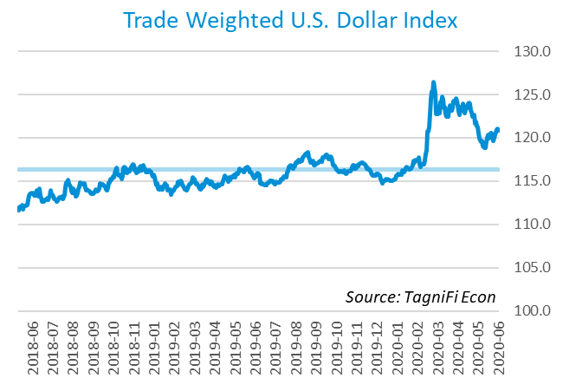

# Economic Highlights

* Real GDP fell at an annual rate of 32.9% in the 2nd quarter, its largest single-quarter drop ever.
* Oil prices reached a 21-year low in April. WTI crude rebounded to $38.31 per barrel in June.
* The U.S. dollar index fell 1.6% in the 2nd quarter and 0.73% compared with the same period last year.
* Throughout the 2nd quarter, the Federal Reserve held the federal funds target rate at a range of 0.00 to 0.25 percent.
* Bond yields remained low during the quarter, with the 10-year U.S. treasury yielding 0.66% and the 30-year U.S. treasury yielding 1.41%.
* Consumer inflation rose 0.71% since last June.
* New housing starts were down 6.5% over the 2nd quarter and 25.3% since the beginning of 2020.
* Unemployment peaked at 14.7% in April 2020 before declining to 11.1% in June 2020, and payroll employment fell by nearly 13.3 million jobs throughout the 2nd quarter.
* U.S. capital markets rallied in the 2nd quarter, with the S&P 500 up 20.0% and the NASDAQ Composite up 30.6%.

# Business Activity

According to the Bureau of Economic Analysis (BEA), real gross domestic product (GDP)[4] for the 2nd quarter of 2020 plummeted at an annual rate of 32.9%, its largest single-quarter drop ever, after the prior quarter’s decrease of 5.0%. The drop was large enough to bring the 30-year average annual rate of GDP growth down slightly to 2.1%. The 2nd-quarter decline in GDP reflected sudden changes in economic activity resulting from the COVID-19 pandemic, as states’ restrictions on in-person activities from March and April shifted and eased throughout the country in May and June. Financial pandemic assistance from the federal government reached households, businesses, and states in the 2nd quarter of 2020. Since the 2nd quarter last year, real GDP fell 9.5%, a series low.

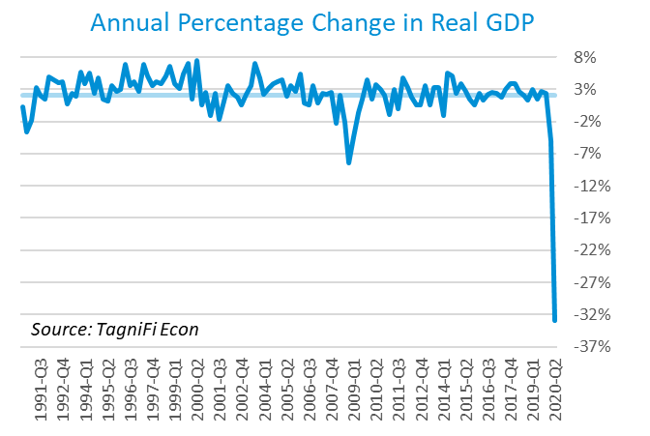

The 2nd quarter GDP drop primarily reflected declines in personal consumption spending, particularly spending on services such as health care, financial, and recreation services; private inventory investment; and both nonresidential and residential investment. Moderating the contraction in GDP were increased federal government spending and a steep reduction in imports, which more than offset a concurrent decrease in exports.

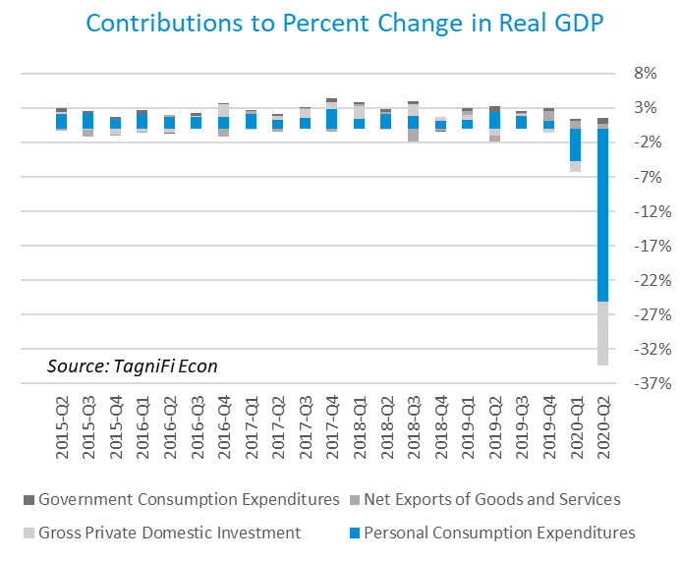

As of June, the Industrial Production Index[5] stood at 97.46, down 6.7% over the 2nd quarter of 2020. Manufacturing shutdowns due to the COVID-19 pandemic, particularly motor vehicles and parts, aerospace, metals, and furniture, led a rapid drop in April, as industrial capacity utilization dipped below 65%, a record low. The Industrial Production Index rebounded partially in May and June. The index was 10.8% lower in June 2020 than one year prior.

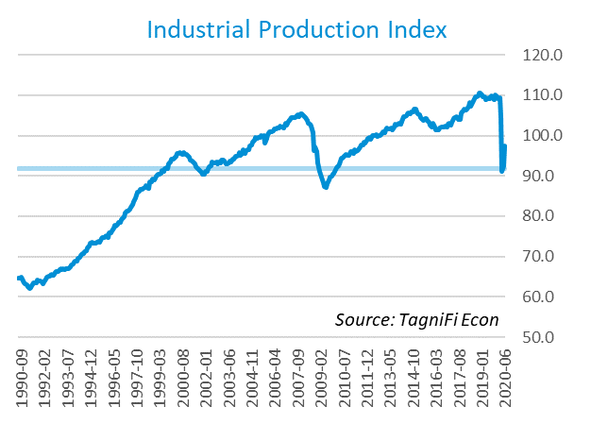

# Interest Rates

Short- and long-term treasury bond yields[6] stagnated throughout the 2nd quarter of 2020, remaining near the 1st quarter’s historic lows as U.S. debt remained generally favorable to riskier equity investments in the wake of economic devastation due to the COVID-19 crisis. The 1-year and 2-year annual treasury yields both ended the quarter at 0.16%. The benchmark 10-year treasury yielded 0.66% annually at the end of June 2020, while the 30-year treasury yielded 1.41%.

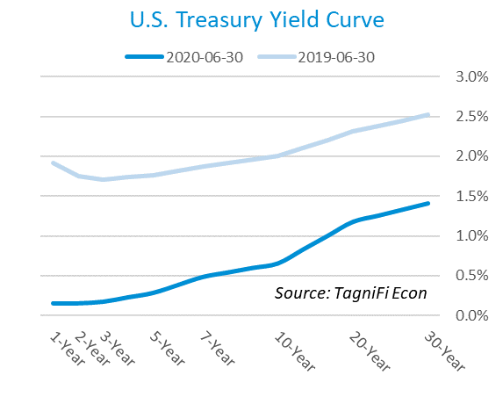

In the 2nd quarter of 2020, the Federal Reserve kept the federal funds target rate steady at a range of 0.00 to 0.25 percent, pledging to hold that rate until the U.S. economy recovers from the pandemic-induced recession. The effective federal funds rate[7] as of June 30th was 0.08%.

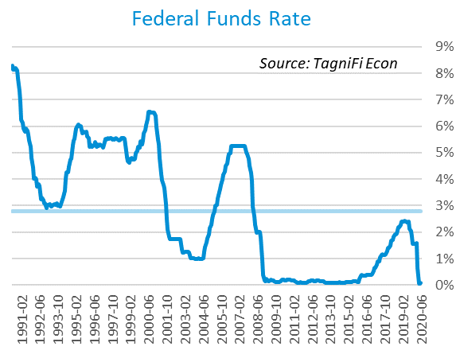

The yield on the benchmark 10-year U.S. treasury[8] fell 0.04 percentage points during the 2nd quarter to end June at 0.66%, well below the average yield of 4.38% over the last 30 years and the 2.00% yield from the same period last year.

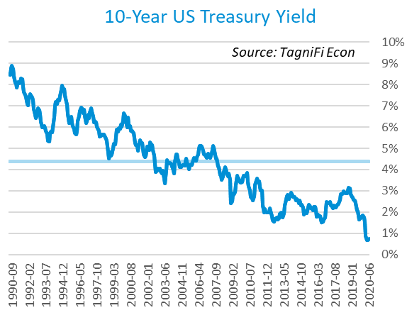

Corporate bond yields fell steadily throughout the 2nd quarter, with the Moody’s Baa Corporate Bond Yield Index[9] ending the quarter at 3.64% compared to 4.29% for the 1st quarter. Rates were below both the index’s average yield of 6.77% for the last 30 years and the 4.46% yield from the same period last year.

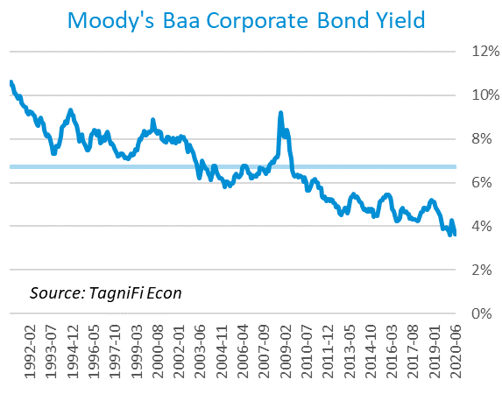

# Employment

The U.S. unemployment rate reached its highest level ever recorded in April 2020 and remained in double-digits to end the quarter. The U.S. lost nearly 13.3 million jobs throughout the 2nd quarter, as total nonfarm payrolls[10] plunged by 20.8 million in April, then partially recovered in May and June when states began to ease restrictions on nonessential in-person activities. The largest losses were in leisure & hospitality, especially eating & drinking places; health care and social assistance; professional services; and retail trade. Leisure and hospitality led the late-spring rebounds, but remained more than 3 million jobs lower than pre-COVID reports. Payrolls were up 4.8 million in June; still 13.0 million below last June’s levels.

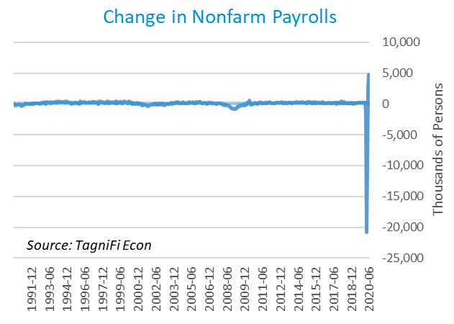

The unemployment rate[11] peaked at 14.7% in April 2020 before easing to 11.1% in June 2020. Those reporting temporary layoffs fell by 4.8 million in June, yet those experiencing permanent job losses rose 0.6 million. The June unemployment rate was up 7.4% from the same period a year ago and well above the 30-year average unemployment rate of 5.9%.

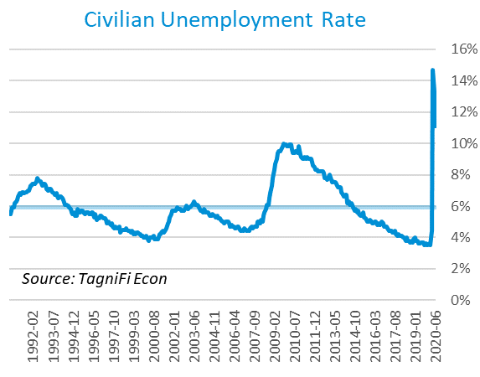

# Inflation

Inflation rebounded at the end of the 2nd quarter, led by higher prices for gasoline and food as business and consumer activity perked up in June. Still, economists expect inflation to remain mild throughout the current economic crisis. The Consumer Price Index (CPI)[12] has increased by 0.71% since last June. According to the Federal Reserve Bank of New York’s Survey of Consumer Expectations, inflation expectations[13] softened in June to 2.7% for the one-year horizon and 2.5% for the three-year horizon.

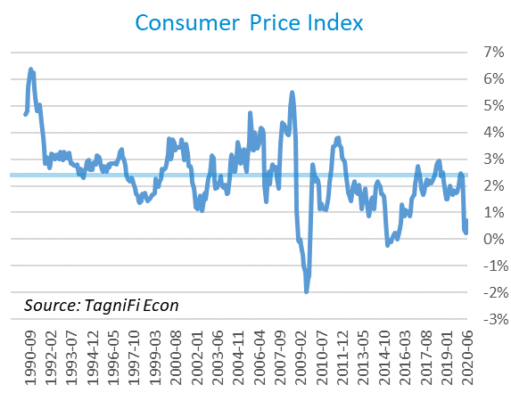

Prices at the producer level dropped in April before partially rebounding for the remainder of the quarter, with June prices up 0.90% for all commodities, especially fuels and accommodations. The Producer Price Index (PPI)[14] for all commodities was 4.59% lower in June compared to the same period last year, falling well short of the 30-year average of a 1.95% annual increase.

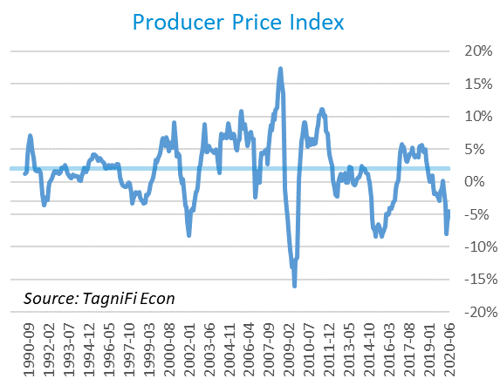

During the 2nd quarter, U.S. crude oil[15] prices reached a 21-year low in April before beginning their recovery, supported by output restrictions. Additionally, demand for oil began a gradual worldwide rebound during the May and June as many countries worldwide eased travel and in-person business constraints imposed to control the COVID-19 pandemic. Crude oil prices ended the quarter at $38.31 per barrel in June, up 31.2% from the previous quarter yet still 29.9% lower than last June.

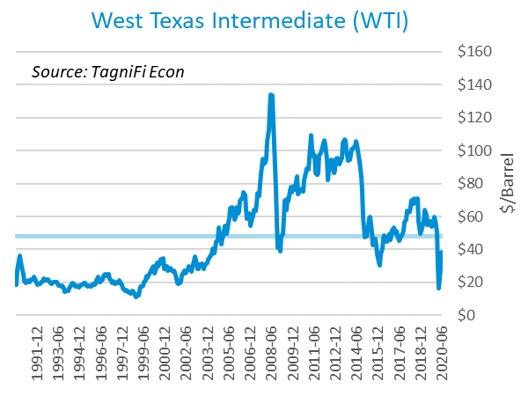

# Housing

During the 2nd quarter, the housing market also felt the effects of nonessential business restrictions and economic contraction, with new home starts[16] dropping below 1 million in April before partially recovering to 1.19 million in June. Total new housing starts were down 6.5% over the 2nd quarter and 25.3% since the beginning of 2020. Though caution lingered as COVID-19 infection rates rose in some parts of the country in late June, mortgage rates at 50-year lows and building permit applications up 2.1% were bright spots for the homebuilding industry. New home starts remained below the 30-year average of 1.30 million units per month throughout the 2nd quarter of 2020.

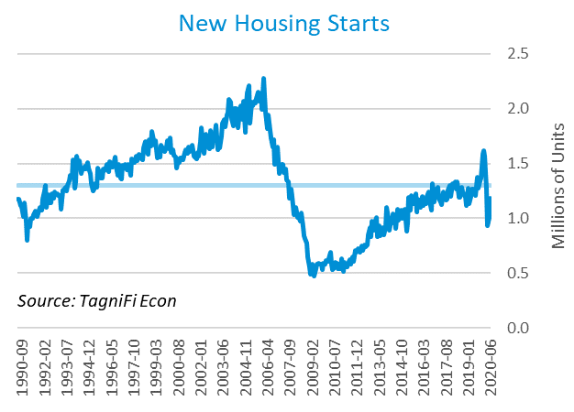

The cost of financing for would-be homebuyers continued to decline during the 2nd quarter as the 30-year fixed-rate mortgage[17] slid to 3.13% to end June 2020. The Fed held target interest rates at 0.00% to 0.25% throughout the 2nd quarter.

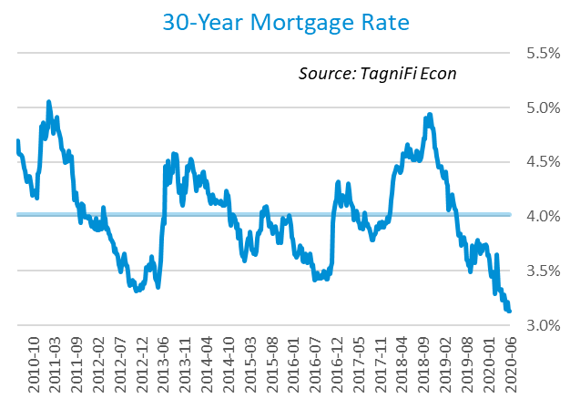

The S&P Case-Shiller Home Price Index (20-city)[18] for May 2020 increased by 3.7% over the year, with the strongest gains again in Phoenix, Seattle, and Tampa. The 20-city composite lagged the national index. Pandemic-induced demand for homes outside of major cities, combined with historically low mortgage rates and constrained supply, buoyed home prices after initial slackening in the earlier stages of COVID-19’s spread. Last May, home prices were increasing at a 2.3% annual rate.

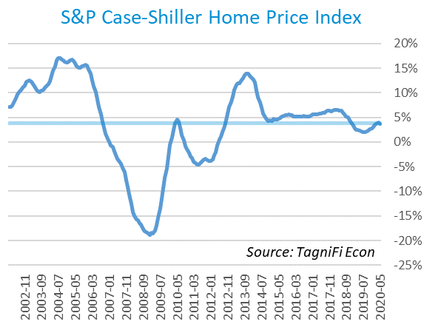

# Consumer Spending

The level of Personal Consumption Expenditures (PCE)[19] fell by 12.9% in April—the steepest monthly drop on record and nearly double the previous record in March—before partially recuperating in May and June. PCE rose 5.63% in June but remained 4.84% below the previous June’s level. June’s spending gains were led by clothing & footwear, health care, and food services and accommodations. Optimism inspired by May and June’s strong upswing in spending was tempered by a resurgence of new COVID-19 infections late in the quarter.

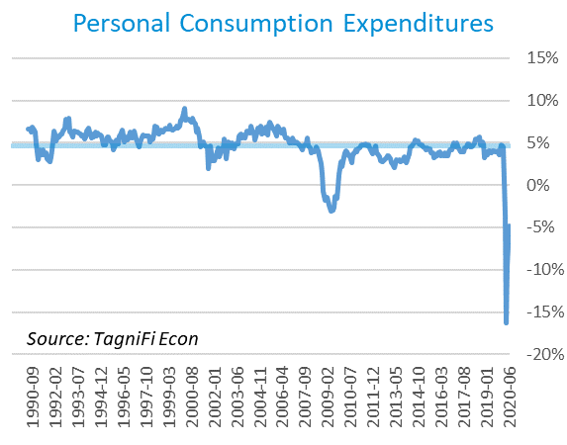

Automotive companies reported 13.1 million autos and light trucks sold[20] in June, up 0.9 million units from May and 4.3 million from April’s record low. June sales remained 4.2 million units below the year-ago levels and 2.3 million units below the 30-year average of 15.3 million units per month.

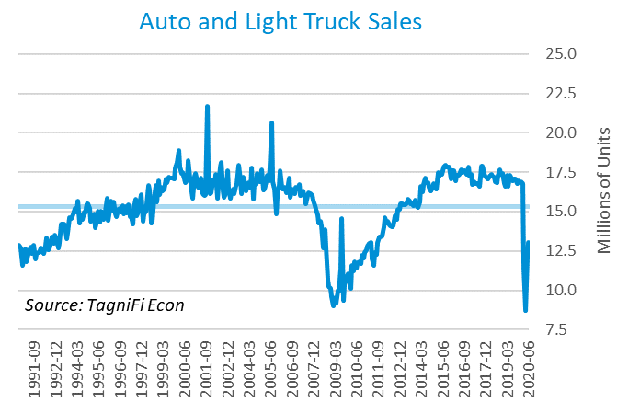

The consumer sentiment[21] index ended the 2nd quarter at 78.1, rebounding 6.3 points in June after hitting a nearly 8.5-year low of 71.8 in April. While strong, June’s rebound fell slightly short of economists’ expectations. June’s consumer sentiment reading was well below its level of 98.2 one year prior and the 30-year average of 87.5.

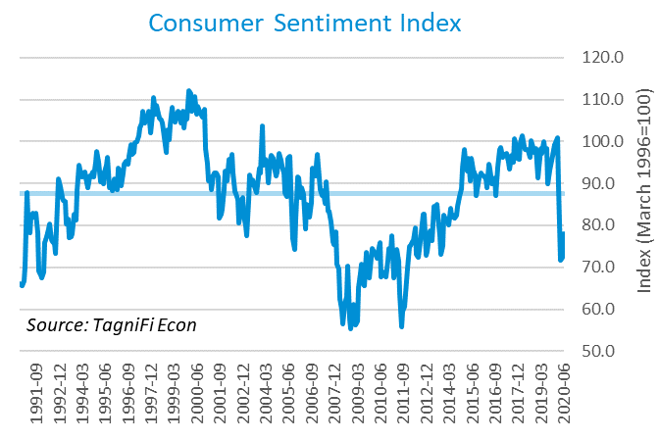

# Capital Markets

The U.S. stock market rallied strongly during the 2nd quarter, after beginning 2020 with its worst quarter since 2008’s Great Recession. Economic stimulus moves by the Fed and Congress, combined with a lull in new COVID-19 infections and renewed economic activity, brought hope and confidence back to investors. The rally began to level off in late June, when parts of the U.S. began to see a resurgence of new viral infections and some states were forced to renew restrictions for public health reasons. The NASDAQ Composite jumped 30.6% in the 2nd quarter and was 24.3% higher over the last 12 months. The S&P 500 climbed 20.0% during the 2nd quarter and was 4.6% higher over the last 12 months. With the transportation sector particularly hard-hit by the pandemic, The Dow Jones Transportation Average gained 18.6% over the quarter, yet still fell 12.7% short of its year-ago level.



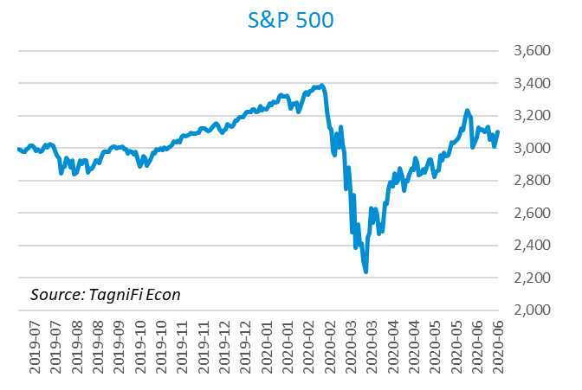

Stock market volatility[22] ended the 2nd quarter at 30.4, down 52.3 points from the peak last quarter, yet well above the 10-year average of 19.7. The volatility index, a proxy for investor anxiety derived from tracking options prices on S&P 500 stocks, fell throughout the 2nd quarter after hitting an all-time high in mid-March amid economic uncertainty inspired by the COVID-19 pandemic.

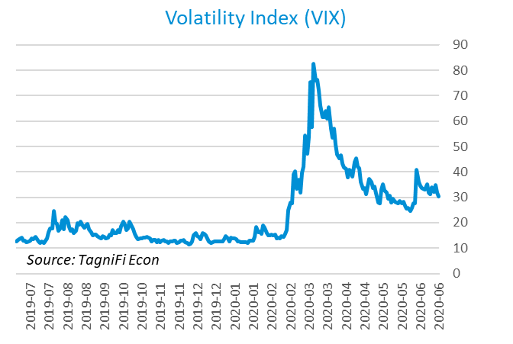

# Outlook

In June 2020, the FOMC projected real GDP to decline[23] 6.55% during 2020, followed by 5.25% growth in 2021, slowing to 3.75% in 2022. They expected growth in Personal Consumption Expenditures (PCE)[24] to cool to 0.80% in 2020, then bounce back to 1.70% by 2022. They forecast that the unemployment rate[25] will end 2020 at 9.50%, easing to 5.45% by 2022.



# About This Report

The *Quarterly Economic Update* is a free publication sponsored by TagniFi. You are free to share this report and include its contents in the economic outlook section of your valuation reports as required by *Revenue Ruling 59-60*. Please forward this free report to a colleague to help us spread the word about TagniFi.

# About TagniFi

In July 2015 we released our first dataset, TagniFi Fundamentals, because we thought investors and finance professionals needed a better solution for financial data. Since then our mission has remained the same: to serve our clients with the best financial data available at a reasonable price. We do this by developing innovative solutions to leverage tagged financial statements which allow us to deliver better, faster and more detailed data at a fraction of the cost.

Today TagniFi is a platform of financial data aimed at making our clients more productive and prosperous. We're helping clients in all corners of finance make better decisions with better data. We relentlessly focus on quality and the trust we've earned from our clients is our greatest asset. Our growth is centered around our clients' needs as we look to expand our platform with new data. Referrals from our existing clients is the ultimate compliment so we choose to invest in our product, not flashy marketing campaigns.For more information on TagniFi, please visit [www.tagnifi.com](http://www.tagnifi.com).

How TagniFi Helps Business Valuation Teams

TagniFi’s financial data platform empowers business valuation teams to quickly and easily build highly accurate financial models with full transparency—and within seconds.

**Better Public Comps**  
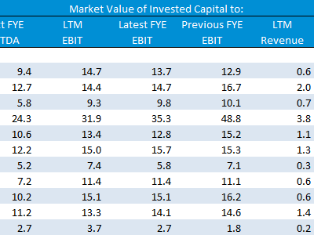Search for public companies with TagniFi Web. Simply enter your valuation date and ticker symbols in Excel to run a guideline public company method. Your Excel model populates instantly with the financial statements, analyst estimates, interest rates and economic data for your valuation date.

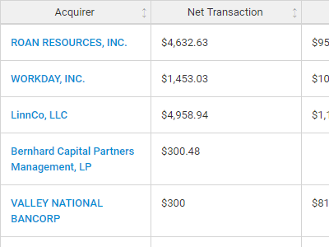**Better Transaction Comps**  
Search for public and private M&A transactions with TagniFi Web. Run your transaction comps within seconds by pasting the Deal ID into your Excel model. Every deal disclosed in an SEC filing (8-K, 10-K, or 10-Q) is available for your analysis. Choose from over 90 fields of data available for every deal.

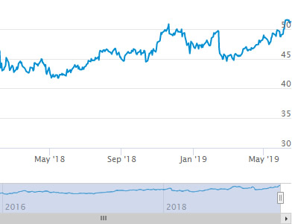

**Historical Beta and Volatility**Calculate historical beta and volatility as of your valuation date automatically. Simply enter the tickers and valuation date in Excel - TagniFi does the rest. In addition to beta and volatility, there are over 40 Excel models available in the Model Library to help with your valuation report.

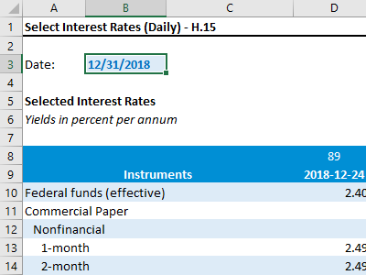**Interest Rates and Economic Data**Automate the interest rates and economic data in your valuation report using the TagniFi Excel plugin. Choose from over 200,000 time series available. All data in this *Quarterly Economic Update* is from the TagniFi platform. Use economic and interest rate data for your own valuation models with the TagniFi Excel plugin.

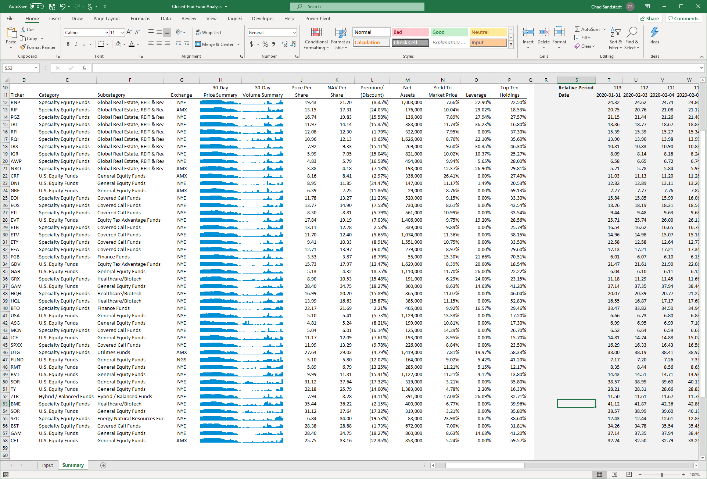

**Closed-End Mutual Fund Data**Search for closed-end mutual funds by keyword, category, subcategory, and more with the TagniFi Console. Use the TagniFi Excel plugin to calculate historical discounts, yields, leverage, as of your valuation date automatically. Simply enter the tickers and valuation date in Excel - TagniFi does the rest.

1. *Coronavirus Locations: COVID-19 Map by County and State, retrieved from USAFacts,* [*https://usafacts.org/visualizations/coronavirus-covid-19-spread-map/*](https://usafacts.org/visualizations/coronavirus-covid-19-spread-map/)*, May 2, 2020*
2. *State Coincident Indexes, retrieved from the Federal Reserve Bank of Philadelphia,* [*https://www.philadelphiafed.org/-/media/research-and-data/regional-economy/indexes/coincident/2020/coincidentindexes0620.pdf*](https://www.philadelphiafed.org/-/media/research-and-data/regional-economy/indexes/coincident/2020/coincidentindexes0620.pdf?la=en)*, Aug 1, 2020.*
3. *Board of Governors of the Federal Reserve System (US), Trade Weighted U.S. Dollar Index: Broad, Goods and Services [DTWEXBGS], retrieved from FRED, Federal Reserve Bank of St. Louis;* [*https://fred.stlouisfed.org/series/DTWEXBGS*](https://fred.stlouisfed.org/series/DTWEXBGS)*, Aug 1, 2020.*
4. U.S. Bureau of Economic Analysis, Real Gross Domestic Product [GDPC1], *retrieved from FRED, Federal Reserve Bank of St. Louis;*[*https://fred.stlouisfed.org/series/GDPC1*](https://fred.stlouisfed.org/series/GDPC1)*, Aug 1, 2020.*
5. Board of Governors of the Federal Reserve System (US), Industrial Production Index [INDPRO], *retrieved from FRED, Federal Reserve Bank of St. Louis;*[*https://fred.stlouisfed.org/series/INDPRO*](https://fred.stlouisfed.org/series/INDPRO)*, Aug 1, 2020.*
6. *Selected Interest Rates Instruments, Yields in percent per annum, retrieved from FRED, Federal Reserve Bank of St. Louis;* [*https://fred.stlouisfed.org/release/tables?rid=18&eid=289&od=2020-03-31#*](https://fred.stlouisfed.org/release/tables?rid=18&eid=289&od=2020-03-31)*, Aug 1, 2020.*
7. *Board of Governors of the Federal Reserve System (US), Effective Federal Funds Rate [FEDFUNDS], retrieved from FRED, Federal Reserve Bank of St. Louis;*[*https://fred.stlouisfed.org/series/FEDFUNDS*](https://fred.stlouisfed.org/series/FEDFUNDS)*, Aug 1, 2020.*
8. Board of Governors of the Federal Reserve System (US), 10-Year Treasury Constant Maturity Rate [DGS10], *retrieved from FRED, Federal Reserve Bank of St. Louis;*[*https://fred.stlouisfed.org/series/DGS10*](https://fred.stlouisfed.org/series/DGS10)*, Aug 1, 2020.*
9. Moody’s, Moody’s Seasoned Baa Corporate Bond Yield [BAAS], *retrieved from FRED, Federal Reserve Bank of St. Louis;*[*https://fred.stlouisfed.org/series/BAA*](https://fred.stlouisfed.org/series/BAA)*, Aug 1, 2020.*
10. U.S. Bureau of Labor Statistics, All Employees: Total Nonfarm Payrolls [PAYEMS], *retrieved from FRED, Federal Reserve Bank of St. Louis;*[*https://fred.stlouisfed.org/series/PAYEMS*](https://fred.stlouisfed.org/series/PAYEMS)*, Aug 1, 2020.*
11. U.S. Bureau of Labor Statistics, Civilian Unemployment Rate [UNRATE], *retrieved from FRED, Federal Reserve Bank of St. Louis;*[*https://fred.stlouisfed.org/series/UNRATE*](https://fred.stlouisfed.org/series/UNRATE)*, Aug 1, 2020.*
12. U.S. Bureau of Labor Statistics, Consumer Price Index for All Urban Consumers: All Items [CPIAUCSL], *retrieved from FRED, Federal Reserve Bank of St. Louis;*[*https://fred.stlouisfed.org/series/CPIAUCSL*](https://fred.stlouisfed.org/series/CPIAUCSL)*, Aug 1, 2020.*
13. *Survey of Consumer Expectations, retrieved from Federal Reserve Bank of New York,* [*https://www.newyorkfed.org/microeconomics/sce#indicators/inflation-expectations/g1*](https://www.newyorkfed.org/microeconomics/sce#indicators/inflation-expectations/g1)*, Aug 1, 2020*
14. U.S. Bureau of Labor Statistics, Producer Price Index for All Commodities [PPIACO], *retrieved from FRED, Federal Reserve Bank of St. Louis;*[*https://fred.stlouisfed.org/series/PPIACO*](https://fred.stlouisfed.org/series/PPIACO)*, Aug 1, 2020.*
15. *U.S. Energy Information Administration, Crude Oil Prices: West Texas Intermediate (WTI) – Cushing, Oklahoma [MCOILWTICO], retrieved from FRED, Federal Reserve Bank of St. Louis;*[*https://fred.stlouisfed.org/series/MCOILWTICO*](https://fred.stlouisfed.org/series/MCOILWTICO)*, Aug 1, 2020.*
16. U.S. Bureau of the Census, Housing Starts: Total: New Privately Owned Housing Units Started [HOUST], *retrieved from FRED, Federal Reserve Bank of St. Louis;*[*https://fred.stlouisfed.org/series/HOUST*](https://fred.stlouisfed.org/series/HOUST)*, Aug 1, 2020.*
17. Freddie Mac, 30-Year Fixed Rate Mortgage Average in the United States [MORTGAGE30US], *retrieved from FRED, Federal Reserve Bank of St. Louis;*[*https://fred.stlouisfed.org/series/MORTGAGE30US*](https://fred.stlouisfed.org/series/MORTGAGE30US)*, Aug 1, 2020.*
18. S&P Down Jones Indices LLC, S&P/Case-Shiller 20-City Composite Home Price Index [SPCS20RSA], *retrieved from FRED, Federal Reserve Bank of St. Louis;*[*https://fred.stlouisfed.org/series/SPCS20RSA*](https://fred.stlouisfed.org/series/SPCS20RSA)*, Aug 1, 2020.*
19. U.S. Bureau of Economic Analysis, Personal Consumption Expenditures [PCE], *retrieved from FRED, Federal Reserve Bank of St. Louis;*[*https://fred.stlouisfed.org/series/PCE*](https://fred.stlouisfed.org/series/PCE)*, Aug 1, 2020.*
20. U.S. Bureau of Economic Analysis, Light Weight Vehicle Sales: Autos and Light Trucks [ALTSALES], *retrieved from FRED, Federal Reserve Bank of St. Louis;*[*https://fred.stlouisfed.org/series/ALTSALES*](https://fred.stlouisfed.org/series/ALTSALES)*, Aug 1, 2020.*
21. *University of Michigan, University of Michigan: Consumer Sentiment [UMCSENT], retrieved from FRED, Federal Reserve Bank of St. Louis;* [*https://fred.stlouisfed.org/series/UMCSENT*](https://fred.stlouisfed.org/series/UMCSENT)*, Aug 1, 2020.*
22. *Chicago Board Options Exchange, CBOE Volatility Index: VIX [VIXCLS], retrieved from FRED, Federal Reserve Bank of St. Louis;* [*https://fred.stlouisfed.org/series/VIXCLS*](https://fred.stlouisfed.org/series/VIXCLS)*, Aug 1, 2020.*
23. *Federal Reserve Bank of St. Louis, FOMC Summary of Economic Projections for the Growth Rate of Real Gross Domestic Product [GDPC1CTM], retrieved from FRED, Federal Reserve Bank of St. Louis;*[*https://fred.stlouisfed.org/series/GDPC1CTM*](https://fred.stlouisfed.org/series/GDPC1CTM)*, Aug 1, 2020.*
24. *Federal Reserve Bank of St. Louis, FOMC Summary of Economic Projections for the Personal Consumption Expenditures Inflation Rate, Central Tendency, Midpoint [PCECTPICTM], retrieved from FRED, Federal Reserve Bank of St. Louis;*[*https://fred.stlouisfed.org/series/PCECTPICTM*](https://fred.stlouisfed.org/series/PCECTPICTM)*, Aug 1, 2020.*
25. *Federal Reserve Bank of St. Louis, FOMC Summary of Economic Projections for the Civilian Unemployment Rate, Central Tendency, Midpoint [UNRATECTM], retrieved from FRED, Federal Reserve Bank of St. Louis;*[*https://fred.stlouisfed.org/series/UNRATECTM*](https://fred.stlouisfed.org/series/UNRATECTM)*, Aug 1, 2020.*