QUARTERLY ECONOMIC UPDATE

For the 3rd Quarter of 2020

Abstract

Designed for business valuation professionals, TagniFi’s Quarterly Economic   
Update provides timely economic data to satisfy Revenue Ruling 56-60.

# Summary

In the 3rd quarter of 2020, the U.S. economy continued to rebound from the initial fallout of the COVID-19 pandemic. While growth was strong across many markers of economic vigor, gains thus far have not been sufficient to recoup early Spring’s losses. Third quarter growth, which was especially strong in the housing and automotive markets, mixed with stagnating oil prices and a falling U.S. dollar value. U.S. capital markets recorded strong gains early in the quarter, then suffered a September slump, particularly in the technology sector.

The national economy has been attempting to shake off the effects of COVID-19 since its plunge in April. Most economic measures have been recuperating since May or June, yet at the end of the 3rd quarter, the U.S. economy remained less robust than before the pandemic. The U.S. remained in a recession[1] that marked February as the peak of an economic expansion lasting 128 months from its beginning in June 2009.

By the end of the 3rd quarter of 2020, 7,174,914 cases and 205,231 deaths had been reported in the U.S. from COVID-19[2]. The viral disease has continued to spread exponentially, and as of October 29, 2020 there were 8,864,680 confirmed cases and 226,371 related deaths in the U.S.

Below is a summary timeline of COVID-19 events in the U.S. during the 3rd quarter of 2020:

|  |  |
| --- | --- |
| July 1, 2020 | Daily new COVID-19 cases in U.S. reach 50,000 |
| July 4, 2020 | The application period for the Paycheck Protection Program (PPP) is extended to August 8, 2020 |
| July 6, 2020 | SBA reports 4.9 million PPP loans made |
| July 6, 2020 | Federal Reserve Bank announces that the Main Street Lending Program (MSLP) is fully operational for for-profit businesses |
| July 17, 2020 | Federal Reserve Bank provides greater access to MSLP for educational institutions, hospitals, social service and other nonprofit organizations |
| July 22, 2020 | Global confirmed cases of COVID-19 reach 15 million |
| July 23, 2020 | U.S. confirmed cases of COVID-19 reach 4 million |
| July 28, 2020 | Federal Reserve extends emergency lending facilities by three months |
| July 29, 2020 | U.S. death toll from COVID-19 reaches 150 thousand |
| July 29, 2020 | Federal Reserve extends its temporary U.S. dollar liquidity swap lines and repurchase agreements for international monetary authorities |
| July 31, 2020 | Pandemic Unemployment Assistance (PUA) expires |
| August 9, 2020 | U.S. confirmed cases of COVID-19 reach 5 million |
| August 10, 2020 | Global confirmed cases of COVID-19 reach 20 million |
| August 11, 2020 | Federal Reserve lowers interest rates on tax-exempt notes for Municipal Liquidity Facility (MLF) |
| August 13, 2020 | Department of Labor releases guidance for Lost Wage Assistance (LWA) federal-state funded program |
| August 13, 2020 | Global death toll from COVID-19 reaches 750,000 |
| August 30, 2020 | Global confirmed cases of COVID-19 reach 25 million |
| September 1, 2020 | U.S. confirmed cases of COVID-19 reach 6 million |
| September 4, 2020 | Federal Reserve Bank announces that the Main Street Lending Program (MSLP) is fully operational for nonprofit businesses |
| September 17, 2020 | Global confirmed cases of COVID-19 reach 30 million |
| September 23, 2020 | U.S. death toll from COVID-19 reaches 200 thousand |
| September 26, 2020 | U.S. confirmed cases of COVID-19 reach 7 million |
| September 28, 2020 | Global death toll from COVID-19 reaches 1 million |
| September 30, 2020 | Federal Reserve Board extends measures to ensure capital resilience among large banks by 3 months |

The Philadelphia Fed’s coincident index of economic activity in the U.S. rose 0.5% in September 2020 and 2.3% throughout the 3rd quarter. In September, state coincident indexes[3] showed increased economic activity in 39 states, decreased activity in 8 states, and stable activity in 3. Over the entire quarter, coincident indexes increased in 47 states and decreased in 3. Coincident indexes reflect unemployment, payroll employment, manufacturing hours, and wages and salaries. Unemployment strongly influences the indexes; despite falling in September, unemployment rates and counts remain elevated from their pre-pandemic levels.



The U.S. dollar index for goods and services[4] fell 2.91% during the 3rd quarter of 2020 and 0.54% since the 3rd quarter of 2019. Dollar demand has been falling since the Spring, fueled in part by poor control of the COVID-19 pandemic and in part by monetary policy changes that favor prolonged suppression of interest rates nationally. In September, the dollar index partially rebounded after soft performances in technology stocks led investors to seek safer markets.

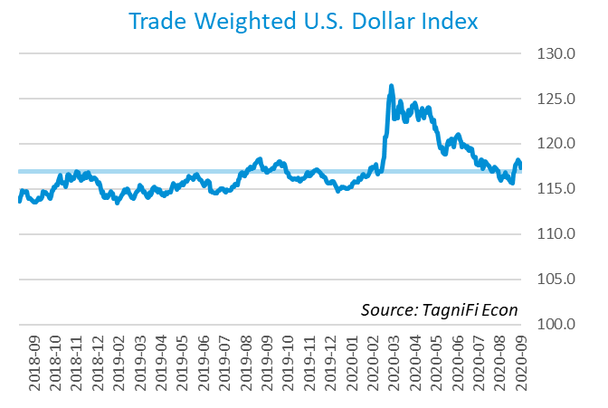

# Economic Highlights

* Real GDP for the 3rd quarter of 2020 rebounded at an annual rate of 33.1% but remained 2.9% below its year-ago level.
* The U.S. dollar index fell 2.91% during the 3rd quarter of 2020 and 0.54% since the 3rd quarter of 2019.
* Throughout the 3rd quarter, the Federal Reserve held the federal funds target rate at a range of 0.00 to 0.25 percent.
* Bond yields remained low during the quarter, with the 10-year U.S. treasury yielding 0.69% annually at the end of September 2020 and the 30-year treasury yielding 1.46%.
* Unemployment fell throughout the 3rd quarter to 7.9% in September 2020, and payroll employment regained 3.9 million jobs during the 3rd quarter.
* Consumer inflation rose 1.41% since last September.
* Oil prices plateaued in the 3rd quarter and were $39.63 per barrel to end September.
* New housing starts grew 11.9% over the 3rd quarter yet remained 12.5% below their 13-year peak in January 2020.
* U.S. capital markets continued their rally into the 3rd quarter but entered a slide in September. During the 3rd quarter, the NASDAQ Composite rose 11.0% the S&P 500 climbed 8.5%.

# Business Activity

According to the Bureau of Economic Analysis (BEA), real gross domestic product (GDP)[5] for the 3rd quarter of 2020 rebounded at an annual rate of 33.1%, its largest single-quarter gain ever, after the prior quarter’s drop of 31.4%. Over the last 30 years, the average compounded annual rate of GDP growth was 2.4%. The better-than-expected 3rd-quarter GDP rally reflected the nation’s ongoing return to business and recreational activities amid the COVID-19 pandemic. Financial pandemic assistance from the federal government, which reached most households, businesses, and states prior to the beginning of the 3rd quarter, fueled some of the rebound, but these supports were largely expiring as the quarter came to a close. Despite the 3rd quarter’s strong gains, real GDP remained 2.9% below its year-ago level.

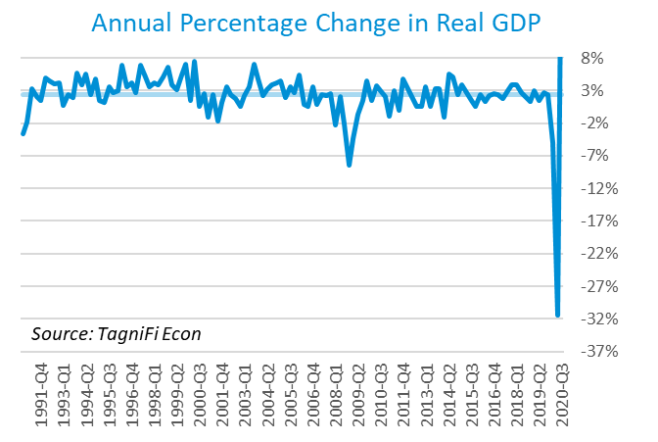

The 3rd quarter GDP bounce primarily reflected strong personal consumption spending, particularly spending on household services and healthcare, and private inventory investment. Exports also rose during the 3rd quarter but were more than offset by a sharper rise in imports.

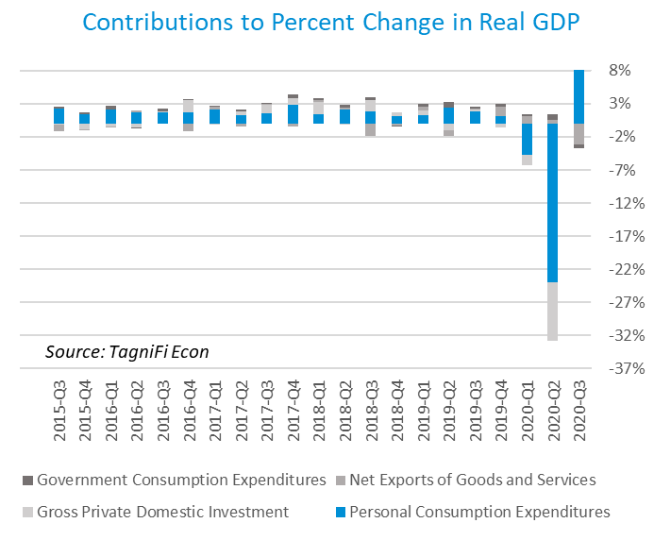

The Industrial Production Index[6] stood at 101.51 to end the 3rd quarter of 2020, up 4.0% from the 2nd quarter. Much of the gain occurred in July, as automobile and auto parts rebounded after Spring shutdowns and rising temps boosted demand for energy. The Industrial Production Index softened later in the 3rd quarter, decreasing 0.6% in the month of September 2020. The index remained 7.3% lower than in September 2019.

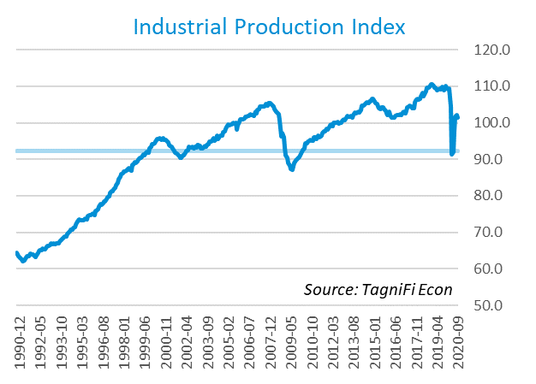

# Interest Rates

Short- and long-term treasury bond yields[7] remained near historic lows throughout the 3rd quarter of 2020, as weak economic data were released and stimulus talks stalled in the U.S. capitol. The 1-year and 2-year annual treasury yields ended the quarter at 0.12% and 0.13%, respectively. The benchmark 10-year treasury yielded 0.69% annually at the end of September 2020, while the 30-year treasury yielded 1.46%.

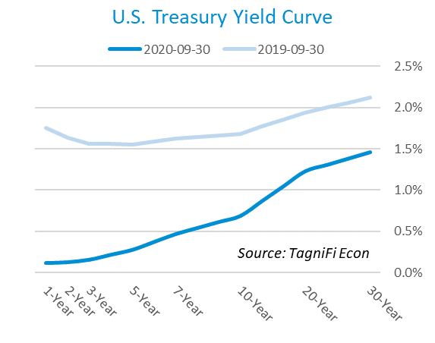

In the 3rd quarter of 2020, the Federal Reserve kept the federal funds target rate steady at a range of 0.00 to 0.25 percent, pledging to hold that rate until U.S. inflation is consistently rising above the Fed’s goals. The effective federal funds rate[8] as of September was 0.09%.

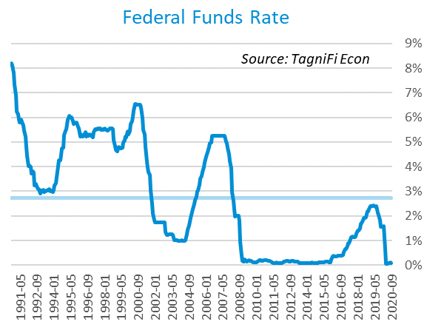

The yield on the benchmark 10-year U.S. treasury[9] rose 0.03 percentage points during the 3rd quarter to end September 2020 at 0.69%, well below the average yield of 4.32% over the last 30 years and the 1.68% yield from the same period last year.

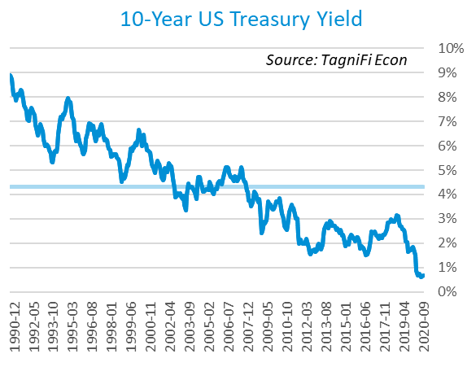

Corporate bond yields declined in the 3rd quarter of 2020, with the Moody’s Baa Corporate Bond Yield Index[10] ending the quarter at 3.36% compared to 3.64% for the 2nd quarter. The 3rd quarter rate is lower than the 3.91% yield from the same period last year, as well as its 30-year average yield of 6.71%.

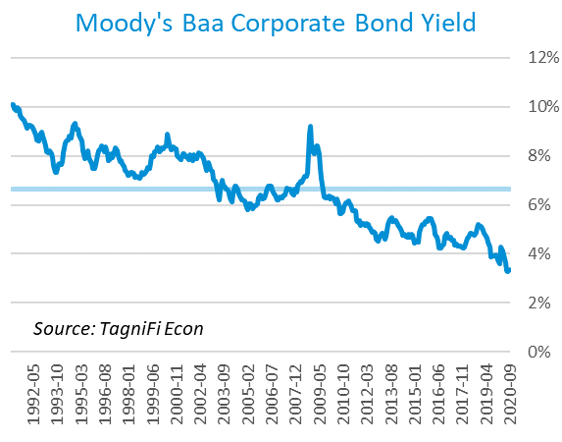

# Employment

The U.S. unemployment rate continued its decline throughout the 3rd quarter yet remained well above pre-pandemic levels. Similarly, while the U.S. regained 3.9 million jobs during the 3rd quarter, total nonfarm payrolls[11] in September 2020 were still more than 10 million jobs below pre-pandemic levels. The largest 3rd-quarter payroll increases were in leisure & hospitality, especially eating & drinking places; retail trade; and health care and social assistance. Payrolls grew 0.7 million in September 2020 but stood 9.6 million below last September’s levels.

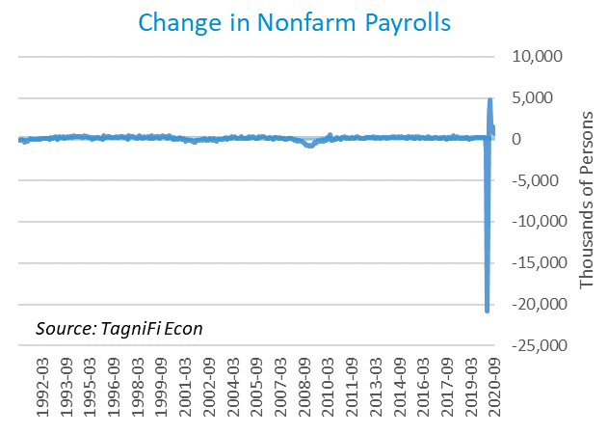

The unemployment rate[12] fell throughout the 3rd quarter to 7.9% in September 2020. Those reporting temporary layoffs fell by 1.5 million in September, yet those experiencing permanent job losses rose by 0.3 million. The September unemployment rate was 4.4 percentage points higher than the previous September and remained above the 30-year average unemployment rate of 5.9%.

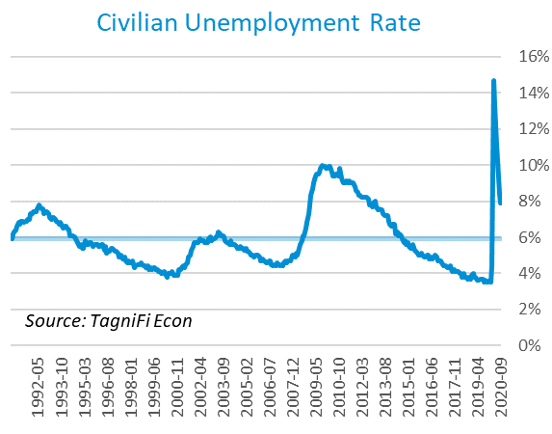

# Inflation

Inflation softened during the 3rd quarter of 2020, continuing to increase, but at a decelerating rate. September price increases were led by used cars and trucks and natural gas, yet moderated by lower prices for fuel oil, motor vehicle insurance, and airline fares. The Consumer Price Index (CPI)[13] has increased by 1.41% since last September. According to the Federal Reserve Bank of New York’s Survey of Consumer Expectations, inflation expectations[14] rose slightly in September to 3.0% for the one-year horizon and 2.7% for the three-year horizon.

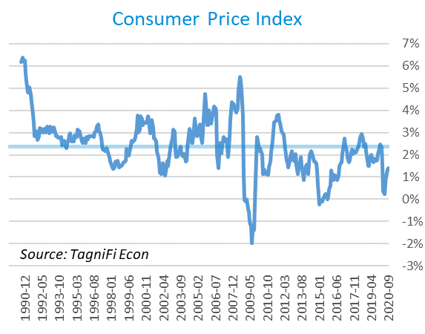

Prices at the producer level continued to rebound during the 3rd quarter, with September 2020 prices up 0.72% over the month for all commodities, especially lumber, farm products, and nonferrous metals. The Producer Price Index (PPI)[15] for all commodities was 1.51% lower in September 2020 compared to the same period last year. The average annual increase of the PPI was 1.91% over the last 30 years.

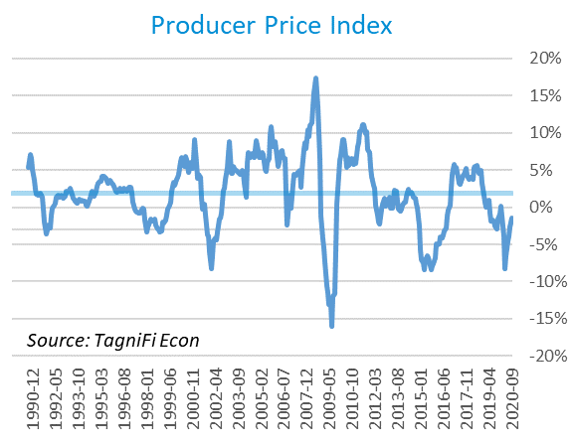

During the 3rd quarter, the late-Spring rebound in U.S. crude oil[16] prices plateaued as worldwide demand for travel fuel weakened again, with renewed travel restrictions in some European countries and U.S. travel remaining below typical levels. The U.S. drew down stocks of crude oil during September, but not enough to overcome demand constraints. Crude oil prices ended the quarter at $39.63 per barrel in September 2020, up 3.4% from the previous quarter yet still 30.4% lower than last September.

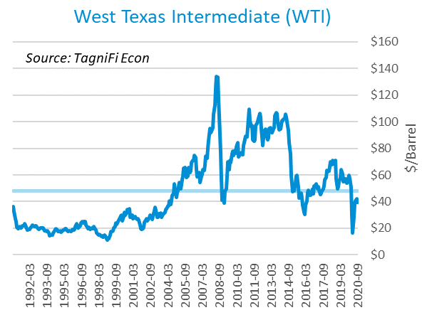

# Housing

The housing market continued its late-Spring rebound in the 3rd quarter of 2020, with new home starts[17] ending the quarter at 1.42 million in September. Total new housing starts grew 11.9% over the 3rd quarter yet remained 12.5% below their 13-year peak in January 2020. Single-family homebuilding surged as mortgage rates remained near record lows and home demand in suburban areas spiked as Americans sought more spacious homes. However, multi-family homebuilding continued to struggle amidst the pandemic. New home starts outpaced the 30-year average of 1.30 million units per month throughout the 3rd quarter of 2020.

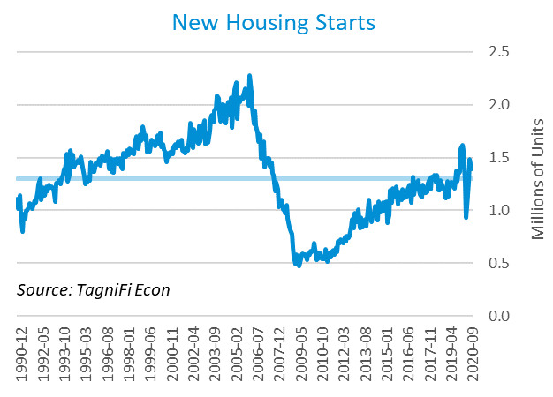

The cost of financing for would-be homebuyers continued to decline during the 3rd quarter as the 30-year fixed-rate mortgage[18] dropped to 2.90% to end September 2020. The Fed held target interest rates at 0.00% to 0.25% throughout the 3rd quarter.

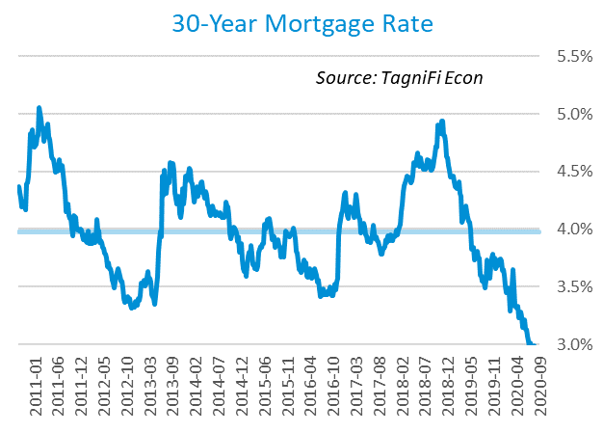

The S&P Case-Shiller Home Price Index (20-city)[19] for August 2020 increased by 5.2% over the year with broad gains led by Phoenix, Seattle, and San Diego. The 20-city composite lagged the national index. Constrained supply at the lower end of the market helped push home prices higher, combined with record-low mortgage rates boosting buyers’ purchasing power. Last August, home prices were increasing at a 2.0% annual rate.

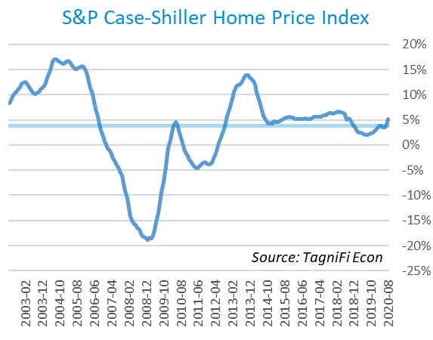

# Consumer Spending

The level of Personal Consumption Expenditures (PCE)[20] rose steadily throughout the 3rd quarter. PCE rose 1.40% in September 2020 yet remained 0.65% below the previous September’s level. September’s spending gains were led by clothing and footwear, motor vehicles and parts, health care, and recreation services. Both personal spending and personal income exceeded economists’ expectations in September.

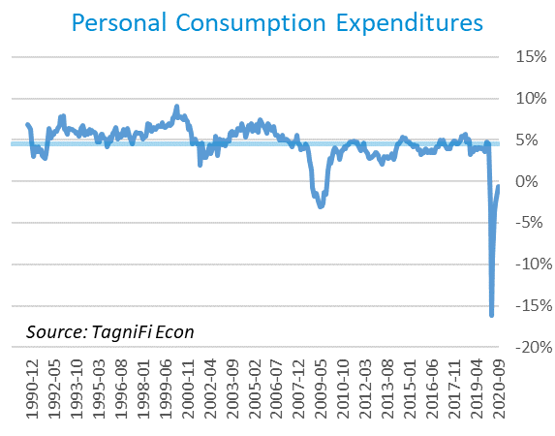

Automotive companies reported 16.5 million autos and light trucks sold[21] in September 2020, up 1.3 million units from August and 3.4 million from the end of the 2nd quarter. September 2020 sales remained 0.6 million units below year-ago levels but exceeded the 30-year average of 15.3 million units per month.

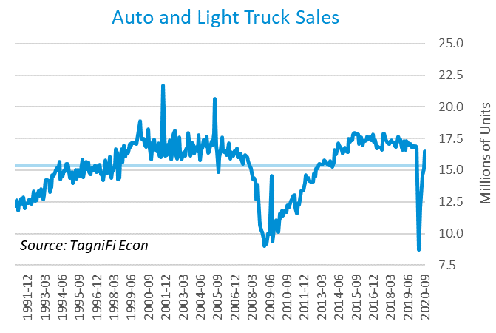

The consumer sentiment[22] index ended the 3rd quarter of 2020 at 80.4, exceeding economists’ expectations. The index was up 2.3 points since the previous quarter despite a July dip. September’s consumer sentiment reading was the highest since March 2020 but was still well below its year-ago level of 93.2 and its 30-year average of 87.4.

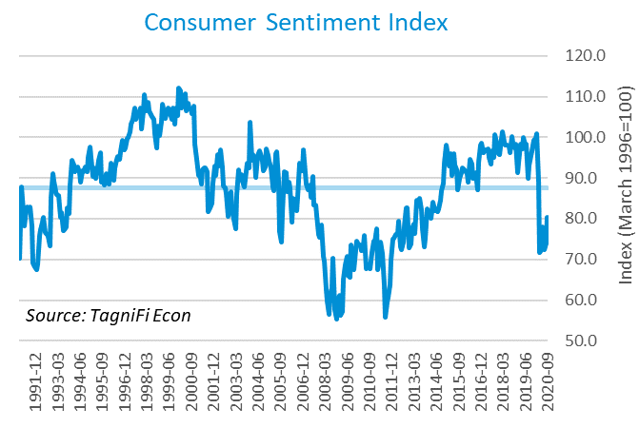

# Capital Markets

The U.S. stock market continued its 2nd quarter rally into the 3rd quarter but entered a slide, considered a healthy market correction by many, in September. The technology sector, which had dominated the Spring and Summer surge, took the biggest hit in September, on concerns about overvaluation, antitrust regulation, and the upcoming national election. The NASDAQ Composite advanced 11.0% in the 3rd quarter and 39.6% over the last 12 months. The S&P 500 climbed 8.5% during the 3rd quarter and 13.0% over the last 12 months. The Dow Jones Transportation Average sustained a steep rebound over the 3rd quarter, up 22.4%, and rose 11.0% above its year-ago level.



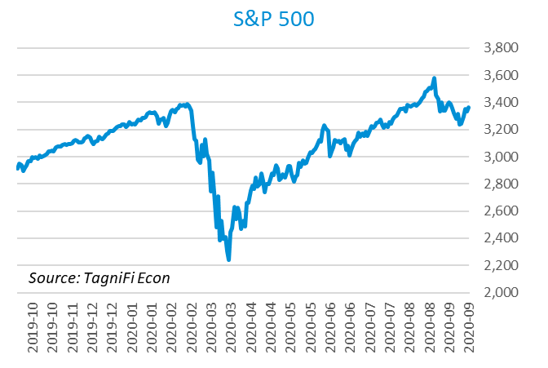

Stock market volatility[23] ended the 3rd quarter of 2020 at 26.4, down 56.3 points from its mid-March peak and 4.1 points since the end of the 2nd quarter. Still, the volatility index remained well above its 10-year average of 17.4. The volatility index, a proxy for investor anxiety derived from tracking options prices on S&P 500 stocks, rose in September in the absence of further federal pandemic emergency funding and in advance of the 2020 presidential election.

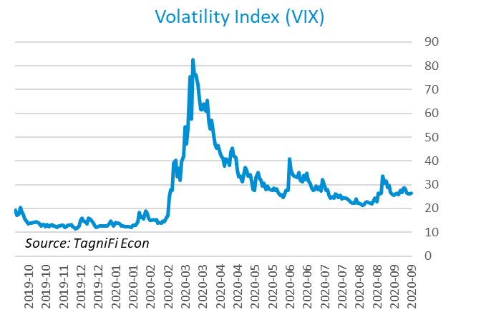

# Outlook

In September 2020, the FOMC projected real GDP to decline[24] 3.50% during 2020, followed by 4.15% growth in 2021, slowing to 2.90% in 2022. They expected Personal Consumption Expenditures (PCE)[25] to grow 1.20% in 2020, then accelerate to 1.80% by 2022. They forecast that the unemployment rate[26] will end 2020 at 7.50%, easing to 4.50% by 2022.



# About This Report

The *Quarterly Economic Update* is a free publication sponsored by TagniFi. You are free to share this report and include its contents in the economic outlook section of your valuation reports as required by *Revenue Ruling 59-60*. Please forward this free report to a colleague to help us spread the word about TagniFi.

# About TagniFi

In July 2015 we released our first dataset, TagniFi Fundamentals, because we thought investors and finance professionals needed a better solution for financial data. Since then our mission has remained the same: to serve our clients with the best financial data available at a reasonable price. We do this by developing innovative solutions to leverage tagged financial statements which allow us to deliver better, faster and more detailed data at a fraction of the cost.

Today TagniFi is a platform of financial data aimed at making our clients more productive and prosperous. We're helping clients in all corners of finance make better decisions with better data. We relentlessly focus on quality and the trust we've earned from our clients is our greatest asset. Our growth is centered around our clients' needs as we look to expand our platform with new data. Referrals from our existing clients is the ultimate compliment so we choose to invest in our product, not flashy marketing campaigns.For more information on TagniFi, please visit [www.tagnifi.com](http://www.tagnifi.com).

How TagniFi Helps Business Valuation Teams

TagniFi’s financial data platform empowers business valuation teams to quickly and easily build highly accurate financial models with full transparency—and within seconds.

**Better Public Comps**  
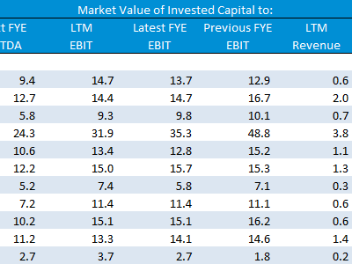Search for public companies with TagniFi Web. Simply enter your valuation date and ticker symbols in Excel to run a guideline public company method. Your Excel model populates instantly with the financial statements, analyst estimates, interest rates and economic data for your valuation date.

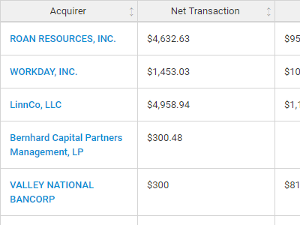**Better Transaction Comps**  
Search for public and private M&A transactions with TagniFi Web. Run your transaction comps within seconds by pasting the Deal ID into your Excel model. Every deal disclosed in an SEC filing (8-K, 10-K, or 10-Q) is available for your analysis. Choose from over 90 fields of data available for every deal.

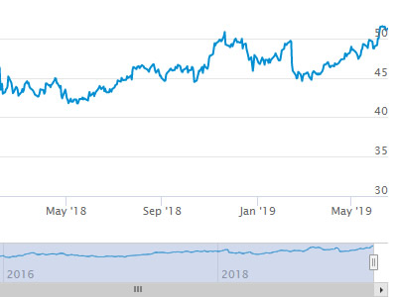

**Historical Beta and Volatility**Calculate historical beta and volatility as of your valuation date automatically. Simply enter the tickers and valuation date in Excel - TagniFi does the rest. In addition to beta and volatility, there are over 40 Excel models available in the Model Library to help with your valuation report.

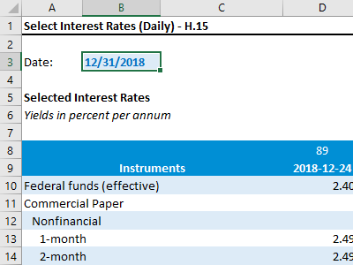**Interest Rates and Economic Data**Automate the interest rates and economic data in your valuation report using the TagniFi Excel plugin. Choose from over 200,000 time series available. All data in this *Quarterly Economic Update* is from the TagniFi platform. Use economic and interest rate data for your own valuation models with the TagniFi Excel plugin.

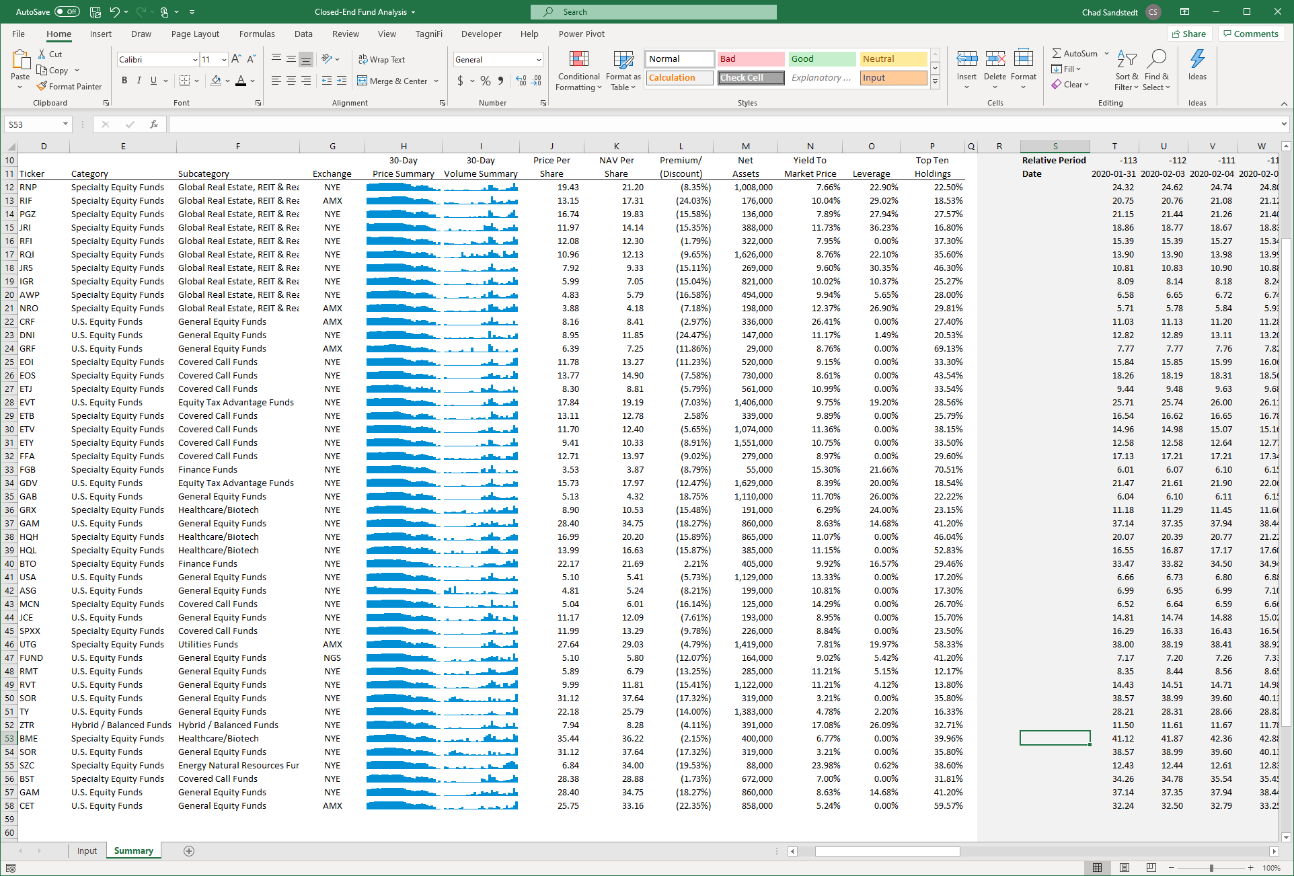

**Closed-End Mutual Fund Data**Search for closed-end mutual funds by keyword, category, subcategory, and more with the TagniFi Console. Use the TagniFi Excel plugin to calculate historical discounts, yields, leverage, as of your valuation date automatically. Simply enter the tickers and valuation date in Excel - TagniFi does the rest.

1. *US Business Cycle Expansions and Contractions, retrieved from the National Bureau of Economic Research (NBER),* [*https://www.nber.org/research/data/us-business-cycle-expansions-and-contractions*](https://www.nber.org/research/data/us-business-cycle-expansions-and-contractions)*, October 31, 2020.*
2. *Coronavirus Locations: COVID-19 Map by County and State, retrieved from USAFacts,* [*https://usafacts.org/visualizations/coronavirus-covid-19-spread-map/*](https://usafacts.org/visualizations/coronavirus-covid-19-spread-map/)*, May 2, 2020*
3. *State Coincident Indexes, retrieved from the Federal Reserve Bank of Philadelphia,* [*https://www.philadelphiafed.org/-/media/research-and-data/regional-economy/indexes/coincident/2020/coincidentindexes0920.pdf*](https://www.philadelphiafed.org/-/media/research-and-data/regional-economy/indexes/coincident/2020/coincidentindexes0920.pdf)*, Oct 31, 2020.*
4. *Board of Governors of the Federal Reserve System (US), Trade Weighted U.S. Dollar Index: Broad, Goods and Services [DTWEXBGS], retrieved from FRED, Federal Reserve Bank of St. Louis;* [*https://fred.stlouisfed.org/series/DTWEXBGS*](https://fred.stlouisfed.org/series/DTWEXBGS)*, Oct 31, 2020.*
5. U.S. Bureau of Economic Analysis, Real Gross Domestic Product [GDPC1], *retrieved from FRED, Federal Reserve Bank of St. Louis;*[*https://fred.stlouisfed.org/series/GDPC1*](https://fred.stlouisfed.org/series/GDPC1)*, Oct 31, 2020.*
6. Board of Governors of the Federal Reserve System (US), Industrial Production Index [INDPRO], *retrieved from FRED, Federal Reserve Bank of St. Louis;*[*https://fred.stlouisfed.org/series/INDPRO*](https://fred.stlouisfed.org/series/INDPRO)*, Oct 31, 2020.*
7. *Selected Interest Rates Instruments, Yields in percent per annum, retrieved from FRED, Federal Reserve Bank of St. Louis;* [*https://fred.stlouisfed.org/release/tables?rid=18&eid=289&od=2020-09-30#*](https://fred.stlouisfed.org/release/tables?rid=18&eid=289&od=2020-09-30)*, Oct 31, 2020.*
8. *Board of Governors of the Federal Reserve System (US), Effective Federal Funds Rate [FEDFUNDS], retrieved from FRED, Federal Reserve Bank of St. Louis;*[*https://fred.stlouisfed.org/series/FEDFUNDS*](https://fred.stlouisfed.org/series/FEDFUNDS)*, Oct 31, 2020.*
9. Board of Governors of the Federal Reserve System (US), 10-Year Treasury Constant Maturity Rate [DGS10], *retrieved from FRED, Federal Reserve Bank of St. Louis;*[*https://fred.stlouisfed.org/series/DGS10*](https://fred.stlouisfed.org/series/DGS10)*, Oct 31, 2020.*
10. Moody’s, Moody’s Seasoned Baa Corporate Bond Yield [BAAS], *retrieved from FRED, Federal Reserve Bank of St. Louis;*[*https://fred.stlouisfed.org/series/BAA*](https://fred.stlouisfed.org/series/BAA)*, Oct 31, 2020.*
11. U.S. Bureau of Labor Statistics, All Employees: Total Nonfarm Payrolls [PAYEMS], *retrieved from FRED, Federal Reserve Bank of St. Louis;*[*https://fred.stlouisfed.org/series/PAYEMS*](https://fred.stlouisfed.org/series/PAYEMS)*, Oct 31, 2020.*
12. U.S. Bureau of Labor Statistics, Civilian Unemployment Rate [UNRATE], *retrieved from FRED, Federal Reserve Bank of St. Louis;*[*https://fred.stlouisfed.org/series/UNRATE*](https://fred.stlouisfed.org/series/UNRATE)*, Oct 31, 2020.*
13. U.S. Bureau of Labor Statistics, Consumer Price Index for All Urban Consumers: All Items [CPIAUCSL], *retrieved from FRED, Federal Reserve Bank of St. Louis;*[*https://fred.stlouisfed.org/series/CPIAUCSL*](https://fred.stlouisfed.org/series/CPIAUCSL)*, Oct 31, 2020.*
14. *Survey of Consumer Expectations, retrieved from Federal Reserve Bank of New York,* [*https://www.newyorkfed.org/microeconomics/sce - indicators/inflation-expectations/g1*](https://www.newyorkfed.org/microeconomics/sce#indicators/inflation-expectations/g1)*, Oct 31, 2020*
15. U.S. Bureau of Labor Statistics, Producer Price Index for All Commodities [PPIACO], *retrieved from FRED, Federal Reserve Bank of St. Louis;*[*https://fred.stlouisfed.org/series/PPIACO*](https://fred.stlouisfed.org/series/PPIACO)*, Oct 31, 2020.*
16. *U.S. Energy Information Administration, Crude Oil Prices: West Texas Intermediate (WTI) – Cushing, Oklahoma [MCOILWTICO], retrieved from FRED, Federal Reserve Bank of St. Louis;*[*https://fred.stlouisfed.org/series/MCOILWTICO*](https://fred.stlouisfed.org/series/MCOILWTICO)*, Oct 31, 2020.*
17. U.S. Bureau of the Census, Housing Starts: Total: New Privately Owned Housing Units Started [HOUST], *retrieved from FRED, Federal Reserve Bank of St. Louis;*[*https://fred.stlouisfed.org/series/HOUST*](https://fred.stlouisfed.org/series/HOUST)*, Oct 31, 2020.*
18. Freddie Mac, 30-Year Fixed Rate Mortgage Average in the United States [MORTGAGE30US], *retrieved from FRED, Federal Reserve Bank of St. Louis;*[*https://fred.stlouisfed.org/series/MORTGAGE30US*](https://fred.stlouisfed.org/series/MORTGAGE30US)*, Oct 31, 2020.*
19. S&P Down Jones Indices LLC, S&P/Case-Shiller 20-City Composite Home Price Index [SPCS20RSA], *retrieved from FRED, Federal Reserve Bank of St. Louis;*[*https://fred.stlouisfed.org/series/SPCS20RSA*](https://fred.stlouisfed.org/series/SPCS20RSA)*, Oct 31, 2020.*
20. U.S. Bureau of Economic Analysis, Personal Consumption Expenditures [PCE], *retrieved from FRED, Federal Reserve Bank of St. Louis;*[*https://fred.stlouisfed.org/series/PCE*](https://fred.stlouisfed.org/series/PCE)*, Oct 31, 2020.*
21. U.S. Bureau of Economic Analysis, Light Weight Vehicle Sales: Autos and Light Trucks [ALTSALES], *retrieved from FRED, Federal Reserve Bank of St. Louis;*[*https://fred.stlouisfed.org/series/ALTSALES*](https://fred.stlouisfed.org/series/ALTSALES)*, Oct 31, 2020.*
22. *University of Michigan, University of Michigan: Consumer Sentiment [UMCSENT], retrieved from FRED, Federal Reserve Bank of St. Louis;* [*https://fred.stlouisfed.org/series/UMCSENT*](https://fred.stlouisfed.org/series/UMCSENT)*, Oct 31, 2020.*
23. *Chicago Board Options Exchange, CBOE Volatility Index: VIX [VIXCLS], retrieved from FRED, Federal Reserve Bank of St. Louis;* [*https://fred.stlouisfed.org/series/VIXCLS*](https://fred.stlouisfed.org/series/VIXCLS)*, Oct 31, 2020.*
24. *Federal Reserve Bank of St. Louis, FOMC Summary of Economic Projections for the Growth Rate of Real Gross Domestic Product [GDPC1CTM], retrieved from FRED, Federal Reserve Bank of St. Louis;*[*https://fred.stlouisfed.org/series/GDPC1CTM*](https://fred.stlouisfed.org/series/GDPC1CTM)*, Oct 31, 2020.*
25. *Federal Reserve Bank of St. Louis, FOMC Summary of Economic Projections for the Personal Consumption Expenditures Inflation Rate, Central Tendency, Midpoint [PCECTPICTM], retrieved from FRED, Federal Reserve Bank of St. Louis;*[*https://fred.stlouisfed.org/series/PCECTPICTM*](https://fred.stlouisfed.org/series/PCECTPICTM)*, Oct 31, 2020.*
26. *Federal Reserve Bank of St. Louis, FOMC Summary of Economic Projections for the Civilian Unemployment Rate, Central Tendency, Midpoint [UNRATECTM], retrieved from FRED, Federal Reserve Bank of St. Louis;*[*https://fred.stlouisfed.org/series/UNRATECTM*](https://fred.stlouisfed.org/series/UNRATECTM)*, Oct 31, 2020.*