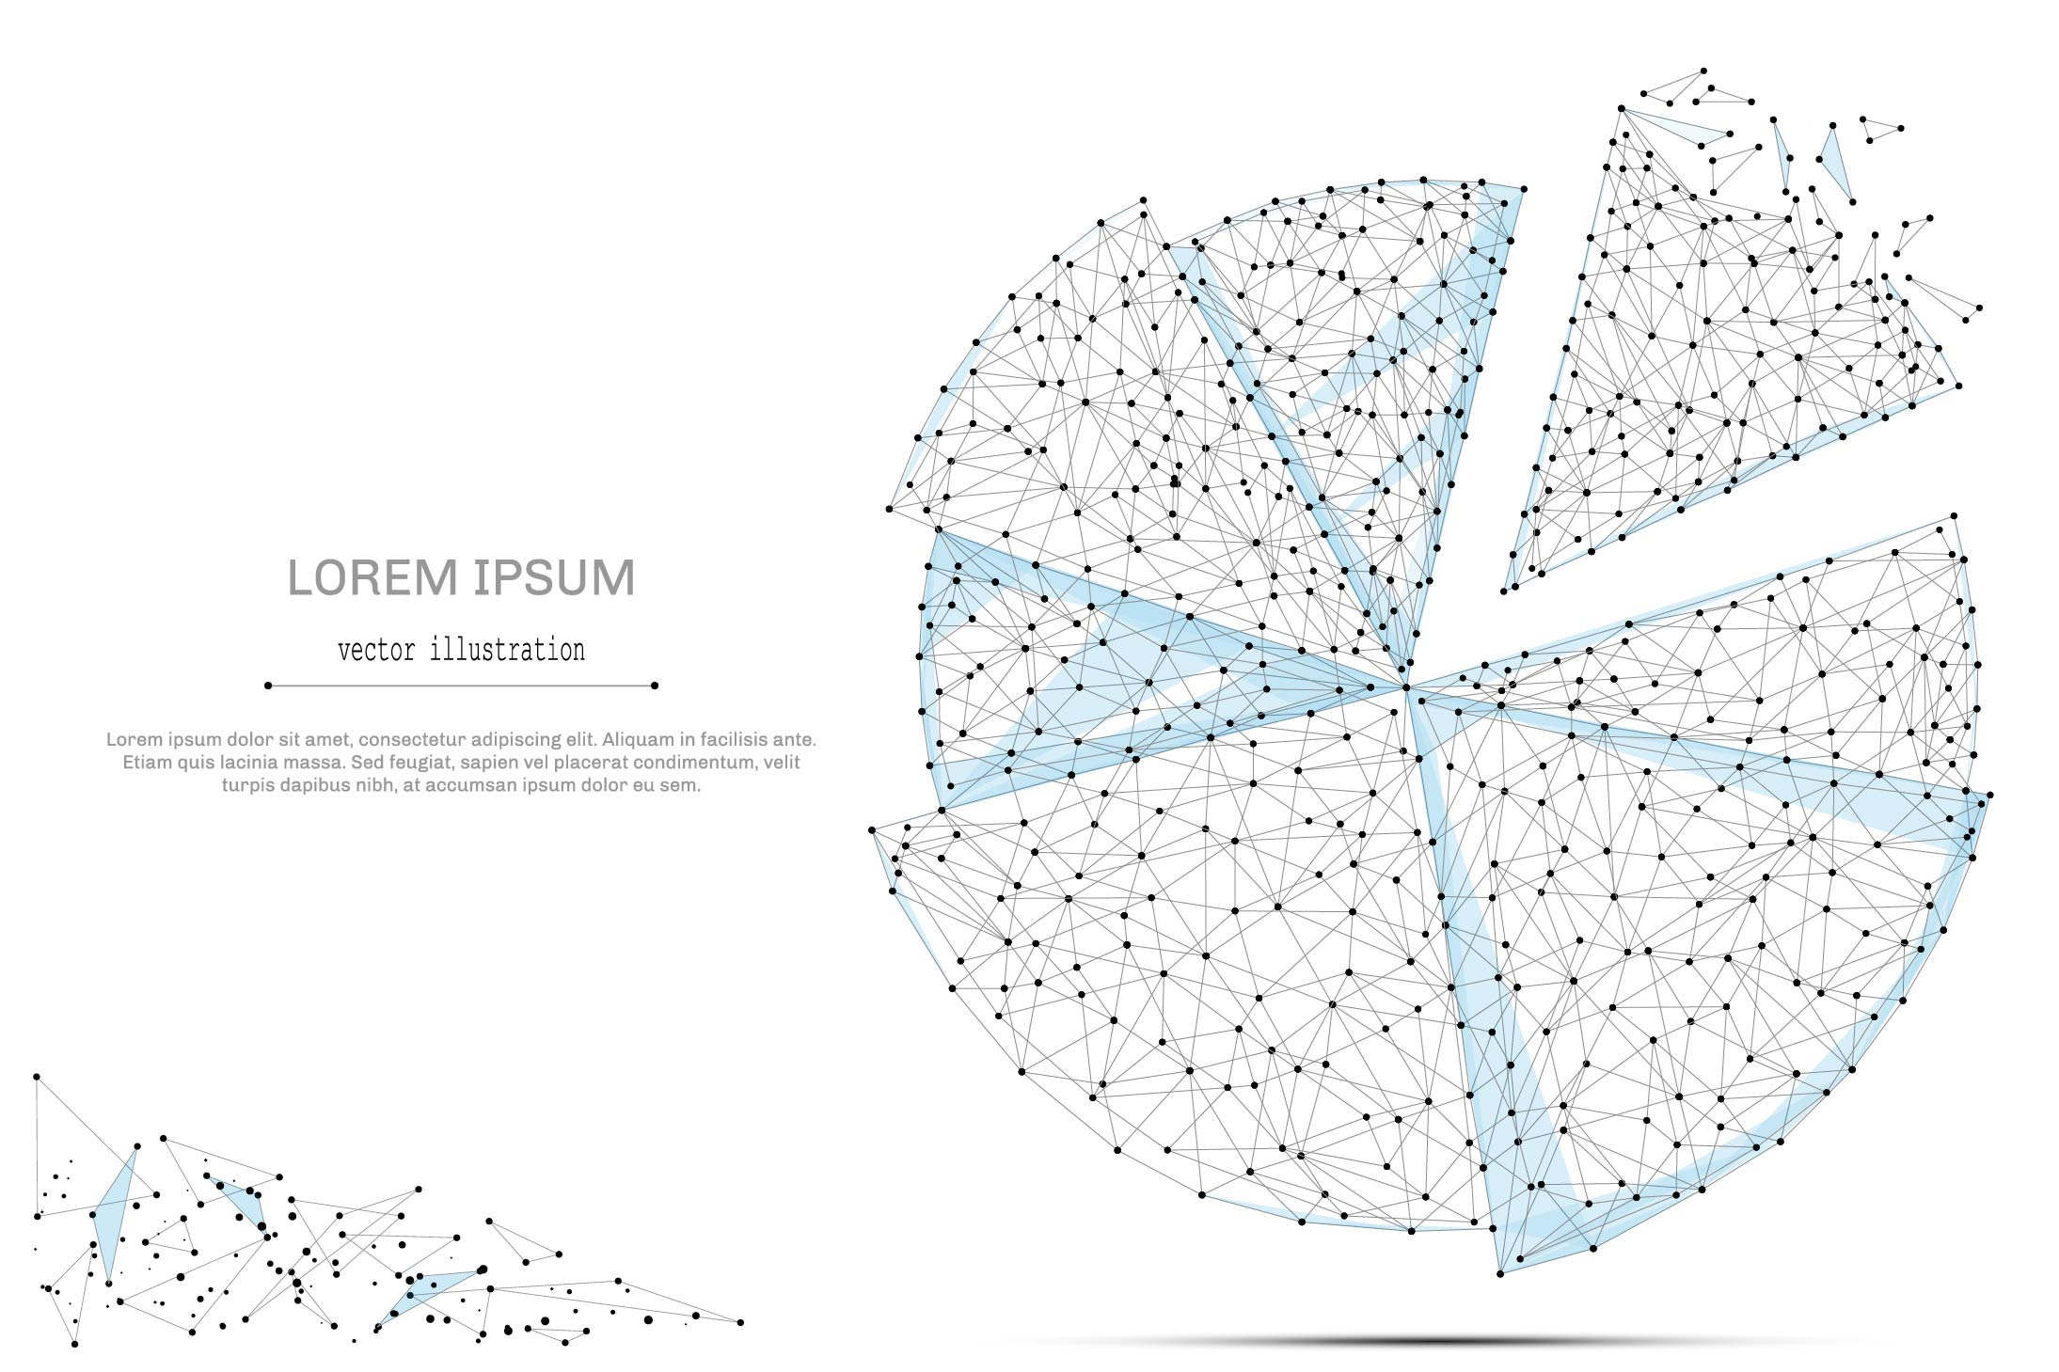

QUARTERLY ECONOMIC UPDATE

For the 4th Quarter of 2020

Abstract

Designed for business valuation professionals, TagniFi’s Quarterly Economic   
Update provides timely economic data to satisfy Revenue Ruling 56-60.

# Summary

In the 4th quarter of 2020, the U.S. economy continued its rebound from the fallout of the COVID-19 pandemic. Emergency vaccine approvals and a second relief bill, the Coronavirus Response and Relief Supplemental Appropriations Act, sparked hope despite surging cases and the discovery of new, more contagious variants. Economic growth was mixed during the 4th quarter; housing and capital markets surged, while the labor market flagged in December and the dollar value dropped.

The national economy has been attempting to shake off the effects of COVID-19 since its plunge in April. Most economic measures have been recuperating since May or June, yet at the end of the 4th quarter, the U.S. economy remained less robust than before the pandemic. The U.S. remained in a recession[1] that marked February as the peak of an economic expansion lasting 128 months from its beginning in June 2009.

By the end of the 4th quarter of 2020, 19,943,605 cases and 344,497 deaths had been reported in the U.S. from COVID-19[2]. The viral disease has continued to spread exponentially, and as of January 28, 2021 there were 25,615,268 confirmed cases and 431,619 related deaths in the U.S.

Below is a summary timeline of COVID-19 events in the U.S. during the 4th quarter of 2020:

|  |  |
| --- | --- |
| October 2, 2020 | President Trump tests positive for COVID-19 |
| October 13, 2020 | U.S. confirmed cases of COVID-19 reach 8 million |
| October 30, 2020 | U.S. daily cases of COVID-19 reach 100 thousand |
| November 8, 2020 | Global confirmed cases of COVID-19 reach 50 million |
| November 8, 2020 | U.S. confirmed cases of COVID-19 reach 10 million |
| November 19, 2020 | Treasury Secretary Mnuchin announces that he will allow Primary and Secondary Market Corporate Credit Facilities, Municipal Liquidity Facility, Main Street Lending Program, and Term Asset Backed Securities Loan Facility to expire on December 31, 2020 |
| November 19, 2020 | U.S. death toll from COVID-19 reaches 250 thousand |
| November 21, 2020 | U.S. confirmed cases of COVID-19 reach 12 million |
| November 30, 2020 | Federal Reserve announces an extension for Commercial Paper Funding Facility, Money Market Mutual Fund Liquidity Facility, Primary Dealer Credit Facility, and Paycheck Protection Program Liquidity Facility through March 31, 2021 |
| December 2, 2020 | U.S. current hospitalizations for COVID-19 reach 100 thousand |
| December 2, 2020 | CDC updates guidelines, advising that quarantine may end 10 days after exposure if the person exposed experiences no symptoms or 7 days after exposure with a negative test result and no symptoms |
| December 3, 2020 | Global death toll from COVID-19 reaches 1.5 million |
| December 3, 2020 | U.S. daily cases of COVID-19 reach 200 thousand |
| December 3, 2020 | U.S. confirmed cases of COVID-19 reach 14 million |
| December 11, 2020 | FDA authorizes the Pfizer-BioNTech COVID-19 vaccine for emergency use in the U.S. for individuals at least 16 years old |
| December 12, 2020 | U.S. confirmed cases of COVID-19 reach 16 million |
| December 14, 2020 | U.S. death toll from COVID-19 reaches 300 thousand |
| December 16, 2020 | Federal Reserve extends its temporary U.S. dollar liquidity swap lines and the temporary repurchase agreement facility for foreign and international monetary authorities through September 30, 2021 |
| December 18, 2020 | The FDA authorizes the Moderna COVID-19 vaccine for emergency use in the United States for individuals at least 18 years old |
| December 19, 2020 | Global confirmed cases of COVID-19 reach 75 million |
| December 21, 2020 | U.S. confirmed cases of COVID-19 reach 18 million |
| December 23, 2020 | CDC estimates U.S. COVID-19 1st-dose vaccinations reach 1 million |
| December 27, 2020 | President Trump signs 2nd COVID-19 relief bill, the Coronavirus Response and Relief Supplemental Appropriations Act, into law |
| December 29, 2020 | Colorado reports first known U.S. case of more contagious COVID-19 variant first identified in the U.K. |
| December 31, 2020 | Federal Reserve extends Main Street Lending Program facilities to January 8, 2021, for loans submitted to the Main Street lender portal on or before December 14, 2020 |

The Philadelphia Fed’s coincident index of economic activity in the U.S. rose 0.1% in December 2020 and 1.2% throughout the 4th quarter. The Federal Reserve noted greater variation in economic activity among states during this time. In December, state coincident indexes[3] showed increased economic activity in 36 states, decreased activity in 12 states, and stable activity in 2. Over the entire quarter, coincident indexes increased in 46 states and decreased in 4. Coincident indexes reflect unemployment, payroll employment, manufacturing hours, and wages and salaries. Unemployment strongly influences the indexes; despite falling in December, the U.S. unemployment rate was still up 3.2 percentage points from February 2020, with an additional 5 million unemployed people. Payroll employment remained 9.8 million jobs below its pre-pandemic level in February 2020.



The U.S. dollar index for goods and services[4] fell 4.86% during the 4th quarter of 2020 and 2.67% since the 4th quarter of 2019. Dollar demand paled against more dynamic equities as COVID-19 vaccines increased hope for global economic recovery. Further suppressing the dollar’s value were U.S. trade and current account deficits, which ballooned during the 4th quarter of 2020.

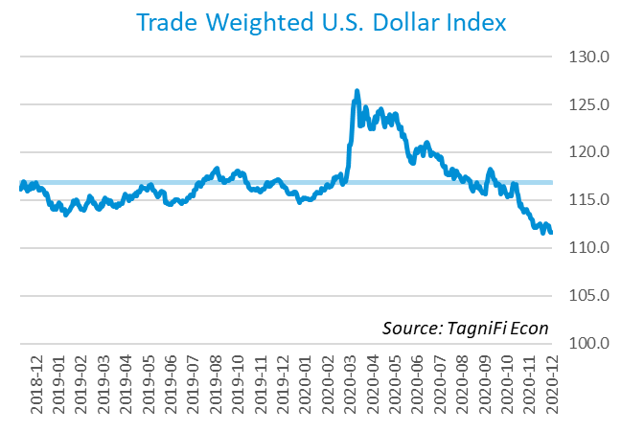

# Economic Highlights

* Real GDP for the 4th quarter of 2020 grew at an annual rate of 4.0% yet remained 2.5% below its year-ago level.
* The U.S. dollar index fell 4.86% during the 4th quarter of 2020 and 2.67% over the last year.
* Throughout the 4th quarter, the Federal Reserve held the federal funds target rate at a range of 0.00 to 0.25 percent.
* Short-term bond yields remained low during the quarter, but long-term yields began to rise. The 10-year U.S. treasury yielded 0.93% annually at the end of December 2020 and the 30-year treasury yielded 1.65%.
* Unemployment fell to 6.7% in November and December 2020, and payroll employment regained 850 thousand jobs during the 4th quarter.
* Consumer inflation rose 1.29% since last December.
* Oil prices rose during the 4th quarter to $47.02 per barrel in December 2020.
* New housing starts grew 16.1% over the 4th quarter to their highest level in over 14 years.
* U.S. capital markets sustained their ongoing boom through the 4th quarter. The NASDAQ Composite advanced 15.4% in the 4th quarter, the Wilshire 5000 climbed 14.0% and the S&P 500 rose 11.7%.

# Business Activity

According to the Bureau of Economic Analysis (BEA), real gross domestic product (GDP)[5] for the 4th quarter of 2020 grew at an annual rate of 4.0%, following the prior quarter’s record rebound of 33.4%. Over the last 30 years, the average compounded annual rate of GDP growth was 2.4%. The 4th quarter advance estimate represented continuing recovery from the devastating economic effects of the COVID-19 pandemic yet fell slightly shy of economists’ expectations. Despite the 4th quarter’s increase, real GDP remained 2.5% below its year-ago level.

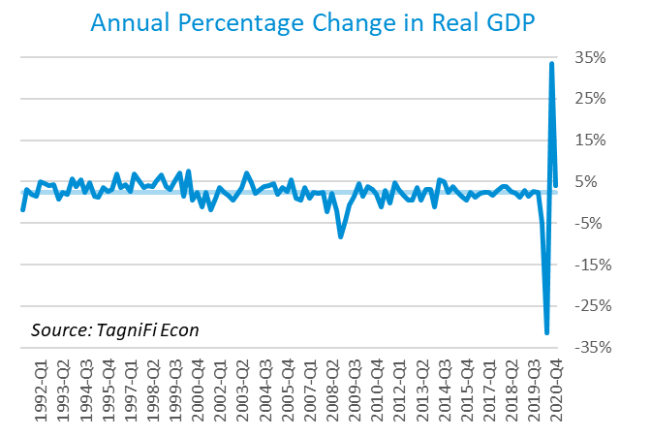

The 4th quarter GDP advance estimate primarily reflected widespread growth in private domestic investment and higher personal spending on services. Imports again outpaced exports, moderating the rise in real GDP, and government spending contracted at the state, local, and federal levels.

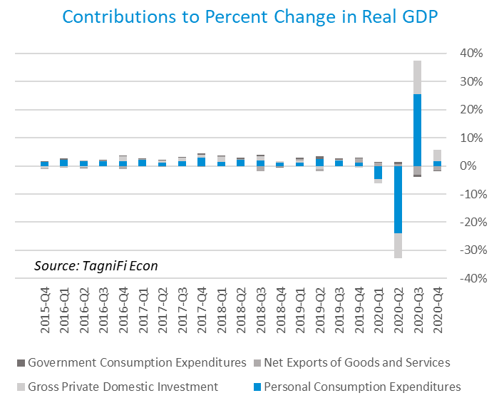

The Industrial Production Index[6] stood at 105.72 to end 2020, up 3.0% for the 4th quarter. More than half of the gain occurred in December, with the index gaining 1.6% during the month as energy demand for heating bounced back from an unseasonably warm November. Factory production, particularly of plastics and rubber, also rose, as did oil and gas extraction. Still, the index remained 3.6% lower than in December 2019.

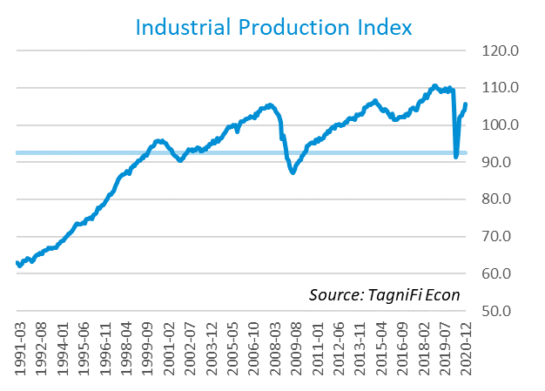

# Interest Rates

While long-term treasury bond yields[7] began to rise, short-term yields remained near historic lows throughout the 4th quarter of 2020. The mixed data echoed investors’ intermingled optimism over new pandemic relief and fears over more contagious COVID-19 strains identified in late 2020. The 1-year and 2-year annual treasury yields ended the quarter at 0.10% and 0.13%, respectively. The benchmark 10-year treasury yielded 0.93% annually at the end of December 2020, while the 30-year treasury yielded 1.65%.

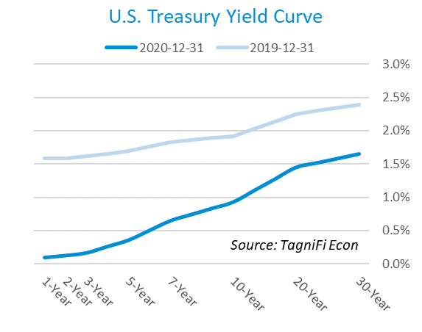

In the 4th quarter of 2020, the Federal Reserve continued to keep the federal funds target rate steady at a range of 0.00 to 0.25 percent, pledging to continue its aggressive monetary policy stance as long as U.S. employment and inflation continue to lag behind the Fed’s goals. The effective federal funds rate[8] as of December was 0.09%.

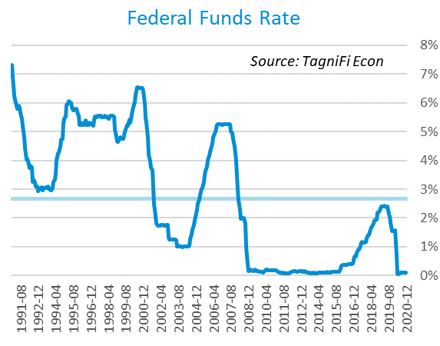

The yield on the benchmark 10-year U.S. treasury[9] rose 0.24 percentage points during the 4th quarter to end December 2020 at 0.93%, well below the average yield of 4.26% over the last 30 years and the 1.92% yield from the same period last year.

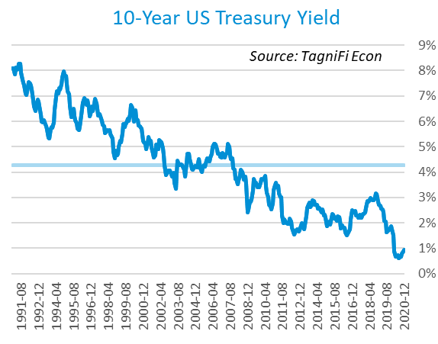

Corporate bond yields continued to decline in the 4th quarter of 2020, with the Moody’s Baa Corporate Bond Yield Index[10] ending the quarter at 3.16% compared to 3.36% for the 3rd quarter. The December rate is lower than the 3.88% yield from the same period last year, as well as its 30-year average yield of 6.65%.

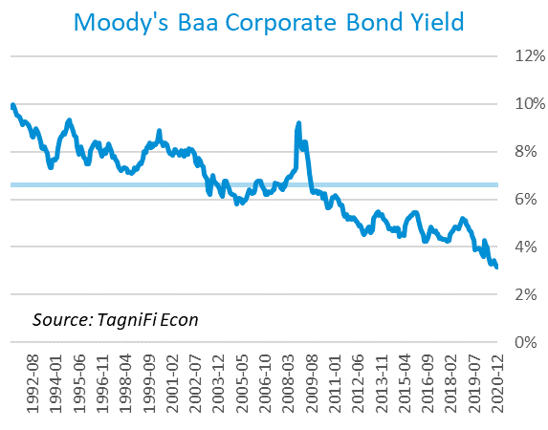

# Employment

Labor market gains tapered off in the 4th quarter of 2020. The U.S. unemployment rate fell early in the quarter, then held steady well above pre-pandemic levels in December 2020. Similarly, while the U.S. regained 850 thousand jobs during the 4th quarter, total nonfarm payrolls[11] in December were still 9.8 million jobs below February’s pre-pandemic peak. The largest 4th-quarter payroll increases were in professional and business services, especially temporary help; transportation and warehousing; and retail trade. Payrolls began to dip again in December 2020, down 140 thousand jobs; losses were led by leisure and hospitality as a winter COVID-19 surge forced a return to restrictions. At the end of 2020, payrolls were 9.4 million below the previous December’s levels.

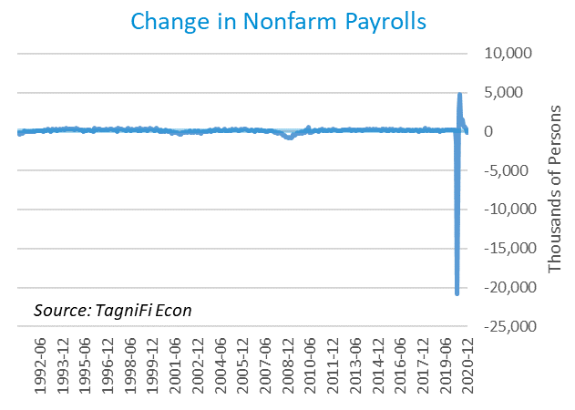

The unemployment rate[12] fell to 6.7% by November 2020, then remained the same in December. Those reporting temporary layoffs rose by 277 thousand in December, while those experiencing permanent job losses fell by 348 thousand. The December unemployment rate was 3.1 percentage points higher than the previous December and remained above the 30-year average unemployment rate of 5.9%.

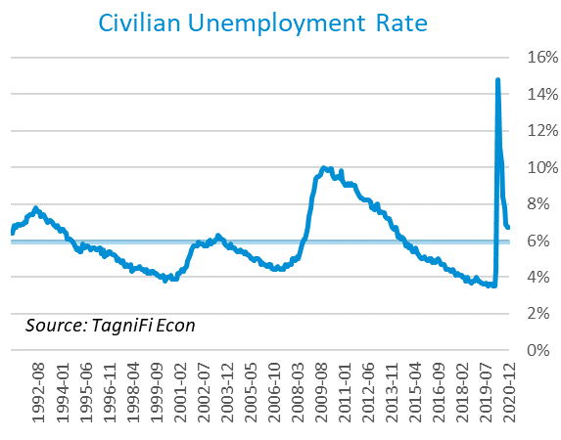

# Inflation

Inflation rose during the 4th quarter of 2020. December price increases were led by gasoline and fuel oil. The Consumer Price Index (CPI)[13] has increased by 1.29% since last December. According to the Federal Reserve Bank of New York’s Survey of Consumer Expectations, inflation expectations[14] rose slightly in December to 3.00% for the one-year horizon and 2.98% for the three-year horizon.

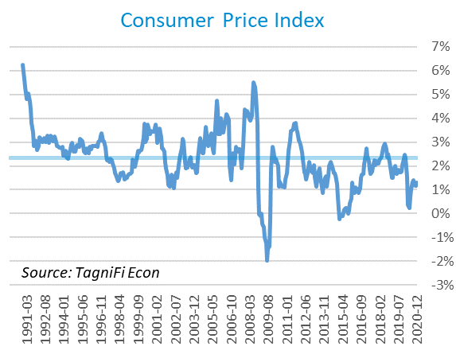

Prices at the producer level continued to rebound during the 4th quarter, with December 2020 prices up 1.21% over the month for all commodities, especially fuel, leather, lumber, and ferrous metals. The Producer Price Index (PPI)[15] for all commodities was 0.80% higher from December 2019 to December 2020, below the average annual increase of 1.85% over the last 30 years.

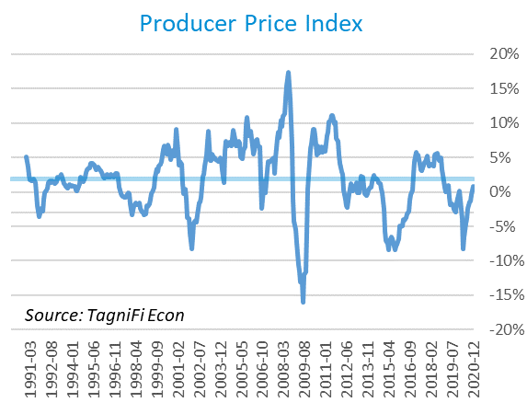

U.S. crude oil[16] prices rose during the 4th quarter of 2020 as optimism over COVID-19 vaccines spurred investment even as the pandemic’s winter surge and the discovery of more contagious virus variants prompted renewed travel restrictions. Crude oil prices ended the quarter at $47.02 per barrel in December 2020, up 18.6% from the previous quarter yet still 21.5% lower than the same period last year.

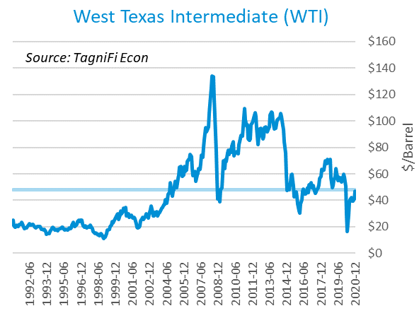

# Housing

The housing market continued to boom in the 4th quarter of 2020, with new home starts[17] ending the quarter at 1.67 million in December, their highest level in over 14 years. Total new housing starts grew 16.1% over the 4th quarter and 5.2% since the prior December. Single-family homebuilding continued to surge as home demand remained strong in suburban areas, supported by record-low mortgage rates and increased telework access amid the pandemic. Conversely, the multi-family housing market is troubled by rising vacancies and flagging demand. New home starts outpaced the 30-year average of 1.31 million units per month throughout the 4th quarter of 2020.

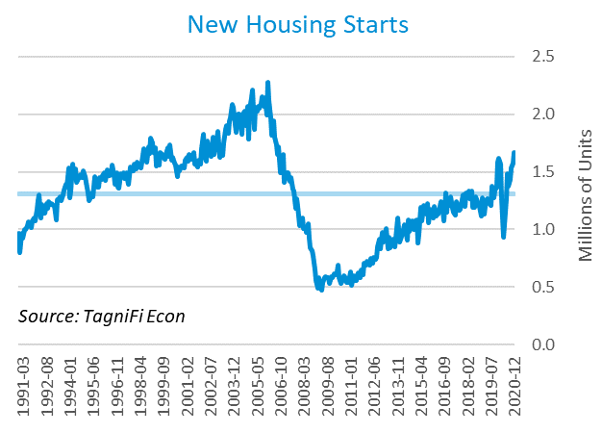

The cost of financing for would-be homebuyers continued to decline during the 4th quarter as the 30-year fixed-rate mortgage[18] dropped to record lows in December 2020, ending the month at 2.67%. The Fed held target interest rates at 0.00% to 0.25% throughout the 4th quarter.

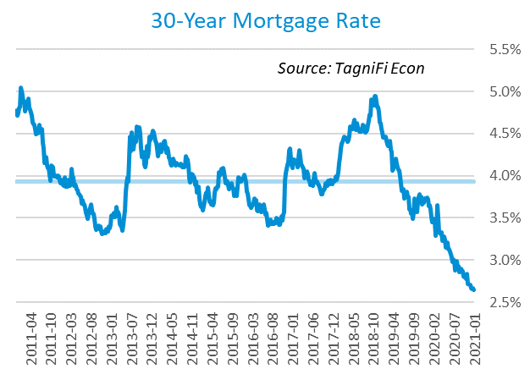

The S&P Case-Shiller Home Price Index (20-city)[19] for November 2020 increased by 9.1% over the year with Phoenix, Seattle, and San Diego continuing to lead. The national index rose even faster than the 20-city composite. Record-low mortgage rates and constrained supply continued to urge prices higher. Last November, home prices were increasing at a 2.5% annual rate.

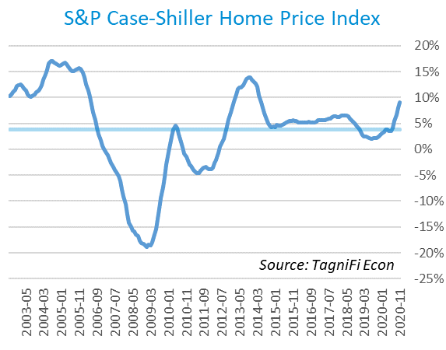

# Consumer Spending

The rebound in Personal Consumption Expenditures (PCE)[20] leveled off during the 4th quarter. PCE declined 0.19% in December 2020 and was down 2.05% from the same period last year. Spending fell in December for recreational goods, food and beverages, food services, and hospitals, but rose for motor vehicles and parts. Both personal income and personal spending outperformed economists’ expectations in December 2020.

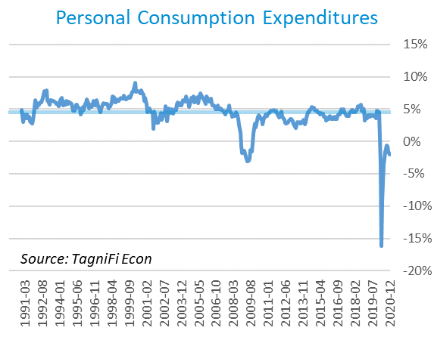

Automotive companies reported 16.3 million autos and light trucks sold[21] in December 2020, up 0.6 million units from November but down 26 thousand from the end of the 3rd quarter. December 2020 sales remained 0.5 million units below year-ago levels but exceeded the 30-year average of 15.4 million units per month.

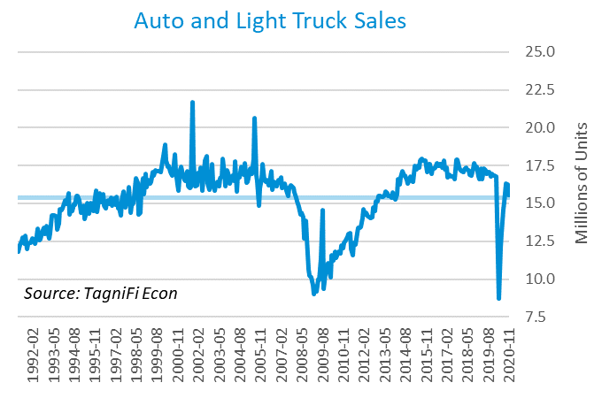

The consumer sentiment[22] index ended the 4th quarter of 2020 at 80.7, falling slightly short of economists’ expectations. The index was up 0.3 points since the previous quarter despite a November dip. The consumer sentiment index has been on a general upward trend since its April 2020 low, but December’s reading was still well below its year-ago level of 99.3 and its 30-year average of 87.5.

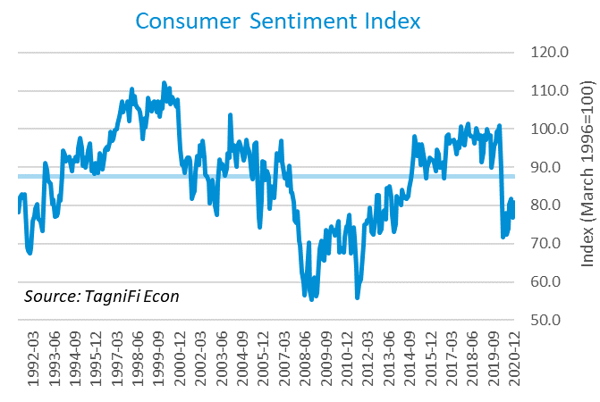

# Capital Markets

The U.S. stock market sustained its ongoing boom through the 4th quarter of 2020, reacting to enthusiasm over the arrival of COVID-19 vaccines. Stocks continued to push quickly higher despite a bumpy and incomplete recovery in the broader economy, leading experts to surmise widespread overvaluation. The NASDAQ Composite advanced 15.4% in the 4th quarter and 43.6% from the end of the previous year. The Wilshire 5000 climbed 14.0% during the 4th quarter and 18.6% since the end of 2019. The S&P 500 rose 11.7% in the 4th quarter and 16.3% over the last 12 months.



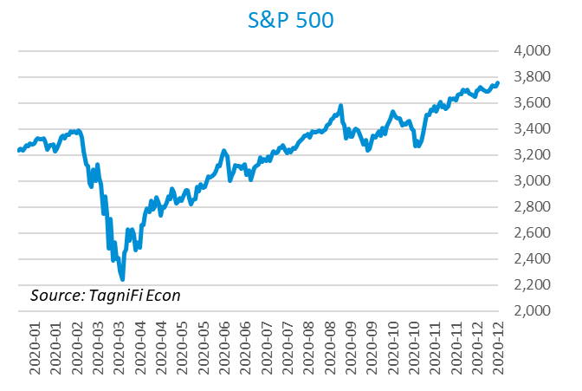

Stock market volatility[23] ended the 4th quarter of 2020 at 22.8, down 59.9 points from its mid-March peak and 3.6 points since the end of the 3rd quarter. Still, the volatility index remained above its 10-year average of 19.4. The volatility index, a proxy for investor anxiety derived from tracking options prices on S&P 500 stocks, rose in late October but subsided in November after the results of the 2020 presidential election became clear.

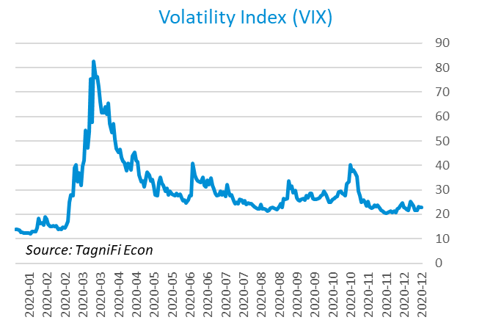

# Outlook

In December 2020, the FOMC projected real GDP[24] to recover to 4.35% growth in 2021, slowing to 2.45% by 2023. They expected Personal Consumption Expenditures (PCE)[25] to grow 1.80% in 2021, gently accelerating to 2.00% by 2023. They forecast that the unemployment rate[26] will ease to 5.05% in 2021 and 3.90% by 2023.



# About This Report

The *Quarterly Economic Update* is a free publication sponsored by TagniFi. You are free to share this report and include its contents in the economic outlook section of your valuation reports as required by *Revenue Ruling 59-60*. Please forward this free report to a colleague to help us spread the word about TagniFi.

# About TagniFi

In July 2015 we released our first dataset, TagniFi Fundamentals, because we thought investors and finance professionals needed a better solution for financial data. Since then our mission has remained the same: to serve our clients with the best financial data available at a reasonable price. We do this by developing innovative solutions to leverage tagged financial statements which allow us to deliver better, faster and more detailed data at a fraction of the cost.

Today TagniFi is a platform of financial data aimed at making our clients more productive and prosperous. We're helping clients in all corners of finance make better decisions with better data. We relentlessly focus on quality and the trust we've earned from our clients is our greatest asset. Our growth is centered around our clients' needs as we look to expand our platform with new data. Referrals from our existing clients is the ultimate compliment so we choose to invest in our product, not flashy marketing campaigns.For more information on TagniFi, please visit [www.tagnifi.com](http://www.tagnifi.com).

How TagniFi Helps Business Valuation Teams

TagniFi’s financial data platform empowers business valuation teams to quickly and easily build highly accurate financial models with full transparency—and within seconds.

**Better Public Comps**  
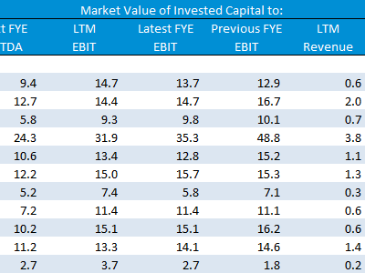Search for public companies with TagniFi Web. Simply enter your valuation date and ticker symbols in Excel to run a guideline public company method. Your Excel model populates instantly with the financial statements, analyst estimates, interest rates and economic data for your valuation date.

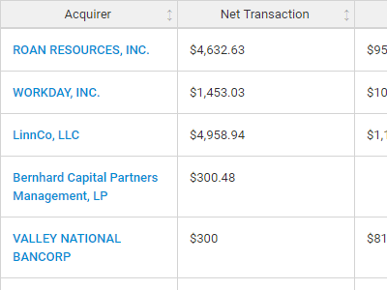**Better Transaction Comps**  
Search for public and private M&A transactions with TagniFi Web. Run your transaction comps within seconds by pasting the Deal ID into your Excel model. Every deal disclosed in an SEC filing (8-K, 10-K, or 10-Q) is available for your analysis. Choose from over 90 fields of data available for every deal.

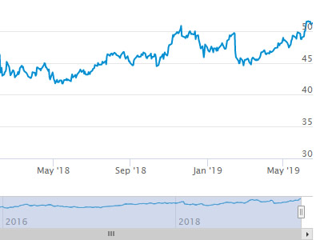

**Historical Beta and Volatility**Calculate historical beta and volatility as of your valuation date automatically. Simply enter the tickers and valuation date in Excel - TagniFi does the rest. In addition to beta and volatility, there are over 40 Excel models available in the Model Library to help with your valuation report.

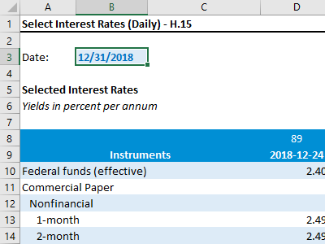**Interest Rates and Economic Data**Automate the interest rates and economic data in your valuation report using the TagniFi Excel plugin. Choose from over 200,000 time series available. All data in this *Quarterly Economic Update* is from the TagniFi platform. Use economic and interest rate data for your own valuation models with the TagniFi Excel plugin.

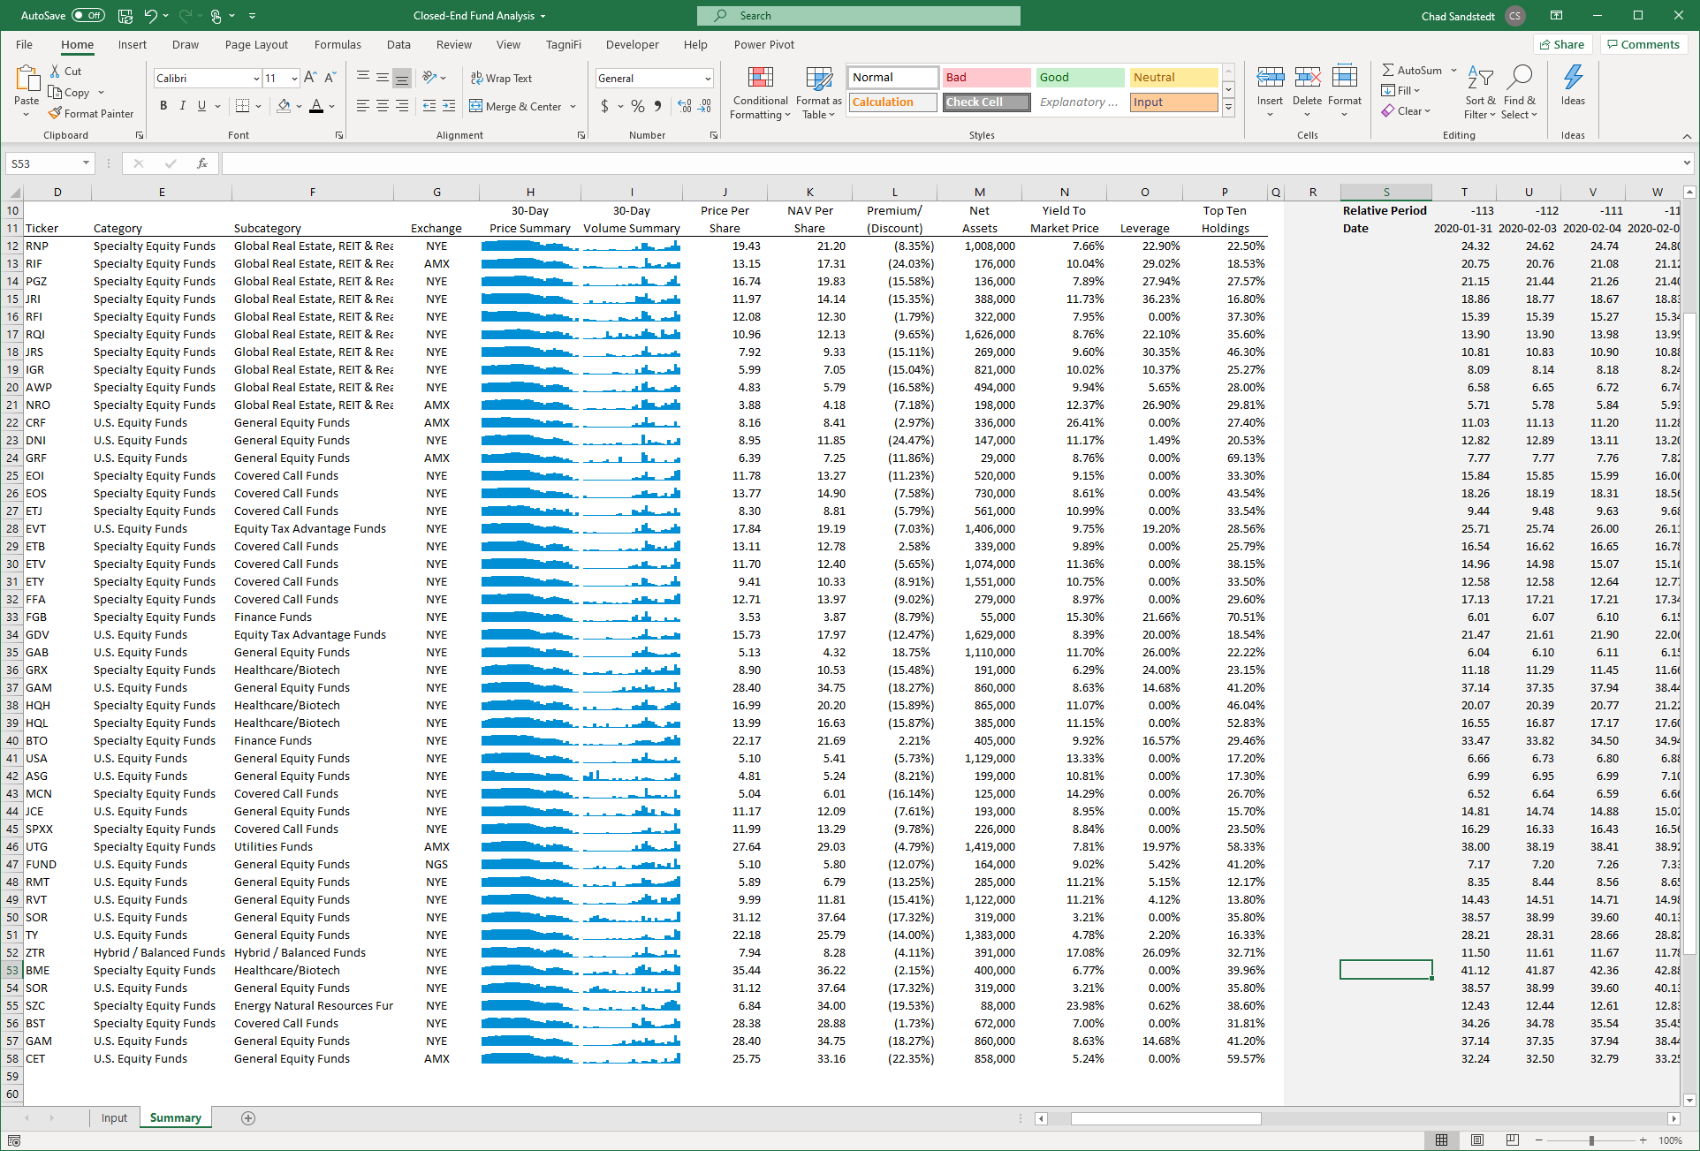

**Closed-End Mutual Fund Data**Search for closed-end mutual funds by keyword, category, subcategory, and more with the TagniFi Console. Use the TagniFi Excel plugin to calculate historical discounts, yields, leverage, as of your valuation date automatically. Simply enter the tickers and valuation date in Excel - TagniFi does the rest.

1. *US Business Cycle Expansions and Contractions, retrieved from the National Bureau of Economic Research (NBER),* [*https://www.nber.org/research/data/us-business-cycle-expansions-and-contractions*](https://www.nber.org/research/data/us-business-cycle-expansions-and-contractions)*, Jan 30, 2021.*
2. *Trends in Number of COVID-19 Cases and Deaths in the US Reported to CDC, by State/Territory, retrieved from the Centers for Disease Control and Prevention (CDC),* [*https://covid.cdc.gov/covid-data-tracker/ - trends_totalandratecases*](https://covid.cdc.gov/covid-data-tracker/#trends_totalandratecases)*, Jan 30, 2021.*
3. *State Coincident Indexes, retrieved from the Federal Reserve Bank of Philadelphia,* [*https://www.philadelphiafed.org/-/media/research-and-data/regional-economy/indexes/coincident/2020/coincidentindexes0920.pdf*](https://www.philadelphiafed.org/-/media/research-and-data/regional-economy/indexes/coincident/2020/coincidentindexes0920.pdf)*, Jan 30, 2021.*
4. *Board of Governors of the Federal Reserve System (US), Trade Weighted U.S. Dollar Index: Broad, Goods and Services [DTWEXBGS], retrieved from FRED, Federal Reserve Bank of St. Louis;* [*https://fred.stlouisfed.org/series/DTWEXBGS*](https://fred.stlouisfed.org/series/DTWEXBGS)*, Jan 30, 2021.*
5. U.S. Bureau of Economic Analysis, Real Gross Domestic Product [GDPC1], *retrieved from FRED, Federal Reserve Bank of St. Louis;*[*https://fred.stlouisfed.org/series/GDPC1*](https://fred.stlouisfed.org/series/GDPC1)*, Jan 30, 2021.*
6. Board of Governors of the Federal Reserve System (US), Industrial Production Index [INDPRO], *retrieved from FRED, Federal Reserve Bank of St. Louis;*[*https://fred.stlouisfed.org/series/INDPRO*](https://fred.stlouisfed.org/series/INDPRO)*, Jan 30, 2021.*
7. *Selected Interest Rates Instruments, Yields in percent per annum, retrieved from FRED, Federal Reserve Bank of St. Louis;* [*https://fred.stlouisfed.org/release/tables?rid=18&eid=289&od=2020-09-30#*](https://fred.stlouisfed.org/release/tables?rid=18&eid=289&od=2020-09-30)*, Jan 30, 2021.*
8. *Board of Governors of the Federal Reserve System (US), Effective Federal Funds Rate [FEDFUNDS], retrieved from FRED, Federal Reserve Bank of St. Louis;*[*https://fred.stlouisfed.org/series/FEDFUNDS*](https://fred.stlouisfed.org/series/FEDFUNDS)*, Jan 30, 2021.*
9. Board of Governors of the Federal Reserve System (US), 10-Year Treasury Constant Maturity Rate [DGS10], *retrieved from FRED, Federal Reserve Bank of St. Louis;*[*https://fred.stlouisfed.org/series/DGS10*](https://fred.stlouisfed.org/series/DGS10)*, Jan 30, 2021.*
10. Moody’s, Moody’s Seasoned Baa Corporate Bond Yield [BAAS], *retrieved from FRED, Federal Reserve Bank of St. Louis;*[*https://fred.stlouisfed.org/series/BAA*](https://fred.stlouisfed.org/series/BAA)*, Jan 30, 2021.*
11. U.S. Bureau of Labor Statistics, All Employees: Total Nonfarm Payrolls [PAYEMS], *retrieved from FRED, Federal Reserve Bank of St. Louis;*[*https://fred.stlouisfed.org/series/PAYEMS*](https://fred.stlouisfed.org/series/PAYEMS)*, Jan 30, 2021.*
12. U.S. Bureau of Labor Statistics, Civilian Unemployment Rate [UNRATE], *retrieved from FRED, Federal Reserve Bank of St. Louis;*[*https://fred.stlouisfed.org/series/UNRATE*](https://fred.stlouisfed.org/series/UNRATE)*, Jan 30, 2021.*
13. U.S. Bureau of Labor Statistics, Consumer Price Index for All Urban Consumers: All Items [CPIAUCSL], *retrieved from FRED, Federal Reserve Bank of St. Louis;*[*https://fred.stlouisfed.org/series/CPIAUCSL*](https://fred.stlouisfed.org/series/CPIAUCSL)*, Jan 30, 2021.*
14. *Survey of Consumer Expectations, retrieved from Federal Reserve Bank of New York,* [*https://www.newyorkfed.org/microeconomics/sce - indicators/inflation-expectations/g1*](https://www.newyorkfed.org/microeconomics/sce#indicators/inflation-expectations/g1)*, Jan 30, 2021*
15. U.S. Bureau of Labor Statistics, Producer Price Index for All Commodities [PPIACO], *retrieved from FRED, Federal Reserve Bank of St. Louis;*[*https://fred.stlouisfed.org/series/PPIACO*](https://fred.stlouisfed.org/series/PPIACO)*, Jan 30, 2021.*
16. *U.S. Energy Information Administration, Crude Oil Prices: West Texas Intermediate (WTI) – Cushing, Oklahoma [MCOILWTICO], retrieved from FRED, Federal Reserve Bank of St. Louis;*[*https://fred.stlouisfed.org/series/MCOILWTICO*](https://fred.stlouisfed.org/series/MCOILWTICO)*, Jan 30, 2021.*
17. U.S. Bureau of the Census, Housing Starts: Total: New Privately Owned Housing Units Started [HOUST], *retrieved from FRED, Federal Reserve Bank of St. Louis;*[*https://fred.stlouisfed.org/series/HOUST*](https://fred.stlouisfed.org/series/HOUST)*, Jan 30, 2021.*
18. Freddie Mac, 30-Year Fixed Rate Mortgage Average in the United States [MORTGAGE30US], *retrieved from FRED, Federal Reserve Bank of St. Louis;*[*https://fred.stlouisfed.org/series/MORTGAGE30US*](https://fred.stlouisfed.org/series/MORTGAGE30US)*, Jan 30, 2021.*
19. S&P Down Jones Indices LLC, S&P/Case-Shiller 20-City Composite Home Price Index [SPCS20RSA], *retrieved from FRED, Federal Reserve Bank of St. Louis;*[*https://fred.stlouisfed.org/series/SPCS20RSA*](https://fred.stlouisfed.org/series/SPCS20RSA)*, Jan 30, 2021.*
20. U.S. Bureau of Economic Analysis, Personal Consumption Expenditures [PCE], *retrieved from FRED, Federal Reserve Bank of St. Louis;*[*https://fred.stlouisfed.org/series/PCE*](https://fred.stlouisfed.org/series/PCE)*, Jan 30, 2021.*
21. U.S. Bureau of Economic Analysis, Light Weight Vehicle Sales: Autos and Light Trucks [ALTSALES], *retrieved from FRED, Federal Reserve Bank of St. Louis;*[*https://fred.stlouisfed.org/series/ALTSALES*](https://fred.stlouisfed.org/series/ALTSALES)*, Jan 30, 2021.*
22. *University of Michigan, University of Michigan: Consumer Sentiment [UMCSENT], retrieved from FRED, Federal Reserve Bank of St. Louis;* [*https://fred.stlouisfed.org/series/UMCSENT*](https://fred.stlouisfed.org/series/UMCSENT)*, Jan 30, 2021.*
23. *Chicago Board Options Exchange, CBOE Volatility Index: VIX [VIXCLS], retrieved from FRED, Federal Reserve Bank of St. Louis;* [*https://fred.stlouisfed.org/series/VIXCLS*](https://fred.stlouisfed.org/series/VIXCLS)*, Jan 30, 2021.*
24. *Federal Reserve Bank of St. Louis, FOMC Summary of Economic Projections for the Growth Rate of Real Gross Domestic Product [GDPC1CTM], retrieved from FRED, Federal Reserve Bank of St. Louis;*[*https://fred.stlouisfed.org/series/GDPC1CTM*](https://fred.stlouisfed.org/series/GDPC1CTM)*, Jan 30, 2021.*
25. *Federal Reserve Bank of St. Louis, FOMC Summary of Economic Projections for the Personal Consumption Expenditures Inflation Rate, Central Tendency, Midpoint [PCECTPICTM], retrieved from FRED, Federal Reserve Bank of St. Louis;*[*https://fred.stlouisfed.org/series/PCECTPICTM*](https://fred.stlouisfed.org/series/PCECTPICTM)*, Jan 30, 2021.*
26. *Federal Reserve Bank of St. Louis, FOMC Summary of Economic Projections for the Civilian Unemployment Rate, Central Tendency, Midpoint [UNRATECTM], retrieved from FRED, Federal Reserve Bank of St. Louis;*[*https://fred.stlouisfed.org/series/UNRATECTM*](https://fred.stlouisfed.org/series/UNRATECTM)*, Jan 30, 2021.*