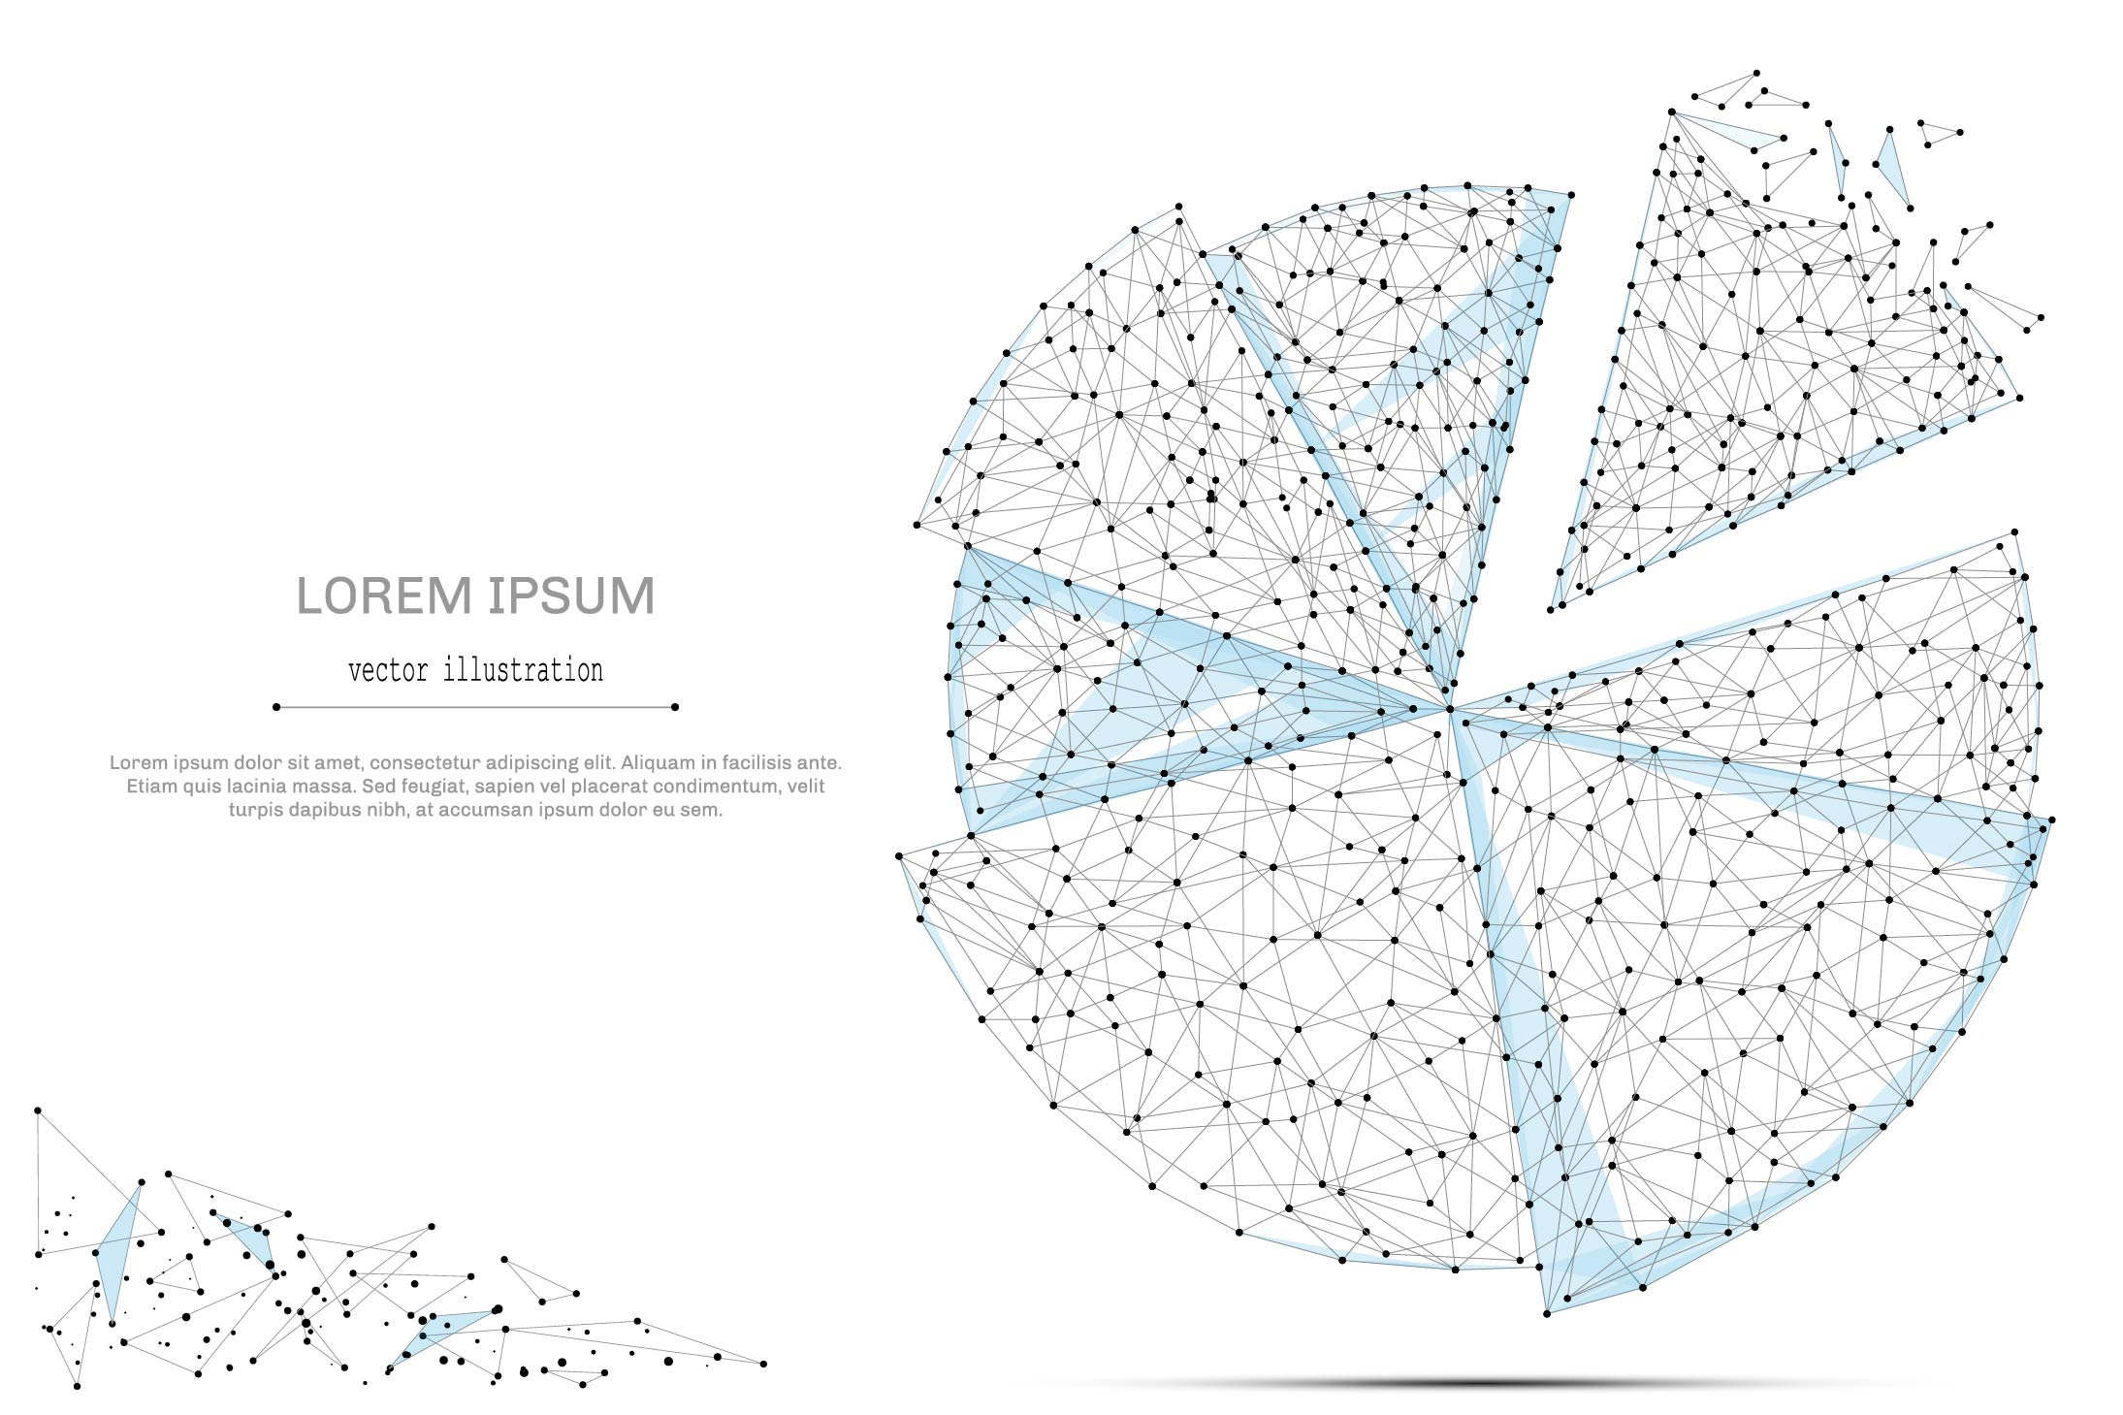

QUARTERLY ECONOMIC UPDATE

For the 1st Quarter of 2021

Abstract

Designed for business valuation professionals, TagniFi’s Quarterly Economic   
Update provides timely economic data to satisfy Revenue Ruling 56-60.

# Summary

The first quarter of 2021 experienced the peak of U.S. cases in early January and a shaky vaccine rollout before offering a glimmer of hope in late January. While U.S. cases peaked in early January, the second stimulus, which started hitting bank accounts in late December, provided some relief, and while vaccine rollouts were less-than-perfect, the rapid expansion in testing, distribution, and vaccinations led to more Americans being vaccinated than infected for the first time. With the rollout of a third vaccine, the vaccination program beginning to hit its stride, and with a third round of stimulus checks going out to around 85% of Americans, the first quarter of 2021 was a big step forward in the fight against COVID-19 and getting back to normal.

The national economy has been attempting to shake off the effects of COVID-19 since its plunge in April 2020. Most economic measures have been recuperating since May or June of 2020, and while economic indicators were positive this quarter, the U.S. economy has yet to get back to pre-pandemic levels. The U.S. remained in a recession[1] that marked February as the peak of an economic expansion lasting 128 months from its beginning in June 2009.

By the end of the fourth quarter of 2020, 19,943,605 cases and 344,497 deaths had been reported in the U.S. from COVID-19[2]. It continued to spread exponentially into January 2021, hitting its peak on January 8th. By March 31, 2021 there were 30,282,764 confirmed cases and 551,784 COVID-19 related deaths in the U.S.

Below is a summary timeline of COVID-19 events in the U.S. during the first quarter of 2021:

|  |  |
| --- | --- |
| January 6, 2021 | HHS announces $22 billion to support expanded testing, vaccine distribution |
| January 8, 2021 | U.S. daily and 7-day moving average of cases peaks |
| January 8, 2021 | Then President-elect Biden announces plan to reverse President Trump policy by releasing most COVID-19 doses |
| January 11, 2021 | Then President-elect Biden receives 2nd dose of vaccine |
| February 1, 2021 | More Americans are vaccinated than infected for the first time |
| February 3, 2021 | Global vaccinations eclipse number of active cases for first time |
| February 5, 2021 | Johnson & Johnson submits its COVID-19 vaccine for emergency use authorization |
| February 12, 2021 | U.S. makes purchase of 200 million Moderna and Pfizer vaccines |
| February 22, 2021 | U.S. COVID-19 deaths reaches 500,000 |
| February 25, 2021 | Pfizer/BioNTech vaccine independent study is released with live data |
| February 26, 2021 | 50 millionth vaccine is administered |
| March 1, 2021 | Johnson & Johnson vaccine rollout begins |
| March 1, 2021 | Trump advisor confirms that Trump received vaccine in January before leaving office |
| March 3, 2021 | President Biden announces vaccines will be available for all U.S. adults over the age of 18 by May |
| March 8, 2021 | CDC issues first guidelines for vaccinated individuals |
| March 11, 2021 | President Biden tells states to make vaccines available for all adults by May 1st |
| March 11, 2021 | President Biden signs $1.9 trillion covid relief bill, allowing $1,400 stimulus checks to go out |
| March 13, 2021 | Third round of stimulus checks begin to hit bank accounts |
| March 19, 2021 | 100 millionth vaccine is administered |
| March 25, 2021 | President Biden revises 100 million dose goal to be 200 million doses in his first 100 days in office |
| March 29, 2021 | First states open vaccinations for all adults |
| March 3, 2021 | President Biden announces vaccines will be available for all U.S. adults over the age of 18 by May |
| March 8, 2021 | CDC issues first guidelines for vaccinated individuals |
| March 11, 2021 | President Biden tells states to make vaccines available for all adults by May 1st |
| March 11, 2021 | President Biden signs $1.9 trillion covid relief bill, allowing $1,400 stimulus checks to go out |

The Philadelphia Fed’s coincident index of economic activity in the U.S. rose 0.6% in March 2021 and 1.6% for the 1st quarter. In December, state coincident indexes[3] showed increased economic activity in 49 states and decreased activity in one state. These directional movements held for the entire quarter.



Coincident indexes reflect unemployment, payroll employment, manufacturing hours, and wages and salaries. Unemployment strongly influences these indices. Despite falling in March 2021, the U.S. unemployment rate was still up 2.5 percentage points from February 2020, with an additional 4 million unemployed people. Payroll employment remained 8.4 million jobs below its pre-pandemic level in February 2020.

The U.S. dollar index for goods and services[4] increased 2.68% during the 1st quarter of 2021 and decreased 0.14% since the 4th quarter of 2019. Factors such as uncertainty around the presidential transition, record daily cases in the U.S. in early January, a more positive global outlook dragged down the index to its lowest levels since 2018 before stabilizing.

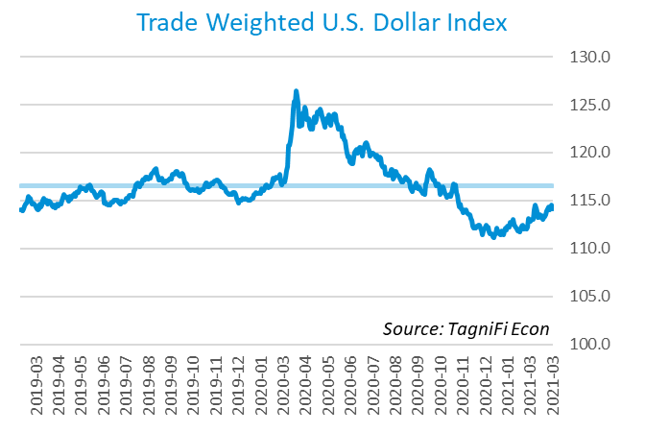

# Economic Highlights

* Real GDP for the 1st quarter of 2021 grew at an annual rate of 6.4% compared to a decline of 4.8% in the 1st quarter of 2020.
* The U.S. dollar index increased 2.68% during the 1st quarter of 2021 and decreased 0.14% over the past year.
* Throughout the 1st quarter, the Federal Reserve held the federal funds target rate at a range of 0.00 to 0.25 percent.
* The 10-year U.S. treasury climbed through the 1st quarter, yielding 1.74% annually at the end of March 2021 and the 30-year treasury yielded 2.41%.
* Unemployment fell to 6.0% in March 2021, and payroll employment regained 916,000 jobs during the first quarter.
* Consumer inflation rose 2.63% since last March.
* Oil prices rose during the 1st quarter to $59.19 per barrel on March 31, 2020.
* New housing sales were up 66.83% in the first quarter, making it the highest level in over 20 years.
* U.S. equity markets sustained their growth, although they pulled back in March 2021. The NASDAQ Composite advanced 2.78% in the 1st quarter, the Wilshire 5000 climbed 6.11% and the S&P 500 rose 5.77%.

# Business Activity

According to the Bureau of Economic Analysis (BEA), real gross domestic product (GDP)[5] for Q1 2021 grew at an annual rate of 6.4% following a 4.0% annual rate in Q4. Over the last 30 years, the average compounded annual rate of GDP growth was 2.4%. The Q1 advance estimate showed continued recovery from the crippling effects of the COVID-19 pandemic, beating economists’ expectations for the quarter. Q1 2021 growth respresented a reversal over the Q1 2020 rate of -4.8%.

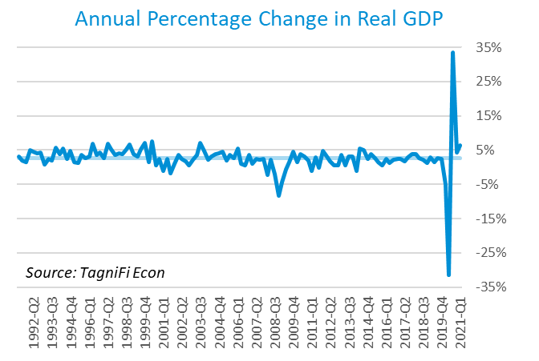

The uptick in Q1 is largely due to continued government assistance payments, such as a third round of stimulus checks, expanded unemployment benefits, increased spending due to higher household disposable income, a largely successful vaccine rollout, and the reopening of state economies.

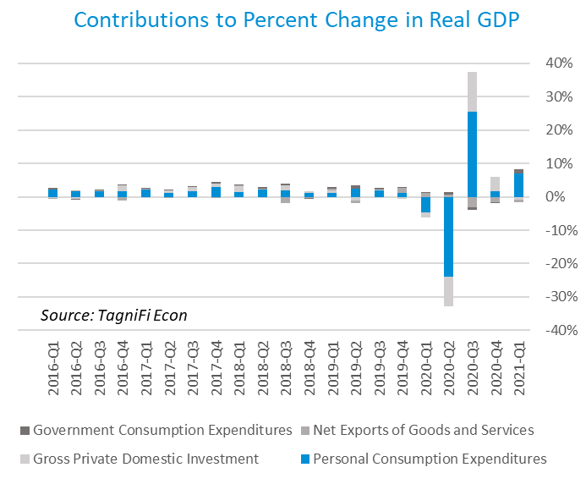

The Industrial Production Index[6] stood at 105.6 to end Q1, down slightly from the Q4 index of 105.9. Widespread outages related to severe winter weather in the southern U.S. were largely at fault for the drop in February, before production began to increase and stabilized to close out the quarter. Utilities output also dropped 11.4%, as heating demand fell due to storm-driven utility outages in Texas and the warmer-than-normal March.

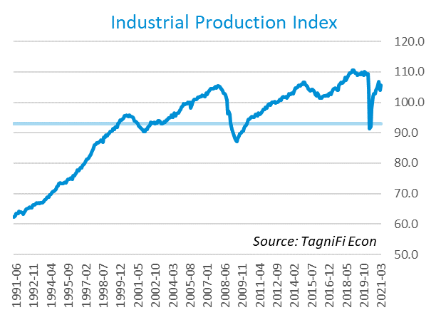

# Interest Rates

While long-term treasury bond yields[7] began to rise, short-term yields remained near historic lows throughout the 1st quarter of 2021. The long-term yield increase represented an accelerated recovery from COVID-19, an improved economic outlook, and strong fiscal and monetary support. The 1-year and 2-year annual treasury yields ended the quarter at 0.07% and 0.16%, respectively. The benchmark 10-year treasury yielded 1.74% annually at the end of March 2021, while the 30-year treasury yielded 2.41%.

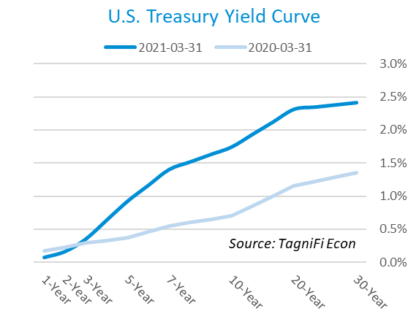

In the first quarter of 2021, the Federal Reserve continued to keep the federal funds target rate steady at a range of 0.00 to 0.25 percent, pledging to continue its easy-money policy stance until the labor market recovers fully and inflation reaches the 2% target. The effective federal funds rate[8] as of March 2021 was 0.07%.

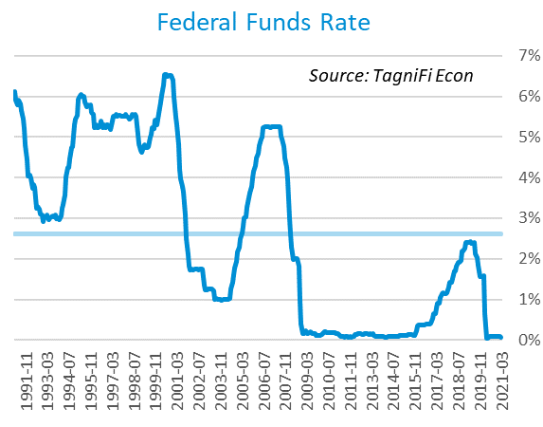

The yield on the benchmark 10-year U.S. treasury[9] rose 0.81 percentage points during the 1st quarter to end March 2021 at 1.74%, well below the average yield of 4.26% over the last 30 years and more than double the 0.70% yield one year ago.

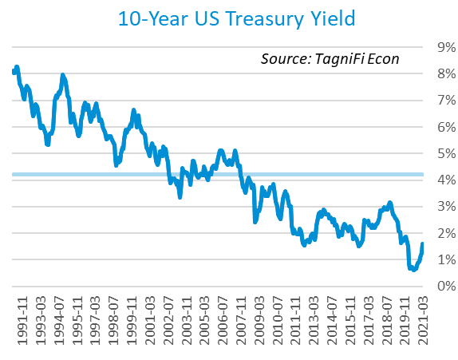

Corporate bond yields trended upward in the 1st quarter of 2021, with the Moody’s Baa Corporate Bond Yield Index[10] ending the quarter at 3.74% compared to 3.16% at the end of December 2020. The March 2021 rate is lower than the 4.29% yield from the same period last year, as well as its 30-year average yield of 6.65%.

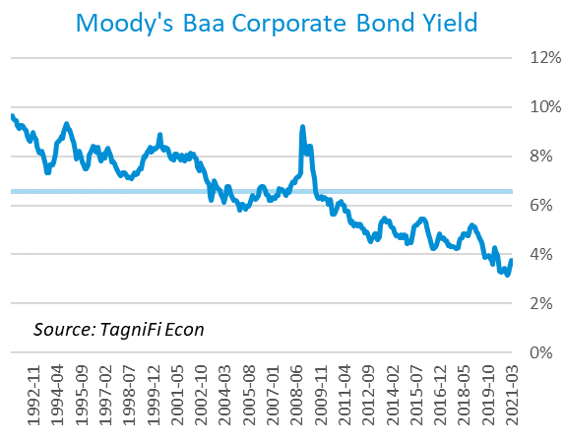

# Employment

Labor market gains steadily increased in the first quarter of 2021 as state economies began to reopen. The U.S. unemployment rate ended the quarter at 6.0%. Similarly, while the U.S. regained 916,000 jobs during the 1st quarter, total nonfarm payrolls[11] in March were still 8.1 million jobs below last February’s pre-pandemic peak. The increases were led by gains in leisure and hospitality, public and private education, and construction. At the end of March 2021, payrolls were 6.7 million below the previous March’s levels.

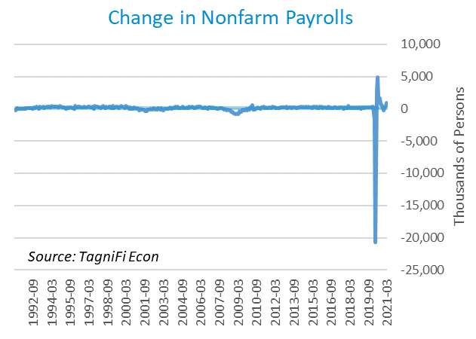

The unemployment rate[12] fell to 6.0% in March 2021, dropping each month of the quarter from the December 2020 level of 6.7%. The March 2021 unemployment rate was 1.6 percentage points higher than the previous March and dropped closer to the 30-year average unemployment rate of 5.9%. Both temporary layoffs and permanent layoffs fell from December 2020 levels in Q1 2021.

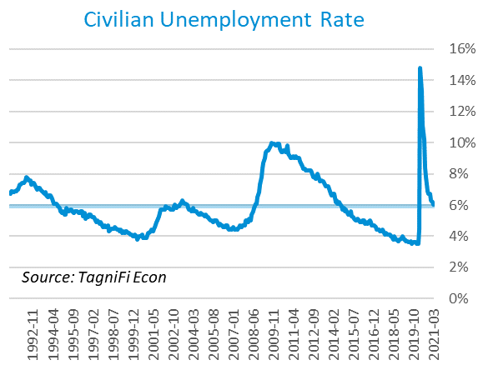

# Inflation

Inflation rose during the first quarter of 2021, with almost all commodity prices rising. Partly driven by the recovery and partly by supply factors, metals, corn, oil, and lumber all saw sharp gains. The Consumer Price Index (CPI)[13] has increased by 2.64% since last March. According to the Federal Reserve Bank of New York’s Survey of Consumer Expectations, inflation expectations[14] rose slightly in March 2021 to 3.2% for the one-year horizon and 3.1% for the three-year horizon.

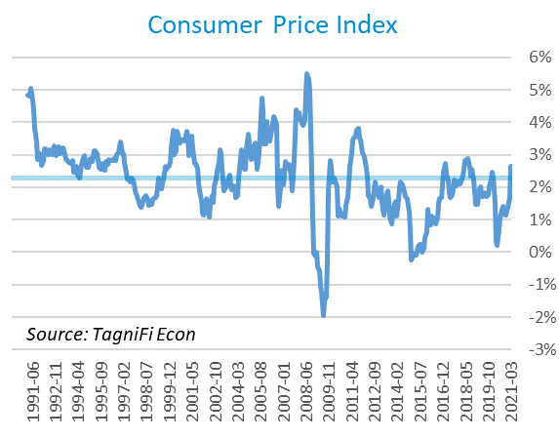

Prices at the producer level continued to climb in the first quarter with a slightly faster growth rate than has been observed since April 2020, with March 2021 prices up 7.82% since December 2020. Fuel, lumber, iron, steel, industrial chemicals, and industrial electric power were some of the drivers of this increase. The Producer Price Index (PPI)[15] for all commodities was 12.01% higher from March 2020 to March 2021, well above the average annual increase of 1.85% over the last 30 years.

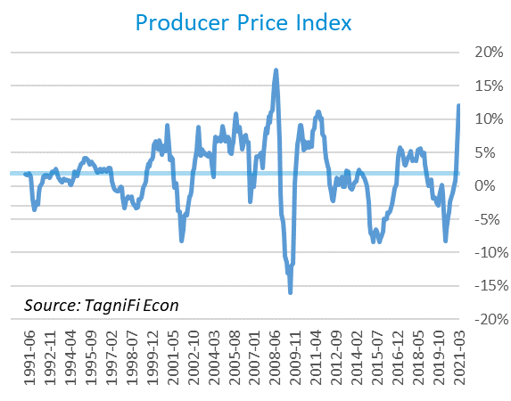

U.S. crude oil[16] prices continued the upward trend from Q4 2020 during Q1 as optimism over COVID-19 vaccines spurred investment even as vaccine rollout and reopening economies increased demand. Crude oil prices ended the quarter at $62.33 per barrel, up 32.6% from the previous quarter and 113.4% higher than the same period last year. Iron ore, copper, corn, and aluminum all saw sharp increases in Q1, due to a mix of increased demand, supply chain issues, and an overall increase in aggregate demand driven by low-interest rates and fiscal stimulus.

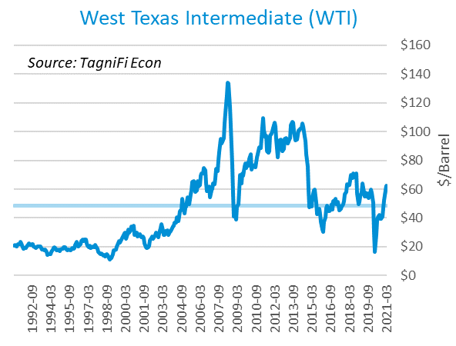

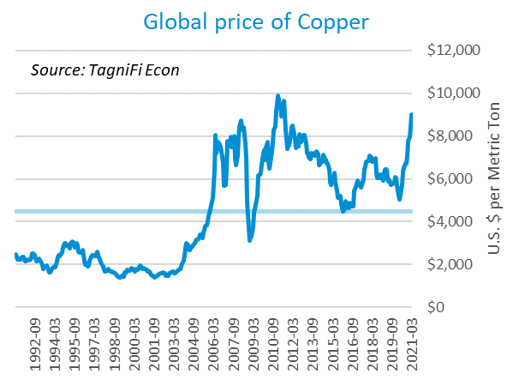

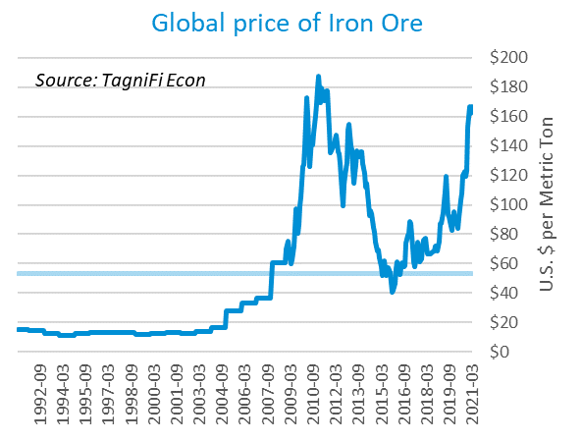

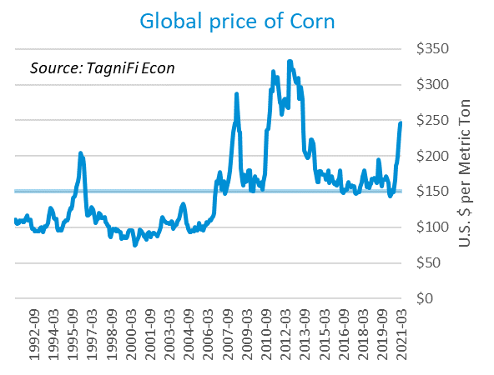

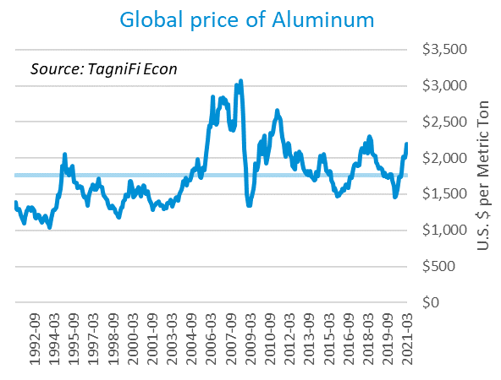

# Housing

The housing market continued to boom in the first quarter of 2021, with new home starts[17] ending the quarter at 1.74 million, their highest level in over 14 years. Total new housing starts grew 4.1% in the 1st quarter and 37.0% over the prior March. New home starts outpaced the 30-year average of 1.31 million units per month throughout the first quarter of 2021. Existing-home sales were up 12.3% YoY in March 2021, while median sales price increased 17.2% YoY. Lagging supply and increased demand are the key drivers as buyers (and sellers) look to relocate permanently based on job trend changes and the continued movement into a more stable economic environment.

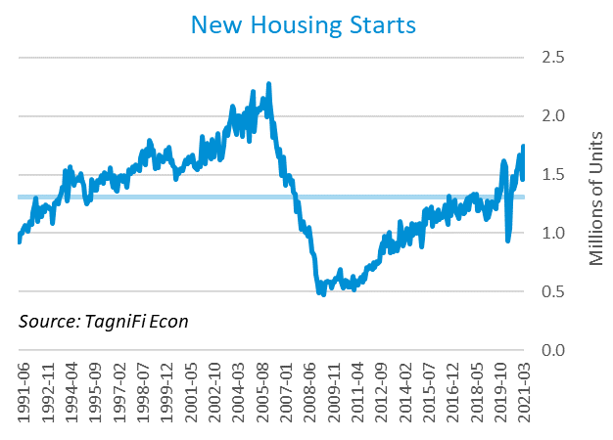

The cost of financing for would-be homebuyers ticked upward 0.31 percentage points during the first quarter, as the 30-year fixed-rate mortgage[18] ended the quarter at 2.98%. The Fed held target interest rates at 0.00% to 0.25% throughout the first quarter.

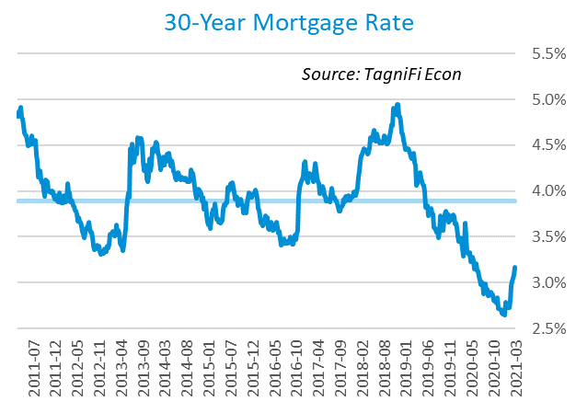

The S&P Case-Shiller Home Price Index (20-city)[19] for February 2021 increased by 11.9% year over year, with Charlotte, Seattle, and Phoenix continuing to lead. The national index rose even faster than the 20-city composite. Mortgage rates staying near record lows coupled with lagging supply and increased demand drove house prices higher.

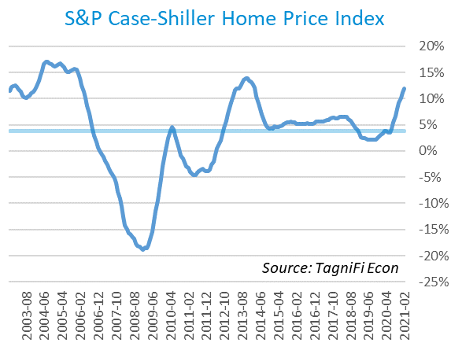

# Consumer Spending

Personal Consumption Expenditures (PCE)[20] saw steady growth in Q1 2021 after stagnating in Q4 2020, rising 6.6%. PCE saw a 11.0% increase year-over-year. Consumer spending rose mostly due to a second round of stimulus checks hitting bank accounts in late December, a third round hitting bank accounts in Q1, the continued reopening of state economies, steady job gains, and the rolling out of COVID-19 vaccines.

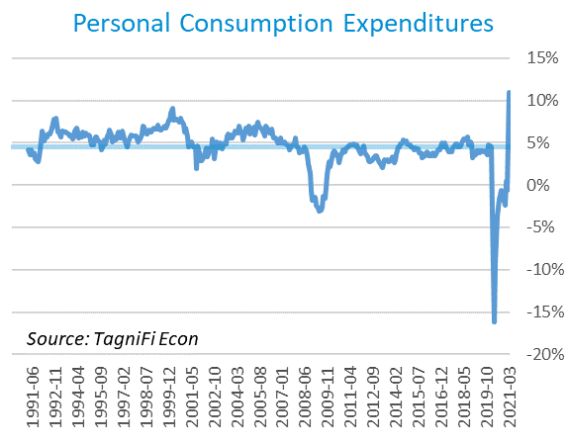

Automotive companies reported 17.8 million automotive vehicles and light trucks sold[21] in March 2021, up 10.0% over December levels, which also represented the highest levels seen since October 2017.

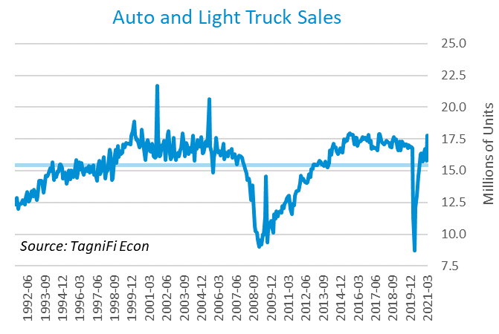

The consumer sentiment[22] index ended Q1 2021 at 84.9, the highest level seen since March 2020. The index was up 4.2 points since the end of Q4 2020 despite a sharp dip in February, due to the emergence of variants and a less-than-perfect initial rollout of the COVID-19 vaccine. The consumer sentiment index has been on a choppy, but general upward trend since its April 2020 low. March’s reading was still well below its high of 101.0 in February 2020 and still approaching its 30-year average of 87.5.

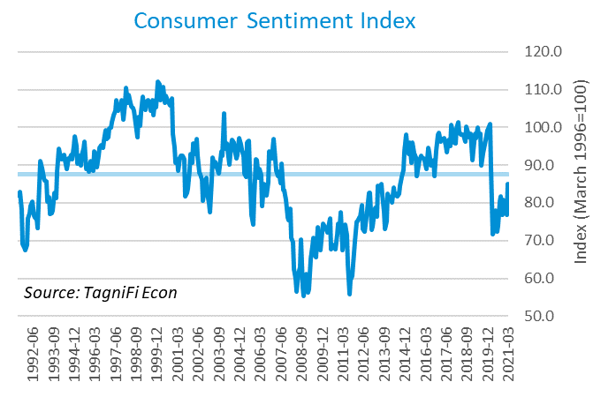

# Capital Markets

U.S. equity markets sustained their growth, although they pulled back in March 2021. The NASDAQ Composite advanced 2.8% in the first quarter, the Wilshire 5000 climbed 5.8%, and the S&P 500 rose 5.8%. As widespread fears of overvaluation by experts and shifts to cryptocurrency began to take place, stocks pulled back, but still showed gains due to the influx of fiscal stimulus and a more friendly economic climate.



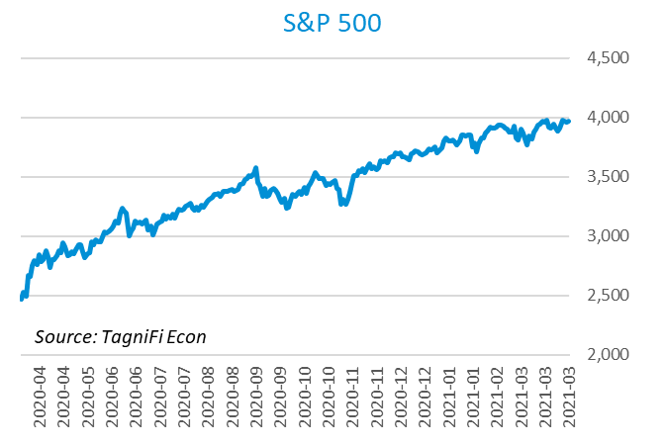

Stock market volatility[23] ended the first quarter at 19.4, down 63.3 points from its mid-March peak and 3.4 points from the end of Q4 2020. Q1 also saw the VIX drop below its 10-year average of 19.4. The volatility index, a proxy for investor anxiety derived from tracking options prices on S&P 500 stocks which can also be a proxy for consumer confidence, showed that consumers are generally feeling more stable as people get back to work and economies begin to open up.

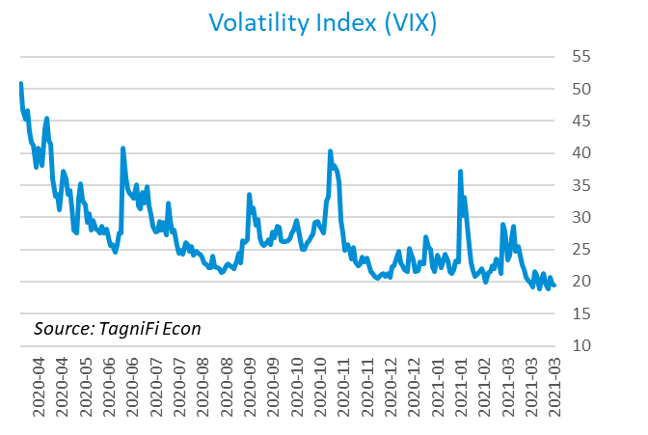

# Outlook

In March 2021, the FOMC projected real GDP[24] to recover to 6.20% growth in 2021, slowing to 2.25% by 2023. The 2023 forecast was adjusted downward from 2.45%, and with Q1 2021 forecasts beating expectations, this represents a quicker recovery in 2021. Personal Consumption Expenditures (PCE)[25] are forecast to grow 2.30% in 2021 while the unemployment rate[26] is forecasted to decline to 4.45% in 2021.



# About This Report

The *Quarterly Economic Update* is a free publication sponsored by TagniFi. You are free to share this report and include its contents in the economic outlook section of your valuation reports as required by *Revenue Ruling 59-60*. Please forward this free report to a colleague to help us spread the word about TagniFi.

# About TagniFi

In July 2015 we released our first dataset, TagniFi Fundamentals, because we thought investors and finance professionals needed a better solution for financial data. Since then our mission has remained the same: to serve our clients with the best financial data available at a reasonable price. We do this by developing innovative solutions to leverage tagged financial statements which allow us to deliver better, faster and more detailed data at a fraction of the cost.

Today TagniFi is a platform of financial data aimed at making our clients more productive and prosperous. We're helping clients in all corners of finance make better decisions with better data. We relentlessly focus on quality and the trust we've earned from our clients is our greatest asset. Our growth is centered around our clients' needs as we look to expand our platform with new data. Referrals from our existing clients is the ultimate compliment so we choose to invest in our product, not flashy marketing campaigns. For more information on TagniFi, please visit [www.tagnifi.com](http://www.tagnifi.com).

How TagniFi Helps Business Valuation Teams

TagniFi’s financial data platform empowers business valuation teams to quickly and easily build highly accurate financial models with full transparency—and within seconds.

**Better Public Comps**  
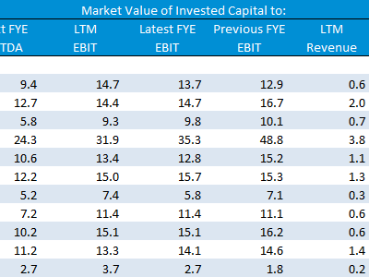Search for public companies with TagniFi Web. Simply enter your valuation date and ticker symbols in Excel to run a guideline public company method. Your Excel model populates instantly with the financial statements, analyst estimates, interest rates and economic data for your valuation date.

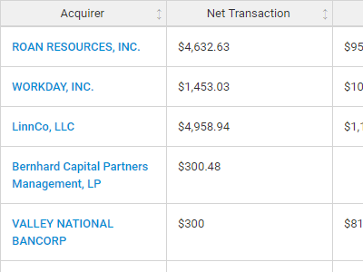**Better Transaction Comps**  
Search for public and private M&A transactions with TagniFi Web. Run your transaction comps within seconds by pasting the Deal ID into your Excel model. Every deal disclosed in an SEC filing (8-K, 10-K, or 10-Q) is available for your analysis. Choose from over 90 fields of data available for every deal.

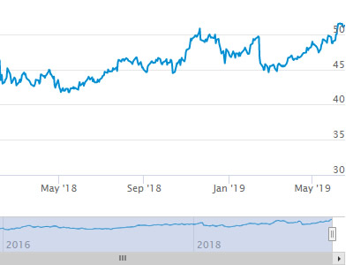

**Historical Beta and Volatility**Calculate historical beta and volatility as of your valuation date automatically. Simply enter the tickers and valuation date in Excel - TagniFi does the rest. In addition to beta and volatility, there are over 40 Excel models available in the Model Library to help with your valuation report.

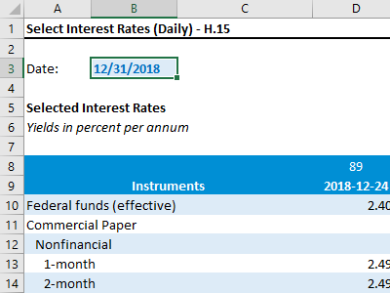**Interest Rates and Economic Data**Automate the interest rates and economic data in your valuation report using the TagniFi Excel plugin. Choose from over 200,000 time series available. All data in this *Quarterly Economic Update* is from the TagniFi platform. Use economic and interest rate data for your own valuation models with the TagniFi Excel plugin.

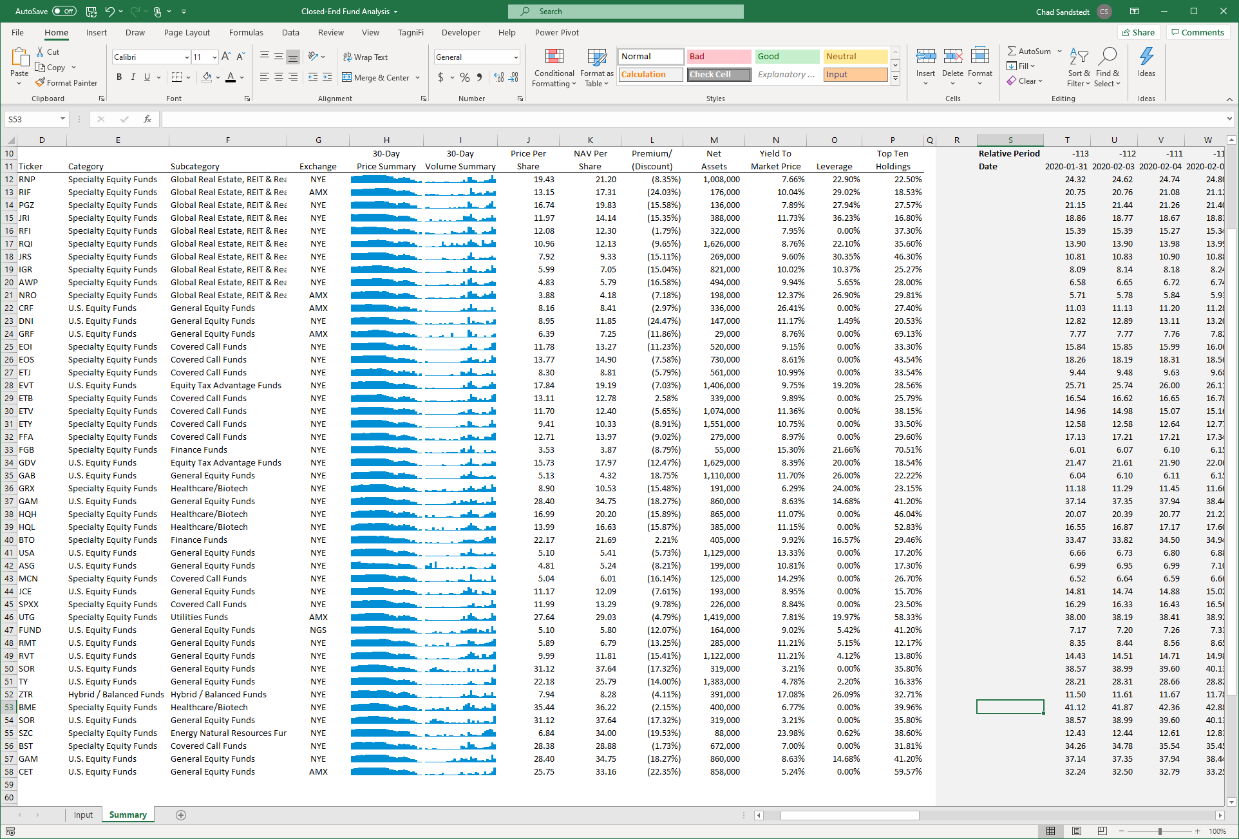

**Closed-End Mutual Fund Data**Search for closed-end mutual funds by keyword, category, subcategory, and more with the TagniFi Console. Use the TagniFi Excel plugin to calculate historical discounts, yields, leverage, as of your valuation date automatically. Simply enter the tickers and valuation date in Excel - TagniFi does the rest.

1. *US Business Cycle Expansions and Contractions, retrieved from the National Bureau of Economic Research (NBER),* [*https://www.nber.org/research/data/us-business-cycle-expansions-and-contractions*](https://www.nber.org/research/data/us-business-cycle-expansions-and-contractions)*, Apr 30, 2021.*
2. *Trends in Number of COVID-19 Cases and Deaths in the US Reported to CDC, by State/Territory, retrieved from the Centers for Disease Control and Prevention (CDC),* [*https://covid.cdc.gov/covid-data-tracker/ - trends_totalandratecases*](https://covid.cdc.gov/covid-data-tracker/#trends_totalandratecases)*, Apr 30, 2021.*
3. *State Coincident Indexes, retrieved from the Federal Reserve Bank of Philadelphia,* *https://www.philadelphiafed.org/-/media/frbp/assets/surveys-and-data/coincident/2021/coincidentindexes0321.pdf, Apr. 30, 2021.*
4. *Board of Governors of the Federal Reserve System (US), Trade Weighted U.S. Dollar Index: Broad, Goods and Services [DTWEXBGS], retrieved from FRED, Federal Reserve Bank of St. Louis;* [*https://fred.stlouisfed.org/series/DTWEXBGS*](https://fred.stlouisfed.org/series/DTWEXBGS)*, Apr 30, 2021.*
5. U.S. Bureau of Economic Analysis, Real Gross Domestic Product [GDPC1], *retrieved from FRED, Federal Reserve Bank of St. Louis;*[*https://fred.stlouisfed.org/series/GDPC1*](https://fred.stlouisfed.org/series/GDPC1)*, Apr 30, 2021.*
6. Board of Governors of the Federal Reserve System (US), Industrial Production Index [INDPRO], *retrieved from FRED, Federal Reserve Bank of St. Louis;*[*https://fred.stlouisfed.org/series/INDPRO*](https://fred.stlouisfed.org/series/INDPRO)*, Apr 30, 2021.*
7. *Selected Interest Rates Instruments, Yields in percent per annum, retrieved from FRED, Federal Reserve Bank of St. Louis;* *https://fred.stlouisfed.org/release/tables?rid=18&eid=289&od=#, Apr 30, 2021.*
8. *Board of Governors of the Federal Reserve System (US), Effective Federal Funds Rate [FEDFUNDS], retrieved from FRED, Federal Reserve Bank of St. Louis;*[*https://fred.stlouisfed.org/series/FEDFUNDS*](https://fred.stlouisfed.org/series/FEDFUNDS)*, Apr 30, 2021.*
9. Board of Governors of the Federal Reserve System (US), 10-Year Treasury Constant Maturity Rate [DGS10], *retrieved from FRED, Federal Reserve Bank of St. Louis;*[*https://fred.stlouisfed.org/series/DGS10*](https://fred.stlouisfed.org/series/DGS10)*, Apr 30, 2021.*
10. Moody’s, Moody’s Seasoned Baa Corporate Bond Yield [BAAS], *retrieved from FRED, Federal Reserve Bank of St. Louis;*[*https://fred.stlouisfed.org/series/BAA*](https://fred.stlouisfed.org/series/BAA)*, Apr 30, 2021.*
11. U.S. Bureau of Labor Statistics, All Employees: Total Nonfarm Payrolls [PAYEMS], *retrieved from FRED, Federal Reserve Bank of St. Louis;*[*https://fred.stlouisfed.org/series/PAYEMS*](https://fred.stlouisfed.org/series/PAYEMS)*, Apr 30, 2021.*
12. U.S. Bureau of Labor Statistics, Civilian Unemployment Rate [UNRATE], *retrieved from FRED, Federal Reserve Bank of St. Louis;*[*https://fred.stlouisfed.org/series/UNRATE*](https://fred.stlouisfed.org/series/UNRATE)*, Apr 30, 2021.*
13. U.S. Bureau of Labor Statistics, Consumer Price Index for All Urban Consumers: All Items [CPIAUCSL], *retrieved from FRED, Federal Reserve Bank of St. Louis;*[*https://fred.stlouisfed.org/series/CPIAUCSL*](https://fred.stlouisfed.org/series/CPIAUCSL)*, Apr 30, 2021.*
14. *Survey of Consumer Expectations, retrieved from Federal Reserve Bank of New York,* [*https://www.newyorkfed.org/microeconomics/sce - indicators/inflation-expectations/g1*](https://www.newyorkfed.org/microeconomics/sce#indicators/inflation-expectations/g1)*, Apr 30, 2021*
15. U.S. Bureau of Labor Statistics, Producer Price Index for All Commodities [PPIACO], *retrieved from FRED, Federal Reserve Bank of St. Louis;*[*https://fred.stlouisfed.org/series/PPIACO*](https://fred.stlouisfed.org/series/PPIACO)*, Apr 30, 2021.*
16. *U.S. Energy Information Administration, Crude Oil Prices: West Texas Intermediate (WTI) – Cushing, Oklahoma [MCOILWTICO], retrieved from FRED, Federal Reserve Bank of St. Louis;*[*https://fred.stlouisfed.org/series/MCOILWTICO*](https://fred.stlouisfed.org/series/MCOILWTICO)*, Apr 30, 2021.*
17. U.S. Bureau of the Census, Housing Starts: Total: New Privately Owned Housing Units Started [HOUST], *retrieved from FRED, Federal Reserve Bank of St. Louis;*[*https://fred.stlouisfed.org/series/HOUST*](https://fred.stlouisfed.org/series/HOUST)*, Apr 30, 2021.*
18. Freddie Mac, 30-Year Fixed Rate Mortgage Average in the United States [MORTGAGE30US], *retrieved from FRED, Federal Reserve Bank of St. Louis;*[*https://fred.stlouisfed.org/series/MORTGAGE30US*](https://fred.stlouisfed.org/series/MORTGAGE30US)*, Apr 30, 2021.*
19. S&P Down Jones Indices LLC, S&P/Case-Shiller 20-City Composite Home Price Index [SPCS20RSA], *retrieved from FRED, Federal Reserve Bank of St. Louis;*[*https://fred.stlouisfed.org/series/SPCS20RSA*](https://fred.stlouisfed.org/series/SPCS20RSA)*, Apr 30, 2021.*
20. U.S. Bureau of Economic Analysis, Personal Consumption Expenditures [PCE], *retrieved from FRED, Federal Reserve Bank of St. Louis;*[*https://fred.stlouisfed.org/series/PCE*](https://fred.stlouisfed.org/series/PCE)*, Apr 30, 2021.*
21. U.S. Bureau of Economic Analysis, Light Weight Vehicle Sales: Autos and Light Trucks [ALTSALES], *retrieved from FRED, Federal Reserve Bank of St. Louis;*[*https://fred.stlouisfed.org/series/ALTSALES*](https://fred.stlouisfed.org/series/ALTSALES)*, Apr 30, 2021.*
22. *University of Michigan, University of Michigan: Consumer Sentiment [UMCSENT], retrieved from FRED, Federal Reserve Bank of St. Louis;* [*https://fred.stlouisfed.org/series/UMCSENT*](https://fred.stlouisfed.org/series/UMCSENT)*, Apr 30, 2021.*
23. *Chicago Board Options Exchange, CBOE Volatility Index: VIX [VIXCLS], retrieved from FRED, Federal Reserve Bank of St. Louis;* [*https://fred.stlouisfed.org/series/VIXCLS*](https://fred.stlouisfed.org/series/VIXCLS)*, Apr 30, 2021.*
24. *Federal Reserve Bank of St. Louis, FOMC Summary of Economic Projections for the Growth Rate of Real Gross Domestic Product [GDPC1CTM], retrieved from FRED, Federal Reserve Bank of St. Louis;*[*https://fred.stlouisfed.org/series/GDPC1CTM*](https://fred.stlouisfed.org/series/GDPC1CTM)*, Apr 30, 2021.*
25. *Federal Reserve Bank of St. Louis, FOMC Summary of Economic Projections for the Personal Consumption Expenditures Inflation Rate, Central Tendency, Midpoint [PCECTPICTM], retrieved from FRED, Federal Reserve Bank of St. Louis;*[*https://fred.stlouisfed.org/series/PCECTPICTM*](https://fred.stlouisfed.org/series/PCECTPICTM)*, Apr 30, 2021.*
26. *Federal Reserve Bank of St. Louis, FOMC Summary of Economic Projections for the Civilian Unemployment Rate, Central Tendency, Midpoint [UNRATECTM], retrieved from FRED, Federal Reserve Bank of St. Louis;*[*https://fred.stlouisfed.org/series/UNRATECTM*](https://fred.stlouisfed.org/series/UNRATECTM)*, Apr 30, 2021.*