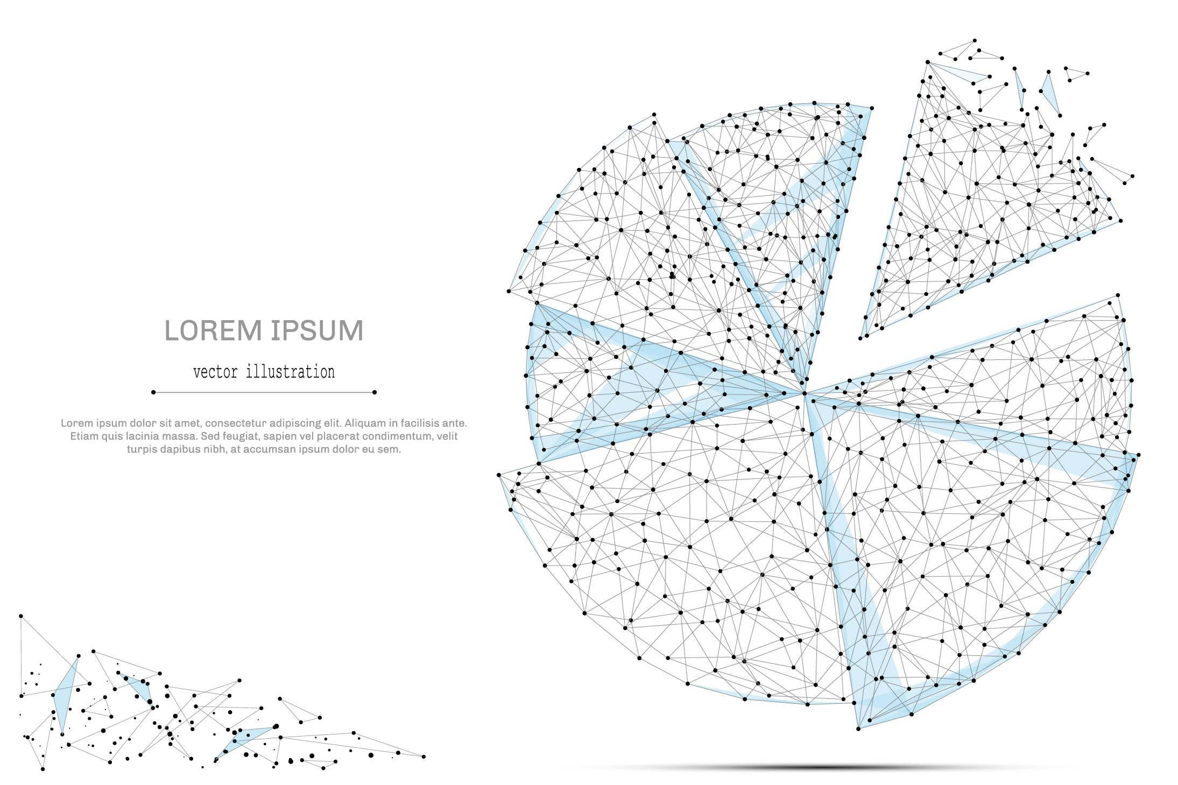

QUARTERLY ECONOMIC UPDATE

For the 2nd Quarter of 2021

Abstract

Designed for business valuation professionals, TagniFi’s Quarterly Economic   
Update provides timely economic data to satisfy Revenue Ruling 56-60.

# Summary

The second quarter of 2021 was defined by robust consumer demand as the economy kicks back into high gear, as well as a struggle for domestic and global productive capacity to meet that demand. This combination saw an increase in output, driven by record-breaking private consumption, as well as inflationary pressure. Prices, especially manufacturing inputs, dramatically increased in Q2, partially due to productive capacity and supply chains lagging the recovery in demand. Employment has slowed in its recovery, stubbornly trending at the 30-year historical average. Though the country and the rest of the world are recovering, albeit at varying speeds, from the pandemic, the economy continues to underutilize its capacity, both in the United States and abroad.

The defining economic challenge of the near term is balancing an economic recovery with inflationary pressure. Driven by a successful vaccination rollout and economic reopening, the US has seen a positive phase shift in its recovery, particularly on the demand side, which many countries have yet to fully realize. The US trade deficit, which ballooned during the pandemic, is partially due to foreign consumption struggling to catch up.

Despite cause for optimism in the first half of 2021, we are not out of the woods yet regarding COVID-19. Major challenges and uncertainties remain. Vaccination rates have begun to plateau, as a sizeable portion of the population, nearly one third, has access but no interest in receiving a vaccine. This has led to a resurgence in cases, driven as well by more virulent variants of the virus, such as the Delta and Lambda variants. The near-term economic outlook will largely depend on the US and the rest of the world’s success in inoculating its populace from the virus while rebuilding the economy.

Below is a summary timeline of key COVID-19 events in the U.S. during the 2nd quarter of 2021:

|  |  |
| --- | --- |
| April 1, 2021 | US begins the quarter at 66,000 daily cases, 925 daily deaths. 30% of Americans are fully vaccinated. |
| April 8, 2021 | UK Variant Now Dominant in United States |
| April 18, 2021 | Half of All US Adults Have Received 1 COVID-19 Dose |
| April 23, 2021 | States See Drops in Demand for COVID-19 Vaccines |
| April 27, 2021 | CDC Eases Mask Restrictions for Fully Vaccinated Individuals |
| April 29, 2021 | Half of US States Report Drops in COVID-19 Cases |
| May 1, 2021 | Cases drop to 52,000 per day, 720 deaths. |
| May 10, 2021 | Pfizer/BioNTech Vaccine Approved for Adolescents |
| May 10, 2021 | FDA authorizes Pfizer vaccine for emergency use in adolescents. |
| May 25, 2021 | Half of American adults are fully vaccinated. |
| June 1, 2021 | 17,000 cases, 430 deaths per day. |
| June 3, 2021 | Initiative Announced to Boost Vaccine Rates |
| June 15, 2021 | California becomes one of the last US states to drop most coronavirus restrictions. |
| June 23, 2021 | Delta Variant Concerns Mount |
| June 25, 2021 | COVID-19 Deaths Most Common in Unvaccinated |
| June 30, 2021 | US ends the quarter with 13,000 daily cases (80% reduction), 270 daily deaths (70% reduction). |

In the second quarter of 2021, the U.S. economy continued to rebound from the fallout of the COVID-19 pandemic, with emergency vaccine approvals sparking hope despite surging cases and the spread of new more contagious variants.

By the end of the first quarter of 2021, US daily case rates fell to an average 14,000 from a peak of 282,000 near the beginning of the year. Deaths similarly fell from a high of around 3,500 per day to around 250 in late June. This recovery surpassed expectations, fueling optimism that the recovery from the health crisis and resulting economic shock may move ahead of schedule. However, though outside the scope of this Q2 report, we must note that July saw cases quickly surge again, driven by the far more contagious Delta variant of the coronavirus, toward 100,000 per day. Deaths increased as well, with roughly 99% of those deaths now suffered by the unvaccinated.

The continued economic recovery hinges on America’s ability to balance public health priorities with commercial dynamism. The best way to do that still appears to be through vaccination. However, the rate of vaccination began to flatten in Q2, inching upward once it reached 50%. To illustrate, the percentage of the population that had received the vaccine increased 14% in April, 6% in May, and less than 4% in June to end the quarter at 55%.

Rather than logistics or supply, the limiting factor is many Americans’ unwillingness to receive the shot. The amount of public health and economic damage that the resurgence of COVID can inflict on the US will likely depend to some extent on the rate of vaccination.

The Philadelphia Fed’s coincident index[1] of economic activity in the U.S. rose 0.4% in June 2021 and 1.3% during the 2nd quarter. For the quarter, coincident indexes increased in 46 states and decreased in 4. Coincident indexes reflect unemployment, payroll employment, manufacturing hours, and wages and salaries. Unemployment, a major factor in the index, fell just 0.1% over the quarter, marking the smallest drop since the economy began recovering from the pandemic.



The U.S. dollar index for goods and services[2] fell 1.13% during the 2nd quarter of 2021 and 6.57% compared to June of 2020. The dollar’s steady fall reflects greater risk appetite and concerns about the ballooning American deficit, as rising inflation expectations. Further suppressing the dollar’s value: The U.S. current account deficit, which has grown every quarter since the start of 2020, approached $200 billion in Q1.

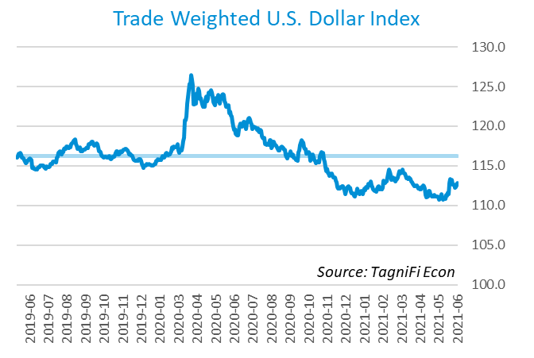

# Q2 Economic Highlights

* Real GDP for the 2nd quarter of 2021 grew at an annual rate of 6.5%, reaching an all-time high on better-than-expected consumer demand.
* The U.S. dollar index fell 1.13% during the quarter and 6.63% over the last year.
* Throughout the 2nd quarter, the effective federal funds rate stayed below 0.1%, consistent with aggressive expansionary policy since the pandemic began.
* Short-term bond yields remained low during the quarter, and long-term yields lost some of their gains. The 10-year U.S. treasury yielded 1.45% annually at the end of June 2021 and the 30-year treasury yielded 2.06%, both down from the previous quarter.
* Unemployment fell to 5.9% in June, and nonfarm payroll employment gained 1.7 million jobs during the 2nd quarter.
* The Consumer Price Index rose 5.32% year-over-year, driven by higher fuel costs.
* Oil prices continued to rise during the 2nd quarter, ending at $73.52 per barrel.
* New housing starts fell 2% compared to the first quarter but were up 44% year-over-year.
* U.S. capital markets continued to climb through the second quarter, as the VIX fell. The NASDAQ Composite led US equities at 9.5%, and the S&P 500 and Wilshire 5000 Index gained 8.2 and 8.1%, respectively.

# Business Activity

According to the Bureau of Economic Analysis (BEA), real gross domestic product (GDP)[3] for the 2nd quarter of 2021 grew at an annualized rate of 6.5%, slightly higher than the first quarter’s 6.3%. The 2nd quarter’s growth represented continuing recovery from the devastating economic effects of the COVID-19 pandemic, yet was well below economists’ expectations of an annualized growth rate of 8.4%.

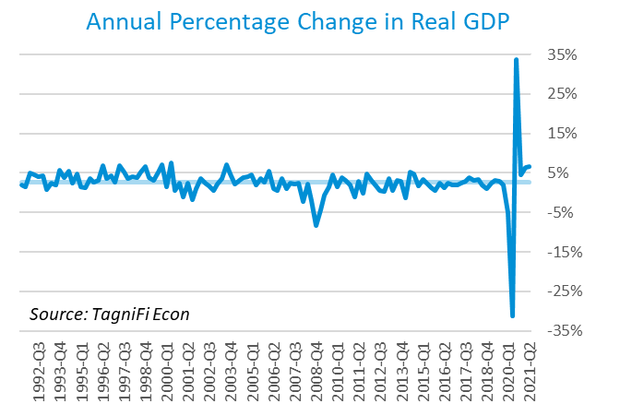

GDP growth in the second quarter was due almost entirely to a 7.8% annualized contribution from personal consumption, the only component to beat expectations. Private and domestic investment, government consumption and net exports all had a slightly negative impact on GDP, bringing annualized growth down by 1.3% between the three.

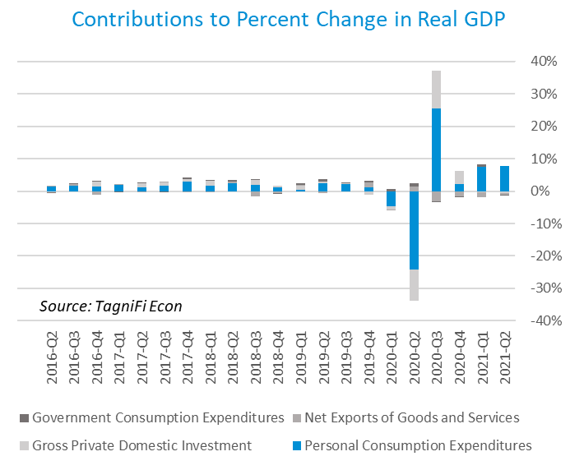

The Industrial Production Index[4] is an economic indicator that measures real output for all facilities located in the United States manufacturing, mining, and electric, and gas utilities. The index stood at 100.1 at the end of Q2, up 1.17% for the 2nd quarter.

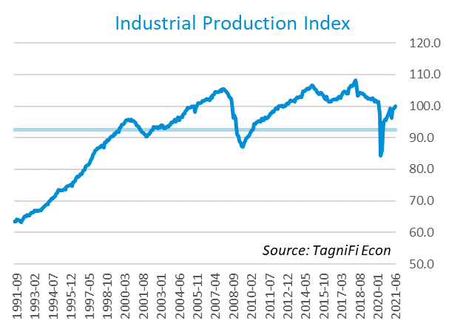

The Capacity Utilization Index[5], which attempts to capture industrial output as a percentage of the economy’s maximum production capacity, increased to 75.5%, slowing as it approaches the pre-pandemic level of 76.5%. The 10-year high for the metric was 78.4% in August of 2018.

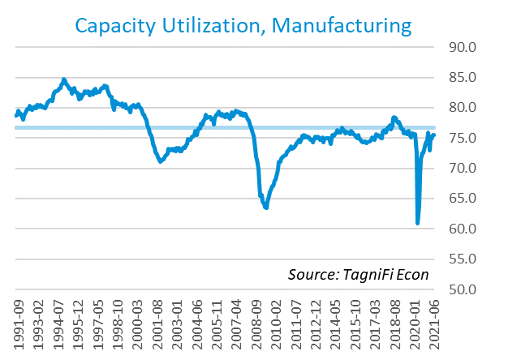

# Interest Rates

The effective funds rate stayed near its all-time low during the quarter rising slightly from .07% to .08%, while short-term treasury rates moved little during the quarter. Long-term treasury bond yields, which had risen during Q4 2020 and Q1 2021, fell slightly as coronavirus concerns weighed on investor sentiment and inflation expectations continued to rise. The Fed’s upward revision of inflation forecasts was the primary catalyst during the quarter, while concerns that the Delta-variant could hamper the recovery tapered this movement. The result was a slight drop in longer-term Treasuries, while 1-year and 2-year annual treasury yields ended the quarter at 0.7% and 0.25%, respectively. The benchmark 10-year treasury yielded 1.45 % annually at the end of the quarter, while the 30-year treasury yielded 2.06%. See *Appendix – Selected Interest Rates* for detailed interest rate data.

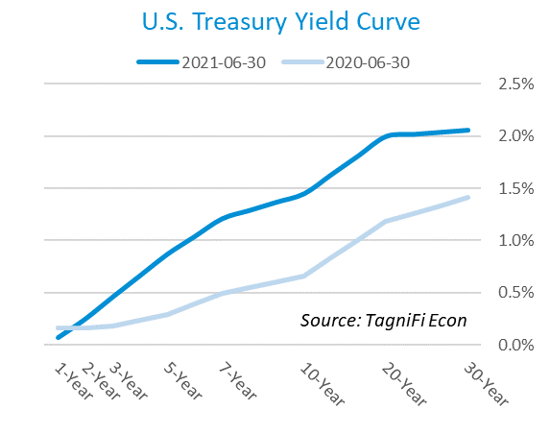

In the 2nd quarter of 2020, the Federal Reserve continued to keep the federal funds target rate steady at a range of 0.00 to 0.25 percent, stating that reducing unemployment outweighed growing inflation as the central bank’s first priority. The effective federal funds rate[6] at the end of Q2 was 0.08, similar to recent quarters.

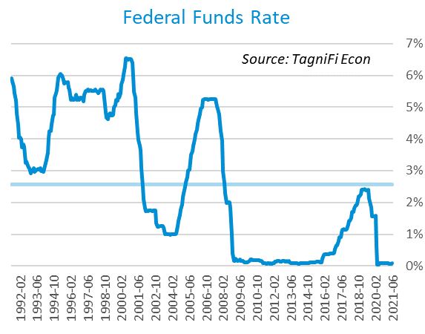

The yield on the benchmark 10-year U.S. treasury[7] fell 29 basis points during the 2nd quarter to 1.45%, well below the average yield of 4.16% over the last 30 years.

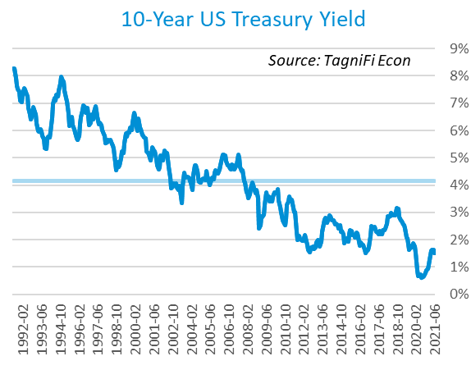

After rising every month of the first quarter, corporate bond yields reversed and fell every month of Q2. Moody’s Baa Corporate Bond Yield Index[8] ended the quarter at 3.32% compared to 3.77% in March. Moody’s Aaa Index moved similarly from 3.04% to 2.63%. Starting in March of 2020, the Federal Reserve took the unprecedented measure of building a portfolio of corporate bonds, effectively backstopping the corporate bond market. Shortly after doing so, the riskier Baa index reversed its yield spike and began to fall lower. The move was less dramatic for Aaa, but both markets were affected directly by the Fed’s $13 billion portfolio, as well as by its expansionary operations in 2020.

In early July, the Fed announced that it would begin gradually selling its off its bond holdings, which could put near-term upward pressure on yields, especially for the riskier Baa index. More broadly, the Federal Reserve’s decision to actively purchase corporate bonds marked a new frontier for its role in capital markets.

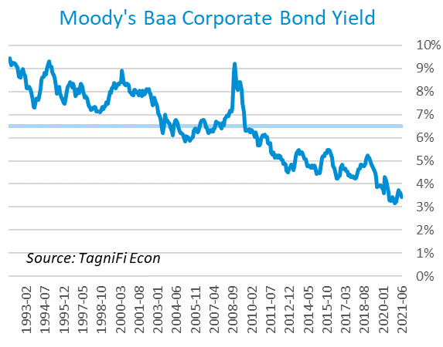

# Employment

The official unemployment rate[9] saw its recovery slow in Q2, falling marginally to 5.9%. This figure matches the 30-year historical average but is substantially higher than its pre-pandemic level of 3.5%. In response to stronger data, economists surveyed by the Livingston Survey[10] revised their unemployment projections for the end of 2021 to 4.7%, down from a predicted 5.5% in December of 2020.

The U-6 unemployment rate[11] is an alternative measure of unemployment with a broader definition, such as discouraged workers who are not actively searching for jobs but want full-time work and part-time workers who want full-time work. The U‑6 unemployment rate has generally followed the same pattern as the official rate, and has fallen in every month since April of 2020, reaching 9.8% in June.

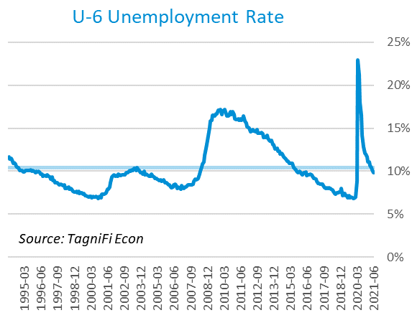

Nonfarm payrolls[12] grew by 1.7 million jobs in Q2 and 7.9 million compared to the same period last year, marking a continued rebound from the massive job losses of the first half of 2020. The economy is still about 7 million shy of Q1 2020’s nonfarm payrolls of 152.5 million.

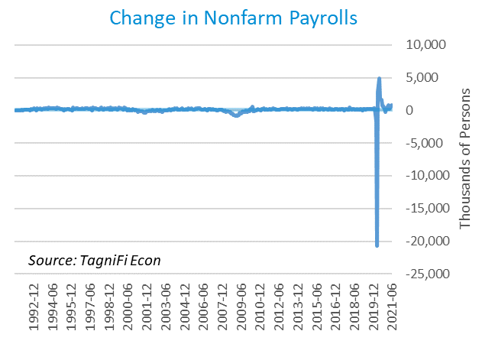

# Inflation

For the first time in many years, inflation is squarely back on the minds of consumers and market watchers. The Consumer Price Index[13] rose 5.3% year-over-year in June, 4.5% without food and energy prices included. Notably, the price of a gallon of gas increased 47% in June over the preceding year, from a national average of $2.08 to $3.06. The Federal Reserve acknowledged their awareness of the issue, but did not foresee any rate hikes in the near term. Speculation abounds over whether the jump in inflation is transitory, driven by rebounding demand and still-recovering productive capacity, or more structural, driven by government transfer payments and a large, sustained federal deficit.

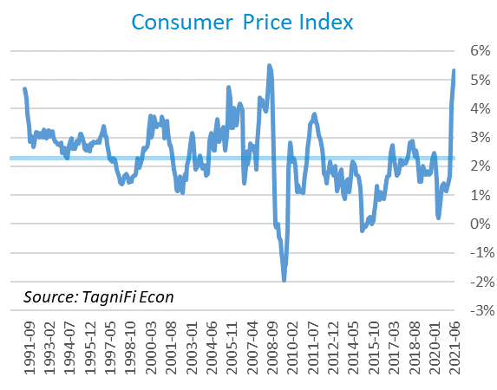

The Producer Price Index[14] rose 5.6% over the quarter to 228.5, well above the average annual increase of 2.0% over the last 30 years. Notable increases include gasoline at 9%, wood pallets at 21%, and metals at 13%. The increase in metals was largely driven by iron and steel, which were up an average 21% between them.

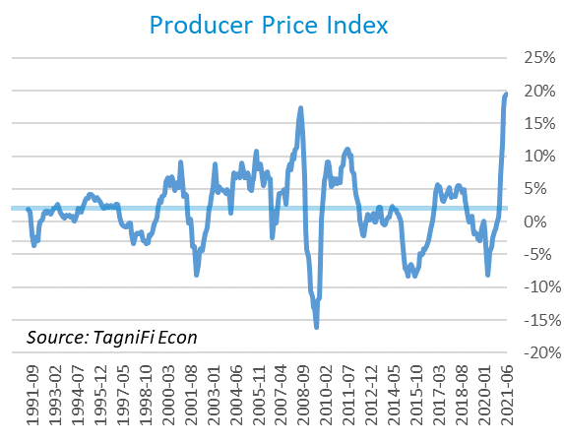

Treasury Inflation-Protected Securities (TIPS) are a longer-term Treasury debt instrument which pays a fixed interest rate but adjusts the principal value according to inflation, effectively indexing interest payments to inflation. TIPS have continued to sell at a higher premium, reflecting higher inflation expectations for the future. The 5-year breakeven inflation rate[15], an indicator for the market’s inflation expectations for the period, rose to 2.72% in May before falling to 2.47%, slightly below the rate at the start of the quarter.

U.S. crude oil[16] prices rose substantially in Q2. Crude oil prices ended the quarter at $73.52 per barrel in June 2021, up 24% from the previous quarter. The price was driven upward by several factors, including accelerating demand in the United States and OPEC’s continued inventory reduction.

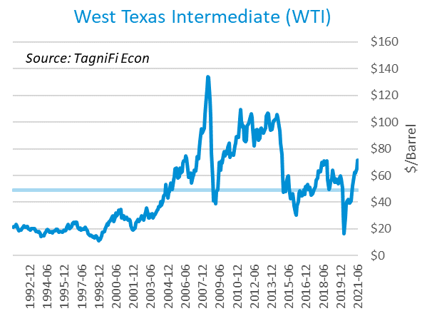

Below we present several examples of inflation at the input level to provide an historical perspective on the recent price spikes of some popular commodities. The charts include the global price of copper[17], iron ore[18], and corn[19].

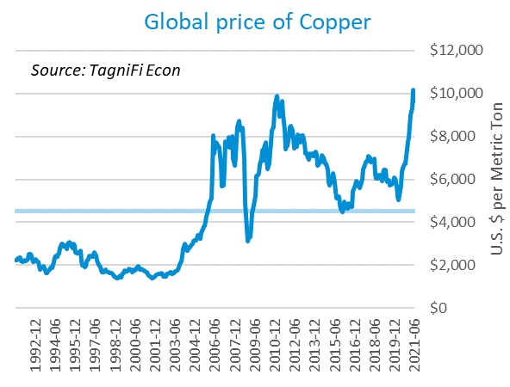

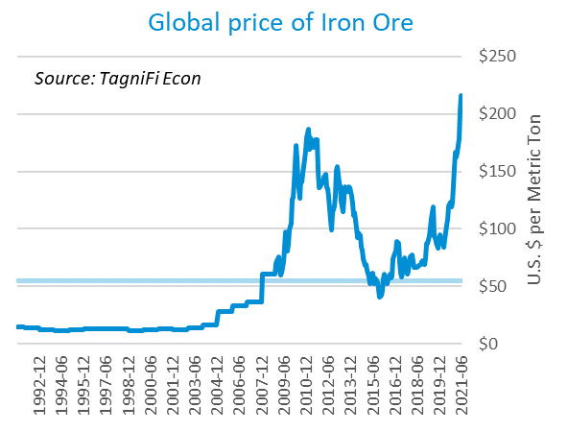

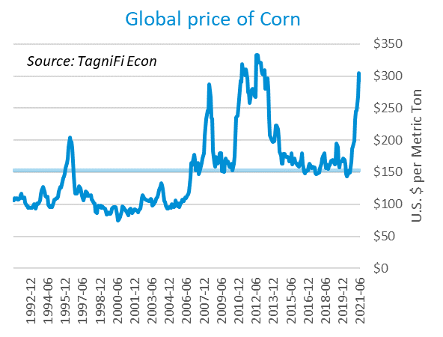

# Housing

The housing market continued to show its resilience to, and in some ways benefit from, the economic conditions created by COVID0-19. New home starts[20] ended the quarter at 1.64 million, 25% above the 30-year average and consistent with figures seen over roughly the past twelve months. Single-family homebuilding continued to surge as home demand remained strong in suburban areas, while multi-family construction began to rebound from a substantial drop since the pandemic began. Roughly 29% of housing starts were multi-family projects, compared to 31% and 28% on average in 2019 and 2020, respectively.

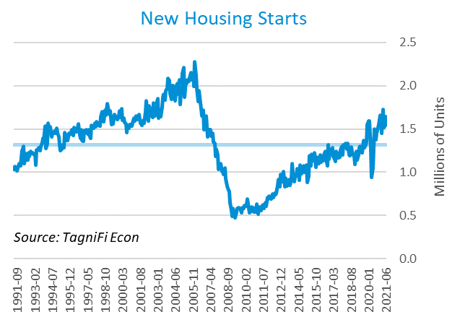

The cost of financing for would-be homebuyers remained near record lows as the 30-year fixed-rate mortgage[21] fell during the quarter to 3.02%.

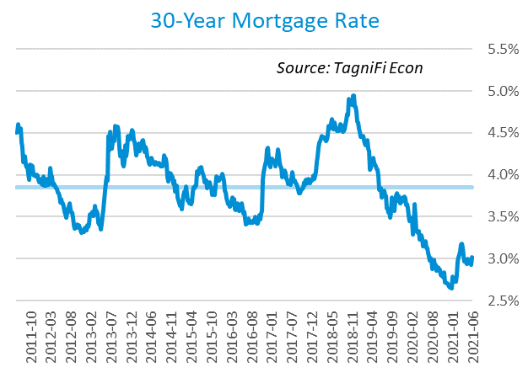

The S&P Case-Shiller Home Price Index (20-city)[22] for May 2021 increased by 17% year-over-year with Phoenix, Seattle, and San Diego continuing to lead the nation in price growth. Record-low mortgage rates and constrained supply continued to push home prices higher, a dynamic seen since the pandemic began.

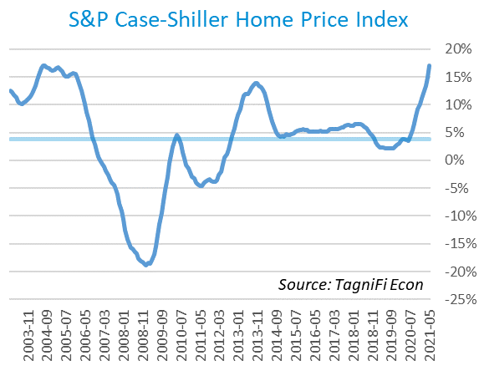

# Consumer Spending

Personal Consumption Expenditures (PCE)[23] soared in Q2, with June setting a record $15.7 trillion. PCE grew 4.4% compared to the previous quarter and 20.7% over the same quarter last year.

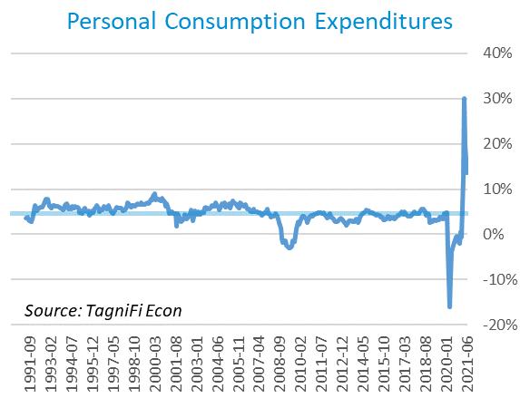

Auto manufacturers reported 15.4 million autos and light trucks sold[24] in June 2021, up 18% year over year but down 13% from the end of the first quarter. Coinciding with falling sales was a nearly 4% jump in new vehicle prices during Q2, driven by inventory and chip shortages, to a record 154.8. Used cars have seen an even greater spike in prices; the relevant index[25] jumped a headline-grabbing 30% in Q2 to another record of 197.23.

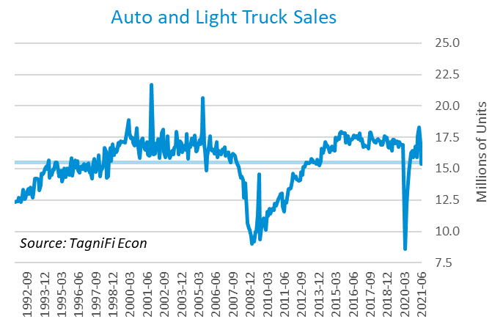

The University of Michigan’s consumer sentiment index[26] ended the 2nd quarter at 85.5, a modest rise from Q1’s 84.9 finish. During the previous 5 years, the index regularly touched 20-year highs around 100 before cratering to a low of 71.8 in April of 2020, still well above the 55.3 low of 2011. The consumer sentiment index has been on a general upward trend since its April 2020 low but is still short of its 30-year average of 87.7.

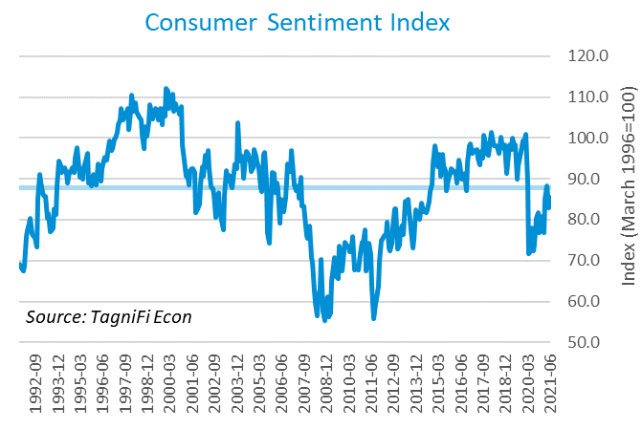

# Capital Markets

The table below shows the quarterly, year-to-date, and 12-month performance of major US equity indices. Capital markets continued their bullish rebound from the March 2020 crash, buoyed by improving sentiment, encouraging economic and vaccine data, and bolstered by aggressive monetary and fiscal policy. The Dow jones Transportation Average had the smallest increase this quarter at 1.7%, while the tech-heavy NASDAQ and S&P 500 Index were the highest performers at 9.5% and 8.2%, respectively.



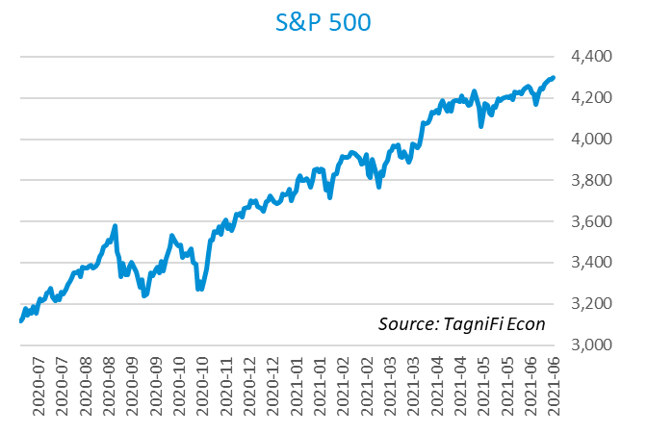

Stock market volatility, as measured by the VIX [27], ended the 2nd quarter at 15.8. It has trended downward over the last 12 months as the market outlook recovered quickly on major government stimulus, improving investor sentiment, and encouraging economic data. This pattern continued, though at a slower rate, in Q2, ending the quarter at a new low since the pandemic began and 18% lower than the end of Q1.

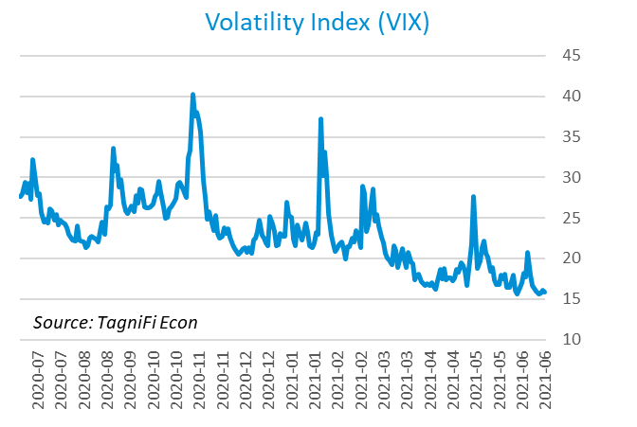

# Outlook

In June 2021, the FOMC revised their inflation and real GDP growth projections upward, while expectations for unemployment remained steady, as did longer run projections for all three indicators.

The FOMC revised their March projection for real GDP[28] to 7.05% growth in 2021, slowing to 2.25% by 2023. They expected Personal Consumption Expenditures (PCE)[29] to grow 3.3% in 2021. They forecast that the unemployment rate[30] will reach to 4.6% in 2021 and 3.5% by 2023. Notably, the board projected at least 2 rate hikes by the end of 2023, likely in response to the quarter’s higher than expected inflation figures.



Appendix – Selected Interest Rates



# About This Report

The *Quarterly Economic Update* is a free publication sponsored by TagniFi. You are free to share this report and include its contents in the economic outlook section of your valuation reports as required by *Revenue Ruling 59-60*. Please forward this free report to a colleague to help us spread the word about TagniFi.

# About TagniFi

In July 2015 we released our first dataset, TagniFi Fundamentals, because we thought investors and finance professionals needed a better solution for financial data. Since then, our mission has remained the same: to serve our clients with the best financial data available at a reasonable price. We do this by developing innovative solutions to leverage tagged financial statements which allow us to deliver better, faster, and more detailed data at a fraction of the cost.

Today TagniFi is a platform of financial data aimed at making our clients more productive and prosperous. We're helping clients in all corners of finance make better decisions with better data. We relentlessly focus on quality and the trust we've earned from our clients is our greatest asset. Our growth is centered around our clients' needs as we look to expand our platform with new data. Referrals from our existing clients is the ultimate compliment so we choose to invest in our product, not flashy marketing campaigns. For more information on TagniFi, please visit [www.tagnifi.com](http://www.tagnifi.com).

How TagniFi Helps Business Valuation Teams

TagniFi’s financial data platform empowers business valuation teams to quickly and easily build highly accurate financial models with full transparency—and within seconds.

**Better Public Comps**  
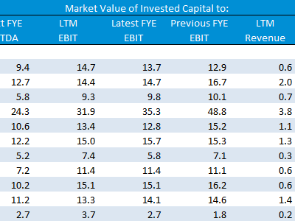Search for public companies with TagniFi Web. Simply enter your valuation date and ticker symbols in Excel to run a guideline public company method. Your Excel model populates instantly with the financial statements, analyst estimates, interest rates and economic data for your valuation date.

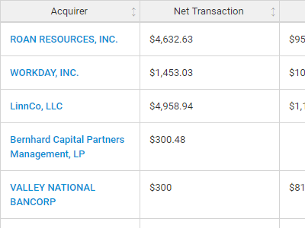**Better Transaction Comps**  
Search for public and private M&A transactions with TagniFi Web. Run your transaction comps within seconds by pasting the Deal ID into your Excel model. Every deal disclosed in an SEC filing (8-K, 10-K, or 10-Q) is available for your analysis. Choose from over 90 fields of data available for every deal.

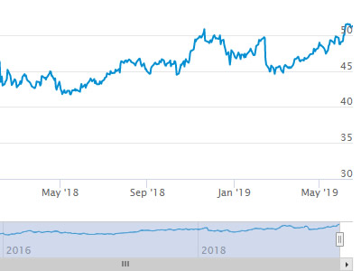

**Historical Beta and Volatility**Calculate historical beta and volatility as of your valuation date automatically. Simply enter the tickers and valuation date in Excel - TagniFi does the rest. In addition to beta and volatility, there are over 40 Excel models available in the Model Library to help with your valuation report.

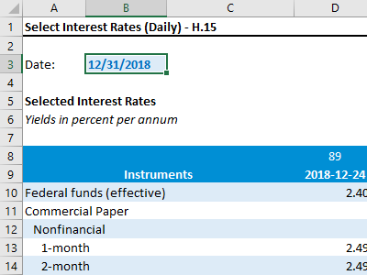**Interest Rates and Economic Data**Automate the interest rates and economic data in your valuation report using the TagniFi Excel plugin. Choose from over 200,000 time series available. All data in this *Quarterly Economic Update* is from the TagniFi platform. Use economic and interest rate data for your own valuation models with the TagniFi Excel plugin.

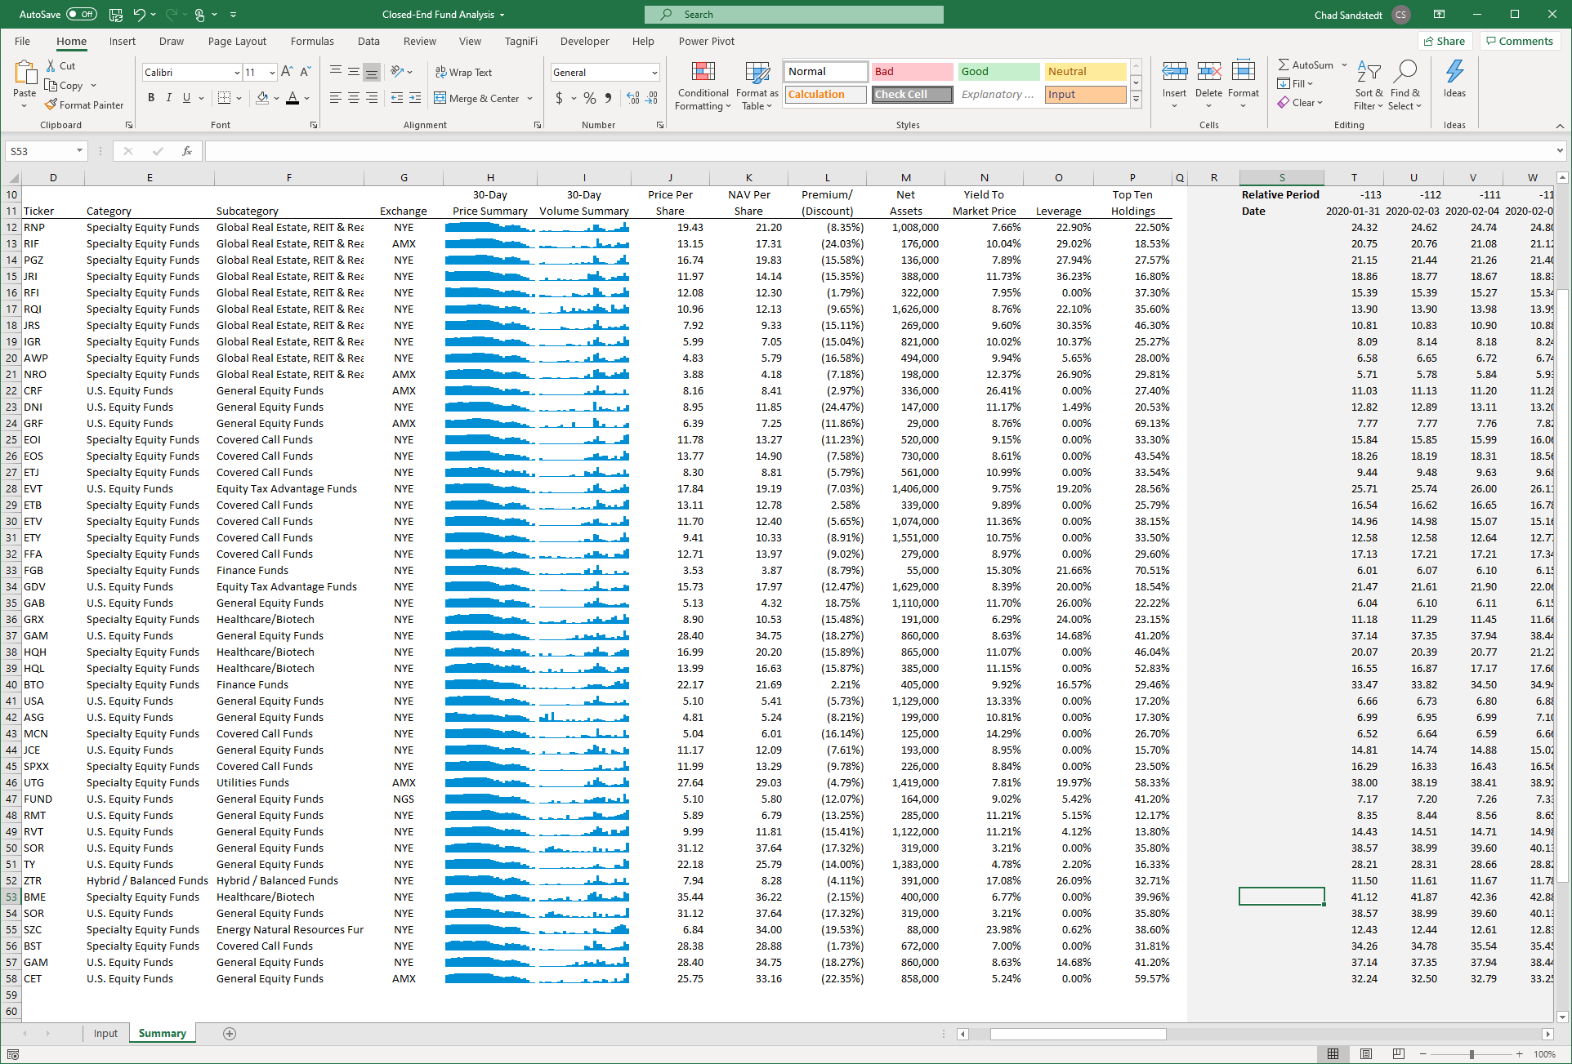

**Closed-End Mutual Fund Data**Search for closed-end mutual funds by keyword, category, subcategory, and more with the TagniFi Console. Use the TagniFi Excel plugin to calculate historical discounts, yields, leverage, as of your valuation date automatically. Simply enter the tickers and valuation date in Excel - TagniFi does the rest.

1. *Federal Reserve Bank of Philadelphia, Coincident Economic Activity Index for the United States [USPHCI], retrieved from FRED, Federal Reserve Bank of St. Louis;* [*https://fred.stlouisfed.org/series/USPHCI*](https://fred.stlouisfed.org/series/USPHCI)*, Jul 30, 2021.*
2. *Board of Governors of the Federal Reserve System (US), Trade Weighted U.S. Dollar Index: Broad, Goods and Services [DTWEXBGS], retrieved from FRED, Federal Reserve Bank of St. Louis;* [*https://fred.stlouisfed.org/series/DTWEXBGS*](https://fred.stlouisfed.org/series/DTWEXBGS)*, Jul 30, 2021.*
3. U.S. Bureau of Economic Analysis, Real Gross Domestic Product [GDPC1], *retrieved from FRED, Federal Reserve Bank of St. Louis;*[*https://fred.stlouisfed.org/series/GDPC1*](https://fred.stlouisfed.org/series/GDPC1)*, Jul 30, 2021.*
4. Board of Governors of the Federal Reserve System (US), Industrial Production Index [INDPRO], *retrieved from FRED, Federal Reserve Bank of St. Louis;*[*https://fred.stlouisfed.org/series/INDPRO*](https://fred.stlouisfed.org/series/INDPRO)*, Jul 30, 2021.*
5. Board of Governors of the Federal Reserve System (US), Capacity Utilization, Manufacturing (NAICS), retrieved from FRED, Federal Reserve Bank of St. Louis; <https://fred.stlouisfed.org/series/MCUMFN>, Jul 30, 2021
6. *Board of Governors of the Federal Reserve System (US), Effective Federal Funds Rate [FEDFUNDS], retrieved from FRED, Federal Reserve Bank of St. Louis;*[*https://fred.stlouisfed.org/series/FEDFUNDS*](https://fred.stlouisfed.org/series/FEDFUNDS)*, Jul 30, 2021.*
7. Board of Governors of the Federal Reserve System (US), 10-Year Treasury Constant Maturity Rate [DGS10], *retrieved from FRED, Federal Reserve Bank of St. Louis;*[*https://fred.stlouisfed.org/series/DGS10*](https://fred.stlouisfed.org/series/DGS10)*, Jul 30, 2021.*
8. Moody’s, Moody’s Seasoned Baa Corporate Bond Yield [BAAS], *retrieved from FRED, Federal Reserve Bank of St. Louis;*[*https://fred.stlouisfed.org/series/BAA*](https://fred.stlouisfed.org/series/BAA)*, Jul 30, 2021.*
9. U.S. Bureau of Labor Statistics, Civilian Unemployment Rate [UNRATE], *retrieved from FRED, Federal Reserve Bank of St. Louis;*[*https://fred.stlouisfed.org/series/UNRATE*](https://fred.stlouisfed.org/series/UNRATE)*, Jul 30, 2021.*
10. Federal Reserve Bank of Philadelphia, Livingston Survey, [*https://www.philadelphiafed.org/surveys-and-data/real-time-data-research/livingston-survey*](https://www.philadelphiafed.org/surveys-and-data/real-time-data-research/livingston-survey)*, Jul 30, 2021.*
11. U.S. Bureau of Labor Statistics Total Unemployed, Plus All Persons Marginally Attached to the Labor Force, Plus Total Employed Part Time for Economic Reasons, as a Percent of the Civilian Labor Force Plus All Persons Marginally Attached to the Labor Force (U-6) [U6RATE], *retrieved from FRED, Federal Reserve Bank of St. Louis;*[*https://fred.stlouisfed.org/series/U6RATE*](https://fred.stlouisfed.org/series/U6RATE)*, Jul 30, 2021.*
12. U.S. Bureau of Labor Statistics, All Employees: Total Nonfarm Payrolls [PAYEMS], *retrieved from FRED, Federal Reserve Bank of St. Louis;*[*https://fred.stlouisfed.org/series/PAYEMS*](https://fred.stlouisfed.org/series/PAYEMS)*, Jul 30, 2021.*
13. U.S. Bureau of Labor Statistics, Consumer Price Index for All Urban Consumers: All Items [CPIAUCSL], *retrieved from FRED, Federal Reserve Bank of St. Louis;*[*https://fred.stlouisfed.org/series/CPIAUCSL*](https://fred.stlouisfed.org/series/CPIAUCSL)*, Jul 30, 2021.*
14. U.S. Bureau of Labor Statistics, Producer Price Index for All Commodities [PPIACO], *retrieved from FRED, Federal Reserve Bank of St. Louis;*[*https://fred.stlouisfed.org/series/PPIACO*](https://fred.stlouisfed.org/series/PPIACO)*, July 30, 2021.*
15. *Federal Reserve Bank of St. Louis, 5-Year Breakeven Inflation Rate [T5YIE], retrieved from FRED, Federal Reserve Bank of St. Louis;*[*https://fred.stlouisfed.org/series/T5YIE*](https://fred.stlouisfed.org/series/T5YIE)*, Jul 30, 2021.*
16. *U.S. Energy Information Administration, Crude Oil Prices: West Texas Intermediate (WTI) – Cushing, Oklahoma [MCOILWTICO], retrieved from FRED, Federal Reserve Bank of St. Louis;*[*https://fred.stlouisfed.org/series/MCOILWTICO*](https://fred.stlouisfed.org/series/MCOILWTICO)*, Jul 30, 2021.*
17. *International Monetary Fund, Global Price of Copper [PCOPPUSDM], retrieved from FRED, Federal Reserve Bank of St. Louis;*[*https://fred.stlouisfed.org/series/PCOPPUSDM*](https://fred.stlouisfed.org/series/PCOPPUSDM)*, Jul 30, 2021.*
18. *International Monetary Fund, Global Price of Iron Ore [PIORECRUSDM], retrieved from FRED, Federal Reserve Bank of St. Louis;*[*https://fred.stlouisfed.org/series/PIORECRUSDM*](https://fred.stlouisfed.org/series/PIORECRUSDM)*, Jul 30, 2021.*
19. *International Monetary Fund, Global Price of Corn [PMAIZMTUSDM], retrieved from FRED, Federal Reserve Bank of St. Louis;*[*https://fred.stlouisfed.org/series/PMAIZMTUSDM*](https://fred.stlouisfed.org/series/PMAIZMTUSDM)*, Jul 30, 2021.*
20. U.S. Bureau of the Census, Housing Starts: Total: New Privately Owned Housing Units Started [HOUST], *retrieved from FRED, Federal Reserve Bank of St. Louis;*[*https://fred.stlouisfed.org/series/HOUST*](https://fred.stlouisfed.org/series/HOUST)*, Jul 30, 2021.*
21. Freddie Mac, 30-Year Fixed Rate Mortgage Average in the United States [MORTGAGE30US], *retrieved from FRED, Federal Reserve Bank of St. Louis;*[*https://fred.stlouisfed.org/series/MORTGAGE30US*](https://fred.stlouisfed.org/series/MORTGAGE30US)*, Jul 30, 2021.*
22. S&P Down Jones Indices LLC, S&P/Case-Shiller 20-City Composite Home Price Index [SPCS20RSA], *retrieved from FRED, Federal Reserve Bank of St. Louis;*[*https://fred.stlouisfed.org/series/SPCS20RSA*](https://fred.stlouisfed.org/series/SPCS20RSA)*, Jul 30, 2021.*
23. U.S. Bureau of Economic Analysis, Personal Consumption Expenditures [PCE], *retrieved from FRED, Federal Reserve Bank of St. Louis;*[*https://fred.stlouisfed.org/series/PCE*](https://fred.stlouisfed.org/series/PCE)*, Jul 30, 2021.*
24. U.S. Bureau of Economic Analysis, Light Weight Vehicle Sales: Autos and Light Trucks [ALTSALES], *retrieved from FRED, Federal Reserve Bank of St. Louis; <https://fred.stlouisfed.org/series/ALTSALES>, Jul 30, 2021.*
25. U.S. Bureau of Labor Statistics, Consumer Price Index for All Urban Consumers: Used Cars and Trucks in U.S. City Average [CUSR0000SETA02], retrieved from FRED, Federal Reserve Bank of St. Louis; <https://fred.stlouisfed.org/series/CUSR0000SETA02>, *Jul 30, 2021.*
26. *University of Michigan, University of Michigan: Consumer Sentiment [UMCSENT], retrieved from FRED, Federal Reserve Bank of St. Louis;* [*https://fred.stlouisfed.org/series/UMCSENT*](https://fred.stlouisfed.org/series/UMCSENT)*, Jul 30, 2021.*
27. *Chicago Board Options Exchange, CBOE Volatility Index: VIX [VIXCLS], retrieved from FRED, Federal Reserve Bank of St. Louis;* [*https://fred.stlouisfed.org/series/VIXCLS*](https://fred.stlouisfed.org/series/VIXCLS)*, Jul 30, 2021.*
28. *Federal Reserve Bank of St. Louis, FOMC Summary of Economic Projections for the Growth Rate of Real Gross Domestic Product [GDPC1CTM], retrieved from FRED, Federal Reserve Bank of St. Louis;*[*https://fred.stlouisfed.org/series/GDPC1CTM*](https://fred.stlouisfed.org/series/GDPC1CTM)*, Jul 30, 2021.*
29. *Federal Reserve Bank of St. Louis, FOMC Summary of Economic Projections for the Personal Consumption Expenditures Inflation Rate, Central Tendency, Midpoint [PCECTPICTM], retrieved from FRED, Federal Reserve Bank of St. Louis;*[*https://fred.stlouisfed.org/series/PCECTPICTM*](https://fred.stlouisfed.org/series/PCECTPICTM)*, Jul 30, 2021.*
30. *Federal Reserve Bank of St. Louis, FOMC Summary of Economic Projections for the Civilian Unemployment Rate, Central Tendency, Midpoint [UNRATECTM], retrieved from FRED, Federal Reserve Bank of St. Louis;*[*https://fred.stlouisfed.org/series/UNRATECTM*](https://fred.stlouisfed.org/series/UNRATECTM)*, Jul 30, 2021.*