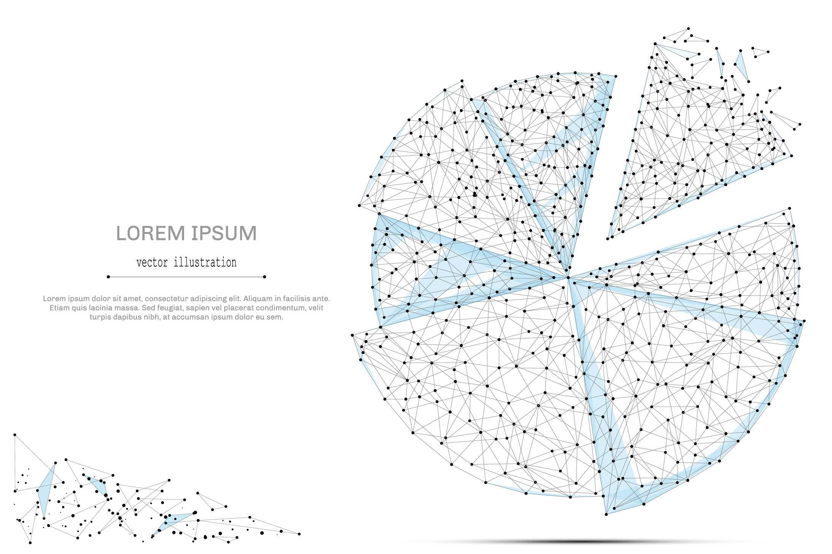

QUARTERLY ECONOMIC UPDATE

For the 3rd Quarter of 2021

Abstract

Designed for business valuation professionals, TagniFi’s Quarterly Economic   
Update provides timely economic data to satisfy Revenue Ruling 56-60.

# Summary

In the 3rd quarter of 2021, the U.S.’s dogged economic recuperation from the COVID-19 pandemic pushed up against constraints in supply and labor, inflationary pressures, and the specter of waning monetary policy supports. The American economy eked out gains in production despite the pandemic’s ongoing upheaval to global supply chains and labor markets.

Supply chains across the globe continue to face complex challenges in both production and shipment. Worker shortages represent a particular challenge to supply, affecting availability of parts as well as movement of both inputs and final demand goods by truck and at bottlenecked U.S. ports. Although the unemployment rate dropped low enough to put the U.S. economy technically at full employment, labor market participation remained depressed through September. Notably, the labor market participation rate inched down in September despite the end of federal programs that augmented unemployment compensation benefits, hinting that there may be more complex reasons holding workers back.

Balancing a robust economic recovery with stubborn inflationary pressures continues to be a main challenge for the U.S. Several consecutive months of elevated inflation prompted the Fed to tighten the predicted timeline for winding down their aggressive expansionary monetary policy. The Fed indicated they may begin selling off government securities as soon as the 4th quarter of 2021 and raising target interest rates as soon as 2022.

As the U.S. economy continued to battle forward during the 3rd quarter, the spread of the Delta variant fueled a brutal fourth wave of the COVID-19 pandemic. By the end of the quarter, COVID-19 had killed more than 1 in 500 Americans and surpassed the 1918 Spanish Flu to become the deadliest pandemic in United States history.

Below is a summary timeline of key COVID-19 events in the U.S. during the 3rd quarter of 2021:

|  |  |
| --- | --- |
| July 1, 2021 | US begins the quarter at 18,949 daily cases, 229 daily deaths (7-day moving average). 47% of Americans are fully vaccinated. |
| July 3, 2021 | Delta variant becomes dominant strain in US according to CDC 2-week estimates |
| July 27, 2021 | CDC recommends indoor masking for fully vaccinated individuals in areas with substantial community spread of COVID-19 |
| July 30, 2021 | Half of all US citizens are fully vaccinated |
| August 2, 2021 | US reaches President Biden’s goal of 70% of adults receiving at least 1 dose of COVID-19 vaccine |
| August 18, 2021 | CDC announces plans for COVID-19 booster shots |
| August 23, 2021 | FDA extends full approval to Pfizer-BioNTech COVID-19 vaccine |
| August 31, 2021 | Fourth wave of COVID-19 in US peaks at 161,665 daily cases (7-day moving average) |
| September 4, 2021 | US reaches 40 million total COVID-19 cases |
| September 6, 2021 | CARES Act unemployment benefits expire |
| September 9, 2021 | 1 in 500 Americans have died from COVID-19 |
| September 15, 2021 | COVID-19 becomes deadliest pandemic in US history, having killed more than 675,000 Americans |
| September 15, 2021 | Deaths from fourth wave of COVID-19 in US peak at 1,854 daily (7-day moving average) |
| September 29, 2021 | US reaches 700,000 total deaths from COVID-19 |
| September 30, 2021 | US ends the quarter at 107,444 daily cases, 1,720 daily deaths (7-day moving average) 56% of Americans are fully vaccinated. |

The more contagious Delta variant became the dominant strain in the U.S. in early July and cases began their dramatic resurgence, subverting continued progress in vaccination efforts. By the time Americans reached President Biden’s well-advertised goal of 70% of adults receiving at least one dose, the country was fully in the throes of another COVID-19 wave. By the end of the 3rd quarter, 700,000 Americans had died of COVID-19. An average of 1,720 died daily, with unvaccinated individuals 11 times more likely to join their ranks.

The fourth wave of COVID-19 cases in the U.S. began to recede in September, just as booster shots were becoming available to already-vaccinated Americans. Broadening vaccination efforts still appear to be the most viable way to mitigate further damage to public health and the economy, yet by October, far more Americans were receiving booster shots than initial doses.

Rather than logistics or supply, the limiting factor in vaccinating Americans is an unwillingness of a large part of the population to receive the shot. The amount of public health and economic damage that the resurgence of COVID-19 cases can inflict on the U.S. will continue to be directly related to the rate of vaccination.

A multifactor indicator of economic strength, the Philadelphia Fed’s coincident index[1] of economic activity in the U.S. rose 0.4% in September 2021 and 1.6% during the 3rd quarter. For the quarter, coincident indexes increased in 48 states, decreased in 1, and remained stable in 1. Coincident indexes reflect unemployment, payroll employment, manufacturing hours, and wages and salaries. Unemployment, a major factor in the index, fell 0.4 percentage points over the quarter, yet the unemployment rate and the number of unemployed people remain 1.3 percentage points and 2.0 million higher, respectively, since February 2020.



The U.S. dollar index for goods and services[2] rose 1.90% during the 3rd quarter of 2021 but remained 2.01% lower than in September of 2020. The dollar climbed throughout the 3rd quarter to its highest level of 2021. The advancement reflected swelling treasury yields as investors anticipated the waning of the Fed’s aggressive monetary supports.

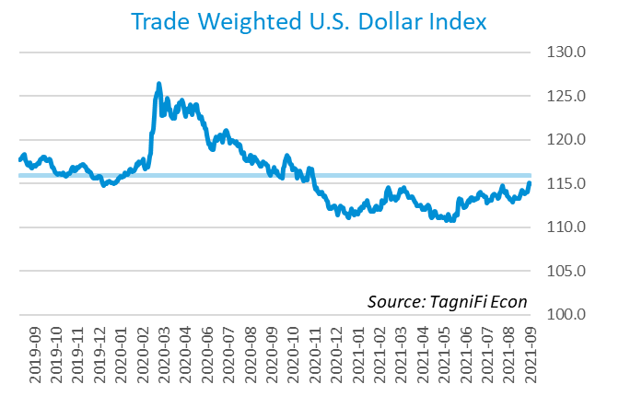

# Q3 Economic Highlights

* Real GDP for the 3rd quarter of 2021 grew at an annual rate of 2.0%, further building on the previous quarter’s all-time high.
* The U.S. dollar index rose 1.90% during the quarter and fell 1.94% from last year.
* After rising slightly to start the 3rd quarter, the effective federal funds rate steadily inched back down to end the quarter at 0.08%, near its all-time low.
* Short-term bond yields changed little during the quarter, and long-term yields rose slightly. The benchmark 10-year treasury yielded 1.52% annually at the end of the quarter, while the 30-year treasury yielded 2.08%.
* Unemployment fell to 4.8% in September, and nonfarm payroll employment grew by 1.7 million jobs during the 3rd quarter.
* The Consumer Price Index rose 5.4% year-over-year in September, a more than 12-year high. Excluding volatile energy prices, the index rose 4.1%.
* Oil prices fluctuated during the 3rd quarter, ending at $71.65 per barrel, 0.4% higher than one quarter earlier.
* New housing starts were down 6.2% over the quarter but 7.4% higher than last year.
* U.S. capital markets experienced mixed results in the 3rd quarter, as the VIX jumped. The Dow Jones Industrial Average posted a strong growth of 7.6% during the quarter while the Dow Jones Transportation and Composite Indexes declined 5.9% and 2.8%, respectively.

# Business Activity

According to the Bureau of Economic Analysis (BEA), real gross domestic product (GDP)[3] for the 3rd quarter of 2021 grew at an annualized rate of 2.0%, well below the 2nd quarter’s 6.7%. The 3rd quarter built on a year’s worth of prior gains to push real GDP to record levels for the second consecutive quarter.

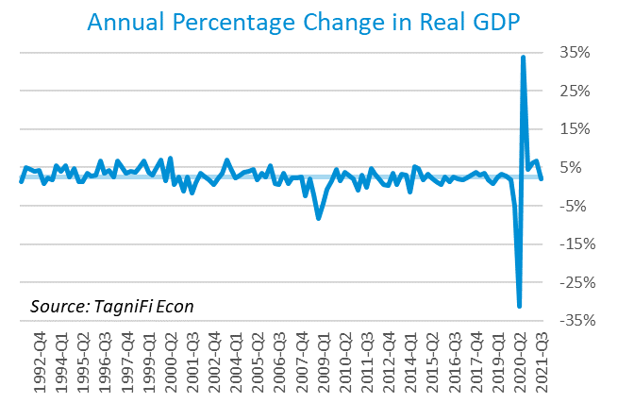

The leading contributor was gross domestic private investment[4], boosting the overall figure by 2.0%. Private investment climbed in nonfarm inventories as well as in intellectual property products such as software and research & development.

Personal consumption expenditures[5] (PCE) contributed 1.1% of the growth in real GDP in the 3rd quarter, as broad increases in household services consumption more than offset a drop in spending for goods, especially motor vehicles and parts. Underlying the drop in automobile sales in the 3rd quarter were ongoing inventory shortages due to disruptions in the supply chain for semiconductor chips used in automobile manufacturing.

Government expenditures[6] also increased, contributing 0.1% to the real GDP gain. State and local government consumption more than made up for a drop in federal consumption—a result of funding reallocation driven by the American Rescue Plan earlier in the year.

Net exports[7] continued to constrain real GDP growth with a negative effect of 1.4%. Global supply chains remain bottlenecked by worker and parts shortages, along with crippling shipment issues such as border restrictions, lack of trucking personnel, and backups at U.S. ports. Rebounding U.S. demand and the deepening supply crisis continue to place upward pressure on the trade deficit and domestic inflation.

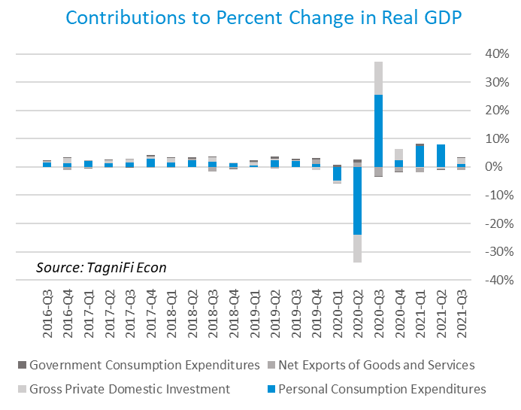

The Industrial Production Index[8] is an economic indicator that measures real output for all facilities located in the United States manufacturing, mining, and electric, and gas utilities. The index stood at 100.0 at the end of the 3rd quarter, down 0.41% since the previous quarter.

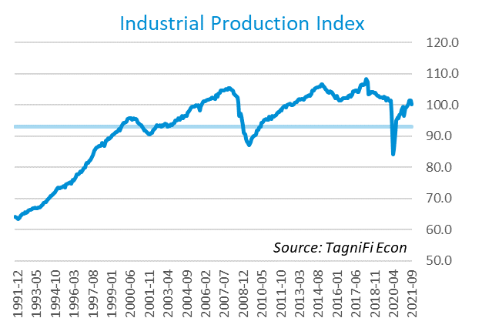

The Capacity Utilization Index[9], which attempts to capture industrial output as a percentage of the economy’s maximum production capacity, increased to 76.2%, slowing as it approaches the pre-pandemic level of 76.5%. The 10-year high for the metric was 78.4% in August of 2018.

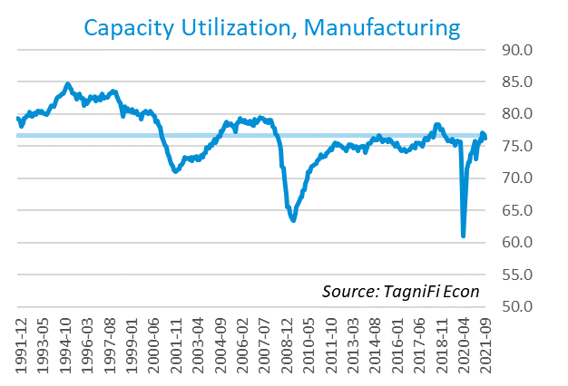

# Interest Rates

After rising slightly to start the 3rd quarter, the effective federal funds rate[10] steadily inched back down to end the quarter at 0.08%, near its all-time low. Short-term treasury bond yields[11] were little changed during the 3rd quarter. Long-term treasury yields fell early in the quarter amid fears of rising inflation and rapidly spreading COVID-19 variants, then rebounded on speculation of Federal Reserve action to fight inflation. The 1-year and 2-year annual treasury yields ended the 3rd quarter at 0.09% and 0.28%, respectively. The benchmark 10-year treasury yielded 1.52% annually at the end of the quarter, while the 30-year treasury yielded 2.08%. See *Appendix – Selected Interest Rates* for detailed interest rate data.

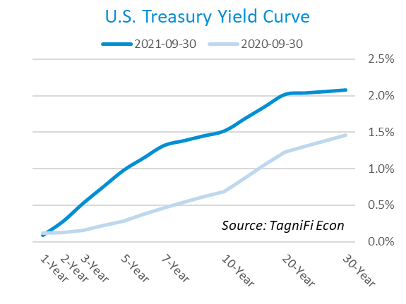

In the 3rd quarter of 2021, the Federal Reserve continued to keep the federal funds target rate steady at a range of 0.00 to 0.25 percent but foreshadowed that it would act on plans to increase rates in 2022 and begin phasing down its aggressive bond-buying program before the end of 2021. The effective federal funds rate[12] at the end of the 3rd quarter was 0.08, similar to recent quarters.

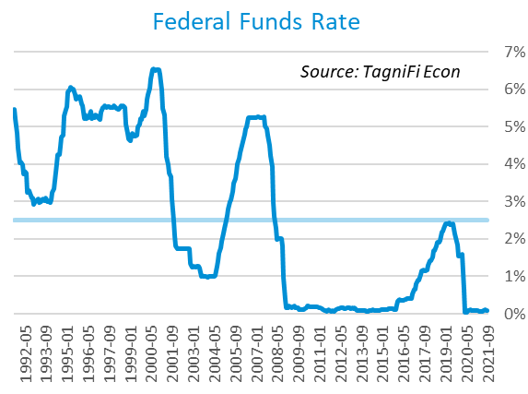

The yield on the benchmark 10-year U.S. treasury[13] rose 7 basis points during the 3rd quarter to 1.52%, well below the average yield of 4.09% over the last 30 years.

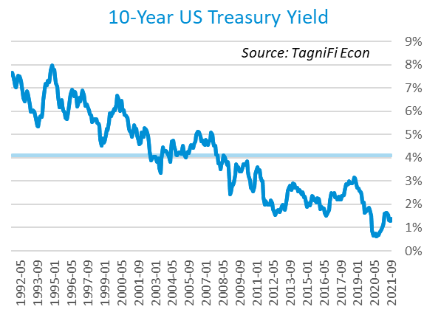

Moody’s Baa Corporate Bond Yield Index[14] ended the 3rd quarter at 3.37%, up slightly from its 2nd-quarter level of 3.32%. Moody’s Aaa[15] Index similarly edged up to end the quarter at 2.70%, compared to 2.63% in the previous quarter.

Starting in March of 2020, the Federal Reserve took the unprecedented measure of building a portfolio of corporate bonds, effectively backstopping the corporate bond market. Shortly after doing so, the riskier Baa index reversed its yield spike and began to fall lower. The move was less dramatic for Aaa, but both markets were affected directly by the Fed’s $13 billion portfolio, as well as by its expansionary operations in 2020. The Fed announced in September 2021 that its widely anticipated gradual sell-off of its bond holdings could begin by December, which could put temporary upward pressure on yields, especially for the riskier Baa index.

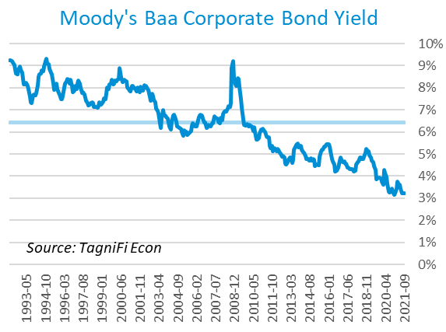

# Employment

The official unemployment rate[16] fell to 4.8% in September 2021, dipping below the level at which the economy is considered to be at full employment for the first time since the COVID-19 pandemic began. However, the labor force[17] remained 3.1 million workers smaller since February 2020, with a labor force participation rate[18] of just 61.6 percent. Prior to the COVID-19 pandemic, the last time labor force participation was that low in the U.S. was January 1977. The rate remained below its 30-year average of 5.9% throughout the 3rd quarter. Economists polled by the Livingston Survey[19] projected in June projected that unemployment would fall to 4.7% by December 2021 and continue declining to 4.4% in June of 2022.

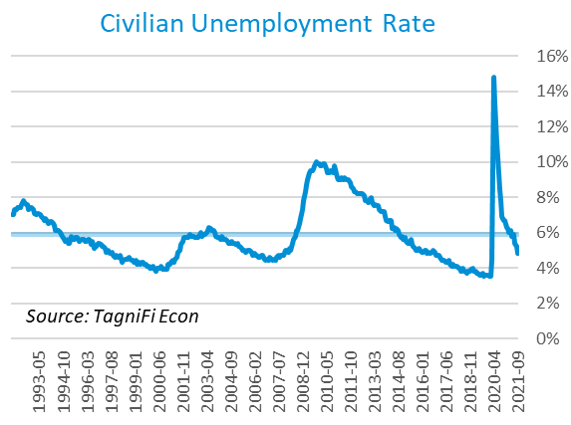

The U-6 unemployment rate[20] is an alternative measure of unemployment with a broader definition, including such groups as discouraged workers who are not actively searching for jobs but want full-time work and part-time workers who want full-time work. The U‑6 unemployment rate has generally followed the same pattern as the official rate; it fell to 8.5% in September 2021, its lowest level since February 2020, prior to the onset of the COVID-19 pandemic.

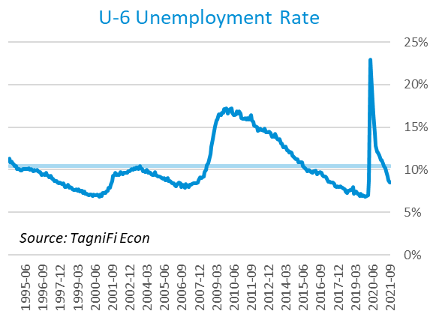

Nonfarm payrolls[21] grew by 1.7 million jobs in the 3rd quarter, although the job gains slowed later in the quarter. US nonfarm payrolls in September 2021 totaled 147.6, up 5.7 million compared to the same period last year, yet still 5.0 million jobs below their pre-pandemic (February 2020) levels.

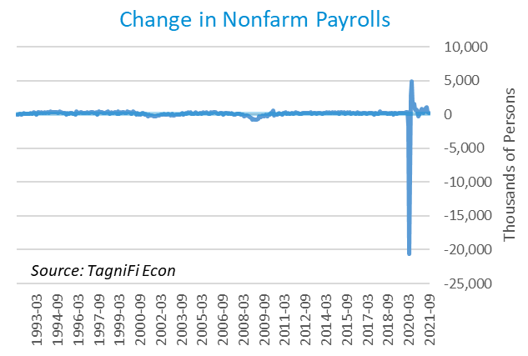

# Inflation

After many tame years, inflation is squarely back on the minds of consumers and market watchers. The Consumer Price Index[22] rose 5.4% year-over-year in September, its fastest growth in more than 12 years. Excluding volatile energy prices, the index rose 4.1%. Notably, the price of a gallon of gas[23] increased 49% from a national average of $2.19 in September 2020 to $3.27 in September 2021. The Federal Reserve, which has so far treated rising prices as temporary effects of supply chain issues, indicated that it would likely begin to withdraw economic supports in the coming months in an effort to counteract the persistent inflation affecting markets for necessities such as housing, food, and fuel.

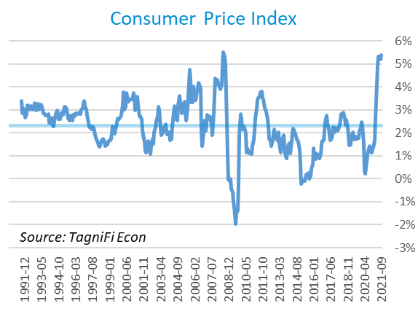

The Producer Price Index[24] rose 1.1% over the month and 3.0% since June. The PPI was 20.4% higher in September than one year prior, the highest annual gain since December 1974 and well above the 2.2% average annual increase over the last 30 years.

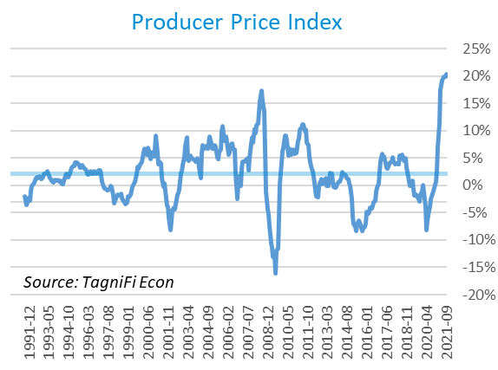

Treasury Inflation-Protected Securities (TIPS) are a longer-term Treasury debt instrument which pays a fixed interest rate but adjusts the principal value according to inflation, effectively indexing interest payments to inflation. TIPS have continued to sell at a premium, reflecting higher inflation expectations for the future; however, rising supply and falling demand are expected once the Fed moves to combat inflation through bond selloffs. The 5-year breakeven inflation rate[25], an indicator for the market’s inflation expectations for the period, changed little over the 3rd quarter, ending September at 2.51%, slightly higher than June’s 2.47% rate.

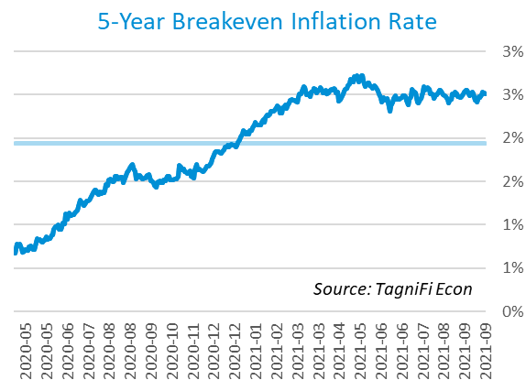

U.S. crude oil[26] prices fluctuated in the 3rd quarter after peaking in July at their highest value since November 2014. Hurricane Ida restricted refining capacity in the gulf even as the spread of the Delta variant of COVID-19 caused demand to falter anew. Crude prices ended the period at $75.22 per barrel, 2.3% higher than one quarter earlier.

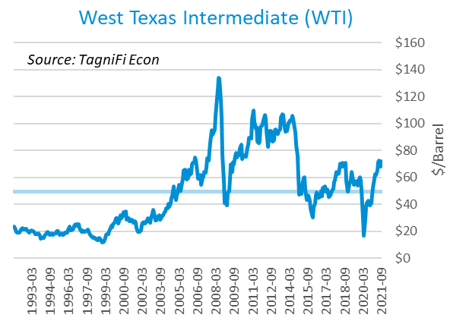

# Housing

The housing market showed the first small signs of vulnerability since the pandemic sent demand soaring amid tight supply. New home starts[27] numbered 1.55 million in September, down 6.2% over the quarter as building material and construction labor shortages constrained the growth needed to meet demand. While lumber futures have toppled from their 2nd-quarter peak, costs for homebuilders are still elevated and the labor shortage is expected to endure. Still, housing starts were 7.4% higher than last year and well above their 30-year average of 1.32 million.

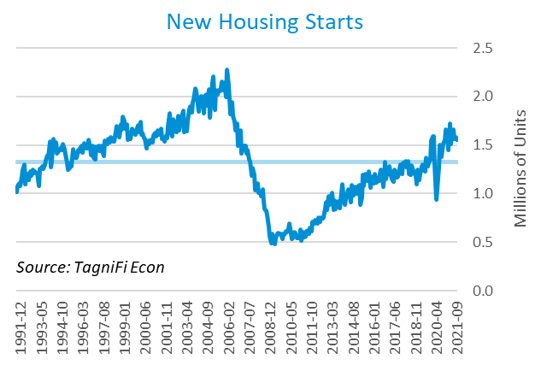

The cost of financing for would-be homebuyers remained near record lows in the 3rd quarter as the 30-year fixed-rate mortgage[28] slipped to 3.01%.

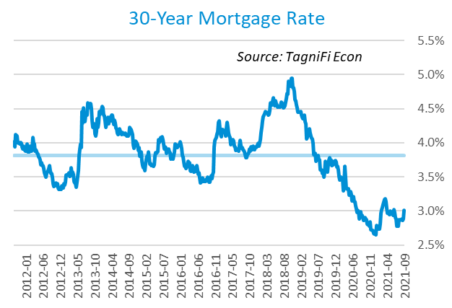

The S&P Case-Shiller Home Price Index (20-city)[29] for August 2021 rose 19.7% since the previous August with all 20 cities reporting price increases, led by Phoenix, San Diego, and Tampa. Record-low mortgage rates and constrained supply continued to push home prices higher, a dynamic seen since the pandemic began. However, the year-over-year gain in August slightly lagged that of the prior month for the first time since June 2020, hinting that skyrocketing housing prices could be finally starting to cool.

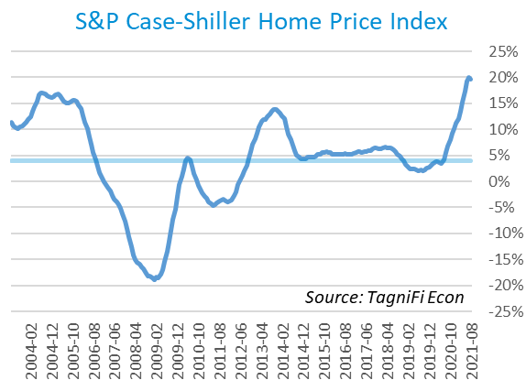

# Consumer Spending

Personal Consumption Expenditures (PCE)[30] rose 1.6% in the 3rd quarter to $16.1 trillion. PCE 11.6% since the 3rd quarter last year. Spending on services grew on broad increases in household services consumption, more than offsetting a drop in spending for goods, especially motor vehicles and parts.

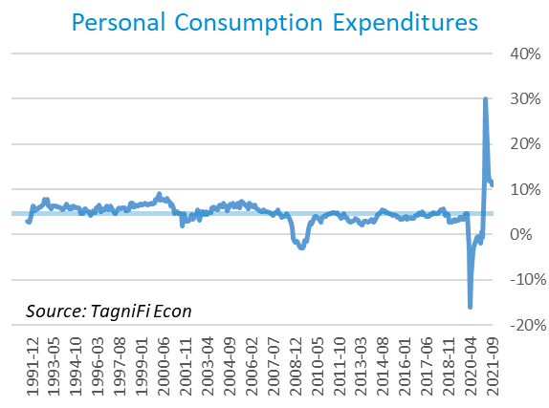

Auto manufacturers reported 12.2 million autos and light trucks sold[31] in September 2021, down 21.4% from June, the steepest quarterly drop in sales since the 1st quarter 2020. Ongoing semiconductor chip shortages inventory pushed inventories to record lows and continued to boost new vehicle prices[32], which in September stood at an all-time high after rising 3.4% during the 3rd quarter. Used car prices[33] remained elevated after hitting their record high in July 2021.

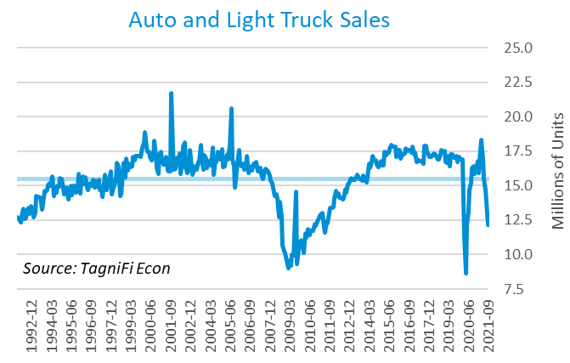

The University of Michigan’s consumer sentiment index[34] ended the 3rd quarter at 72.8, after crashing in August to 70.3, below even the initial trough of the pandemic and its lowest level in nearly 10 years. A grim fourth wave of COVID-19 cases, rising inflation, and the waning effect of federal relief set the stage for cooling consumer sentiment. The index remains well above its previous nadir of 55.8 in August 2011 but far short of its 30-year average of 87.6.

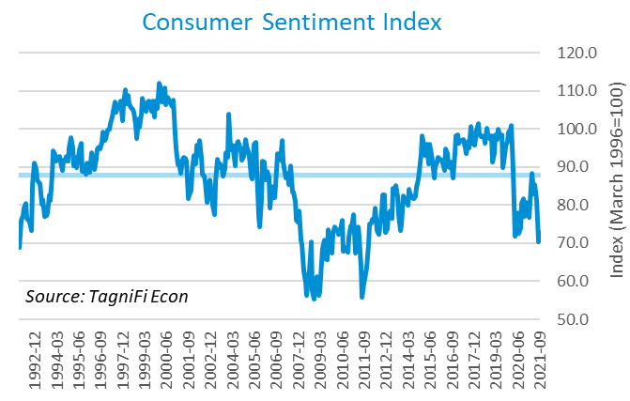

# Capital Markets

The table below shows the quarterly, year-to-date, and 12-month performance of major US equity indices. After several months of bullish conditions, capital markets ended the 3rd quarter on a low note on concerns over inflation and the impending drawdown of the Fed’s pandemic-era equity buying program. The Dow Jones Industrial Average slid 1.9% during the quarter and the Dow Jones Transportation and Composite Indexes declined 5.9% and 2.8%, respectively. Other market indices ended the quarter with little change.



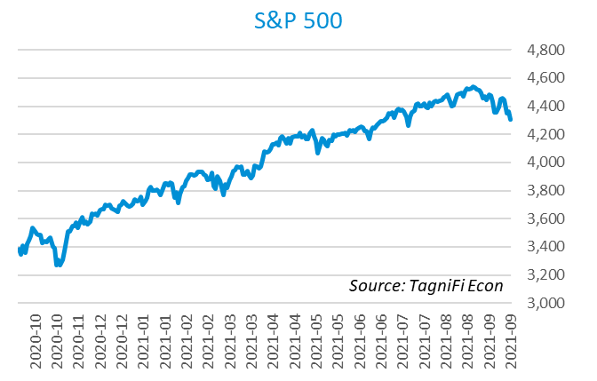

Stock market volatility, as measured by the VIX [35], ended the 3rd quarter at 23.1, up 46.2% since the prior quarter. After a quiet summer, the index jumped in September amid speculation over monetary policy reversal, Washington negotiations on the debt ceiling, and potential tax increases including a tax on unrealized capital gains.

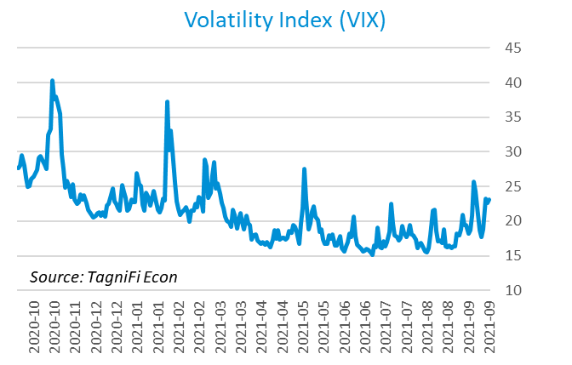

# Outlook

In September 2021, the FOMC revised their core inflation and unemployment rate projections upward, while expectations for real GDP softened. Longer run projections for all three indicators held relatively steady.

The FOMC revised their projection for real GDP[36] to 5.90% growth in 2021, slowing to 2.10% by 2024. They expected Personal Consumption Expenditures (PCE)[37] to grow 4.15% in 2021. They forecast that the unemployment rate[38] will reach to 4.70% in 2021 and 3.45% by 2024. Notably, the board projected interest rate hikes each year through 2024, likely in response to the continued elevation in inflation figures.



Appendix – Selected Interest Rates



# About This Report

The *Quarterly Economic Update* is a free publication sponsored by TagniFi. You are free to share this report and include its contents in the economic outlook section of your valuation reports as required by *Revenue Ruling 59-60*. Please forward this free report to a colleague to help us spread the word about TagniFi.

# About TagniFi

In July 2015 we released our first dataset, TagniFi Fundamentals, because we thought investors and finance professionals needed a better solution for financial data. Since then, our mission has remained the same: to serve our clients with the best financial data available at a reasonable price. We do this by developing innovative solutions to leverage tagged financial statements which allow us to deliver better, faster, and more detailed data at a fraction of the cost.

Today TagniFi is a platform of financial data aimed at making our clients more productive and prosperous. We're helping clients in all corners of finance make better decisions with better data. We relentlessly focus on quality and the trust we've earned from our clients is our greatest asset. Our growth is centered around our clients' needs as we look to expand our platform with new data. Referrals from our existing clients is the ultimate compliment so we choose to invest in our product, not flashy marketing campaigns. For more information on TagniFi, please visit [www.tagnifi.com](http://www.tagnifi.com).

How TagniFi Helps Business Valuation Teams

TagniFi’s financial data platform empowers business valuation teams to quickly and easily build highly accurate financial models with full transparency—and within seconds.

**Better Public Comps**  
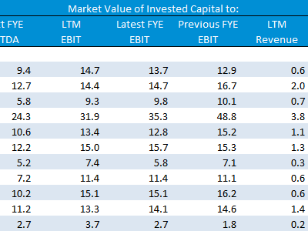Search for public companies with TagniFi Web. Simply enter your valuation date and ticker symbols in Excel to run a guideline public company method. Your Excel model populates instantly with the financial statements, analyst estimates, interest rates and economic data for your valuation date.

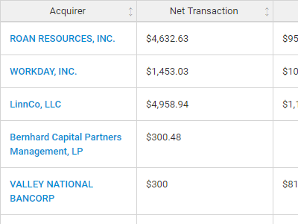**Better Transaction Comps**  
Search for public and private M&A transactions with TagniFi Web. Run your transaction comps within seconds by pasting the Deal ID into your Excel model. Every deal disclosed in an SEC filing (8-K, 10-K, or 10-Q) is available for your analysis. Choose from over 90 fields of data available for every deal.

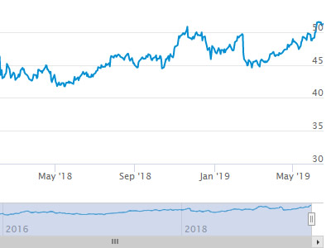

**Historical Beta and Volatility**Calculate historical beta and volatility as of your valuation date automatically. Simply enter the tickers and valuation date in Excel - TagniFi does the rest. In addition to beta and volatility, there are over 40 Excel models available in the Model Library to help with your valuation report.

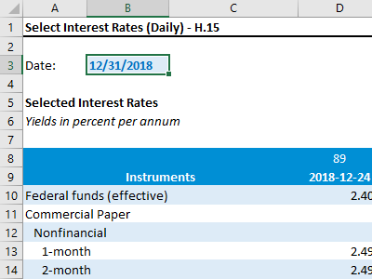**Interest Rates and Economic Data**Automate the interest rates and economic data in your valuation report using the TagniFi Excel plugin. Choose from over 200,000 time series available. All data in this *Quarterly Economic Update* is from the TagniFi platform. Use economic and interest rate data for your own valuation models with the TagniFi Excel plugin.

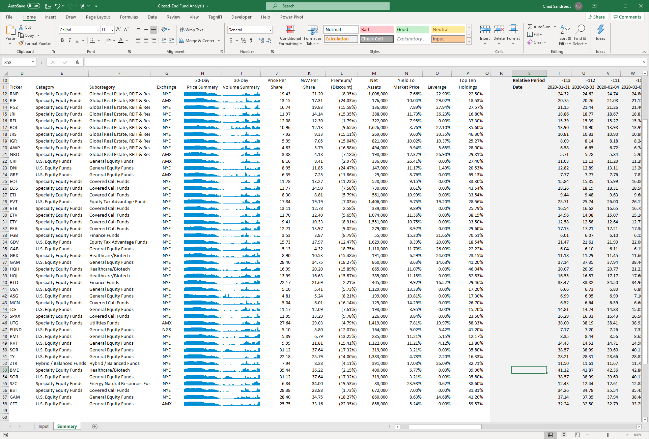

**Closed-End Mutual Fund Data**Search for closed-end mutual funds by keyword, category, subcategory, and more with the TagniFi Console. Use the TagniFi Excel plugin to calculate historical discounts, yields, leverage, as of your valuation date automatically. Simply enter the tickers and valuation date in Excel - TagniFi does the rest.

1. Federal Reserve Bank of Philadelphia, Coincident Economic Activity Index for the United States [USPHCI], *retrieved from FRED, Federal Reserve Bank of St. Louis;* [*https://fred.stlouisfed.org/series/USPHCI*](https://fred.stlouisfed.org/series/USPHCI)*, Jul 30, 2021.*
2. Board of Governors of the Federal Reserve System (US), Trade Weighted U.S. Dollar Index: Broad, Goods and Services [DTWEXBGS], *retrieved from FRED, Federal Reserve Bank of St. Louis;* [*https://fred.stlouisfed.org/series/DTWEXBGS*](https://fred.stlouisfed.org/series/DTWEXBGS)*, Oct 20, 2021.*
3. U.S. Bureau of Economic Analysis, Real Gross Domestic Product [GDPC1], *retrieved from FRED, Federal Reserve Bank of St. Louis;*[*https://fred.stlouisfed.org/series/GDPC1*](https://fred.stlouisfed.org/series/GDPC1)*, Oct 30, 2021.*
4. U.S. Bureau of Economic Analysis, Contributions to percent change in real gross domestic product: Gross private domestic investment [A006RY2Q224SBEA], *retrieved from FRED, Federal Reserve Bank of St. Louis;* [*https://fred.stlouisfed.org/series/A006RY2Q224SBEA*](https://fred.stlouisfed.org/series/A006RY2Q224SBEA)*, Nov 1, 2021.*
5. U.S. Bureau of Economic Analysis, Contributions to percent change in real gross domestic product: Personal consumption expenditures [DPCERY2Q224SBEA], *retrieved from FRED, Federal Reserve Bank of St. Louis;* [*https://fred.stlouisfed.org/series/DPCERY2Q224SBEA*](https://fred.stlouisfed.org/series/DPCERY2Q224SBEA)*, Nov 1, 2021.*
6. U.S. Bureau of Economic Analysis, Contributions to percent change in real gross domestic product: Government consumption expenditures and gross investment [A822RY2Q224SBEA], *retrieved from FRED, Federal Reserve Bank of St. Louis;* [*https://fred.stlouisfed.org/series/A822RY2Q224SBEA*](https://fred.stlouisfed.org/series/A822RY2Q224SBEA)*, Nov 1, 2021.*
7. U.S.. Bureau of Economic Analysis, Contributions to percent change in real gross domestic product: Personal consumption expenditures [DPCERY2Q224SBEA], *retrieved from FRED, Federal Reserve Bank of St. Louis;* [*https://fred.stlouisfed.org/series/DPCERY2Q224SBEA*](https://fred.stlouisfed.org/series/DPCERY2Q224SBEA)*, Nov 1, 2021..*
8. Board of Governors of the Federal Reserve System (US), Industrial Production Index [INDPRO], *retrieved from FRED, Federal Reserve Bank of St. Louis;*[*https://fred.stlouisfed.org/series/INDPRO*](https://fred.stlouisfed.org/series/INDPRO)*, Nov 1, 2021.*
9. Board of Governors of the Federal Reserve System (US), Capacity Utilization, Manufacturing (NAICS), *retrieved from FRED, Federal Reserve Bank of St. Louis;* [*https://fred.stlouisfed.org/series/MCUMFN*](https://fred.stlouisfed.org/series/MCUMFN)*, Nov 1, 2021.*
10. Board of Governors of the Federal Reserve System (US), Federal Funds Effective Rate [FEDFUNDS], *retrieved from FRED, Federal Reserve Bank of St. Louis;* [*https://fred.stlouisfed.org/series/FEDFUNDS*](https://fred.stlouisfed.org/series/FEDFUNDS)*, Oct 24, 2021.*
11. Selected Interest Rates Instruments, Yields in percent per annum, *retrieved from FRED, Federal Reserve Bank of St. Louis;* [*https://fred.stlouisfed.org/release/tables?rid=18&eid=289&od=2021-09-30*](https://fred.stlouisfed.org/release/tables?rid=18&eid=289&od=2021-09-30)*, Oct 24, 2021.*
12. Board of Governors of the Federal Reserve System (US), Effective Federal Funds Rate [FEDFUNDS], *retrieved from FRED, Federal Reserve Bank of St. Louis;*[*https://fred.stlouisfed.org/series/FEDFUNDS*](https://fred.stlouisfed.org/series/FEDFUNDS)*, Oct 24, 2021.*
13. Board of Governors of the Federal Reserve System (US), 10-Year Treasury Constant Maturity Rate [DGS10], *retrieved from FRED, Federal Reserve Bank of St. Louis;*[*https://fred.stlouisfed.org/series/DGS10*](https://fred.stlouisfed.org/series/DGS10)*, Oct 24, 2021.*
14. Moody’s, Moody's Seasoned Baa Corporate Bond Yield [DBAA], *retrieved from FRED, Federal Reserve Bank of St. Louis;* [*https://fred.stlouisfed.org/series/DBAA*](https://fred.stlouisfed.org/series/DBAA)*, Nov 1, 2021.*
15. Moody’s, Moody's Seasoned Aaa Corporate Bond Yield [DAAA], *retrieved from FRED, Federal Reserve Bank of St. Louis;* [*https://fred.stlouisfed.org/series/DAAA*](https://fred.stlouisfed.org/series/DAAA)*, Nov 1, 2021.*
16. U.S. Bureau of Labor Statistics, Civilian Unemployment Rate [UNRATE], *retrieved from FRED, Federal Reserve Bank of St. Louis;*[*https://fred.stlouisfed.org/series/UNRATE*](https://fred.stlouisfed.org/series/UNRATE)*, Oct 20, 2021.*
17. U.S. Bureau of Labor Statistics, Civilian Labor Force Level [CLF16OV], *retrieved from FRED, Federal Reserve Bank of St. Louis;* [*https://fred.stlouisfed.org/series/CLF16OV*](https://fred.stlouisfed.org/series/CLF16OV)*, Oct 31, 2021.*
18. U.S. Bureau of Labor Statistics, Labor Force Participation Rate [CIVPART], *retrieved from FRED, Federal Reserve Bank of St. Louis;* [*https://fred.stlouisfed.org/series/CIVPART*](https://fred.stlouisfed.org/series/CIVPART)*, Oct 31, 2021.*
19. Federal Reserve Bank of Philadelphia, Livingston Survey, [*https://www.philadelphiafed.org/surveys-and-data/real-time-data-research/livingston-survey*](https://www.philadelphiafed.org/surveys-and-data/real-time-data-research/livingston-survey)*, Oct 20, 2021.*
20. U.S. Bureau of Labor Statistics Total Unemployed, Plus All Persons Marginally Attached to the Labor Force, Plus Total Employed Part Time for Economic Reasons, as a Percent of the Civilian Labor Force Plus All Persons Marginally Attached to the Labor Force (U-6) [U6RATE], *retrieved from FRED, Federal Reserve Bank of St. Louis;*[*https://fred.stlouisfed.org/series/U6RATE*](https://fred.stlouisfed.org/series/U6RATE)*, Oct 20, 2021.*
21. U.S. Bureau of Labor Statistics, All Employees: Total Nonfarm Payrolls [PAYEMS], *retrieved from FRED, Federal Reserve Bank of St. Louis;*[*https://fred.stlouisfed.org/series/PAYEMS*](https://fred.stlouisfed.org/series/PAYEMS)*, Oct 20, 2021.*
22. U.S. Bureau of Labor Statistics, Consumer Price Index for All Urban Consumers: All Items [CPIAUCSL], *retrieved from FRED, Federal Reserve Bank of St. Louis;*[*https://fred.stlouisfed.org/series/CPIAUCSL*](https://fred.stlouisfed.org/series/CPIAUCSL)*, Oct 24, 2021.*
23. U.S. Bureau of Labor Statistics, Average Price: Gasoline, Unleaded Regular (Cost per Gallon/3.785 Liters) in U.S. City Average [APU000074714], *retrieved from FRED, Federal Reserve Bank of St. Louis;* [*https://fred.stlouisfed.org/series/APU000074714*](https://fred.stlouisfed.org/series/APU000074714)*, Oct 24, 2021.*
24. U.S. Bureau of Labor Statistics, Producer Price Index for All Commodities [PPIACO], *retrieved from FRED, Federal Reserve Bank of St. Louis;*[*https://fred.stlouisfed.org/series/PPIACO*](https://fred.stlouisfed.org/series/PPIACO)*, Oct 24, 2021.*
25. *Federal Reserve Bank of St. Louis, 5-Year Breakeven Inflation Rate [T5YIE], retrieved from FRED, Federal Reserve Bank of St. Louis;*[*https://fred.stlouisfed.org/series/T5YIE*](https://fred.stlouisfed.org/series/T5YIE)*, Oct 24, 2021.*
26. U.S. Energy Information Administration, Crude Oil Prices: West Texas Intermediate (WTI) - Cushing, Oklahoma [DCOILWTICO], *retrieved from FRED, Federal Reserve Bank of St. Louis;* [*https://fred.stlouisfed.org/series/DCOILWTICO*](https://fred.stlouisfed.org/series/DCOILWTICO)*, Nov 3, 2021..*
27. U.S. Bureau of the Census, Housing Starts: Total: New Privately Owned Housing Units Started [HOUST], *retrieved from FRED, Federal Reserve Bank of St. Louis;*[*https://fred.stlouisfed.org/series/HOUST*](https://fred.stlouisfed.org/series/HOUST)*, Oct 25, 2021.*
28. Freddie Mac, 30-Year Fixed Rate Mortgage Average in the United States [MORTGAGE30US], *retrieved from FRED, Federal Reserve Bank of St. Louis;*[*https://fred.stlouisfed.org/series/MORTGAGE30US*](https://fred.stlouisfed.org/series/MORTGAGE30US)*, Oct 25, 2021.*
29. S&P Down Jones Indices LLC, S&P/Case-Shiller 20-City Composite Home Price Index [SPCS20RSA], *retrieved from FRED, Federal Reserve Bank of St. Louis;*[*https://fred.stlouisfed.org/series/SPCS20RSA*](https://fred.stlouisfed.org/series/SPCS20RSA)*, Oct 28, 2021.*
30. U.S. Bureau of Economic Analysis, Personal Consumption Expenditures [PCE], *retrieved from FRED, Federal Reserve Bank of St. Louis;*[*https://fred.stlouisfed.org/series/PCE*](https://fred.stlouisfed.org/series/PCE)*, Jul 30, 2021.*
31. U.S. Bureau of Economic Analysis, Light Weight Vehicle Sales: Autos and Light Trucks [ALTSALES], *retrieved from FRED, Federal Reserve Bank of St. Louis; <https://fred.stlouisfed.org/series/ALTSALES>, Oct 28, 2021.*
32. U.S. Bureau of Labor Statistics, Consumer Price Index for All Urban Consumers: New Vehicles in U.S. City Average [CUUR0000SETA01], *retrieved from FRED, Federal Reserve Bank of St. Louis;* [*https://fred.stlouisfed.org/series/CUUR0000SETA01*](https://fred.stlouisfed.org/series/CUUR0000SETA01)*, Oct 28, 2021.*
33. U.S. Bureau of Labor Statistics, Consumer Price Index for All Urban Consumers: Used Cars and Trucks in U.S. City Average [CUSR0000SETA02], *retrieved from FRED, Federal Reserve Bank of St. Louis;* [*https://fred.stlouisfed.org/series/CUSR0000SETA02*](https://fred.stlouisfed.org/series/CUSR0000SETA02), *Oct 28, 2021.*
34. *University of Michigan, University of Michigan: Consumer Sentiment [UMCSENT], retrieved from FRED, Federal Reserve Bank of St. Louis;* [*https://fred.stlouisfed.org/series/UMCSENT*](https://fred.stlouisfed.org/series/UMCSENT)*, Oct 30, 2021.*
35. *Chicago Board Options Exchange, CBOE Volatility Index: VIX [VIXCLS], retrieved from FRED, Federal Reserve Bank of St. Louis;* [*https://fred.stlouisfed.org/series/VIXCLS*](https://fred.stlouisfed.org/series/VIXCLS)*, Jul 30, 2021.*
36. *Federal Reserve Bank of St. Louis, FOMC Summary of Economic Projections for the Growth Rate of Real Gross Domestic Product [GDPC1CTM], retrieved from FRED, Federal Reserve Bank of St. Louis;*[*https://fred.stlouisfed.org/series/GDPC1CTM*](https://fred.stlouisfed.org/series/GDPC1CTM)*, Jul 30, 2021.*
37. *Federal Reserve Bank of St. Louis, FOMC Summary of Economic Projections for the Personal Consumption Expenditures Inflation Rate, Central Tendency, Midpoint [PCECTPICTM], retrieved from FRED, Federal Reserve Bank of St. Louis;*[*https://fred.stlouisfed.org/series/PCECTPICTM*](https://fred.stlouisfed.org/series/PCECTPICTM)*, Jul 30, 2021.*
38. *Federal Reserve Bank of St. Louis, FOMC Summary of Economic Projections for the Civilian Unemployment Rate, Central Tendency, Midpoint [UNRATECTM], retrieved from FRED, Federal Reserve Bank of St. Louis;*[*https://fred.stlouisfed.org/series/UNRATECTM*](https://fred.stlouisfed.org/series/UNRATECTM)*, Jul 30, 2021.*