QUARTERLY M&A UPDATE

For the 4th Quarter of 2021

Abstract

Designed for M&A and private equity professionals, TagniFi’s Quarterly   
M&A Update provides an overview of deal activity with key trends and activity levels.

# Q4 Highlights

By all measures, the 4th quarter was a spectacular quarter for M&A activity across the United States. There were a record 3,401 deals announced in Q4, an increase of 10% over Q3 and 72% over the same quarter last year.

* There were 3,401 M&A deals announced in Q4-2021.
* The total disclosed transaction value was $545 billion.
* California led the nation with 419 announced deals.
* The most popular deal type was the 100% Buyout which represented 46% of the announced deals.
* Private companies were the most popular acquirer type with 47% of the deals announced.
* The most active sector was Services with 60% of the deals announced.
* Maxon Computer was the most acquisitive strategic buyer.
* KKR was the most acquisitive financial buyer.
* J.P. Morgan Securities LLC was the most active financial advisor.
* Kirkland & Ellis LLP was the most active legal advisor.

# M&A Activity by State

The M&A boom in Q4 was felt across the nation where every state in the union had M&A activity. California, Texas, and New York lead the pack with 419, 212, and 211 deals announced, respectively. The next tier of activity was in Florida, Illinois, and Massachusetts, which ended the quarter with 134, 111, and 106 deals announced, respectively.

Regionally, the West, Midwest, Mid-Atlantic, and Southern regions experienced robust M&A activity with the plains and mid-south lagging on a relative basis.



# M&A Activity by Deal Type

Q4 saw more 100% buyouts than any other deal type with 1,539 deals. These deals are primarily acquisitions made by companies that are not affiliated with an investor. The next most popular deal type during the quarter with 880 transactions was add-on acquisitions by companies that are affiliated with an investor. Minority stakes and private equity acquisitions followed next with 309 and 185 deals during the quarter, respectively.

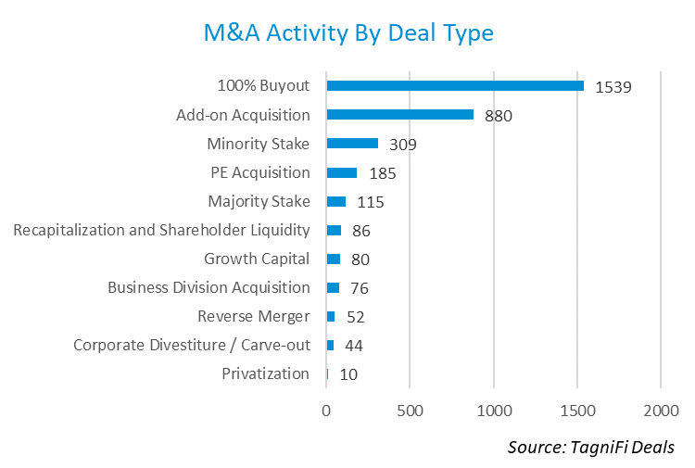

# M&A Activity by Acquirer Type

Private companies went on a buying spree in Q4 with 47% of the deals announced. Public companies were involved in 31% of the deals while investors were involved in 22% of the deals.

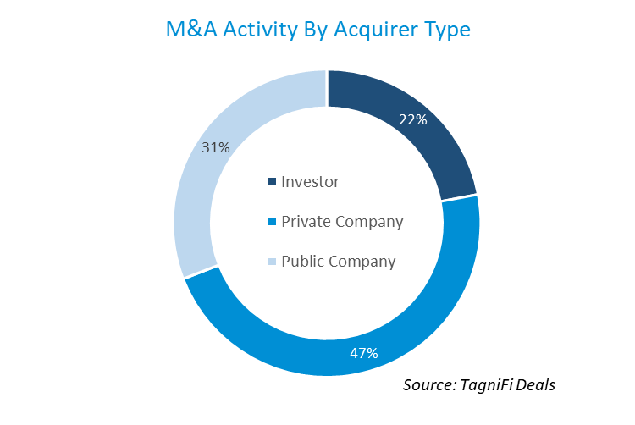

# Deal Activity by Sector

Transactions in the Services sector were more than the all other sectors combined in Q4 with 1,882 total deals. Manufacturing had 463 deals with Financial and Trade (retail and wholesale) following with 310 and 301 transactions, respectively.

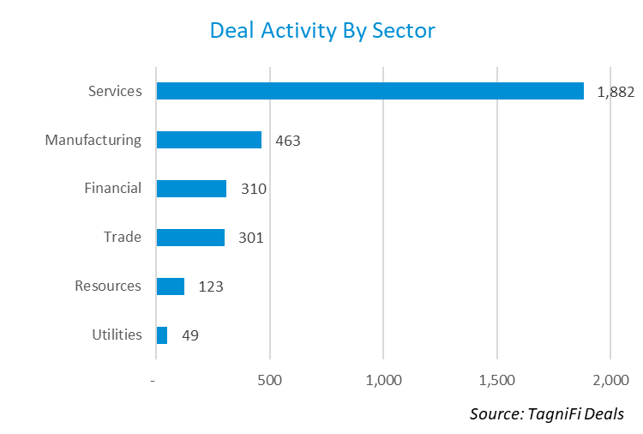

# Strategic Buyer Activity

During Q4 there were 2,181 strategic buyers with acquisition activity. Below is a chart of the 25 most acquisitive strategic buyers during the quarter.

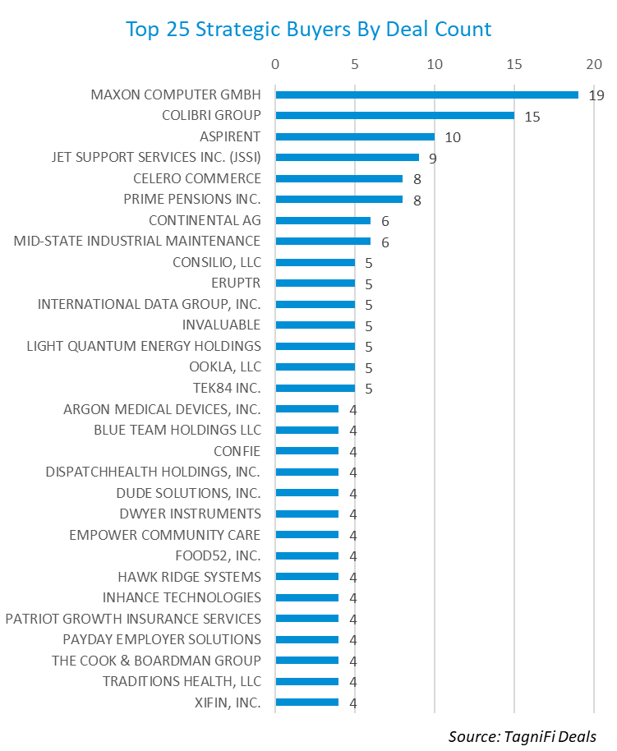

# Financial Buyer Activity

During Q4 there were 473 financial buyers with deal activity. Below is a chart of the 25 most active financial buyers during the quarter.

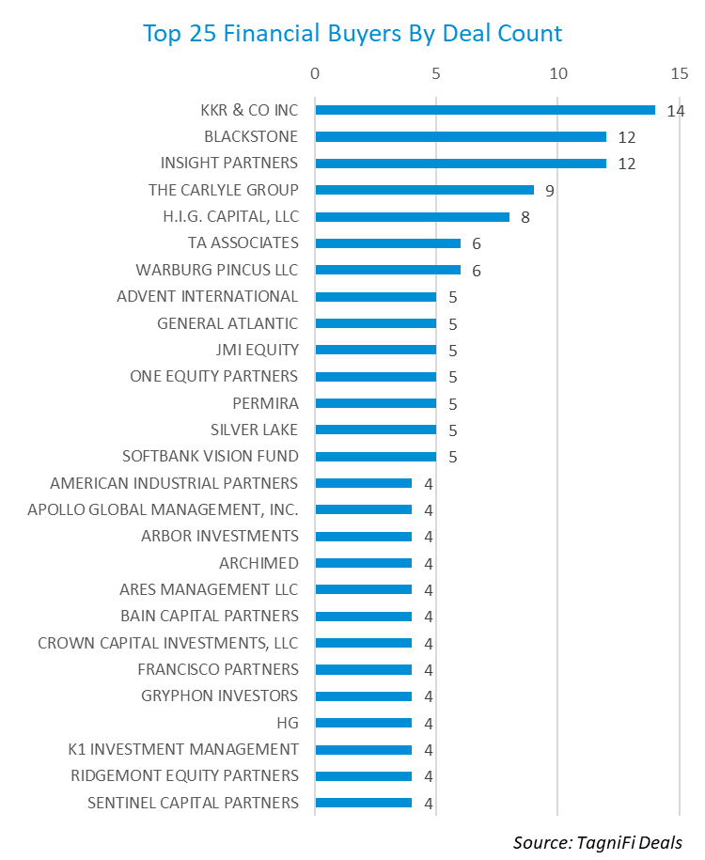

# Financial Advisor Activity

During Q4 there were 539 financial advisors tagged in deals. Below is a chart of the 25 most active financial advisors during the quarter.

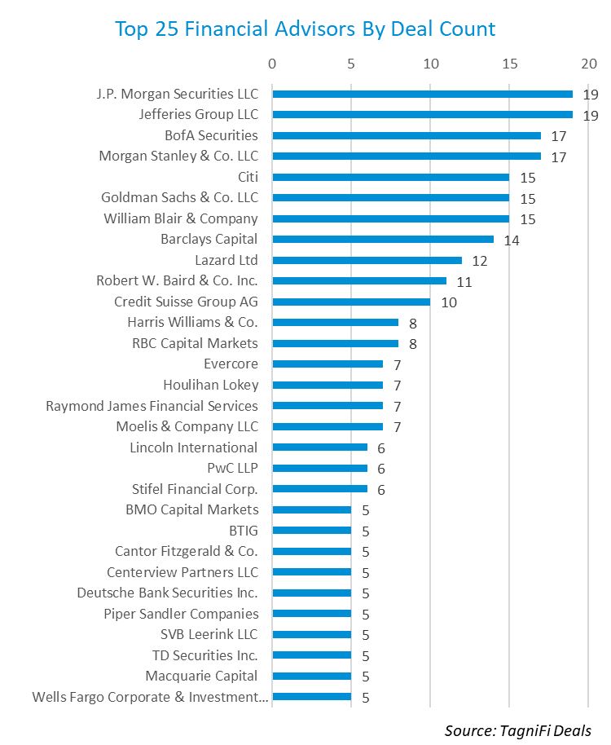

# Legal Advisor Activity

During Q4 there were 396 legal advisors tagged in deals. Below is a chart of the 25 most active legal advisors during the quarter.

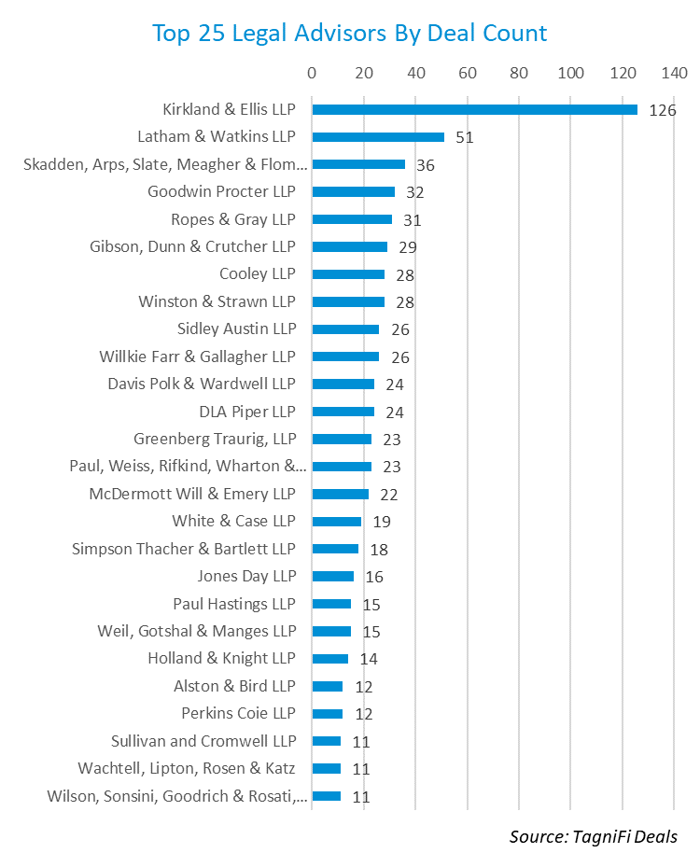

# About This Report

The *Quarterly M&A Update* is a free publication sponsored by TagniFi. You are free to share this report with your colleagues and clients. In fact, we would appreciate it if you would please forward this free report to a few friends to help us spread the word about TagniFi as an alternative data platform. We typically save our clients 85% when they make the switch from Capital IQ or PitchBook. Learn more or request a demo at [tagnifi.com](https://tagnifi.com).

As of the date of this report, the TagniFi platform includes data on the following:

* 8,915 public companies
* 64,988 private companies
* 42,931 M&A transactions
* 4,578 private equity investors
* 1,786 financial (M&A) advisors
* 1,656 legal advisors
* 25,009 private equity professionals
* 14,696 advisor professionals
* 812,576 economic and industry time series

[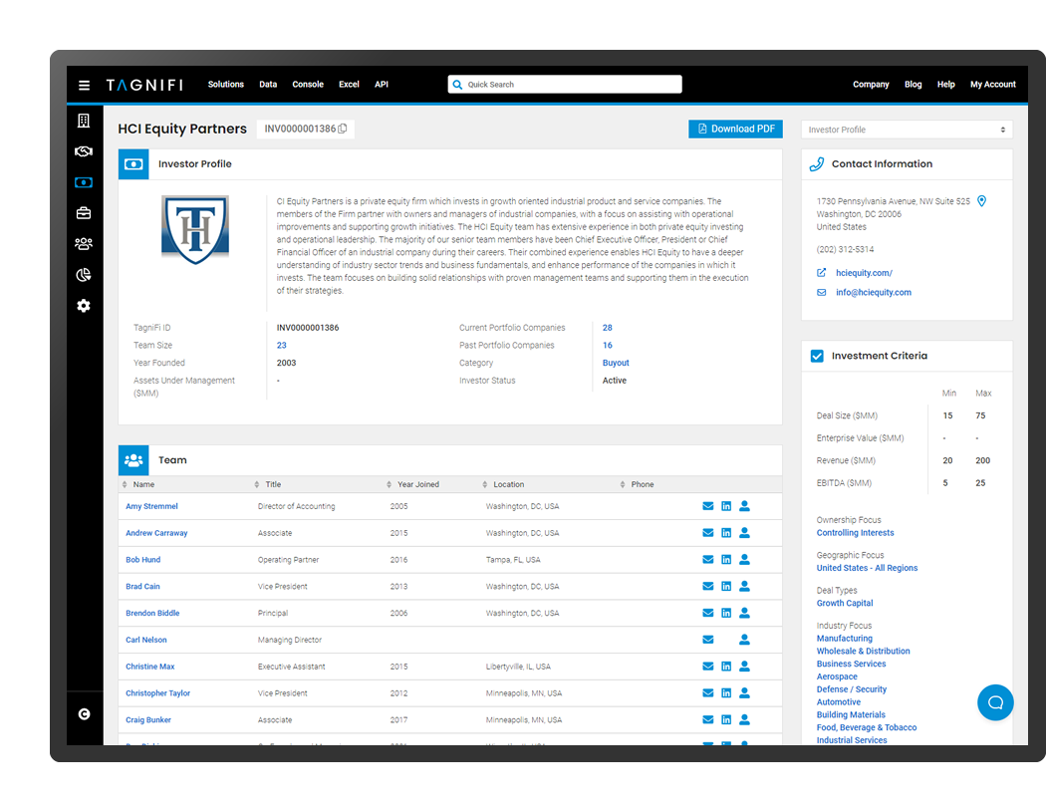](https://tagnifi.com)