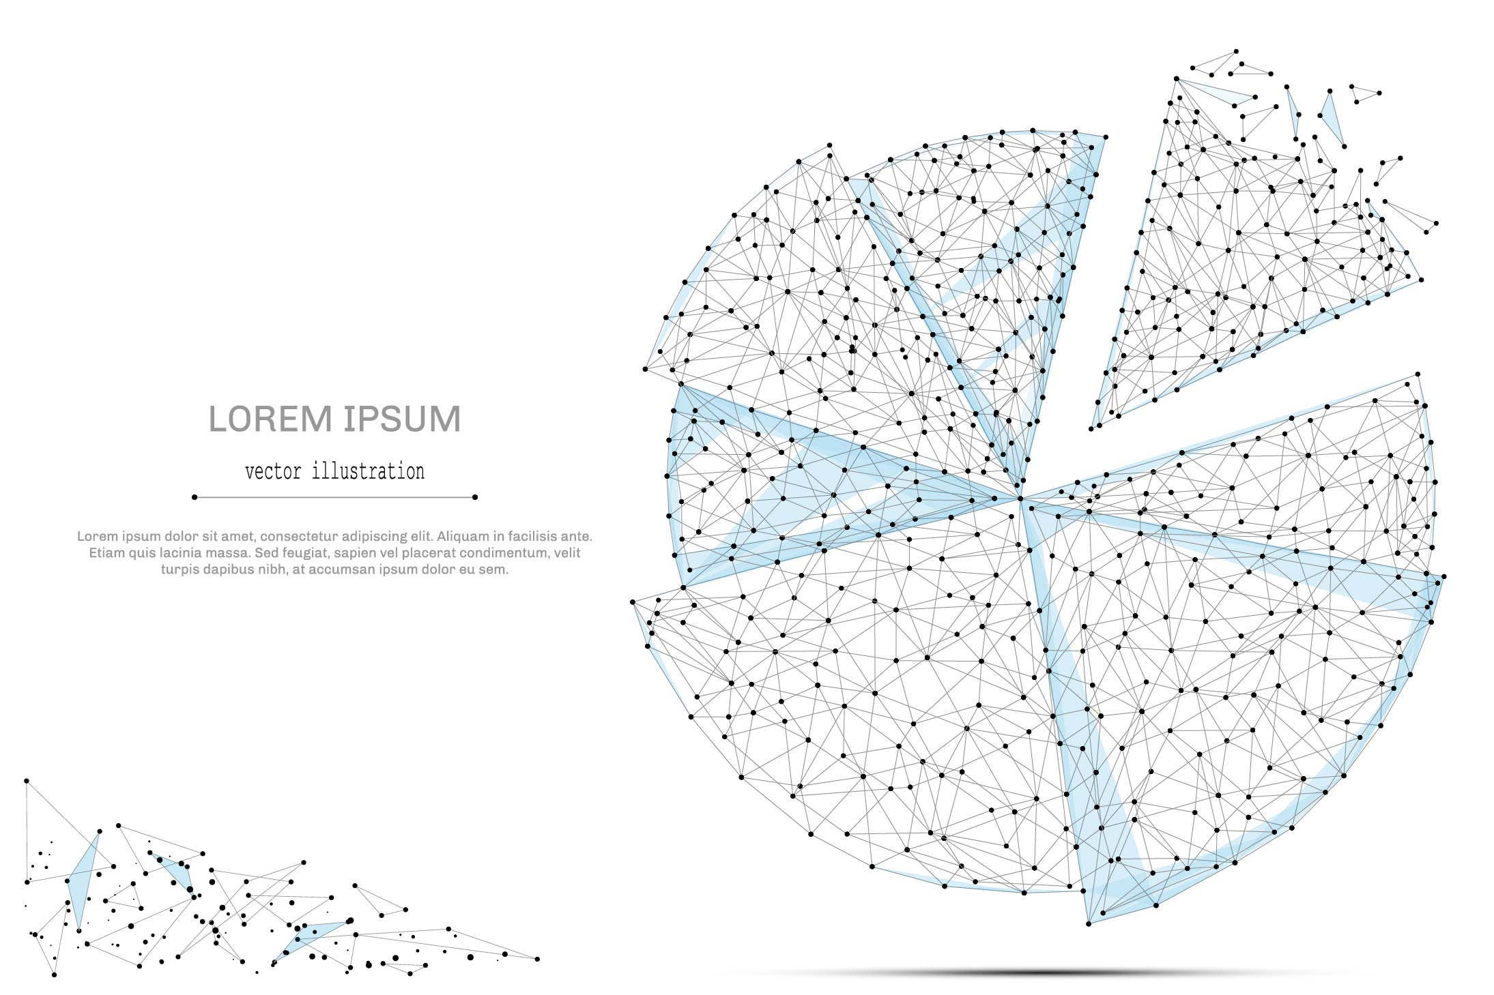

QUARTERLY ECONOMIC UPDATE

For the 4th Quarter of 2021

Abstract

Designed for business valuation professionals, TagniFi’s Quarterly Economic   
Update provides timely economic data to satisfy Revenue Ruling 56-60.

# Summary

In the 4th quarter of 2021, the U.S. economy pressed forth in its recuperation from the blow of the COVID-19 pandemic, posting strong gains in production despite continued disruptions to supply chains and labor availability, soaring inflation, and the anticipation of waning monetary policy supports.

Supply chains across the globe continue to face challenges in capitalizing on vigorous consumer demand. With COVID-19 case rates soaring, worker shortages continue to challenge supply, affecting both production and shipping at the wholesale and retail levels. Although the unemployment rate continues to drop, nearing pre-pandemic levels, labor market participation remained depressed throughout the quarter. Prior to the COVID-19 pandemic, the last time labor force participation was as low was more than 45 years ago.

Balancing a robust economic recovery with searing inflationary pressures continues to be a main challenge for the U.S. Inflation reached 30-year highs during the 4th quarter, taking a toll on consumer sentiment. In December, the Fed reiterated its plans to raise target interest rates and taper its bond-buying programs in 2022.

As the U.S. economy continued to expand during the 4th quarter, the Delta variant-dominant 4th wave of the COVID-19 pandemic receded and gave way to the ultra-contagious Omicron variant. Omicron rapidly swept the globe, becoming the dominant strain in the U.S. within 3.5 weeks after being declared a variant of concern by the WHO. Daily confirmed cases of COVID-19 in the U.S. jumped by 3.5 times by the end of the fourth quarter and continued to trend steeply upward. However, daily deaths, which lag one to two weeks behind case trends, were down by nearly one-third at the end of December.

Below is a summary timeline of key COVID-19 events in the U.S. during the 4th quarter of 2021:

|  |  |
| --- | --- |
| October 1, 2021 | U.S. begins the quarter at 107,684 daily cases, 1,848 daily deaths (7-day moving average). 56% of Americans are fully vaccinated. |
| October 29, 2021 | FDA authorizes Pfizer-BioNTech COVID-19 vaccine for emergency use for children 5-11 years of age |
| November 26, 2021 | WHO declares B.1.1.529 variant, named Omicron, a variant of concern |
| December 3, 2021 | 60% of Americans are fully vaccinated |
| December 13, 2021 | U.S. reaches 50 million total COVID-19 cases |
| December 15, 2021 | U.S. reaches 800,000 total deaths from COVID-19 |
| December 17, 2021 | Pfizer and BioNTech announce plans to trial 3rd dose of COVID-19 vaccine in children under 5, extending vaccine wait for the age group |
| December 20, 2021 | Omicron variant becomes dominant strain in U.S. according to CDC 1-week estimates |
| December 27, 2021 | CDC shortens recommended isolation and quarantine period |
| December 31, 2021 | U.S. ends the quarter at 397,460 daily cases, 1,253 daily deaths (7-day moving average). 63% of Americans are fully vaccinated. |

Despite the significantly mutated Omicron variant causing frequent “breakthrough cases” of vaccinated people becoming infected with COVID-19, vaccines continued to prove highly effective at preventing serious illness and death. Although a large part of the U.S. population is still unwilling to receive the shot, many experts predict that rising global vaccination rates will help mitigate the dangers of COVID-19 mutation and global spread. Through global vaccination efforts and the sheer infectiousness of the Omicron variant, enough immunity may be achieved to push the pandemic into its endemic stage, where the circulating disease becomes limited in both deadliness and reach due to immunity throughout the population. Some experts believe COVID-19 could become endemic in the U.S. as early as 2022.

A multifactor indicator of economic strength, the Philadelphia Fed’s coincident index[1] of economic activity in the U.S. rose 0.4% in December 2021 and 1.2% during the 4th quarter. For the quarter, coincident indexes increased in all 50 states. Coincident indexes reflect unemployment, payroll employment, manufacturing hours, and wages and salaries. Unemployment, a major factor in the index, fell 0.8 percentage points over the quarter, yet the unemployment rate and the number of unemployed people are up 0.4 percentage point and 0.6 million, respectively, since February 2020.



The U.S. dollar index for goods and services[2] rose 0.28% during the 4th quarter of 2021 to a level 3.36% higher than in December of 2020. The dollar climbed in November to its highest level of 2021 and remained high through the end of 2021. The advancement came as Fed chairman Jerome Powell was renominated for his role, firming investors’ expectations of target interest rate hikes in the coming year. The low-risk investment remained attractive despite an uptick in global risk appetite as talks sputtered on the beleaguered Build Back Better bill in Washington, and the Omicron variant pushed yet another surge of COVID cases worldwide.

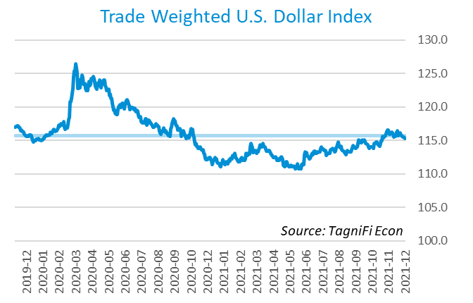

# Q4 Economic Highlights

* The Philadelphia Fed’s coincident index[3] of economic activity in the U.S. rose 0.4% in December 2021 and 1.2% during the 4th quarter.
* Real GDP for the 4th quarter of 2021 grew at an annual rate of 6.9%, bouncing back from a 2.3% showing in the 3rd quarter.
* The U.S. dollar index rose 0.28% during the 4th quarter of 2021 to a level 3.36% higher than in December of 2020.
* The effective federal funds rate remained steady throughout the 4th quarter at 0.08%, near its all-time low.
* The 1-year and 2-year annual treasury yields ended the 4th quarter at 0.39% and 0.73%, respectively. The benchmark 10-year treasury yielded 1.52% annually at the end of the quarter, while the 30-year treasury yielded 1.90%.
* Unemployment fell to 3.9% in December 2021, and nonfarm payroll employment grew by 1.1 million jobs in the 4th quarter.
* The Consumer Price Index rose 7.1% year-over-year in December, its fastest growth since June of 1982. Excluding volatile energy prices, the index rose 5.6%.
* Crude prices ended the period at $71.71 per barrel, 0.1% higher than the prior quarter.
* New home starts[4] numbered 1.70 million in December, up 9.8% over September amid a severe shortage of housing supply.
* The S&P 500 rose 10.6% during the 4th quarter of 2021. The Dow Jones Industrial Average climbed 7.4% during the quarter while the Dow Jones Transportation and Composite Indexes jumped 17.7% and 10.7%, respectively.

# Business Activity

Real gross domestic product (GDP)[5] for the 4th quarter of 2021 grew at an annualized rate of 6.9%, bouncing back from a 2.3% showing in the 3rd quarter. The 4th quarter built on more than a year’s worth of gains to push real GDP to record levels for the third consecutive quarter.

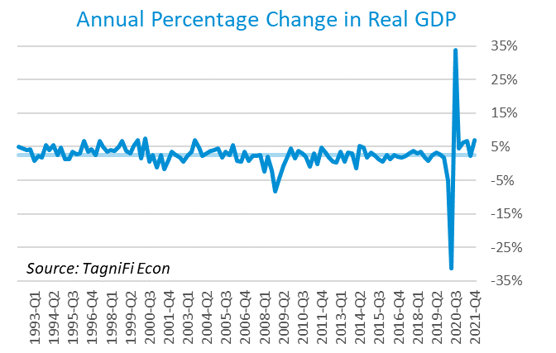

The leading contributor was gross domestic private investment[6], boosting the overall figure by 5.2%, attributable mainly to nonfarm private inventory investment. Personal consumption expenditures[7] (PCE) contributed 2.3% of the growth in real GDP in the 4th quarter, led by broad increases in household services consumption including health care, recreation, and transportation.

Government expenditures[8] constrained 4th quarter real GDP growth with a negative effect of 0.5%. Government consumption dropped at both the federal and state and local levels. In the 4th quarter of 2021, federally funded pandemic assistance such as forgivable business loans, grants for state and local governments, and household benefits expired or wound down.

Net exports[9] had a neutral effect on overall real GDP in the 4th quarter, as both exports and imports increased.

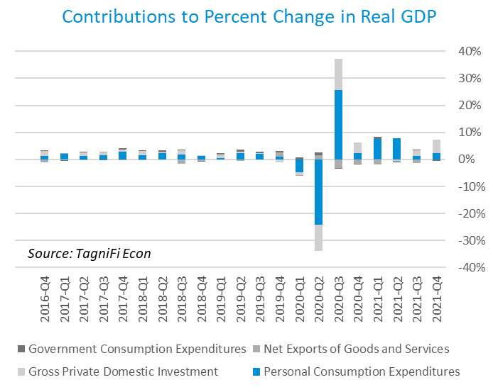

The Industrial Production Index[10] is an economic indicator that measures real output for all facilities located in the United States manufacturing, mining, and electric, and gas utilities. The index stood at 101.9 at the end of the 4th quarter, up 1.9% since the previous quarter.

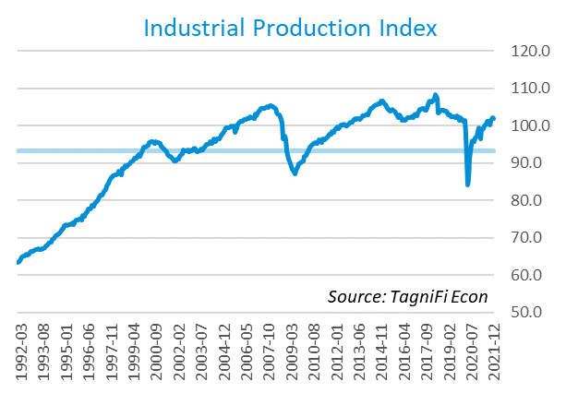

The Capacity Utilization Index[11], which attempts to capture industrial output as a percentage of the economy’s maximum production capacity, increased to 77.2% during the 4th quarter, exceeding its pre-pandemic level. Capacity utilization reached a nearly 3-year high in November 2021 and remained near that peak in December. The 10-year high for the metric was 78.4% in August of 2018.

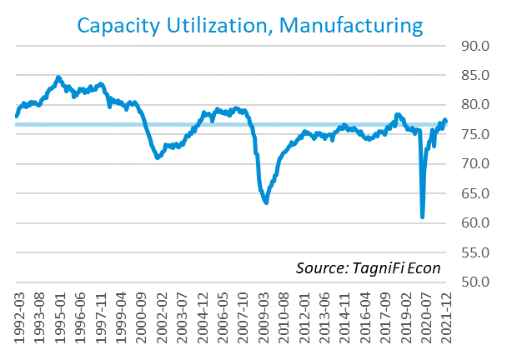

# Interest Rates

The effective federal funds rate[12] remained steady throughout the 4th quarter at 0.08%, near its all-time low. Short-term treasury bond yields[13] were little changed during the 4th quarter. Long-term treasury yields fell in November upon speculation about a change in Federal Reserve leadership, then climbed after Jerome Powell was renominated and Fed plans to raise target rates and taper bond-buying programs proceeded. The 1-year and 2-year annual treasury yields ended the 4th quarter at 0.39% and 0.73%, respectively. The benchmark 10-year treasury yielded 1.52% annually at the end of the quarter, while the 30-year treasury yielded 1.90%. See *Appendix – Selected Interest Rates* for detailed interest rate data.

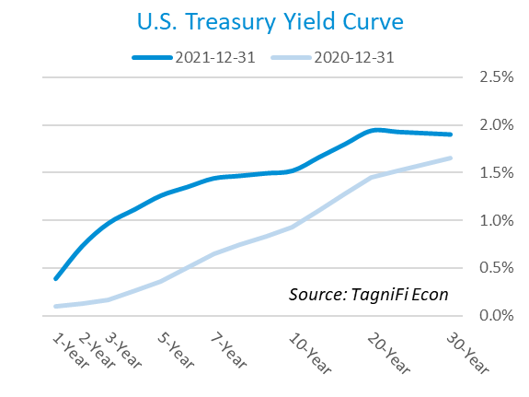

In the 4th quarter of 2021, the Federal Reserve continued to keep the federal funds target rate steady at a range of 0.00% to 0.25% but reiterated its plans to increase rates and phase down its aggressive bond-buying program in 2022. Investors expect the target rates to begin rising in March of 2022. The effective federal funds rate[14] was unchanged throughout the 4th quarter at 0.08%.

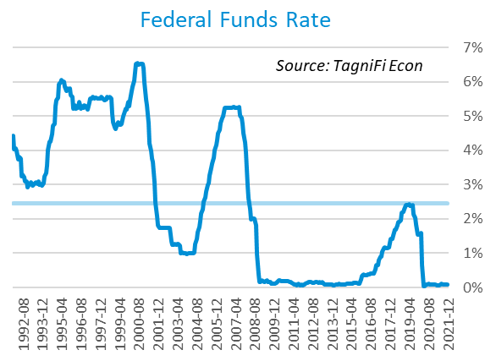

The yield on the benchmark 10-year U.S. treasury[15] ended the 4th quarter at 1.52%, unchanged from the previous quarter, but well below the average yield of 4.05% over the last 30 years.

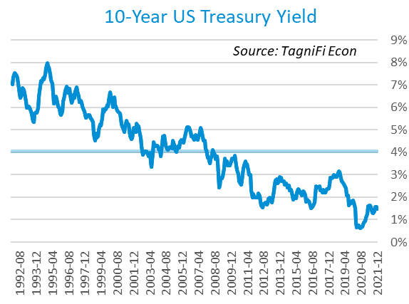

Moody’s Baa Corporate Bond Yield Index[16] ended the 4th quarter at 3.37%, matching its 3rd quarter level. Moody’s Aaa[17] Index was similarly little changed, ending the 4th quarter at 2.71%, compared to 2.70% in the previous quarter.

Starting in March of 2020, the Federal Reserve took the unprecedented measure of building a portfolio of corporate bonds, effectively backstopping the corporate bond market. Shortly after doing so, the riskier Baa index reversed its yield spike and began to fall lower. The move was less dramatic for Aaa, but both markets were affected directly by the Fed’s $13 billion portfolio, as well as by its expansionary operations in 2020. The Fed indicated in December 2021 that its gradual sell-off of its bond holdings would likely begin shortly after its first target rate increase, widely expected in early 2022. The tapering could put temporary upward pressure on yields, especially for the riskier Baa index.

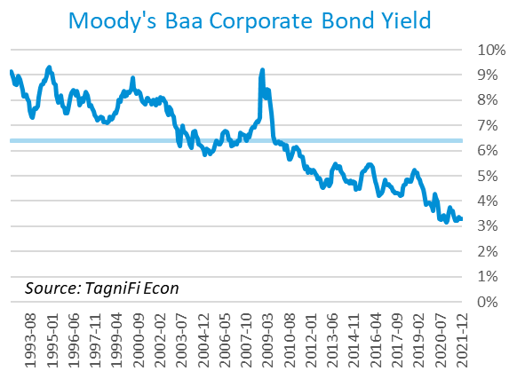

# Employment

The official unemployment rate[18] fell to 3.9% in December 2021, continuing its downward trend toward its pre-pandemic level and outperforming its 30-year average of 5.9%. However, the labor force[19] remained 2.3 million workers smaller since February 2020, with a labor force participation rate[20] of just 61.9%. Prior to the COVID-19 pandemic, the last time labor force participation was that low in the U.S. was February 1977. Economists polled by the Livingston Survey[21] in December projected an unemployment rate of 4.0% in June 2022, declining to 3.8% in December 2022.

In what is becoming known as The Great Resignation, nonfarm worker quits[22] set their fifth record in eight months in November 2021, with 4.5 million workers handing in their notice. The number of quits jumped 8.9% from the prior month and 37.3% from November 2020. The unprecedented level of resignations has been attributed to disparate reasons, with burnout, anxiety, and dissatisfaction arising from the COVID-19 pandemic on the one hand, and increased opportunities on the other. Even as quits set record highs, job openings outnumber job-seekers by approximately 1.5 times, according to some estimates.

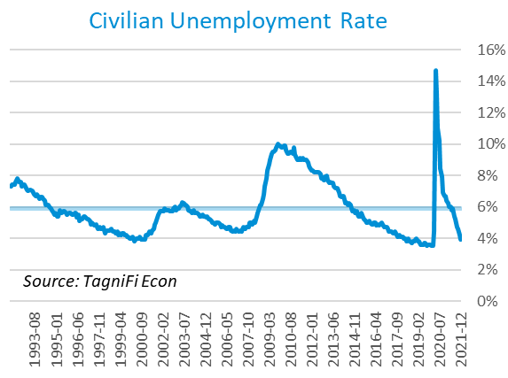

The U-6 unemployment rate[23] is an alternative measure of unemployment with a broader definition, including such groups as discouraged workers who are not actively searching for jobs but want full-time work and part-time workers who want full-time work. The U‑6 unemployment rate has generally followed the same pattern as the official rate; it fell to 7.3% in December 2021, its lowest level since February 2020, prior to the onset of the COVID-19 pandemic.

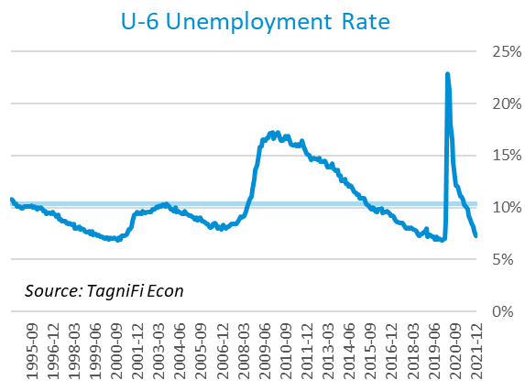

Nonfarm payrolls[24] grew by 1.1 million jobs in the 4th quarter, although the job gains slowed later in the quarter. U.S. nonfarm payrolls in December 2021 totaled 149.0, up 6.4 million compared to the same period last year, yet still 3.6 million jobs below their pre-pandemic (February 2020) levels.

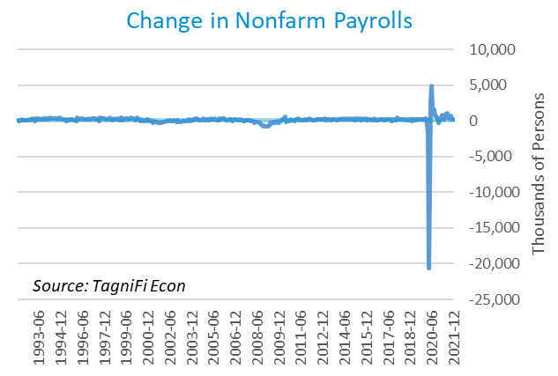

# Inflation

After many tame years, inflation is now at the forefront of the economic conversation. The Consumer Price Index[25] rose 7.1% year-over-year in December, its fastest growth since June of 1982. Excluding volatile energy prices[26], the index rose 5.6%. Notably, the price of a gallon of gas[27] jumped 57% from a national average of $2.17 in December 2020 to $3.41 in December 2021. The Federal Reserve, attributing the inflationary pressure to ebullient demand outpacing constrained supply chains, further developed plans to withdraw economic supports in the coming year. Currently the Fed’s main tools are the target interest rates and a gradual selloff of its massive bond holdings, in contrast to historical inflationary spikes when the Fed relied on blunter and less predictable tools such as manipulating the supply of circulating currency.

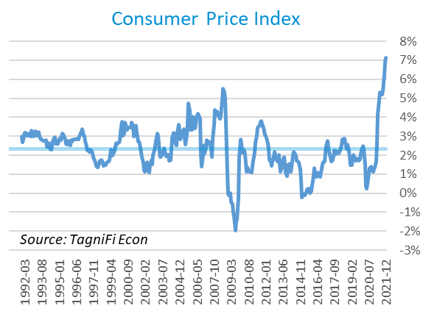

The Producer Price Index[28] fell 0.9% in December, the first over-the-month decline since April 2020. Still, the PPI was 20.2% higher in December than one year prior, well above the 2.4% average annual increase over the last 30 years.

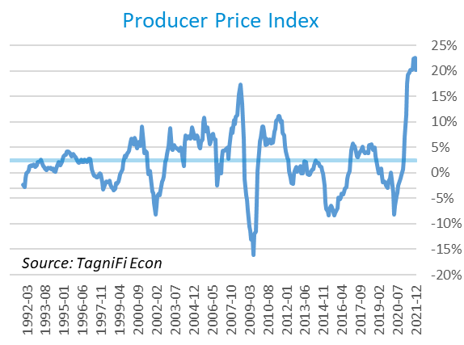

Treasury Inflation-Protected Securities (TIPS) are a longer-term Treasury debt instrument which pays a fixed interest rate but adjusts the principal value according to inflation, effectively indexing interest payments to inflation. TIPS have continued to sell at a premium, reflecting higher inflation expectations for the future; however, rising supply and falling demand are expected once the Fed moves to combat inflation through bond selloffs. The 5-year breakeven inflation rate[29], an indicator for the market’s inflation expectations for the period, rose to 2.87% to end the 4th quarter, slightly higher than the 2.51% rate at the end of the 3rd quarter.

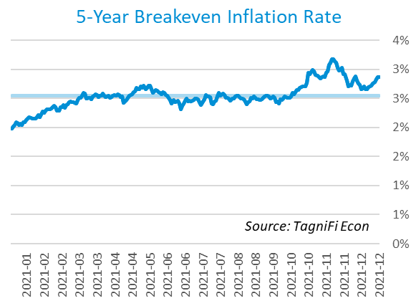

U.S. crude oil[30] prices peaked in October at their highest value in seven years, the result of a global shortfall in energy supply. In November and December, prices fell nearly back to prior-quarter levels amid speculations about the release of reserve oil in multiple countries and lockdowns in response to the spread of the Omicron variant. Crude prices ended the period at $71.71 per barrel, 0.1% higher than one quarter earlier.

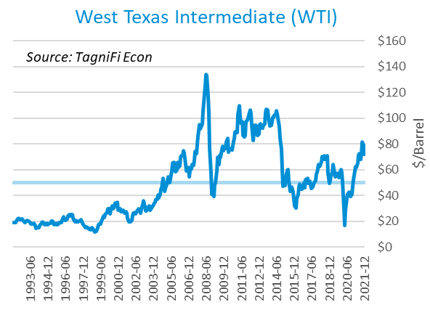

# Housing

The housing market was characterized by renewed efforts to meet pent-up demand despite the continued challenges of soaring materials costs and an ongoing labor shortage. New home starts[31] numbered 1.70 million in December, up 9.8% over September amid a severe shortage of housing supply. Multifamily units led the climb, while single family home starts fluctuated over the quarter. Prices of construction materials remain markedly elevated, with an increase in duties on Canadian softwood helping to push lumber prices up 15.5% in December. Housing starts were 2.5% higher than last year and well above their 30-year average of 1.33 million.

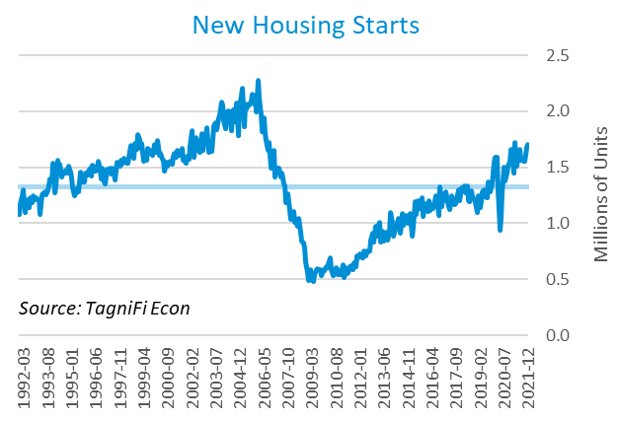

The cost of financing for would-be homebuyers remained near record lows in the 4th quarter, with the 30-year fixed-rate mortgage[32] ending the quarter at 3.11%.

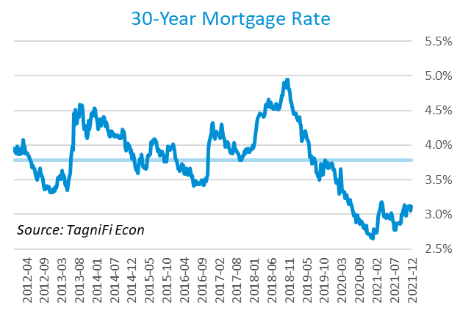

The S&P Case-Shiller Home Price Index (20-city)[33] for November 2021 rose 18.3% since the previous November with Phoenix, Tampa, and Miami reporting the largest increases. Supply constraints, combined with mortgage rates continuing to hover near record lows, pushed home prices even higher, a dynamic seen since the pandemic began.

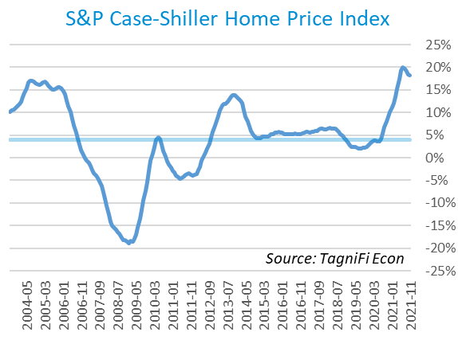

# Consumer Spending

Personal Consumption Expenditures (PCE)[34] rose 2.4% in the 4th quarter to $16.3 trillion. PCE were up 13.0% since the 4th quarter last year. Spending on services grew on broad increases in household services consumption, led by health care and recreation services. Spending for goods increased more moderately, with scattered increases led by recreational goods and vehicles outpacing various declines led by motor vehicles and parts.

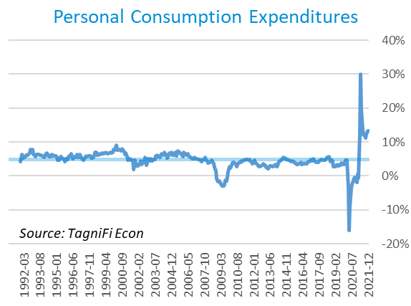

Auto manufacturers reported 12.4 million autos and light trucks sold[35] in December 2021, up 1.2% from September. The lingering impacts of a semiconductor chip shortage held inventories near record lows and continued to prop up prices for new vehicle prices[36], which in December stood at an all-time high after rising 4.0% during the 4th quarter. Used car prices[37] also stood at a record high in December after rising 8.8% over the quarter.

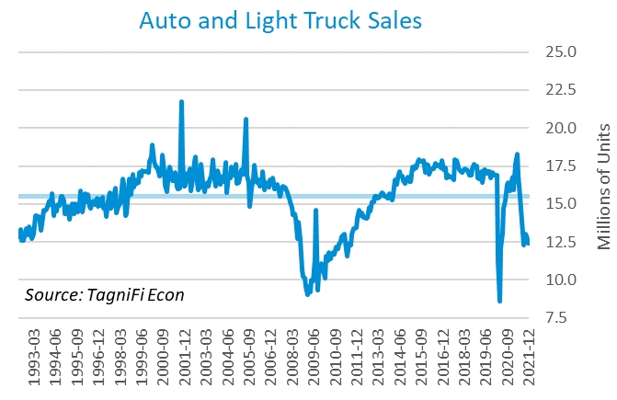

The University of Michigan’s consumer sentiment index[38] ended the 4th quarter at 70.6, after dropping to 67.4 in November, its lowest level in 10 years. The decline reflected consumers’ outlooks on skyrocketing inflation combined with waning confidence in policymakers’ ability to curb price pressures. Additionally, labor turnover continued its intensified churn, with worker quits setting a new record. The consumer sentiment index remains well above its previous low of 55.8 in August 2011 but far short of its 30-year average of 87.6.

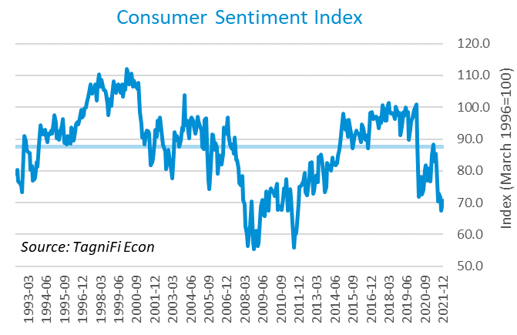

# Capital Markets

The table below shows the quarterly, year-to-date, and 12-month performance of major U.S. equity indices. Capital markets made a strong showing in the 4th quarter of 2021 to cap a year of strong corporate earnings growth and highly supportive pandemic-era monetary policy. The S&P 500 rose 10.6% during the 4th quarter of 2021. The Dow Jones Industrial Average climbed 7.4% during the quarter while the Dow Jones Transportation and Composite Indexes jumped 17.7% and 10.7%, respectively.



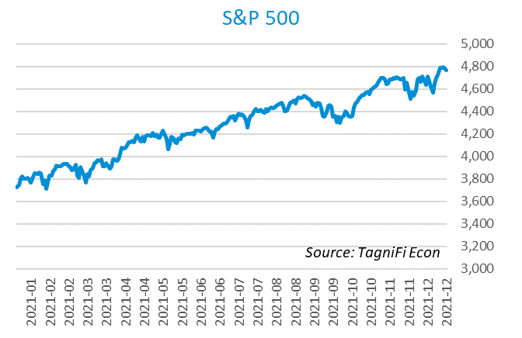

Stock market volatility, as measured by the VIX [39], ended the 4th quarter at 17.2, down 18.6% since the prior quarter. The index began to spike in the last week of November, reaching a peak on December 1, as concerns deepened about the ultra-contagious Omicron variant and hawkish statements by Fed chairman Jerome Powell.

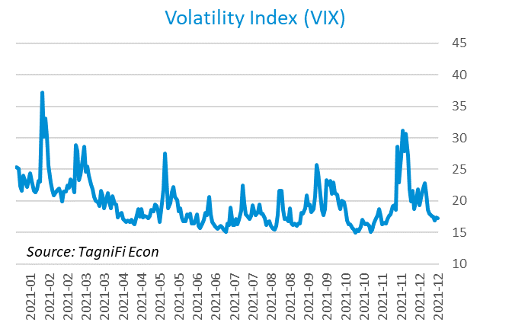

# Outlook

In December 2021, the FOMC revised their near-term inflation projections upward, and both their unemployment rate and real GDP projections downward. Longer run projections for all three indicators held relatively steady.

The FOMC revised their projection for real GDP[40] to 4.05% growth in 2022, slowing to 1.90% by 2024. They expected Personal Consumption Expenditures (PCE)[41] to fall to 2.60% by 2022 and taper to 2.10% in 2024. They forecast that the unemployment rate[42] would be 3.55% in 2022 and 3.45% in 2024. Notably, the board projected interest rate hikes each year through 2024, likely in response to the continued elevation in inflation figures.



Appendix – Selected Interest Rates



# About This Report

The *Quarterly Economic Update* is a free publication sponsored by TagniFi. You are free to share this report and include its contents in the economic outlook section of your valuation reports as required by *Revenue Ruling 59-60*. Please forward this free report to a colleague to help us spread the word about TagniFi.

# About TagniFi

In July 2015 we released our first dataset, TagniFi Fundamentals, because we thought investors and finance professionals needed a better solution for financial data. Since then, our mission has remained the same: to serve our clients with the best financial data available at a reasonable price. We do this by developing innovative solutions to leverage tagged financial statements which allow us to deliver better, faster, and more detailed data at a fraction of the cost.

Today TagniFi is a platform of financial data aimed at making our clients more productive and prosperous. We're helping clients in all corners of finance make better decisions with better data. We relentlessly focus on quality and the trust we've earned from our clients is our greatest asset. Our growth is centered around our clients' needs as we look to expand our platform with new data. Referrals from our existing clients is the ultimate compliment so we choose to invest in our product, not flashy marketing campaigns. For more information on TagniFi, please visit [www.tagnifi.com](http://www.tagnifi.com).

How TagniFi Helps Business Valuation Teams

TagniFi’s financial data platform empowers business valuation teams to quickly and easily build highly accurate financial models with full transparency—and within seconds.

**Better Public Comps**  
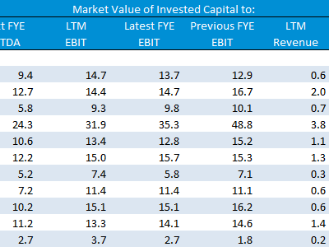Search for public companies with TagniFi Web. Simply enter your valuation date and ticker symbols in Excel to run a guideline public company method. Your Excel model populates instantly with the financial statements, analyst estimates, interest rates and economic data for your valuation date.

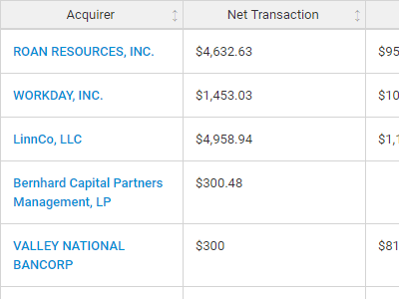**Better Transaction Comps**  
Search for public and private M&A transactions with TagniFi Web. Run your transaction comps within seconds by pasting the Deal ID into your Excel model. Every deal disclosed in an SEC filing (8-K, 10-K, or 10-Q) is available for your analysis. Choose from over 90 fields of data available for every deal.

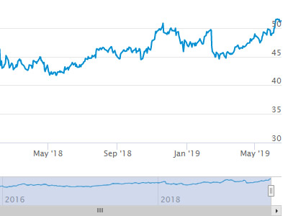

**Historical Beta and Volatility**Calculate historical beta and volatility as of your valuation date automatically. Simply enter the tickers and valuation date in Excel - TagniFi does the rest. In addition to beta and volatility, there are over 40 Excel models available in the Model Library to help with your valuation report.

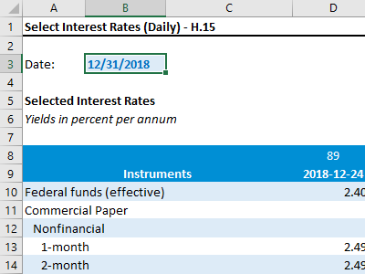**Interest Rates and Economic Data**Automate the interest rates and economic data in your valuation report using the TagniFi Excel plugin. Choose from over 200,000 time series available. All data in this *Quarterly Economic Update* is from the TagniFi platform. Use economic and interest rate data for your own valuation models with the TagniFi Excel plugin.

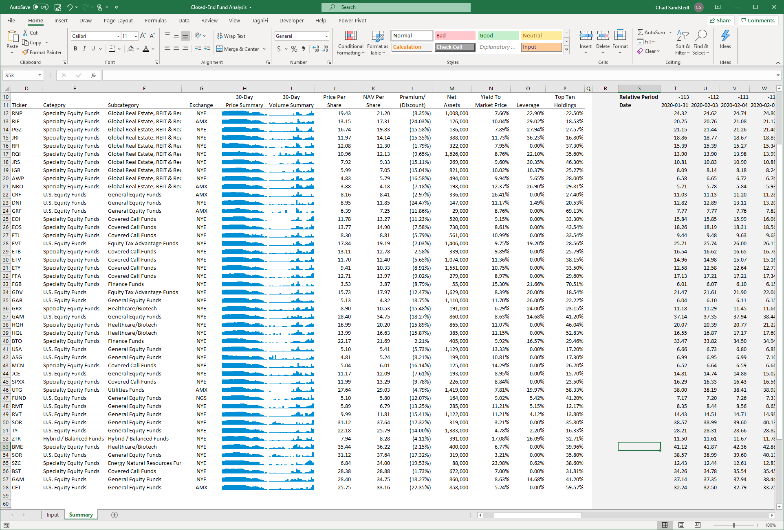

**Closed-End Mutual Fund Data**Search for closed-end mutual funds by keyword, category, subcategory, and more with the TagniFi Console. Use the TagniFi Excel plugin to calculate historical discounts, yields, leverage, as of your valuation date automatically. Simply enter the tickers and valuation date in Excel - TagniFi does the rest.

1. Federal Reserve Bank of Philadelphia, Coincident Economic Activity Index for the United States [USPHCI], *retrieved from FRED, Federal Reserve Bank of St. Louis;* [*https://fred.stlouisfed.org/series/USPHCI*](https://fred.stlouisfed.org/series/USPHCI)*, Jan 27, 2022.*
2. Board of Governors of the Federal Reserve System (US), Trade Weighted U.S. Dollar Index: Broad, Goods and Services [DTWEXBGS], *retrieved from FRED, Federal Reserve Bank of St. Louis;* [*https://fred.stlouisfed.org/series/DTWEXBGS*](https://fred.stlouisfed.org/series/DTWEXBGS)*, Jan 27, 2022.*
3. Federal Reserve Bank of Philadelphia, Coincident Economic Activity Index for the United States [USPHCI], *retrieved from FRED, Federal Reserve Bank of St. Louis;* [*https://fred.stlouisfed.org/series/USPHCI*](https://fred.stlouisfed.org/series/USPHCI)*, Jan 28, 2022.*
4. U.S. Bureau of the Census, Housing Starts: Total: New Privately Owned Housing Units Started [HOUST], *retrieved from FRED, Federal Reserve Bank of St. Louis;*[*https://fred.stlouisfed.org/series/HOUST*](https://fred.stlouisfed.org/series/HOUST)*, Jan 27, 2022.*
5. U.S. Bureau of Economic Analysis, Real Gross Domestic Product [GDPC1], *retrieved from FRED, Federal Reserve Bank of St. Louis;*[*https://fred.stlouisfed.org/series/GDPC1*](https://fred.stlouisfed.org/series/GDPC1)*, Jan 27, 2022.*
6. U.S. Bureau of Economic Analysis, Contributions to percent change in real gross domestic product: Gross private domestic investment [A006RY2Q224SBEA], *retrieved from FRED, Federal Reserve Bank of St. Louis;* [*https://fred.stlouisfed.org/series/A006RY2Q224SBEA*](https://fred.stlouisfed.org/series/A006RY2Q224SBEA)*, Jan 27, 2022.*
7. U.S. Bureau of Economic Analysis, Contributions to percent change in real gross domestic product: Personal consumption expenditures [DPCERY2Q224SBEA], *retrieved from FRED, Federal Reserve Bank of St. Louis;* [*https://fred.stlouisfed.org/series/DPCERY2Q224SBEA*](https://fred.stlouisfed.org/series/DPCERY2Q224SBEA)*, Jan 27, 2022.*
8. U.S. Bureau of Economic Analysis, Contributions to percent change in real gross domestic product: Government consumption expenditures and gross investment [A822RY2Q224SBEA], *retrieved from FRED, Federal Reserve Bank of St. Louis;* [*https://fred.stlouisfed.org/series/A822RY2Q224SBEA*](https://fred.stlouisfed.org/series/A822RY2Q224SBEA)*, Jan 27, 2022.*
9. U.S. Bureau of Economic Analysis, Contributions to percent change in real gross domestic product: Net exports of goods and services [A019RY2Q224SBEA], *retrieved from FRED, Federal Reserve Bank of St. Louis;* [*https://fred.stlouisfed.org/series/A019RY2Q224SBEA*](https://fred.stlouisfed.org/series/A019RY2Q224SBEA)*, Jan 27, 2022.*
10. Board of Governors of the Federal Reserve System (US), Industrial Production Index [INDPRO], *retrieved from FRED, Federal Reserve Bank of St. Louis;*[*https://fred.stlouisfed.org/series/INDPRO*](https://fred.stlouisfed.org/series/INDPRO)*, Nov 1, 2021.*
11. Board of Governors of the Federal Reserve System (US), Capacity Utilization, Manufacturing (NAICS), *retrieved from FRED, Federal Reserve Bank of St. Louis;* [*https://fred.stlouisfed.org/series/MCUMFN*](https://fred.stlouisfed.org/series/MCUMFN)*, Jan 27, 2022.*
12. Board of Governors of the Federal Reserve System (US), Federal Funds Effective Rate [FEDFUNDS], *retrieved from FRED, Federal Reserve Bank of St. Louis;* [*https://fred.stlouisfed.org/series/FEDFUNDS*](https://fred.stlouisfed.org/series/FEDFUNDS)*, Jan 27, 2022.*
13. Selected Interest Rates Instruments, Yields in percent per annum, *retrieved from FRED, Federal Reserve Bank of St. Louis;* [*https://fred.stlouisfed.org/release/tables?rid=18&eid=289&od=2021-09-30*](https://fred.stlouisfed.org/release/tables?rid=18&eid=289&od=2021-09-30)*, Jan 27, 2022.*
14. Board of Governors of the Federal Reserve System (US), Effective Federal Funds Rate [FEDFUNDS], *retrieved from FRED, Federal Reserve Bank of St. Louis;*[*https://fred.stlouisfed.org/series/FEDFUNDS*](https://fred.stlouisfed.org/series/FEDFUNDS)*, Jan 27, 2022.*
15. Board of Governors of the Federal Reserve System (US), 10-Year Treasury Constant Maturity Rate [DGS10], *retrieved from FRED, Federal Reserve Bank of St. Louis;*[*https://fred.stlouisfed.org/series/DGS10*](https://fred.stlouisfed.org/series/DGS10)*, Jan 27, 2022.*
16. Moody’s, Moody's Seasoned Baa Corporate Bond Yield [DBAA], *retrieved from FRED, Federal Reserve Bank of St. Louis;* [*https://fred.stlouisfed.org/series/DBAA*](https://fred.stlouisfed.org/series/DBAA)*, Jan 27, 2022.*
17. Moody’s, Moody's Seasoned Aaa Corporate Bond Yield [DAAA], *retrieved from FRED, Federal Reserve Bank of St. Louis;* [*https://fred.stlouisfed.org/series/DAAA*](https://fred.stlouisfed.org/series/DAAA)*, Jan 27, 2022.*
18. U.S. Bureau of Labor Statistics, Civilian Unemployment Rate [UNRATE], *retrieved from FRED, Federal Reserve Bank of St. Louis;*[*https://fred.stlouisfed.org/series/UNRATE*](https://fred.stlouisfed.org/series/UNRATE)*, Jan 27, 2022.*
19. U.S. Bureau of Labor Statistics, Civilian Labor Force Level [CLF16OV], *retrieved from FRED, Federal Reserve Bank of St. Louis;* [*https://fred.stlouisfed.org/series/CLF16OV*](https://fred.stlouisfed.org/series/CLF16OV)*, Jan 27, 2022.*
20. U.S. Bureau of Labor Statistics, Labor Force Participation Rate [CIVPART], *retrieved from FRED, Federal Reserve Bank of St. Louis;* [*https://fred.stlouisfed.org/series/CIVPART*](https://fred.stlouisfed.org/series/CIVPART)*, Jan 27, 2022.*
21. Federal Reserve Bank of Philadelphia, Livingston Survey, [*https://www.philadelphiafed.org/surveys-and-data/real-time-data-research/livingston-survey*](https://www.philadelphiafed.org/surveys-and-data/real-time-data-research/livingston-survey)*, Jan 27, 2022.*
22. U.S. Bureau of Labor Statistics, Quits: Total Nonfarm [JTSQUL], *retrieved from FRED, Federal Reserve Bank of St. Louis;* [*https://fred.stlouisfed.org/series/JTSQUL*](https://fred.stlouisfed.org/series/JTSQUL)*, Jan 28, 2022*.
23. U.S. Bureau of Labor Statistics Total Unemployed, Plus All Persons Marginally Attached to the Labor Force, Plus Total Employed Part Time for Economic Reasons, as a Percent of the Civilian Labor Force Plus All Persons Marginally Attached to the Labor Force (U-6) [U6RATE], *retrieved from FRED, Federal Reserve Bank of St. Louis;*[*https://fred.stlouisfed.org/series/U6RATE*](https://fred.stlouisfed.org/series/U6RATE)*, Jan 27, 2022.*
24. U.S. Bureau of Labor Statistics, All Employees: Total Nonfarm Payrolls [PAYEMS], *retrieved from FRED, Federal Reserve Bank of St. Louis;*[*https://fred.stlouisfed.org/series/PAYEMS*](https://fred.stlouisfed.org/series/PAYEMS)*, Jan 27, 2022.*
25. U.S. Bureau of Labor Statistics, Consumer Price Index for All Urban Consumers: All Items [CPIAUCSL], *retrieved from FRED, Federal Reserve Bank of St. Louis;*[*https://fred.stlouisfed.org/series/CPIAUCSL*](https://fred.stlouisfed.org/series/CPIAUCSL)*, Jan 27, 2022.*
26. U.S. Bureau of Labor Statistics, Consumer Price Index for All Urban Consumers: All Items Less Energy in U.S. City Average [CPILEGSL], *retrieved from FRED, Federal Reserve Bank of St. Louis;* [*https://fred.stlouisfed.org/series/CPILEGSL*](https://fred.stlouisfed.org/series/CPILEGSL)*, Jan 27, 2022*.
27. U.S. Bureau of Labor Statistics, Average Price: Gasoline, Unleaded Regular (Cost per Gallon/3.785 Liters) in U.S. City Average [APU000074714], *retrieved from FRED, Federal Reserve Bank of St. Louis;* [*https://fred.stlouisfed.org/series/APU000074714*](https://fred.stlouisfed.org/series/APU000074714)*, Jan 27, 2022.*
28. U.S. Bureau of Labor Statistics, Producer Price Index for All Commodities [PPIACO], *retrieved from FRED, Federal Reserve Bank of St. Louis;*[*https://fred.stlouisfed.org/series/PPIACO*](https://fred.stlouisfed.org/series/PPIACO)*, Jan 27, 2022.*
29. *Federal Reserve Bank of St. Louis, 5-Year Breakeven Inflation Rate [T5YIE], retrieved from FRED, Federal Reserve Bank of St. Louis;*[*https://fred.stlouisfed.org/series/T5YIE*](https://fred.stlouisfed.org/series/T5YIE)*, Jan 27, 2022.*
30. U.S. Energy Information Administration, Crude Oil Prices: West Texas Intermediate (WTI) - Cushing, Oklahoma [DCOILWTICO], *retrieved from FRED, Federal Reserve Bank of St. Louis;* [*https://fred.stlouisfed.org/series/DCOILWTICO*](https://fred.stlouisfed.org/series/DCOILWTICO)*, Jan 27, 2022.*
31. U.S. Bureau of the Census, Housing Starts: Total: New Privately Owned Housing Units Started [HOUST], *retrieved from FRED, Federal Reserve Bank of St. Louis;*[*https://fred.stlouisfed.org/series/HOUST*](https://fred.stlouisfed.org/series/HOUST)*, Jan 27, 2022.*
32. Freddie Mac, 30-Year Fixed Rate Mortgage Average in the United States [MORTGAGE30US], *retrieved from FRED, Federal Reserve Bank of St. Louis;*[*https://fred.stlouisfed.org/series/MORTGAGE30US*](https://fred.stlouisfed.org/series/MORTGAGE30US)*, Jan 27, 2022.*
33. S&P Dow Jones Indices LLC, S&P/Case-Shiller 20-City Composite Home Price Index [SPCS20RSA], *retrieved from FRED, Federal Reserve Bank of St. Louis;*[*https://fred.stlouisfed.org/series/SPCS20RSA*](https://fred.stlouisfed.org/series/SPCS20RSA)*, Jan 27, 2022.*
34. U.S. Bureau of Economic Analysis, Personal Consumption Expenditures [PCE], *retrieved from FRED, Federal Reserve Bank of St. Louis;*[*https://fred.stlouisfed.org/series/PCE*](https://fred.stlouisfed.org/series/PCE)*, Jan 27, 2022.*
35. U.S. Bureau of Economic Analysis, Light Weight Vehicle Sales: Autos and Light Trucks [ALTSALES], *retrieved from FRED, Federal Reserve Bank of St. Louis; <https://fred.stlouisfed.org/series/ALTSALES>, Jan 28, 2022.*
36. U.S. Bureau of Labor Statistics, Consumer Price Index for All Urban Consumers: New Vehicles in U.S. City Average [CUUR0000SETA01], *retrieved from FRED, Federal Reserve Bank of St. Louis;* [*https://fred.stlouisfed.org/series/CUUR0000SETA01*](https://fred.stlouisfed.org/series/CUUR0000SETA01)*, Jan 27, 2022.*
37. U.S. Bureau of Labor Statistics, Consumer Price Index for All Urban Consumers: Used Cars and Trucks in U.S. City Average [CUSR0000SETA02], *retrieved from FRED, Federal Reserve Bank of St. Louis;* [*https://fred.stlouisfed.org/series/CUSR0000SETA02*](https://fred.stlouisfed.org/series/CUSR0000SETA02), *Jan 27, 2022.*
38. *University of Michigan, University of Michigan: Consumer Sentiment [UMCSENT], retrieved from FRED, Federal Reserve Bank of St. Louis;* [*https://fred.stlouisfed.org/series/UMCSENT*](https://fred.stlouisfed.org/series/UMCSENT)*, Oct 30, 2021.*
39. *Chicago Board Options Exchange, CBOE Volatility Index: VIX [VIXCLS], retrieved from FRED, Federal Reserve Bank of St. Louis;* [*https://fred.stlouisfed.org/series/VIXCLS*](https://fred.stlouisfed.org/series/VIXCLS)*, Jan 27, 2022.*
40. *Federal Reserve Bank of St. Louis, FOMC Summary of Economic Projections for the Growth Rate of Real Gross Domestic Product [GDPC1CTM], retrieved from FRED, Federal Reserve Bank of St. Louis;*[*https://fred.stlouisfed.org/series/GDPC1CTM*](https://fred.stlouisfed.org/series/GDPC1CTM)*, Jan 27, 2022.*
41. *Federal Reserve Bank of St. Louis, FOMC Summary of Economic Projections for the Personal Consumption Expenditures Inflation Rate, Central Tendency, Midpoint [PCECTPICTM], retrieved from FRED, Federal Reserve Bank of St. Louis;*[*https://fred.stlouisfed.org/series/PCECTPICTM*](https://fred.stlouisfed.org/series/PCECTPICTM)*, Jan 27, 2022.*
42. *Federal Reserve Bank of St. Louis, FOMC Summary of Economic Projections for the Civilian Unemployment Rate, Central Tendency, Midpoint [UNRATECTM], retrieved from FRED, Federal Reserve Bank of St. Louis;*[*https://fred.stlouisfed.org/series/UNRATECTM*](https://fred.stlouisfed.org/series/UNRATECTM)*, Jan 27, 2022.*