QUARTERLY M&A UPDATE

For the 1st Quarter of 2022

Abstract

Designed for M&A and private equity professionals, TagniFi’s Quarterly   
M&A Update provides an overview of deal activity with key trends and activity levels.

# Q1 Highlights

U.S. M&A activity decreased noticeably in Q1 relative to Q4 yet remains well above the same quarter of 2021. There were 3,012 deals announced in Q1, a decrease of 11% compared to Q4 yet still up 23% over the same quarter last year.

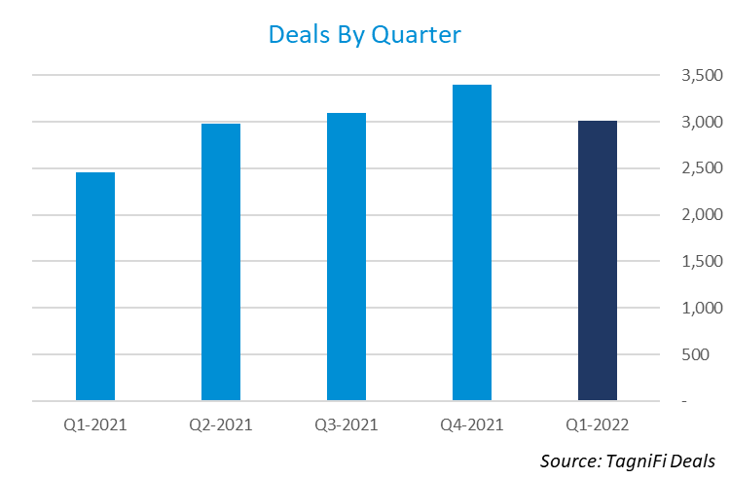

* There were 3,012 M&A deals announced in Q1.
* The total disclosed transaction value was $442 billion, down 19% from the $545 billion of deal value disclosed in Q4.
* California led the nation with 382 announced deals.
* The most popular deal type was the 100% Buyout which represented 41% of the announced deals.
* Private companies were the most popular acquirer type with 55% of the deals announced, up from 47% last quarter.
* The most active sector was Services with 63% of the deals announced, up from 60% last quarter.
* Integrity Marketing Group, LLC was the most acquisitive strategic buyer with 19 deals announced.
* Insight Partners was the most active financial buyer with 21 deals announced.
* Goldman Sachs was the most active financial advisor with 37 deals announced.
* Kirkland & Ellis LLP was the most active legal advisor with 86 deals announced.

# M&A Activity by State

Quarter-over-quarter deal activity declined in 36 states, increased in 9 states, and was unchanged in 5 states. Arkansas has the largest percentage gain in deal activity, up 63% compared to Q4 (13 vs. 8 deals). Minnesota was next with 39% growth in deal volume (50 vs. 36 deals). Other states that experienced an increase in announced deal volume were Delaware, Florida, Idaho, Illinois, Mississippi, Oregon, and Rhode Island.

California, Texas, and New York continued to lead the pack in Q1 with 419, 193, and 175 deals announced, respectively. Florida was next in line with 142 deals announced followed by Illinois with 116 deals and Massachusetts with 96 deals.



# M&A Activity by Deal Type

Q1 saw more 100% buyouts than any other deal type but they were down 19% compared to Q4. The number of add-on acquisitions increased by 3% over the prior quarter, indicating a shift away from new platforms towards enhancing existing portfolio companies. Minority stake deals also bucked the downward trend in Q1, increasing by 8% over Q4. Business division acquisitions saw the largest increase this quarter, up 38% over Q4. The hardest hit deal type for the quarter was growth capital which decreased by 75% compared to Q4.

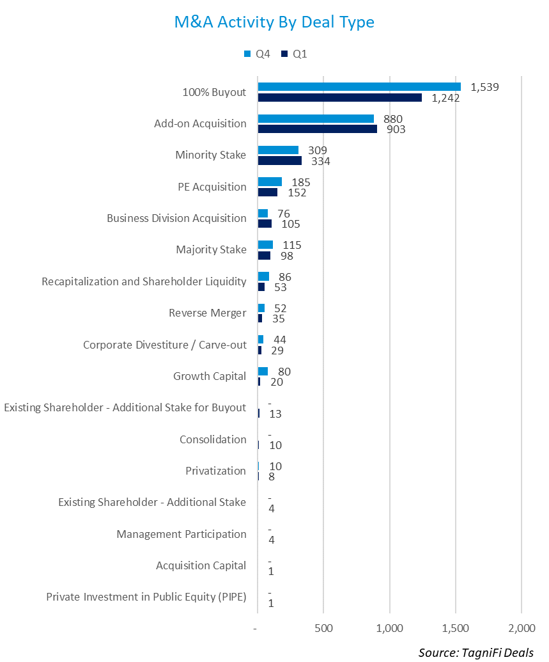

# M&A Activity by Acquirer Type

Private companies increased their share of deals announced in Q1 with 55% of all acquisitions being made by private companies, up from 47% in Q4. Public companies were involved in 25% of the deals announced in Q1, down 31% in Q4. Investors were involved in 20% of the deals in Q1, down from 22% in Q4.

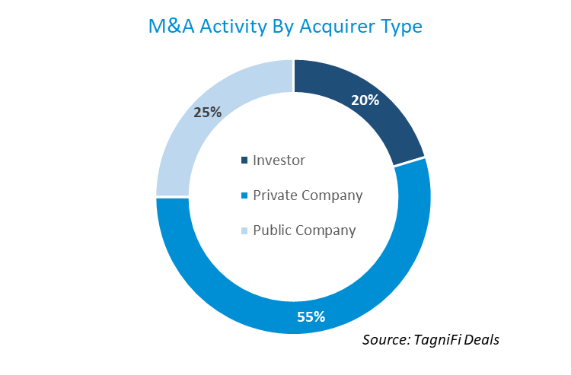

# Deal Activity by Sector

The Services sector continue to be the most active sector during Q1 with 1,733 deals announced representing 63% of all deals. This represents a decrease of 8% from Q4 when 1,882 deals were announced in the Services sector. The Trade sector was hit hardest in Q1, with deal announcements down 32% from Q4. The next worst performance was the Trade sector (retailers and distributors) which experienced a decline of 23% compared to Q4.

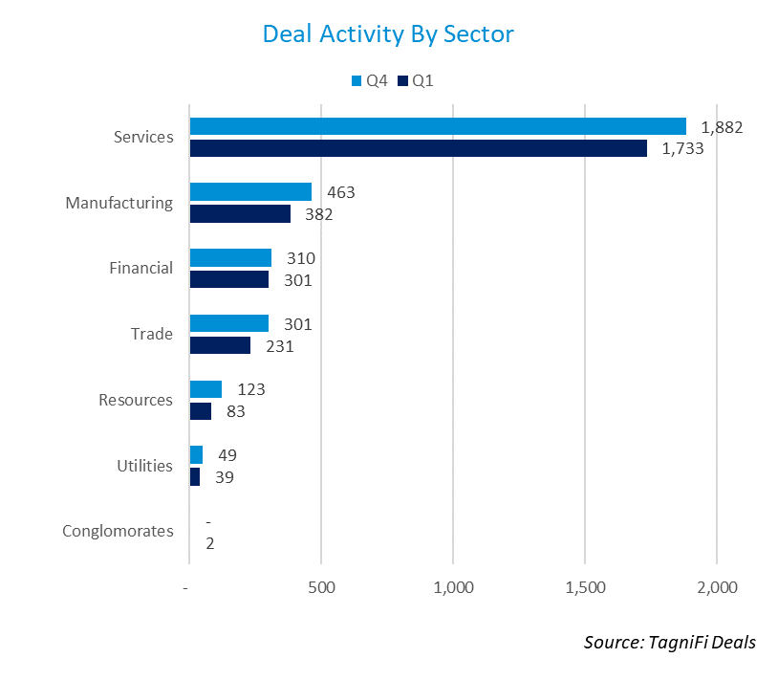

# Strategic Buyer Activity

There were 2,055 different strategic buyers with acquisition activity in Q1. This figure is down 6% from Q4 when 2,181 different strategic buyers announced an acquisition. Below is a chart of the most acquisitive strategic buyers during the quarter.

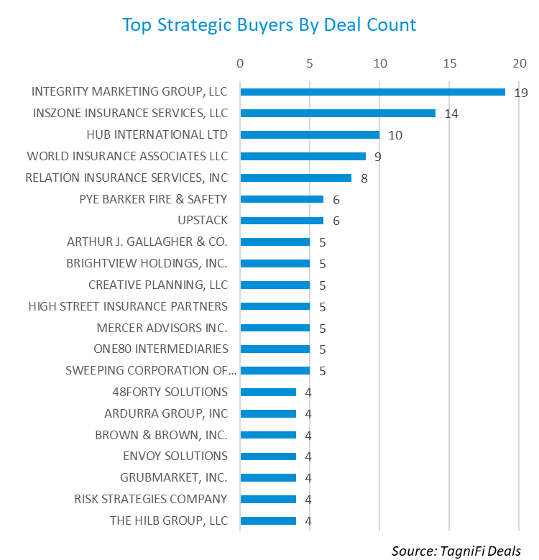

# Financial Buyer Activity

There were 392 different financial buyers with deal activity in Q1. This figure is down 17.1% from Q4 when 473 different financial buyers had deal activity. Below is a chart of the most active financial buyers during the quarter.

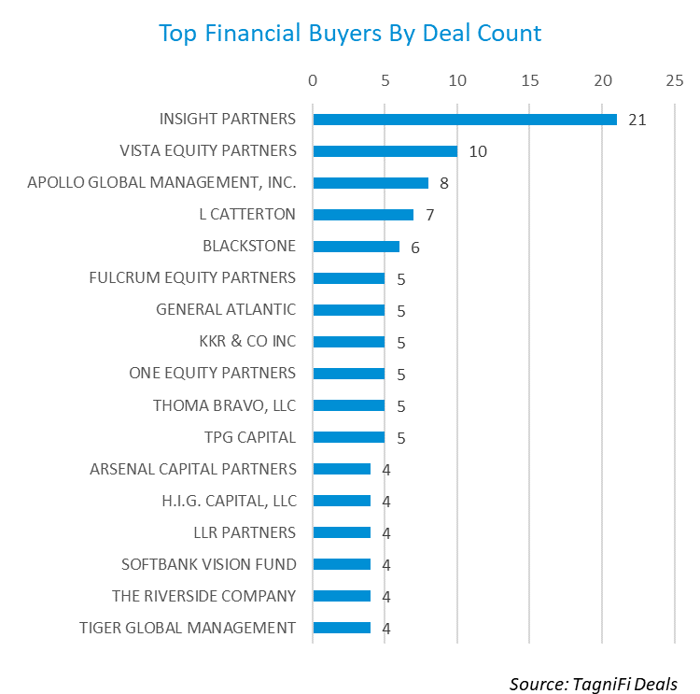

# Financial Advisor Activity

There were 349 different financial advisors disclosed on 989 transactions during Q1. This figure is down 35% from Q4 when 539 different financial advisors were disclosed in transactions. Below is a chart of the most active financial advisors during the quarter.

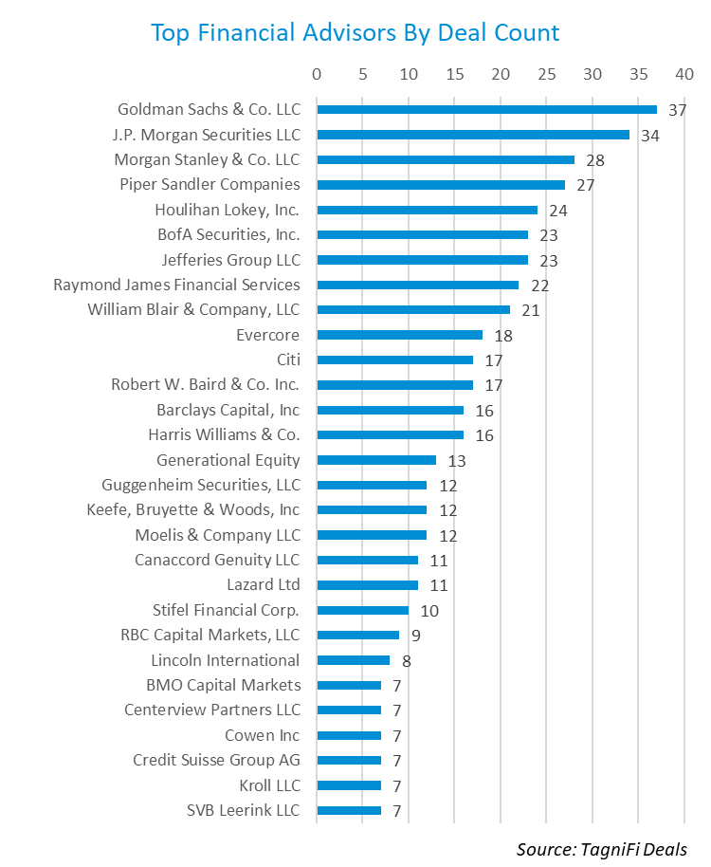

# Legal Advisor Activity

There were 339 different legal advisors disclosed in 1,001 transactions during Q1. This figure is down 14% from Q4 when 396 different legal advisors were disclosed in transactions. Below is a chart of the most active legal advisors during the quarter.

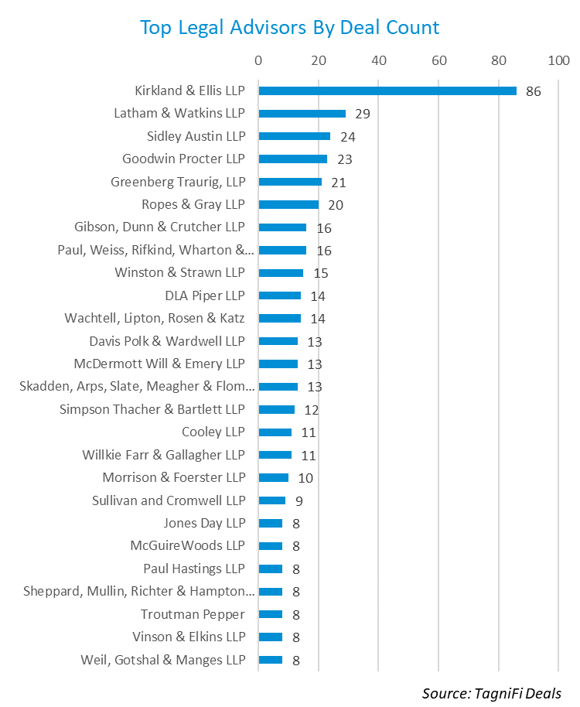

# About This Report

The *Quarterly M&A Update* is a free publication sponsored by TagniFi. You are free to share this report with your colleagues and clients. In fact, we would appreciate it if you would please forward this free report to a few friends to help us spread the word about TagniFi as an alternative data platform. We typically save our clients 85% when they make the switch from Capital IQ or PitchBook. Learn more or request a demo at [tagnifi.com](https://tagnifi.com).

As of the date of this report, the TagniFi platform includes data on the following:

* 8,982 public companies
* 74,469 private companies
* 48,417 M&A transactions
* 4,903 private equity investors
* 1,878 financial (M&A) advisors
* 1,742 legal advisors
* 26,377 private equity bios
* 15,371 financial and legal advisor bios
* 812,576 economic and industry time series

[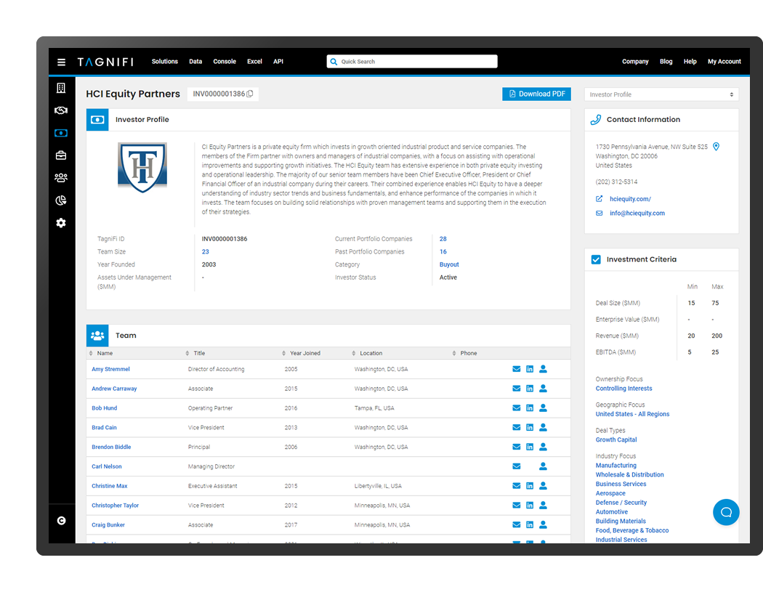](https://tagnifi.com)