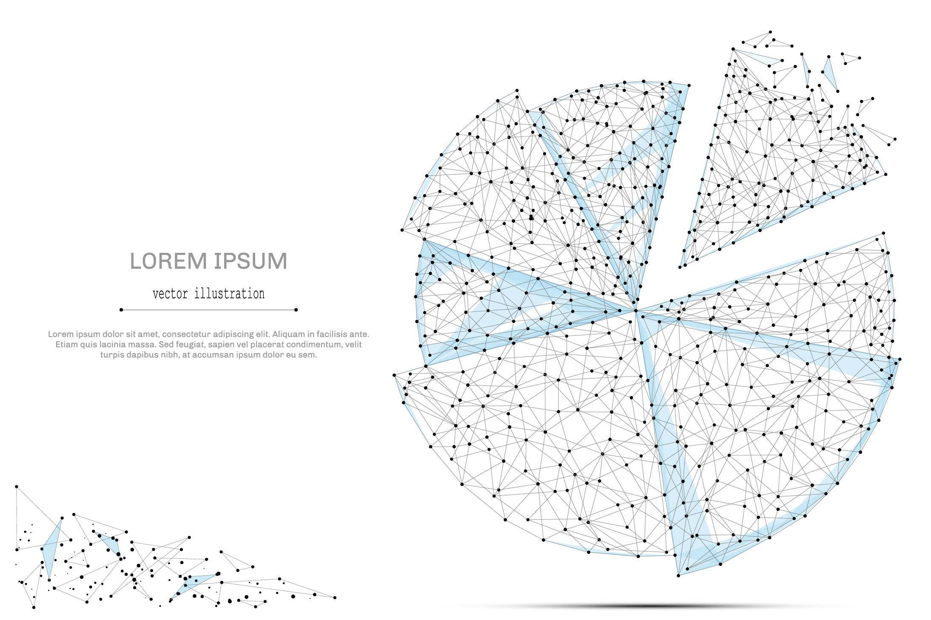

QUARTERLY ECONOMIC UPDATE

For the 1st Quarter of 2022

Abstract

Designed for business valuation professionals, TagniFi’s Quarterly Economic   
Update provides timely economic data to satisfy Revenue Ruling 56-60.

# Summary

In the 1st quarter of 2022, searing inflation, sky-high COVID-19 case counts from the extremely contagious Omicron variant, and a Russian war in Ukraine all took their toll on the U.S. economy. A gaping trade deficit and government spending pullbacks sent the value of national output into retreat for the first time since the pandemic’s initial economic wallop.

Counteracting powerful inflationary pressures without reversing the economic recovery continues to be a main challenge for the U.S. and globally. Supply chains across the globe remain encumbered. The Russian invasion of Ukraine shocked energy markets by provoking a U.S. embargo on Russian oil that sent gasoline prices over $4.00 for the first time since 2008. Consumer demand has thus far remained strong despite price pressures throughout the value chain being passed on to consumers; however, more than half of consumers now expect their financial situations to worsen over the coming year. The Federal Reserve warned that tightening monetary policy to curb inflation—namely, tapering its highly effective bond-buying program and beginning a series of interest rate hikes—would also constrain economic growth.

The labor market continued to be a bright spot in the economy during the 1st quarter of 2022, with the unemployment rate nearly reaching its pre-pandemic low while labor force participation climbed to within 1.0 percentage point of its pre-COVID level.

Amidst these challenges to economic recovery, the Omicron variant-dominant fifth wave of COVID-19 soared to a crescendo with more than three times as many daily cases as the previous peak one year earlier. Deaths per day remained more than 20 percent below the year-ago apex. By the end of the 1st quarter, the wave had receded, with daily case rates reaching a trough in late March and daily deaths on their way steeply down to follow.

Below is a summary timeline of key COVID-19 events in the U.S. during the 1st quarter of 2022:

|  |  |
| --- | --- |
| January 1, 2022 | U.S. begins the quarter at 420,755 daily cases, 1,245 daily deaths (7-day moving average). 62% of Americans are fully vaccinated; 22% have received an additional booster. |
| January 10, 2022 | U.S. exceeds 1 million daily COVID-19 cases. |
| January 15, 2022 | Fifth wave of COVID-19 in US peaks at 808,229 daily cases (7-day moving average). |
| January 31, 2022 | U.S. reaches 75 million total COVID-19 cases. |
| February 2, 2022 | Deaths from fifth wave of COVID-19 in U.S. peak at 2,682 daily (7-day moving average). |
| February 8, 2022 | U.S. reaches 900,000 total deaths from COVID-19. |
| February 11, 2022 | Pfizer and BioNTech delay emergency use authorization application for vaccine for children 6 months to 4 years old. |
| February 17, 2022 | 65% of Americans are fully vaccinated. |
| March 26, 2021 | Omicron BA.2 variant becomes dominant strain in U.S. according to CDC 1-week estimates. |
| March 31, 2021 | U.S. ends the quarter at 25,571 daily cases, 612 daily deaths (7-day moving average). 66% of Americans are fully vaccinated; 29% have received an additional booster. |

Despite the significantly mutated Omicron variant causing frequent “breakthrough infections” among vaccinated people, vaccines continued to prove highly effective at preventing serious illness and death. Although many in the U.S. are still unwilling to receive the shot and children under age 5 continue to await an approved vaccine, global vaccination efforts are pushing closer to the WHO’s 70% goal. Through worldwide vaccination and the huge numbers of people recently infected with the Omicron variant—including nearly 60 percent of the U.S. population—the pandemic is moving into a more controlled phase. Still, experts agree that the ever-mutating COVID-19 virus is not yet limited enough in deadliness and reach to be considered endemic, leaving governments still striving to balance virus control with opportunity for economic growth.

A multifactor indicator of economic strength, the Philadelphia Fed’s coincident index[1] of economic activity in the U.S. rose 0.5% in March 2022 and 1.4% during the 1st quarter. For the quarter, coincident indexes increased in 46 states, remained unchanged in 2 states, a declined in 2 states. Coincident indexes reflect unemployment, payroll employment, manufacturing hours, and wages and salaries.



The U.S. dollar index for goods and services[2] was virtually unchanged during the 1st quarter of 2022, inching up 0.03% to a level 1.06% higher than in March of 2021. The dollar dominated foreign exchange markets in early March after Russia waged war on the Ukraine, sending investors flocking toward low-risk investments, then regressed as peace negotiations and Ukraine’s defenses seemed more promising throughout the month. Meanwhile, inflation continued to intensify, pushing the Federal Reserve to its first target interest rate hike in more than 3 years. Fed officials signaled intentions for a forceful push against the mounting price pressures, bolstering the dollar’s position in the investment market.

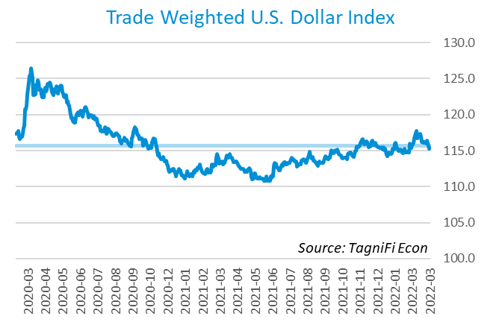

# Q1 Economic Highlights

* The Philadelphia Fed’s coincident index of economic activity in the U.S. rose 0.5% in March 2022 and 1.4% during the 1st quarter.
* Real GDP for the 1st quarter of 2022 declined at an annualized rate of 1.4%, a slide from the 4th quarter’s 6.9% gain and the first decrease since the 2nd quarter of 2020.
* The U.S. dollar index was virtually unchanged during the 1st quarter of 2022, inching up 0.03% to a level 1.06% higher than in March of 2021.
* The effective federal funds rate rose to 0.20% during the 1st quarter after remaining near zero since April 2020.
* The 1-year and 2-year annual treasury yields ended the 1st quarter at 1.63% and 2.28%, respectively. The benchmark 10-year treasury yielded 2.32% annually at the end of the quarter, while the 30-year treasury yielded 2.44%.
* Unemployment fell to 3.6% in March 2022, and nonfarm payroll employment grew by 1.7 million jobs in the 1st quarter.
* The Consumer Price Index rose 8.6% year-over-year in March, its fastest growth since December of 1981. Excluding volatile energy prices, the index rose 6.8%.
* Crude oil prices ended the period at $100.53 per barrel, 33.5% higher than one quarter earlier.
* New home starts rose to 1.79 million in March, up 2.2% for the quarter and 3.9% for the year.
* The NASDAQ Composite dropped 9.1% during the 1st quarter of 2022 and the Wilshire 5000 fell 8.5%. The S&P 500 was down 4.9% during the quarter and the Dow Jones Industrial Average was down 4.6%.

# Business Activity

Real gross domestic product (GDP)[3] for the 1st quarter of 2022 declined at an annualized rate of 1.4%, a slide from the 4th quarter’s 6.9% gain and the first decrease since the 2nd quarter of 2020. During the 1st quarter, a wave of COVID-19 fueled by the Omicron variant disrupted business operations in some regions while federal assistance dwindled, including the tapering of the Fed’s dovish bond-buying program. Meanwhile, blazing inflation, exacerbated by Russia’s invasion of the Ukraine, further constrained growth. Although the decrease in GDP disappointed economists’ expectations, underlying figures paint a less-dismal picture.

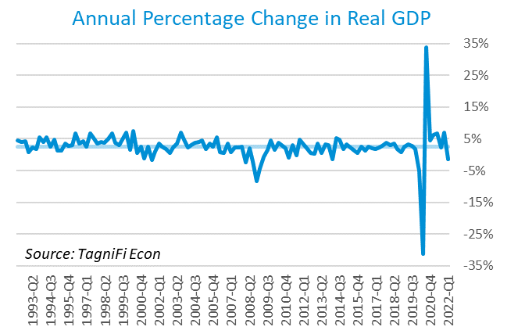

Net exports[4] were the leading contributor to the drop in GDP in the 1st quarter of 2022 with a negative 3.2% effect resulting from another strong advance in imports and a concurrent decrease in exports. While supply chains struggles persist, businesses are endeavoring to meet consumer demand. Falling government expenditures[5] at the federal level, including a notable drop in defense spending, as well as at the state and local level contributed an additional negative 0.5% to the 1st-quarter GDP decline.

Gross domestic private investment[6] had a small positive effect of 0.4% on the GDP in the 1st quarter of 2022; however, the sub-category of private inventories contributed negative 0.8% to the overall drop, falling in both the nonfarm and farm sectors. Fixed investment rose during the 1st quarter, particularly for equipment and intellectual property.

Personal consumption expenditures[7] (PCE) moderated the 1st quarter’s GDP decline with a positive 1.8% effect on real GDP. Growth in personal spending was led by broad increases in household services consumption including health care, financial services and insurance, and housing and utilities.

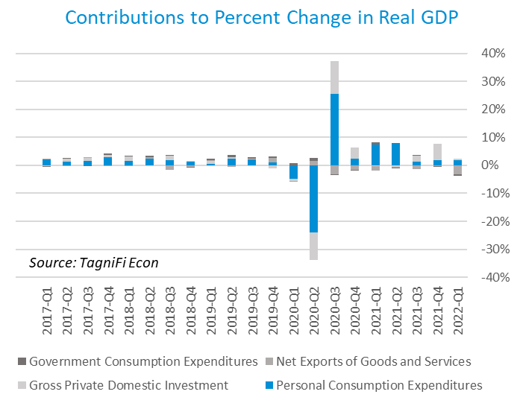

The Industrial Production Index[8] is an economic indicator that measures real output for all facilities located in the United States manufacturing, mining, and electric, and gas utilities. The index stood at 104.6 at the end of the 1st quarter, up 2.9% from the previous quarter.

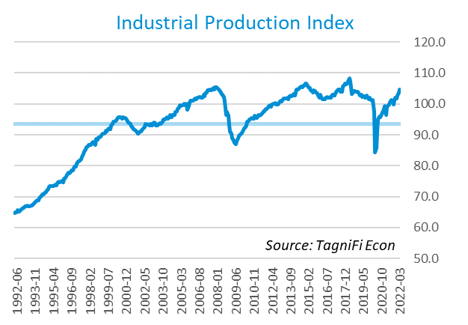

The Capacity Utilization Index[9], which attempts to capture industrial output as a percentage of the economy’s maximum production capacity, increased to 79.0% during the 1st quarter of 2022, its highest level since July 2007. March 2022’s level was above the 30-year average of 76.7% for this metric.

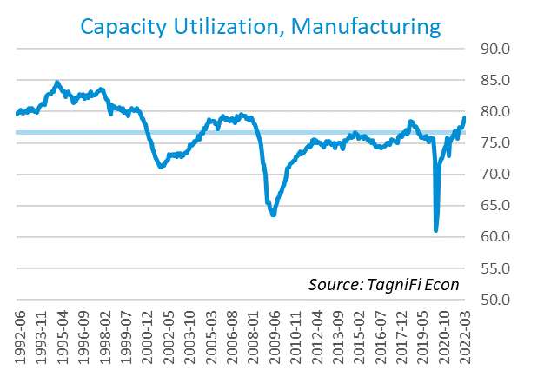

# Interest Rates

The effective federal funds rate[10] rose during the 1st quarter after remaining near zero since April 2020. Short-term treasury bond yields[11] rose accordingly during the 1st quarter. Long-term treasury yields rose to a lesser degree, resulting in a flatter-than-usual yield curve. The two- and ten-year rates inverted briefly at the end of March 2022, yet the ten-year rate quickly overtook the two-year rate again. The 1-year and 2-year annual treasury yields ended the 1st quarter at 1.63% and 2.28%, respectively. The benchmark 10-year treasury yielded 2.32% at the end of the quarter, while the 30-year treasury yielded 2.44%. See *Appendix – Selected Interest Rates* for detailed interest rate data.

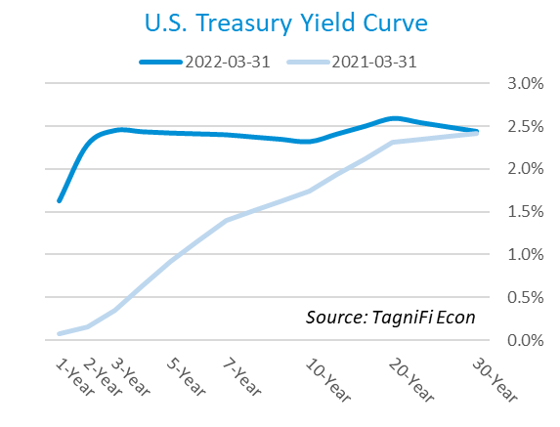

In the 1st quarter of 2022, the Federal Reserve enacted the first federal funds target rate hike since December 2018, an increase of 25 basis points to a range of 0.25% to 0.50%. The committee signaled an intention to continue raising target rates at each of the six remaining meetings in 2022. The effective federal funds rate[12] rose to 0.20% in March.

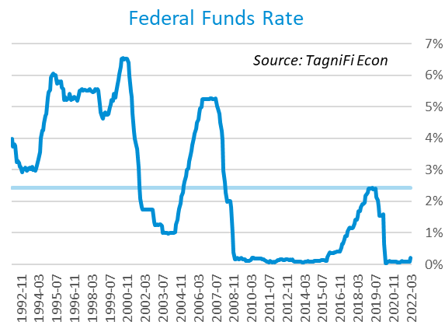

The yield on the benchmark 10-year U.S. treasury[13] ended the 1st quarter at 2.32%, up 0.8 percentage points from the previous quarter, but still well below the average yield of 4.01% over the last 30 years.

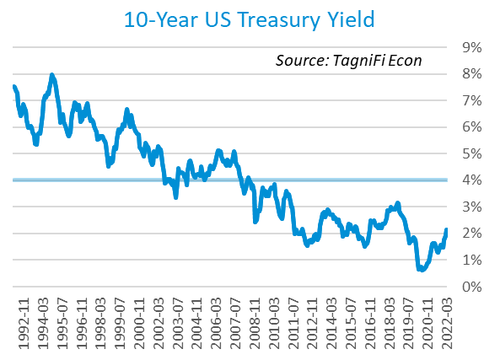

Moody’s Baa Corporate Bond Yield Index[14] ended the 1st quarter of 2022 at 4.25%, up 0.88% since the previous quarter. Moody’s less-risky Aaa[15] Index similarly rose 0.67% during the quarter to a level of 3.38%.

The upward pressure on corporate bond yields came at least in part due to policy moves by the Federal Reserve to cool searing inflation. The Fed followed through on promises to taper its pandemic-era quantitative easing program during the 1st quarter of 2022. The multi-billion-dollar bond buying program had effectively backstopped the corporate bond market since March of 2020—shortly after the program began, both the Baa and Aaa markets reversed the spikes brought on by the initial pandemic anxiety. In March, the Fed indicated that sales of its bond holdings could begin in the 2nd quarter of 2022.

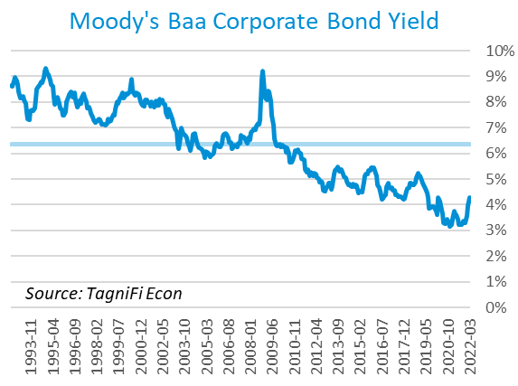

# Employment

The official unemployment rate[16] fell to 3.6% in March 2022, inching nearer to its pre-pandemic level and outperforming its 30-year average of 5.8%. Additionally, the labor force[17] increased by 2.1 million workers during the 1st quarter. The labor force participation rate[18] rose to 62.4%, climbing within 1.0 percentage point of its pre-pandemic level. Economists polled by the Livingston Survey[19] in December of 2021 had projected an unemployment rate of 4.0% in June 2022, declining to 3.8% in December of 2022.

In February 2022, nonfarm worker quits[20] stood at 4.4 million, almost 0.2 million lower than their record high in November 2021, yet 0.8 million higher than their pre-pandemic level. The number of quits rose 2.2% over the month and 26.5% since February 2021. The elevated level of quits, sometimes referred to as The Great Resignation, has been attributed to disparate reasons, with burnout, anxiety, and dissatisfaction arising from the COVID-19 pandemic on the one hand, and increased opportunities on the other. Job openings[21] totaled 11.3 million in February 2022, 0.2 million below their record high in December 2021 and 2.6 times the number of resignations.

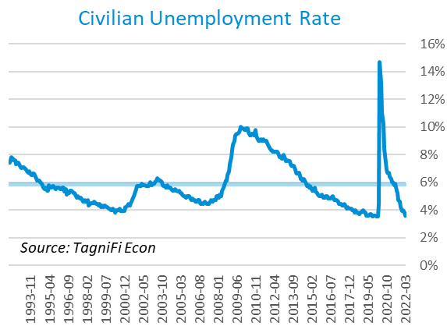

The U-6 unemployment rate[22] is an alternative measure of unemployment with a broader definition, including such groups as discouraged workers who are not actively searching for jobs but want full-time work and part-time workers who want full-time work. The U‑6 unemployment rate has generally followed the same pattern as the official rate; it fell to 6.9% in March 2022, reaching a level not seen since prior to the onset of the COVID-19 pandemic.

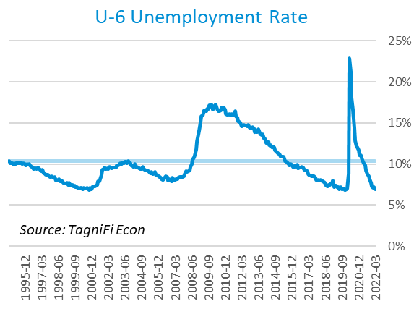

Nonfarm payrolls[23] grew by 1.7 million jobs in the 1st quarter. U.S. nonfarm payrolls in March 2022 totaled 150.9, up 6.5 million compared to the same period last year, yet still 1.6 million jobs below their pre-pandemic (February 2020) levels. The largest gains were recorded in the leisure and hospitality industry and the professional and business services industry.

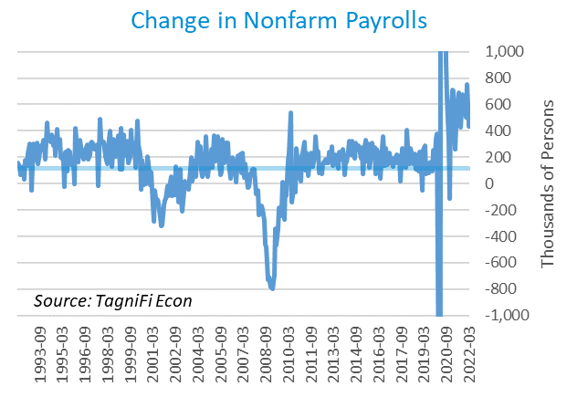

# Inflation

After many tame years, inflation is now at the forefront of the economic conversation. The Consumer Price Index[24] rose 8.6% year-over-year in March, its fastest growth since December of 1981. Excluding volatile energy prices[25], the index rose 6.8%. Notably, the price of a gallon of gas[26] jumped 54.5% from a national average of $2.79 in March 2021 to a record-high $4.31 in March 2022 after Russia’s invasion of Ukraine shocked energy markets and triggered a US import ban on Russian oil. In addition to gasoline, shelter and food prices were among the largest contributors to the severe inflation. The Federal Reserve has begun taking action to curb inflation, beginning a series of target interest rate hikes and reversing its massive bond-buying program.

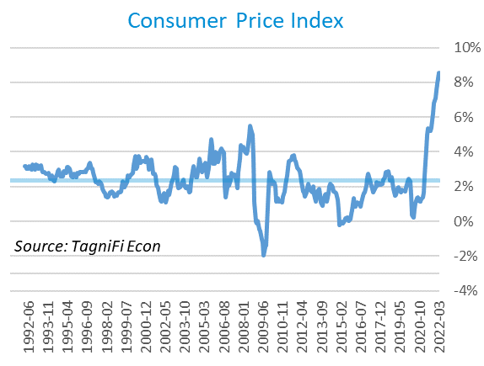

The Producer Price Index[27] rose 2.3% in March to a level 20.5% higher than March 2021, far outpacing the 2.6% average annual increase over the last 30 years.

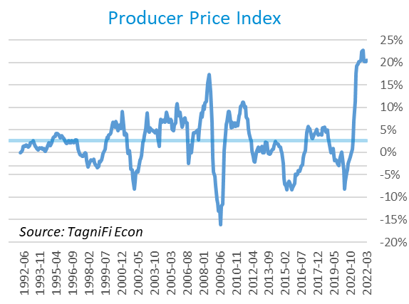

Treasury Inflation-Protected Securities (TIPS) are a longer-term Treasury debt instrument which pays a fixed interest rate but adjusts the principal value according to inflation, effectively indexing interest payments to inflation. TIPS have sold at a premium, reflecting higher inflation expectations; however, the Fed’s impending bond selloffs are expected to dilute the market. The 5-year breakeven inflation rate[28], an indicator for the market’s inflation expectations for the period, rose to 3.34% to end the 1st quarter from the 2.87% rate at the end of the 4th quarter.

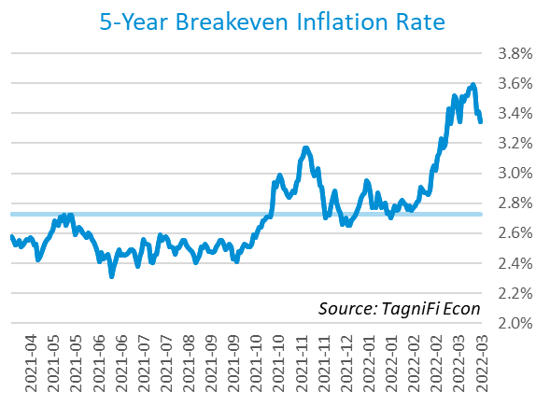

U.S. crude oil[29] prices spiked in March to their highest value since August 2008 when major players in the western market discussed joining the US in a Russian oil embargo following Russia’s invasion of the Ukraine. Prices retreated on a lack of unanimity in banning Russian oil products and moves by the US to replace some of the oil supply impacted by its embargo. Crude prices ended the quarter at $100.53 per barrel, 33.5% higher than one quarter earlier.

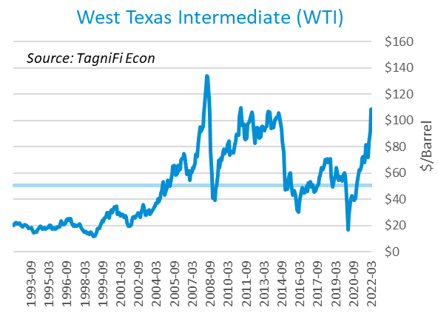

# Housing

In the ultra-tight housing market, the price pressures of record-low housing supply and a continually struggling supply chain now clash with rising mortgage rates, resulting in reduced affordability for first-time buyers. New home starts[30] rose to 1.79 million in March due to an increase in multifamily unit starts. Higher mortgage rates prompted a decline in single-family home starts in March. Total new home starts were up 2.2% for the quarter and 3.9% for the year, ending the 1st quarter at a level well above their 30-year average of 1.33 million.

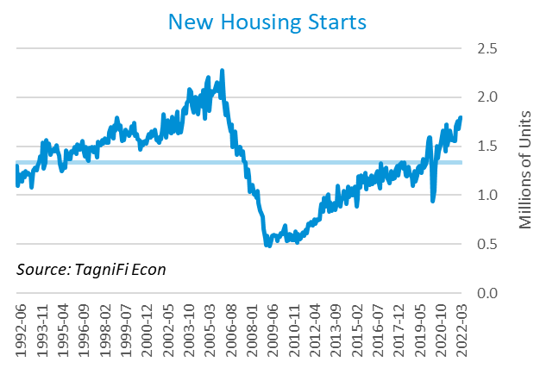

The cost of financing for would-be homebuyers jumped to its highest level in more than three years, with the 30-year fixed-rate mortgage[31] ending the 1st quarter at 4.67%.

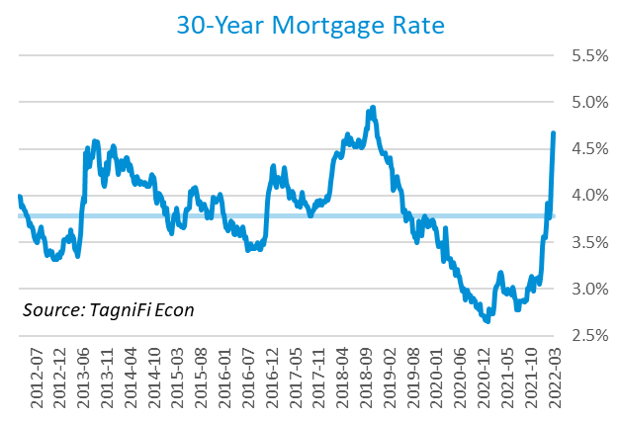

The S&P Case-Shiller Home Price Index (20-city)[32] rose 20.2% during the year ended February 2022, with all 20 cities reporting double-digit increases, led once again by Phoenix, Tampa, and Miami. February’s rise likely reflected a swell of buyers trying to secure some of the limited housing supply before the Fed’s widely expected interest rate hikes boosted mortgage rates in March.

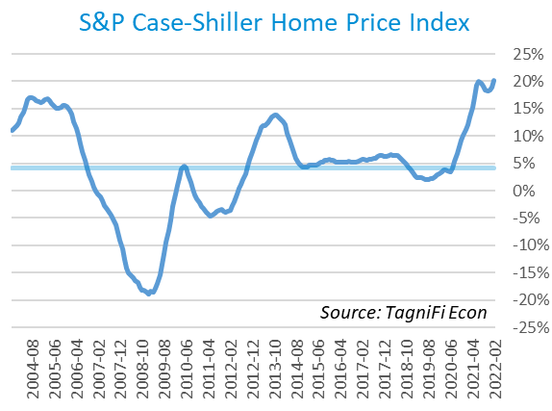

# Consumer Spending

Personal Consumption Expenditures (PCE)[33] rose 3.8% in the 1st quarter to $16.9 trillion. PCE were up 9.1% since the 1st quarter last year. Spending on services grew broadly, led by other services (a category including international travel) and food services and accommodations. Spending for goods also increased, specifically nondurable goods, led by energy goods including gasoline. A decrease in spending on durable goods, especially motor vehicles and parts, moderated the advance in PCE.

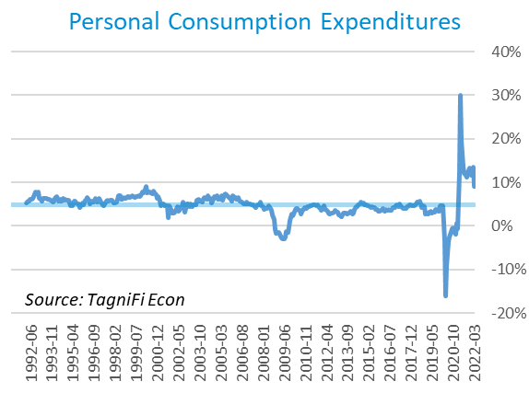

Auto manufacturers reported 13.3 million autos and light trucks sold[34] in March 2022, up 6.3% from December. New vehicle prices[35], built on their record high by a further 0.8% during the 1st quarter. In contrast, used car prices[36] fell 2.6% for the quarter.

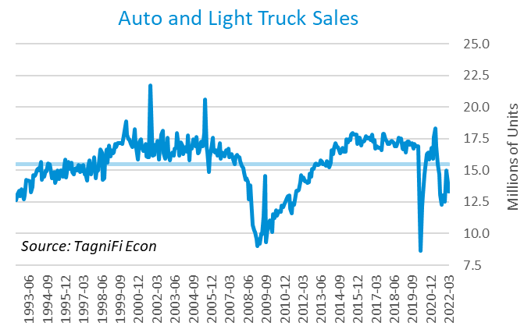

The University of Michigan’s consumer sentiment index[37] fell throughout the 1st quarter to 59.4, its lowest level since the summer of 2011. The decline primarily reflected expectations held by half of all consumers that inflation would erode their household incomes and reduce their living standards in the coming year. The consumer sentiment index in March stood far short of its 30-year average of 87.5.

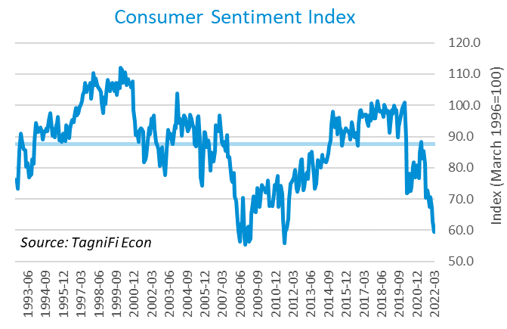

# Capital Markets

The table below shows the quarterly, year-to-date, and 12-month performance of major U.S. equity indices. Capital markets suffered losses in the 1st quarter of 2022 as investors anticipated a series of interest rate hikes from the Fed in response to still-surging inflation, as well as the geopolitical reaction to Russia’s invasion of Ukraine. The NASDAQ Composite dropped 9.1% druing the 1st quarter of 2022 and the Wilshire 5000 fell 8.5%. The S&P 500 was down 4.9% during the quarter and the Dow Jones Industrial Average was down 4.6%.



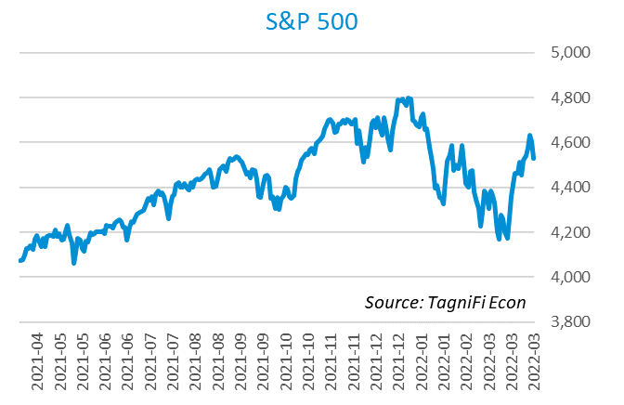

Stock market volatility, as measured by the VIX [38], ended the 1st quarter at 20.6, up 19.4% since the prior quarter. After climbing through most of February, the index reached a peak on March 7, as a 3rd round of peace talks between Ukraine and Russia proved fruitless, renewing concerns over global energy costs.

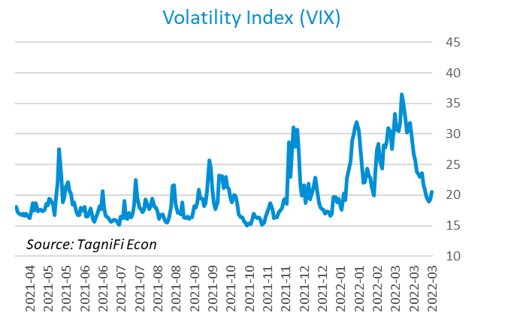

# Outlook

In March 2022, the FOMC revised their near-term inflation projections upward and real GDP projections downward; unemployment rate projections were little changed. Longer-run projections for all three indicators held relatively steady.

The FOMC revised their projection for real GDP[39] to 2.75% growth in 2022, slowing to 1.90% by 2024. They expected Personal Consumption Expenditures (PCE)[40] to grow 4.40% in 2022 but fall to 2.25% in 2024. They forecast that the unemployment rate[41] would be 3.50% in 2022 and 3.45% in 2024. Notably, the board projected swifter and steeper interest rate hikes than they did in December. The committee’s projections were reflective of the Fed’s intent to use monetary policy to cool searing inflation, a plan they expect to constrain GDP growth in the short term.



Appendix – Selected Interest Rates



# About This Report

The *Quarterly Economic Update* is a free publication sponsored by TagniFi. You are free to share this report and include its contents in the economic outlook section of your valuation reports as required by *Revenue Ruling 59-60*. Please forward this free report to a colleague to help us spread the word about TagniFi.

How TagniFi Helps Business Valuation Teams

TagniFi’s financial data platform empowers business valuation teams to quickly and easily build highly accurate financial models with full transparency—and within seconds.

**Better Public Comps**  
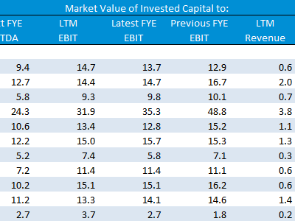Search for public companies with TagniFi Web. Simply enter your valuation date and ticker symbols in Excel to run a guideline public company method. Your Excel model populates instantly with the financial statements, analyst estimates, interest rates and economic data for your valuation date.

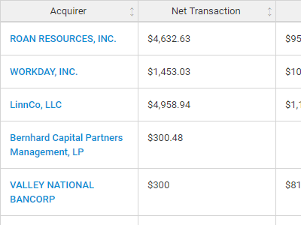**Better Transaction Comps**  
Search for public and private M&A transactions with TagniFi Web. Run your transaction comps within seconds by pasting the Deal ID into your Excel model. Every deal disclosed in an SEC filing (8-K, 10-K, or 10-Q) is available for your analysis. Choose from over 90 fields of data available for every deal.

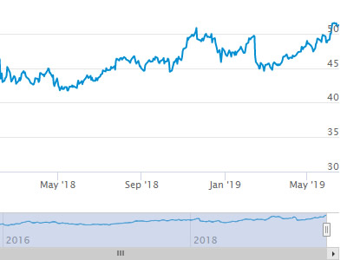

**Historical Beta and Volatility**Calculate historical beta and volatility as of your valuation date automatically. Simply enter the tickers and valuation date in Excel - TagniFi does the rest. In addition to beta and volatility, there are over 40 Excel models available in the Model Library to help with your valuation report.

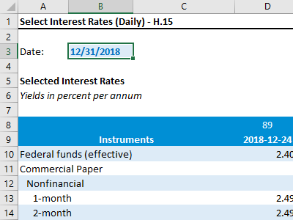**Interest Rates and Economic Data**Automate the interest rates and economic data in your valuation report using the TagniFi Excel plugin. Choose from over 200,000 time series available. All data in this *Quarterly Economic Update* is from the TagniFi platform. Use economic and interest rate data for your own valuation models with the TagniFi Excel plugin.

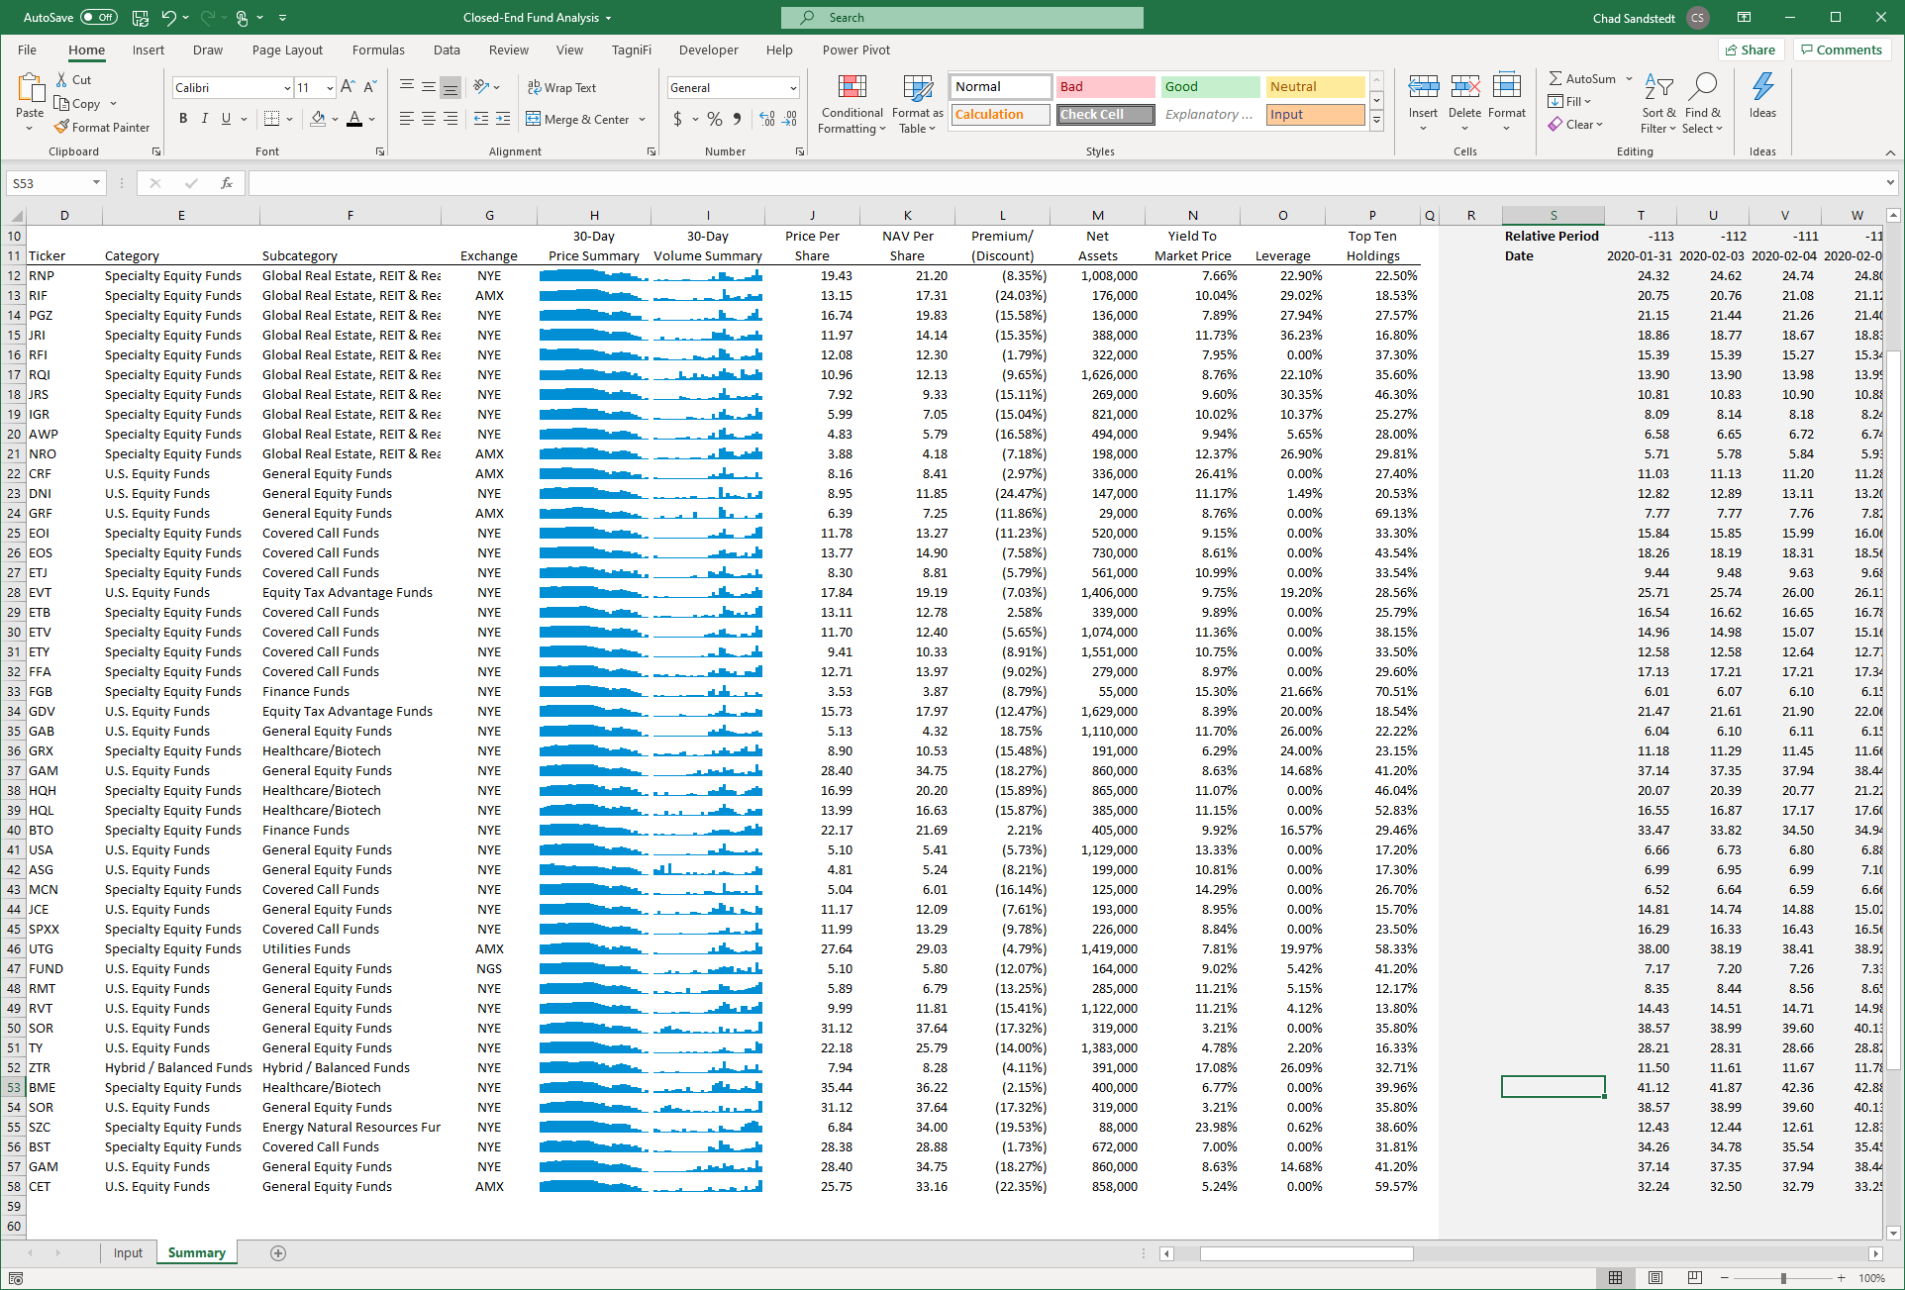

**Closed-End Mutual Fund Data**Search for closed-end mutual funds by keyword, category, subcategory, and more with the TagniFi Console. Use the TagniFi Excel plugin to calculate historical discounts, yields, leverage, as of your valuation date automatically. Simply enter the tickers and valuation date in Excel - TagniFi does the rest.

1. Federal Reserve Bank of Philadelphia, Coincident Economic Activity Index for the United States [USPHCI], *retrieved from FRED, Federal Reserve Bank of St. Louis;* [*https://fred.stlouisfed.org/series/USPHCI*](https://fred.stlouisfed.org/series/USPHCI)*, Apr 29, 2022.*
2. Board of Governors of the Federal Reserve System (US), Trade Weighted U.S. Dollar Index: Broad, Goods and Services [DTWEXBGS], *retrieved from FRED, Federal Reserve Bank of St. Louis;* [*https://fred.stlouisfed.org/series/DTWEXBGS*](https://fred.stlouisfed.org/series/DTWEXBGS)*, Apr 29, 2022.*
3. U.S. Bureau of Economic Analysis, Real Gross Domestic Product [GDPC1], *retrieved from FRED, Federal Reserve Bank of St. Louis;*[*https://fred.stlouisfed.org/series/GDPC1*](https://fred.stlouisfed.org/series/GDPC1)*, Apr 29, 2022.*
4. U.S. Bureau of Economic Analysis, Contributions to percent change in real gross domestic product: Net exports of goods and services [A019RY2Q224SBEA], *retrieved from FRED, Federal Reserve Bank of St. Louis;* [*https://fred.stlouisfed.org/series/A019RY2Q224SBEA*](https://fred.stlouisfed.org/series/A019RY2Q224SBEA)*, Apr 29, 2022.*
5. U.S. Bureau of Economic Analysis, Contributions to percent change in real gross domestic product: Government consumption expenditures and gross investment [A822RY2Q224SBEA], *retrieved from FRED, Federal Reserve Bank of St. Louis;* [*https://fred.stlouisfed.org/series/A822RY2Q224SBEA*](https://fred.stlouisfed.org/series/A822RY2Q224SBEA)*, Apr 29, 2022.*
6. U.S. Bureau of Economic Analysis, Contributions to percent change in real gross domestic product: Gross private domestic investment [A006RY2Q224SBEA], *retrieved from FRED, Federal Reserve Bank of St. Louis;* [*https://fred.stlouisfed.org/series/A006RY2Q224SBEA*](https://fred.stlouisfed.org/series/A006RY2Q224SBEA)*, Apr 29, 2022.*
7. U.S. Bureau of Economic Analysis, Contributions to percent change in real gross domestic product: Personal consumption expenditures [DPCERY2Q224SBEA], *retrieved from FRED, Federal Reserve Bank of St. Louis;* [*https://fred.stlouisfed.org/series/DPCERY2Q224SBEA*](https://fred.stlouisfed.org/series/DPCERY2Q224SBEA)*, Apr 29, 2022.*
8. Board of Governors of the Federal Reserve System (US), Industrial Production Index [INDPRO], *retrieved from FRED, Federal Reserve Bank of St. Louis;*[*https://fred.stlouisfed.org/series/INDPRO*](https://fred.stlouisfed.org/series/INDPRO)*, Apr 29, 2022.*
9. Board of Governors of the Federal Reserve System (US), Capacity Utilization, Manufacturing (NAICS), *retrieved from FRED, Federal Reserve Bank of St. Louis;* [*https://fred.stlouisfed.org/series/MCUMFN*](https://fred.stlouisfed.org/series/MCUMFN)*, Apr 29, 2022.*
10. Board of Governors of the Federal Reserve System (US), Federal Funds Effective Rate [FEDFUNDS], *retrieved from FRED, Federal Reserve Bank of St. Louis;* [*https://fred.stlouisfed.org/series/FEDFUNDS*](https://fred.stlouisfed.org/series/FEDFUNDS)*, Apr 29, 2022.*
11. Selected Interest Rates Instruments, Yields in percent per annum, *retrieved from FRED, Federal Reserve Bank of St. Louis;* [*https://fred.stlouisfed.org/release/tables?rid=18&eid=289&od=2021-09-30*](https://fred.stlouisfed.org/release/tables?rid=18&eid=289&od=2021-09-30)*, Apr 29, 2022.*
12. Board of Governors of the Federal Reserve System (US), Federal Funds Target Range - Upper Limit [DFEDTARU], *retrieved from FRED, Federal Reserve Bank of St. Louis;* [*https://fred.stlouisfed.org/series/DFEDTARU*](https://fred.stlouisfed.org/series/DFEDTARU)*, Apr 29, 2022*.
13. Board of Governors of the Federal Reserve System (US), 10-Year Treasury Constant Maturity Rate [DGS10], *retrieved from FRED, Federal Reserve Bank of St. Louis;*[*https://fred.stlouisfed.org/series/DGS10*](https://fred.stlouisfed.org/series/DGS10)*, Apr 29, 2022.*
14. Moody’s, Moody's Seasoned Baa Corporate Bond Yield [DBAA], *retrieved from FRED, Federal Reserve Bank of St. Louis;* [*https://fred.stlouisfed.org/series/DBAA*](https://fred.stlouisfed.org/series/DBAA)*, Apr 29, 2022.*
15. Moody’s, Moody's Seasoned Aaa Corporate Bond Yield [DAAA], *retrieved from FRED, Federal Reserve Bank of St. Louis;* [*https://fred.stlouisfed.org/series/DAAA*](https://fred.stlouisfed.org/series/DAAA)*, Apr 29, 2022.*
16. U.S. Bureau of Labor Statistics, Civilian Unemployment Rate [UNRATE], *retrieved from FRED, Federal Reserve Bank of St. Louis;*[*https://fred.stlouisfed.org/series/UNRATE*](https://fred.stlouisfed.org/series/UNRATE)*, Apr 29, 2022.*
17. U.S. Bureau of Labor Statistics, Civilian Labor Force Level [CLF16OV], *retrieved from FRED, Federal Reserve Bank of St. Louis;* [*https://fred.stlouisfed.org/series/CLF16OV*](https://fred.stlouisfed.org/series/CLF16OV)*, Apr 29, 2022.*
18. U.S. Bureau of Labor Statistics, Labor Force Participation Rate [CIVPART], *retrieved from FRED, Federal Reserve Bank of St. Louis;* [*https://fred.stlouisfed.org/series/CIVPART*](https://fred.stlouisfed.org/series/CIVPART)*, Apr 29, 2022.*
19. Federal Reserve Bank of Philadelphia, Livingston Survey, [*https://www.philadelphiafed.org/surveys-and-data/real-time-data-research/livingston-survey*](https://www.philadelphiafed.org/surveys-and-data/real-time-data-research/livingston-survey)*, Apr 29, 2022.*
20. U.S. Bureau of Labor Statistics, Quits: Total Nonfarm [JTSQUL], *retrieved from FRED, Federal Reserve Bank of St. Louis;* [*https://fred.stlouisfed.org/series/JTSQUL*](https://fred.stlouisfed.org/series/JTSQUL)*, Apr 29, 2022*.
21. U.S. Bureau of Labor Statistics, Job Openings: Total Nonfarm [JTSJOL], *retrieved from FRED, Federal Reserve Bank of St. Louis;* [*https://fred.stlouisfed.org/series/JTSJOL*](https://fred.stlouisfed.org/series/JTSJOL)*, Apr 29, 2022.*
22. U.S. Bureau of Labor Statistics Total Unemployed, Plus All Persons Marginally Attached to the Labor Force, Plus Total Employed Part Time for Economic Reasons, as a Percent of the Civilian Labor Force Plus All Persons Marginally Attached to the Labor Force (U-6) [U6RATE], *retrieved from FRED, Federal Reserve Bank of St. Louis;*[*https://fred.stlouisfed.org/series/U6RATE*](https://fred.stlouisfed.org/series/U6RATE)*, Apr 29, 2022.*
23. U.S. Bureau of Labor Statistics, All Employees: Total Nonfarm Payrolls [PAYEMS], *retrieved from FRED, Federal Reserve Bank of St. Louis;*[*https://fred.stlouisfed.org/series/PAYEMS*](https://fred.stlouisfed.org/series/PAYEMS)*, Apr 29, 2022.*
24. U.S. Bureau of Labor Statistics, Consumer Price Index for All Urban Consumers: All Items [CPIAUCSL], *retrieved from FRED, Federal Reserve Bank of St. Louis;*[*https://fred.stlouisfed.org/series/CPIAUCSL*](https://fred.stlouisfed.org/series/CPIAUCSL)*, Apr 29, 2022.*
25. U.S. Bureau of Labor Statistics, Consumer Price Index for All Urban Consumers: All Items Less Energy in U.S. City Average [CPILEGSL], *retrieved from FRED, Federal Reserve Bank of St. Louis;* [*https://fred.stlouisfed.org/series/CPILEGSL*](https://fred.stlouisfed.org/series/CPILEGSL)*, Apr 29 2022*.
26. U.S. Bureau of Labor Statistics, Average Price: Gasoline, Unleaded Regular (Cost per Gallon/3.785 Liters) in U.S. City Average [APU000074714], *retrieved from FRED, Federal Reserve Bank of St. Louis;* [*https://fred.stlouisfed.org/series/APU000074714*](https://fred.stlouisfed.org/series/APU000074714)*, Apr 29, 2022.*
27. U.S. Bureau of Labor Statistics, Producer Price Index for All Commodities [PPIACO], *retrieved from FRED, Federal Reserve Bank of St. Louis;*[*https://fred.stlouisfed.org/series/PPIACO*](https://fred.stlouisfed.org/series/PPIACO)*, Apr 29, 2022.*
28. *Federal Reserve Bank of St. Louis, 5-Year Breakeven Inflation Rate [T5YIE], retrieved from FRED, Federal Reserve Bank of St. Louis;*[*https://fred.stlouisfed.org/series/T5YIE*](https://fred.stlouisfed.org/series/T5YIE)*, Apr 29, 2022.*
29. U.S. Energy Information Administration, Crude Oil Prices: West Texas Intermediate (WTI) - Cushing, Oklahoma [DCOILWTICO], *retrieved from FRED, Federal Reserve Bank of St. Louis;* [*https://fred.stlouisfed.org/series/DCOILWTICO*](https://fred.stlouisfed.org/series/DCOILWTICO)*, Apr 29, 2022.*
30. U.S. Bureau of the Census, Housing Starts: Total: New Privately Owned Housing Units Started [HOUST], *retrieved from FRED, Federal Reserve Bank of St. Louis;*[*https://fred.stlouisfed.org/series/HOUST*](https://fred.stlouisfed.org/series/HOUST)*, Apr 29, 2022.*
31. Freddie Mac, 30-Year Fixed Rate Mortgage Average in the United States [MORTGAGE30US], *retrieved from FRED, Federal Reserve Bank of St. Louis;*[*https://fred.stlouisfed.org/series/MORTGAGE30US*](https://fred.stlouisfed.org/series/MORTGAGE30US)*, Apr 29, 2022.*
32. S&P Dow Jones Indices LLC, S&P/Case-Shiller 20-City Composite Home Price Index [SPCS20RSA], *retrieved from FRED, Federal Reserve Bank of St. Louis;*[*https://fred.stlouisfed.org/series/SPCS20RSA*](https://fred.stlouisfed.org/series/SPCS20RSA)*, Apr 29, 2022.*
33. U.S. Bureau of Economic Analysis, Personal Consumption Expenditures [PCE], *retrieved from FRED, Federal Reserve Bank of St. Louis;*[*https://fred.stlouisfed.org/series/PCE*](https://fred.stlouisfed.org/series/PCE)*, Apr 29, 2022.*
34. U.S. Bureau of Economic Analysis, Light Weight Vehicle Sales: Autos and Light Trucks [ALTSALES], *retrieved from FRED, Federal Reserve Bank of St. Louis; <https://fred.stlouisfed.org/series/ALTSALES>, Apr 29, 2022.*
35. U.S. Bureau of Labor Statistics, Consumer Price Index for All Urban Consumers: New Vehicles in U.S. City Average [CUUR0000SETA01], *retrieved from FRED, Federal Reserve Bank of St. Louis;* [*https://fred.stlouisfed.org/series/CUUR0000SETA01*](https://fred.stlouisfed.org/series/CUUR0000SETA01)*, Apr 29, 2022.*
36. U.S. Bureau of Labor Statistics, Consumer Price Index for All Urban Consumers: Used Cars and Trucks in U.S. City Average [CUSR0000SETA02], *retrieved from FRED, Federal Reserve Bank of St. Louis;* [*https://fred.stlouisfed.org/series/CUSR0000SETA02*](https://fred.stlouisfed.org/series/CUSR0000SETA02), *Apr 29, 2022.*
37. *University of Michigan, University of Michigan: Consumer Sentiment [UMCSENT], retrieved from FRED, Federal Reserve Bank of St. Louis;* [*https://fred.stlouisfed.org/series/UMCSENT*](https://fred.stlouisfed.org/series/UMCSENT)*, Apr 29, 2022.*
38. *Chicago Board Options Exchange, CBOE Volatility Index: VIX [VIXCLS], retrieved from FRED, Federal Reserve Bank of St. Louis;* [*https://fred.stlouisfed.org/series/VIXCLS*](https://fred.stlouisfed.org/series/VIXCLS)*, Apr 29, 2022.*
39. *Federal Reserve Bank of St. Louis, FOMC Summary of Economic Projections for the Growth Rate of Real Gross Domestic Product [GDPC1CTM], retrieved from FRED, Federal Reserve Bank of St. Louis;*[*https://fred.stlouisfed.org/series/GDPC1CTM*](https://fred.stlouisfed.org/series/GDPC1CTM)*, Apr 29, 2022.*
40. *Federal Reserve Bank of St. Louis, FOMC Summary of Economic Projections for the Personal Consumption Expenditures Inflation Rate, Central Tendency, Midpoint [PCECTPICTM], retrieved from FRED, Federal Reserve Bank of St. Louis;*[*https://fred.stlouisfed.org/series/PCECTPICTM*](https://fred.stlouisfed.org/series/PCECTPICTM)*, Apr 29, 2022.*
41. *Federal Reserve Bank of St. Louis, FOMC Summary of Economic Projections for the Civilian Unemployment Rate, Central Tendency, Midpoint [UNRATECTM], retrieved from FRED, Federal Reserve Bank of St. Louis;*[*https://fred.stlouisfed.org/series/UNRATECTM*](https://fred.stlouisfed.org/series/UNRATECTM)*, Apr 29, 2022.*