QUARTERLY M&A UPDATE

For the 2nd Quarter of 2022

Abstract

Designed for M&A and private equity professionals, TagniFi’s Quarterly   
M&A Update provides an overview of deal activity with key trends and activity levels.

# Q2 Highlights

U.S. M&A activity continued its decline in Q2 due to increased borrowing costs and reduced valuation multiples, ending the quarter down 12% from Q1 as well as compared to the same quarter last year. There were 2,639 deals announced in Q2, a decrease of 22% compared to the record number of deals reported in Q4 when 3,400 deals were announced.

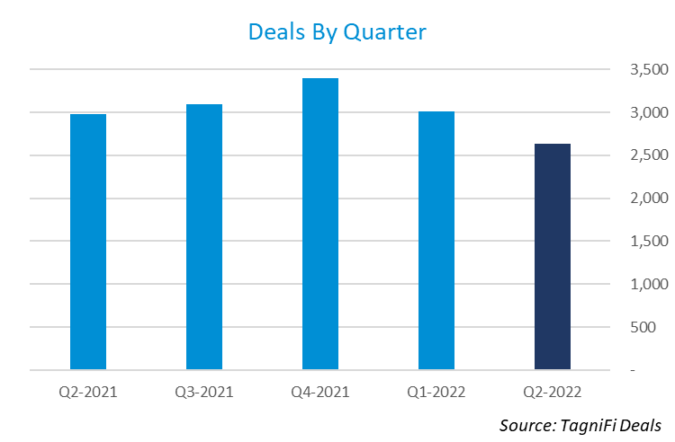

* There were 2,639 M&A deals announced in Q2.
* The total disclosed transaction value was $451 billion, up 2% from the $442 billion of deal value disclosed in Q1.
* California led the nation with 381 announced deals.
* The most popular deal type was the 100% Buyout which represented 40% of the announced deals.
* Private companies were the most popular acquirer type with 56% of the deals announced, up from 55% last quarter.
* The most active sector was Services with 61% of the deals announced, down from 63% last quarter.
* Arthur J. Gallagher & Co. was the most acquisitive public strategic buyer with 9 deals announced.
* HUB International Ltd. was the most acquisitive private strategic buyer with 14 deals announced.
* Advent International was the most active financial buyer with 7 deals announced.
* Goldman Sachs was the most active financial advisor with 31 deals announced.
* Kirkland & Ellis LLP was the most active legal advisor with 87 deals announced.

# M&A Activity by State

Quarter-over-quarter deal activity declined in 36 states, increased in 13 states, and was unchanged in 1 state. Connecticut had the largest gain in deal activity, gaining 15 deals compared to Q1. North Carolina and Tennessee were next with an increase of 13 and 12 deals over the quarter, respectively.

California add Texas continued to lead the pack in Q2 with 381 and 147 deals announced, respectively. Florida moved up the list to 3rd place in deal volume with 141 deals announced in Q2. New York was next in line with 139 deals announced followed by Massachusetts with 85 deals and Illinois with 73 deals.



# M&A Activity by Deal Type

Q2 saw more 100% buyouts than any other deal type but they were down 15% compared to Q1. The number of add-on acquisitions decreased by only 9% from the prior quarter, indicating a continued shift from new platforms towards enhancing value through existing portfolio companies. Minority stake deals were also down in Q2, declining by 21% from Q1. Growth Capital deals saw the largest increase this quarter, up 95% over Q1. Corporate divestitures also experienced an increase in deal activity, up 31% for the quarter.

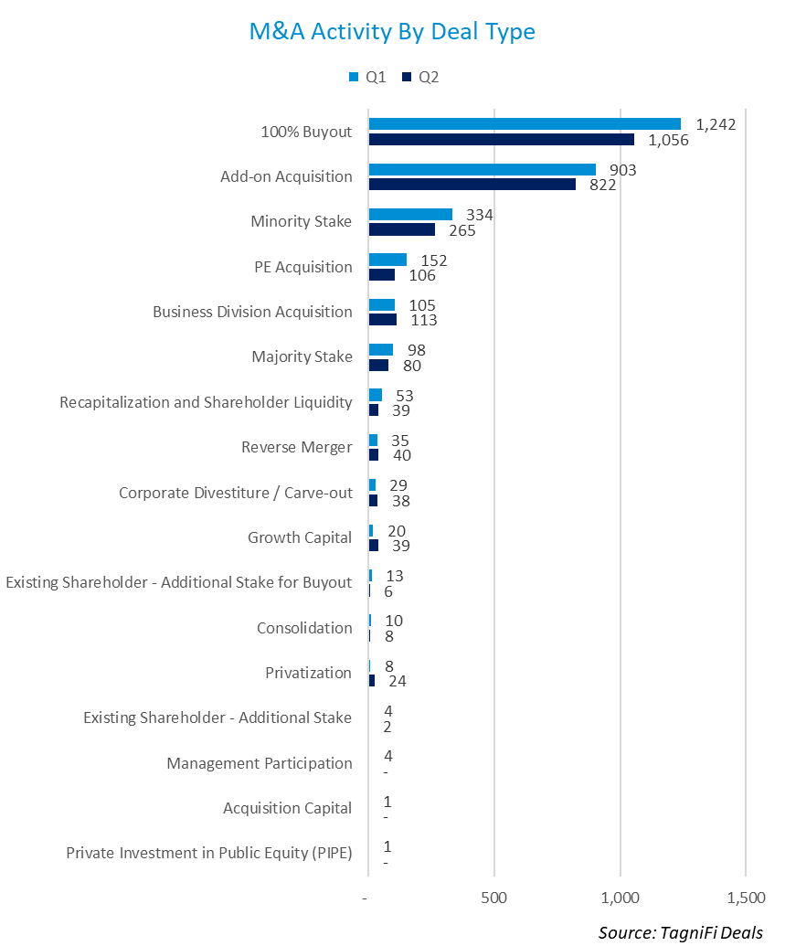

# M&A Activity by Acquirer Type

Private companies increased their share of deals announced in Q2 with 56% of all transactions, up from 55% in Q1. Public companies were involved in 24% of the deals announced in Q2, down 25% in Q1. Investors were involved in 20% of the deals in Q2, unchanged from Q1.

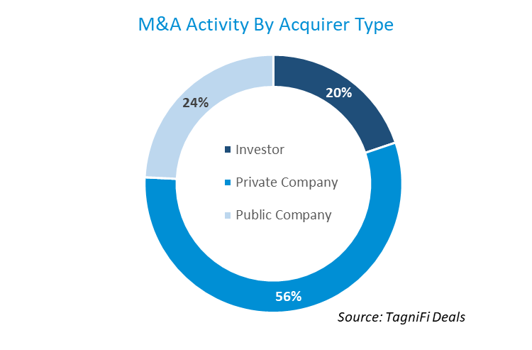

# Deal Activity by Sector

The Services sector continue to be the most active sector during Q2 with 1,479 deals announced representing 61% of all deals. This represents a decrease of 15% from Q1 when 1,733 deals were announced in the Services sector. The Manufacturing sector was hit hardest in Q2, with deal announcements down 16% from Q1. The next worst performance was the Utilities sector which experienced a decline of 13% compared to Q1. The Financial sector was the lone bright spot, with 39 deals announced in Q1 compared to 34 the prior quarter.

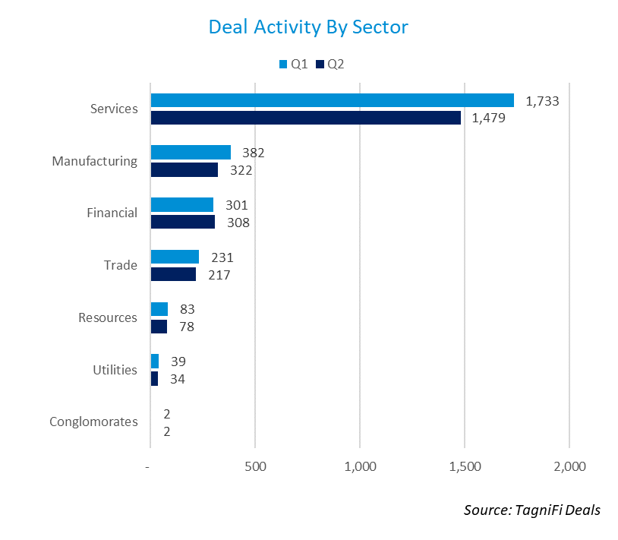

# Public Strategic Buyer Activity

There were 536 different public strategic buyers with acquisition activity in Q2. This figure is down 19% from Q1 when 662 different public strategic buyers announced an acquisition. Below is a chart of the most acquisitive public strategic buyers during the quarter.

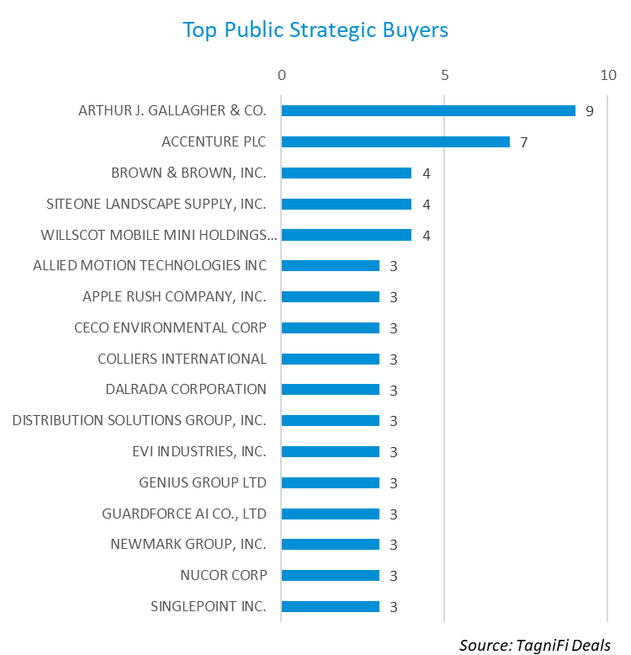

# Private Strategic Buyer Activity

There were 1,256 different private strategic buyers with acquisition activity in Q2. This figure is down 10% from Q1 when 1,394 different private strategic buyers announced an acquisition. Below is a chart of the most acquisitive private strategic buyers during the quarter.

# 

# Financial Buyer Activity

There were 358 different financial buyers with deal activity in Q2. This figure is down 9% from Q1 when 392 different financial buyers had deal activity. Below is a chart of the most active financial buyers during the quarter.

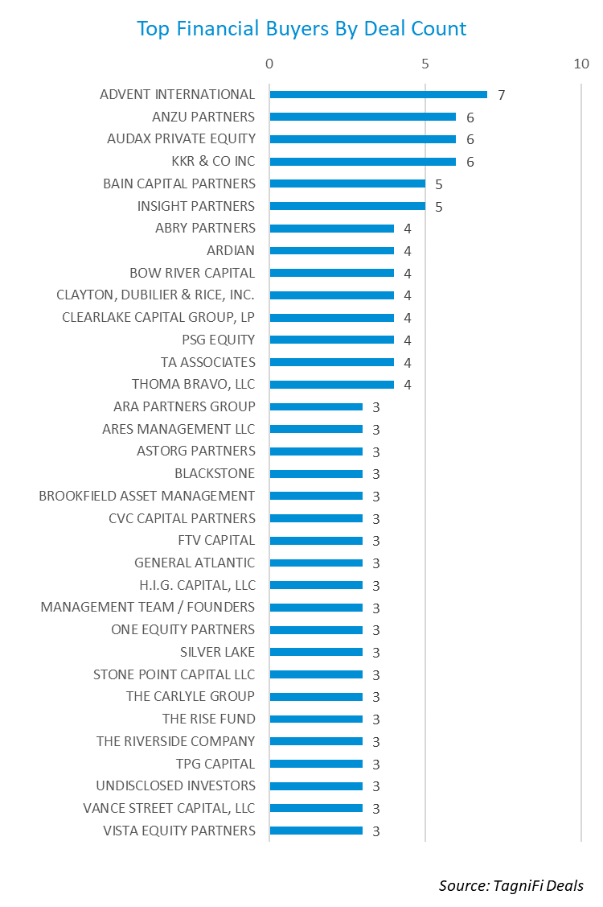

# Financial Advisor Activity

There were 363 different financial advisors disclosed on 994 transactions during Q2. This figure is up 4% from Q1 when 349 different financial advisors were disclosed in transactions. Below is a chart of the most active financial advisors during the quarter.

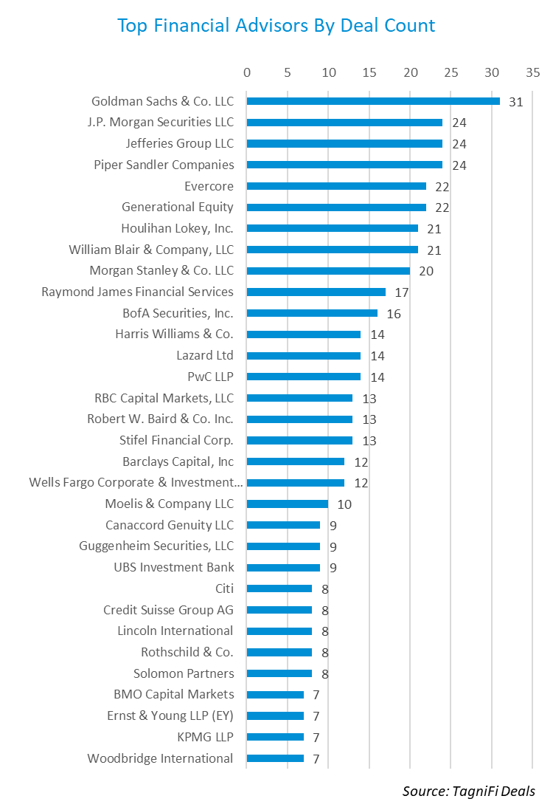

# Legal Advisor Activity

There were 336 different legal advisors disclosed in 986 transactions during Q2. This figure is down 1% from Q1 when 339 different legal advisors were disclosed in transactions. Below is a chart of the most active legal advisors during the quarter.

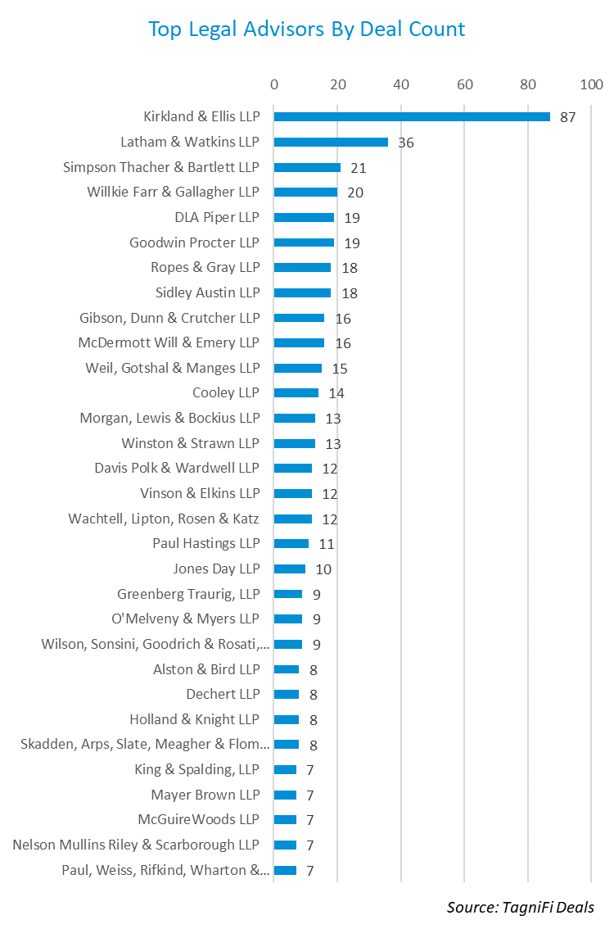

# About This Report

The *Quarterly M&A Update* is a free publication sponsored by TagniFi. You are free to share this report with your colleagues and clients. In fact, we would appreciate it if you would please forward this free report to a few friends to help us spread the word about TagniFi as an alternative data platform. Learn more or request a demo at [tagnifi.com](https://tagnifi.com).

As of the date of this report, the TagniFi platform includes data on the following:

* 9,034 public companies
* 657,491 private companies
* 54,395 M&A transactions
* 5,043 private equity investors
* 2,015 financial (M&A) advisors
* 1,837 legal advisors
* 26,730 private equity bios
* 15,593 financial and legal advisor bios
* 812,576 economic and industry time series

[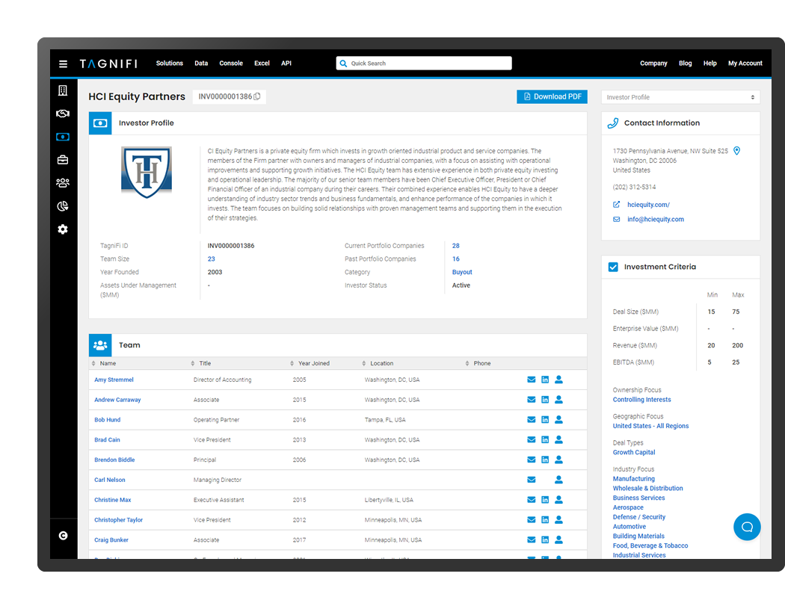](https://tagnifi.com)