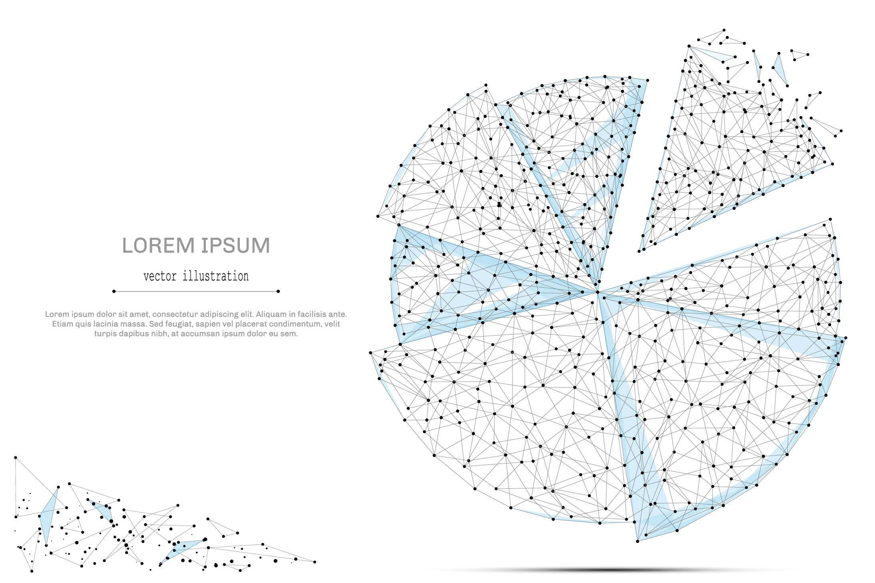

QUARTERLY ECONOMIC UPDATE

For the 2nd Quarter of 2022

Abstract

Designed for business valuation professionals, TagniFi’s Quarterly Economic   
Update provides timely economic data to satisfy Revenue Ruling 56-60.

# Summary

In the 2nd quarter of 2022, inflation was the focal point of the U.S. economic picture. Contrary to officials’ hopes that price pressures would be transitory, inflation proved to be persistent. Meanwhile, lowered private investment and government spending pulled real GDP into its second consecutive quarterly decline—a common informal recession hallmark.

Counteracting the stubborn inflationary pressures without tipping the economy into recession continued to be the central concern for the U.S. Supply chains were not yet operating smoothly, especially at shipping ports, and the Russian war on Ukraine continued to constrain oil supply as gasoline prices shattered former record highs in the U.S. The Federal Reserve has undertaken efforts to curb inflation with tightening monetary policy including a series of target interest rate increases and an end to a two-year quantitative easing campaign. The Fed established plans to tighten its nearly $9 trillion asset holdings by halting acquisitions and letting currently-held bonds mature.

The labor market brought rare good news in the 2nd quarter of 2022, with the unemployment rate holding steady and the broader U-6 rate that includes discouraged and involuntary part-time workers reaching a record low.

Amidst these challenges to economic recovery, Omicron subvariants spread, generating a sixth wave of COVID-19 cases in the U.S. The wave had not yet reached an apex as the 2nd quarter ended with a daily case count (as measured by the 7-day moving average) of 112,442, 86% below the prior quarter’s peak. Deaths per day, which lag cases by 2-3 weeks, largely declined throughout the 2nd quarter, trending up again in June to end the quarter at 367, much lower than any prior wave and 87% below the previous quarter’s peak.

Below is a summary timeline of key COVID-19 events in the U.S. during the 2nd quarter of 2022:

|  |  |
| --- | --- |
| April 1, 2022 | U.S. begins the quarter at 25,546 daily cases, 596 daily deaths (7-day moving average). 66% of Americans are fully vaccinated. |
| April 18, 2022 | Federal mandate requiring masks on public transportation voided by U.S. District Court of Florida |
| May 3, 2022 | CDC recommends mask wearing for all persons over the age of 2 on public transportation |
| May 20, 2022 | U.S. reaches 1 million total deaths from COVID-19. |
| June 18, 2022 | CDC recommends Pfizer-BioNTech and Moderna COVID-19 vaccines for children 6 months through 5 years of age. |
| June 30, 2022 | U.S. ends the quarter at 112,442 daily cases, 367 daily deaths (7-day moving average). 67% of Americans are fully vaccinated. |

Despite the significantly mutated Omicron variant family causing frequent “breakthrough infections” among vaccinated people, vaccines continued to prove highly effective at preventing serious illness and death. In June, the U.S. joined the list of countries offering COVID-19 vaccines to children under 5, making vaccines available for Americans 6 months and up, although many remain unwilling to utilize them. Global vaccination efforts continue to push closer to the WHO’s 70% goal. Through vaccination and the huge numbers of people previously infected—including around 60 percent of the U.S. population—the pandemic is moving into a more controlled phase. Still, experts agree that the ever-mutating COVID-19 virus is not yet limited enough in deadliness and reach to be considered endemic, leaving governments still striving to balance virus control with opportunity for economic growth.

A multifactor indicator of economic strength, the Philadelphia Fed’s coincident index[1] of economic activity in the U.S. rose 0.3% in June 2022 and 0.9% during the 2nd quarter. For the quarter, coincident indexes increased in 47 states and decreased in 3 states. Coincident indexes reflect unemployment, payroll employment, manufacturing hours, and wages and salaries.



The U.S. dollar index for goods and services[2] rose 4.09% during the 2nd quarter of 2022 and 8.50% since June 2021. The dollar, a common safe-haven investment when the world economy shows signs of weakness, benefited from rampant inflation in the EU even as domestic inflation soared to a 40-year high. Meanwhile, the Federal Reserve followed its 1st-quarter target interest rate hike with 2 more during the 2nd quarter. Investors anticipated the Fed would remain hawkish, at least in the short term, despite mounting fears of a U.S. recession.

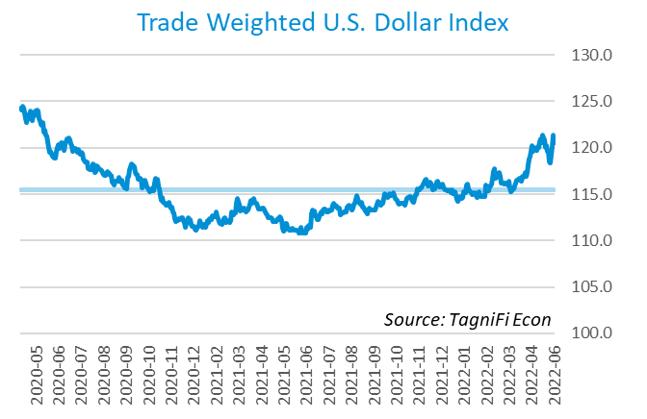

# Q1 Economic Highlights

* The Philadelphia Fed’s coincident index of economic activity in the U.S. rose 0.3% in June 2022 and 0.9% during the 2nd quarter.
* Real GDP for the 2nd quarter of 2022 fell at an annualized rate of 0.9%, following a 1.6% decrease in the 1st quarter of 2022.
* The U.S. dollar index rose 4.09% during the 2nd quarter of 2022 and 8.50% since June of 2021.
* The effective federal funds rate rose 1.01 percentage point to 1.21% during the 2nd quarter after beginning the climb from near-zero levels in March.
* The 1-year and 2-year annual treasury yields ended the 2nd quarter at 2.80% and 2.92%, respectively. The benchmark 10-year treasury yielded 2.98% at the end of the quarter, while the 30-year treasury yielded 3.14%.
* Unemployment remained steady at 3.6% throughout the 2nd quarter of 2022, near its pre-pandemic level of 3.5%. Nonfarm payrolls grew by 1.3 million jobs in the 2nd quarter.
* The Consumer Price Index rose 9.0% year-over-year in June, its fastest growth since November of 1981. Excluding volatile energy prices, the index rose 6.6%.
* Crude oil prices ended the quarter at $107.76 per barrel, 7.2% higher than one quarter earlier.
* New home starts fell to 1.56 million in June, down 9.8% for the quarter and 6.3% for the year.
* The NASDAQ Composite dropped 22.4% during the 2nd quarter of 2022 and the Dow Jones Transportation Average fell 19.2%. The Wilshire 5000 was down 17.6% during the quarter and the S&P 500 was down 16.4%.

# Business Activity

Real gross domestic product (GDP)[3] for the 2nd quarter of 2022 fell at an annualized rate of 0.9%, following a 1.6% decrease in the 1st quarter of 2022. During the 2nd quarter, production battled with surging inflation and the resultant tightening of monetary policy by the Federal reserve. Inflation bit into business investment and government spending, while moderating the 8th straight quarter of gains in consumer spending.

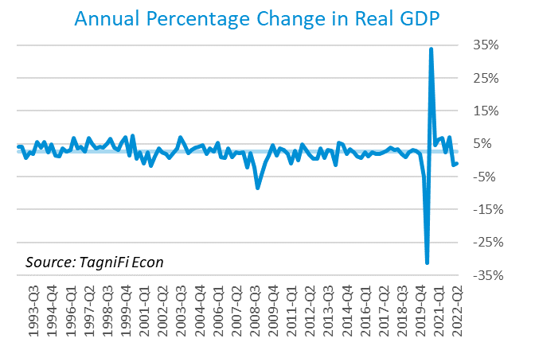

Gross domestic private investment[4], particularly in private inventories and residential fixed investment, was the leading contributor to the 2nd quarter’s decline, with a negative 2.7% effect. Lowered inventory investment reflected a slowdown in the retail sector. Falling government expenditures[5] at both the federal level and the state and local level contributed an additional negative 0.3% to the 2nd-quarter GDP decline. The contraction in federal spending resulted from the sale of petroleum from the national Strategic Petroleum Reserve, which has a negative effect on consumption totals. Reduced state and local government spending primarily reflected lower investment in structures.

Net exports[6] moderated the decline in GDP with a positive 1.4% effect as exports rose more swiftly than imports. While exports have been inconsistent, imports have risen every quarter during the 2 years since the COVID-19 pandemic’s initial economic blow.

Personal consumption expenditures[7] (PCE) had a positive 0.7% effect on real GDP. Growth in personal spending was led by broad increases in household services consumption, especially food services and accommodations and health care services.

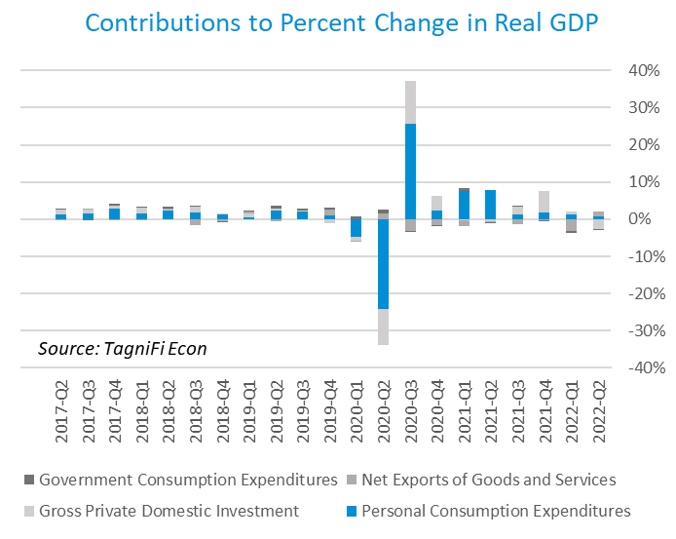

The Industrial Production Index[8] is an economic indicator that measures real output for all facilities located in the United States manufacturing, mining, and electric, and gas utilities. The index stood at 104.4 at the end of the 2nd quarter, down 0.2% from the previous quarter.

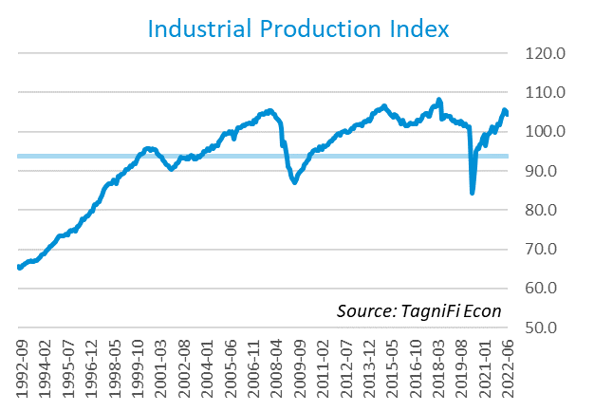

The Capacity Utilization Index[9], which attempts to capture industrial output as a percentage of the economy’s maximum production capacity, declined to 79.3% during the 2nd quarter of 2022. June 2022’s level was above the 30-year average of 76.7% for this metric and 0.4% higher than the previous quarter.

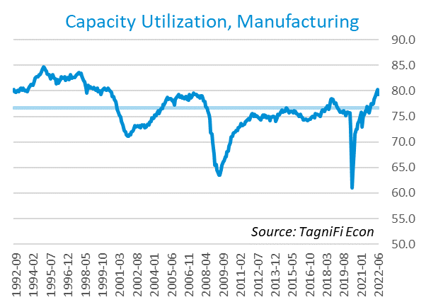

# Interest Rates

The effective federal funds rate[10] rose 1.01 percentage point to 1.21% during the 2nd quarter after beginning the climb from near-zero levels in March. Short-term treasury bond yields[11] rose accordingly during the 2nd quarter. Long-term treasury yields rose as well, although the yield curve remained flatter than usual. The spread between the two- and ten-year rates became very narrow during June. The 1-year and 2-year annual treasury yields ended the 2nd quarter at 2.80% and 2.92%, respectively. The benchmark 10-year treasury yielded 2.98% at the end of the quarter, while the 30-year treasury yielded 3.14%. See *Appendix – Selected Interest Rates* for detailed interest rate data.

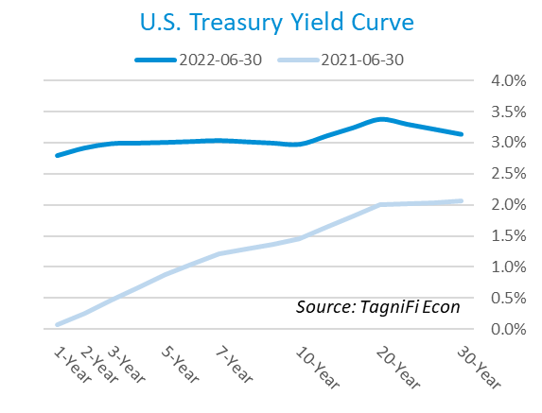

In the 2nd quarter of 2022, the Federal Reserve continued the series of federal funds target rate[12] hikes that it began in March. Two increases in May and June totaling 125 basis points brought the target rate to a range of 1.50% to 1.75% to end the 2nd quarter. The committee indicated that inflation is its primary concern, even more so than recession. The effective federal funds rate[13] rose to 1.21% in June.

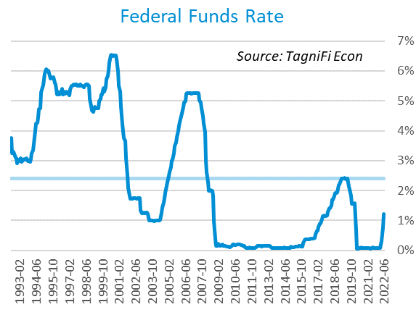

The yield on the benchmark 10-year U.S. treasury[14] ended the 2nd quarter at 3.14%, up 1.01 percentage points from the previous quarter, but still below the average yield of 3.97% over the last 30 years.

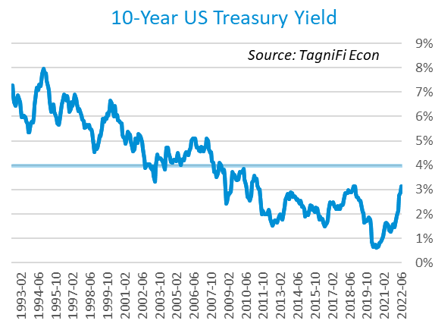

Moody’s Baa Corporate Bond Yield Index[15] ended the 2nd quarter of 2022 at 5.29%, up 1.04% since the previous quarter. Moody’s less-risky Aaa[16] Index rose 0.81% during the quarter to a level of 4.19%.

The upward pressure on corporate bond yields came as the Federal Reserve took available policy moves to cool searing inflation, raising interest rate targets stepwise and ending the multi-billion-dollar bond purchases that had effectively backstopped the corporate bond market since March of 2020. Investor expectations have inspired widespread moves from riskier equities into the bond market preceding the recent Fed rate hikes.

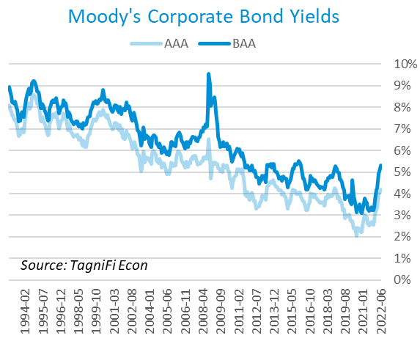

# Employment

The official unemployment rate[17] remained steady at 3.6% throughout the 2nd quarter of 2022, near its pre-pandemic level of 3.5%. The unemployment rate in June was well below the 30-year historical average of 5.8%. However, the labor force[18] declined by 0.4 million workers during the quarter, and the labor force participation rate[19] slid to 62.2%. Economists polled by the Livingston Survey[20] in June of 2022 projected an unemployment rate of 3.4% in December 2022, inching up to 3.5% in June of 2023.

In May 2022, nonfarm worker quits[21] stood at 4.3 million, 0.2 million lower than their record high in November 2021, yet 0.7 million higher than their pre-pandemic level. The number of quits fell 1.3% over the month yet remained 11.3% higher than in May 2021. The elevated level of quits, sometimes referred to as The Great Resignation, may be waning, but will leave in its wake potentially permanent changes to American work culture, including increased flexibility and a focus on employee wellness. Job openings[22] totaled 11.3 million in May 2022, 0.6 million below their record high in March 2022 and 2.6 times the number of resignations.

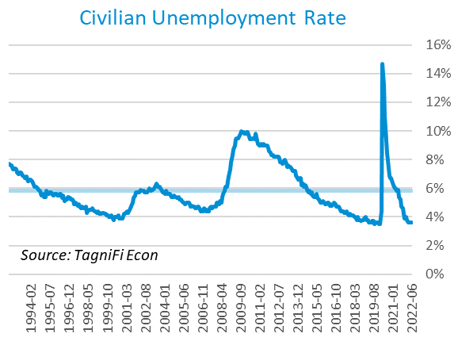

The U-6 unemployment rate[23] is an alternative measure of unemployment with a broader definition, including such groups as discouraged workers who are not actively searching for jobs but want full-time work and part-time workers who want full-time work. The U‑6 unemployment rate has generally followed the same pattern as the official rate before falling to record-low 6.7% in June 2022.

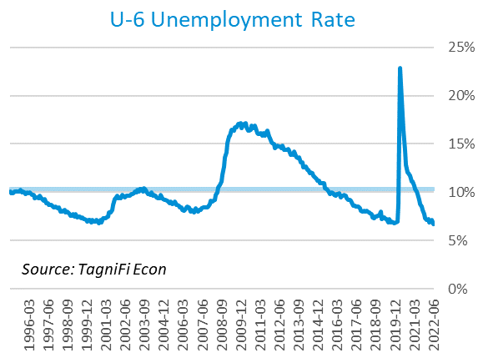

Nonfarm payrolls[24] grew by 1.3 million jobs in the 2nd quarter. U.S. nonfarm payrolls in June 2022 totaled 152.0 jobs, up 6.3 million compared to the same period last year, yet still 0.5 million jobs below their pre-pandemic (February 2020) levels. The largest gains were recorded in the professional and business services, leisure and hospitality, and health care industries.

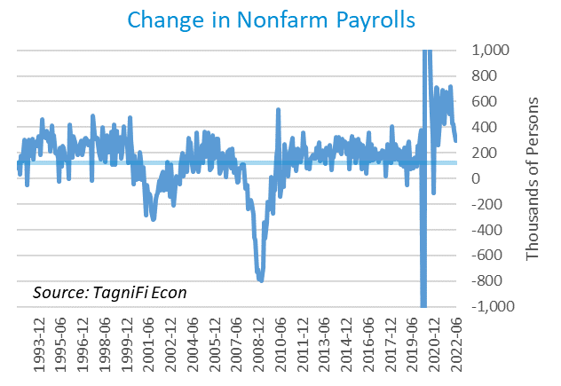

# Inflation

At the forefront of the economic conversation, inflation is proving to be more stubborn than officials hoped and has not yet reached a clear peak. The Consumer Price Index[25] rose 9.0% year-over-year in June, its fastest growth since November of 1981. Excluding volatile energy prices[26], the index rose 6.6%. Notably, the price of a gallon of gas[27] jumped 60.4% from a national average of $3.15 in June 2021 to a record-high $5.06 in June 2022. In addition to gasoline, shelter and food prices were among the largest contributors to the severe inflation. The Federal Reserve has begun taking action to curb inflation with a series of target interest rate hikes totaling 1.5% from March to June.

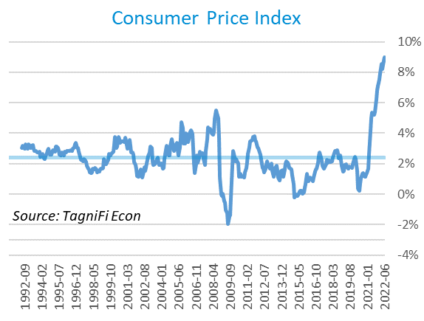

The Producer Price Index[28] rose 3.3% in June to a level 23.4% higher than June 2021, far outpacing the 2.8% average annual increase over the last 30 years.

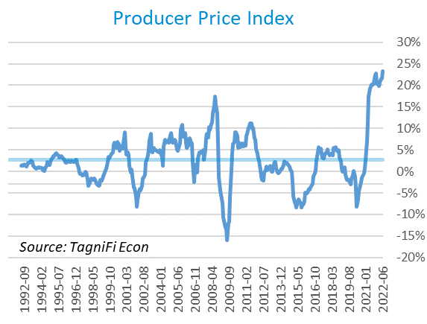

Treasury Inflation-Protected Securities (TIPS) are a longer-term Treasury debt instrument which pays a fixed interest rate but adjusts the principal value according to inflation, effectively indexing interest payments to inflation. TIPS have sold at a premium, reflecting higher inflation expectations; however, the Fed’s asset-reduction program is expected to dilute the market. The 5-year breakeven inflation rate[29], an indicator for the market’s inflation expectations for the period, fell from 3.34% at the end of the 1st quarter to 2.58% to end the 2nd quarter.

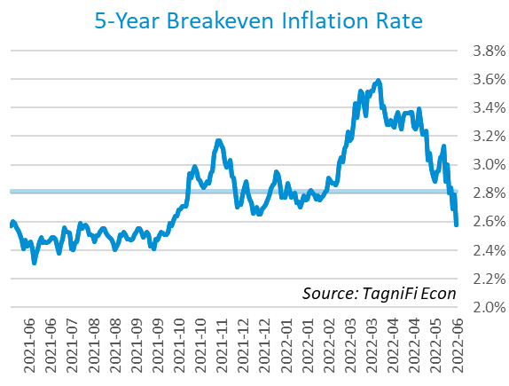

U.S. crude oil[30] prices climbed throughout much of the 2nd quarter due to constrained global supply as OPEC and other major producers fell short of expected output increases. Prices moderated in the second half of June on fears of U.S. recession and signs of weakness in the broader global economy. Crude prices ended the quarter at $107.76 per barrel, 7.2% higher than one quarter earlier.

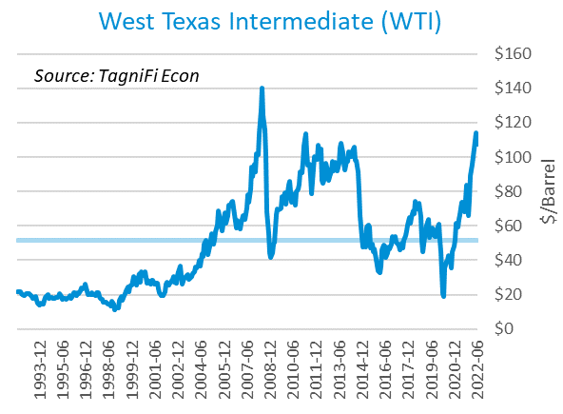

# Housing

The real estate market has reflected a strong theme of the economic recovery: demand outpacing supply. Housing demand, especially for single-family homes, swelled during the pandemic, sending prices soaring as supply remained constricted due to seller reluctance and materials shortages. While still robust, price growth has begun to decelerate as rising mortgage rates reduce affordability and limit the pool of potential buyers. New home starts[31] fell to 1.56 million in June; single-family home starts were sharply down over the quarter, while starts rose for multifamily buildings with 5 or more units. Total new home starts were down 9.8% for the quarter and 6.3% for the year, but still ended the 2nd quarter at a level above their 30-year average of 1.33 million.

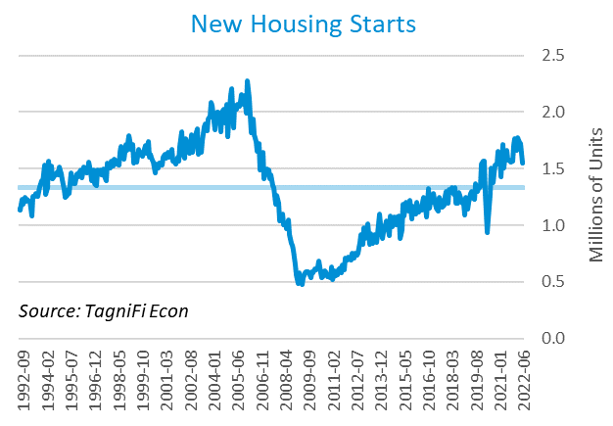

The cost of financing for would-be homebuyers continued to climb during the 2nd quarter, with the 30-year fixed-rate mortgage[32] ending the quarter at 5.70%, the highest rate since late 2008, when the U.S. was in the throes of the Great Recession.

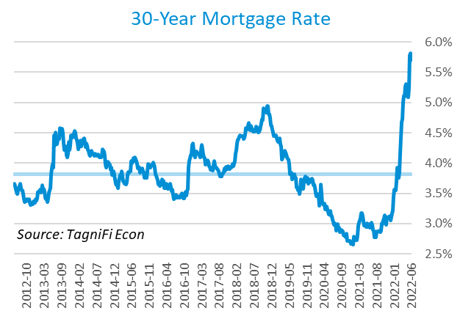

The S&P Case-Shiller Home Price Index (20-city)[33] rose 20.5% year-over-year in May 2022, down from April’s 21.2% record. All 20 cities continued to report double-digit increases, led by Tampa, Miami, and Dallas.

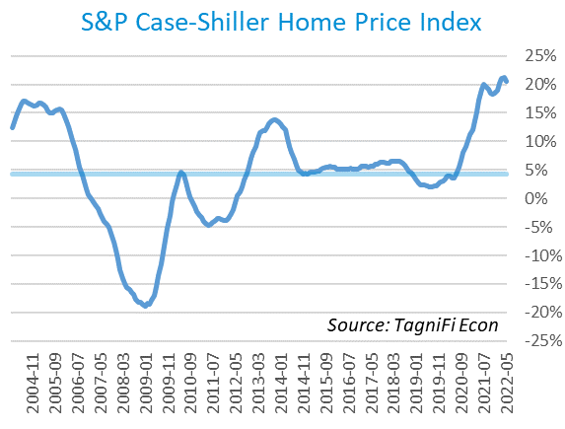

# Consumer Spending

Personal Consumption Expenditures (PCE)[34] rose 1.6% in the 2nd quarter to $17.1 trillion. PCE were up 8.4% since the 2nd quarter last year. Notable spending increases included motor vehicles and parts, health care services, food services and accommodations, and international travel.

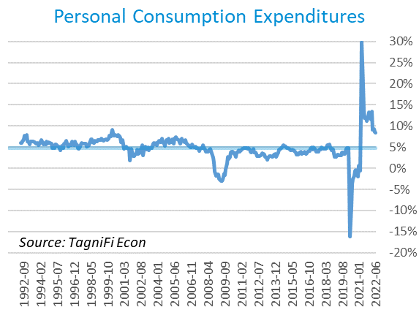

Auto manufacturers reported 13.0 million autos and light trucks sold[35] in June 2022, down 3.0% from March. New vehicle prices[36] built on their record high by a further 2.7% during the 2nd quarter. Used car prices[37], also near record levels, rose 3.1% for the quarter.

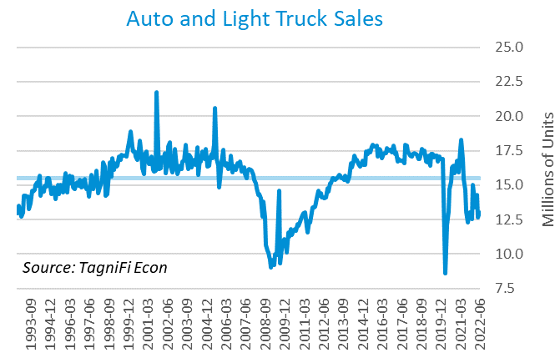

The University of Michigan’s consumer sentiment index[38] ended the 2nd quarter at a record-low 50.0. The decline reflected low expectations across a broad base of consumers of varying demographics; the primary concern was inflation, which consumers expect to continue eroding household incomes and reducing living standards. The consumer sentiment index in June stood far short of its 30-year average of 87.3.

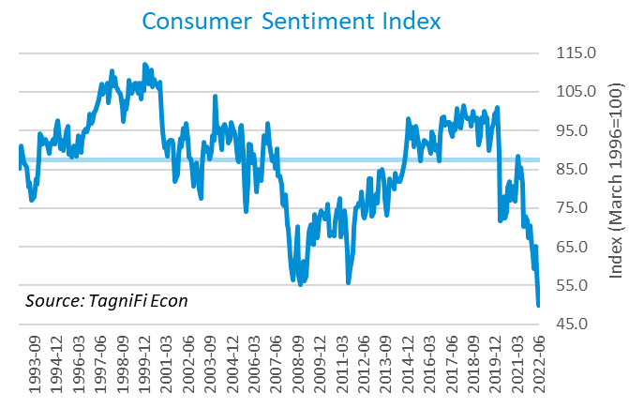

# Capital Markets

The table below shows the quarterly, year-to-date, and 12-month performance of major U.S. equity indices. Capital markets, which had enjoyed bullish conditions during the initial pandemic recovery, crumpled in the 1st and 2nd quarters of 2022, with the broad S&P 500 index posting its worst first-half performance in more than 5 decades. Investors point to persistently high inflation, largely due to supply chain constraints in the wake of the COVID-19 pandemic and the Russian war on Ukraine, as a main concern. The Fed’s recent aggressive action on inflation has compounded investor anxiety as growth becomes constrained, raising worries of recession. The NASDAQ Composite dropped 22.4% druing the 2nd quarter of 2022 and the Dow Jones Transportation Average fell 19.2%. The Wilshire 5000 was down 17.6% during the quarter and the S&P 500 was down 16.4%.



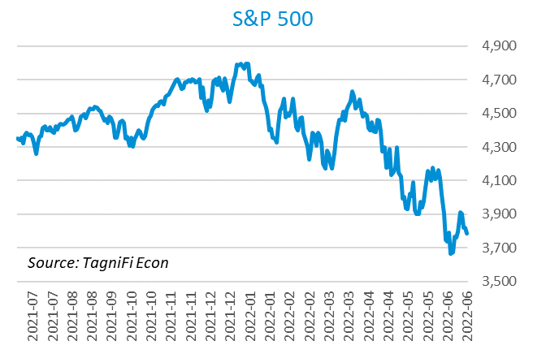

Stock market volatility, as measured by the VIX [39], ended the 2nd quarter at 28.7, up 39.6% since the prior quarter. The VIX has trended generally upward during the first half of 2022 as investor sentiment was plagued by recession worries centering on persistent inflation, so far uncontained by Fed policy moves.

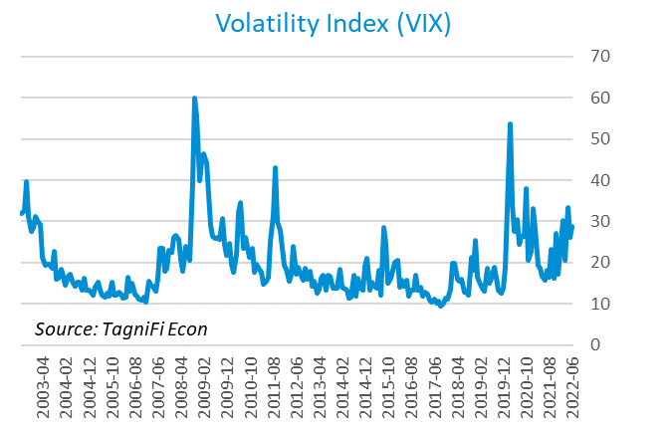

# Outlook

In June 2022, the FOMC revised their near-term inflation and unemployment rate projections upward and real GDP projections downward. Longer-run projections for all three indicators held relatively steady.

The FOMC revised their projection for real GDP[40] to 1.70% growth in 2022, dipping to 1.65% in 2023, then rising to 1.75% by 2024. They expected Personal Consumption Expenditures (PCE) inflation[41] to grow to 5.15% in 2022 but fall to 2.25% in 2024. They forecast that the unemployment rate[42] would be 3.70% in 2022, rising to 4.0% by 2024. The board again increased projections of future target rates and signaled continued resolve to tighten monetary policy against blazing inflation despite signs of a potential recession on the horizon.



Appendix – Selected Interest Rates



# About This Report

The *Quarterly Economic Update* is a free publication sponsored by TagniFi. You are free to share this report and include its contents in the economic outlook section of your valuation reports as required by *Revenue Ruling 59-60*. Please forward this free report to a colleague to help us spread the word about TagniFi.

How TagniFi Helps Business Valuation Teams

TagniFi’s financial data platform empowers business valuation teams to quickly and easily build highly accurate financial models with full transparency—and within seconds.

**Better Public Comps**  
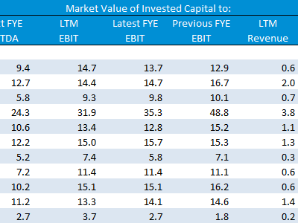Search for public companies with TagniFi Web. Simply enter your valuation date and ticker symbols in Excel to run a guideline public company method. Your Excel model populates instantly with the financial statements, analyst estimates, interest rates and economic data for your valuation date.

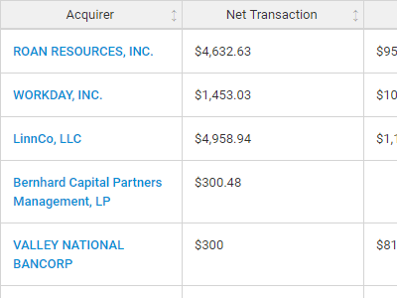**Better Transaction Comps**  
Search for public and private M&A transactions with TagniFi Web. Run your transaction comps within seconds by pasting the Deal ID into your Excel model. Every deal disclosed in an SEC filing (8-K, 10-K, or 10-Q) is available for your analysis. Choose from over 90 fields of data available for every deal.

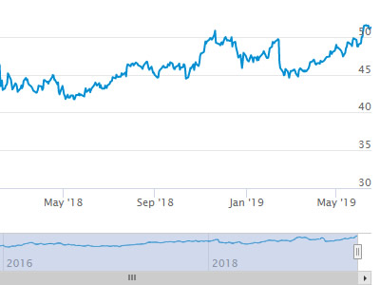

**Historical Beta and Volatility**Calculate historical beta and volatility as of your valuation date automatically. Simply enter the tickers and valuation date in Excel - TagniFi does the rest. In addition to beta and volatility, there are over 40 Excel models available in the Model Library to help with your valuation report.

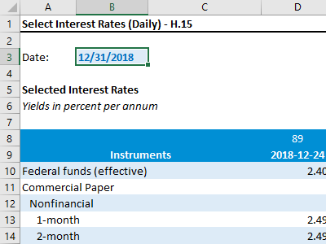**Interest Rates and Economic Data**Automate the interest rates and economic data in your valuation report using the TagniFi Excel plugin. Choose from over 200,000 time series available. All data in this *Quarterly Economic Update* is from the TagniFi platform. Use economic and interest rate data for your own valuation models with the TagniFi Excel plugin.

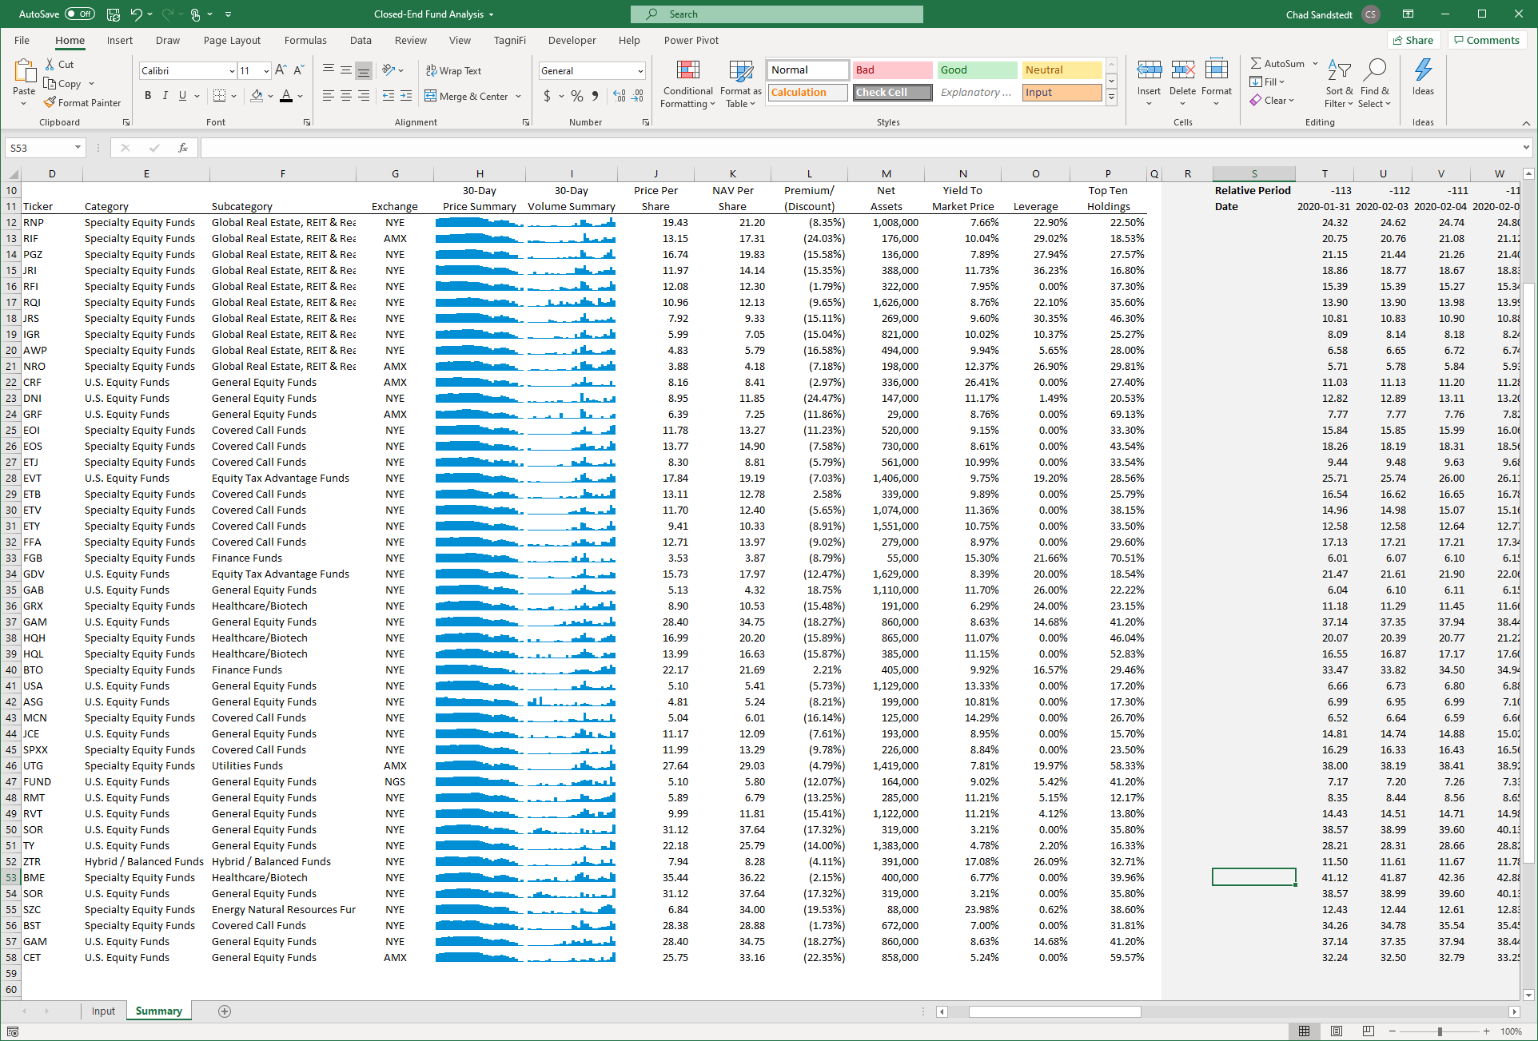

**Closed-End Mutual Fund Data**Search for closed-end mutual funds by keyword, category, subcategory, and more with the TagniFi Console. Use the TagniFi Excel plugin to calculate historical discounts, yields, leverage, as of your valuation date automatically. Simply enter the tickers and valuation date in Excel - TagniFi does the rest.

1. Federal Reserve Bank of Philadelphia, Coincident Economic Activity Index for the United States [USPHCI], *retrieved from FRED, Federal Reserve Bank of St. Louis;* [*https://fred.stlouisfed.org/series/USPHCI*](https://fred.stlouisfed.org/series/USPHCI)*, Jul 30, 2022.*
2. Board of Governors of the Federal Reserve System (US), Trade Weighted U.S. Dollar Index: Broad, Goods and Services [DTWEXBGS], *retrieved from FRED, Federal Reserve Bank of St. Louis;* [*https://fred.stlouisfed.org/series/DTWEXBGS*](https://fred.stlouisfed.org/series/DTWEXBGS)*, Jul 30, 2022.*
3. U.S. Bureau of Economic Analysis, Real Gross Domestic Product [GDPC1], *retrieved from FRED, Federal Reserve Bank of St. Louis;*[*https://fred.stlouisfed.org/series/GDPC1*](https://fred.stlouisfed.org/series/GDPC1)*, Jul 28, 2022.*
4. U.S. Bureau of Economic Analysis, Contributions to percent change in real gross domestic product: Gross private domestic investment [A006RY2Q224SBEA], *retrieved from FRED, Federal Reserve Bank of St. Louis;* [*https://fred.stlouisfed.org/series/A006RY2Q224SBEA*](https://fred.stlouisfed.org/series/A006RY2Q224SBEA)*, Jul 28, 2022.*
5. U.S. Bureau of Economic Analysis, Contributions to percent change in real gross domestic product: Government consumption expenditures and gross investment [A822RY2Q224SBEA], *retrieved from FRED, Federal Reserve Bank of St. Louis;* [*https://fred.stlouisfed.org/series/A822RY2Q224SBEA*](https://fred.stlouisfed.org/series/A822RY2Q224SBEA)*, Jul 28, 2022.*
6. U.S. Bureau of Economic Analysis, Contributions to percent change in real gross domestic product: Net exports of goods and services [A019RY2Q224SBEA], *retrieved from FRED, Federal Reserve Bank of St. Louis;* [*https://fred.stlouisfed.org/series/A019RY2Q224SBEA*](https://fred.stlouisfed.org/series/A019RY2Q224SBEA)*, Jul 28, 2022.*
7. U.S. Bureau of Economic Analysis, Contributions to percent change in real gross domestic product: Personal consumption expenditures [DPCERY2Q224SBEA], *retrieved from FRED, Federal Reserve Bank of St. Louis;* [*https://fred.stlouisfed.org/series/DPCERY2Q224SBEA*](https://fred.stlouisfed.org/series/DPCERY2Q224SBEA)*, Jul 28, 2022.*
8. Board of Governors of the Federal Reserve System (US), Industrial Production Index [INDPRO], *retrieved from FRED, Federal Reserve Bank of St. Louis;*[*https://fred.stlouisfed.org/series/INDPRO*](https://fred.stlouisfed.org/series/INDPRO)*, Jul 30, 2022.*
9. Board of Governors of the Federal Reserve System (US), Capacity Utilization, Manufacturing (NAICS), *retrieved from FRED, Federal Reserve Bank of St. Louis;* [*https://fred.stlouisfed.org/series/MCUMFN*](https://fred.stlouisfed.org/series/MCUMFN)*, Jul 30, 2022.*
10. Board of Governors of the Federal Reserve System (US), Federal Funds Effective Rate [FEDFUNDS], *retrieved from FRED, Federal Reserve Bank of St. Louis;* [*https://fred.stlouisfed.org/series/FEDFUNDS*](https://fred.stlouisfed.org/series/FEDFUNDS)*, Apr 29, 2022.*
11. Selected Interest Rates Instruments, Yields in percent per annum, *retrieved from FRED, Federal Reserve Bank of St. Louis;* [*https://fred.stlouisfed.org/release/tables?rid=18&eid=289&od=2022-06-30*](https://fred.stlouisfed.org/release/tables?rid=18&eid=289&od=2022-06-30)*, Jul 30, 2022.*
12. Board of Governors of the Federal Reserve System (US), Federal Funds Target Range - Upper Limit [DFEDTARU], *retrieved from FRED, Federal Reserve Bank of St. Louis;* [*https://fred.stlouisfed.org/series/DFEDTARU*](https://fred.stlouisfed.org/series/DFEDTARU)*, Jul 28, 2022*.
13. Board of Governors of the Federal Reserve System (US), Federal Funds Effective Rate [FEDFUNDS], *retrieved from FRED, Federal Reserve Bank of St. Louis;* [*https://fred.stlouisfed.org/series/FEDFUNDS*](https://fred.stlouisfed.org/series/FEDFUNDS)*, Jul 30, 2022*.
14. Board of Governors of the Federal Reserve System (US), 10-Year Treasury Constant Maturity Rate [DGS10], *retrieved from FRED, Federal Reserve Bank of St. Louis;*[*https://fred.stlouisfed.org/series/DGS10*](https://fred.stlouisfed.org/series/DGS10)*, Apr 29, 2022.*
15. Moody’s, Moody's Seasoned Baa Corporate Bond Yield [DBAA], *retrieved from FRED, Federal Reserve Bank of St. Louis;* [*https://fred.stlouisfed.org/series/DBAA*](https://fred.stlouisfed.org/series/DBAA)*, Apr 29, 2022.*
16. Moody’s, Moody's Seasoned Aaa Corporate Bond Yield [DAAA], *retrieved from FRED, Federal Reserve Bank of St. Louis;* [*https://fred.stlouisfed.org/series/DAAA*](https://fred.stlouisfed.org/series/DAAA)*, Apr 29, 2022.*
17. U.S. Bureau of Labor Statistics, Civilian Unemployment Rate [UNRATE], *retrieved from FRED, Federal Reserve Bank of St. Louis;*[*https://fred.stlouisfed.org/series/UNRATE*](https://fred.stlouisfed.org/series/UNRATE)*, Jul 29, 2022.*
18. U.S. Bureau of Labor Statistics, Civilian Labor Force Level [CLF16OV], *retrieved from FRED, Federal Reserve Bank of St. Louis;* [*https://fred.stlouisfed.org/series/CLF16OV*](https://fred.stlouisfed.org/series/CLF16OV)*, Jul 29, 2022.*
19. U.S. Bureau of Labor Statistics, Labor Force Participation Rate [CIVPART], *retrieved from FRED, Federal Reserve Bank of St. Louis;* [*https://fred.stlouisfed.org/series/CIVPART*](https://fred.stlouisfed.org/series/CIVPART)*, Jul 29, 2022.*
20. Federal Reserve Bank of Philadelphia, Livingston Survey, [*https://www.philadelphiafed.org/surveys-and-data/real-time-data-research/livingston-survey*](https://www.philadelphiafed.org/surveys-and-data/real-time-data-research/livingston-survey)*, Jul 29, 2022.*
21. U.S. Bureau of Labor Statistics, Quits: Total Nonfarm [JTSQUL], *retrieved from FRED, Federal Reserve Bank of St. Louis;* [*https://fred.stlouisfed.org/series/JTSQUL*](https://fred.stlouisfed.org/series/JTSQUL)*, Jul 31, 2022*.
22. U.S. Bureau of Labor Statistics, Job Openings: Total Nonfarm [JTSJOL], *retrieved from FRED, Federal Reserve Bank of St. Louis;* [*https://fred.stlouisfed.org/series/JTSJOL*](https://fred.stlouisfed.org/series/JTSJOL)*, Jul 31, 2022.*
23. U.S. Bureau of Labor Statistics Total Unemployed, Plus All Persons Marginally Attached to the Labor Force, Plus Total Employed Part Time for Economic Reasons, as a Percent of the Civilian Labor Force Plus All Persons Marginally Attached to the Labor Force (U-6) [U6RATE], *retrieved from FRED, Federal Reserve Bank of St. Louis;*[*https://fred.stlouisfed.org/series/U6RATE*](https://fred.stlouisfed.org/series/U6RATE)*, Jul 31, 2022.*
24. U.S. Bureau of Labor Statistics, All Employees: Total Nonfarm Payrolls [PAYEMS], *retrieved from FRED, Federal Reserve Bank of St. Louis;*[*https://fred.stlouisfed.org/series/PAYEMS*](https://fred.stlouisfed.org/series/PAYEMS)*, Jul 31, 2022.*
25. U.S. Bureau of Labor Statistics, Consumer Price Index for All Urban Consumers: All Items [CPIAUCSL], *retrieved from FRED, Federal Reserve Bank of St. Louis;*[*https://fred.stlouisfed.org/series/CPIAUCSL*](https://fred.stlouisfed.org/series/CPIAUCSL)*, Jul 28, 2022.*
26. U.S. Bureau of Labor Statistics, Consumer Price Index for All Urban Consumers: All Items Less Energy in U.S. City Average [CPILEGSL], *retrieved from FRED, Federal Reserve Bank of St. Louis;* [*https://fred.stlouisfed.org/series/CPILEGSL*](https://fred.stlouisfed.org/series/CPILEGSL)*, Jul 28, 2022*.
27. U.S. Bureau of Labor Statistics, Average Price: Gasoline, Unleaded Regular (Cost per Gallon/3.785 Liters) in U.S. City Average [APU000074714], *retrieved from FRED, Federal Reserve Bank of St. Louis;* [*https://fred.stlouisfed.org/series/APU000074714*](https://fred.stlouisfed.org/series/APU000074714)*, Jul 28, 2022.*
28. U.S. Bureau of Labor Statistics, Producer Price Index for All Commodities [PPIACO], *retrieved from FRED, Federal Reserve Bank of St. Louis;*[*https://fred.stlouisfed.org/series/PPIACO*](https://fred.stlouisfed.org/series/PPIACO)*, Jul 31, 2022.*
29. *Federal Reserve Bank of St. Louis, 5-Year Breakeven Inflation Rate [T5YIE], retrieved from FRED, Federal Reserve Bank of St. Louis;*[*https://fred.stlouisfed.org/series/T5YIE*](https://fred.stlouisfed.org/series/T5YIE)*, Apr 29, 2022.*
30. U.S. Energy Information Administration, Crude Oil Prices: West Texas Intermediate (WTI) - Cushing, Oklahoma [DCOILWTICO], *retrieved from FRED, Federal Reserve Bank of St. Louis;* [*https://fred.stlouisfed.org/series/DCOILWTICO*](https://fred.stlouisfed.org/series/DCOILWTICO)*, Apr 29, 2022.*
31. U.S. Bureau of the Census, Housing Starts: Total: New Privately Owned Housing Units Started [HOUST], *retrieved from FRED, Federal Reserve Bank of St. Louis;*[*https://fred.stlouisfed.org/series/HOUST*](https://fred.stlouisfed.org/series/HOUST)*, Jul 31, 2022.*
32. Freddie Mac, 30-Year Fixed Rate Mortgage Average in the United States [MORTGAGE30US], *retrieved from FRED, Federal Reserve Bank of St. Louis;*[*https://fred.stlouisfed.org/series/MORTGAGE30US*](https://fred.stlouisfed.org/series/MORTGAGE30US)*, Jul 31, 2022.*
33. S&P Dow Jones Indices LLC, S&P/Case-Shiller 20-City Composite Home Price Index [SPCS20RSA], *retrieved from FRED, Federal Reserve Bank of St. Louis;*[*https://fred.stlouisfed.org/series/SPCS20RSA*](https://fred.stlouisfed.org/series/SPCS20RSA)*, Jul 29, 2022.*
34. U.S. Bureau of Economic Analysis, Personal Consumption Expenditures [PCE], *retrieved from FRED, Federal Reserve Bank of St. Louis;*[*https://fred.stlouisfed.org/series/PCE*](https://fred.stlouisfed.org/series/PCE)*, Jul 31, 2022.*
35. U.S. Bureau of Economic Analysis, Light Weight Vehicle Sales: Autos and Light Trucks [ALTSALES], *retrieved from FRED, Federal Reserve Bank of St. Louis; <https://fred.stlouisfed.org/series/ALTSALES>, Jul 31, 2022.*
36. U.S. Bureau of Labor Statistics, Consumer Price Index for All Urban Consumers: New Vehicles in U.S. City Average [CUUR0000SETA01], *retrieved from FRED, Federal Reserve Bank of St. Louis;* [*https://fred.stlouisfed.org/series/CUUR0000SETA01*](https://fred.stlouisfed.org/series/CUUR0000SETA01)*, Jul 31, 2022.*
37. U.S. Bureau of Labor Statistics, Consumer Price Index for All Urban Consumers: Used Cars and Trucks in U.S. City Average [CUSR0000SETA02], *retrieved from FRED, Federal Reserve Bank of St. Louis;* [*https://fred.stlouisfed.org/series/CUSR0000SETA02*](https://fred.stlouisfed.org/series/CUSR0000SETA02), *Jul 31, 2022.*
38. *University of Michigan, University of Michigan: Consumer Sentiment [UMCSENT], retrieved from FRED, Federal Reserve Bank of St. Louis;* [*https://fred.stlouisfed.org/series/UMCSENT*](https://fred.stlouisfed.org/series/UMCSENT)*, Jul 29, 2022.*
39. *Chicago Board Options Exchange, CBOE Volatility Index: VIX [VIXCLS], retrieved from FRED, Federal Reserve Bank of St. Louis;* [*https://fred.stlouisfed.org/series/VIXCLS*](https://fred.stlouisfed.org/series/VIXCLS)*, Jul 29, 2022.*
40. *Federal Reserve Bank of St. Louis, FOMC Summary of Economic Projections for the Growth Rate of Real Gross Domestic Product [GDPC1CTM], retrieved from FRED, Federal Reserve Bank of St. Louis;*[*https://fred.stlouisfed.org/series/GDPC1CTM*](https://fred.stlouisfed.org/series/GDPC1CTM)*, Jul 29, 2022.*
41. *Federal Reserve Bank of St. Louis, FOMC Summary of Economic Projections for the Personal Consumption Expenditures Inflation Rate, Central Tendency, Midpoint [PCECTPICTM], retrieved from FRED, Federal Reserve Bank of St. Louis;*[*https://fred.stlouisfed.org/series/PCECTPICTM*](https://fred.stlouisfed.org/series/PCECTPICTM)*, Jul 29, 2022.*
42. *Federal Reserve Bank of St. Louis, FOMC Summary of Economic Projections for the Civilian Unemployment Rate, Central Tendency, Midpoint [UNRATECTM], retrieved from FRED, Federal Reserve Bank of St. Louis;*[*https://fred.stlouisfed.org/series/UNRATECTM*](https://fred.stlouisfed.org/series/UNRATECTM)*, Jul 29, 2022.*