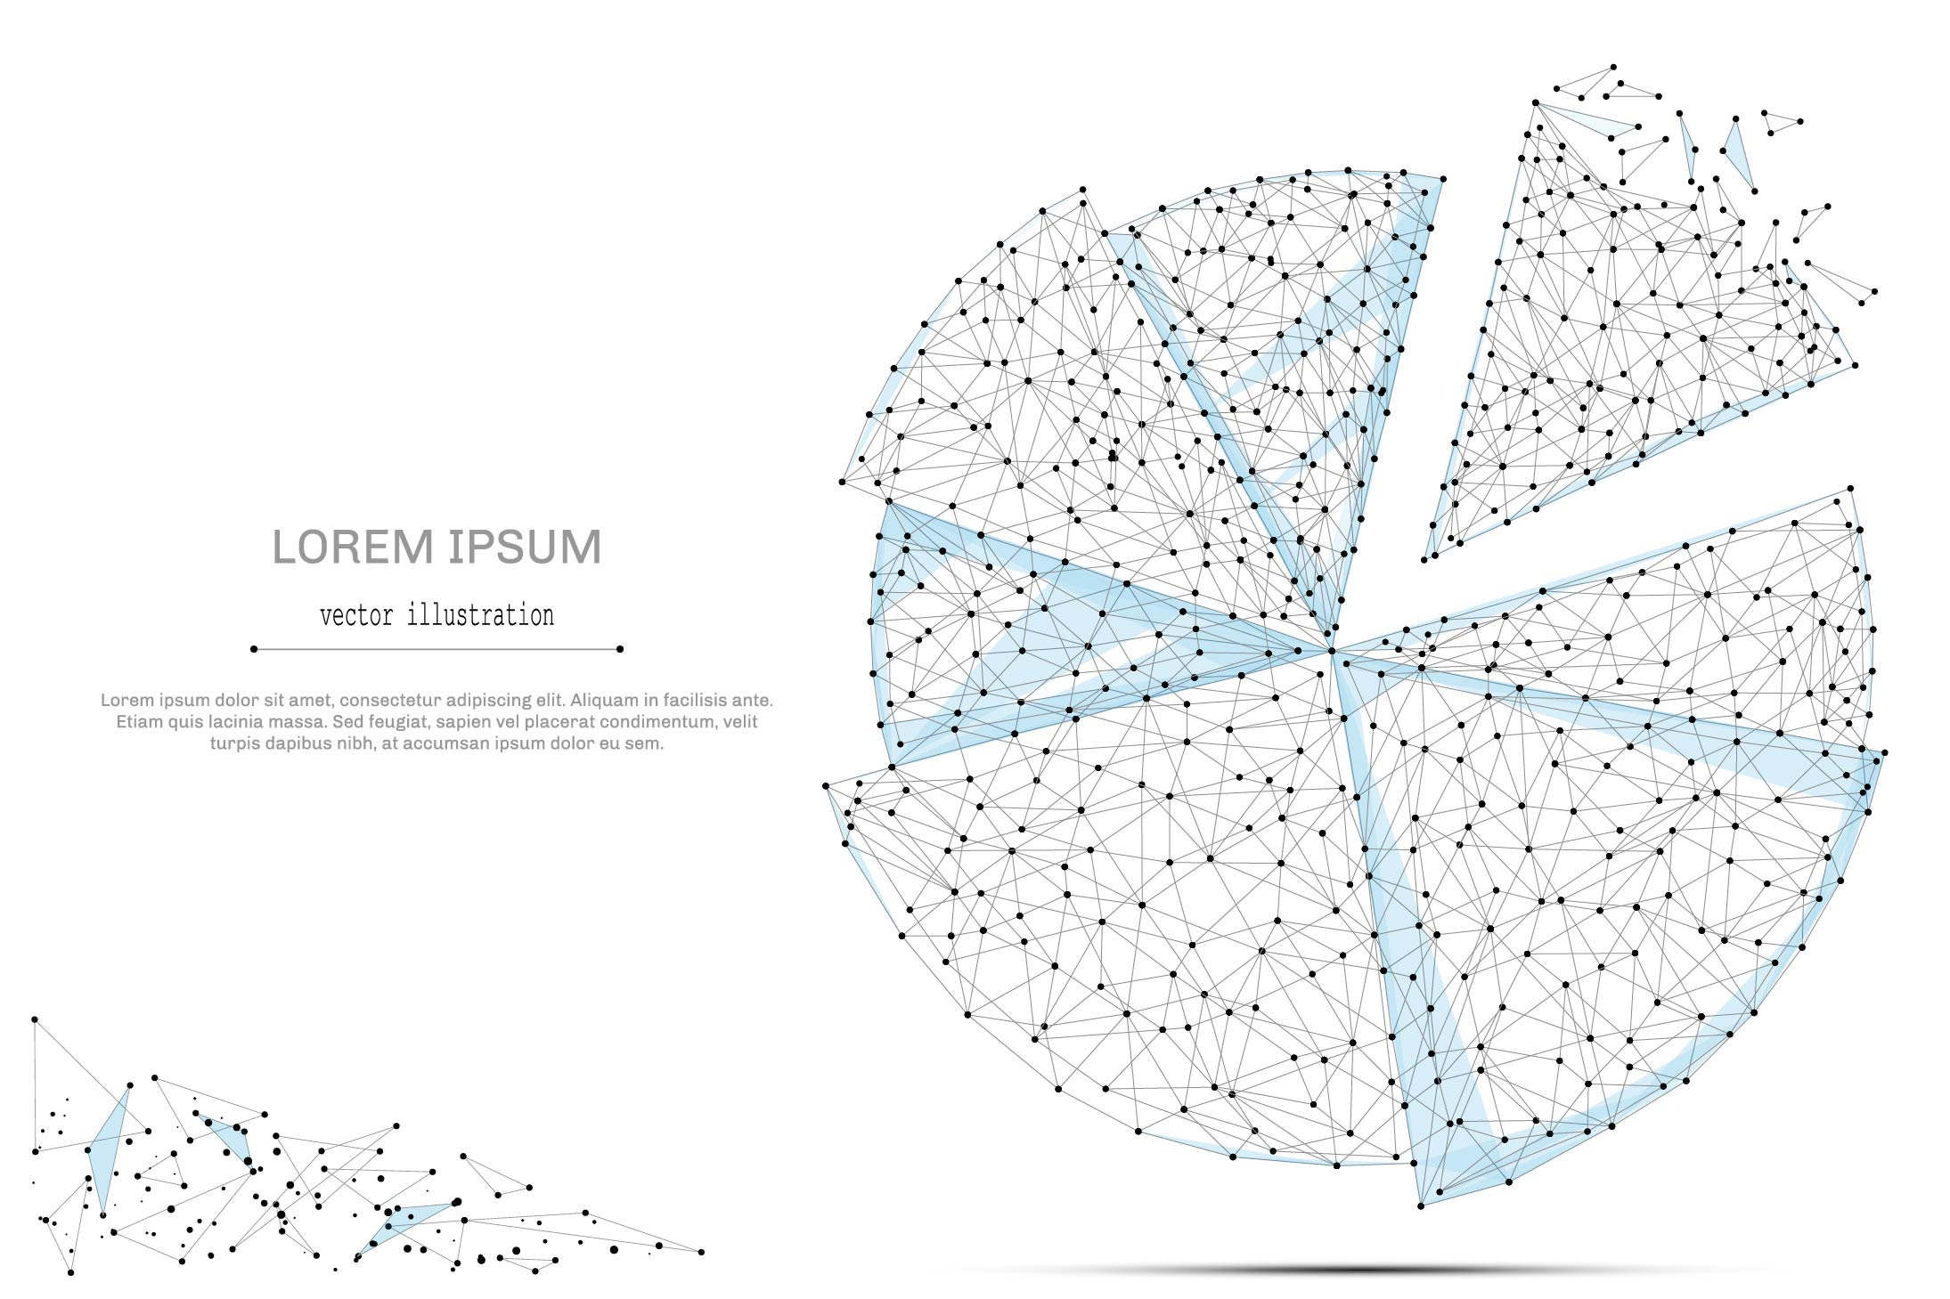

QUARTERLY ECONOMIC UPDATE

For the 3rd Quarter of 2022

Abstract

Designed for business valuation professionals, TagniFi’s Quarterly Economic   
Update provides timely economic data to satisfy Revenue Ruling 56-60.

# Summary

In the 3rd quarter of 2022, inflation continued to be the focal point of the U.S. economic picture. The Federal Reserve’s hawkish interest rate hikes and quantitative tightening plans have thus far underperformed expectations to temper blazing inflation. Further, volatile energy costs are no longer at the forefront of price increases; while inflation among all items fades slightly, “core” inflation, which sets aside traditionally volatile categories, is accelerating. Meanwhile, elevated interest rates have taken a heavy toll on capital markets and slowed the housing industry’s seemingly unstoppable momentum.

The Federal Reserve has repeatedly declared their intent to continue aggressive counter-inflationary policies, particularly interest rate raises, despite the constraints such policies are placing on the U.S. economy. In the view of the Fed, the need to contain inflation exceeds the need to keep the economy from the grips of recession.

Concerns of recession abated slightly with the first positive real GDP reading of 2022; however, the major factor behind the boosted production numbers, a narrowing trade deficit, is expected to be short-lived. The labor market continued to be a bright spot in the 3rd quarter of 2022, with the unemployment rate finally reaching its pre-pandemic level and the labor force participation rate continuing to slowly recover as well.

Recorded COVID-19 cases waned throughout the 3rd quarter of 2022. With widely available at-home tests and relaxed testing policies in public and private spaces across the U.S., official COVID case rates likely no longer give an accurate picture of the virus’s reach.

Vaccines have been established as a reliable way to limit serious illness and death from COVID-19; 4.29 million people were newly vaccinated in the U.S. during the 3rd quarter. Additionally, 11.1 million booster doses were distributed, including bivalent vaccines authorized for use as booster doses on August 31, 2022. While speculation continues as to when COVID-19 will reach an endemic phase in the U.S., a combination of vaccination and prior infection has allowed many aspects of life and commerce to return closer to normal, a situation reflected by increased spending on travel-related services in the 3rd quarter.

A multifactor indicator of economic strength, the Philadelphia Fed’s coincident index[1] of economic activity in the U.S. rose 0.4% in September 2022 and 1.0% during the 3rd quarter. For the quarter, coincident indexes increased in 44 states, decreased in 3 states, and were unchanged in 3 states. Coincident indexes reflect unemployment, payroll employment, manufacturing hours, and wages and salaries.



The U.S. dollar index for goods and services[2] rose 5.44% during the 3rd quarter of 2022 and 11.3% since September 2021. The dollar, a common safe-haven investment when the world economy shows signs of weakness, soared past its pandemic-era apex as the Federal Reserve continued enacting aggressive interest rate hikes, which raised target rates 300 basis points from March to September. The dollar’s strength amplified inflationary pressures elsewhere in the global economy, especially as England unveiled dovish plans despite its own high inflation. Historically, dollar surges this strong have heralded troubled economic waters.

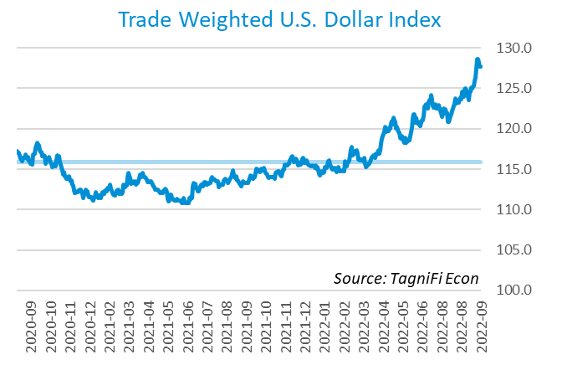

# Q3 Economic Highlights

* The Philadelphia Fed’s coincident index of economic activity in the U.S. rose 0.4% in September 2022 and 1.0% during the 3rd quarter.
* Real GDP for the 3rd quarter of 2022 grew at an annualized rate of 2.6%, following a 0.6% decrease in the 2nd quarter of 2022.
* The U.S. dollar index rose 5.44% during the 3rd quarter of 2022 and 11.3% since September of 2021.
* The effective federal funds rate rose 1.35 percentage points to 2.56% during the 3rd quarter, continuing the climb from near-zero levels in March.
* The 1-year and 2-year annual treasury yields ended the 3rd quarter at 4.05% and 4.22%, respectively. The benchmark 10-year treasury yielded 3.83% at the end of the quarter, while the 30-year treasury yielded 3.79%.
* Unemployment inched down to 3.5% during the 3rd quarter of 2022. Nonfarm payrolls grew by 1.1 million jobs in the 3rd quarter.
* The Consumer Price Index rose 8.2% year-over-year in September, down from its 40-year high of 9.0% in June. Excluding volatile energy prices, the annual increase was 7.3%.
* Crude oil prices ended the quarter at $79.91 per barrel, 25.8% lower than one quarter earlier.
* New home starts fell to 1.44 million in September, down 8.6% for the quarter and 7.7% for the year.
* The Dow Jones Transportation Average dropped 8.4% during the 3rd quarter of 2022, the Dow Jones Composite fell 7.4%, and the Dow Jones Industrial decreased 6.7%. The S&P 500 was down 5.3%.

# Business Activity

Real gross domestic product (GDP)[3] exceeded expectations for the 3rd quarter of 2022 to grow at an annualized rate of 2.6%, following a 0.6% decrease in the 2nd quarter of 2022. The 3rd quarter gain was the first positive quarterly reading of 2022; real GDP was virtually unchanged year-to-date. While the increase in real GDP reflected rises in three of the four major contributing categories, the main factor, a narrowing trade deficit, was widely expected to be temporary.

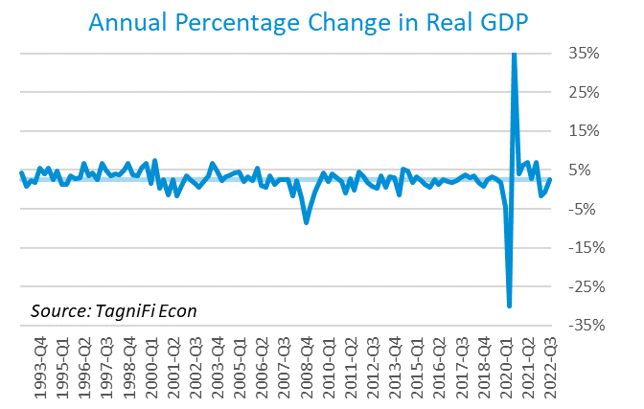

Net exports[4] led the recent rebound in GDP with a positive 2.8% effect, as exports jumped and imports fell during the 3rd quarter. The rise in exports was led by travel and financial business services. While exports have been inconsistent in recent years, the 3rd quarter’s decline in imports broke a two-year streak of consecutive increases. Lowered imports of goods, especially consumer goods, more than offset rising imports of services, particularly travel.

Personal consumption expenditures[5] (PCE) had a positive 1.0% effect on real GDP. Growth in personal spending was led by broad increases in services consumption, especially nonprofit institution output and health care services.

Government expenditures[6] rose at both the federal level and the state and local level to contribute 0.4% to the 3rd quarter GDP gain. National defense consumption led the rise in federal spending. Higher state and local government spending primarily reflected increases in employee compensation.

Gross domestic private investment[7] moderated the 3rd quarter’s rally with a negative 1.6% effect. Residential fixed investment, primarily in new single-family construction and brokers’ commissions, led the 3rd quarter decline. An additional decrease in nonfarm inventories primarily reflected lower retail trade.

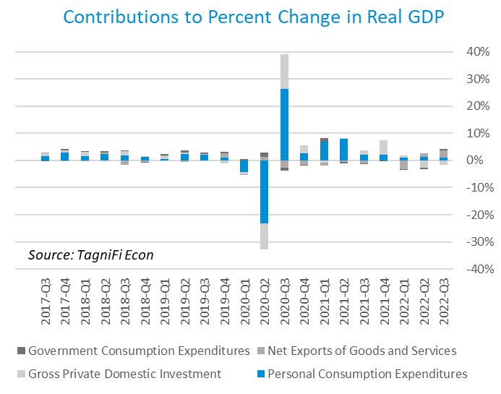

The Industrial Production Index[8] is an economic indicator that measures real output for all facilities located in the United States manufacturing, mining, and electric, and gas utilities. The index stood at 105.2 at the end of the 3rd quarter, up 1.0% from the previous quarter.

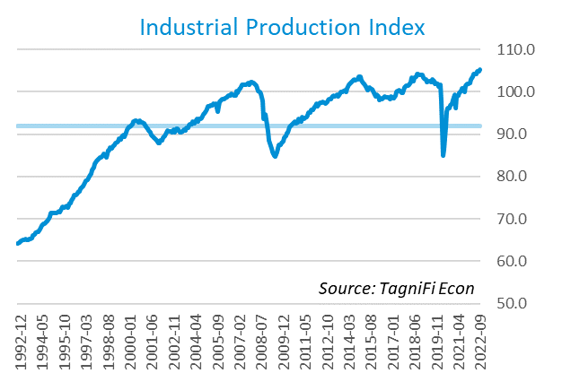

The Capacity Utilization Index[9], which attempts to capture industrial output as a percentage of the economy’s maximum production capacity, rose to 80.0% during the 3rd quarter of 2022. September 2022’s level was above the 30-year average of 76.9% for this metric and 1.1% higher than the previous quarter.

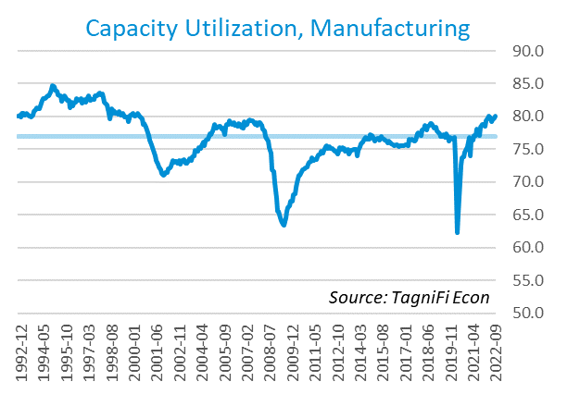

# Interest Rates

The effective federal funds rate[10] rose 1.35 percentage points to 2.56% during the 3rd quarter, continuing the climb from near-zero levels that began in March. Short-term treasury bond yields[11] rose accordingly during the 3rd quarter. Long-term treasury yields rose as well, though not as strongly, turning an already flattened yield curve slightly inverted. The closely watched two- and ten-year rates inverted early in July and remained that way throughout the 3rd quarter. The 1-year and 2-year annual treasury yields ended the 3rd quarter at 4.05% and 4.22%, respectively. The benchmark 10-year treasury yielded 3.83% at the end of the quarter, while the 30-year treasury yielded 3.79%. See *Appendix – Selected Interest Rates* for detailed interest rate data.

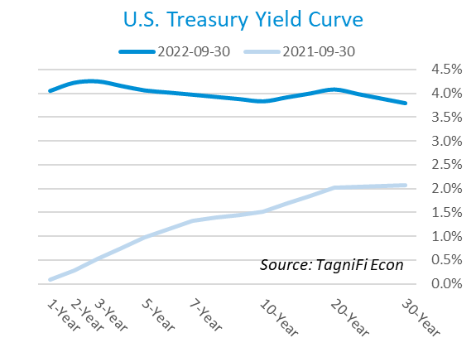

In the 3rd quarter of 2022, the Federal Reserve continued their series of federal funds target rate[12] hikes with two increases totaling 150 basis points, ending the quarter at a range of 3.00% to 3.25%. The committee indicated its intent to continue raising target rates, then hold at an elevated level as long as needed to fully contain inflation, despite dampening expectations for other areas of the economy and the real possibility of recession.

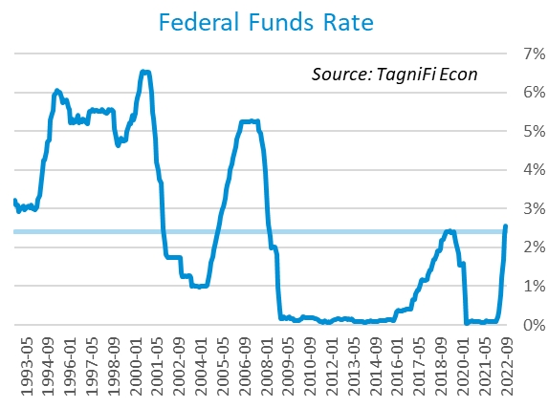

The yield on the benchmark 10-year U.S. treasury[13] ended the 3rd quarter at 3.83%, up 0.85 percentage points from the previous quarter, but still below the average yield of 3.94% over the last 30 years.

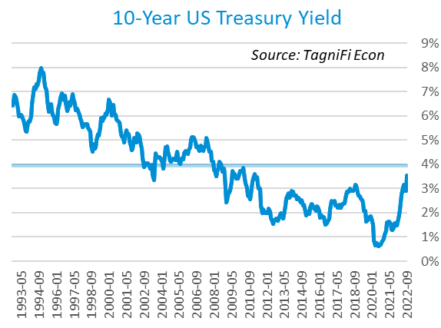

Moody’s Baa Corporate Bond Yield Index[14] ended the 3rd quarter of 2022 at 6.07%, up 0.78 percentage points since the previous quarter. Moody’s less-risky Aaa[15] Index rose 0.72 percentage points during the quarter to a level of 4.91%.

The upward pressure on corporate and treasury bond yields came as the Federal Reserve took a hawkish stance on the economy’s searing inflation, raising interest rate targets five times so far in 2022. Investor expectations have inspired widespread moves from riskier equities into the bond market in anticipation of the Fed rate hikes.

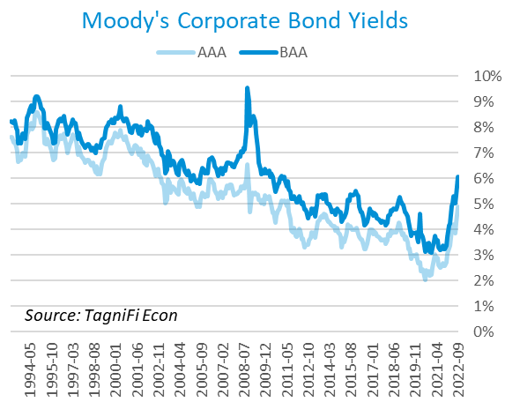

# Employment

The official unemployment rate[16] inched down to 3.5% during the 3rd quarter of 2022, equaling its pre-pandemic level and well below the 30-year historical average of 5.8%. The labor force[17] expanded by 0.7 million workers during the quarter. The labor force participation rate[18] ticked up to 62.3% yet remained 1.1 percentage points below its pre-pandemic level. Economists polled by the Livingston Survey[19] in June of 2022 projected an unemployment rate of 3.4% in December 2022, inching up to 3.5% in June of 2023.

In August 2022, nonfarm worker quits[20] stood at 4.2 million, up 0.8% since August 2021. The number of quits in August was 0.4 million lower than the record high in November 2021 yet remained 0.7 million higher than their pre-pandemic level. The elevated level of quits, sometimes referred to as The Great Resignation, appears to be waning, but will leave in its wake potentially permanent changes to American work culture, including increased flexibility and a focus on employee wellness. Job openings[21] totaled 10.1 million in August 2022, 1.8 million below their record high in March 2022 and 2.4 times the number of resignations.

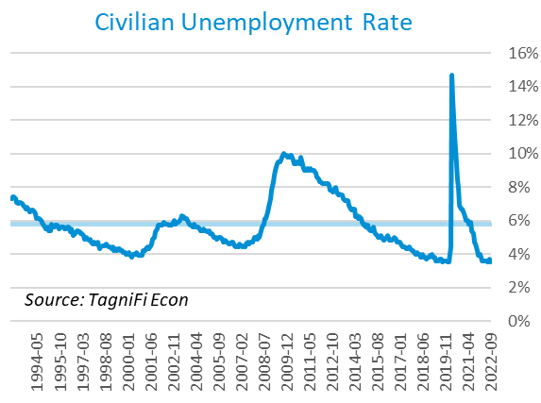

The U-6 unemployment rate[22] is an alternative measure of unemployment with a broader definition, including such groups as discouraged workers who are not actively searching for jobs but want full-time work and part-time workers who want full-time work. The U‑6 unemployment rate has generally followed the same pattern as the official rate, and stood at 6.7% in September 2022, matching June’s record low.

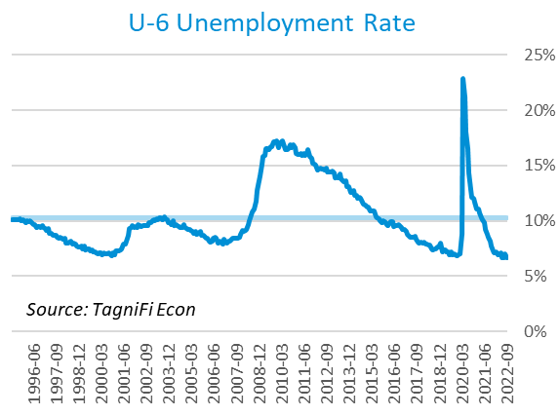

Nonfarm payrolls[23] grew by 1.1 million jobs in the 3rd quarter. U.S. nonfarm payrolls in September 2022 totaled 153.0 million jobs, up 5.7 million compared to the same period last year and exceeding their pre-pandemic (February 2020) levels. Many of the 3rd quarter job gains occurred early in the quarter, and September’s figures fell slightly shy of expectations. The largest gains were recorded in the leisure and hospitality, health care, and professional and business services industries.

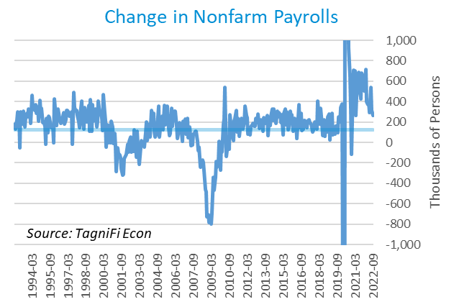

# Inflation

Still at the forefront of the economic conversation, inflation is largely resisting aggressive policy moves to reign it in. The Consumer Price Index[24] rose 8.2% year-over-year in September, down from its 40-year high of 9.0% in June. Excluding volatile energy prices[25], the annual increase was 7.3%, another 40-year high. The average price of a gallon of gas[26] in the U.S. rose 18.9% from $3.27 in September 2021 to $3.88 in September 2022. In the month of September 2022, higher prices for shelter, food, and medical care were the largest contributors to inflation. Shelter and food have been among the top three contributors to inflation every month since July 2021. The Federal Reserve has been taking action to curb inflation with a series of target interest rate hikes totaling 3.00 percentage points since March 2022 and has signaled its intent to continue.

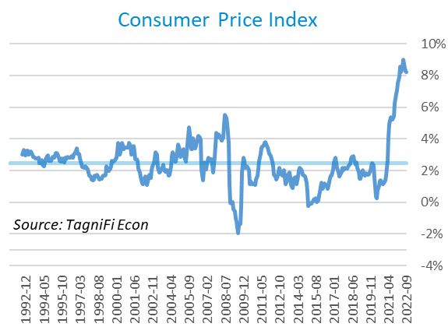

The Producer Price Index[27] inched down 0.1% in September yet remained 14.3% higher than September 2021, far outpacing the 2.9% average annual increase over the last 30 years.

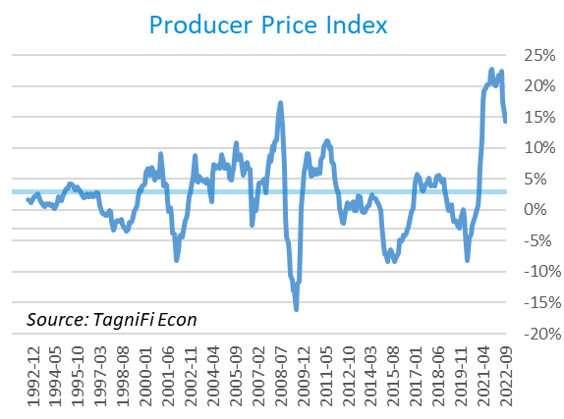

Treasury Inflation-Protected Securities (TIPS) are a longer-term Treasury debt instrument which pays a fixed interest rate but adjusts the principal value according to inflation, effectively indexing interest payments to inflation. TIPS, along with the rest of the bond market, have suffered the consequences of interest rate hikes. The 5-year breakeven inflation rate[28], an indicator for the market’s inflation expectations for the period, fell from 2.58% to end the 2nd quarter to 2.14% to end the 3rd quarter.

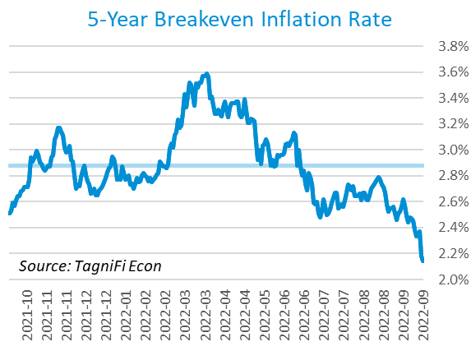

U.S. crude oil[29] prices trended downward throughout the 3rd quarter as a rapidly strengthening dollar tempered foreign demand for oil and other dollar-denominated assets. Crude prices ended the quarter at $79.91 per barrel, 25.8% lower than one quarter earlier.

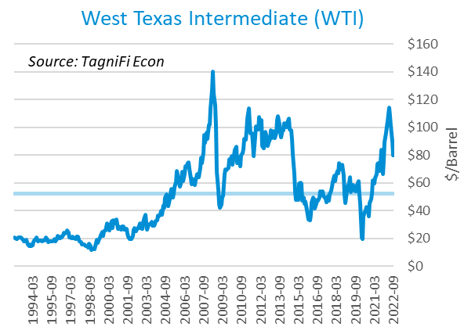

# Housing

The real estate market, which has in recent years been characterized by powerful demand and meager supply, continued to adjust to a high interest rate environment. While prices continue to advance, their climb has slowed as rising mortgage rates reduce affordability. Notably, inventories remain low as high mortgage rates limit the pool not only of potential buyers, but of potential sellers as well—for many, selling now would mean trading a low rate for a much higher one. New home starts[30] fell to 1.44 million in September; starts for single-family homes and multifamily buildings with 5 or more units were down over the quarter, while starts rose for smaller multi-unit buildings. Total new home starts were down 8.6% for the quarter and 7.7% for the year, but still ended the 3rd quarter at a level above their 30-year average of 1.34 million.

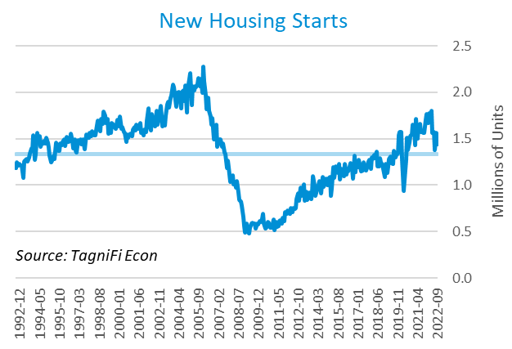

The cost of financing for would-be homebuyers continued to climb during the 3rd quarter, with the 30-year fixed-rate mortgage[31] ending the quarter at 6.70%, the highest rate since mid 2007, just before the U.S. entered the Great Recession.

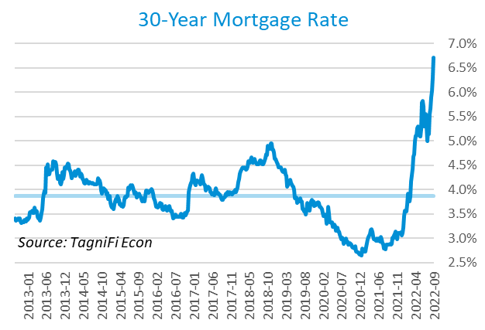

The S&P Case-Shiller Home Price Index (20-city)[32] rose 13.2% year-over-year in August 2022, decelerating for the fourth straight month. All 20 cities continued to report price increases, led by Miami, Tampa, and Charlotte.

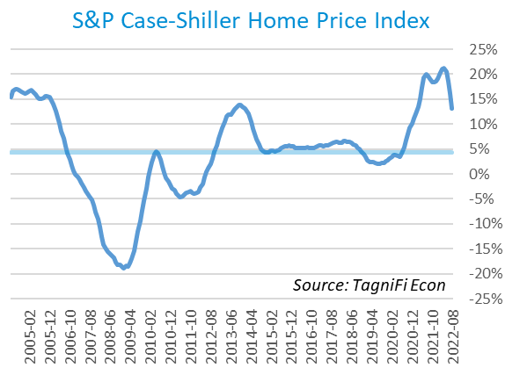

# Consumer Spending

Personal Consumption Expenditures (PCE)[33] rose 1.0% in the 3rd quarter to $17.6 trillion. PCE were up 9.4% since the 3rd quarter last year. Notable spending increases included housing, international travel, air transportation, prescription drugs, and new vehicles.

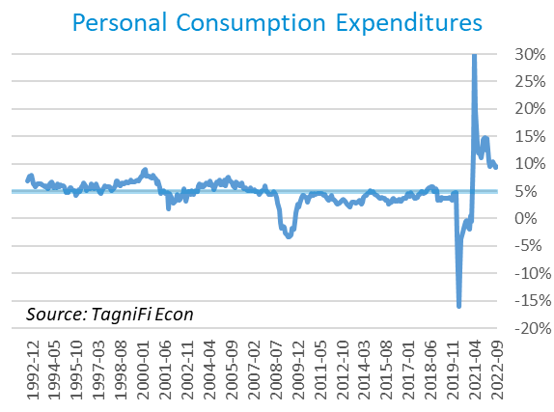

Auto manufacturers reported 13.6 million autos and light trucks sold[34] in September 2022, up 4.1% from June. New vehicle prices[35] built on their record high by a further 1.6% during the 3rd quarter. Used car prices[36] fell 1.6% for the quarter yet were just 2.6% below January’s all-time high.

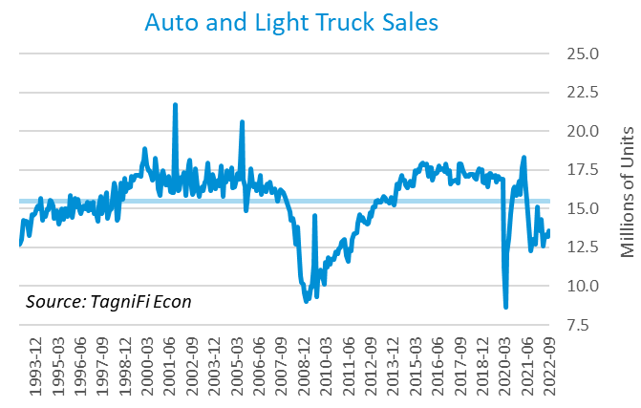

The University of Michigan’s consumer sentiment index[37] rose from its all-time low of 50.0 in June 2022 to end the 3rd quarter at 58.6. September’s reading fell short of expectations as tentative improvement in inflation expectations failed to improve attitudes toward living standards. Recession concerns and global geopolitical risks also hemmed in consumer sentiment. September’s consumer sentiment index was well below its 30-year average of 87.1.

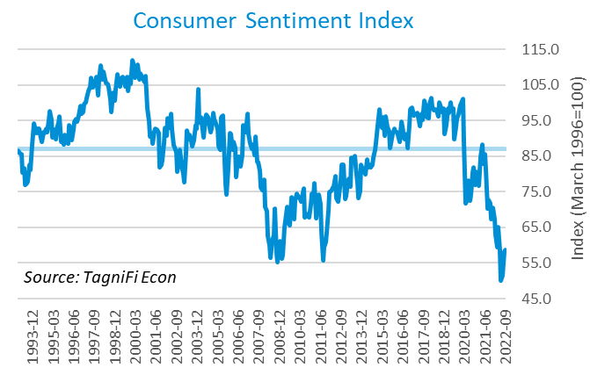

# Capital Markets

The table below shows the quarterly, year-to-date, and 12-month performance of major U.S. equity indices. Capital markets, which had enjoyed bullish conditions during the initial pandemic recovery, suffered a reversal of fortunes in the first three quarters of 2022 that brought the S&P 500 and Dow Jones Industrial averages back down to late-2020 levels. Investors point to persistently high inflation and expectations that the Fed will hold interest rates high despite constrained growth, even if the economy tips into recession. The Dow Jones Transportation Average dropped 8.4% during the 3rd quarter of 2022, the Dow Jones Composite fell 7.4%, and the Dow Jones Industrial decreased 6.7%. The S&P 500 was down 5.3%.



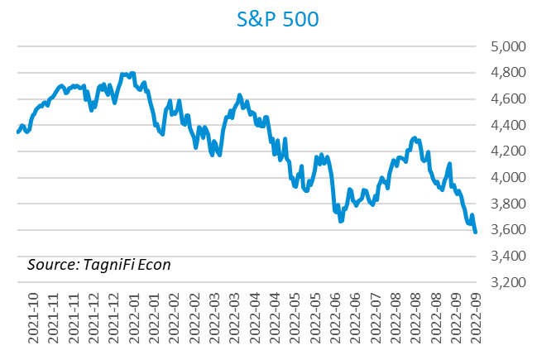

Stock market volatility, as measured by the VIX [38], ended the 3rd quarter at 31.6, up 10.1% since the prior quarter and up 83.6% since the end of 2021. The VIX has fluctuated markedly throughout the first three quarters of 2022, with a general upward trend as investor sentiment was plagued by anxiety about inflation and the hawkish Federal Reserve policy that has yet to contain it.

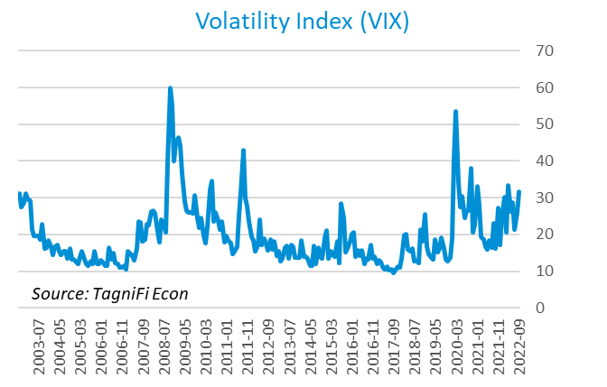

# Outlook

In June 2022, the FOMC revised their near-term inflation and unemployment rate projections slightly upward and real GDP projections sharply downward. Adjustments to longer-run projections for all three indicators were mild yet followed a similar pattern, with inflation and unemployment rising and real GDP declining.

The FOMC revised their projection for real GDP[39] to 0.20% growth in 2022, rising to 1.00% in 2023, then to 1.70% by 2024. They expected Personal Consumption Expenditures (PCE) inflation[40] to grow to 5.50% in 2022 but moderate to 3.05% by 2023 and 2.35% by 2024. They forecast that the unemployment rate[41] would be 3.85% in 2022, rising to 4.30% in 2023 and 2024. The board again increased projections of future target rates and maintained their resolve to continue tightening monetary policy against blazing inflation despite expected consequences, including a potential recession.



Appendix – Selected Interest Rates



# About This Report

The *Quarterly Economic Update* is a free publication sponsored by TagniFi. You are free to share this report and include its contents in the economic outlook section of your valuation reports as required by *Revenue Ruling 59-60*. Please forward this free report to a colleague to help us spread the word about TagniFi.

How TagniFi Helps Business Valuation Teams

TagniFi’s financial data platform empowers business valuation teams to quickly and easily build highly accurate financial models with full transparency—and within seconds.

**Better Public Comps**  
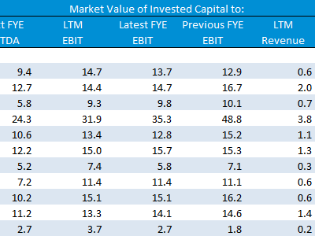Search for public companies with TagniFi Web. Simply enter your valuation date and ticker symbols in Excel to run a guideline public company method. Your Excel model populates instantly with the financial statements, analyst estimates, interest rates and economic data for your valuation date.

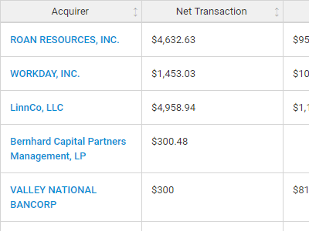**Better Transaction Comps**  
Search for public and private M&A transactions with TagniFi Web. Run your transaction comps within seconds by pasting the Deal ID into your Excel model. Every deal disclosed in an SEC filing (8-K, 10-K, or 10-Q) is available for your analysis. Choose from over 90 fields of data available for every deal.

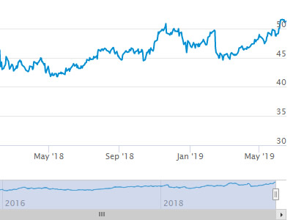

**Historical Beta and Volatility**Calculate historical beta and volatility as of your valuation date automatically. Simply enter the tickers and valuation date in Excel - TagniFi does the rest. In addition to beta and volatility, there are over 40 Excel models available in the Model Library to help with your valuation report.

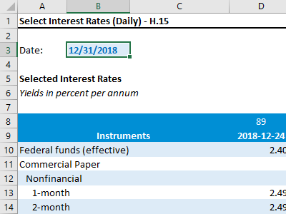**Interest Rates and Economic Data**Automate the interest rates and economic data in your valuation report using the TagniFi Excel plugin. Choose from over 200,000 time series available. All data in this *Quarterly Economic Update* is from the TagniFi platform. Use economic and interest rate data for your own valuation models with the TagniFi Excel plugin.

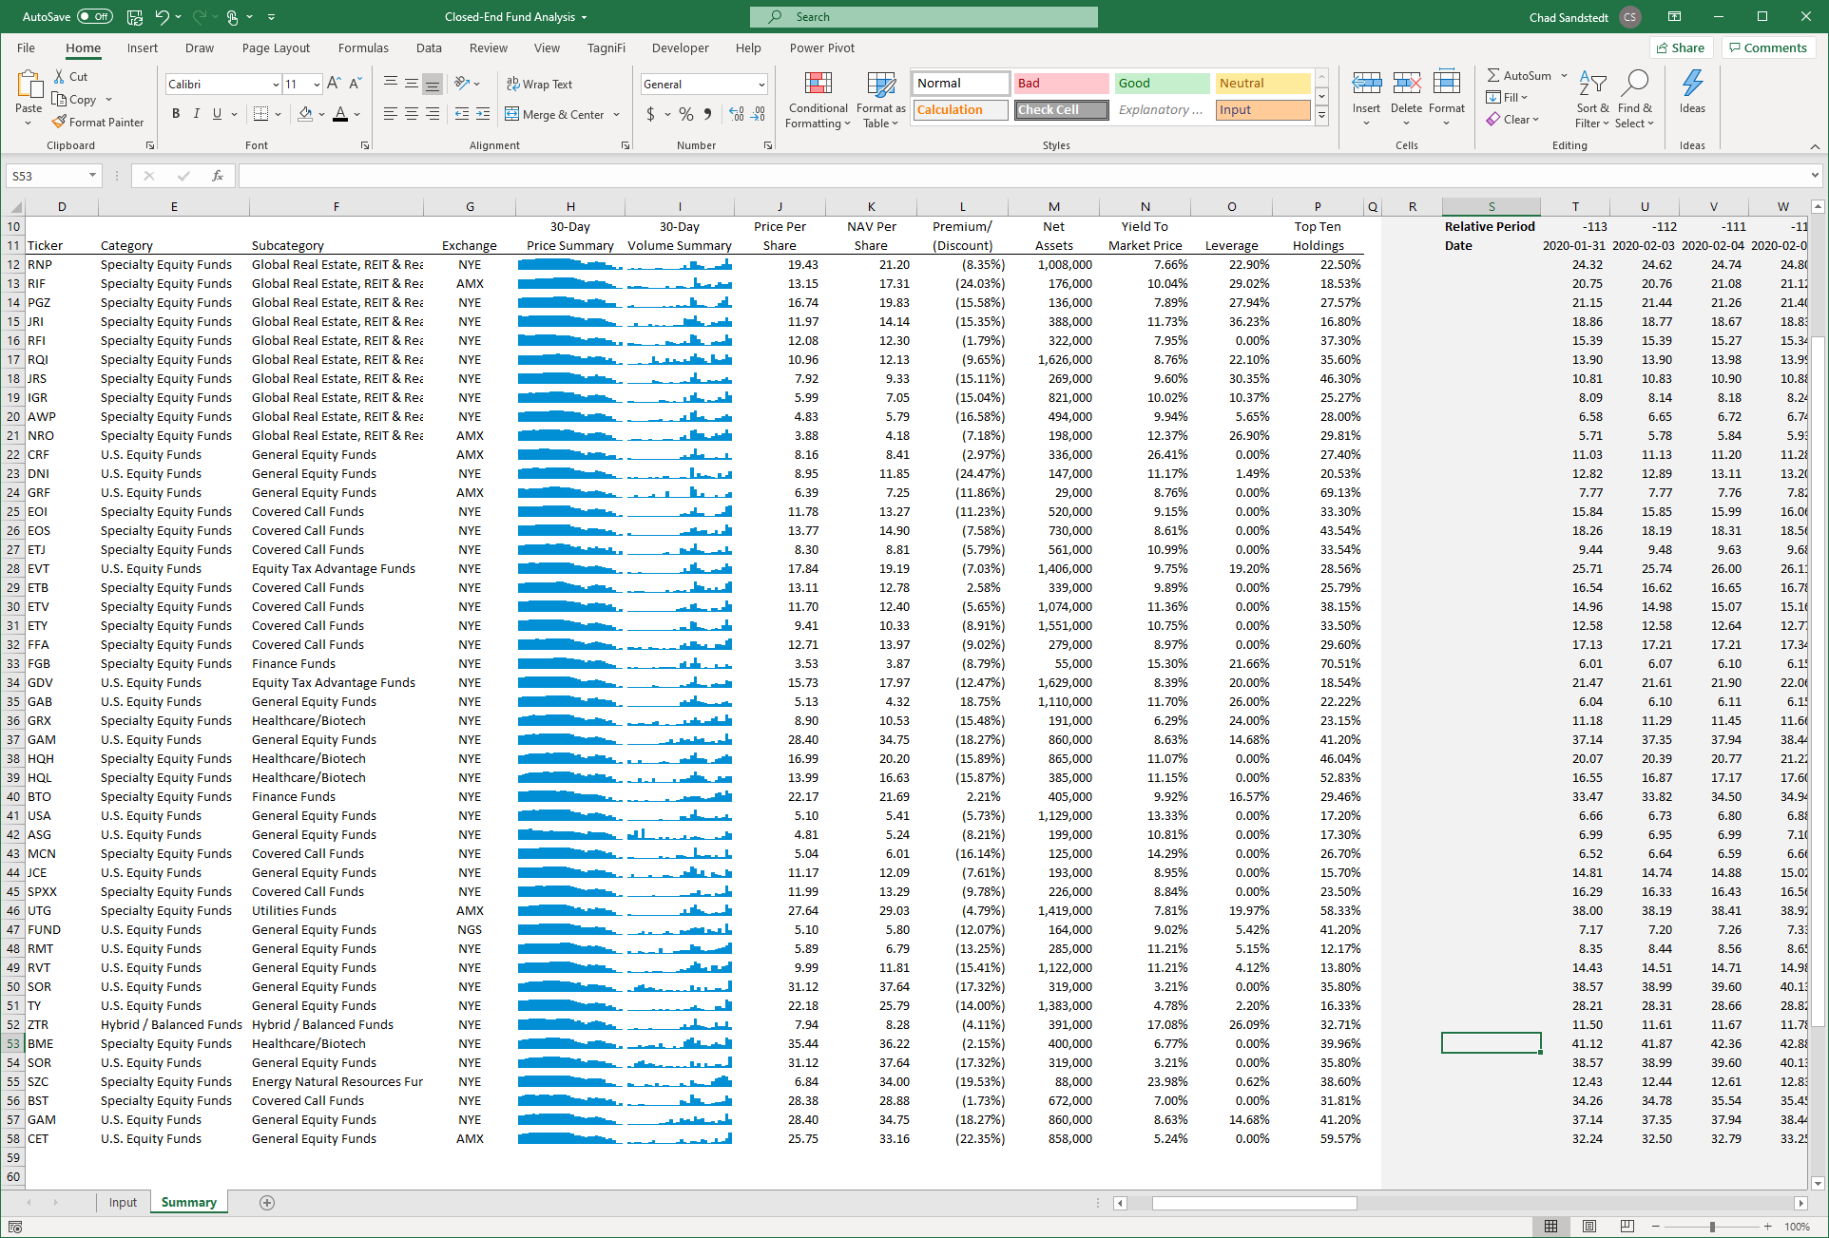

**Closed-End Mutual Fund Data**Search for closed-end mutual funds by keyword, category, subcategory, and more with the TagniFi Console. Use the TagniFi Excel plugin to calculate historical discounts, yields, leverage, as of your valuation date automatically. Simply enter the tickers and valuation date in Excel - TagniFi does the rest.

1. Federal Reserve Bank of Philadelphia, Coincident Economic Activity Index for the United States [USPHCI], *retrieved from FRED, Federal Reserve Bank of St. Louis;* [*https://fred.stlouisfed.org/series/USPHCI*](https://fred.stlouisfed.org/series/USPHCI)*, Oct 31, 2022.*
2. Board of Governors of the Federal Reserve System (US), Trade Weighted U.S. Dollar Index: Broad, Goods and Services [DTWEXBGS], *retrieved from FRED, Federal Reserve Bank of St. Louis;* [*https://fred.stlouisfed.org/series/DTWEXBGS*](https://fred.stlouisfed.org/series/DTWEXBGS)*, Oct 31, 2022.*
3. U.S. Bureau of Economic Analysis, Real Gross Domestic Product [GDPC1], *retrieved from FRED, Federal Reserve Bank of St. Louis;*[*https://fred.stlouisfed.org/series/GDPC1*](https://fred.stlouisfed.org/series/GDPC1)*, Oct 30, 2022.*
4. U.S. Bureau of Economic Analysis, Contributions to percent change in real gross domestic product: Net exports of goods and services [A019RY2Q224SBEA], *retrieved from FRED, Federal Reserve Bank of St. Louis;* [*https://fred.stlouisfed.org/series/A019RY2Q224SBEA*](https://fred.stlouisfed.org/series/A019RY2Q224SBEA)*, Oct 30, 2022.*
5. U.S. Bureau of Economic Analysis, Contributions to percent change in real gross domestic product: Personal consumption expenditures [DPCERY2Q224SBEA], *retrieved from FRED, Federal Reserve Bank of St. Louis;* [*https://fred.stlouisfed.org/series/DPCERY2Q224SBEA*](https://fred.stlouisfed.org/series/DPCERY2Q224SBEA)*, Oct 30, 2022.*
6. U.S. Bureau of Economic Analysis, Contributions to percent change in real gross domestic product: Government consumption expenditures and gross investment [A822RY2Q224SBEA], *retrieved from FRED, Federal Reserve Bank of St. Louis;* [*https://fred.stlouisfed.org/series/A822RY2Q224SBEA*](https://fred.stlouisfed.org/series/A822RY2Q224SBEA)*, Oct 30, 2022.*
7. U.S. Bureau of Economic Analysis, Contributions to percent change in real gross domestic product: Gross private domestic investment [A006RY2Q224SBEA], *retrieved from FRED, Federal Reserve Bank of St. Louis;* [*https://fred.stlouisfed.org/series/A006RY2Q224SBEA*](https://fred.stlouisfed.org/series/A006RY2Q224SBEA)*, Oct 30, 2022.*
8. Board of Governors of the Federal Reserve System (US), Industrial Production Index [INDPRO], *retrieved from FRED, Federal Reserve Bank of St. Louis;*[*https://fred.stlouisfed.org/series/INDPRO*](https://fred.stlouisfed.org/series/INDPRO)*, Oct 31, 2022.*
9. Board of Governors of the Federal Reserve System (US), Capacity Utilization, Manufacturing (NAICS), *retrieved from FRED, Federal Reserve Bank of St. Louis;* [*https://fred.stlouisfed.org/series/MCUMFN*](https://fred.stlouisfed.org/series/MCUMFN)*, Oct 31, 2022.*
10. Board of Governors of the Federal Reserve System (US), Federal Funds Effective Rate [FEDFUNDS], *retrieved from FRED, Federal Reserve Bank of St. Louis;* [*https://fred.stlouisfed.org/series/FEDFUNDS*](https://fred.stlouisfed.org/series/FEDFUNDS)*, Oct 31, 2022.*
11. Selected Interest Rates Instruments, Yields in percent per annum, *retrieved from FRED, Federal Reserve Bank of St. Louis;* [*https://fred.stlouisfed.org/release/tables?rid=18&eid=289&od=2022-06-30*](https://fred.stlouisfed.org/release/tables?rid=18&eid=289&od=2022-06-30)*, Oct 31, 2022.*
12. Board of Governors of the Federal Reserve System (US), Federal Funds Target Range - Upper Limit [DFEDTARU], *retrieved from FRED, Federal Reserve Bank of St. Louis;* [*https://fred.stlouisfed.org/series/DFEDTARU*](https://fred.stlouisfed.org/series/DFEDTARU)*, Oct 30, 2022*.
13. Board of Governors of the Federal Reserve System (US), 10-Year Treasury Constant Maturity Rate [DGS10], *retrieved from FRED, Federal Reserve Bank of St. Louis;*[*https://fred.stlouisfed.org/series/DGS10*](https://fred.stlouisfed.org/series/DGS10)*, Oct 30, 2022.*
14. Moody’s, Moody's Seasoned Baa Corporate Bond Yield [DBAA], *retrieved from FRED, Federal Reserve Bank of St. Louis;* [*https://fred.stlouisfed.org/series/DBAA*](https://fred.stlouisfed.org/series/DBAA)*, Oct 30, 2022.*
15. Moody’s, Moody's Seasoned Aaa Corporate Bond Yield [DAAA], *retrieved from FRED, Federal Reserve Bank of St. Louis;* [*https://fred.stlouisfed.org/series/DAAA*](https://fred.stlouisfed.org/series/DAAA)*, Oct 30, 2022.*
16. U.S. Bureau of Labor Statistics, Civilian Unemployment Rate [UNRATE], *retrieved from FRED, Federal Reserve Bank of St. Louis;*[*https://fred.stlouisfed.org/series/UNRATE*](https://fred.stlouisfed.org/series/UNRATE)*, Oct 30, 2022.*
17. U.S. Bureau of Labor Statistics, Civilian Labor Force Level [CLF16OV], *retrieved from FRED, Federal Reserve Bank of St. Louis;* [*https://fred.stlouisfed.org/series/CLF16OV*](https://fred.stlouisfed.org/series/CLF16OV)*, Oct 30, 2022.*
18. U.S. Bureau of Labor Statistics, Labor Force Participation Rate [CIVPART], *retrieved from FRED, Federal Reserve Bank of St. Louis;* [*https://fred.stlouisfed.org/series/CIVPART*](https://fred.stlouisfed.org/series/CIVPART)*, Oct 30, 2022.*
19. Federal Reserve Bank of Philadelphia, Livingston Survey, [*https://www.philadelphiafed.org/surveys-and-data/real-time-data-research/livingston-survey*](https://www.philadelphiafed.org/surveys-and-data/real-time-data-research/livingston-survey)*, Oct 30, 2022.*
20. U.S. Bureau of Labor Statistics, Quits: Total Nonfarm [JTSQUL], *retrieved from FRED, Federal Reserve Bank of St. Louis;* [*https://fred.stlouisfed.org/series/JTSQUL*](https://fred.stlouisfed.org/series/JTSQUL)*, Oct 30, 2022*.
21. U.S. Bureau of Labor Statistics, Job Openings: Total Nonfarm [JTSJOL], *retrieved from FRED, Federal Reserve Bank of St. Louis;* [*https://fred.stlouisfed.org/series/JTSJOL*](https://fred.stlouisfed.org/series/JTSJOL)*, Oct 30, 2022.*
22. U.S. Bureau of Labor Statistics Total Unemployed, Plus All Persons Marginally Attached to the Labor Force, Plus Total Employed Part Time for Economic Reasons, as a Percent of the Civilian Labor Force Plus All Persons Marginally Attached to the Labor Force (U-6) [U6RATE], *retrieved from FRED, Federal Reserve Bank of St. Louis;*[*https://fred.stlouisfed.org/series/U6RATE*](https://fred.stlouisfed.org/series/U6RATE)*, Oct 30, 2022.*
23. U.S. Bureau of Labor Statistics, All Employees: Total Nonfarm Payrolls [PAYEMS], *retrieved from FRED, Federal Reserve Bank of St. Louis;*[*https://fred.stlouisfed.org/series/PAYEMS*](https://fred.stlouisfed.org/series/PAYEMS)*, Oct 31, 2022.*
24. U.S. Bureau of Labor Statistics, Consumer Price Index for All Urban Consumers: All Items [CPIAUCSL], *retrieved from FRED, Federal Reserve Bank of St. Louis;*[*https://fred.stlouisfed.org/series/CPIAUCSL*](https://fred.stlouisfed.org/series/CPIAUCSL)*, Oct 30, 2022.*
25. U.S. Bureau of Labor Statistics, Consumer Price Index for All Urban Consumers: All Items Less Energy in U.S. City Average [CPILEGSL], *retrieved from FRED, Federal Reserve Bank of St. Louis;* [*https://fred.stlouisfed.org/series/CPILEGSL*](https://fred.stlouisfed.org/series/CPILEGSL)*, Oct 30, 2022*.
26. U.S. Bureau of Labor Statistics, Average Price: Gasoline, Unleaded Regular (Cost per Gallon/3.785 Liters) in U.S. City Average [APU000074714], *retrieved from FRED, Federal Reserve Bank of St. Louis;* [*https://fred.stlouisfed.org/series/APU000074714*](https://fred.stlouisfed.org/series/APU000074714)*, Oct 30, 2022.*
27. U.S. Bureau of Labor Statistics, Producer Price Index for All Commodities [PPIACO], *retrieved from FRED, Federal Reserve Bank of St. Louis;*[*https://fred.stlouisfed.org/series/PPIACO*](https://fred.stlouisfed.org/series/PPIACO)*, Oct 31, 2022.*
28. *Federal Reserve Bank of St. Louis, 5-Year Breakeven Inflation Rate [T5YIE], retrieved from FRED, Federal Reserve Bank of St. Louis;*[*https://fred.stlouisfed.org/series/T5YIE*](https://fred.stlouisfed.org/series/T5YIE)*, Oct 31, 2022.*
29. U.S. Energy Information Administration, Crude Oil Prices: West Texas Intermediate (WTI) - Cushing, Oklahoma [DCOILWTICO], *retrieved from FRED, Federal Reserve Bank of St. Louis;* [*https://fred.stlouisfed.org/series/DCOILWTICO*](https://fred.stlouisfed.org/series/DCOILWTICO)*, Oct 31, 2022.*
30. U.S. Bureau of the Census, Housing Starts: Total: New Privately Owned Housing Units Started [HOUST], *retrieved from FRED, Federal Reserve Bank of St. Louis;*[*https://fred.stlouisfed.org/series/HOUST*](https://fred.stlouisfed.org/series/HOUST)*, Oct 31, 2022.*
31. Freddie Mac, 30-Year Fixed Rate Mortgage Average in the United States [MORTGAGE30US], *retrieved from FRED, Federal Reserve Bank of St. Louis;*[*https://fred.stlouisfed.org/series/MORTGAGE30US*](https://fred.stlouisfed.org/series/MORTGAGE30US)*, Oct 31, 2022.*
32. S&P Dow Jones Indices LLC, S&P/Case-Shiller 20-City Composite Home Price Index [SPCS20RSA], *retrieved from FRED, Federal Reserve Bank of St. Louis;*[*https://fred.stlouisfed.org/series/SPCS20RSA*](https://fred.stlouisfed.org/series/SPCS20RSA)*, Oct 30, 2022.*
33. U.S. Bureau of Economic Analysis, Personal Consumption Expenditures [PCE], *retrieved from FRED, Federal Reserve Bank of St. Louis;*[*https://fred.stlouisfed.org/series/PCE*](https://fred.stlouisfed.org/series/PCE)*, Oct 31, 2022.*
34. U.S. Bureau of Economic Analysis, Light Weight Vehicle Sales: Autos and Light Trucks [ALTSALES], *retrieved from FRED, Federal Reserve Bank of St. Louis; <https://fred.stlouisfed.org/series/ALTSALES>, Oct 31, 2022.*
35. U.S. Bureau of Labor Statistics, Consumer Price Index for All Urban Consumers: New Vehicles in U.S. City Average [CUUR0000SETA01], *retrieved from FRED, Federal Reserve Bank of St. Louis;* [*https://fred.stlouisfed.org/series/CUUR0000SETA01*](https://fred.stlouisfed.org/series/CUUR0000SETA01)*, Oct 31, 2022.*
36. U.S. Bureau of Labor Statistics, Consumer Price Index for All Urban Consumers: Used Cars and Trucks in U.S. City Average [CUSR0000SETA02], *retrieved from FRED, Federal Reserve Bank of St. Louis;* [*https://fred.stlouisfed.org/series/CUSR0000SETA02*](https://fred.stlouisfed.org/series/CUSR0000SETA02), *Oct 31, 2022.*
37. *University of Michigan, University of Michigan: Consumer Sentiment [UMCSENT], retrieved from FRED, Federal Reserve Bank of St. Louis;* [*https://fred.stlouisfed.org/series/UMCSENT*](https://fred.stlouisfed.org/series/UMCSENT)*, Oct 30, 2022.*
38. *Chicago Board Options Exchange, CBOE Volatility Index: VIX [VIXCLS], retrieved from FRED, Federal Reserve Bank of St. Louis;* [*https://fred.stlouisfed.org/series/VIXCLS*](https://fred.stlouisfed.org/series/VIXCLS)*, Oct 30, 2022.*
39. *Federal Reserve Bank of St. Louis, FOMC Summary of Economic Projections for the Growth Rate of Real Gross Domestic Product [GDPC1CTM], retrieved from FRED, Federal Reserve Bank of St. Louis;*[*https://fred.stlouisfed.org/series/GDPC1CTM*](https://fred.stlouisfed.org/series/GDPC1CTM)*, Oct 31, 2022.*
40. *Federal Reserve Bank of St. Louis, FOMC Summary of Economic Projections for the Personal Consumption Expenditures Inflation Rate, Central Tendency, Midpoint [PCECTPICTM], retrieved from FRED, Federal Reserve Bank of St. Louis;*[*https://fred.stlouisfed.org/series/PCECTPICTM*](https://fred.stlouisfed.org/series/PCECTPICTM)*, Oct 31, 2022.*
41. *Federal Reserve Bank of St. Louis, FOMC Summary of Economic Projections for the Civilian Unemployment Rate, Central Tendency, Midpoint [UNRATECTM], retrieved from FRED, Federal Reserve Bank of St. Louis;*[*https://fred.stlouisfed.org/series/UNRATECTM*](https://fred.stlouisfed.org/series/UNRATECTM)*, Oct 31, 2022.*