

www.tagnifi.com

Abstract

Designed for business valuation professionals, TagniFi’s Quarterly Economic Update provides timely macroeconomic data to satisfy Revenue Ruling 59-60.

Quarterly Economic Update

For the 4th Quarter of 2018

# Summary

According to Federal Reserve Chairman Jerome Powell, the U.S. maintained “solid” economic growth in 2018 but showed some signs of weakening toward year-end. The Fed’s outlook is growing uncertain due to a softening in global economic indicators, especially as signs point to economic slowdown in China. A strong labor market and gains in disposable income provide some momentum for the U.S. economy as it faces headwinds from concerns over global trade policy, weakening international economies, and a slow start on home soil due to the U.S. government shutdown to begin 2019.

Worries over the global economy have had an impact on oil prices, which had been rising since mid-2017. Crude oil prices[1] fell sharply over the 4th quarter to $49.52 per barrel in December, down 29.5% from the previous quarter and 14.4% over the last year.

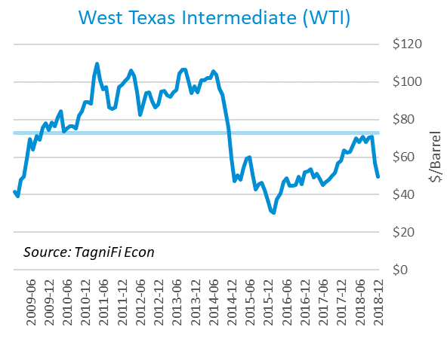

Driven by the prospect of continued interest rate hikes, the U.S. dollar index[2] has risen by 2.38% from the 3rd quarter and 7.12% since the same period last year. The gains came despite a U.S. government shutdown, mounting tension between President Donald Trump and the Fed, and fears that FOMC rate increases could cause the U.S. economy to be dragged down by worrying global economic and political conditions such as slowed growth in China and the EU and the impending implementation of Brexit.

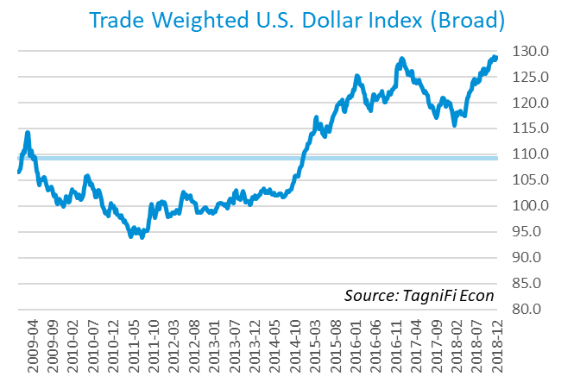

# Economic Highlights

* Real GDP growth decelerated in the 4th quarter to an annual rate of 2.6%, down by 0.8% from the previous quarter.
* Oil prices plummeted, with WTI crude down to $49.52 per barrel in December.
* The U.S. dollar index increased by 2.38% in the 4th quarter and 7.12% since the same period last year.
* In December, the Federal Reserve raised the federal funds target rate to a range of 2.25 to 2.50 percent.
* Interest rates declined slightly during the quarter with the 10-year U.S. treasury yielding 2.69% yield and the 30-year U.S. treasury yielding 3.02%.
* Inflation was maintained at the Fed’s target level of 2 percent for the quarter.
* The housing market showed weakness as the number of new housing starts in December decreased by 14.0% to 1.04 million, their lowest monthly level since March 2015.
* The US labor market remained strong, although the unemployment rate edged up slightly to end the 4th quarter at 3.9%.
* U.S. capital markets weakened among fears of economic slowdown, with the S&P 500 dropping 14.0% from the previous quarter.

# Business Activity

According to the Bureau of Economic Analysis (BEA), real gross domestic product (GDP)[3] for the 4th quarter of 2018 grew at an annual rate of 2.6%, about the same as the 30-year average rate of 2.5%. The growth rate decreased 0.8% from the 3.4% recorded in the 3rd quarter. According to the BEA, the recent deceleration reflected declines in private inventory investment, PCE, and government spending at the federal, state, and local levels.

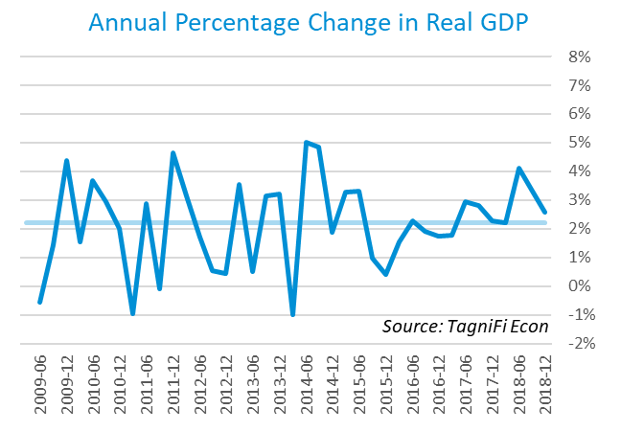

As of December, the Industrial Production Index[4] continued rising to an all-time high of 110.08 boosted by the manufacturing sector, especially motor vehicle production. The mining industry also had increased output, while utility production fell. The Industrial Production Index rose by 1.0% compared to the previous quarter and 4.1% over the same period last year.

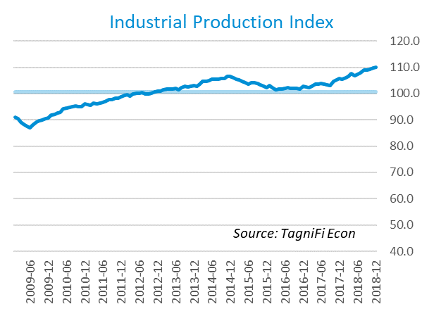

# Interest Rates

The U.S. treasury yield curve[5] remains relatively flat with the 1-year treasury yielding 2.63% and the 30-year treasury yielding 3.02%. The annual yield on the 10-year treasury ended the quarter at 2.69%. The yield curve has come close to inverting during December 2018, indicating the potential for an economic slowdown. Recent volatility in treasury reflect investors’ fears surrounding tighter monetary policy and an ongoing U.S.-China trade war.

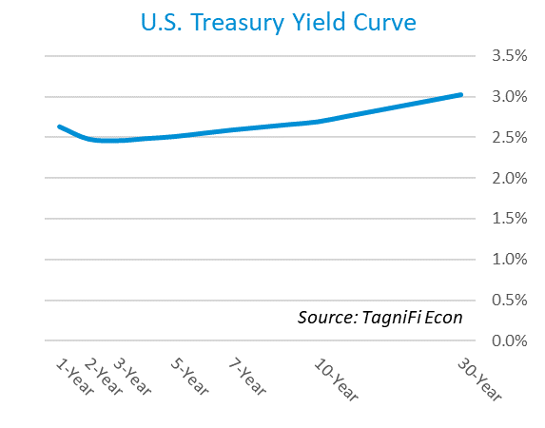

In December, the Federal Reserve voted to raise the federal funds target rate to a range of 2.25 to 2.50 percent, the fourth increase in 2018. This action was in keeping with the Committee’s medium-term plans and was attributed to sustained economic growth, strong labor market conditions, and inflation. The Committee expects to slow rate increases to slow in 2019. The effective federal funds rate[6] as of December is at 2.27%.

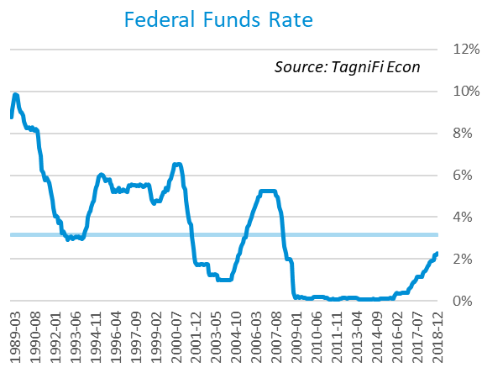

During the fourth quarter, the yield on the 10-year U.S. treasury[7] peaked at 3.24% in November, then slid steadily to 2.69% to end the quarter. This is well below the average yield of 4.72% over the last 30 years, yet above the 2.40% yield from the same period last year.

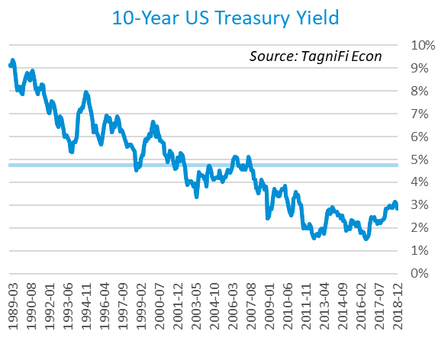

Corporate bond yields also increased this quarter, with the Moody’s Baa Corporate Bond Yield Index[8] ending the 4th quarter at 5.13% compared to 4.88% for the previous quarter and 4.22% for the same period last year. While higher than last year, these rates remain well below the index’s average yield of 7.07% for the last 30 years.

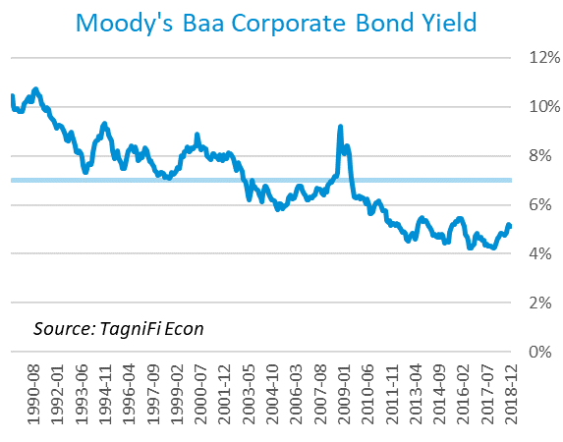

# Employment

In the 4th quarter, the U.S. unemployment rate remained close to its lowest level since 1969. While the unemployment rate increased slightly, the rise was attributed to new job seekers being enticed into the labor market. Total nonfarm payrolls[9] have increased by 2.7 million over the same period last year.

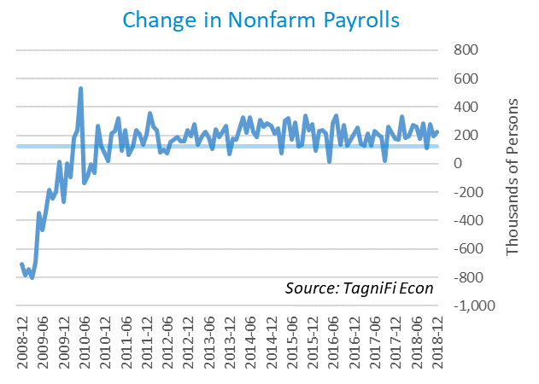

The unemployment rate[10] edged up from its 39-year low of 3.7% to end the 4th quarter at 3.9%. Despite the recent uptick, the rate was down 0.2 percentage point from the same period a year ago and remained well below the 30-year average unemployment rate of 5.9%. The unemployment rate has been falling steadily since the Great Recession.

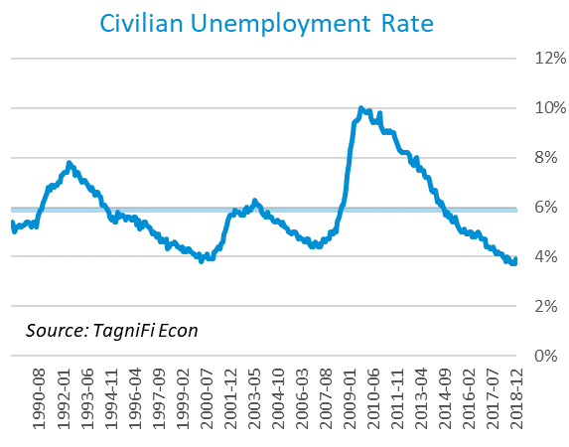

# Inflation

The Fed reported that the U.S. economy achieved its 2-percent inflation target in the 4th quarter. Going forward, the Fed is expecting inflationary pressures to moderate, as world financial conditions have tightened. The Consumer Price Index (CPI)[11] increased by 1.95% from the same period last year. According to Federal Reserve Bank of New York’s Survey of Consumer Expectations, inflation expectations one and three years out are holding virtually steady at 3%.

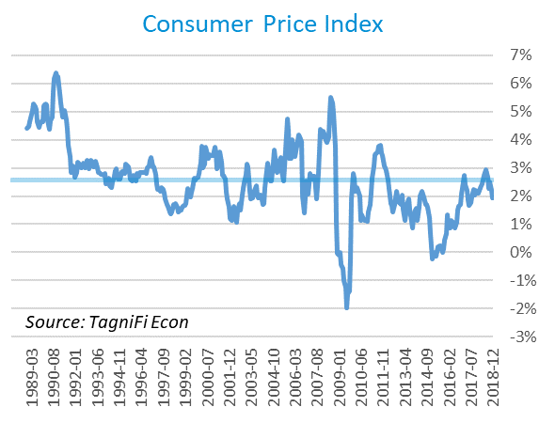

Prices at the producer level decelerated in the 4th quarter, with the Producer Price Index (PPI)[12] increasing by 2.95% compared to the same period last year. Producer-level inflation remains above the 30-year average of 2.26%.

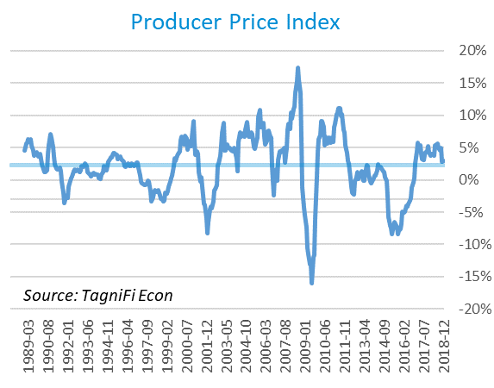

# Housing

During the 4th quarter, the housing market continued to show signs of weakness as new home starts[13] fell by 14.0% to 1.04 million in December, their lowest monthly level since March 2015. Multi-family dwellings saw the largest drop. The main factors for the monthly decline are believed to be high mortgage rates and home prices, coupled with stock market declines. The current level is well above the lows seen in 2009 when only 0.5 million new homes were built, yet below the 30-year average of 1.31 million.

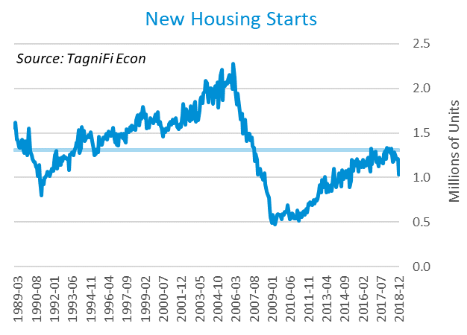

The cost of financing for would-be home-buyers peaked in November as the 30-year fixed-rate mortgage[14] reached 4.94%, the highest level since February 2011, then slipped to 4.55% to close out 2018. The decline was attributed to investor anxiety.

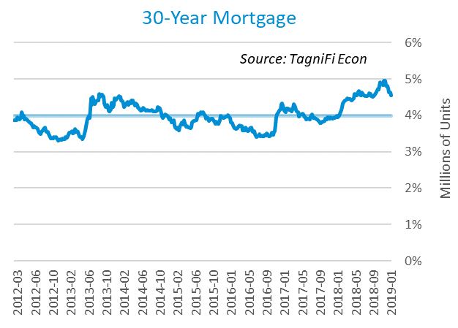

The S&P Case-Shiller Home Price Index (20-city)[15] for December 2018 reaffirms the vulnerability of the housing market in the 4th quarter as home prices are still rising but the rate of increase slowed down, a by-product of a decline in demand. December’s growth in annual home prices was 4.2%, the lowest since September 2012. The index had been experiencing steady annual price increases of at least 5.0% since July 2015.

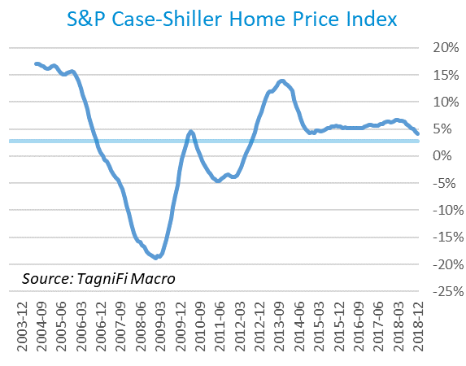

# Consumer Spending

Boosted by gains for long-lasting goods and for services, the level of Personal Consumption Expenditures (PCE)[16] increased by 3.98% from December 2017 to December 2018. The rise was below both the 30-year average level of 5.02% and the 4.53% level from the same period a year ago. The continued reports of strong consumer spending are a boon amidst the negative economic effects of the U.S.-China trade war.

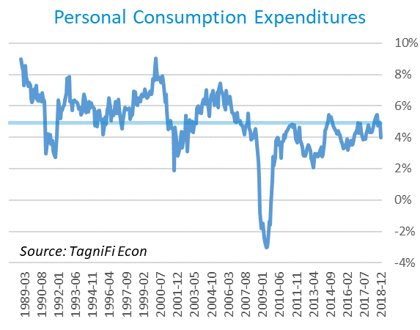

Automotive companies reported 17.5 million autos and light trucks sold[17] in December, up 0.2 million units from the same period last year and 2.2 million units above the 30-year average of 15.3 million units. The 2018 increases in light vehicle sales were attributable to corporate, government, and rental fleets; sales to consumers were little changed, and an economic slowdown in China could dampen sales in the coming year.

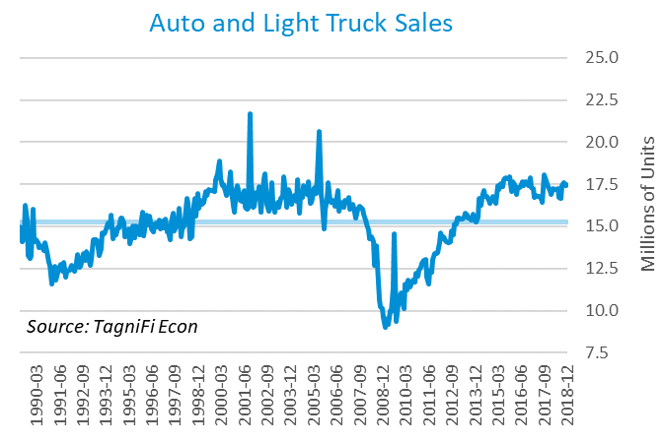

# Capital Markets

U.S. stock indices tumbled in the 4th quarter of 2018, due partly to heavy December losses. Fears of slowed economic activity, trade negotiations with China, and the Fed’s recent policy moves all motivated investors’ decisions. The S&P 500 closed the quarter at 2,506.85, down 14.0% from the previous quarter and 6.2% for the year. The Dow Jones was down 11.8% in the 4th quarter and 5.6% since the end of 2017. The Russell 2000 fell even more sharply, dropping 20.5% from the previous quarter and 12.2% over the year.

|  |  |  |  |  |  |
| --- | --- | --- | --- | --- | --- |
|  | **Closing** |  | **% Change** | | |
| **Index** | **Value** |  | **Quarter** | **YTD** | **12-Mo.** |
| S&P 500 | 2,506.85 |  | -14.0% | -6.2% | -6.2% |
| Dow Jones Industrial Average | 23,327.46 |  | -11.8% | -5.6% | -5.6% |
| Russell 1000 | 2,660.99 |  | -14.3% | -6.6% | -6.6% |
| Russell 2000 | 3,351.51 |  | -20.5% | -12.2% | -12.2% |
| Russell 3000 | 2,704.37 |  | -14.7% | -7.0% | -7.0% |
| NASDAQ Composite | 6,635.28 |  | -17.5% | -3.9% | -3.9% |

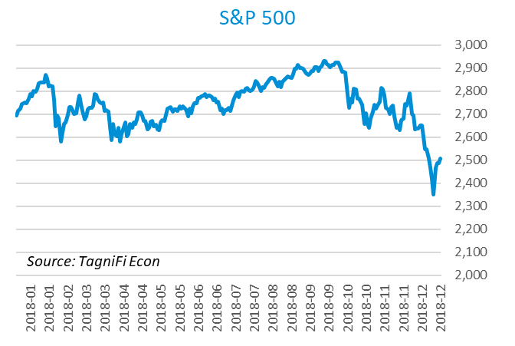

# Outlook

The U.S. Federal Open Market Committee is projecting real GDP growth[18] to slow gradually to 1.80% by 2021. They expect growth in Personal Consumption Expenditures (PCE)[19] to accelerate to 2.10% by 2020 and 2021. Their forecast for the unemployment rate[20] is a decline to 3.60% in 2019 followed by a slight increase to 3.75% by 2021.

|  |  |  |  |
| --- | --- | --- | --- |
| **FOMC Summary of Economic Projections** | | | |
| Year | Real GDP | PCE | Unemployment |
| 2019 | 2.05% | 1.85% | 3.70% |
| 2020 | 1.90% | 2.05% | 3.75% |
| 2021 | 1.85% | 2.05% | 3.90% |
| 2022 | 1.85% | 2.05% | 3.90% |

# About This Report

The *Quarterly Economic Update* is a free publication sponsored by TagniFi. You are free to share this report and include its contents in the economic outlook section of your valuation reports as required by *Revenue Ruling 59-60*. Please forward this free report to a colleague to help us spread the word about TagniFi.

# About TagniFi

TagniFi is bringing financial data into the modern age with the industry's most timely and accurate financial data. TagniFi helps business valuation professionals automate the guideline public company method. All TagniFi data passes through hundreds of quality checks to ensure that you are using the industry’s most accurate data in your valuation reports. In addition, TagniFi clients have access to market data, transaction data, analyst estimates for forward multiples, economic data, profiles, and more. For additional information, please visit [www.tagnifi.com](http://www.tagnifi.com).

Please [follow us](https://www.linkedin.com/company/tagnifi) on LinkedIn to receive updates when future *Quarterly Economic Updates* are released.

[](https://www.linkedin.com/company/tagnifi)

1. *U.S. Energy Information Administration, Crude Oil Prices: West Texas Intermediate (WTI) – Cushing, Oklahoma [MCOILWTICO], retrieved from FRED, Federal Reserve Bank of St. Louis;*[*https://fred.stlouisfed.org/series/MCOILWTICO*](https://fred.stlouisfed.org/series/MCOILWTICO)*, March 11, 2019.*
2. *Board of Governors of the Federal Reserve System (US), Trade Weighted U.S. Dollar Index: Broad [TWEXB], retrieved from FRED, Federal Reserve Bank of St. Louis;*[*https://fred.stlouisfed.org/series/TWEXB*](https://fred.stlouisfed.org/series/TWEXB)*, March 11, 2019.*
3. U.S. Bureau of Economic Analysis, Real Gross Domestic Product [GDPC1], *retrieved from FRED, Federal Reserve Bank of St. Louis;*[*https://fred.stlouisfed.org/series/GDPC1*](https://fred.stlouisfed.org/series/GDPC1)*, March 11, 2019.*
4. Board of Governors of the Federal Reserve System (US), Industrial Production Index [INDPRO], *retrieved from FRED, Federal Reserve Bank of St. Louis;*[*https://fred.stlouisfed.org/series/INDPRO*](https://fred.stlouisfed.org/series/INDPRO)*, March 11, 2019.*
5. Board of Governors of the Federal Reserve System (US), 1-Year to 10-Year Treasury Constant Maturity Rate [IDGS1 – IDGS30], *retrieved from FRED, Federal Reserve Bank of St. Louis;*[*https://fred.stlouisfed.org*](https://fred.stlouisfed.org/series/DGS1)*, March 11, 2019.*
6. Board of Governors of the Federal Reserve System (US), Effective Federal Funds Rate [FEDFUNDS], *retrieved from FRED, Federal Reserve Bank of St. Louis;*[*https://fred.stlouisfed.org/series/FEDFUNDS*](https://fred.stlouisfed.org/series/FEDFUNDS)*, March 11, 2019.*
7. Board of Governors of the Federal Reserve System (US), 10-Year Treasury Constant Maturity Rate [DGS10], *retrieved from FRED, Federal Reserve Bank of St. Louis;*[*https://fred.stlouisfed.org/series/DGS10*](https://fred.stlouisfed.org/series/DGS10)*, March 11, 2019.*
8. Moody’s, Moody’s Seasoned Baa Corporate Bond Yield [BAAS], *retrieved from FRED, Federal Reserve Bank of St. Louis;*[*https://fred.stlouisfed.org/series/BAA*](https://fred.stlouisfed.org/series/BAA)*, March 11, 2019.*
9. U.S. Bureau of Labor Statistics, All Employees: Total Nonfarm Payrolls [PAYEMS], *retrieved from FRED, Federal Reserve Bank of St. Louis;*[*https://fred.stlouisfed.org/series/PAYEMS*](https://fred.stlouisfed.org/series/PAYEMS)*, March 11, 2019.*
10. U.S. Bureau of Labor Statistics, Civilian Unemployment Rate [UNRATE], *retrieved from FRED, Federal Reserve Bank of St. Louis;*[*https://fred.stlouisfed.org/series/UNRATE*](https://fred.stlouisfed.org/series/UNRATE)*, March 11, 2019.*
11. U.S. Bureau of Labor Statistics, Consumer Price Index for All Urban Consumers: All Items [CPIAUCSL], *retrieved from FRED, Federal Reserve Bank of St. Louis;*[*https://fred.stlouisfed.org/series/CPIAUCSL*](https://fred.stlouisfed.org/series/CPIAUCSL)*, March 11, 2019.*
12. U.S. Bureau of Labor Statistics, Producer Price Index for All Commodities [PPIACO], *retrieved from FRED, Federal Reserve Bank of St. Louis;*[*https://fred.stlouisfed.org/series/PPIACO*](https://fred.stlouisfed.org/series/PPIACO)*, March 11, 2019.*
13. U.S. Bureau of the Census, Housing Starts: Total: New Privately Owned Housing Units Started [HOUST], *retrieved from FRED, Federal Reserve Bank of St. Louis;*[*https://fred.stlouisfed.org/series/HOUST*](https://fred.stlouisfed.org/series/HOUST)*, March 11, 2019.*
14. Freddie Mac, 30-Year Fixed Rate Mortgage Average in the United States [MORTGAGE30US], *retrieved from FRED, Federal Reserve Bank of St. Louis;*[*https://fred.stlouisfed.org/series/MORTGAGE30US*](https://fred.stlouisfed.org/series/MORTGAGE30US)*, March 11, 2019.*
15. S&P Down Jones Indices LLC, S&P/Case-Shiller 20-City Composite Home Price Index [SPCS20RSA], *retrieved from FRED, Federal Reserve Bank of St. Louis;*[*https://fred.stlouisfed.org/series/SPCS20RSA*](https://fred.stlouisfed.org/series/SPCS20RSA)*, March 11, 2019.*
16. U.S. Bureau of Economic Analysis, Personal Consumption Expenditures [PCE], *retrieved from FRED, Federal Reserve Bank of St. Louis;*[*https://fred.stlouisfed.org/series/PCE*](https://fred.stlouisfed.org/series/PCE)*, March 11, 2019.*
17. U.S. Bureau of Economic Analysis, Light Weight Vehicle Sales: Autos and Light Trucks [ALTSALES], *retrieved from FRED, Federal Reserve Bank of St. Louis;*[*https://fred.stlouisfed.org/series/ALTSALES*](https://fred.stlouisfed.org/series/ALTSALES)*, March 11, 2019.*
18. Federal Reserve Bank of St. Louis, FOMC Summary of Economic Projections for the Growth Rate of Real Gross Domestic Product [GDPC1CTM], *retrieved from FRED, Federal Reserve Bank of St. Louis;*[*https://fred.stlouisfed.org/series/GDPC1CTM*](https://fred.stlouisfed.org/series/GDPC1CTM)*, March 11, 2019.*
19. Federal Reserve Bank of St. Louis, FOMC Summary of Economic Projections for the Personal Consumption Expenditures Inflation Rate, Central Tendency, Midpoint [PCECTPICTM], *retrieved from FRED, Federal Reserve Bank of St. Louis;*[*https://fred.stlouisfed.org/series/PCECTPICTM*](https://fred.stlouisfed.org/series/PCECTPICTM)*, March 11, 2019.*
20. Federal Reserve Bank of St. Louis, FOMC Summary of Economic Projections for the Civilian Unemployment Rate, Central Tendency, Midpoint [UNRATECTM], *retrieved from FRED, Federal Reserve Bank of St. Louis;*[*https://fred.stlouisfed.org/series/UNRATECTM*](https://fred.stlouisfed.org/series/UNRATECTM)*, March 11, 2019.*