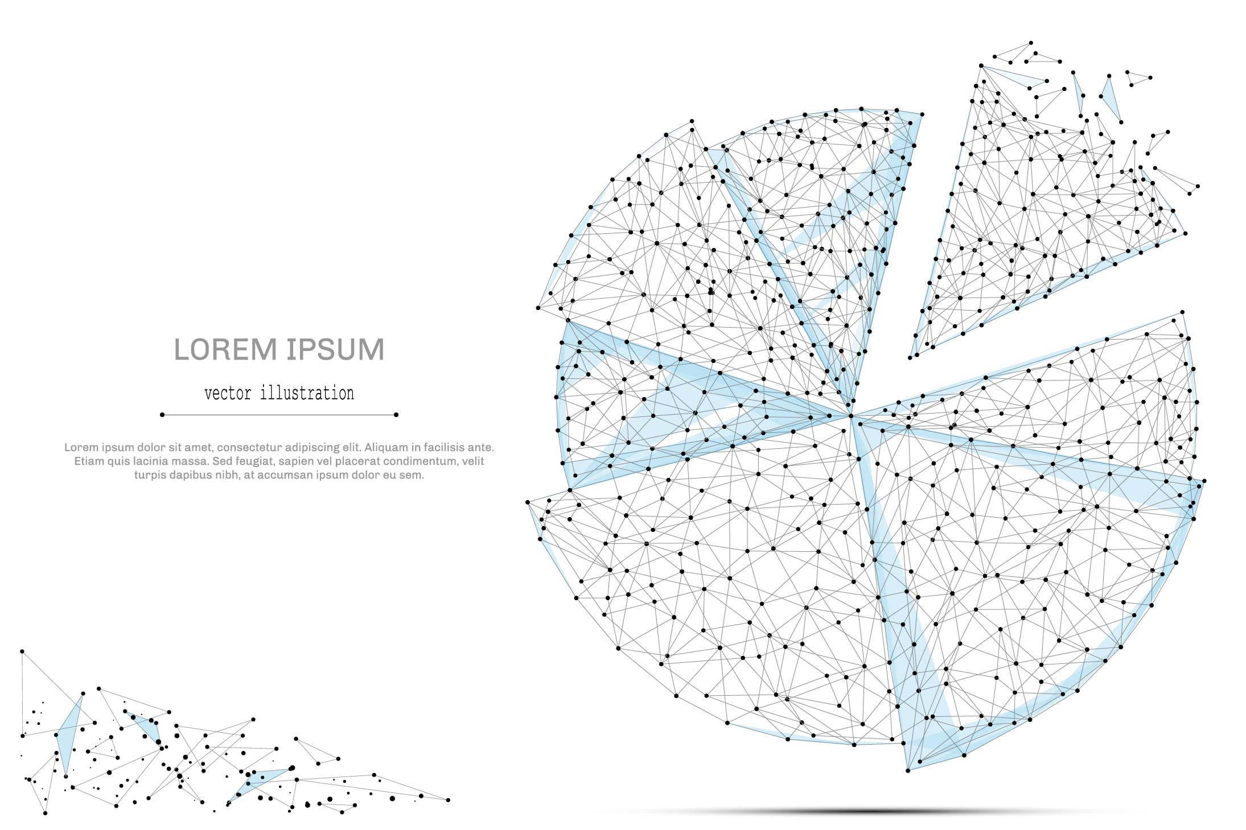

QUARTERLY ECONOMIC UPDATE

For the 4th Quarter of 2022

Abstract

Designed for business valuation professionals, TagniFi’s Quarterly Economic   
Update provides timely economic data to satisfy Revenue Ruling 56-60.

# Summary

In the 4th quarter of 2022, the ongoing battle between inflation and interest rates threatened, but did not thwart, economic growth. Gains in real GDP and a still-strong job market, with unemployment still equal to its low pre-pandemic rate, stood out as bright spots in the economic landscape. Inflation finally showed signs of dulling its roar, with energy prices down and the index for the remaining categories decelerating. However, the Federal Reserve, still awaiting consistent evidence of inflation control, indicated that its target interest rate has not yet peaked. The elevated interest rates have deflated a buoyant housing market and wreaked havoc in the bond market. Despite a slight rebound in the 4th quarter, stocks also suffered the tolls of higher interest rates in 2022.

While GDP has continued to expand, many economists believe the days of growth to be numbered, pointing to a drop in residential fixed investment and slowing economic activity as the 4th quarter went on. The Federal Reserve’s aggressive counter-inflationary policies, particularly interest rate raises, are expected to have a delayed restrictive effect on the economy. FOMC members lowered projections of economic growth to 0.7% in 2023.

Both the stock and bond markets suffered the effects of the inflation-interest rate battle in 2022. While stocks posted their worst-performing year since the Great Recession, higher interest rates drove bond yields up and dragged prices down. The U.S. Treasury yield curve inversion—widely regarded as a harbinger of recession—became more pronounced as the second half of 2022 progressed.

Recorded COVID-19 cases rose during the 4th quarter of 2022. With widely available at-home tests and relaxed testing policies in public and private spaces across the U.S., official COVID case rates likely no longer give an accurate picture of the virus’s reach.

Vaccines have been established as a reliable way to limit serious illness and death from COVID-19. During the 4th quarter, 39.7 million vaccine doses were administered, most of them boosters. 4.1 million people received their first doses of vaccine and 3.1 million became fully vaccinated. Although it is still too early to tell when COVID-19 will reach an endemic phase in the U.S., a combination of vaccination and prior infection has allowed many aspects of life and commerce to return closer to normal.

A multifactor indicator of economic strength, the Philadelphia Fed’s coincident index[1] of economic activity in the U.S. rose 0.3% in December 2022 and 0.8% during the 4th quarter. For the quarter, coincident indexes increased in 28 states, decreased in 13 states, and were unchanged in 9 states. Coincident indexes reflect unemployment, payroll employment, manufacturing hours, and wages and salaries.



The U.S. dollar index for goods and services[2] fell 4.8% during the 4th quarter of 2022, but was up 5.4% since the end of 2021. Despite weakening throughout the 4th quarter as inflation began to cool, the dollar enjoyed its best year since 2015 amid high inflation and aggressive Federal Reserve interest rate hikes, which totaled 425 basis points from March to December. The specter of weak GDP growth could temper the dollar’s success in 2023, especially if inflation continues to ease. But uncertainty elsewhere in the global economy, such as the war in Ukraine and a shaky loosening of COVID restrictions in China, could bolster the dollar’s position in 2023.

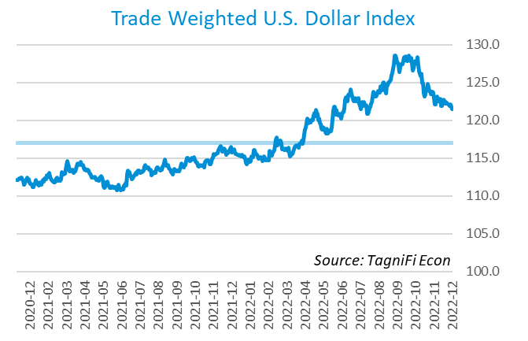

# Q4 Economic Highlights

* The Philadelphia Fed’s coincident index of economic activity in the U.S. rose 0.3% in December 2022 and 0.8% during the 4th quarter.
* Real GDP for the 4th quarter of 2022 grew at an annualized rate of 2.9%, following a 3.2% increase in the 3rd quarter of 2022.
* The U.S. dollar index fell 4.8% during the 4th quarter of 2022 but was up 5.4% since the end of 2021.
* The effective federal funds rate rose 1.54 percentage points to 4.10% during the 4th quarter, continuing the climb from near-zero levels that began in March.
* The 1-year and 2-year annual treasury yields ended the 4th quarter at 4.73% and 4.41%, respectively. The benchmark 10-year treasury yielded 3.88% at the end of the quarter, while the 30-year treasury yielded 3.97%.
* Unemployment ended the 4th quarter at 3.5%, unchanged from the prior quarter. Nonfarm payrolls grew by 0.7 million jobs in the 4th quarter.
* The Consumer Price Index for all items rose 6.4% year-over-year in December, down from its 40-year high of 9.0% in June. Excluding volatile energy prices, the annual increase was also 6.4%.
* Crude oil prices ended the quarter at $80.16 per barrel, 0.3% higher than one quarter earlier.
* New home starts fell to 1.4 million in December, down 5.7% for the quarter and 21.8% for the year.
* The Dow Jones Industrial Average climbed 15.4%, the Dow Jones Composite rose 13.3%, and the Dow Jones Transportation increased 11.1%. The S&P 500 was up 7.1% since the 3rd quarter.

# Business Activity

Real gross domestic product (GDP)[3] exceeded expectations for the 4th quarter of 2022 to grow at an annualized rate of 2.9%, following a 3.2% increase in the 3rd quarter of 2022. After declines in the first half of the year, the gains in the second half of 2022 brought real GDP up 1.0% since the end of 2021. The 4th quarter growth was broad-based, with increases in all four major contributing categories. Still, many economists expect the ongoing surge in interest rates to dampen growth in 2023.

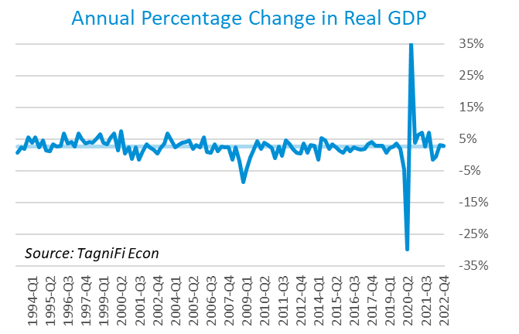

Personal consumption expenditures[4] (PCE) had a positive 1.4% effect on real GDP in the 4th quarter. Growth in personal spending was led by broad increases in services consumption, especially health care and housing and utilities. Spending on goods also rose, led by motor vehicles and parts.

Government expenditures[5] rose at both the federal level and the state and local level to contribute 0.6% to the 4th-quarter GDP gain. Nondefense consumption led the rise in federal spending. Higher state and local government spending primarily reflected increases in employee compensation.

Net exports[6] contributed a further 0.6% to real GDP growth in the 4th quarter, as imports fell more steeply than exports. The decline in imports was led by durable consumer goods. Exports of services rose, particularly travel and transport, but were more than offset by lower exports of goods.

Gross domestic private investment[7] contributed 0.3% to the 4th quarter’s gain in real GDP. A rise in private inventory investment, one of the brightest spots in the real GDP landscape, was mostly offset by a decline in residential fixed investment, especially new single-family construction and broker’s commissions.

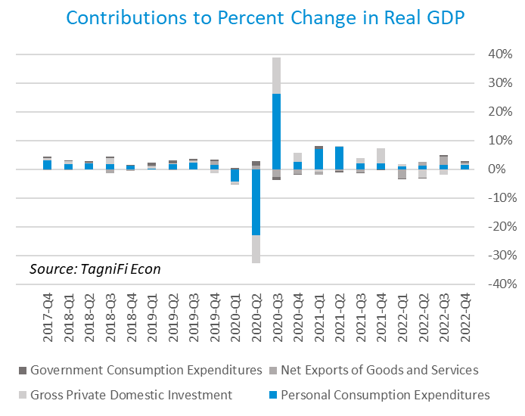

The Industrial Production Index[8] is an economic indicator that measures real output for all facilities located in the United States manufacturing, mining, and electric, and gas utilities. The index stood at 103.4 at the end of the 4th quarter, down 1.3% from the previous quarter.

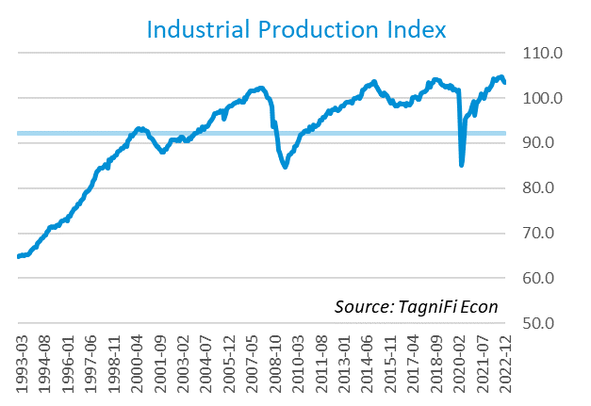

The Capacity Utilization Index[9], which attempts to capture industrial output as a percentage of the economy’s maximum production capacity, fell to 77.5% during the 4th quarter of 2022. December 2022’s level was slightly higher than the 30-year average of 76.9% for this metric, but 2.3% lower than the previous quarter.

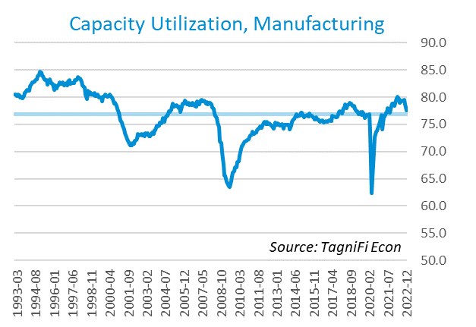

# Interest Rates

The effective federal funds rate[10] rose 1.54 percentage points to 4.10% during the 4th quarter, continuing the climb from near-zero levels that began in March. Both short- and long-term treasury bond yields[11] rose during the 4th quarter, but the yield curve remained inverted as long-term treasury yields continued to lag shorter-term yields. The closely watched two- and ten-year rates inverted early in July and have remained that way, with the gap widening in the 4th quarter. The 1-year and 2-year annual treasury yields ended the 4th quarter at 4.73% and 4.41%, respectively. The benchmark 10-year treasury yielded 3.88% at the end of the quarter, while the 30-year treasury yielded 3.97%. See *Appendix – Selected Interest Rates* for detailed interest rate data.

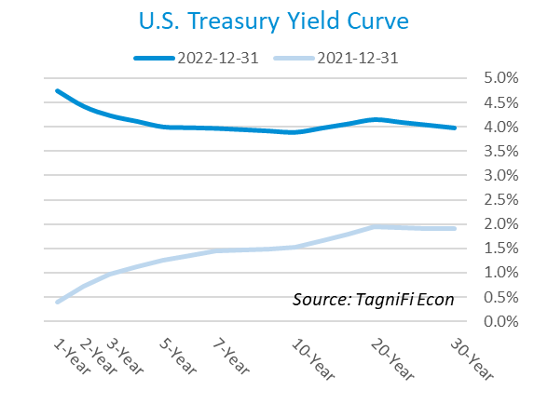

In the 4th quarter of 2022, the Federal Reserve continued their series of federal funds target rate[12] hikes with two increases totaling 125 basis points, ending the quarter at a 15-year high: a range of 4.25% to 4.50%. The committee indicated that despite recent markers of softening inflation, more evidence was needed to recover confidence. Member expect target rates will likely remain elevated throughout 2023 with an expected apex range of 5.00% to 5.25%.

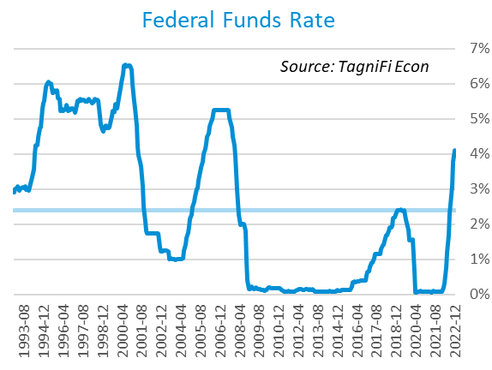

The yield on the benchmark 10-year U.S. treasury[13] ended the 4th quarter at 3.88%, up 0.05 percentage points from the previous quarter, but still slightly below the average yield of 3.91% over the last 30 years.

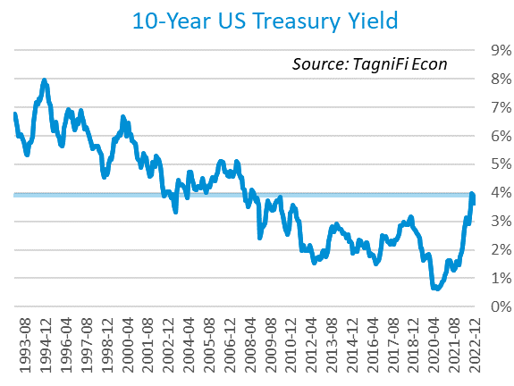

Moody’s Baa Corporate Bond Yield Index[14] ended the 4th quarter of 2022 at 5.87%, down 0.20 percentage points since the previous quarter. Moody’s less-risky Aaa[15] Index slid 0.21 percentage points during the quarter to a level of 4.70%.

The Federal Reserve’s hawkish stance on searing inflation, with target rate hikes totaling 425 basis points in 2022, heralded a difficult year for the bond market, placing upward pressure on yields and forcing prices, which move inversely to yields, downward.

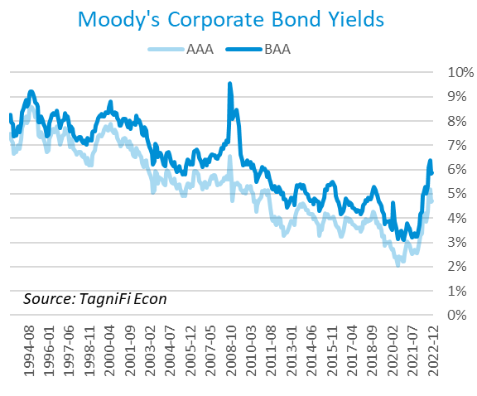

# Employment

The official unemployment rate[16] ended the 4th quarter at 3.5%, unchanged from the prior quarter. The rate equaled its pre-pandemic (February 2020) level and stood well below the 30-year historical average of 5.8%. The labor force[17] expanded by 0.4 million workers during the quarter. The labor force participation rate[18] was 62.3% in December 2022, 1.1 percentage points below its pre-pandemic level. Economists polled by the Livingston Survey[19] in December projected an unemployment rate of 3.7% in December 2022, steadily rising to 4.9% in December of 2023.

In November 2022, nonfarm worker quits[20] stood at 4.2 million, down 7.5% from their record high in November 2021 but 21.1% higher than their pre-pandemic level. The elevated level of quits, sometimes referred to as The Great Resignation, continues to disproportionately affect the leisure and hospitality industry. Job openings[21] totaled 10.5 million in November 2022, 1.4 million below their record high in March 2022 and 2.5 times the number of resignations.

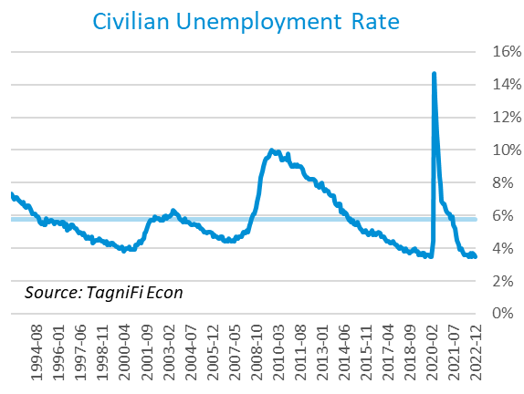

The U-6 unemployment rate[22] is an alternative measure of unemployment with a broader definition, including such groups as discouraged workers who are not actively searching for jobs but want full-time work and part-time workers who want full-time work. The U‑6 unemployment rate has generally followed the same pattern as the official rate, and stood at 6.5% in December 2022, a new record low.

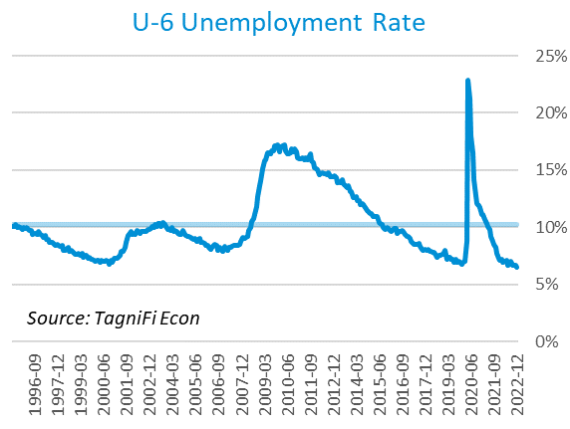

Nonfarm payrolls[23] grew by 0.7 million jobs in the 4th quarter. U.S. nonfarm payrolls in December 2022 totaled 153.7 million jobs, up 4.5 million from the prior December and 1.2 million above their pre-pandemic (February 2020) levels. The better-than expected job market growth was led by the leisure and hospitality, health care, and professional and construction, and social assistance industries.

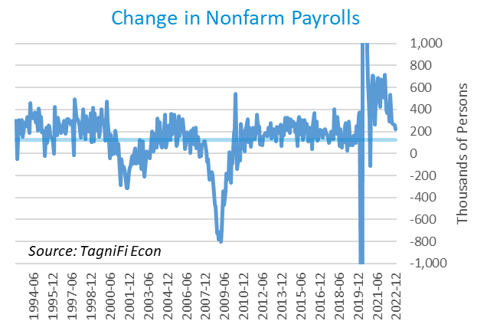

# Inflation

Still at the forefront of the economic conversation, inflation slowed slightly in the 4th quarter of 2022, largely reflecting lower energy costs. Inflation also cooled during the quarter for food, medical care, and both used and new vehicles. The Consumer Price Index[24] for all items rose 6.4% year-over-year in December, down from its 40-year high of 9.0% in June. Excluding volatile energy prices[25], the annual increase was also 6.4%. The average price of a gallon of gas[26] in the U.S. was $3.36 in December 2022, 1.5% lower than the prior December, having fallen during the second half of the year from its record-high $5.06 in June. In the month of December 2022, lower prices for gasoline more than offset price increases for shelter and various other items including food. The Federal Reserve has been taking action to curb inflation with a series of target interest rate hikes totaling 4.25 percentage points since March 2022 and indicated that it has not yet reached its intended peak of over 5%.

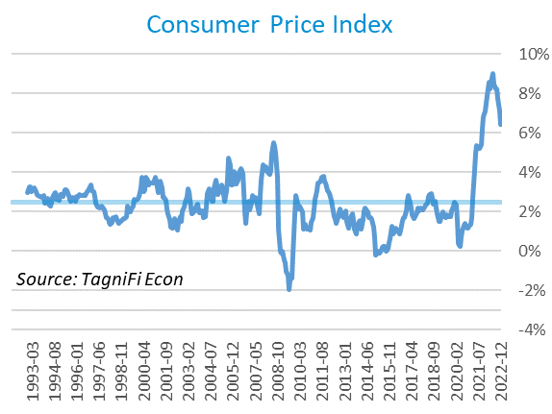

The Producer Price Index[27] fell 2.0% in December yet remained 6.9% higher than December 2021, outpacing the 2.9% average annual increase over the last 30 years.

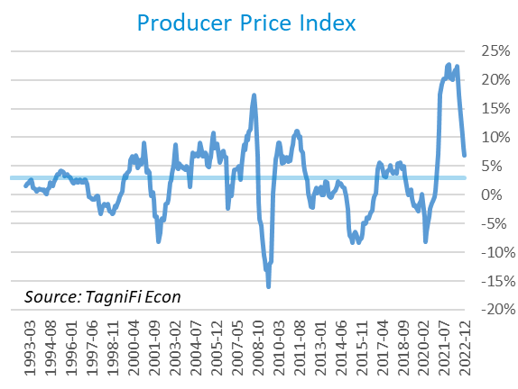

Treasury Inflation-Protected Securities (TIPS) are a longer-term Treasury debt instrument which pays a fixed interest rate but adjusts the principal value according to inflation, effectively indexing interest payments to inflation. Demand for TIPS flagged along with the rest of the bond market in 2022, yet could see more demand as economic slowdown concerns persist. The 5-year breakeven inflation rate[28], an indicator for the market’s inflation expectations for the period, rose to 2.33% at the end of the 4th quarter from 2.14% at the end of the 3rd quarter.

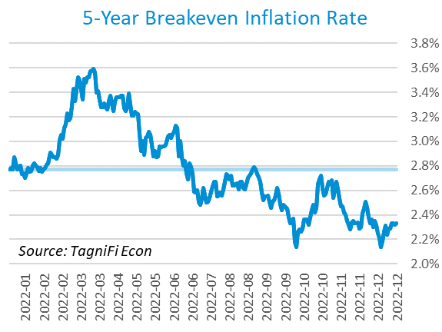

U.S. crude oil[29] prices fell early in the 4th quarter on anxieties about demand, then rebounded as China’s lockdown was lifted and inflation in the U.S. showed signs of easing. Crude prices ended the quarter at $80.16 per barrel, 0.3% higher than one quarter earlier.

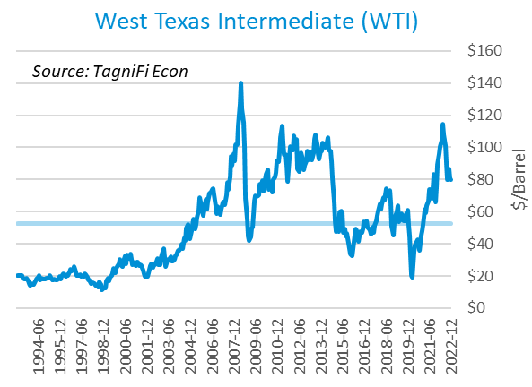

# Housing

For the real estate market, which has in recent years been characterized by powerful demand and meager supply, high interest rates have begun to dominate the picture. Prices in major cities trended downward in recent months, though they remained higher than the prior year. Home sales continued their 11-month decline. After peaking early in the 4th quarter, mortgage rates began to decline, giving cause for hope in the flagging housing market. New home starts[30] fell to 1.4 million in December; starts for single-family homes rose while starts for multifamily buildings with 5 or more units were down sharply over the quarter. Total new home starts were down 5.7% for the quarter and 21.8% for the year, but still ended the 4th quarter at a level slightly above their 30-year average of 1.3 million.

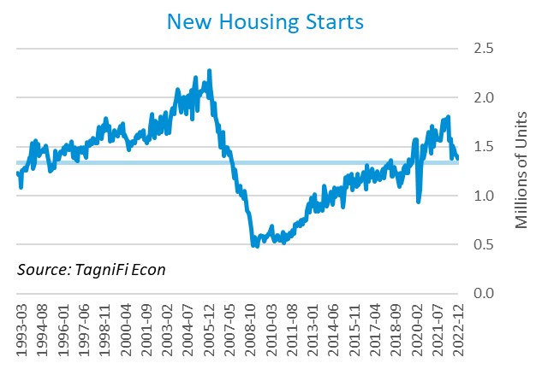

The cost of financing for would-be homebuyers eased slightly during the 4th quarter, with the 30-year fixed-rate mortgage[31] ending the quarter at an average of 6.42% after peaking in late October at a 20-year high of 7.08%.

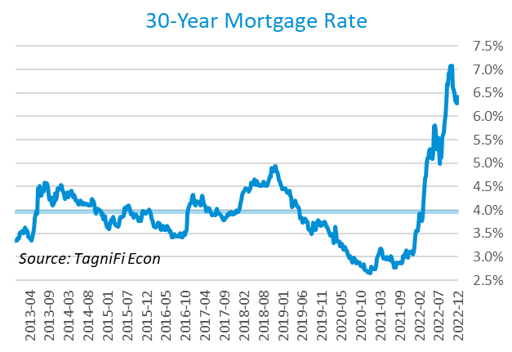

The S&P Case-Shiller Home Price Index (20-city)[32] fell for the fifth straight month but was 6.8% higher since the 4th quarter of 2021. Led by Miami, Tampa, and Atlanta, 19 of the 20 cities continued to report one-year price increases, though the gains shrunk for each of the cities.

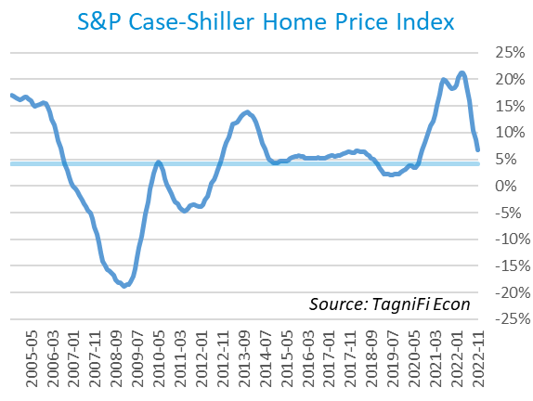

# Consumer Spending

Personal Consumption Expenditures (PCE)[33] rose 0.5% in the 4th quarter to $17.7 trillion. PCE were up 7.4% since the 4th quarter last year. Spending decreased in December for goods such as gasoline and motor vehicles and parts, but increased for services including housing, air transportation, and health care.

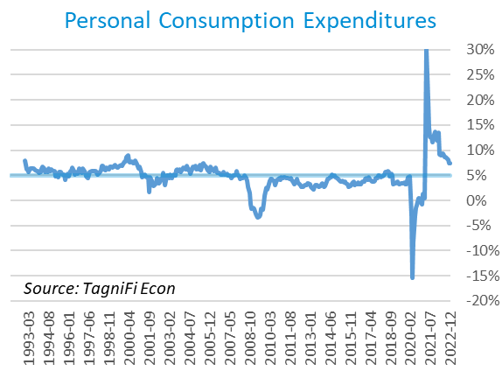

Auto manufacturers reported 13.3 million autos and light trucks sold[34] in December 2022, down 2.3% from September. New vehicle prices[35] built on their record high by a further 0.7% during the 4th quarter, while used car prices[36] fell 7.7 % over the quarter.

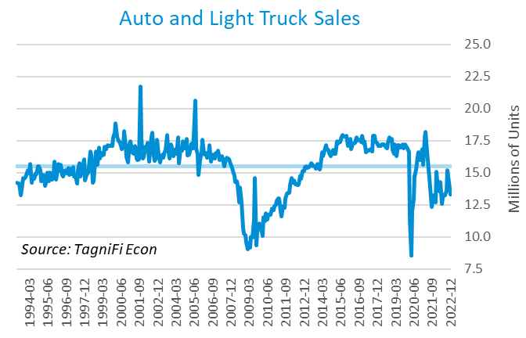

The University of Michigan’s consumer sentiment index[37] rose to 59.7 to end the 4th quarter, continuing its rebound from its all-time low of 50.0 in June yet still well below its 30-year average of 86.9. December’s increase exceeded expectations amid abating inflation expectations. While consumer expectations for the economy have improved, they remain relatively weak, with 65% of consumers expecting unfavorable developments in the coming year.

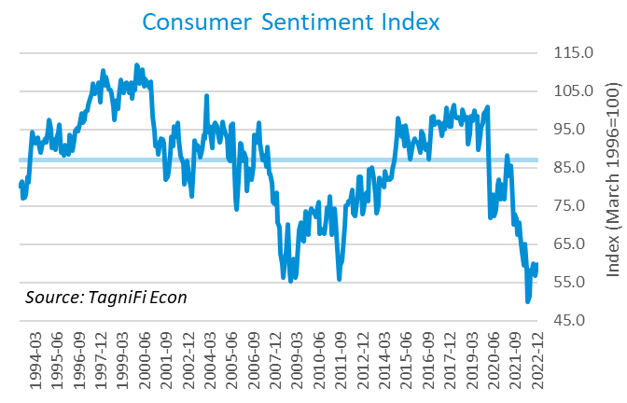

# Capital Markets

The table below shows the quarterly, year-to-date, and 12-month performance of major U.S. equity indices. Capital markets, which had enjoyed bullish conditions during the initial pandemic recovery, suffered a reversal of fortunes in the first three quarters of 2022 that brought the S&P 500 and Dow Jones Industrial averages back down to late-2020 levels. 4th quarter market conditions improved with better-than expected inflation and jobs report news; during the quarter, the Dow Jones Industrial Average climbed 15.4%, the Dow Jones Composite rose 13.3%, and the Dow Jones Transportation increased 11.1%. The S&P 500 was up 7.1% for the quarter. Still, it was not enough to salvage a bearish year—the worst since 2008 for the Dow Jones Industrial Average, S&P 500, and NASDAQ Composite.



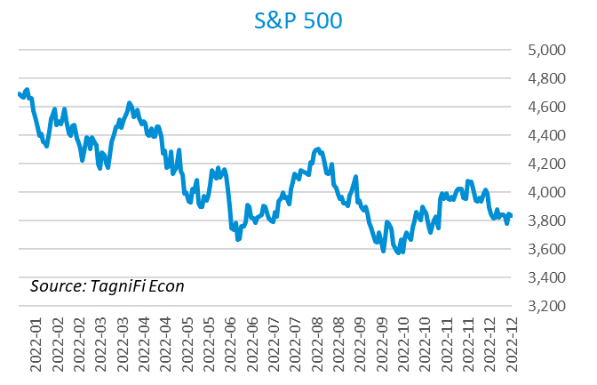

Stock market volatility, as measured by the VIX [38], ended the 4th quarter at 21.7, down 31.5% since the prior quarter but up 25.8% since the end of 2021. Fluctuations in the VIX marked a turbulent year for capital markets plagued by anxiety about inflation, hawkish Federal Reserve policy, geopolitical unease, and mixed economic signals.

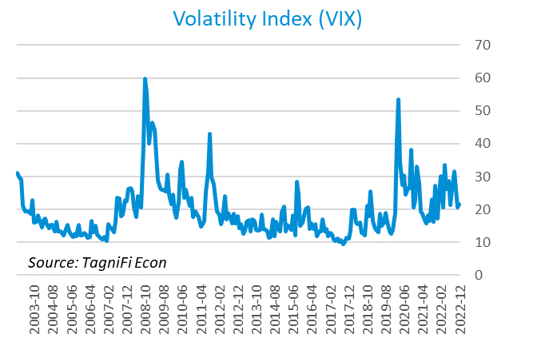

# Outlook

In June 2022, the FOMC revised their near-term inflation and real GDP rate projections slightly upward and unemployment rate projections slightly downward. Little to no adjustments were made to longer-run projections for the three indicators.

The FOMC revised their projection for real GDP[39] to 0.45% growth in 2022, rising to 0.70% in 2023, then to 1.65% by 2024. They expected Personal Consumption Expenditures (PCE) inflation[40] to grow to 5.70% in 2022 but moderate to 3.20% by 2023 and 2.50% by 2024. They forecast that the unemployment rate[41] would be 3.70% in 2022, rising to 4.55% in 2023 and 2024. The board again increased projections of future target rates and resolved to uphold tight monetary policy against elevated inflation through at least the coming year.



Appendix – Selected Interest Rates



# About This Report

The *Quarterly Economic Update* is a free publication sponsored by TagniFi. You are free to share this report and include its contents in the economic outlook section of your valuation reports as required by *Revenue Ruling 59-60*. Please forward this free report to a colleague to help us spread the word about TagniFi.

How TagniFi Helps Business Valuation Teams

TagniFi’s financial data platform empowers business valuation teams to quickly and easily build highly accurate financial models with full transparency—and within seconds.

**Better Public Comps**  
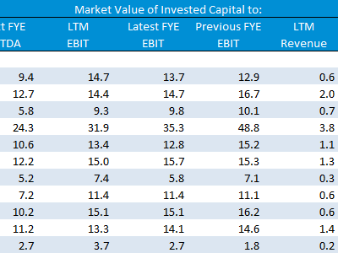Search for public companies with TagniFi Web. Simply enter your valuation date and ticker symbols in Excel to run a guideline public company method. Your Excel model populates instantly with the financial statements, analyst estimates, interest rates and economic data for your valuation date.

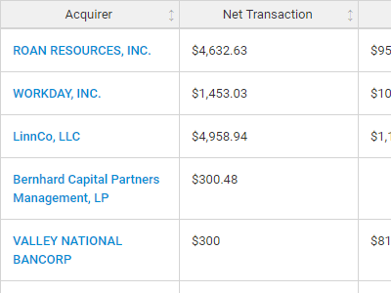**Better Transaction Comps**  
Search for public and private M&A transactions with TagniFi Web. Run your transaction comps within seconds by pasting the Deal ID into your Excel model. Every deal disclosed in an SEC filing (8-K, 10-K, or 10-Q) is available for your analysis. Choose from over 90 fields of data available for every deal.

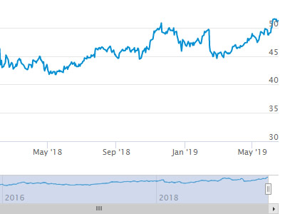

**Historical Beta and Volatility**Calculate historical beta and volatility as of your valuation date automatically. Simply enter the tickers and valuation date in Excel - TagniFi does the rest. In addition to beta and volatility, there are over 40 Excel models available in the Model Library to help with your valuation report.

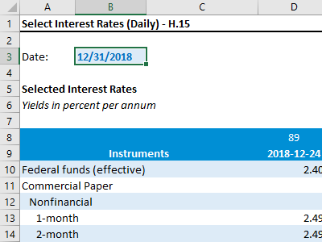**Interest Rates and Economic Data**Automate the interest rates and economic data in your valuation report using the TagniFi Excel plugin. Choose from over 200,000 time series available. All data in this *Quarterly Economic Update* is from the TagniFi platform. Use economic and interest rate data for your own valuation models with the TagniFi Excel plugin.

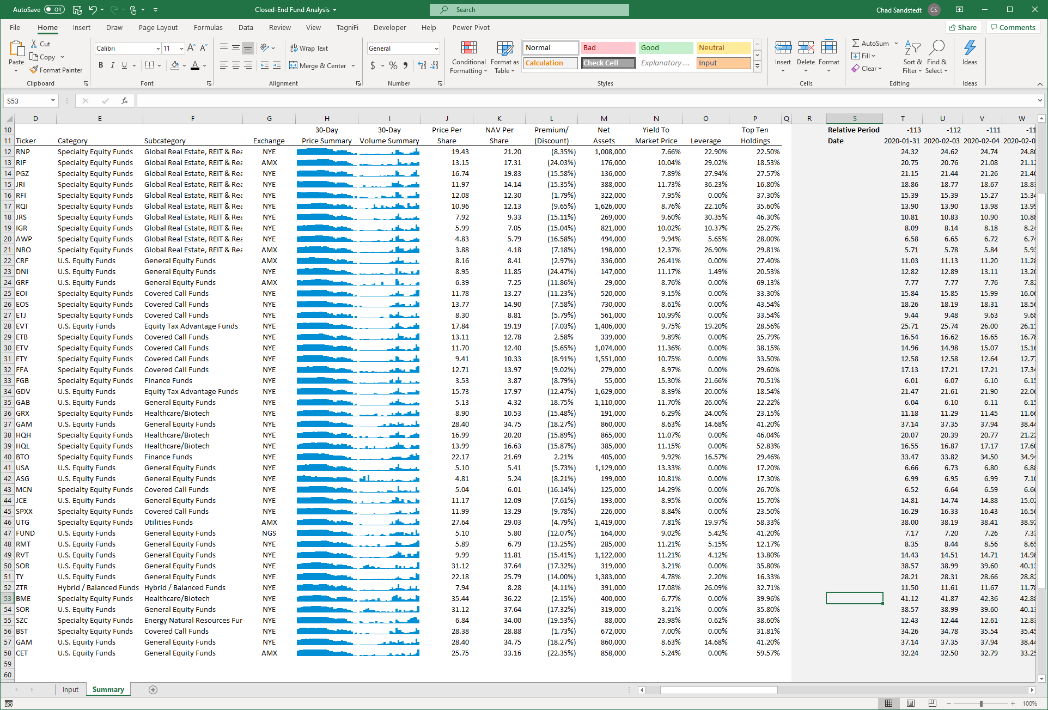

**Closed-End Mutual Fund Data**Search for closed-end mutual funds by keyword, category, subcategory, and more with the TagniFi Console. Use the TagniFi Excel plugin to calculate historical discounts, yields, leverage, as of your valuation date automatically. Simply enter the tickers and valuation date in Excel - TagniFi does the rest.

1. Federal Reserve Bank of Philadelphia, Coincident Economic Activity Index for the United States [USPHCI], *retrieved from FRED, Federal Reserve Bank of St. Louis;* [*https://fred.stlouisfed.org/series/USPHCI*](https://fred.stlouisfed.org/series/USPHCI)*, Jan 27, 2023.*
2. Board of Governors of the Federal Reserve System (US), Trade Weighted U.S. Dollar Index: Broad, Goods and Services [DTWEXBGS], *retrieved from FRED, Federal Reserve Bank of St. Louis;* [*https://fred.stlouisfed.org/series/DTWEXBGS*](https://fred.stlouisfed.org/series/DTWEXBGS)*, Jan 27, 2023.*
3. U.S. Bureau of Economic Analysis, Real Gross Domestic Product [GDPC1], *retrieved from FRED, Federal Reserve Bank of St. Louis;*[*https://fred.stlouisfed.org/series/GDPC1*](https://fred.stlouisfed.org/series/GDPC1)*, Jan 27, 2023.*
4. U.S. Bureau of Economic Analysis, Contributions to percent change in real gross domestic product: Personal consumption expenditures [DPCERY2Q224SBEA], *retrieved from FRED, Federal Reserve Bank of St. Louis;* [*https://fred.stlouisfed.org/series/DPCERY2Q224SBEA*](https://fred.stlouisfed.org/series/DPCERY2Q224SBEA)*, Jan 27, 2023.*
5. U.S. Bureau of Economic Analysis, Contributions to percent change in real gross domestic product: Government consumption expenditures and gross investment [A822RY2Q224SBEA], *retrieved from FRED, Federal Reserve Bank of St. Louis;* [*https://fred.stlouisfed.org/series/A822RY2Q224SBEA*](https://fred.stlouisfed.org/series/A822RY2Q224SBEA)*, Jan 27, 2023.*
6. U.S. Bureau of Economic Analysis, Contributions to percent change in real gross domestic product: Net exports of goods and services [A019RY2Q224SBEA], *retrieved from FRED, Federal Reserve Bank of St. Louis;* [*https://fred.stlouisfed.org/series/A019RY2Q224SBEA*](https://fred.stlouisfed.org/series/A019RY2Q224SBEA)*, Jan 27, 2023.*
7. U.S. Bureau of Economic Analysis, Contributions to percent change in real gross domestic product: Gross private domestic investment [A006RY2Q224SBEA], *retrieved from FRED, Federal Reserve Bank of St. Louis;* [*https://fred.stlouisfed.org/series/A006RY2Q224SBEA*](https://fred.stlouisfed.org/series/A006RY2Q224SBEA)*, Jan 27, 2023.*
8. Board of Governors of the Federal Reserve System (US), Industrial Production Index [INDPRO], *retrieved from FRED, Federal Reserve Bank of St. Louis;*[*https://fred.stlouisfed.org/series/INDPRO*](https://fred.stlouisfed.org/series/INDPRO)*, Jan 27, 2023.*
9. Board of Governors of the Federal Reserve System (US), Capacity Utilization, Manufacturing (NAICS), *retrieved from FRED, Federal Reserve Bank of St. Louis;* [*https://fred.stlouisfed.org/series/MCUMFN*](https://fred.stlouisfed.org/series/MCUMFN)*, Jan 27, 2023.*
10. Board of Governors of the Federal Reserve System (US), Federal Funds Effective Rate [FEDFUNDS], *retrieved from FRED, Federal Reserve Bank of St. Louis;* [*https://fred.stlouisfed.org/series/FEDFUNDS*](https://fred.stlouisfed.org/series/FEDFUNDS)*, Jan 27, 2023.*
11. Selected Interest Rates Instruments, Yields in percent per annum, *retrieved from FRED, Federal Reserve Bank of St. Louis;* [*https://fred.stlouisfed.org/release/tables?rid=18&eid=289&od=2022-06-30*](https://fred.stlouisfed.org/release/tables?rid=18&eid=289&od=2022-06-30)*, Oct 31, 2022.*
12. Board of Governors of the Federal Reserve System (US), Federal Funds Target Range - Upper Limit [DFEDTARU], *retrieved from FRED, Federal Reserve Bank of St. Louis;* [*https://fred.stlouisfed.org/series/DFEDTARU*](https://fred.stlouisfed.org/series/DFEDTARU)*, Oct 30, 2022*.
13. Board of Governors of the Federal Reserve System (US), 10-Year Treasury Constant Maturity Rate [DGS10], *retrieved from FRED, Federal Reserve Bank of St. Louis;*[*https://fred.stlouisfed.org/series/DGS10*](https://fred.stlouisfed.org/series/DGS10)*, Jan 27, 2023.*
14. Moody’s, Moody's Seasoned Baa Corporate Bond Yield [DBAA], *retrieved from FRED, Federal Reserve Bank of St. Louis;* [*https://fred.stlouisfed.org/series/DBAA*](https://fred.stlouisfed.org/series/DBAA)*, Jan 27, 2023.*
15. Moody’s, Moody's Seasoned Aaa Corporate Bond Yield [DAAA], *retrieved from FRED, Federal Reserve Bank of St. Louis;* [*https://fred.stlouisfed.org/series/DAAA*](https://fred.stlouisfed.org/series/DAAA)*, Jan 27, 2023.*
16. U.S. Bureau of Labor Statistics, Civilian Unemployment Rate [UNRATE], *retrieved from FRED, Federal Reserve Bank of St. Louis;*[*https://fred.stlouisfed.org/series/UNRATE*](https://fred.stlouisfed.org/series/UNRATE)*, Jan 27, 2023.*
17. U.S. Bureau of Labor Statistics, Civilian Labor Force Level [CLF16OV], *retrieved from FRED, Federal Reserve Bank of St. Louis;* [*https://fred.stlouisfed.org/series/CLF16OV*](https://fred.stlouisfed.org/series/CLF16OV)*, Jan 27, 2023.*
18. U.S. Bureau of Labor Statistics, Labor Force Participation Rate [CIVPART], *retrieved from FRED, Federal Reserve Bank of St. Louis;* [*https://fred.stlouisfed.org/series/CIVPART*](https://fred.stlouisfed.org/series/CIVPART)*, Jan 27, 2023.*
19. Federal Reserve Bank of Philadelphia, Livingston Survey, [*https://www.philadelphiafed.org/surveys-and-data/real-time-data-research/livingston-survey*](https://www.philadelphiafed.org/surveys-and-data/real-time-data-research/livingston-survey)*, Jan 27, 2023.*
20. U.S. Bureau of Labor Statistics, Quits: Total Nonfarm [JTSQUL], *retrieved from FRED, Federal Reserve Bank of St. Louis;* [*https://fred.stlouisfed.org/series/JTSQUL*](https://fred.stlouisfed.org/series/JTSQUL)*, Jan 27, 2023.*
21. U.S. Bureau of Labor Statistics, Job Openings: Total Nonfarm [JTSJOL], *retrieved from FRED, Federal Reserve Bank of St. Louis;* [*https://fred.stlouisfed.org/series/JTSJOL*](https://fred.stlouisfed.org/series/JTSJOL)*, Jan 27, 2023.*
22. U.S. Bureau of Labor Statistics Total Unemployed, Plus All Persons Marginally Attached to the Labor Force, Plus Total Employed Part Time for Economic Reasons, as a Percent of the Civilian Labor Force Plus All Persons Marginally Attached to the Labor Force (U-6) [U6RATE], *retrieved from FRED, Federal Reserve Bank of St. Louis;*[*https://fred.stlouisfed.org/series/U6RATE*](https://fred.stlouisfed.org/series/U6RATE)*, Jan 27, 2023.*
23. U.S. Bureau of Labor Statistics, All Employees: Total Nonfarm Payrolls [PAYEMS], *retrieved from FRED, Federal Reserve Bank of St. Louis;*[*https://fred.stlouisfed.org/series/PAYEMS*](https://fred.stlouisfed.org/series/PAYEMS)*, Jan 27, 2023.*
24. U.S. Bureau of Labor Statistics, Consumer Price Index for All Urban Consumers: All Items [CPIAUCSL], *retrieved from FRED, Federal Reserve Bank of St. Louis;*[*https://fred.stlouisfed.org/series/CPIAUCSL*](https://fred.stlouisfed.org/series/CPIAUCSL)*, Jan 27, 2023.*
25. U.S. Bureau of Labor Statistics, Consumer Price Index for All Urban Consumers: All Items Less Energy in U.S. City Average [CPILEGSL], *retrieved from FRED, Federal Reserve Bank of St. Louis;* [*https://fred.stlouisfed.org/series/CPILEGSL*](https://fred.stlouisfed.org/series/CPILEGSL)*, Jan 27, 2023*.
26. U.S. Bureau of Labor Statistics, Average Price: Gasoline, Unleaded Regular (Cost per Gallon/3.785 Liters) in U.S. City Average [APU000074714], *retrieved from FRED, Federal Reserve Bank of St. Louis;* [*https://fred.stlouisfed.org/series/APU000074714*](https://fred.stlouisfed.org/series/APU000074714)*, Jan 27, 2023.*
27. U.S. Bureau of Labor Statistics, Producer Price Index for All Commodities [PPIACO], *retrieved from FRED, Federal Reserve Bank of St. Louis;*[*https://fred.stlouisfed.org/series/PPIACO*](https://fred.stlouisfed.org/series/PPIACO)*, Jan 27, 2023.*
28. *Federal Reserve Bank of St. Louis, 5-Year Breakeven Inflation Rate [T5YIE], retrieved from FRED, Federal Reserve Bank of St. Louis;*[*https://fred.stlouisfed.org/series/T5YIE*](https://fred.stlouisfed.org/series/T5YIE)*, Jan 27, 2023.*
29. U.S. Energy Information Administration, Crude Oil Prices: West Texas Intermediate (WTI) - Cushing, Oklahoma [DCOILWTICO], *retrieved from FRED, Federal Reserve Bank of St. Louis;* [*https://fred.stlouisfed.org/series/DCOILWTICO*](https://fred.stlouisfed.org/series/DCOILWTICO)*, Jan 27, 2023.*
30. U.S. Bureau of the Census, Housing Starts: Total: New Privately Owned Housing Units Started [HOUST], *retrieved from FRED, Federal Reserve Bank of St. Louis;*[*https://fred.stlouisfed.org/series/HOUST*](https://fred.stlouisfed.org/series/HOUST)*, Jan 27, 2023.*
31. Freddie Mac, 30-Year Fixed Rate Mortgage Average in the United States [MORTGAGE30US], *retrieved from FRED, Federal Reserve Bank of St. Louis;*[*https://fred.stlouisfed.org/series/MORTGAGE30US*](https://fred.stlouisfed.org/series/MORTGAGE30US)*, Jan 27, 2023.*
32. S&P Dow Jones Indices LLC, S&P/Case-Shiller 20-City Composite Home Price Index [SPCS20RSA], *retrieved from FRED, Federal Reserve Bank of St. Louis;*[*https://fred.stlouisfed.org/series/SPCS20RSA*](https://fred.stlouisfed.org/series/SPCS20RSA)*, Jan 31, 2023.*
33. U.S. Bureau of Economic Analysis, Personal Consumption Expenditures [PCE], *retrieved from FRED, Federal Reserve Bank of St. Louis;*[*https://fred.stlouisfed.org/series/PCE*](https://fred.stlouisfed.org/series/PCE)*, Jan 27, 2023.*
34. U.S. Bureau of Economic Analysis, Light Weight Vehicle Sales: Autos and Light Trucks [ALTSALES], *retrieved from FRED, Federal Reserve Bank of St. Louis; <https://fred.stlouisfed.org/series/ALTSALES>, Jan 27, 2023.*
35. U.S. Bureau of Labor Statistics, Consumer Price Index for All Urban Consumers: New Vehicles in U.S. City Average [CUUR0000SETA01], *retrieved from FRED, Federal Reserve Bank of St. Louis;* [*https://fred.stlouisfed.org/series/CUUR0000SETA01*](https://fred.stlouisfed.org/series/CUUR0000SETA01)*, Jan 27, 2023.*
36. U.S. Bureau of Labor Statistics, Consumer Price Index for All Urban Consumers: Used Cars and Trucks in U.S. City Average [CUSR0000SETA02], *retrieved from FRED, Federal Reserve Bank of St. Louis;* [*https://fred.stlouisfed.org/series/CUSR0000SETA02*](https://fred.stlouisfed.org/series/CUSR0000SETA02), *Jan 27, 2023.*
37. *University of Michigan, University of Michigan: Consumer Sentiment [UMCSENT], retrieved from FRED, Federal Reserve Bank of St. Louis;* [*https://fred.stlouisfed.org/series/UMCSENT*](https://fred.stlouisfed.org/series/UMCSENT)*, Jan 27, 2023.*
38. *Chicago Board Options Exchange, CBOE Volatility Index: VIX [VIXCLS], retrieved from FRED, Federal Reserve Bank of St. Louis;* [*https://fred.stlouisfed.org/series/VIXCLS*](https://fred.stlouisfed.org/series/VIXCLS)*, Jan 27, 2023.*
39. *Federal Reserve Bank of St. Louis, FOMC Summary of Economic Projections for the Growth Rate of Real Gross Domestic Product [GDPC1CTM], retrieved from FRED, Federal Reserve Bank of St. Louis;*[*https://fred.stlouisfed.org/series/GDPC1CTM*](https://fred.stlouisfed.org/series/GDPC1CTM)*, Jan 27, 2023.*
40. *Federal Reserve Bank of St. Louis, FOMC Summary of Economic Projections for the Personal Consumption Expenditures Inflation Rate, Central Tendency, Midpoint [PCECTPICTM], retrieved from FRED, Federal Reserve Bank of St. Louis;*[*https://fred.stlouisfed.org/series/PCECTPICTM*](https://fred.stlouisfed.org/series/PCECTPICTM)*, Jan 27, 2023.*
41. *Federal Reserve Bank of St. Louis, FOMC Summary of Economic Projections for the Civilian Unemployment Rate, Central Tendency, Midpoint [UNRATECTM], retrieved from FRED, Federal Reserve Bank of St. Louis;*[*https://fred.stlouisfed.org/series/UNRATECTM*](https://fred.stlouisfed.org/series/UNRATECTM)*, Jan 27, 2023.*