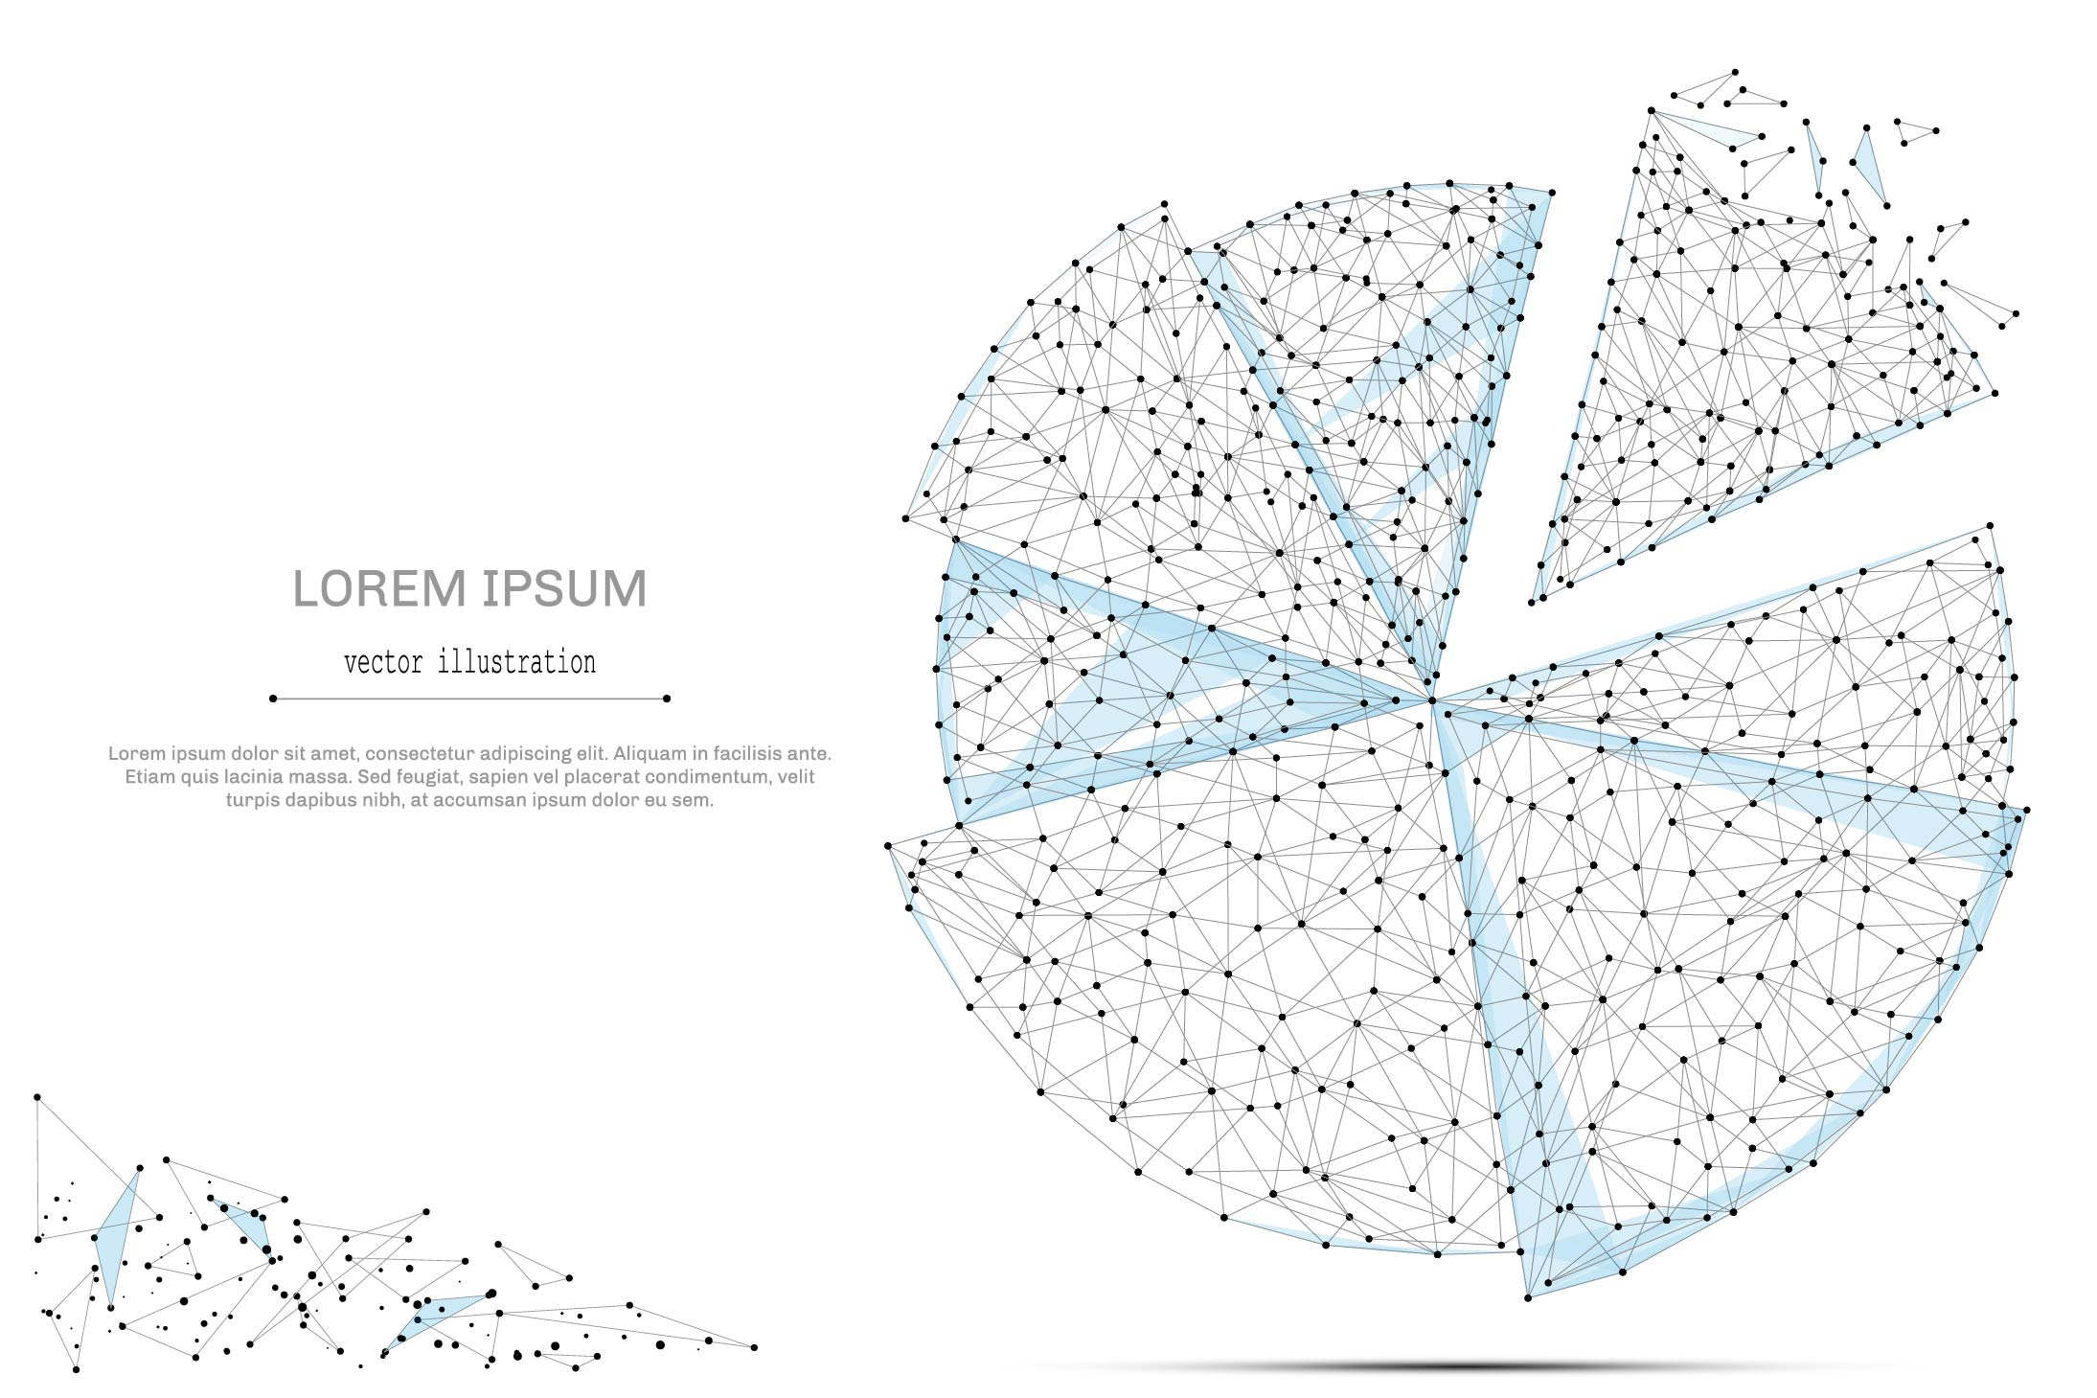

QUARTERLY ECONOMIC UPDATE

For the 1st Quarter of 2023

Abstract

Designed for business valuation professionals, TagniFi’s Quarterly Economic   
Update provides timely economic data to satisfy Revenue Ruling 56-60.

# Summary

In the 1st quarter of 2023, the U.S. economy grew more slowly but spending remained strong, as did the job market, with unemployment equal to its pre-pandemic low. Inflation waned a bit further, mainly due to falling energy prices. Crude oil prices dropped to a 15-month low in the wake of multiple bank insolvencies in March; prices largely recovered as banking relief came swiftly. The banking crisis also briefly rocked stock and bond markets, but calmer conditions prevailed with the arrival of reassuring inflation data. The housing market continued to slow from its blazing pace of recent years as demand and price growth were hampered by high interest rates.

With anti-inflationary policy holding interest rates at a nearly 17-year high, the Federal Reserve finally softened their hawkish stance in the wake of March’s banking crisis. The Fed indicated that while further tightening may be deemed necessary, it would depend on careful monitoring of economic conditions.

As predictions of slower growth begin to come to fruition, many forecasters expect a recession, although the timing remains uncertain. FOMC members lowered projections of economic growth to 0.4% in 2023.

Recorded COVID-19 cases fell throughout the 1st quarter of 2023. With widely available at-home tests and relaxed testing policies in public and private spaces across the U.S., official COVID case rates likely no longer give an accurate picture of the virus’s reach.

Vaccines have been established as a reliable way to limit serious illness and death from COVID-19. During the 1st quarter, 7.7 million vaccine doses were administered in the U.S. The number of vaccinated people in the U.S. rose by 1.34 million and the number fully vaccinated rose by 0.88 million. Although new research out of Canada suggests COVID-19 may be approaching endemic levels, death rates from COVID-19 remained approximately 4 times that of a typical flu season. Still, a combination of vaccination and prior infection has allowed many aspects of life and commerce to return closer to normal, and the federal public health emergency is set to end May 11, 2023. The coming months will reveal more about the seasonality of COVID-19 risk going forward.

A multifactor indicator of economic strength, the Philadelphia Fed’s coincident index[1] of economic activity in the U.S. rose 0.3% in March 2023 and 0.9% during the 1st quarter. For the quarter, coincident indexes increased in 49 states and declined in 1 state. Coincident indexes reflect unemployment, payroll employment, manufacturing hours, and wages and salaries.



The U.S. dollar index for goods and services[2] fell 1.6% during the 1st quarter of 2023 but was up 3.7% compared to the same period one year prior. The dollar slipped in late March after the Federal Reserve raised target rates but softened its predictions on future rate hikes. In its March meetings, which followed two bank failures, the Fed suggested there might be only one further rate hike this year.

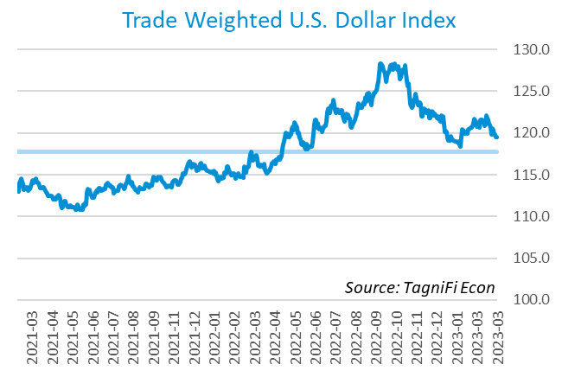

# Q1 Economic Highlights

* The Philadelphia Fed’s coincident index of economic activity in the U.S. rose 0.3% in March 2023 and 0.9% during the 1st quarter.
* The U.S. dollar index fell 1.6% during the 1st quarter of 2023 but was up 3.7% since the same period one year prior.
* Real GDP grew at an annualized rate of 1.1% during the 1st quarter of 2023, decelerating from its 2.6% increase in the 4th quarter of 2022.
* The effective federal funds rate rose 0.55 percentage points to 4.65% during the 1st quarter, continuing the climb from near-zero levels that began last March.
* The 1-year and 2-year annual treasury yields ended the 1st quarter at 4.64% and 4.06%, respectively. The benchmark 10-year treasury yielded 3.48% at the end of the quarter, while the 30-year treasury yielded 3.67%.
* The unemployment rate ended the 1st quarter at 3.5%, unchanged from the prior quarter. Nonfarm payrolls grew by 0.9 million jobs in the 1st quarter.
* The Consumer Price Index for all items rose 5.0% year-over-year in March 2023, down from its more-than-40-year high of 8.9% in June 2022. Excluding volatile energy prices, the annual increase was 6.0%.
* Crude oil prices ended the 1st quarter at $75.68 per barrel, down 5.6% from the prior quarter and 24.7% over one year.
* New home starts rose 5.3% during the first quarter to a level of 1.42 million in March. Total new home starts were down 17.2% year-over-year.
* The NASDAQ composite rose 16.8% during the 1st quarter. The Dow Jones Transportation Average climbed 7.8%, the S&P 500 was up 7.0%, and the Wilshire 5000 was up 6.8% for the quarter.

# Business Activity

Real gross domestic product (GDP)[3] grew at an annualized rate of 1.1% during the 1st quarter of 2023, decelerating from its 2.6% increase in the 4th quarter of 2022. Slower growth was attributed to interest rate hikes and inflation, yet consumer demand remained strong. Personal and government spending contributed to the 1st quarter increase, as did exports. Many economists expect real GDP gains to continue to soften in 2023.

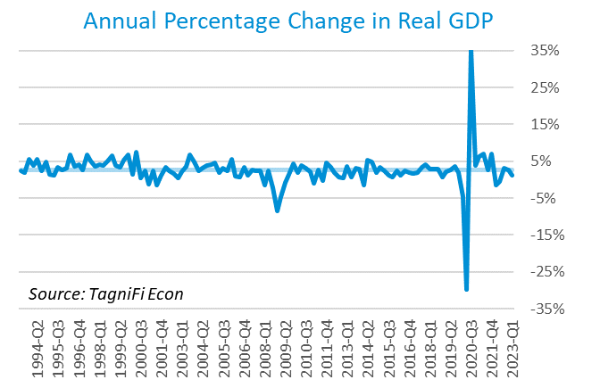

Personal consumption expenditures[4] (PCE) had a positive 2.5% effect on real GDP in the 1st quarter. Growth in personal spending was led by increases in both goods and services consumption, especially for motor vehicles and parts and health care.

Government expenditures[5] rose at both the federal level and the state and local level to contribute 0.8% to the 1st quarter GDP gain. Federal spending growth was led by nondefense consumption; defense consumption also rose. Higher state and local government spending primarily reflected increases in employee compensation.

Net exports[6] contributed a further 0.1% to real GDP growth in the 1st quarter, as exports rose more than imports. The rise in exports was concentrated among goods, especially consumer goods (except food and automotive), while exports of services declined, led by transport. Higher imports of goods, particularly durable consumer goods and automotive vehicles, engines, and parts, moderated the net export gain.

Gross domestic private investment[7] constrained real GDP growth with a negative 2.3% contribution to the 1st quarter estimate. Private inventory investment fell, led by wholesale trade and manufacturing. The top contributor to the decline in residential fixed investment was new single-family construction.

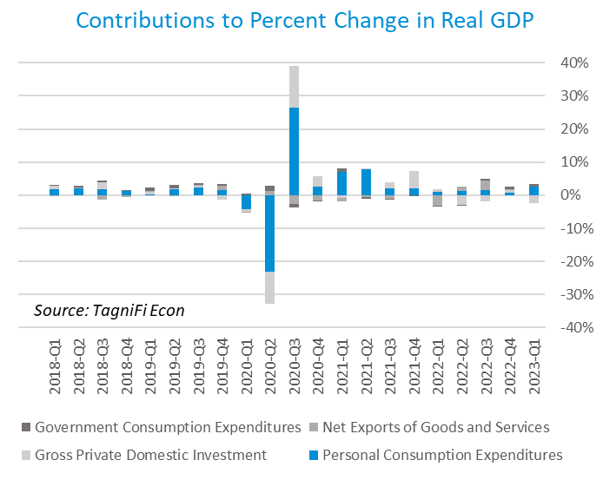

Economists polled by the Livingston Survey[8] in December of 2022 had projected real GDP to rise at an annual rate of 0.4% in the first half of 2023, then to fall at an annual rate of -1.0% in the second half of 2023.

The Industrial Production Index[9] is an economic indicator that measures real output for all facilities located in the United States manufacturing, mining, and electric, and gas utilities. The index stood at 103.0 at the end of the 1st quarter, up 1.5% from the end of 2022.

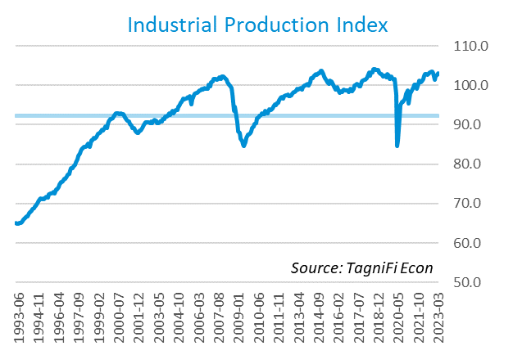

The Capacity Utilization Index[10], which attempts to capture industrial output as a percentage of the economy’s maximum production capacity, ended the 1st quarter of 2023 at 78.2%. March 2023’s level was above the 30-year average of 76.9% for this metric, and 1.3% higher than the previous quarter.

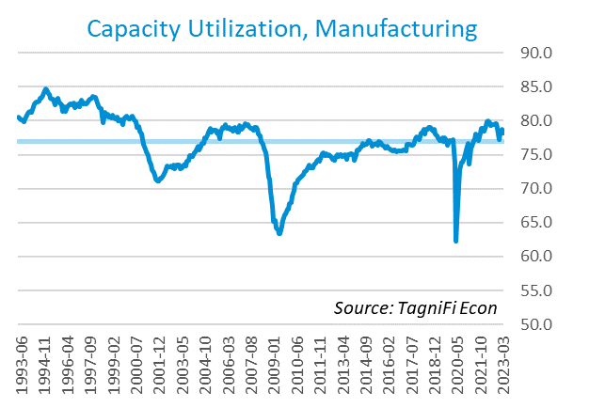

# Interest Rates

The effective federal funds rate[11] rose 0.55 percentage points to 4.65% during the 1st quarter, continuing the climb from near-zero levels that began last March. Both short- and long-term treasury bond yields[12] for periods one year and up fell during the 1st quarter. The yield curve remained inverted as long-term treasury yields continued to lag shorter-term yields. The closely watched two- and ten-year rates inverted early in July 2022 and have remained that way, although the gap narrowed briefly during March as the two-year yield reacted more steeply to the failures of Signature Bank and Silicon Valley Bank. The 1-year and 2-year annual treasury yields ended the 1st quarter at 4.64% and 4.06%, respectively. The benchmark 10-year treasury yielded 3.48% at the end of the quarter, while the 30-year treasury yielded 3.67%. See *Appendix – Selected Interest Rates* for detailed interest rate data.

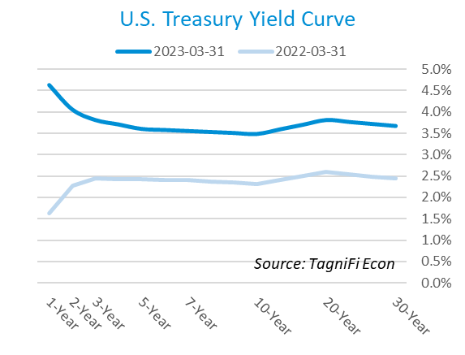

In the 1st quarter of 2023, the Federal Reserve continued their series of federal funds target rate[13] hikes with two increases totaling 50 basis points, ending the quarter at a nearly 17-year high: a range of 4.75% to 5.00%. The committee dialed back on its hawkish rhetoric in the wake of March’s two bank failures, indicating that while some additional tightening would likely be necessary, future rate hikes would depend on economic conditions. Members expect target rates will likely remain elevated throughout 2023 with an expected apex range of 5.00% to 5.25%.

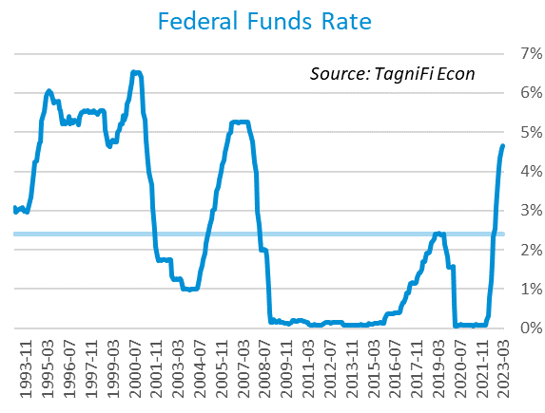

The yield on the benchmark 10-year U.S. treasury[14] ended the 1st quarter at 3.48%, down 0.40 percentage points from the previous quarter and below the average yield of 3.88% over the last 30 years.

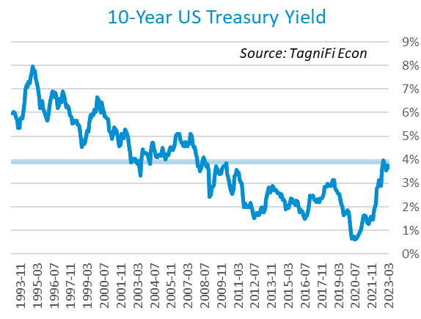

Moody’s Baa Corporate Bond Yield Index[15] ended the 1st quarter of 2023 at 5.59%, down 0.28 percentage points since the previous quarter. Moody’s less-risky Aaa[16] Index slid 0.32 percentage points during the quarter to a level of 4.38%.

The banking crisis resulting from dual bank failures in Mid-March caused treasury bond yields, which move opposite to prices, to briefly spike and then plunge before settling into a relatively flat pattern to end the 1st quarter.

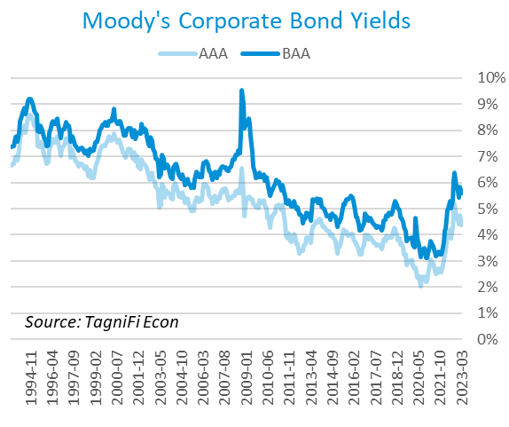

# Employment

The official unemployment rate[17] ended the 1st quarter at 3.5%, unchanged from the prior quarter. The rate equaled its pre-pandemic (February 2020) level and stood well below the 30-year historical average of 5.7%. The labor force[18] expanded by 1.8 million workers during the quarter. The labor force participation rate[19] was 62.6% in March 2023, 0.7 percentage points below its pre-pandemic level. Economists polled by the Livingston Survey in December 2022 had projected an unemployment rate of 4.2% in June 2023, rising to 4.9% in December of 2023.

In March 2023, nonfarm worker quits[20] stood at 3.9 million, down 14.4% from their record high in November 2021 yet still 10.3% higher than their pre-pandemic level. The elevated level of quits (sometimes referred to as The Great Resignation), which has primarily affected the leisure and hospitality industry, appears to be waning. The quit rate in the leisure and hospitality industry fell 1.1 percentage points during the year ended March 2023. Job openings[21] totaled 9.6 million in March 2023, 2.4 million below their record high in March 2022 and 2.5 times the number of resignations.

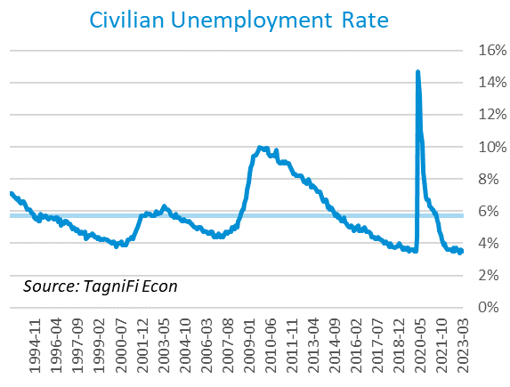

The U-6 unemployment rate[22] is an alternative measure of unemployment with a broader definition, including such groups as discouraged workers who are not actively searching for jobs but want full-time work and part-time workers who want full-time work. The U‑6 unemployment rate has generally followed the same pattern as the official rate and stood at 6.7% in March 2023.

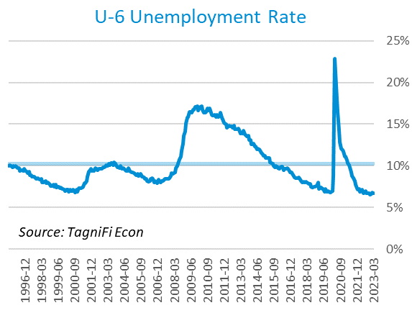

Nonfarm payrolls[23] grew by 0.9 million jobs in the 1st quarter. U.S. nonfarm payrolls in March 2023 totaled 155.4 million jobs, up 4.0 million from the prior March and 3.3 million above their pre-pandemic (February 2020) levels. Although in line with expectations, March’s modest job market growth was the smallest since December 2020; it was led by the leisure and hospitality, government, professional and business services, and health care industries.

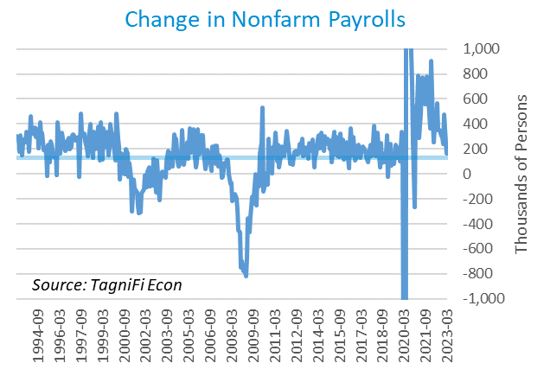

# Inflation

Inflation continued to cool in the 1st quarter of 2023, largely reflecting lower energy costs. Inflation also cooled during the quarter for used cars and trucks, medical care services, and some food groups. The Consumer Price Index[24] for all items rose 5.0% year-over-year in March 2023, down from its more-than-40-year high of 8.9% in June 2022. Excluding volatile energy prices[25], the annual increase was 6.0%. The average price of a gallon of gas[26] in the U.S. was $3.55 in March 2023, 17.6% lower than the prior March, having fallen from its record-high $5.06 in June 2022.

In the month of March 2023, higher prices for shelter led the consumer price index to a modest increase despite across-the-board declines in energy prices. The Federal Reserve has been taking aggressive action to curb inflation with a series of target interest rate hikes totaling 4.75 percentage points since March 2022. The Fed recently softened its stance on future rate hikes, indicating that the increases may be finally nearing an end.

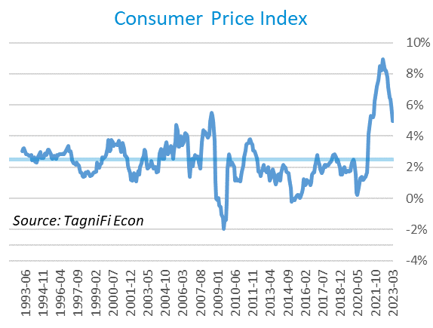

The Producer Price Index[27] fell 0.3% in the quarter and 1.2% since March 2022. The average annual increase over the last 30 years was 2.9%.

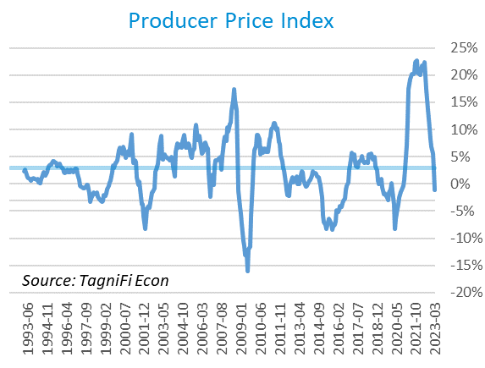

The 5-year breakeven inflation rate[28], an indicator for the market’s inflation expectations for the period, rose to 2.40% at the end of the 1st quarter 2023 from 2.33% at the end of the 4th quarter 2022.

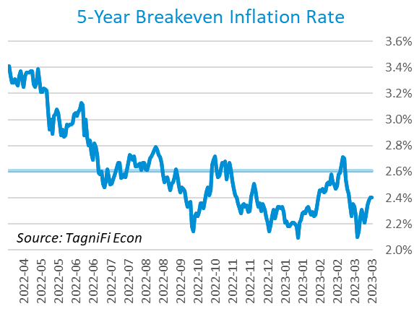

U.S. crude oil[29] prices dropped to a 15-month low after the failure of U.S.-based banks Signature Bank and Silicon Valley Bank were followed by a scare for the international Credit-Suisse bank, sparking fears of financial crisis. Prices largely recovered by the end of the month as the FDIC provided relief for failed banks while Iraqi oil exports were curbed by a governmental dispute. Crude prices ended the 1st quarter at $75.68 per barrel, down 5.6% from the prior quarter and 24.7% over one year.

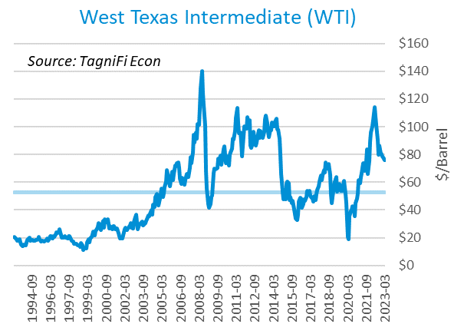

# Housing

High interest rates have slowed the real estate market in recent months, dampening the powerful demand the market had been enjoying. Price growth in major cities has slowed, with a growing number of cities experiencing annual price declines. Supply remained tight, mitigating downward price pressures. Home sales continued to slide as mortgage rates remained near 15-year highs. New home starts[30] rose 5.3% during the first quarter to a level of 1.42 million in March; starts for single-family homes rose while starts for multifamily buildings with 5 or more units fell over the quarter. Total new home starts were down 17.2% year-overyear but remained above their 30-year average of 1.34 million.

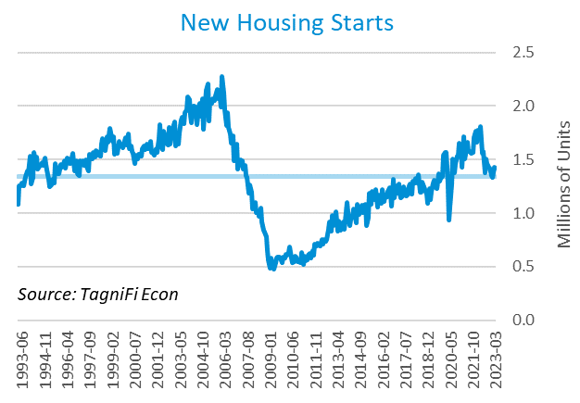

The cost of financing for would-be homebuyers inched down during the 1st quarter, with the 30-year fixed-rate mortgage[31] ending March 2023 at an average of 6.32% after peaking in late October 2022 at a 20-year high of 7.08%.

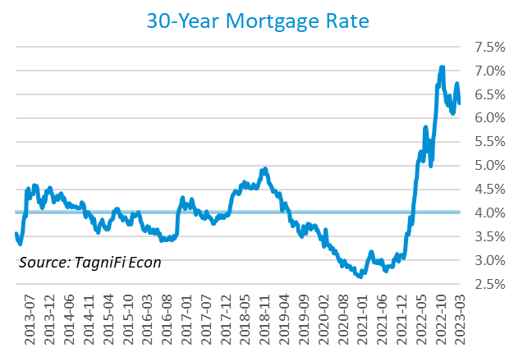

The S&P Case-Shiller Home Price Index (20-city)[32] was 0.1% higher from January to February and 0.4% higher since February 2022. Once again led by Miami, Tampa, and Atlanta, 12 of the 20 cities continued to report one-year price increases; the Southeast continues to outpace other regions, while 7 of the 8 cities with over-the-year price declines were in the West region.

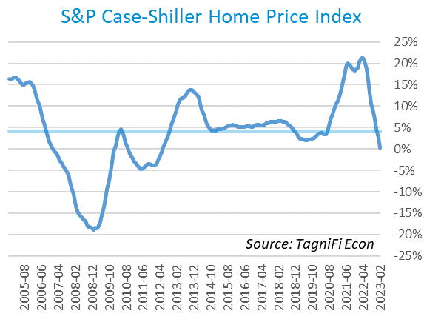

# Consumer Spending

Personal Consumption Expenditures (PCE)[33] rose 2.1% in the 1st quarter to $18.1 trillion. PCE were up 6.2% since the 1st quarter last year. Spending decreased in March for motor vehicles and parts but increased for gasoline and other energy goods as well as services including housing and utilities.

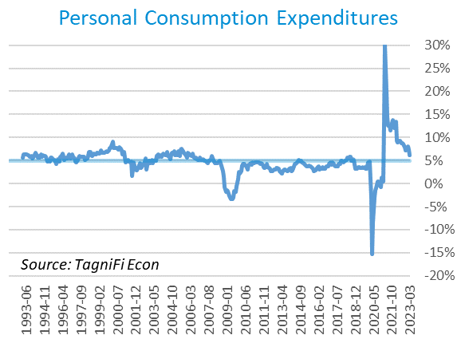

Auto manufacturers reported 14.8 million autos and light trucks sold[34] in March 2023, up 11.0% from December. New vehicle prices[35] built on their record high by a further 1.1% during the 1st quarter, while used car prices[36] fell 5.5% over the quarter.

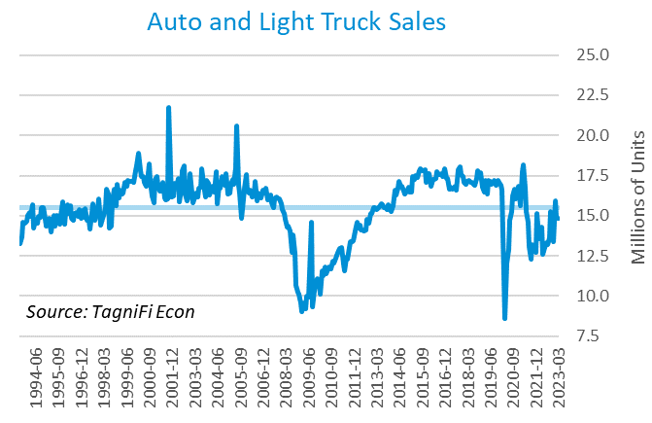

The University of Michigan’s consumer sentiment index[37] continued its rebound from its all-time low of 50.0 in June, peaking at 67.0 in February before waning to 62.0 in March. The index was up 4.4% in the year ended March 2023 yet still well below its 30-year average of 86.8. March’s decline came despite inflation expectations continuing to subside. The decline was concentrated among lower-income, less-educated, and younger consumers, as well as consumers with large stock holdings.

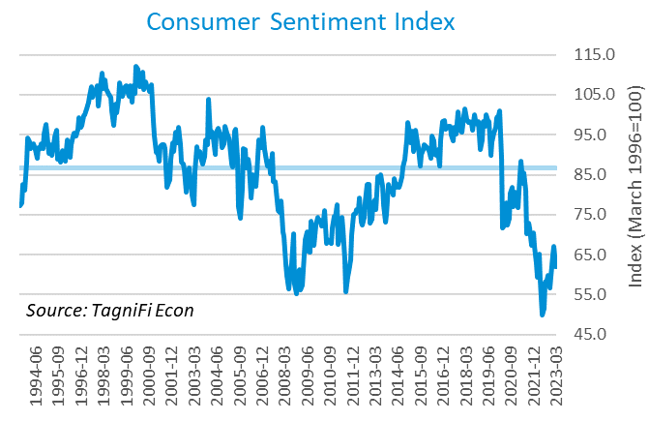

# Capital Markets

The table below shows the quarterly, year-to-date, and 12-month performance of major U.S. equity indices. Capital markets suffered setbacks in 2022 such as the war on Ukraine and aggressive policy moves to combat raging inflation. Market conditions began to improve in the 4th quarter of 2022 and continued into the 1st quarter of 2023 as inflation began to subside while the job market stayed strong. Major market indexes took a hit when multiple banks suddenly failed in mid-March, but rallied to close out the quarter on a better-than expected reading of core PCE inflation, the Fed’s favored inflation marker. Tech stocks, seen as a safe haven from the banking crisis, performed strongly; the NASDAQ composite rose 16.8% during the 1st quarter. The Dow Jones Transportation Average climbed 7.8%, the S&P 500 was up 7.0%, and the Wilshire 5000 was up 6.8% for the quarter. The Dow Jones Industrial Average, which dipped less steeply in 2022, was up just 0.4%.



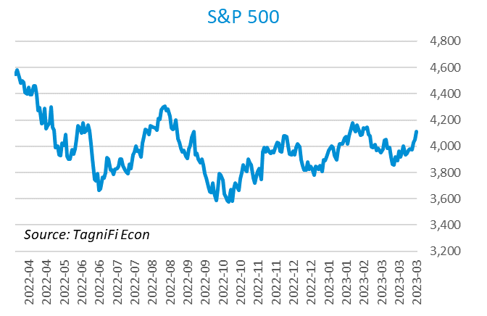

Stock market volatility, as measured by the VIX [38], ended the 1st quarter of 2023 at 18.7, down 13.7% since the prior quarter and 9.0% since the 1st quarter of 2022. The VIX remained relatively steady throughout most of the 1st quarter, with a spike around the time of the mid-March banking crisis and a subsequent recovery.

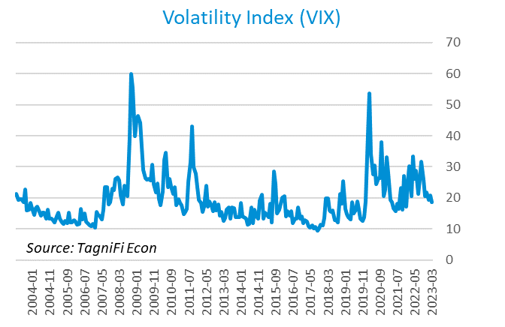

# Outlook

In March 2023, the FOMC revised their near-term inflation projections slightly upward and unemployment rate and real GDP projections slightly downward. Little to no adjustments were made to longer-run projections for the three indicators.

The FOMC revised their projection for real GDP[39] to 0.40% growth in 2023, rising to 1.25% in 2024, then to 1.90% by 2025. They expected Personal Consumption Expenditures (PCE) inflation[40] to cool to 3.40% in 2023, further moderating to 2.50% by 2024 and 2.10% by 2025. They forecast that the unemployment rate[41] would be 4.35% in 2023, rising to 4.60% in 2024 and 4.55% in 2025. The board made little change to projections of future target rates, revising only the 2024 projection slightly upward, and softened their hawkish stance with signals that near-term monetary policy would be responsive to incoming economic data.



Appendix – Selected Interest Rates



# About This Report

The *Quarterly Economic Update* is a free publication sponsored by TagniFi. You are free to share this report and include its contents in the economic outlook section of your valuation reports as required by *Revenue Ruling 59-60*. Please forward this free report to a colleague to help us spread the word about TagniFi.

How TagniFi Helps Business Valuation Teams

TagniFi’s financial data platform empowers business valuation teams to quickly and easily build highly accurate financial models with full transparency—and within seconds.

**Better Public Comps**  
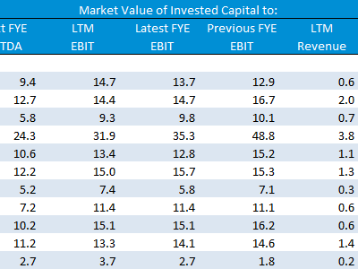Search for public companies with TagniFi Web. Simply enter your valuation date and ticker symbols in Excel to run a guideline public company method. Your Excel model populates instantly with the financial statements, analyst estimates, interest rates and economic data for your valuation date.

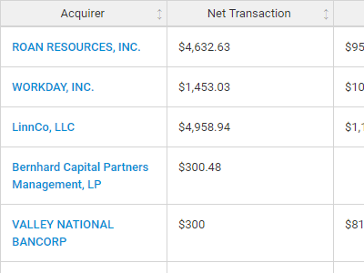**Better Transaction Comps**  
Search for public and private M&A transactions with TagniFi Web. Run your transaction comps within seconds by pasting the Deal ID into your Excel model. Every deal disclosed in an SEC filing (8-K, 10-K, or 10-Q) is available for your analysis. Choose from over 90 fields of data available for every deal.

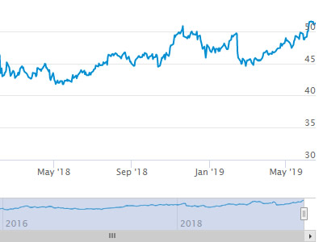

**Historical Beta and Volatility**Calculate historical beta and volatility as of your valuation date automatically. Simply enter the tickers and valuation date in Excel - TagniFi does the rest. In addition to beta and volatility, there are over 40 Excel models available in the Model Library to help with your valuation report.

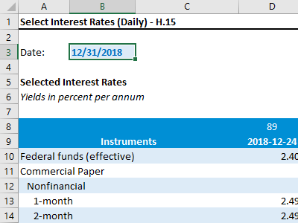**Interest Rates and Economic Data**Automate the interest rates and economic data in your valuation report using the TagniFi Excel plugin. Choose from over 200,000 time series available. All data in this *Quarterly Economic Update* is from the TagniFi platform. Use economic and interest rate data for your own valuation models with the TagniFi Excel plugin.

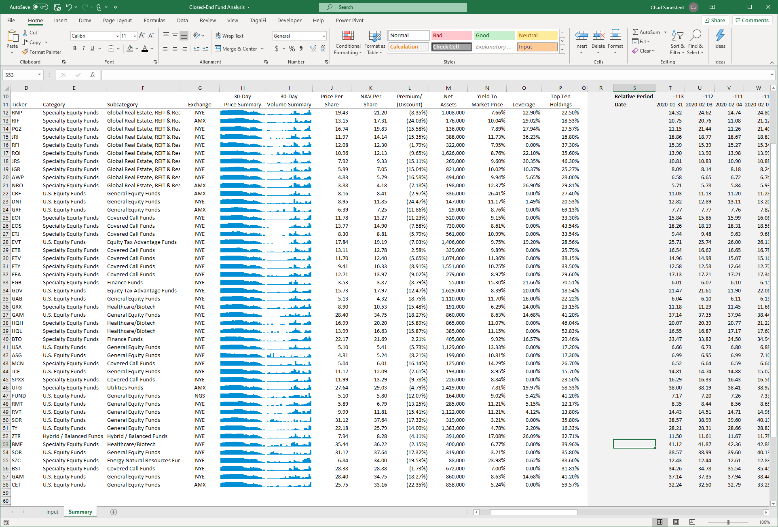

**Closed-End Mutual Fund Data**Search for closed-end mutual funds by keyword, category, subcategory, and more with the TagniFi Console. Use the TagniFi Excel plugin to calculate historical discounts, yields, leverage, as of your valuation date automatically. Simply enter the tickers and valuation date in Excel - TagniFi does the rest.

1. Federal Reserve Bank of Philadelphia, Coincident Economic Activity Index for the United States [USPHCI], *retrieved from FRED, Federal Reserve Bank of St. Louis;* [*https://fred.stlouisfed.org/series/USPHCI*](https://fred.stlouisfed.org/series/USPHCI)*, May 6, 2023.*
2. Board of Governors of the Federal Reserve System (US), Trade Weighted U.S. Dollar Index: Broad, Goods and Services [DTWEXBGS], *retrieved from FRED, Federal Reserve Bank of St. Louis;* [*https://fred.stlouisfed.org/series/DTWEXBGS*](https://fred.stlouisfed.org/series/DTWEXBGS)*, May 6, 2023.*
3. U.S. Bureau of Economic Analysis, Real Gross Domestic Product [GDPC1], *retrieved from FRED, Federal Reserve Bank of St. Louis;*[*https://fred.stlouisfed.org/series/GDPC1*](https://fred.stlouisfed.org/series/GDPC1)*, May 6, 2023.*
4. U.S. Bureau of Economic Analysis, Contributions to percent change in real gross domestic product: Personal consumption expenditures [DPCERY2Q224SBEA], *retrieved from FRED, Federal Reserve Bank of St. Louis;* [*https://fred.stlouisfed.org/series/DPCERY2Q224SBEA*](https://fred.stlouisfed.org/series/DPCERY2Q224SBEA)*, May 6, 2023.*
5. U.S. Bureau of Economic Analysis, Contributions to percent change in real gross domestic product: Government consumption expenditures and gross investment [A822RY2Q224SBEA], *retrieved from FRED, Federal Reserve Bank of St. Louis;* [*https://fred.stlouisfed.org/series/A822RY2Q224SBEA*](https://fred.stlouisfed.org/series/A822RY2Q224SBEA)*, May 6, 2023.*
6. U.S. Bureau of Economic Analysis, Contributions to percent change in real gross domestic product: Net exports of goods and services [A019RY2Q224SBEA], *retrieved from FRED, Federal Reserve Bank of St. Louis;* [*https://fred.stlouisfed.org/series/A019RY2Q224SBEA*](https://fred.stlouisfed.org/series/A019RY2Q224SBEA)*, May 6, 2023.*
7. U.S. Bureau of Economic Analysis, Contributions to percent change in real gross domestic product: Gross private domestic investment [A006RY2Q224SBEA], *retrieved from FRED, Federal Reserve Bank of St. Louis;* [*https://fred.stlouisfed.org/series/A006RY2Q224SBEA*](https://fred.stlouisfed.org/series/A006RY2Q224SBEA)*, May 6, 2023.*
8. Federal Reserve Bank of Philadelphia, The Livingston Survey December 2022, [economic release], retrieved from <https://www.philadelphiafed.org/-/media/frbp/assets/surveys-and-data/livingston-survey/2022/livdec22.pdf>, May 6, 2023.
9. Board of Governors of the Federal Reserve System (US), Industrial Production Index [INDPRO], *retrieved from FRED, Federal Reserve Bank of St. Louis;*[*https://fred.stlouisfed.org/series/INDPRO*](https://fred.stlouisfed.org/series/INDPRO)*, May 6, 2023.*
10. Board of Governors of the Federal Reserve System (US), Capacity Utilization, Manufacturing (NAICS), *retrieved from FRED, Federal Reserve Bank of St. Louis;* [*https://fred.stlouisfed.org/series/MCUMFN*](https://fred.stlouisfed.org/series/MCUMFN)*, May 6, 2023.*
11. Board of Governors of the Federal Reserve System (US), Federal Funds Effective Rate [FEDFUNDS], *retrieved from FRED, Federal Reserve Bank of St. Louis;* [*https://fred.stlouisfed.org/series/FEDFUNDS*](https://fred.stlouisfed.org/series/FEDFUNDS)*, May 6, 2023.*
12. Selected Interest Rates Instruments, Yields in percent per annum, *retrieved from FRED, Federal Reserve Bank of St. Louis;* <https://fred.stlouisfed.org/release/tables?rid=18&eid=289&od=2023-03-31>*, May 6, 2023.*
13. Board of Governors of the Federal Reserve System (US), Federal Funds Target Range - Upper Limit [DFEDTARU], *retrieved from FRED, Federal Reserve Bank of St. Louis;* [*https://fred.stlouisfed.org/series/DFEDTARU*](https://fred.stlouisfed.org/series/DFEDTARU)*, May 6, 2023*.
14. Board of Governors of the Federal Reserve System (US), 10-Year Treasury Constant Maturity Rate [DGS10], *retrieved from FRED, Federal Reserve Bank of St. Louis;*[*https://fred.stlouisfed.org/series/DGS10*](https://fred.stlouisfed.org/series/DGS10)*, May 6, 2023.*
15. Moody’s, Moody's Seasoned Baa Corporate Bond Yield [DBAA], *retrieved from FRED, Federal Reserve Bank of St. Louis;* [*https://fred.stlouisfed.org/series/DBAA*](https://fred.stlouisfed.org/series/DBAA)*, May 6, 2023.*
16. Moody’s, Moody's Seasoned Aaa Corporate Bond Yield [DAAA], *retrieved from FRED, Federal Reserve Bank of St. Louis;* [*https://fred.stlouisfed.org/series/DAAA*](https://fred.stlouisfed.org/series/DAAA)*, May 6, 2023.*
17. U.S. Bureau of Labor Statistics, Civilian Unemployment Rate [UNRATE], *retrieved from FRED, Federal Reserve Bank of St. Louis;*[*https://fred.stlouisfed.org/series/UNRATE*](https://fred.stlouisfed.org/series/UNRATE)*, May 6, 2023.*
18. U.S. Bureau of Labor Statistics, Civilian Labor Force Level [CLF16OV], *retrieved from FRED, Federal Reserve Bank of St. Louis;* [*https://fred.stlouisfed.org/series/CLF16OV*](https://fred.stlouisfed.org/series/CLF16OV)*, May 6, 2023.*
19. U.S. Bureau of Labor Statistics, Labor Force Participation Rate [CIVPART], *retrieved from FRED, Federal Reserve Bank of St. Louis;* [*https://fred.stlouisfed.org/series/CIVPART*](https://fred.stlouisfed.org/series/CIVPART)*, May 6, 2023.*
20. U.S. Bureau of Labor Statistics, Quits: Total Nonfarm [JTSQUL], *retrieved from FRED, Federal Reserve Bank of St. Louis;* [*https://fred.stlouisfed.org/series/JTSQUL*](https://fred.stlouisfed.org/series/JTSQUL)*, May 6, 2023.*
21. U.S. Bureau of Labor Statistics, Job Openings: Total Nonfarm [JTSJOL], *retrieved from FRED, Federal Reserve Bank of St. Louis;* [*https://fred.stlouisfed.org/series/JTSJOL*](https://fred.stlouisfed.org/series/JTSJOL)*, May 6, 2023.*
22. U.S. Bureau of Labor Statistics Total Unemployed, Plus All Persons Marginally Attached to the Labor Force, Plus Total Employed Part Time for Economic Reasons, as a Percent of the Civilian Labor Force Plus All Persons Marginally Attached to the Labor Force (U-6) [U6RATE], *retrieved from FRED, Federal Reserve Bank of St. Louis;*[*https://fred.stlouisfed.org/series/U6RATE*](https://fred.stlouisfed.org/series/U6RATE)*, May 6, 2023.*
23. U.S. Bureau of Labor Statistics, All Employees: Total Nonfarm Payrolls [PAYEMS], *retrieved from FRED, Federal Reserve Bank of St. Louis;*[*https://fred.stlouisfed.org/series/PAYEMS*](https://fred.stlouisfed.org/series/PAYEMS)*, May 6, 2023.*
24. U.S. Bureau of Labor Statistics, Consumer Price Index for All Urban Consumers: All Items [CPIAUCSL], *retrieved from FRED, Federal Reserve Bank of St. Louis;*[*https://fred.stlouisfed.org/series/CPIAUCSL*](https://fred.stlouisfed.org/series/CPIAUCSL)*, May 6, 2023.*
25. U.S. Bureau of Labor Statistics, Consumer Price Index for All Urban Consumers: All Items Less Energy in U.S. City Average [CPILEGSL], *retrieved from FRED, Federal Reserve Bank of St. Louis;* [*https://fred.stlouisfed.org/series/CPILEGSL*](https://fred.stlouisfed.org/series/CPILEGSL)*, May 6, 2023*.
26. U.S. Bureau of Labor Statistics, Average Price: Gasoline, Unleaded Regular (Cost per Gallon/3.785 Liters) in U.S. City Average [APU000074714], *retrieved from FRED, Federal Reserve Bank of St. Louis;* [*https://fred.stlouisfed.org/series/APU000074714*](https://fred.stlouisfed.org/series/APU000074714)*, May 6, 2023.*
27. U.S. Bureau of Labor Statistics, Producer Price Index for All Commodities [PPIACO], *retrieved from FRED, Federal Reserve Bank of St. Louis;*[*https://fred.stlouisfed.org/series/PPIACO*](https://fred.stlouisfed.org/series/PPIACO)*, May 6, 2023.*
28. *Federal Reserve Bank of St. Louis, 5-Year Breakeven Inflation Rate [T5YIE], retrieved from FRED, Federal Reserve Bank of St. Louis;*[*https://fred.stlouisfed.org/series/T5YIE*](https://fred.stlouisfed.org/series/T5YIE)*, May 6, 2023.*
29. U.S. Energy Information Administration, Crude Oil Prices: West Texas Intermediate (WTI) - Cushing, Oklahoma [DCOILWTICO], *retrieved from FRED, Federal Reserve Bank of St. Louis;* [*https://fred.stlouisfed.org/series/DCOILWTICO*](https://fred.stlouisfed.org/series/DCOILWTICO)*, May 6, 2023.*
30. U.S. Bureau of the Census, Housing Starts: Total: New Privately Owned Housing Units Started [HOUST], *retrieved from FRED, Federal Reserve Bank of St. Louis;*[*https://fred.stlouisfed.org/series/HOUST*](https://fred.stlouisfed.org/series/HOUST)*, May 6, 2023.*
31. Freddie Mac, 30-Year Fixed Rate Mortgage Average in the United States [MORTGAGE30US], *retrieved from FRED, Federal Reserve Bank of St. Louis;*[*https://fred.stlouisfed.org/series/MORTGAGE30US*](https://fred.stlouisfed.org/series/MORTGAGE30US)*, May 6, 2023.*
32. S&P Dow Jones Indices LLC, S&P/Case-Shiller 20-City Composite Home Price Index [SPCS20RSA], *retrieved from FRED, Federal Reserve Bank of St. Louis;*[*https://fred.stlouisfed.org/series/SPCS20RSA*](https://fred.stlouisfed.org/series/SPCS20RSA)*, May 6, 2023.*
33. U.S. Bureau of Economic Analysis, Personal Consumption Expenditures [PCE], *retrieved from FRED, Federal Reserve Bank of St. Louis;*[*https://fred.stlouisfed.org/series/PCE*](https://fred.stlouisfed.org/series/PCE)*, May 6, 2023.*
34. U.S. Bureau of Economic Analysis, Light Weight Vehicle Sales: Autos and Light Trucks [ALTSALES], *retrieved from FRED, Federal Reserve Bank of St. Louis; <https://fred.stlouisfed.org/series/ALTSALES>, May 6, 2023.*
35. U.S. Bureau of Labor Statistics, Consumer Price Index for All Urban Consumers: New Vehicles in U.S. City Average [CUUR0000SETA01], *retrieved from FRED, Federal Reserve Bank of St. Louis;* [*https://fred.stlouisfed.org/series/CUUR0000SETA01*](https://fred.stlouisfed.org/series/CUUR0000SETA01)*, May 6, 2023.*
36. U.S. Bureau of Labor Statistics, Consumer Price Index for All Urban Consumers: Used Cars and Trucks in U.S. City Average [CUSR0000SETA02], *retrieved from FRED, Federal Reserve Bank of St. Louis;* [*https://fred.stlouisfed.org/series/CUSR0000SETA02*](https://fred.stlouisfed.org/series/CUSR0000SETA02), *May 6, 2023.*
37. *University of Michigan, University of Michigan: Consumer Sentiment [UMCSENT], retrieved from FRED, Federal Reserve Bank of St. Louis;* [*https://fred.stlouisfed.org/series/UMCSENT*](https://fred.stlouisfed.org/series/UMCSENT)*, May 6, 2023.*
38. *Chicago Board Options Exchange, CBOE Volatility Index: VIX [VIXCLS], retrieved from FRED, Federal Reserve Bank of St. Louis;* [*https://fred.stlouisfed.org/series/VIXCLS*](https://fred.stlouisfed.org/series/VIXCLS)*, May 6, 2023.*
39. *Federal Reserve Bank of St. Louis, FOMC Summary of Economic Projections for the Growth Rate of Real Gross Domestic Product [GDPC1CTM], retrieved from FRED, Federal Reserve Bank of St. Louis;*[*https://fred.stlouisfed.org/series/GDPC1CTM*](https://fred.stlouisfed.org/series/GDPC1CTM)*, May 6, 2023.*
40. *Federal Reserve Bank of St. Louis, FOMC Summary of Economic Projections for the Personal Consumption Expenditures Inflation Rate, Central Tendency, Midpoint [PCECTPICTM], retrieved from FRED, Federal Reserve Bank of St. Louis;*[*https://fred.stlouisfed.org/series/PCECTPICTM*](https://fred.stlouisfed.org/series/PCECTPICTM)*, May 6, 2023.*
41. *Federal Reserve Bank of St. Louis, FOMC Summary of Economic Projections for the Civilian Unemployment Rate, Central Tendency, Midpoint [UNRATECTM], retrieved from FRED, Federal Reserve Bank of St. Louis;*[*https://fred.stlouisfed.org/series/UNRATECTM*](https://fred.stlouisfed.org/series/UNRATECTM)*, May 6, 2023.*