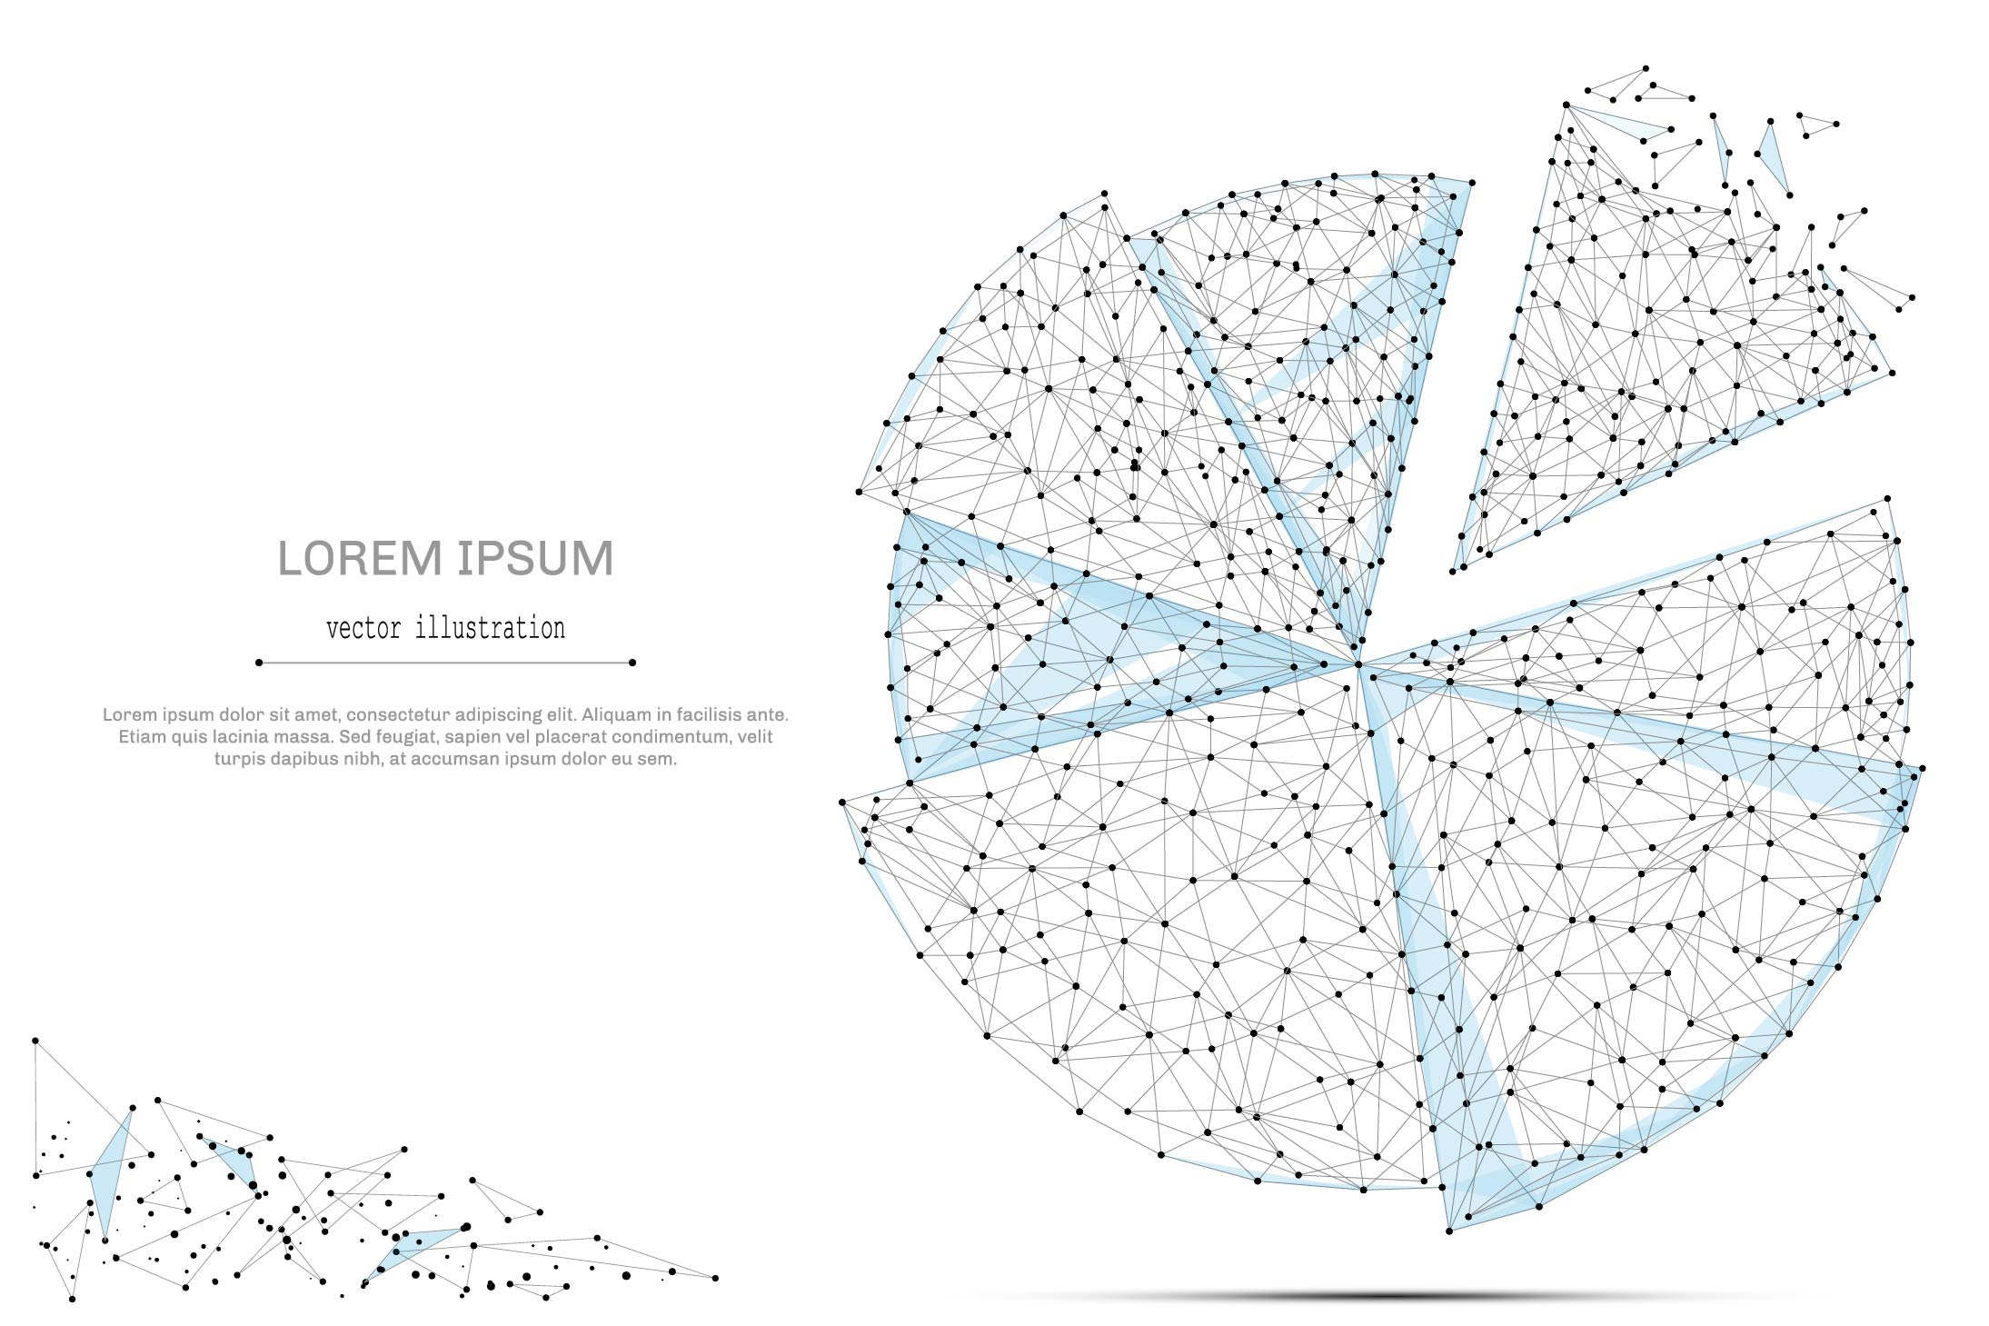

QUARTERLY ECONOMIC UPDATE

For the 2nd Quarter of 2023

Abstract

Designed for business valuation professionals, TagniFi’s Quarterly Economic   
Update provides timely economic data to satisfy Revenue Ruling 56-60.

# Summary

In the 2nd quarter of 2023, the U.S. economy showed broad strength despite widely held fears that high interest rates would tip the nation into recession. The yield curve remains inverted—a sign that bond markets are primed for recession—yet production and spending exceeded expectations, and the job market remained solid. Consumer sentiment is also rising. Inflation waned a bit further, due in part to falling prices within the energy sector. The promising economic data spurred the capital markets to build on their existing rally with another bullish quarter.

Elevated interest rates continue to pose a concern for the U.S. economy in the 2nd quarter of 2023, with target rates reaching a 17-year high. The resulting high mortgage rates, along with a dearth of inventory, have cooled the once-hot housing market, affecting both sales and prices.

After 10 consecutive rate hikes, the Federal Reserve took the first pause in their anti-inflationary campaign in June. While the Fed indicated that careful monitoring of economic conditions was needed before raising target rates further, committee members revised their expectations of future target rates upward.

Despite expecting further rate hikes, FOMC members revised projections of economic growth upward to 0.95% in 2023. Growth projections for future years were reined in slightly at 1.80% for 2025. Unemployment projections were lowered for both the near and longer terms, at 4.15% for 2023 and rising to 4.45% for the next two years.

The Federal COVID-19 Public Health Emergency ended on May 11, 2023, approximately three years and two months after its initial declaration. The CDC notes that as a nation, we have “more tools and resources than ever before to better protect ourselves and our communities.” Indeed, a combination of vaccination and prior infection has allowed many aspects of life and commerce to return to pre-pandemic norms.

A multifactor indicator of economic strength, the Philadelphia Fed’s coincident index[1] of economic activity in the U.S. rose 0.3% in June 2023 and 0.7% during the 2nd quarter. For the quarter, coincident indexes increased in 49 states and was unchanged in 1. Coincident indexes reflect unemployment, payroll employment, manufacturing hours, and wages and salaries.



The U.S. dollar index for goods and services[2] rose 0.4% during the 2nd quarter of 2023 but was down 0.8% compared to the same period one year prior. The dollar strengthened in late June as better-than expected labor and production data increased the likelihood of another Federal Reserve target rate increase. European markets are also battling persistent inflation, especially core inflation (exclusive of volatile energy and food prices), which remains notably elevated in Germany and Spain as well as the U.S.

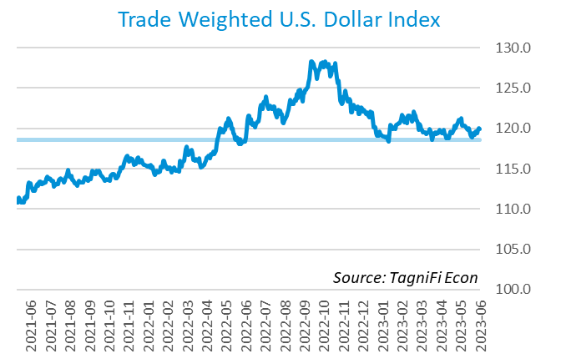

# Q2 Economic Highlights

* The Philadelphia Fed’s coincident index of economic activity in the U.S. rose 0.3% in June 2023 and 0.7% during the 2nd quarter.
* The U.S. dollar index rose 0.3% during the 2nd quarter of 2023 but was down 0.8% since the same period one year prior.
* Real GDP grew at an annualized rate of 2.4% during the 2nd quarter of 2023, up from its 2.0% increase in the 1st quarter of 2023.
* The effective federal funds rate rose 0.43 percentage points to 5.08% during the 2nd quarter, continuing the climb from near-zero levels that began in March 2022.
* The 1-year and 2-year annual treasury yields ended the 2nd quarter at 5.40% and 4.87%, respectively. The benchmark 10-year treasury yielded 3.81% at the end of the quarter, while the 30-year treasury yielded 3.85%.
* The unemployment rate ended the 2nd quarter at 3.6%, up slightly from the prior quarter. Nonfarm payrolls grew by 0.7 million jobs in the 2nd quarter.
* The Consumer Price Index for all items rose 3.1% year-over-year in June 2023, down from its more-than-40-year high of 8.9% in June 2022. Excluding volatile energy prices, the annual increase was 5.0%.
* Crude oil prices ended the 2nd quarter at $70.66 per barrel, down 6.6% from the prior quarter and 34.4% over one year.
* New home starts rose 3.9% during the first quarter to a level of 1.43 million in June. Total new home starts were down 8.1% year-over-year.
* The NASDAQ composite rose 12.8% during the 2nd quarter of 2023. The S&P 500 was up 8.3%, the Wilshire 5000 was up 8.0%, and the Dow Jones Transprtation Avergae was up 7.6% for the quarter.

# Business Activity

Real gross domestic product (GDP)[3] grew at an annualized rate of 2.4% during the 2nd quarter of 2023, up from its 2.0% increase in the 1st quarter of 2023. The accelerated growth exceeded expectations and showed that consumer demand continued to withstand rising interest rates and persistent inflation. Personal consumption and private investment contributed to the 2nd quarter increase, as did government spending. The report indicated broad-based resiliency and tempered economists’ expectations that historically high interest rates would herald a recession.

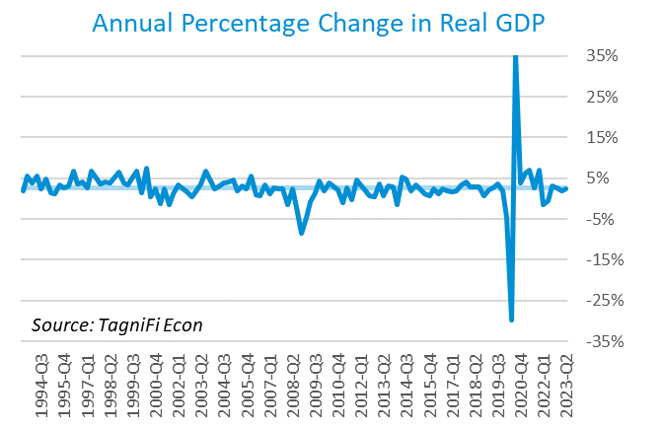

Personal consumption expenditures[4] (PCE) had a positive 1.1% effect on real GDP in the 2nd quarter. Growth in personal spending largely reflected rising services consumption, especially for housing and utilities, health care, financial services and insurance, and transportation services. Increased goods consumption also contributed to real GDP gains, led by recreational goods and vehicles as well as gasoline and other energy goods.

Gross domestic private investment[5] also rose, contributing 1.0% to the 2nd quarter real GDP estimate. Nonresidential fixed investment drove the increase, led by equipment, structures, and intellectual property products. Private inventory investment also rose, while residential fixed investment fell in the 2nd quarter.

Government expenditures[6] rose at both the state and local level and the federal level to contribute 0.5% to the 2nd quarter GDP gain. Higher state and local government spending primarily reflected increases in employee compensation and gross investment in structures. Federal spending growth reflected both national defense and nondefense investment.

Net exports[7] fell in the 2nd quarter, which had a negative 0.1% effect on real GDP. Decreasing exports of goods were responsible for the downturn in net exports. Moderating the decline in net exports were rising exports of services and falling imports of both goods and services (imports have a negative effect on GDP).

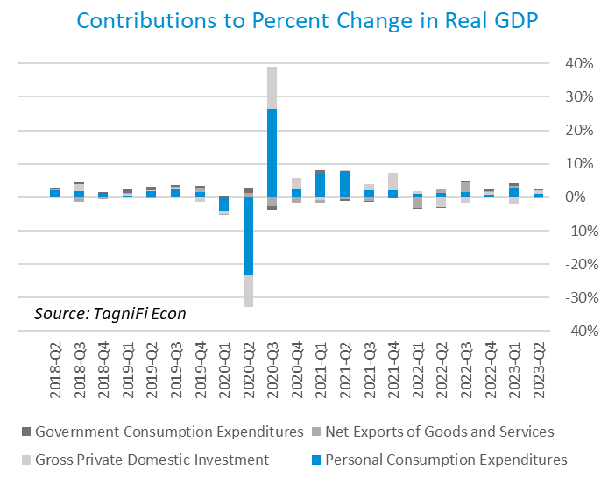

Economists polled by the Livingston Survey[8] in June of 2023 projected real GDP to fall to an annual rate of -0.7% in the 2nd half of 2023 before rebounding to an annual rate of 1.0% in the 1st half of 2024.

The Industrial Production Index[9] is an economic indicator that measures real output for all facilities located in the United States manufacturing, mining, and electric, and gas utilities. The index stood at 102.3 at the end of the 2nd quarter, down 0.4% from the 1st quarter.

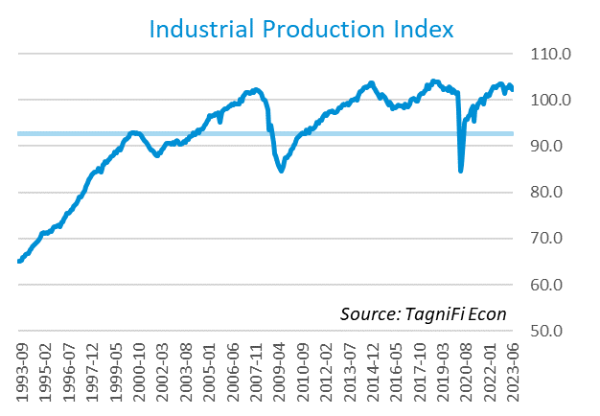

The Capacity Utilization Index[10], which attempts to capture industrial output as a percentage of the economy’s maximum production capacity, ended the 2nd quarter of 2023 at 78.0 %. June 2023’s level was above the 30-year average of 76.9% for this metric, and 0.2% higher than the previous quarter.

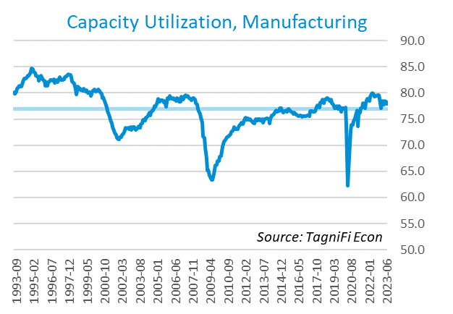

# Interest Rates

The effective federal funds rate[11] rose 0.43 percentage points to 5.08% during the 2nd quarter, continuing the climb from near-zero levels that began in March 2022. Treasury bond yields[12] for periods one year and up rose during the 2nd quarter. The yield curve remained inverted as long-term treasury yields fell further behind shorter-term yields. The closely watched two- and ten-year rates have been inverted since early in July 2022. The 1-year and 2-year annual treasury yields ended the 2nd quarter at 5.40% and 4.87%, respectively. The benchmark 10-year treasury yielded 3.81% at the end of the quarter, while the 30-year treasury yielded 3.85%. See *Appendix – Selected Interest Rates* for detailed interest rate data.

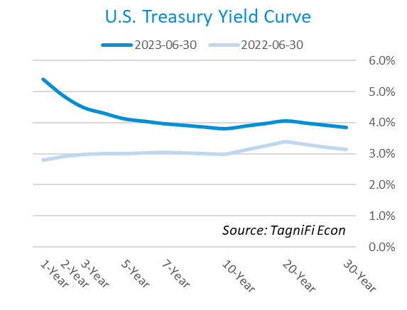

In the 2nd quarter of 2023, the Federal Reserve slowed their series of federal funds target rate[13] hikes, enacting one increase of 25 basis points. The target rate ended the quarter at a 17-year-high range of 5.00% to 5.25%. After ten consecutive rate hikes beginning in March 2022, the committee paused in June to reassess the economic landscape. Still, committee members revised their “dot plot” projections upward, pushing the median interest rate expectation for the end of 2023 to 5.6% and predicting two additional rate hikes in 2023.

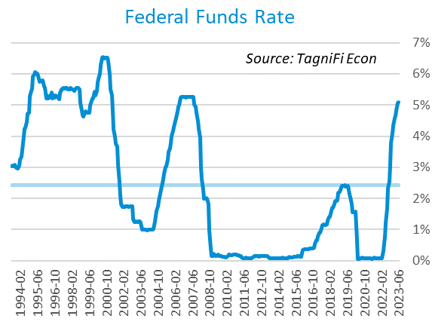

The yield on the benchmark 10-year U.S. treasury[14] ended the 2nd quarter at 3.81%, up 0.33 percentage points from the previous quarter, yet below the average yield of 3.87% over the last 30 years.

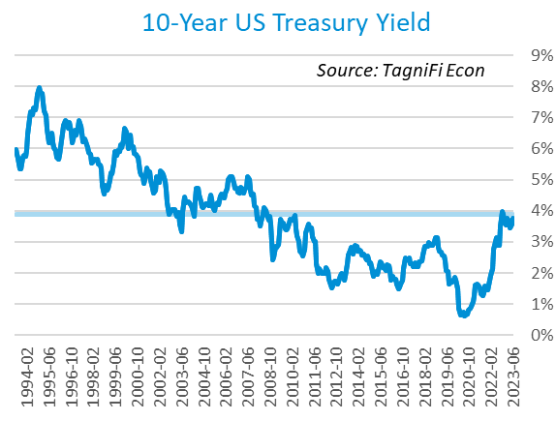

Moody’s Baa Corporate Bond Yield Index[15] ended the 2nd quarter of 2023 at 5.69%, up 0.10 percentage points since the previous quarter. Moody’s less-risky Aaa[16] Index rose 0.22 percentage points during the quarter to a level of 4.60%.

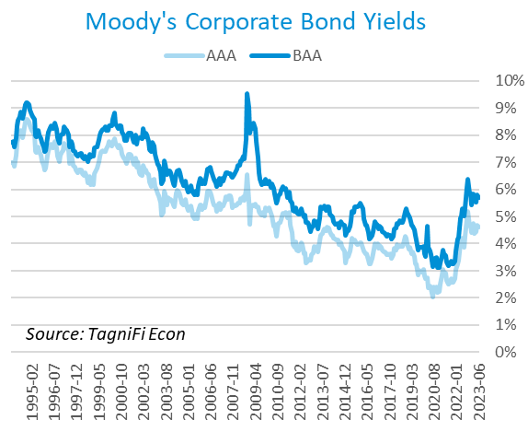

# Employment

The official unemployment rate[17] ended the 2nd quarter at 3.6%, up slightly from the prior quarter. The rate, still near its pre-pandemic (February 2020) level, stood well below the 30-year historical average of 5.7%. The labor force[18] expanded by 0.2 million workers during the quarter. The labor force participation rate[19] held steady throughout the quarter at 62.6%, 0.7 percentage points below its pre-pandemic level. Economists polled by the Livingston Survey in June 2023 projected an unemployment rate of 4.1% in December 2023, rising to 4.6% in June of 2024.

In May 2023, nonfarm worker quits[20] stood at 4.0 million, down 10.8% from their record high in November 2021 yet still 15.0% higher than their pre-pandemic level. Despite an uptick in May, the elevated level of quits (sometimes referred to as The Great Resignation), which has primarily affected the leisure and hospitality industry, appears to be waning. The quit rate in the leisure and hospitality industry fell 9.6 percentage points during the year ended May 2023. Job openings[21] totaled 9.8 million in May 2023, 2.2 million below their record high in March 2022 and 2.4 times the number of resignations.

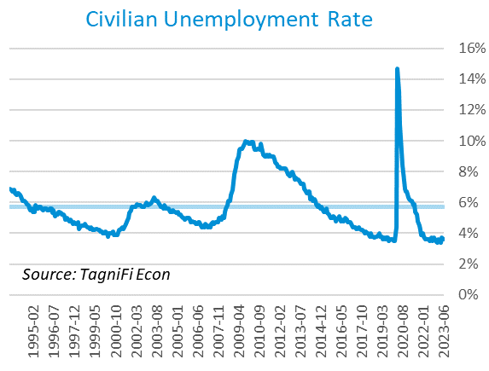

The U-6 unemployment rate[22] is an alternative measure of unemployment with a broader definition, including such groups as discouraged workers who are not actively searching for jobs but want full-time work and part-time workers who want full-time work. The U‑6 unemployment rate has generally followed the same pattern as the official rate and stood at 6.9% in June 2023.

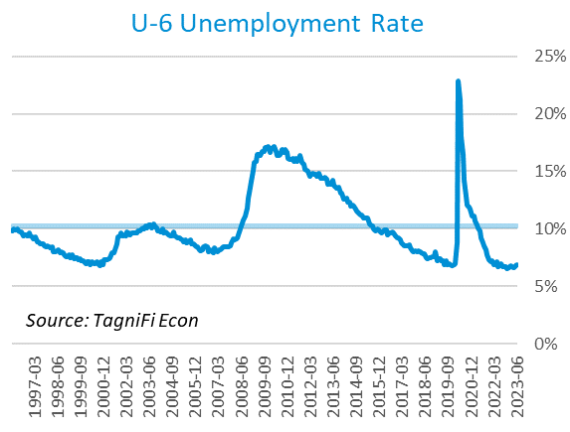

Nonfarm payrolls[23] grew by 0.7 million jobs in the 2nd quarter. U.S. nonfarm payrolls in June 2023 totaled 156.2 million jobs, up 3.8 million from the prior June. The jobs count also stood 3.8 million above its pre-pandemic (February 2020) level. June’s job market growth, while adequate from a historical standpoint, underperformed investor expectations and was the smallest since December 2020. The government, health care, social assistance, and construction industries led June’s job gains.

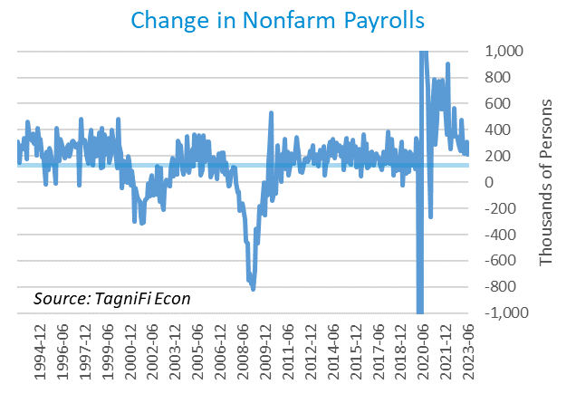

# Inflation

In the 2nd quarter of 2023, inflation continued to rise at a more moderate pace than much of 2021 and 2022; the cooling largely reflects lower costs for energy, airline fares, and vehicles. The Consumer Price Index[24] for all items rose 3.1% year-over-year in June 2023, down from its more-than-40-year high of 8.9% in June 2022. Excluding volatile energy prices[25], the annual increase was 5.0%. The average price of a gallon of gas[26] in the U.S. was $3.71 in June 2023, up 10.6% from its December 2002 trough but still 26.6% lower than its record high of $5.06 in June 2022.

In the month of June 2023, higher prices for shelter and motor vehicle insurance led the consumer price index to a relatively temperate increase. Price outcomes for major energy components were mixed in June, with gasoline and electricity costs up over the month but natural gas and fuel oil and other fuels down. The Federal Reserve has been taking aggressive action to curb inflation with a series of target interest rate hikes totaling 5.00 percentage points since March 2022. The Fed paused its rate hikes in June but indicated that further increases were expected in 2023.

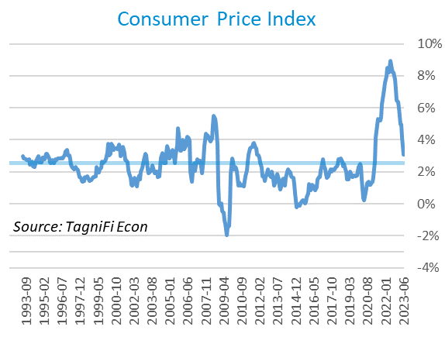

Wholesale inflation has been quicker to regulate than consumer inflation. The Producer Price Index[27] fell 1.3% in the 2nd quarter and 9.5% since June 2022. The average annual increase over the last 30 years was 2.9%.

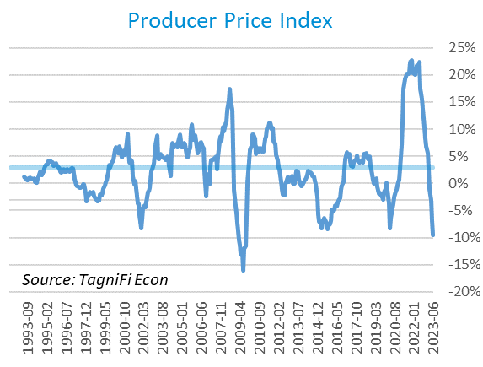

The 5-year breakeven inflation rate[28], an indicator for the market’s inflation expectations for the period, fell to 2.18% at the end of the 2nd quarter from 2.40% at the end of the 1st quarter 2023.

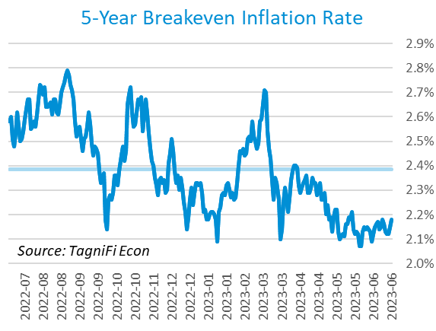

U.S. crude oil[29] prices have fallen in three of the last four quarters, constrained most recently by rising interest rates among major economic players and sluggish growth in the global economy, particularly China. Crude prices ended the 2nd quarter at $70.66 per barrel, down 6.6% from the prior quarter and 34.4% over one year.

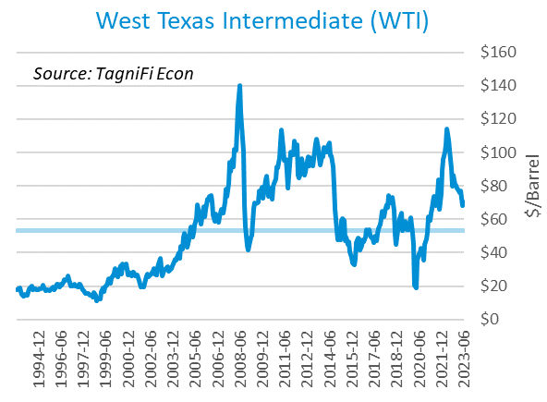

# Housing

High interest rates and a lack of available inventory have plagued the housing market in the first half of 2023. Price growth in major cities has slowed, with a growing number of cities experiencing annual price declines. Home sales continued to slide as mortgage rates remained near the 20-year high reached in late 2022. New home starts[30] rose 3.9% during the first quarter to a level of 1.43 million in June; the increase was concentrated in single-family homes while starts for multifamily buildings with 5 or more units fell over the quarter. Total new home starts were down 8.1% year-over-year but remained above their 30-year average of 1.34 million.

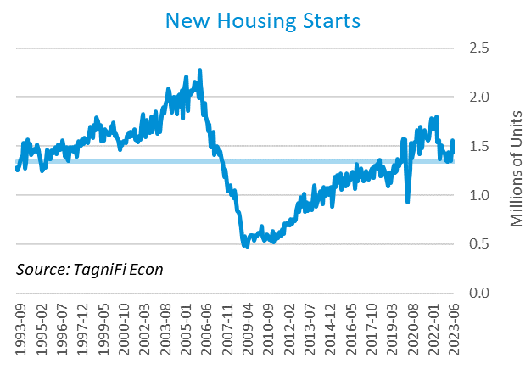

The cost of financing for would-be homebuyers rose during the 2nd quarter, with the 30-year fixed-rate mortgage[31] ending June 2023 at an average of 6.71%, 0.37 percentage points below its 20-year high in the fall of 2022.

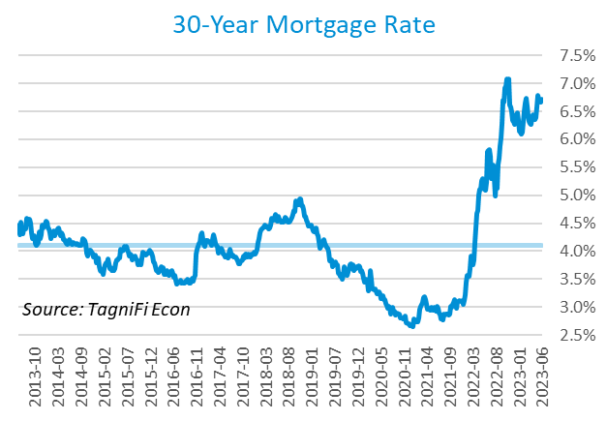

The S&P Case-Shiller Home Price Index (20-city)[32] was 1.0% higher from April to May but was down 1.8% since May 2022. Led by two Midwestern cities, Chicago and Cleveland, 10 of the 20 cities continued to report one-year price increases. Meanwhile, Seattle and San Francisco posted double-digit declines; in all, 7 of the 10 cities with over-the-year price declines were in the West region.

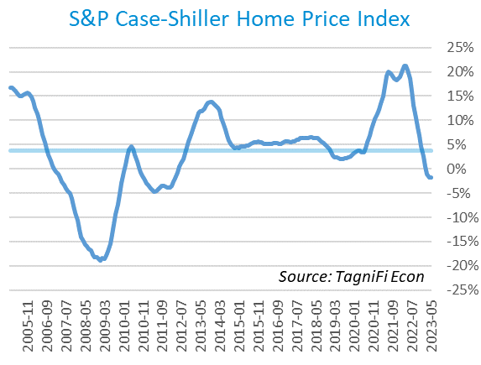

# Consumer Spending

Personal Consumption Expenditures (PCE)[33] rose 1.3% in the 2nd quarter to $18.4 trillion. PCE were up 5.4% since the 2nd quarter last year. Spending increased in June for services such as financial services and insurance, housing and utilities, and recreational services. Goods spending also increased, led by motor vehicles and parts as well as gasoline and other energy goods.

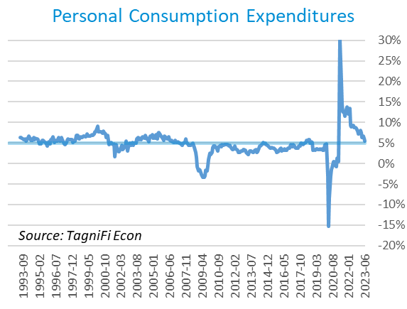

Auto manufacturers reported autos and light trucks sold[34] at an annual rate of 15.7 million in June 2023, up 5.0% from March. New vehicle prices[35] built on their record high by a further 0.7% during the 2nd quarter. Used car prices[36] rebounded after two quarters of decline, up 8.6% over the quarter.

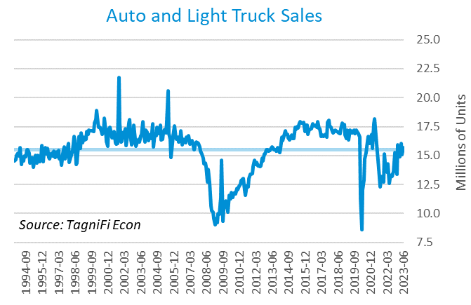

The University of Michigan’s consumer sentiment index[37] rose to 64.4 in June 2023, continuing the rebound from its all-time low of 50.0 in the previous June. The index was up 28.8% in the year ended June 2023 yet still well below its 30-year average of 86.6. June’s boost in sentiment can be credited largely to easing inflation and the evasion of a debt ceiling crisis. The upturn was widespread across demographic groups except for the youngest consumers.

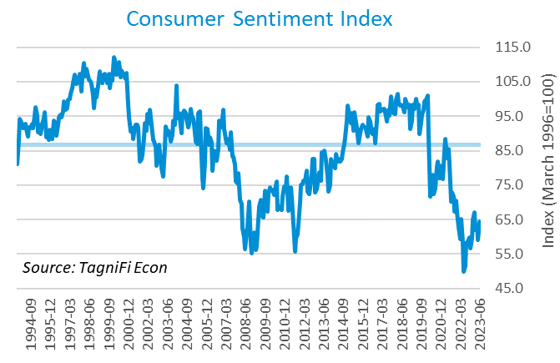

# Capital Markets

The table below shows the quarterly, year-to-date, and 12-month performance of major U.S. equity indices. Capital markets rebounded in the first half of 2023 after a difficult 2022 characterized by threats such as the war on Ukraine and hawkish monetary policy. The infusion of energy came to capital markets with reports of abating inflation, continued strength in the jobs market, and mass-market artificial intelligence ringing in a new frontier in tech. Tech stocks were the major winners; the NASDAQ composite rose 12.8% during the 2nd quarter of 2023. The S&P 500 was up 8.3%, the Wilshire 5000 was up 3.9%, and the Dow Jones Transprtation Average was up 7.6% for the quarter. The Dow Jones Composite and Industrial Averages were up 3.6% and 3.4%, respectively, over the quarter.



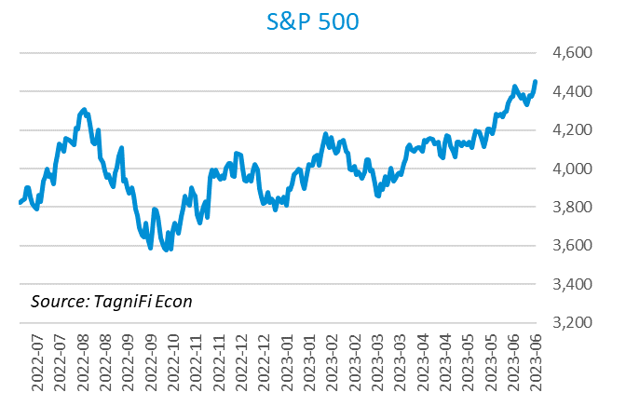

Stock market volatility, as measured by the VIX [38], ended the 2nd quarter of 2023 at 13.6, down 27.3% since the prior quarter and 47.3% since the 2nd quarter of 2022. The VIX trended downward with relative consistency in the 2nd quarter of 2023.

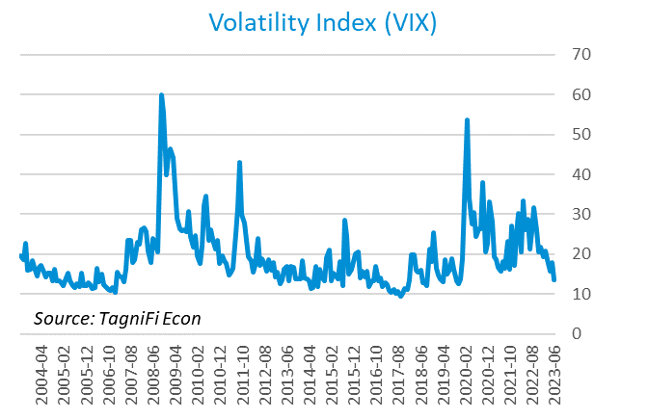

# Outlook

In March 2023, the FOMC revised their near-term real GDP projections upward and unemployment rate projections downward; little change was made to near-term PCE inflation projections. Little to no adjustments were made to longer-run projections for the three indicators.

The FOMC revised their projection for real GDP[39] to 0.95% growth in 2023, rising to 1.20% in 2024, then to 1.80% by 2025. They expected Personal Consumption Expenditures (PCE) inflation[40] to cool to 3.25% in 2023, further moderating to 2.55% by 2024 and 2.20% by 2025. They forecast that the unemployment rate[41] would be 4.15% in 2023, rising to 4.45% in both 2024 and 2025. The board raised projections of future target rates, revising the median projections upward to 5.6% in 2023, 4.6% in 2024, and 3.4% in 2025. While the committee paused target rate increases in June, they foreshadowed future rate hikes this year.



Appendix – Selected Interest Rates



# About This Report

The *Quarterly Economic Update* is a free publication sponsored by TagniFi. You are free to share this report and include its contents in the economic outlook section of your valuation reports as required by *Revenue Ruling 59-60*. Please forward this free report to a colleague to help us spread the word about TagniFi.

How TagniFi Helps Business Valuation Teams

TagniFi’s financial data platform empowers business valuation teams to quickly and easily build highly accurate financial models with full transparency—and within seconds.

**Better Public Comps**  
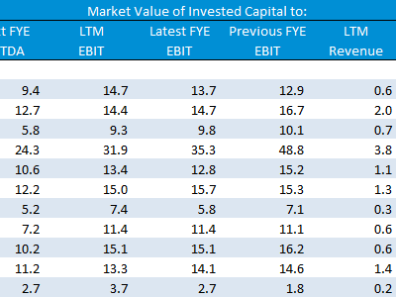Search for public companies with TagniFi Web. Simply enter your valuation date and ticker symbols in Excel to run a guideline public company method. Your Excel model populates instantly with the financial statements, analyst estimates, interest rates and economic data for your valuation date.

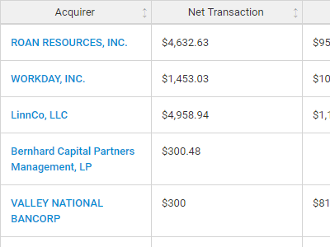**Better Transaction Comps**  
Search for public and private M&A transactions with TagniFi Web. Run your transaction comps within seconds by pasting the Deal ID into your Excel model. Every deal disclosed in an SEC filing (8-K, 10-K, or 10-Q) is available for your analysis. Choose from over 90 fields of data available for every deal.

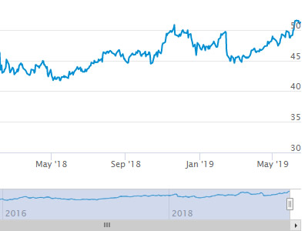

**Historical Beta and Volatility**Calculate historical beta and volatility as of your valuation date automatically. Simply enter the tickers and valuation date in Excel - TagniFi does the rest. In addition to beta and volatility, there are over 40 Excel models available in the Model Library to help with your valuation report.

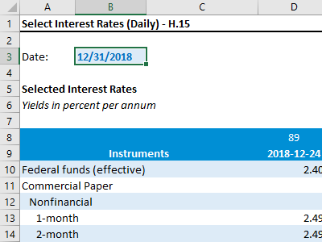**Interest Rates and Economic Data**Automate the interest rates and economic data in your valuation report using the TagniFi Excel plugin. Choose from over 200,000 time series available. All data in this *Quarterly Economic Update* is from the TagniFi platform. Use economic and interest rate data for your own valuation models with the TagniFi Excel plugin.

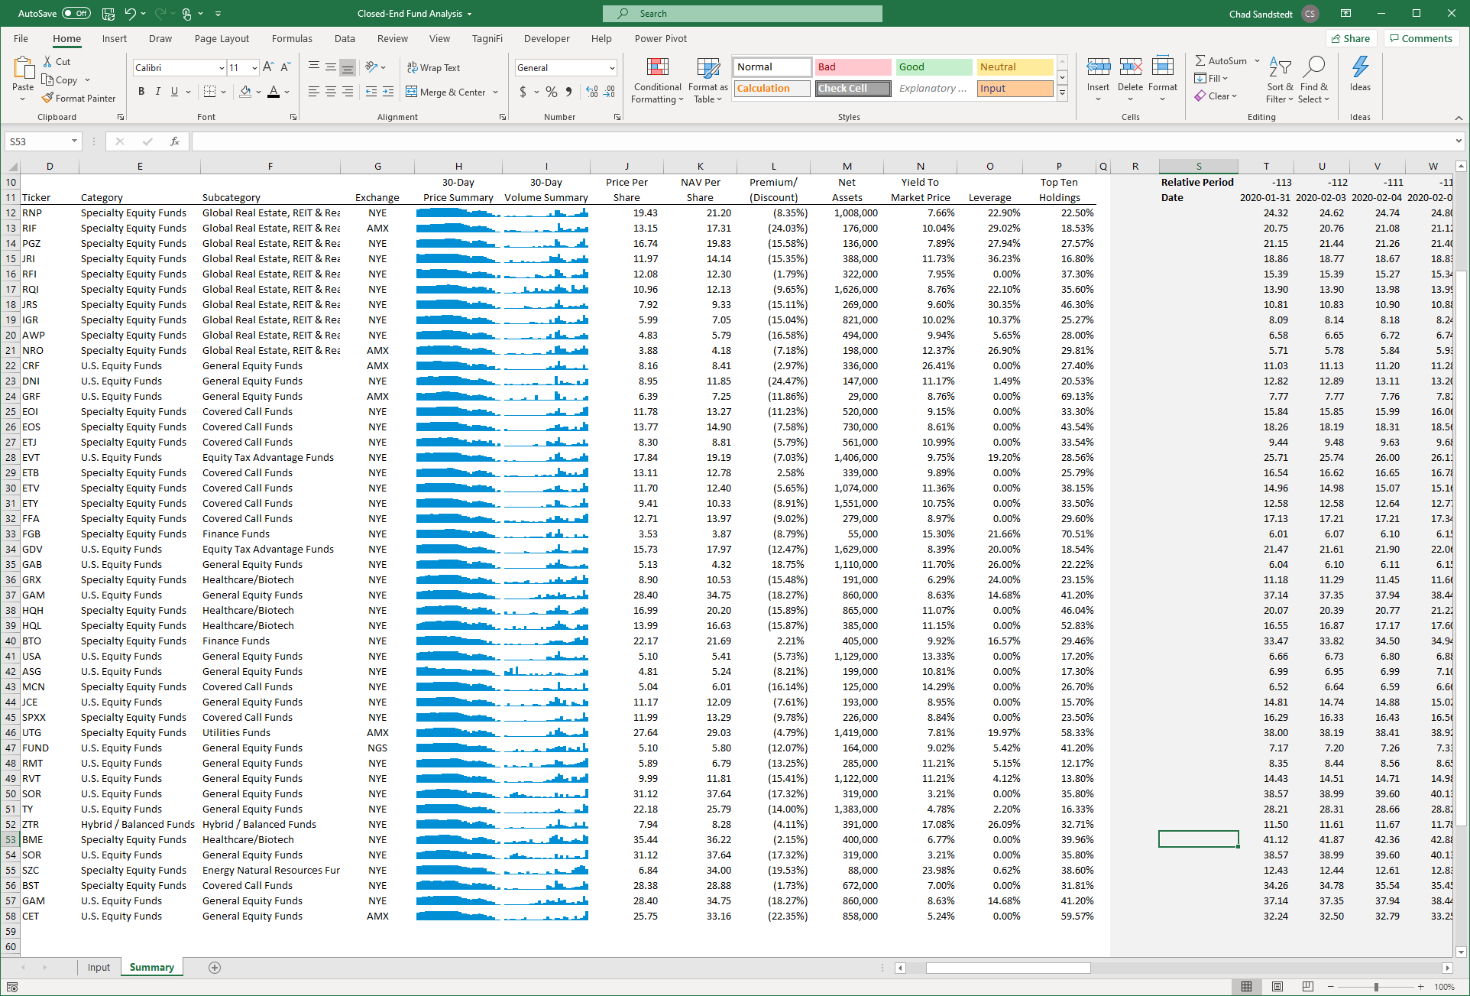

**Closed-End Mutual Fund Data**Search for closed-end mutual funds by keyword, category, subcategory, and more with the TagniFi Console. Use the TagniFi Excel plugin to calculate historical discounts, yields, leverage, as of your valuation date automatically. Simply enter the tickers and valuation date in Excel - TagniFi does the rest.

1. Federal Reserve Bank of Philadelphia, Coincident Economic Activity Index for the United States [USPHCI], *retrieved from FRED, Federal Reserve Bank of St. Louis;* [*https://fred.stlouisfed.org/series/USPHCI*](https://fred.stlouisfed.org/series/USPHCI)*, Jul 28, 2023.*
2. Board of Governors of the Federal Reserve System (US), Trade Weighted U.S. Dollar Index: Broad, Goods and Services [DTWEXBGS], *retrieved from FRED, Federal Reserve Bank of St. Louis;* [*https://fred.stlouisfed.org/series/DTWEXBGS*](https://fred.stlouisfed.org/series/DTWEXBGS)*, Jul 28, 2023.*
3. U.S. Bureau of Economic Analysis, Real Gross Domestic Product [GDPC1], *retrieved from FRED, Federal Reserve Bank of St. Louis;*[*https://fred.stlouisfed.org/series/GDPC1*](https://fred.stlouisfed.org/series/GDPC1)*, Jul 28, 2023.*
4. U.S. Bureau of Economic Analysis, Contributions to percent change in real gross domestic product: Personal consumption expenditures [DPCERY2Q224SBEA], *retrieved from FRED, Federal Reserve Bank of St. Louis;* [*https://fred.stlouisfed.org/series/DPCERY2Q224SBEA*](https://fred.stlouisfed.org/series/DPCERY2Q224SBEA)*, Jul 28, 2023.*
5. U.S. Bureau of Economic Analysis, Contributions to percent change in real gross domestic product: Gross private domestic investment [A006RY2Q224SBEA], *retrieved from FRED, Federal Reserve Bank of St. Louis;* [*https://fred.stlouisfed.org/series/A006RY2Q224SBEA*](https://fred.stlouisfed.org/series/A006RY2Q224SBEA)*, Jul 28, 2023.*
6. U.S. Bureau of Economic Analysis, Contributions to percent change in real gross domestic product: Government consumption expenditures and gross investment [A822RY2Q224SBEA], *retrieved from FRED, Federal Reserve Bank of St. Louis;* [*https://fred.stlouisfed.org/series/A822RY2Q224SBEA*](https://fred.stlouisfed.org/series/A822RY2Q224SBEA)*, Jul 28, 2023.*
7. U.S. Bureau of Economic Analysis, Contributions to percent change in real gross domestic product: Net exports of goods and services [A019RY2Q224SBEA], *retrieved from FRED, Federal Reserve Bank of St. Louis;* [*https://fred.stlouisfed.org/series/A019RY2Q224SBEA*](https://fred.stlouisfed.org/series/A019RY2Q224SBEA)*, Jul 28, 2023.*
8. Federal Reserve Bank of Philadelphia, The Livingston Survey June 2023, [economic release], retrieved from <https://www.philadelphiafed.org/surveys-and-data/real-time-data-research/livingston-survey>, Jul 28, 2023.
9. Board of Governors of the Federal Reserve System (US), Industrial Production Index [INDPRO], *retrieved from FRED, Federal Reserve Bank of St. Louis;*[*https://fred.stlouisfed.org/series/INDPRO*](https://fred.stlouisfed.org/series/INDPRO)*, Jul 28, 2023.*
10. Board of Governors of the Federal Reserve System (US), Capacity Utilization, Manufacturing (NAICS), *retrieved from FRED, Federal Reserve Bank of St. Louis;* [*https://fred.stlouisfed.org/series/MCUMFN*](https://fred.stlouisfed.org/series/MCUMFN)*, Jul 28, 2023.*
11. Board of Governors of the Federal Reserve System (US), Federal Funds Effective Rate [FEDFUNDS], *retrieved from FRED, Federal Reserve Bank of St. Louis;* [*https://fred.stlouisfed.org/series/FEDFUNDS*](https://fred.stlouisfed.org/series/FEDFUNDS)*, Jul 28, 2023.*
12. Selected Interest Rates Instruments, Yields in percent per annum, *retrieved from FRED, Federal Reserve Bank of St. Louis;* [https://fred.stlouisfed.org/release/tables?rid=18&eid=289&od=2023-06-30#](https://fred.stlouisfed.org/release/tables?rid=18&eid=289&od=2023-06-30)*, Jul 28, 2023.*
13. Board of Governors of the Federal Reserve System (US), Federal Funds Target Range - Upper Limit [DFEDTARU], *retrieved from FRED, Federal Reserve Bank of St. Louis;* [*https://fred.stlouisfed.org/series/DFEDTARU*](https://fred.stlouisfed.org/series/DFEDTARU)*, Jul 28, 2023*.
14. Board of Governors of the Federal Reserve System (US), 10-Year Treasury Constant Maturity Rate [DGS10], *retrieved from FRED, Federal Reserve Bank of St. Louis;*[*https://fred.stlouisfed.org/series/DGS10*](https://fred.stlouisfed.org/series/DGS10)*, Jul 28, 2023.*
15. Moody’s, Moody's Seasoned Baa Corporate Bond Yield [DBAA], *retrieved from FRED, Federal Reserve Bank of St. Louis;* [*https://fred.stlouisfed.org/series/DBAA*](https://fred.stlouisfed.org/series/DBAA)*, Jul 28, 2023.*
16. Moody’s, Moody's Seasoned Aaa Corporate Bond Yield [DAAA], *retrieved from FRED, Federal Reserve Bank of St. Louis;* [*https://fred.stlouisfed.org/series/DAAA*](https://fred.stlouisfed.org/series/DAAA)*, Jul 28, 2023.*
17. U.S. Bureau of Labor Statistics, Civilian Unemployment Rate [UNRATE], *retrieved from FRED, Federal Reserve Bank of St. Louis;*[*https://fred.stlouisfed.org/series/UNRATE*](https://fred.stlouisfed.org/series/UNRATE)*, Jul 28, 2023.*
18. U.S. Bureau of Labor Statistics, Civilian Labor Force Level [CLF16OV], *retrieved from FRED, Federal Reserve Bank of St. Louis;* [*https://fred.stlouisfed.org/series/CLF16OV*](https://fred.stlouisfed.org/series/CLF16OV)*, Jul 28, 2023.*
19. U.S. Bureau of Labor Statistics, Labor Force Participation Rate [CIVPART], *retrieved from FRED, Federal Reserve Bank of St. Louis;* [*https://fred.stlouisfed.org/series/CIVPART*](https://fred.stlouisfed.org/series/CIVPART)*, Jul 28, 2023.*
20. U.S. Bureau of Labor Statistics, Quits: Total Nonfarm [JTSQUL], *retrieved from FRED, Federal Reserve Bank of St. Louis;* [*https://fred.stlouisfed.org/series/JTSQUL*](https://fred.stlouisfed.org/series/JTSQUL)*, Jul 28, 2023.*
21. U.S. Bureau of Labor Statistics, Job Openings: Total Nonfarm [JTSJOL], *retrieved from FRED, Federal Reserve Bank of St. Louis;* [*https://fred.stlouisfed.org/series/JTSJOL*](https://fred.stlouisfed.org/series/JTSJOL)*, Jul 28, 2023.*
22. U.S. Bureau of Labor Statistics Total Unemployed, Plus All Persons Marginally Attached to the Labor Force, Plus Total Employed Part Time for Economic Reasons, as a Percent of the Civilian Labor Force Plus All Persons Marginally Attached to the Labor Force (U-6) [U6RATE], *retrieved from FRED, Federal Reserve Bank of St. Louis;*[*https://fred.stlouisfed.org/series/U6RATE*](https://fred.stlouisfed.org/series/U6RATE)*, Jul 28, 2023.*
23. U.S. Bureau of Labor Statistics, All Employees: Total Nonfarm Payrolls [PAYEMS], *retrieved from FRED, Federal Reserve Bank of St. Louis;*[*https://fred.stlouisfed.org/series/PAYEMS*](https://fred.stlouisfed.org/series/PAYEMS)*, Jul 28, 2023.*
24. U.S. Bureau of Labor Statistics, Consumer Price Index for All Urban Consumers: All Items [CPIAUCSL], *retrieved from FRED, Federal Reserve Bank of St. Louis;*[*https://fred.stlouisfed.org/series/CPIAUCSL*](https://fred.stlouisfed.org/series/CPIAUCSL)*, Jul 28, 2023.*
25. U.S. Bureau of Labor Statistics, Consumer Price Index for All Urban Consumers: All Items Less Energy in U.S. City Average [CPILEGSL], *retrieved from FRED, Federal Reserve Bank of St. Louis;* [*https://fred.stlouisfed.org/series/CPILEGSL*](https://fred.stlouisfed.org/series/CPILEGSL)*, Jul 28, 2023*.
26. U.S. Bureau of Labor Statistics, Average Price: Gasoline, Unleaded Regular (Cost per Gallon/3.785 Liters) in U.S. City Average [APU000074714], *retrieved from FRED, Federal Reserve Bank of St. Louis;* [*https://fred.stlouisfed.org/series/APU000074714*](https://fred.stlouisfed.org/series/APU000074714)*, Jul 28, 2023.*
27. U.S. Bureau of Labor Statistics, Producer Price Index for All Commodities [PPIACO], *retrieved from FRED, Federal Reserve Bank of St. Louis;*[*https://fred.stlouisfed.org/series/PPIACO*](https://fred.stlouisfed.org/series/PPIACO)*, Jul 28, 2023.*
28. *Federal Reserve Bank of St. Louis, 5-Year Breakeven Inflation Rate [T5YIE], retrieved from FRED, Federal Reserve Bank of St. Louis;*[*https://fred.stlouisfed.org/series/T5YIE*](https://fred.stlouisfed.org/series/T5YIE)*, Jul 28, 2023.*
29. U.S. Energy Information Administration, Crude Oil Prices: West Texas Intermediate (WTI) - Cushing, Oklahoma [DCOILWTICO], *retrieved from FRED, Federal Reserve Bank of St. Louis;* [*https://fred.stlouisfed.org/series/DCOILWTICO*](https://fred.stlouisfed.org/series/DCOILWTICO)*, Jul 28, 2023.*
30. U.S. Bureau of the Census, Housing Starts: Total: New Privately Owned Housing Units Started [HOUST], *retrieved from FRED, Federal Reserve Bank of St. Louis;*[*https://fred.stlouisfed.org/series/HOUST*](https://fred.stlouisfed.org/series/HOUST)*, Jul 28, 2023.*
31. Freddie Mac, 30-Year Fixed Rate Mortgage Average in the United States [MORTGAGE30US], *retrieved from FRED, Federal Reserve Bank of St. Louis;*[*https://fred.stlouisfed.org/series/MORTGAGE30US*](https://fred.stlouisfed.org/series/MORTGAGE30US)*, Jul 28, 2023.*
32. S&P Dow Jones Indices LLC, S&P/Case-Shiller 20-City Composite Home Price Index [SPCS20RSA], *retrieved from FRED, Federal Reserve Bank of St. Louis;*[*https://fred.stlouisfed.org/series/SPCS20RSA*](https://fred.stlouisfed.org/series/SPCS20RSA)*, Jul 28, 2023.*
33. U.S. Bureau of Economic Analysis, Personal Consumption Expenditures [PCE], *retrieved from FRED, Federal Reserve Bank of St. Louis;*[*https://fred.stlouisfed.org/series/PCE*](https://fred.stlouisfed.org/series/PCE)*, Jul 28, 2023.*
34. U.S. Bureau of Economic Analysis, Light Weight Vehicle Sales: Autos and Light Trucks [ALTSALES], *retrieved from FRED, Federal Reserve Bank of St. Louis; <https://fred.stlouisfed.org/series/ALTSALES>, Jul 28, 2023.*
35. U.S. Bureau of Labor Statistics, Consumer Price Index for All Urban Consumers: New Vehicles in U.S. City Average [CUUR0000SETA01], *retrieved from FRED, Federal Reserve Bank of St. Louis;* [*https://fred.stlouisfed.org/series/CUUR0000SETA01*](https://fred.stlouisfed.org/series/CUUR0000SETA01)*, Jul 28, 2023.*
36. U.S. Bureau of Labor Statistics, Consumer Price Index for All Urban Consumers: Used Cars and Trucks in U.S. City Average [CUSR0000SETA02], *retrieved from FRED, Federal Reserve Bank of St. Louis;* [*https://fred.stlouisfed.org/series/CUSR0000SETA02*](https://fred.stlouisfed.org/series/CUSR0000SETA02), *Jul 28, 2023.*
37. *University of Michigan, University of Michigan: Consumer Sentiment [UMCSENT], retrieved from FRED, Federal Reserve Bank of St. Louis;* [*https://fred.stlouisfed.org/series/UMCSENT*](https://fred.stlouisfed.org/series/UMCSENT)*, Jul 28, 2023.*
38. *Chicago Board Options Exchange, CBOE Volatility Index: VIX [VIXCLS], retrieved from FRED, Federal Reserve Bank of St. Louis;* [*https://fred.stlouisfed.org/series/VIXCLS*](https://fred.stlouisfed.org/series/VIXCLS)*, Jul 28, 2023.*
39. *Federal Reserve Bank of St. Louis, FOMC Summary of Economic Projections for the Growth Rate of Real Gross Domestic Product [GDPC1CTM], retrieved from FRED, Federal Reserve Bank of St. Louis;*[*https://fred.stlouisfed.org/series/GDPC1CTM*](https://fred.stlouisfed.org/series/GDPC1CTM)*, Jul 28, 2023.*
40. *Federal Reserve Bank of St. Louis, FOMC Summary of Economic Projections for the Personal Consumption Expenditures Inflation Rate, Central Tendency, Midpoint [PCECTPICTM], retrieved from FRED, Federal Reserve Bank of St. Louis;*[*https://fred.stlouisfed.org/series/PCECTPICTM*](https://fred.stlouisfed.org/series/PCECTPICTM)*, Jul 28, 2023.*
41. *Federal Reserve Bank of St. Louis, FOMC Summary of Economic Projections for the Civilian Unemployment Rate, Central Tendency, Midpoint [UNRATECTM], retrieved from FRED, Federal Reserve Bank of St. Louis;*[*https://fred.stlouisfed.org/series/UNRATECTM*](https://fred.stlouisfed.org/series/UNRATECTM)*, Jul 28, 2023.*