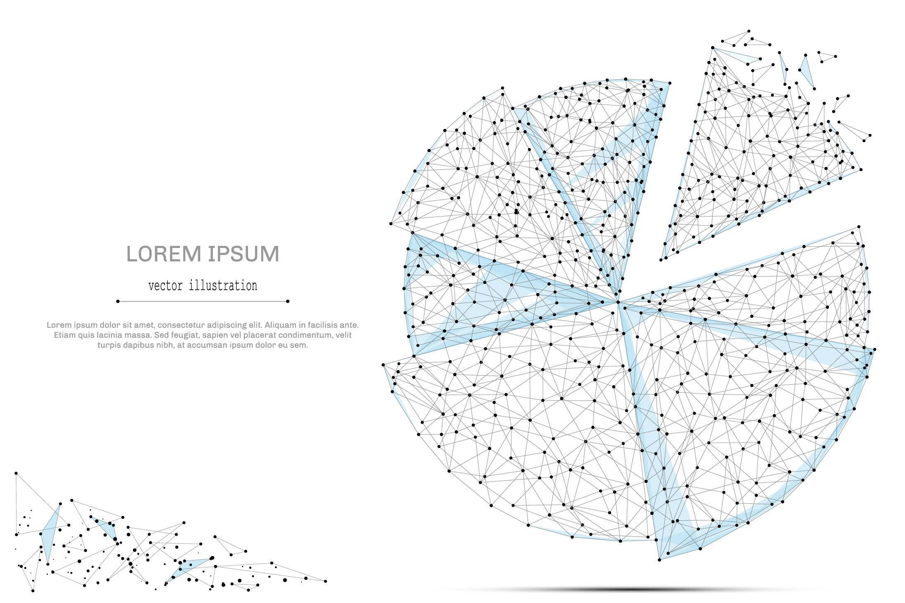

QUARTERLY ECONOMIC UPDATE

For the 3rd Quarter of 2023

Abstract

Designed for business valuation professionals, TagniFi’s Quarterly Economic   
Update provides timely economic data to satisfy Revenue Ruling 56-60.

# Summary

In the 3rd quarter of 2023, the U.S. economy remained durable in the face of headwinds, thanks in large part to the resilience of American consumers. Production, spending, and job gains all exceeded expectations, even as interest rates reached a more than 22-year high. The current pace of growth is not expected to persist, but recession fears seem to be fading as the data continues to support the Fed’s hope of a “soft landing” for the economy.

Though the unemployment rate edged up further from the nearly 54-year low it reached earlier this year, it remains below the 4.0% to 5.0% range widely accepted as an equilibrium level of “full employment.” Additionally, the uptick in unemployment came along with a commensurate increase in labor force participation rate and a 1-million worker gain in the size of the labor force. On the payroll side of the labor market, nonfarm employee counts exceeded expectations and fueled enthusiasm about the state of the economy.

Inflation, which has been generally abating for the last 15 months due to a strong response from the Fed, proved stubborn in the 3rd quarter. The Fed continues to weigh incoming economic data carefully before raising rates further, implementing a rate hike in two of the last four meetings after ten increases in a row. Yet an economy characterized by unflinching consumption means the Fed can keep rates elevated longer. Indeed, the FOMC’s latest projections demonstrate an increase in longer-term target rate expectations.

Weaker spots in the 3rd quarter economic landscape include the housing and capital markets. Inventory constraints and high borrowing costs continued to dampen the housing market, with mortgage rates at an almost 23-year high. Homebuilding starts and existing-home sales were both down in the 3rd quarter, while prices continued to rise.

With investors expecting interest rates to remain high for the foreseeable future, plus multiple highly publicized labor strikes and a near-brush with government shutdown at the end of September, capital markets suffered in the 3rd quarter of 2023. September closed with stocks in the red, bolstering hopes for an October rebound.

FOMC members revised projections of economic growth steeply upward to 2.05% in 2023. Growth is projected to moderate in future years to 1.80% in 2025. Unemployment projections were lowered for both the near and longer terms, at 3.80% for 2023 and rising to 4.10% for the next two years.

A multifactor indicator of economic strength, the Philadelphia Fed’s coincident index[1] of economic activity in the U.S. rose 0.3% in September 2023 and 0.7% during the 3rd quarter. For the quarter, coincident indexes increased in 36 states, decreased in 10 states, and remained unchanged in 4. Coincident indexes reflect unemployment, payroll employment, manufacturing hours, and wages and salaries.



The U.S. dollar index for goods and services[2] rose 2.4% during the 3rd quarter of 2023 but was down 3.6% compared to the same period one year prior. Despite a late-September dip, the dollar enjoyed its best quarter in a year as investors bet that the U.S. economy would continue to show greater resilience to persistent inflation and high oil prices than other nations’ economies.

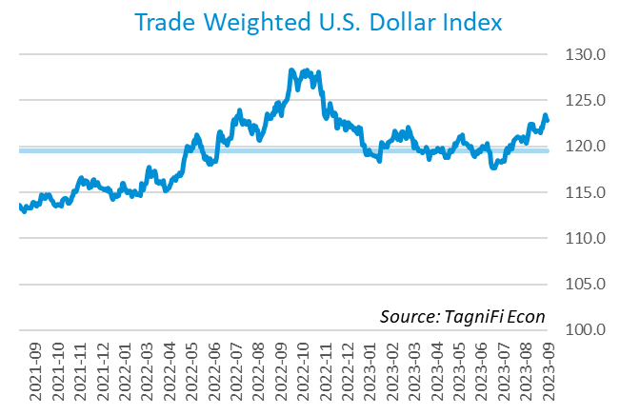

# Q3 Economic Highlights

* The Philadelphia Fed’s coincident index of economic activity in the U.S. rose 0.3% in September 2023 and 0.7% during the 3rd quarter.
* The U.S. dollar index rose 0.6% during the 3rd quarter of 2023 but was down 2.5% since the same period one year prior.
* Real GDP grew at an annualized rate of 4.9% during the 3rd quarter of 2023, up from its 2.1% increase in the 2nd quarter of 2023.
* The effective federal funds rate rose 0.25 percentage points to 5.33% during the 3rd quarter, continuing the climb from near-zero levels that began in March 2022.
* The 1-year and 2-year annual treasury yields ended the 3rd quarter at 5.46% and 5.03%, respectively. The benchmark 10-year treasury yielded 4.59% at the end of the quarter, while the 30-year treasury yielded 4.73%.
* The unemployment rate ended the 3rd quarter at 3.8%, up slightly from the prior quarter. Nonfarm payrolls grew by 0.8 million jobs in the 3rd quarter.
* The Consumer Price Index for all items rose 3.7% year-over-year in September 2023, down from its more-than-40-year high of 8.9% in June 2022. Excluding volatile energy prices, the annual increase was 4.1%.
* Crude oil prices ended the 3rd quarter at $90.77 per barrel, up 28.5% from the prior quarter and 13.6% over one year.
* New home starts fell 4.2% during the 3rd quarter to a level of 1.36 million in September. Total new home starts were down 7.2% year-over-year.
* The Dow Jones Composite Average fell 3.8% during the 3rd quarter of 2023, and the NASDAQ composite fell 3.7%. The S&P 500, Wilshire 5000, and Dow Jones Transportation Average were each down 3.6% for the quarter. The Dow Jones Industrial Average was down 2.6% over the quarter.

# Business Activity

Real gross domestic product (GDP)[3] grew at an annualized rate of 4.9% during the 3rd quarter of 2023, up from its 2.1% increase in the 2nd quarter of 2023. The strong growth exceeded expectations as consumer demand remained high in the face of elevated interest rates and persistent inflation. Personal consumption and private investment led to the 3rd quarter increase; government spending and exports also contributed. Most economists currently predict slowing growth in future months but expect that the U.S. economy can avoid recession.

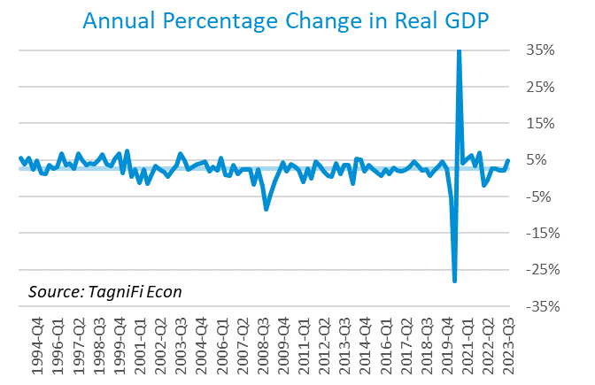

Personal consumption expenditures[4] (PCE) had a positive 2.7% effect on real GDP in the 3rd quarter. Growth in personal spending reflected both services, especially housing and utilities, health care, financial services and insurance, and food services and accommodations, and goods, such as other nondurable goods (led by prescription drugs) and recreational goods and vehicles.

Gross domestic private investment[5] also rose, contributing 1.5% to the 3rd quarter real GDP estimate. Change in private nonfarm inventories drove the increase, particularly in manufacturing and retail trade. Residential fixed investment also rose in the 3rd quarter. Nonresidential fixed investment was unchanged as increased investment in intellectual property products and structures was offset by decreased investment in equipment.

Government expenditures[6] rose at both the state and local level and the federal level to contribute 0.8% to the 3rd quarter GDP gain. Higher government spending reflected both consumption and investment growth at the state and local level as well as the national defense and nondefense sectors of the federal government.

Net exports[7] had a negative 0.1% effect on real GDP in the 3rd quarter as imports rose faster than exports (imports have a negative effect on GDP). Imports and exports for goods outpaced those for services.

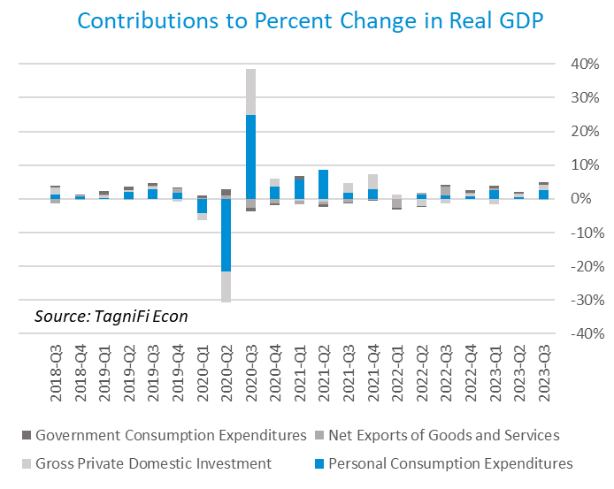

Economists polled by the Livingston Survey[8] in June of 2023 had projected real GDP to fall to an annual rate of -0.7% in the 2nd half of 2023 before rebounding to an annual rate of 1.0% in the 1st half of 2024.

The Industrial Production Index[9] is an economic indicator that measures real output for all facilities located in the United States manufacturing, mining, and electric, and gas utilities. The index stood at 103.6 at the end of the 3rd quarter, up 1.3% from the 2nd quarter.

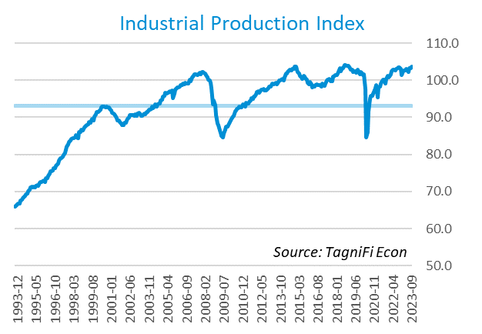

The Capacity Utilization Index[10], which attempts to capture industrial output as a percentage of the economy’s maximum production capacity, ended the 3rd quarter of 2023 at 77.8 %. September 2023’s level was above the 30-year average of 76.9% for this metric and up 0.3% from the previous quarter.

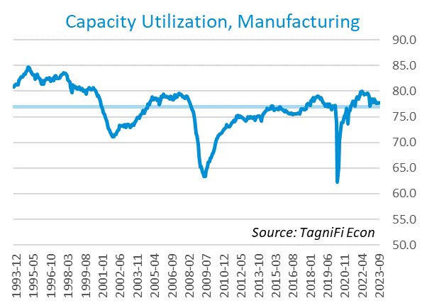

# Interest Rates

The effective federal funds rate[11] rose 0.25 percentage points to 5.33% during the 3rd quarter, continuing the climb from near-zero levels that began in March 2022. Treasury bond yields[12] for periods one year and up rose during the 3rd quarter. The yield curve remained inverted, but long-term treasury yields began to catch up to shorter-term yields. The closely watched two- and ten-year rates have been inverted since early in July 2022. The 1-year and 2-year annual treasury yields ended the 3rd quarter at 5.46% and 5.03%, respectively. The benchmark 10-year treasury yielded 4.59% at the end of the quarter, while the 30-year treasury yielded 4.73%. See *Appendix – Selected Interest Rates* for detailed interest rate data.

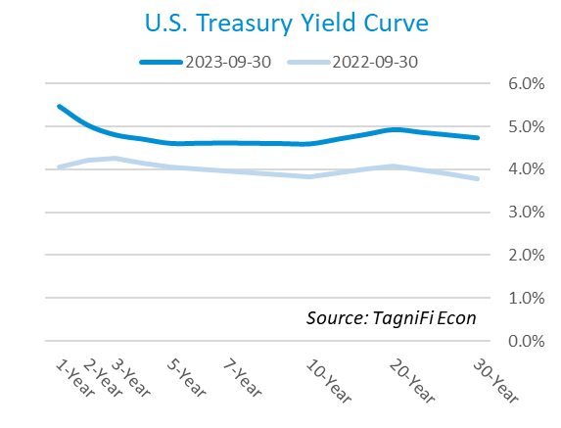

In the 3rd quarter of 2023, the Federal Reserve continued their series of federal funds target rate[13] hikes at a slowed pace, enacting one increase of 25 basis points. The target rate ended the quarter at a range of 5.25% to 5.50%, the highest in more than 22 years. After eleven rate hikes in 13 meetings since March 2022, the markets indicate that investors expect a pause for the remainder of 2023. The FOMC indicated that further hikes are still possible if incoming economic data warrants it. Committee members held their “dot plot” projections steady, with the median interest rate expectation for the end of 2023 at 5.6%. Inflation rose moderately during the 3rd quarter and is still higher than the Federal Reserve’s goal.

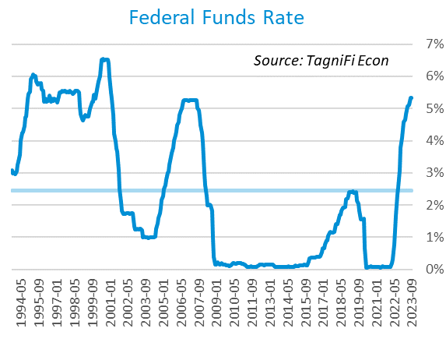

The yield on the benchmark 10-year U.S. treasury[14] ended the 3rd quarter at 4.59%, up 0.78 percentage points from the previous quarter and above the average yield of 3.85% over the last 30 years.

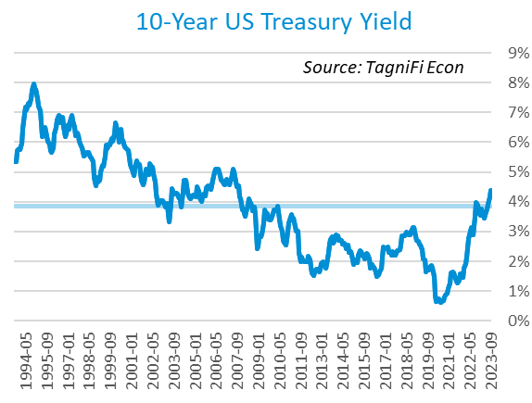

Moody’s Baa Corporate Bond Yield Index[15] ended the 3rd quarter of 2023 at 6.37%, up 0.68 percentage points since the previous quarter. Moody’s less-risky Aaa[16] Index rose 0.76 percentage points during the quarter to a level of 5.36%.

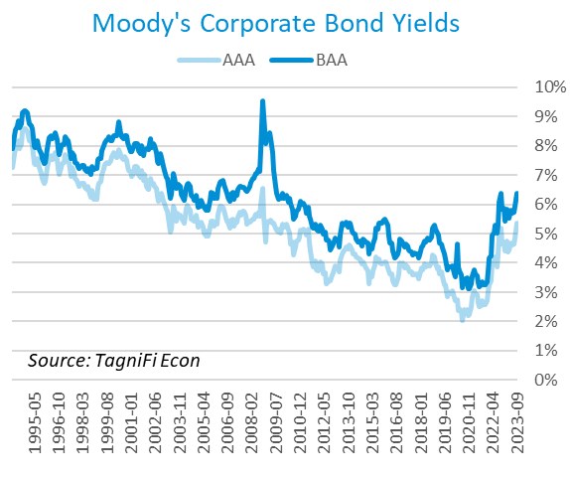

# Employment

The official unemployment rate[17] ended the 3rd quarter at 3.8%, up slightly from the prior quarter. Still, the rate stood well below the 30-year historical average of 5.7% and below the 4.0% to 5.0% range accepted as an equilibrium level of “full employment.” Additionally, the labor force[18] expanded by 1.0 million workers during the quarter. The labor force participation rate[19] rose slightly during the quarter to 62.8% but was still 0.5 percentage points below its pre-pandemic level. Economists polled by the Livingston Survey in June 2023 had projected an unemployment rate of 4.1% in December 2023, rising to 4.6% in June of 2024.

In August 2023, nonfarm worker quits[20] stood at 3.6 million, down 19.1% from their record high in November 2021 and coming back within 5.0% of its pre-pandemic level. Despite a slight uptick in August, the elevated level of quits (sometimes referred to as The Great Resignation), which has primarily affected the leisure and hospitality industry, may be coming to an end. Total quits in the leisure and hospitality industry fell 9.2 percentage points during the year ended August 2023. Job openings[21] totaled 9.6 million in August 2023, 2.4 million below their record high in March 2022 and 2.6 times the number of resignations.

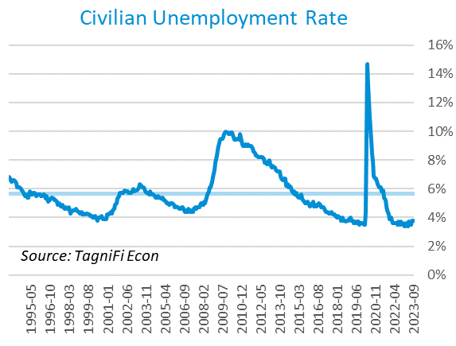

The U-6 unemployment rate[22] is an alternative measure of unemployment with a broader definition, including such groups as discouraged workers who are not actively searching for jobs but want full-time work and part-time workers who want full-time work. The U‑6 unemployment rate has generally followed the same pattern as the official rate and stood at 7.0% in September 2023.

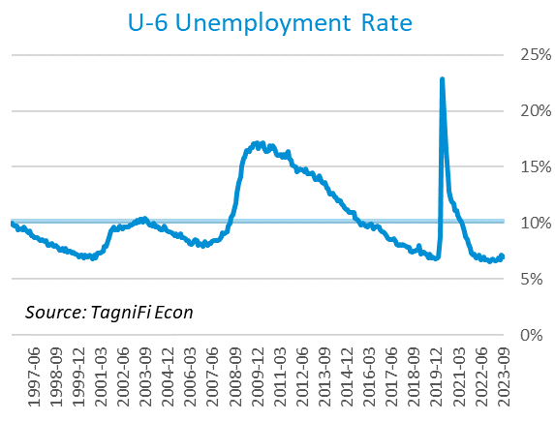

Nonfarm payrolls[23] grew by 0.8 million jobs in the 3rd quarter. U.S. nonfarm payrolls in September 2023 totaled 156.9 million jobs, up 3.2 million from the prior September. The jobs count also stood 4.5 million above its pre-pandemic (February 2020) level. September’s strong job market growth outperformed expectations despite elevated interest rates and high-profile labor strikes. September’s job gains were led by the leisure and hospitality, government, and health care industries.

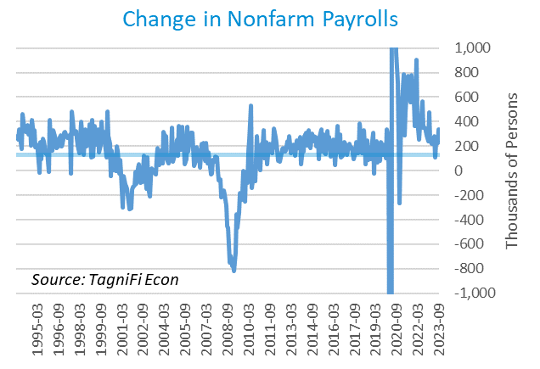

# Inflation

In the 3rd quarter of 2023, inflation accelerated, but continued to rise at a more moderate pace than much of 2021 and 2022. The Consumer Price Index[24] for all items rose 3.7% year-over-year in September 2023, down from its more-than-40-year high of 8.9% in June 2022. Shelter prices accounted for most of September’s annual increase; motor vehicle insurance, recreation, personal care, and new vehicles also contributed. Energy costs were down in September 2023 due to lower prices for natural gas and fuel oil. Excluding volatile energy prices[25], the annual increase was 4.1%. The average price of a gallon of gas[26] in the U.S. rose to $3.99 in September 2023, up 18.8% from its December 2022 trough but still 21.2% lower than its record high of $5.06 in June 2022.

In the month of September 2023, higher prices for shelter and motor vehicle insurance led the increase in the consumer price index. Gasoline, electricity, and fuel oil costs rose in September, but natural gas prices fell. The Federal Reserve has been taking aggressive action to curb inflation with a series of target interest rate hikes totaling 5.25 percentage points since March 2022. The Fed held its target rate steady in September but offered little clarity on future rate hikes in 2023.

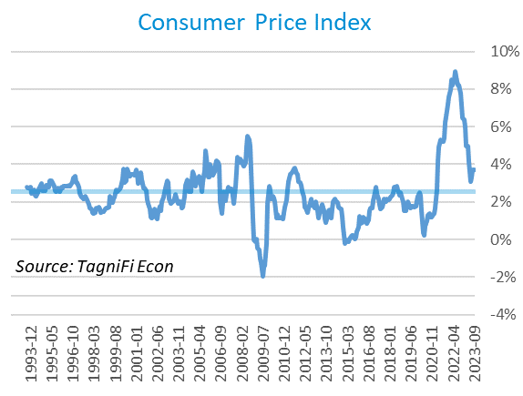

Wholesale inflation has been quicker to regulate than consumer inflation. The Producer Price Index[27] rose 2.1% in the 3rd quarter but fell 3.3% since September 2022. The average annual increase over the last 30 years was 2.8%.

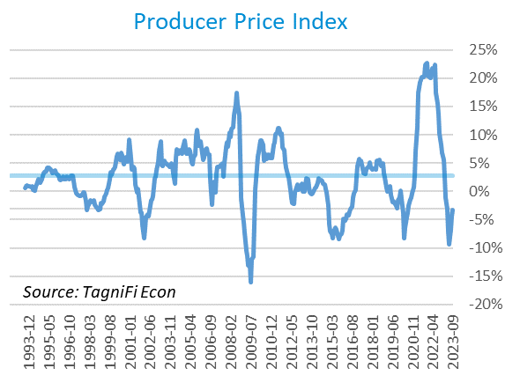

The 5-year breakeven inflation rate[28], an indicator for the market’s inflation expectations for the period, rose to 2.22% at the end of the 3rd quarter from 2.18% at the end of the 2nd quarter 2023.

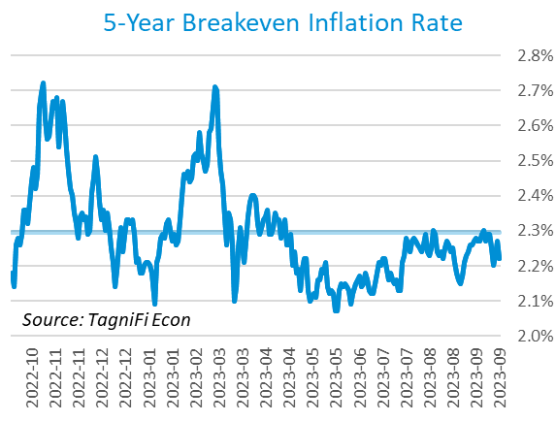

U.S. crude oil[29] prices rose in the third quarter, as domestic inventories at a key storage hub fell close to their operational minimum. OPEC+ production cuts have triggered a global deficit, and key suppliers such as Saudi Arabia and Russia have pledged to continue restricting production through the end of 2023. Crude prices ended the 3rd quarter at $90.77 per barrel, up 28.5% from the prior quarter and 13.6% over one year.

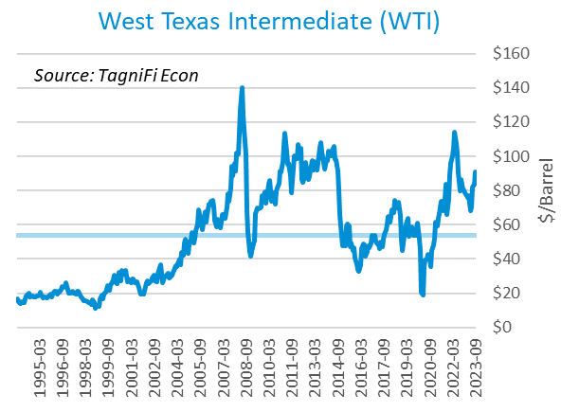

# Housing

High interest rates and a lack of available inventory continued to plague the housing market in the 3rd quarter of 2023. Home prices in major cities continued to rise overall, but results were mixed regionally. Home sales continued to slide as mortgage rates reached a nearly-23-year high. New home starts[30] fell 4.2% during the 3rd quarter to a level of 1.36 million in September; the decrease was concentrated among multifamily buildings with 5 or more units; single-family home starts rose modestly over the quarter. Total new home starts were down 7.2% year-over-year but remained above their 30-year average of 1.34 million.

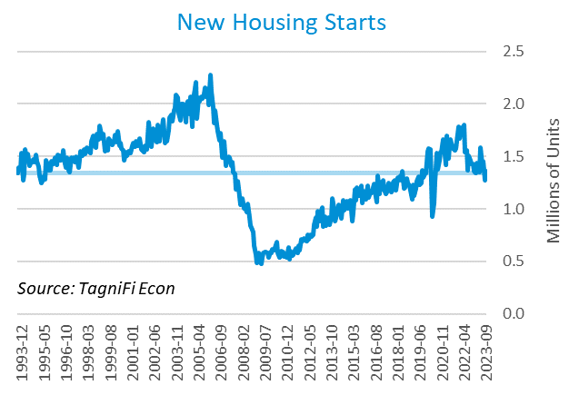

The cost of financing for would-be homebuyers continued to rise during the 3rd quarter, with the 30-year fixed-rate mortgage[31] ending September 2023 at an average of 7.31%, its highest level since December 2000.

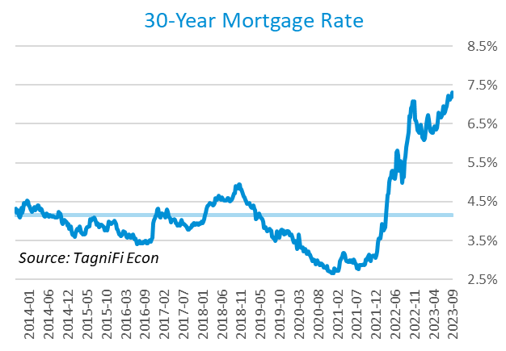

The S&P Case-Shiller Home Price Index (20-city)[32] was 1.0% higher from July to August and 2.2% higher since August 2022. Led by Chicago, New York, and Detroit, 12 of the 20 cities experienced one-year price increases; 1 had unchanged prices, and 7 cities experienced decreases. All cities in the Midwest and Northeast had rising prices over the year; 6 of the 7 cities with year-over-year price declines were in the West region.

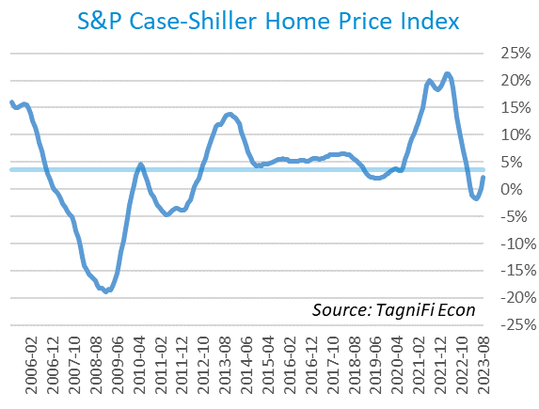

# Consumer Spending

Personal Consumption Expenditures (PCE)[33] rose 2.0% in the 3rd quarter to $18.9 trillion. PCE were up 5.9% since the 2nd quarter last year. Spending increased in September for services such as other services (led by international travel), housing and utilities, health care, and transportation. Goods spending also increased, other nondurable goods (led by prescription drugs) and motor vehicles and parts.

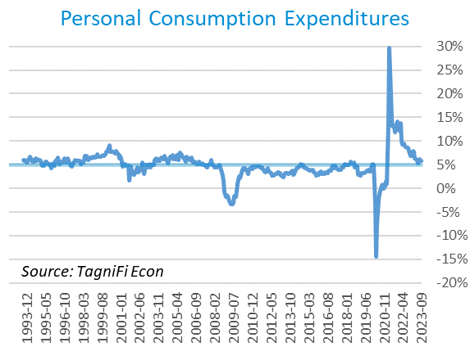

Auto manufacturers reported autos and light trucks sold[34] at an annual rate of 15.7 million in September 2023, down 2.0% from June. New vehicle prices[35] remained at a record high, inching up 0.1% during the 3rd quarter. Used car prices[36], which have declined in 3 of the last 4 quarters, fell 5.0% from June to September.

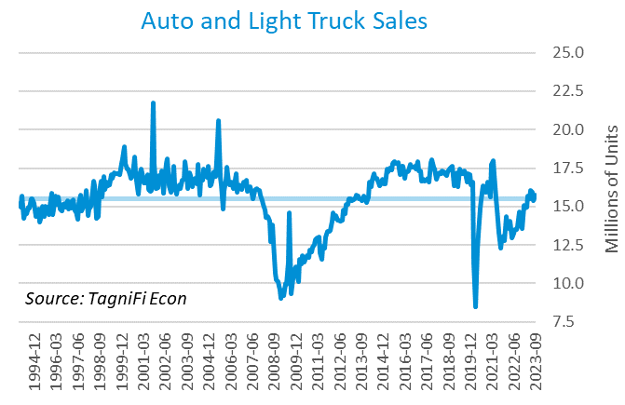

The University of Michigan’s consumer sentiment index[37] stood at 67.9 in September 2023, continuing the rebound from its all-time low of 50.0 fifteen months earlier. The index was up 15.9% in the year ended September 2023 yet still well below its 30-year average of 86.5. September’s index underperformed expectations, yet consumer perceptions of inflation were lower for both the one-year and five-year timeframes.

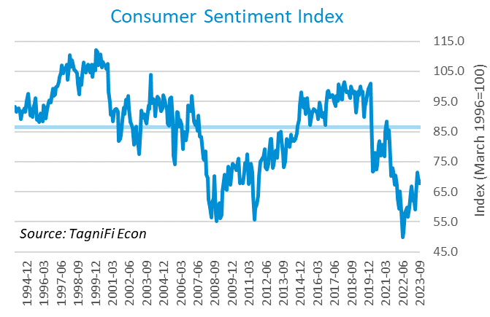

# Capital Markets

The table below shows the quarterly, year-to-date, and 12-month performance of major U.S. equity indices. Capital markets suffered a difficult 3rd quarter in 2023, ending their 1st-half rally. The most serious struggles came in September, a historically challenging month for stocks. Amid a government shutdown scare, high-profile labor strikes, and the continuing drag of elevated inflation and interest rates, stocks closed the quarter in the red. The Dow Jones Composite Average fell 3.8% during the 3rd quarter of 2023, and the NASDAQ composite fell 3.7%. The S&P 500, Wilshire 5000, and Dow Jones Transportation Average were each down 3.6% for the quarter. The Dow Jones Industrial Average fared a bit better, down 2.6% over the quarter.



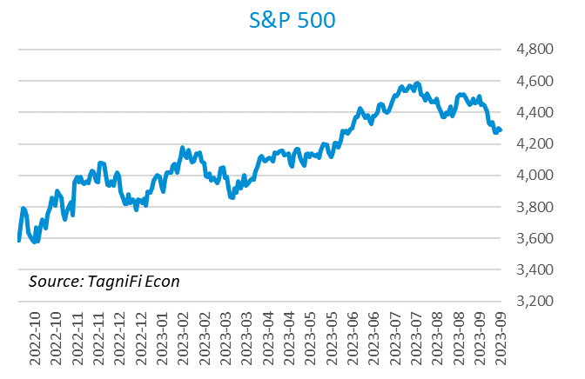

Stock market volatility, as measured by the VIX [38], ended the 3rd quarter of 2023 at 17.5, up 28.9% since the prior quarter but down 44.6% since the 3rd quarter of 2022. The VIX rose during the 3rd quarter, particularly September.

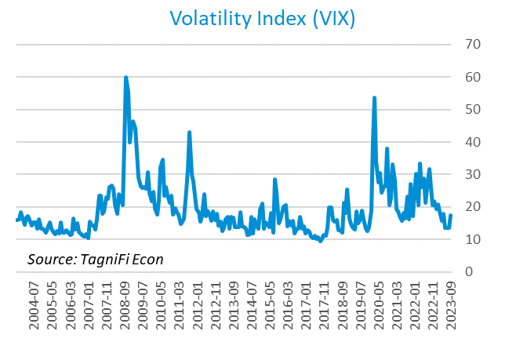

# Outlook

In September 2023, the FOMC revised their near-term real GDP projections upward and unemployment rate projections downward; little change was made to near-term PCE inflation projections. Little to no adjustments were made to longer-run projections for the three indicators.

The FOMC revised their projection for real GDP[39] sharply upward for the near term, to 2.05% growth in 2023, cooling to 1.50% in 2024 and 1.80% in 2025. They forecast Personal Consumption Expenditures (PCE) inflation[40] of 3.30% in 2023, moderating to 2.50% by 2024 and 2.15% by 2025. They expected that the unemployment rate[41] would be 3.80% in 2023, rising to 4.15% in 2024 and 4.10% in 2025. The board raised long-term projections of future target rates, revising the median projections to 5.6% in 2023, 5.1% in 2024, and 3.9% in 2025. While the committee paused target rate increases in June, they foreshadowed future rate hikes this year.



Appendix – Selected Interest Rates



# About This Report

The *Quarterly Economic Update* is a free publication sponsored by TagniFi. You are free to share this report and include its contents in the economic outlook section of your valuation reports as required by *Revenue Ruling 59-60*. Please forward this free report to a colleague to help us spread the word about TagniFi.

How TagniFi Helps Business Valuation Teams

TagniFi’s financial data platform empowers business valuation teams to quickly and easily build highly accurate financial models with full transparency—and within seconds.

**Better Public Comps**  
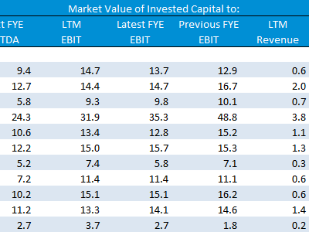Search for public companies with TagniFi Web. Simply enter your valuation date and ticker symbols in Excel to run a guideline public company method. Your Excel model populates instantly with the financial statements, analyst estimates, interest rates and economic data for your valuation date.

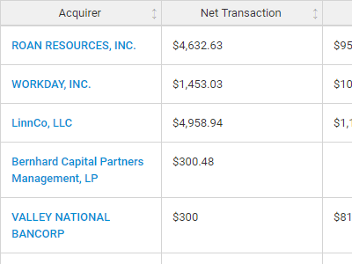**Better Transaction Comps**  
Search for public and private M&A transactions with TagniFi Web. Run your transaction comps within seconds by pasting the Deal ID into your Excel model. Every deal disclosed in an SEC filing (8-K, 10-K, or 10-Q) is available for your analysis. Choose from over 90 fields of data available for every deal.

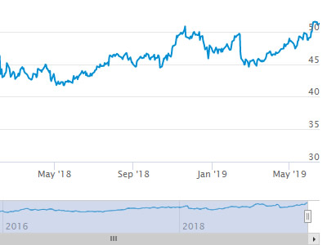

**Historical Beta and Volatility**Calculate historical beta and volatility as of your valuation date automatically. Simply enter the tickers and valuation date in Excel - TagniFi does the rest. In addition to beta and volatility, there are over 40 Excel models available in the Model Library to help with your valuation report.

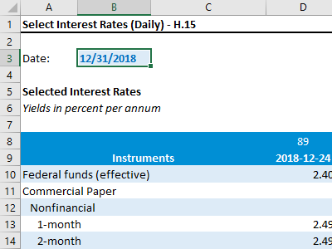**Interest Rates and Economic Data**Automate the interest rates and economic data in your valuation report using the TagniFi Excel plugin. Choose from over 200,000 time series available. All data in this *Quarterly Economic Update* is from the TagniFi platform. Use economic and interest rate data for your own valuation models with the TagniFi Excel plugin.

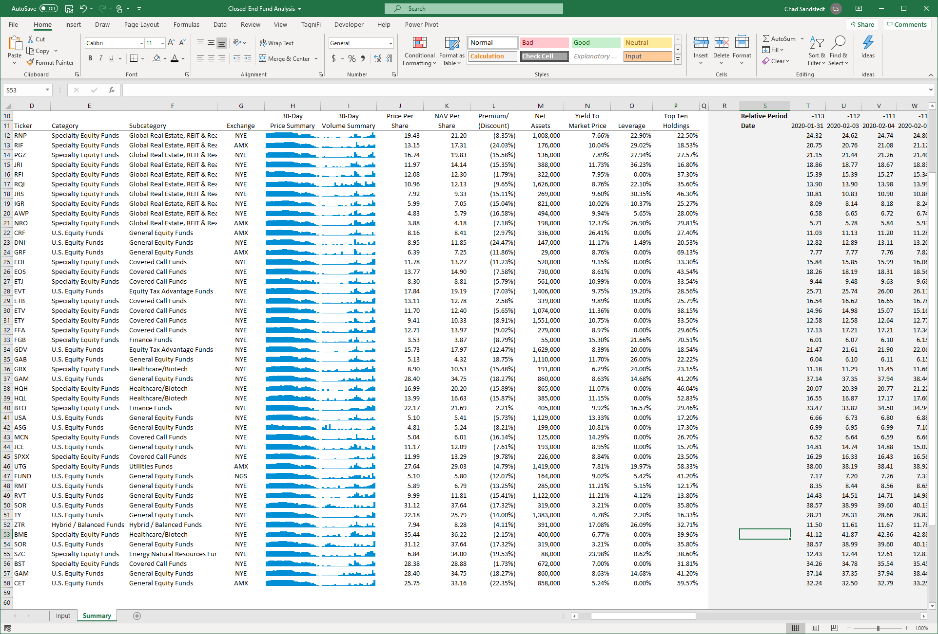

**Closed-End Mutual Fund Data**Search for closed-end mutual funds by keyword, category, subcategory, and more with the TagniFi Console. Use the TagniFi Excel plugin to calculate historical discounts, yields, leverage, as of your valuation date automatically. Simply enter the tickers and valuation date in Excel - TagniFi does the rest.

1. Federal Reserve Bank of Philadelphia, Coincident Economic Activity Index for the United States [USPHCI], *retrieved from FRED, Federal Reserve Bank of St. Louis;* [*https://fred.stlouisfed.org/series/USPHCI*](https://fred.stlouisfed.org/series/USPHCI)*, Oct 27, 2023.*
2. Board of Governors of the Federal Reserve System (US), Trade Weighted U.S. Dollar Index: Broad, Goods and Services [DTWEXBGS], *retrieved from FRED, Federal Reserve Bank of St. Louis;* [*https://fred.stlouisfed.org/series/DTWEXBGS*](https://fred.stlouisfed.org/series/DTWEXBGS)*, Oct 27, 2023.*
3. U.S. Bureau of Economic Analysis, Real Gross Domestic Product [GDPC1], *retrieved from FRED, Federal Reserve Bank of St. Louis;*[*https://fred.stlouisfed.org/series/GDPC1*](https://fred.stlouisfed.org/series/GDPC1)*, Oct 27, 2023.*
4. U.S. Bureau of Economic Analysis, Contributions to percent change in real gross domestic product: Personal consumption expenditures [DPCERY2Q224SBEA], *retrieved from FRED, Federal Reserve Bank of St. Louis;* [*https://fred.stlouisfed.org/series/DPCERY2Q224SBEA*](https://fred.stlouisfed.org/series/DPCERY2Q224SBEA)*, Oct 27, 2023.*
5. U.S. Bureau of Economic Analysis, Contributions to percent change in real gross domestic product: Gross private domestic investment [A006RY2Q224SBEA], *retrieved from FRED, Federal Reserve Bank of St. Louis;* [*https://fred.stlouisfed.org/series/A006RY2Q224SBEA*](https://fred.stlouisfed.org/series/A006RY2Q224SBEA)*, Oct 27, 2023.*
6. U.S. Bureau of Economic Analysis, Contributions to percent change in real gross domestic product: Government consumption expenditures and gross investment [A822RY2Q224SBEA], *retrieved from FRED, Federal Reserve Bank of St. Louis;* [*https://fred.stlouisfed.org/series/A822RY2Q224SBEA*](https://fred.stlouisfed.org/series/A822RY2Q224SBEA)*, Oct 27, 2023.*
7. U.S. Bureau of Economic Analysis, Contributions to percent change in real gross domestic product: Net exports of goods and services [A019RY2Q224SBEA], *retrieved from FRED, Federal Reserve Bank of St. Louis;* [*https://fred.stlouisfed.org/series/A019RY2Q224SBEA*](https://fred.stlouisfed.org/series/A019RY2Q224SBEA)*, Oct 27, 2023.*
8. Federal Reserve Bank of Philadelphia, The Livingston Survey June 2023, [economic release], retrieved from <https://www.philadelphiafed.org/surveys-and-data/real-time-data-research/livingston-survey>, Oct 27, 2023.
9. Board of Governors of the Federal Reserve System (US), Industrial Production Index [INDPRO], *retrieved from FRED, Federal Reserve Bank of St. Louis;*[*https://fred.stlouisfed.org/series/INDPRO*](https://fred.stlouisfed.org/series/INDPRO)*, Oct 27, 2023.*
10. Board of Governors of the Federal Reserve System (US), Capacity Utilization, Manufacturing (NAICS), *retrieved from FRED, Federal Reserve Bank of St. Louis;* [*https://fred.stlouisfed.org/series/MCUMFN*](https://fred.stlouisfed.org/series/MCUMFN)*, Oct 27, 2023.*
11. Board of Governors of the Federal Reserve System (US), Federal Funds Effective Rate [FEDFUNDS], *retrieved from FRED, Federal Reserve Bank of St. Louis;* [*https://fred.stlouisfed.org/series/FEDFUNDS*](https://fred.stlouisfed.org/series/FEDFUNDS)*, Oct 27, 2023.*
12. Selected Interest Rates Instruments, Yields in percent per annum, *retrieved from FRED, Federal Reserve Bank of St. Louis;* [https://fred.stlouisfed.org/release/tables?rid=18&eid=289&od=2023-06-30#](https://fred.stlouisfed.org/release/tables?rid=18&eid=289&od=2023-06-30)*, Oct 27, 2023.*
13. Board of Governors of the Federal Reserve System (US), Federal Funds Target Range - Upper Limit [DFEDTARU], *retrieved from FRED, Federal Reserve Bank of St. Louis;* [*https://fred.stlouisfed.org/series/DFEDTARU*](https://fred.stlouisfed.org/series/DFEDTARU)*, Oct 27, 2023*.
14. Board of Governors of the Federal Reserve System (US), 10-Year Treasury Constant Maturity Rate [DGS10], *retrieved from FRED, Federal Reserve Bank of St. Louis;*[*https://fred.stlouisfed.org/series/DGS10*](https://fred.stlouisfed.org/series/DGS10)*, Oct 27, 2023.*
15. Moody’s, Moody's Seasoned Baa Corporate Bond Yield [DBAA], *retrieved from FRED, Federal Reserve Bank of St. Louis;* [*https://fred.stlouisfed.org/series/DBAA*](https://fred.stlouisfed.org/series/DBAA)*, Oct 27, 2023.*
16. Moody’s, Moody's Seasoned Aaa Corporate Bond Yield [DAAA], *retrieved from FRED, Federal Reserve Bank of St. Louis;* [*https://fred.stlouisfed.org/series/DAAA*](https://fred.stlouisfed.org/series/DAAA)*, Oct 27, 2023.*
17. U.S. Bureau of Labor Statistics, Civilian Unemployment Rate [UNRATE], *retrieved from FRED, Federal Reserve Bank of St. Louis;*[*https://fred.stlouisfed.org/series/UNRATE*](https://fred.stlouisfed.org/series/UNRATE)*, Oct 27, 2023.*
18. U.S. Bureau of Labor Statistics, Civilian Labor Force Level [CLF16OV], *retrieved from FRED, Federal Reserve Bank of St. Louis;* [*https://fred.stlouisfed.org/series/CLF16OV*](https://fred.stlouisfed.org/series/CLF16OV)*, Oct 27, 2023.*
19. U.S. Bureau of Labor Statistics, Labor Force Participation Rate [CIVPART], *retrieved from FRED, Federal Reserve Bank of St. Louis;* [*https://fred.stlouisfed.org/series/CIVPART*](https://fred.stlouisfed.org/series/CIVPART)*, Oct 27, 2023.*
20. U.S. Bureau of Labor Statistics, Quits: Total Nonfarm [JTSQUL], *retrieved from FRED, Federal Reserve Bank of St. Louis;* [*https://fred.stlouisfed.org/series/JTSQUL*](https://fred.stlouisfed.org/series/JTSQUL)*, Oct 27, 2023.*
21. U.S. Bureau of Labor Statistics, Job Openings: Total Nonfarm [JTSJOL], *retrieved from FRED, Federal Reserve Bank of St. Louis;* [*https://fred.stlouisfed.org/series/JTSJOL*](https://fred.stlouisfed.org/series/JTSJOL)*, Oct 27, 2023.*
22. U.S. Bureau of Labor Statistics Total Unemployed, Plus All Persons Marginally Attached to the Labor Force, Plus Total Employed Part Time for Economic Reasons, as a Percent of the Civilian Labor Force Plus All Persons Marginally Attached to the Labor Force (U-6) [U6RATE], *retrieved from FRED, Federal Reserve Bank of St. Louis;*[*https://fred.stlouisfed.org/series/U6RATE*](https://fred.stlouisfed.org/series/U6RATE)*, Oct 27, 2023.*
23. U.S. Bureau of Labor Statistics, All Employees: Total Nonfarm Payrolls [PAYEMS], *retrieved from FRED, Federal Reserve Bank of St. Louis;*[*https://fred.stlouisfed.org/series/PAYEMS*](https://fred.stlouisfed.org/series/PAYEMS)*, Oct 27, 2023.*
24. U.S. Bureau of Labor Statistics, Consumer Price Index for All Urban Consumers: All Items [CPIAUCSL], *retrieved from FRED, Federal Reserve Bank of St. Louis;*[*https://fred.stlouisfed.org/series/CPIAUCSL*](https://fred.stlouisfed.org/series/CPIAUCSL)*, Oct 27, 2023.*
25. U.S. Bureau of Labor Statistics, Consumer Price Index for All Urban Consumers: All Items Less Energy in U.S. City Average [CPILEGSL], *retrieved from FRED, Federal Reserve Bank of St. Louis;* [*https://fred.stlouisfed.org/series/CPILEGSL*](https://fred.stlouisfed.org/series/CPILEGSL)*, Oct 27, 2023*.
26. U.S. Bureau of Labor Statistics, Average Price: Gasoline, Unleaded Regular (Cost per Gallon/3.785 Liters) in U.S. City Average [APU000074714], *retrieved from FRED, Federal Reserve Bank of St. Louis;* [*https://fred.stlouisfed.org/series/APU000074714*](https://fred.stlouisfed.org/series/APU000074714)*, Oct 27, 2023.*
27. U.S. Bureau of Labor Statistics, Producer Price Index for All Commodities [PPIACO], *retrieved from FRED, Federal Reserve Bank of St. Louis;*[*https://fred.stlouisfed.org/series/PPIACO*](https://fred.stlouisfed.org/series/PPIACO)*, Oct 27, 2023.*
28. *Federal Reserve Bank of St. Louis, 5-Year Breakeven Inflation Rate [T5YIE], retrieved from FRED, Federal Reserve Bank of St. Louis;*[*https://fred.stlouisfed.org/series/T5YIE*](https://fred.stlouisfed.org/series/T5YIE)*, Oct 27, 2023.*
29. U.S. Energy Information Administration, Crude Oil Prices: West Texas Intermediate (WTI) - Cushing, Oklahoma [DCOILWTICO], *retrieved from FRED, Federal Reserve Bank of St. Louis;* [*https://fred.stlouisfed.org/series/DCOILWTICO*](https://fred.stlouisfed.org/series/DCOILWTICO)*, Oct 27, 2023.*
30. U.S. Bureau of the Census, Housing Starts: Total: New Privately Owned Housing Units Started [HOUST], *retrieved from FRED, Federal Reserve Bank of St. Louis;*[*https://fred.stlouisfed.org/series/HOUST*](https://fred.stlouisfed.org/series/HOUST)*, Oct 27, 2023.*
31. Freddie Mac, 30-Year Fixed Rate Mortgage Average in the United States [MORTGAGE30US], *retrieved from FRED, Federal Reserve Bank of St. Louis;*[*https://fred.stlouisfed.org/series/MORTGAGE30US*](https://fred.stlouisfed.org/series/MORTGAGE30US)*, Oct 27, 2023.*
32. S&P Dow Jones Indices LLC, S&P/Case-Shiller 20-City Composite Home Price Index [SPCS20RSA], *retrieved from FRED, Federal Reserve Bank of St. Louis;*[*https://fred.stlouisfed.org/series/SPCS20RSA*](https://fred.stlouisfed.org/series/SPCS20RSA)*, Nov 2, 2023.*
33. U.S. Bureau of Economic Analysis, Personal Consumption Expenditures [PCE], *retrieved from FRED, Federal Reserve Bank of St. Louis;*[*https://fred.stlouisfed.org/series/PCE*](https://fred.stlouisfed.org/series/PCE)*, Oct 27, 2023.*
34. U.S. Bureau of Economic Analysis, Light Weight Vehicle Sales: Autos and Light Trucks [ALTSALES], *retrieved from FRED, Federal Reserve Bank of St. Louis; <https://fred.stlouisfed.org/series/ALTSALES>, Oct 27, 2023.*
35. U.S. Bureau of Labor Statistics, Consumer Price Index for All Urban Consumers: New Vehicles in U.S. City Average [CUUR0000SETA01], *retrieved from FRED, Federal Reserve Bank of St. Louis;* [*https://fred.stlouisfed.org/series/CUUR0000SETA01*](https://fred.stlouisfed.org/series/CUUR0000SETA01)*, Oct 27, 2023.*
36. U.S. Bureau of Labor Statistics, Consumer Price Index for All Urban Consumers: Used Cars and Trucks in U.S. City Average [CUSR0000SETA02], *retrieved from FRED, Federal Reserve Bank of St. Louis;* [*https://fred.stlouisfed.org/series/CUSR0000SETA02*](https://fred.stlouisfed.org/series/CUSR0000SETA02), *Oct 27, 2023.*
37. *University of Michigan, University of Michigan: Consumer Sentiment [UMCSENT], retrieved from FRED, Federal Reserve Bank of St. Louis;* [*https://fred.stlouisfed.org/series/UMCSENT*](https://fred.stlouisfed.org/series/UMCSENT)*, Oct 27, 2023.*
38. *Chicago Board Options Exchange, CBOE Volatility Index: VIX [VIXCLS], retrieved from FRED, Federal Reserve Bank of St. Louis;* [*https://fred.stlouisfed.org/series/VIXCLS*](https://fred.stlouisfed.org/series/VIXCLS)*, Oct 27, 2023.*
39. *Federal Reserve Bank of St. Louis, FOMC Summary of Economic Projections for the Growth Rate of Real Gross Domestic Product [GDPC1CTM], retrieved from FRED, Federal Reserve Bank of St. Louis;*[*https://fred.stlouisfed.org/series/GDPC1CTM*](https://fred.stlouisfed.org/series/GDPC1CTM)*, Oct 27, 2023.*
40. *Federal Reserve Bank of St. Louis, FOMC Summary of Economic Projections for the Personal Consumption Expenditures Inflation Rate, Central Tendency, Midpoint [PCECTPICTM], retrieved from FRED, Federal Reserve Bank of St. Louis;*[*https://fred.stlouisfed.org/series/PCECTPICTM*](https://fred.stlouisfed.org/series/PCECTPICTM)*, Oct 27, 2023.*
41. *Federal Reserve Bank of St. Louis, FOMC Summary of Economic Projections for the Civilian Unemployment Rate, Central Tendency, Midpoint [UNRATECTM], retrieved from FRED, Federal Reserve Bank of St. Louis;*[*https://fred.stlouisfed.org/series/UNRATECTM*](https://fred.stlouisfed.org/series/UNRATECTM)*, Oct 27, 2023.*