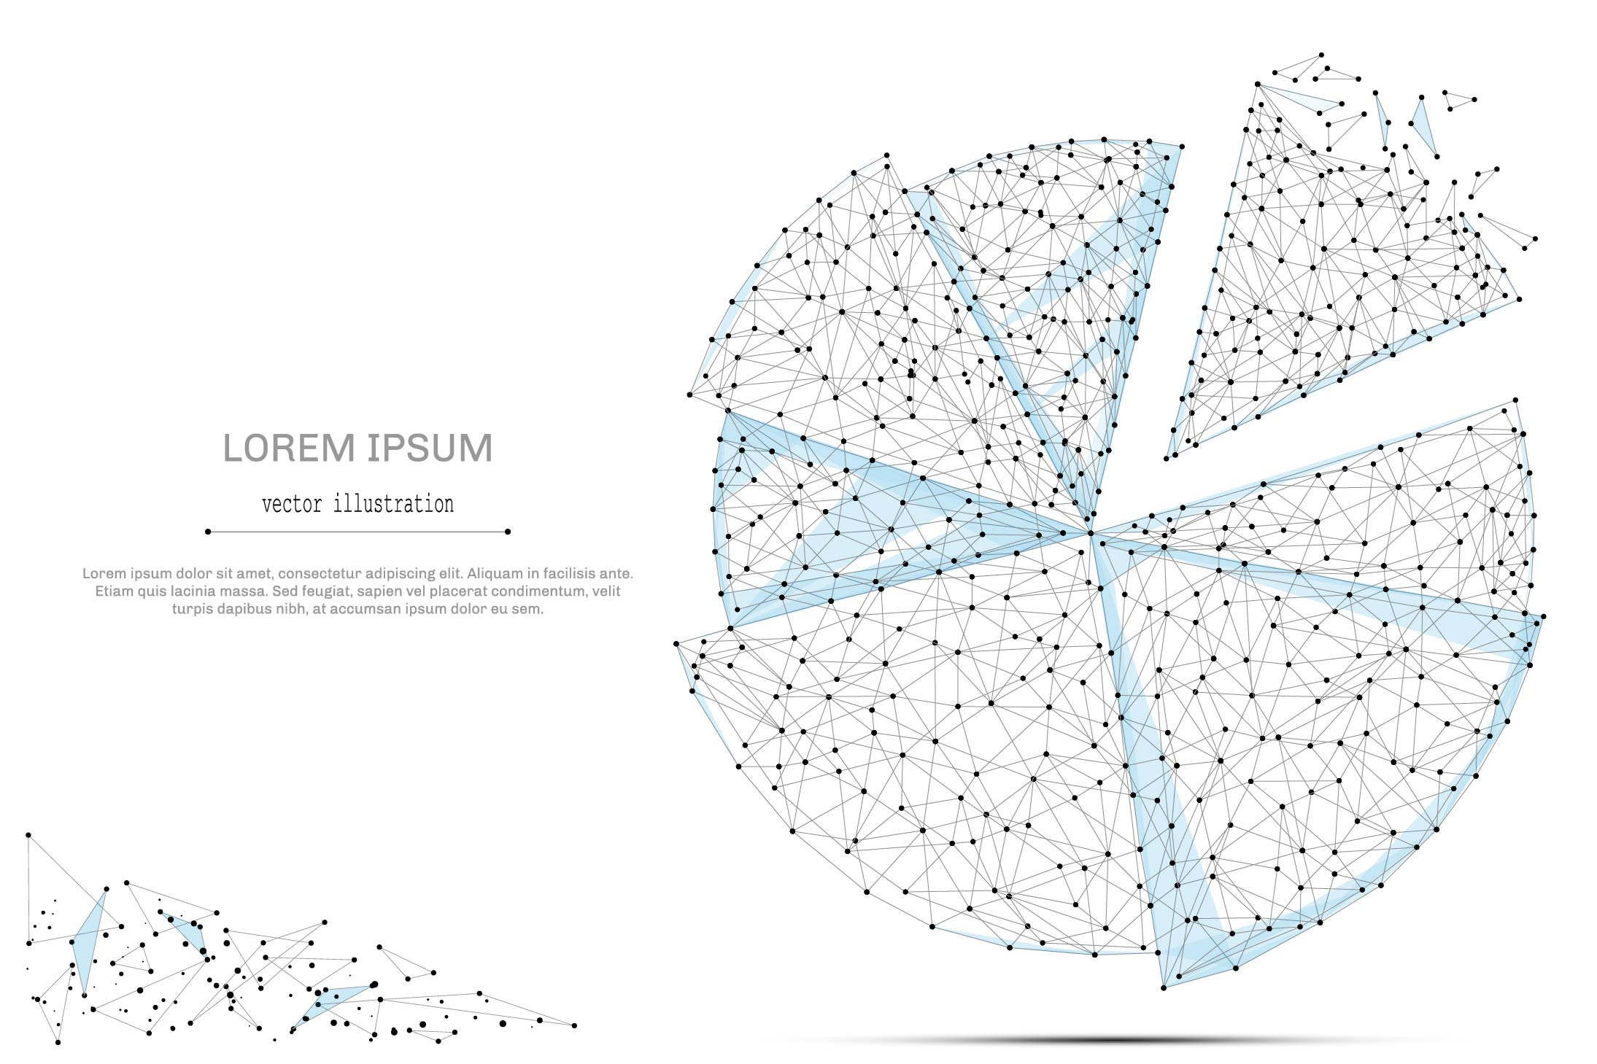

QUARTERLY ECONOMIC UPDATE

For the 4th Quarter of 2023

Abstract

Designed for business valuation professionals, TagniFi’s Quarterly Economic   
Update provides timely economic data to satisfy Revenue Ruling 56-60.

# Summary

As inflation descends closer to typical levels with production, job growth and capital markets performing strongly, economists continued their predictions of a soft landing for the economy to come to fruition. In light of the data suggesting that runaway inflation has finally been curtailed, the Federal Reserve foreshadowed a gradual reversal of the hawkish policy that began in March 2022.

Domestic production outperformed expectations with broad growth among the major components, especially personal spending. Job growth also exceeded expectations with sustainable gains in nonfarm payrolls. Consumer sentiment continued its rebound from June 2022’s historic low as inflation worries ebbed. Investors’ anticipation of easing interest rates spurred capital markets to a 4th-quarter rally in 2023.

However, the housing market remains constrained by currently elevated interest rates and limited inventory. Home sales have been slowing since early 2023, and prices in major cities continue to rise, albeit at a decelerating pace.

Notwithstanding indications of upcoming monetary policy reversal and downward revisions to projections of future target rates, FOMC members’ projections of economic performance for 2024 and beyond changed little.

A multifactor indicator of economic strength, the Philadelphia Fed’s coincident index[1] of economic activity in the U.S. rose 0.2% in December 2023 and 0.7% during the 4th quarter. For the quarter, coincident indexes increased in 25 states, decreased in 21 states, and remained unchanged in 4. Coincident indexes reflect unemployment, payroll employment, manufacturing hours, and wages and salaries.



The U.S. dollar index for goods and services[2] fell 3.2% during the 4th quarter of 2023. The dollar closed out 2023 down 2.2% from the prior year, the first such decline since 2020, on expectations that the fed will begin lowering interest rates in response to cooling inflation.

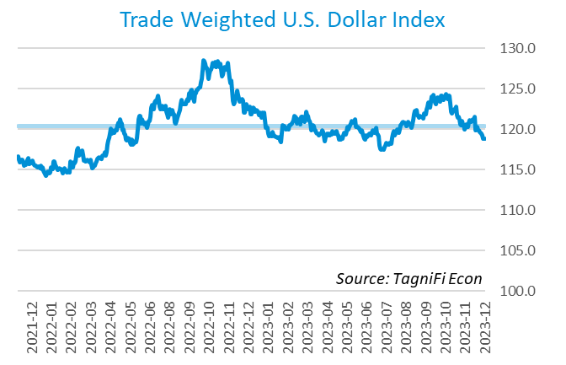

# Q4 Economic Highlights

* The Philadelphia Fed’s coincident index of economic activity in the U.S. rose 0.2% in December 2023 and 0.7% during the 4th quarter.
* The U.S. dollar index fell 3.2% during the 4th quarter of 2023 and was down 2.2% from the prior year.
* Real GDP grew at an annualized rate of 3.3% during the 4th quarter of 2023.
* The effective federal funds rate was unchanged at 5.33% during the 4th quarter, matching the 23-year high reached the prior quarter.
* The 1-year and 2-year annual treasury yields ended the 4th quarter at 4.79% and 4.23%, respectively. The benchmark 10-year treasury yielded 3.88% at the end of the quarter, while the 30-year treasury yielded 4.03%.
* The unemployment rate ended the 4th quarter at 3.7%, down slightly from the prior quarter. Nonfarm payrolls grew by 0.7 million jobs in the 4th quarter.
* The Consumer Price Index for all items rose 3.3% for the year ended December 2023, down from its more-than-40-year high of 8.9% in June 2022. Excluding volatile energy prices, the annual increase was 3.7%.
* Crude oil prices ended the 3rd quarter at $71.89 per barrel, down 20.8% from the prior quarter and 10.3% over one year.
* New home starts rose 7.7% during the 4th quarter to a level of 1.46 million in December. Total new home starts were up 7.6% year-over-year.
* The NASDAQ Composite jumped 13.6% during the 4th quarter of 2023, and the Dow Jones Industrial Average rose 12.5%. The Wilshire 5000, S&P 500, and Dow Jones Composite Average indexes increased 11.7%, 11.2%, and 10.2%, respectively, during the quarter. The Dow Jones Transportation Average was up 6.2% over the 4th quarter.

# Business Activity

Real gross domestic product (GDP)[3] grew at an annualized rate of 3.3% during the 4th quarter of 2023. Though down from a 4.9% increase in the 3rd quarter of 2023, GDP gains again exceeded expectations with higher consumer and government spending, net exports, and private investment. Broad growth across components of the GDP, combined with moderating inflation, supported economists’ expectations of a soft landing for the economy.

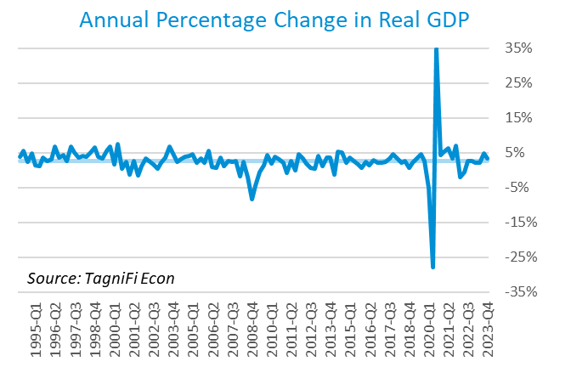

Personal consumption expenditures[4] (PCE) had a positive 1.9% effect on real GDP in the 4th quarter. The rise in personal spending reflected both services, especially food services and accommodations and health care, and goods, such as other nondurable goods (led by pharmaceutical products) and recreational goods and vehicles (led by computer software).

Government expenditures[5] increased at both the state and local level and the federal level to contribute 0.6% to the 4th quarter GDP gain. Higher government spending at the state and local level was led by growth in compensation of state and local government employees and investment in structures. Nondefense spending, both consumption and investment, led the increase at the federal level.

Net exports[6] had a positive 0.4% effect on real GDP in the 4th quarter as growth of exports outpaced that of imports (which have a negative effect on GDP). Exports rose in both goods (led by petroleum) and services (led by financial services), while import gains were primarily concentrated in services (led by travel).

Gross domestic private investment[7] also contributed 0.4% to the increase in the 4th quarter real GDP estimate. Nonresidential fixed investment drove the increase, particularly for intellectual property products, structures, and equipment. Gains in private nonfarm inventory investment were led by wholesale trade industries. Residential fixed investment also rose, with an increase in new residential structures more than offsetting a decrease in brokers’ commissions.

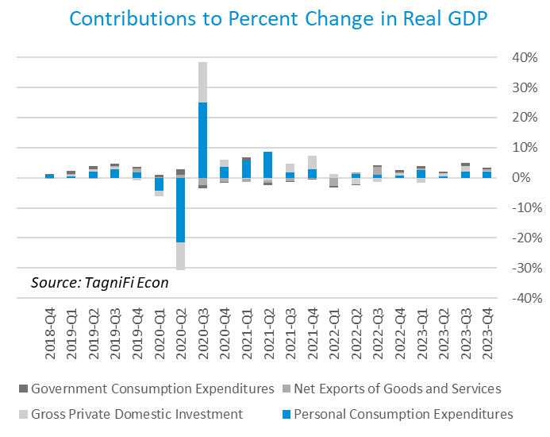

Economists polled by the Livingston Survey[8] in December 2023 projected real GDP to moderate to an annual rate of 1.0% in the 1st half of 2024 and an annual rate of 1.2% in the 2nd half of 2024.

The Industrial Production Index[9] is an economic indicator that measures real output for all facilities located in the United States manufacturing, mining, and electric, and gas utilities. The index stood at 102.5 at the end of the 4th quarter, down 0.8% from the 3rd quarter.

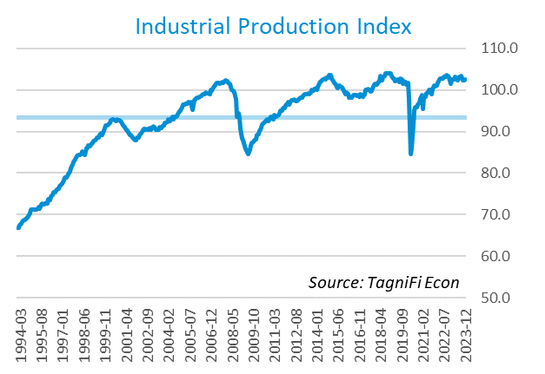

The Capacity Utilization Index[10], which attempts to capture industrial output as a percentage of the economy’s maximum production capacity, ended the 4th quarter of 2023 at 77.0%. December 2023’s level was above the 30-year average of 76.9% for this metric but down 0.9% from the previous quarter.

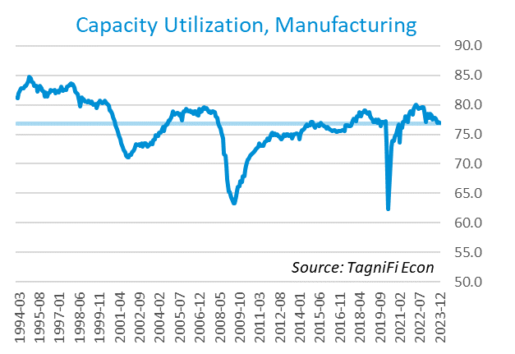

# Interest Rates

The effective federal funds rate[11] was unchanged at 5.33% during the 4th quarter, matching the 23-year high reached the prior quarter. Treasury bond yields[12] for periods one year and up fell during the 4th quarter, with the yield curve remaining inverted. The closely watched two- and ten-year rates have been inverted since early in July 2022. The 1-year and 2-year annual treasury yields ended the 4th quarter at 4.79% and 4.23%, respectively. The benchmark 10-year treasury yielded 3.88% at the end of the quarter, while the 30-year treasury yielded 4.03%. See *Appendix – Selected Interest Rates* for detailed interest rate data.

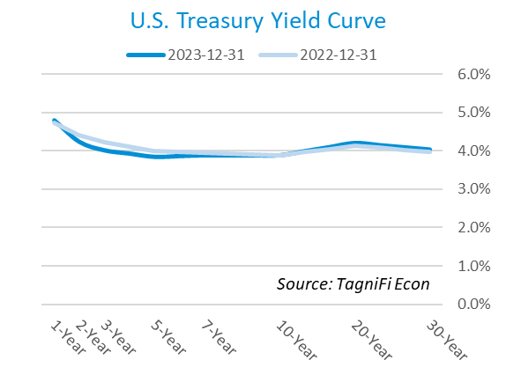

In the 4th quarter of 2023, the Federal Reserve paused their series of federal funds target rate[13] hikes, holding steady throughout the quarter at a range of 5.25% to 5.50%—still the highest in nearly 23 years. The decision could herald the end of a series of eleven rate hikes since March 2022. The FOMC indicated that with inflation subsiding, three rate cuts, each 0.25 percentage points, may be coming in 2024. Committee members’ “dot plot” projections indicate a median interest rate expectation of 4.65% by the end of 2024.

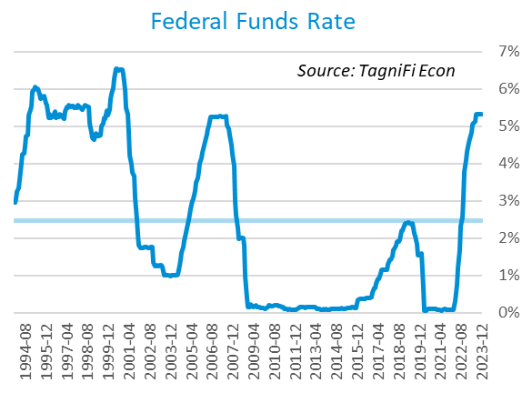

The yield on the benchmark 10-year U.S. treasury[14] ended the 4th quarter at 3.88%, down 0.71 percentage points from the previous quarter and above the average yield of 3.84% over the last 30 years.

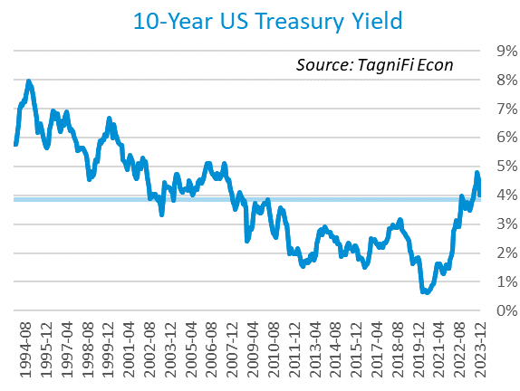

Moody’s Baa Corporate Bond Yield Index[15] ended the 4th quarter of 2023 at 5.49%, down 0.88 percentage points since the previous quarter. Moody’s less-risky Aaa[16] Index fell 0.71 percentage points during the quarter to a level of 4.65%.

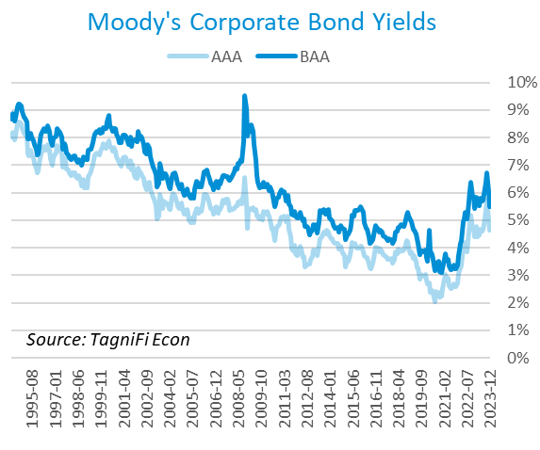

# Employment

The official unemployment rate[17] ended the 4th quarter at 3.7%, down slightly from the prior quarter. The rate stood well below the 30-year historical average of 5.6% and below the 4.0% to 5.0% range accepted as an equilibrium level of “full employment.” The labor force[18] fell by 0.4 million workers during the quarter as the labor force participation rate[19] slipped to 62.5%, 0.8 percentage points below its pre-pandemic level. Economists polled by the Livingston Survey in December 2023 projected the unemployment rate to rise to 4.2% in both June and December 2024.

In December 2023, nonfarm worker quits[20] stood at 3.4 million, down 24.6% from their record high in November 2021. Quits dipped below their pre-pandemic level in December, ending nearly 3 years of elevation (sometimes referred to as The Great Resignation), which has primarily affected the leisure and hospitality industry. Quits in the leisure and hospitality industry fell 9.4 percentage points during the year ended December 2023. Job openings[21] totaled 9.0 million in December 2023, 3.0 million below their record high in March 2022 and 2.7 times the number of resignations.

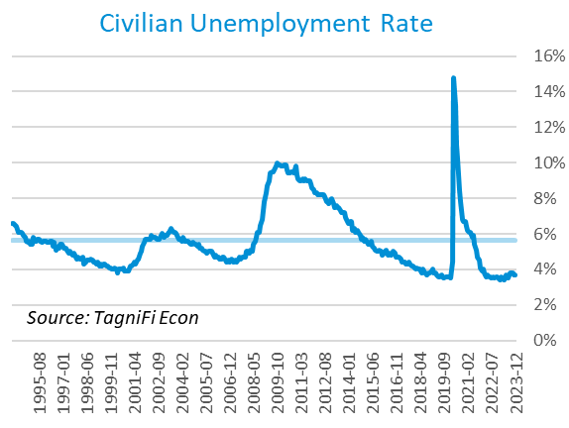

The U-6 unemployment rate[22] is an alternative measure of unemployment with a broader definition, including such groups as discouraged workers who are not actively searching for jobs but want full-time work and part-time workers who want full-time work. The U‑6 unemployment rate has generally followed the same pattern as the official rate and stood at 7.1% in December 2023.

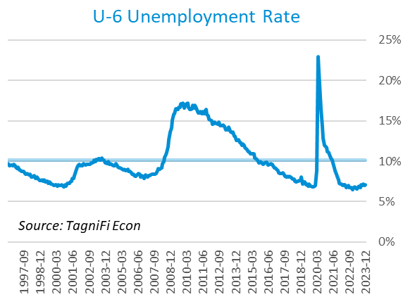

Nonfarm payrolls[23] grew by 0.7 million jobs in the 4th quarter. U.S. nonfarm payrolls in December 2023 totaled 157.3 million jobs, up 3.1 million from the prior December. The jobs count also stood 5.0 million above its pre-pandemic (February 2020) level. December’s job market growth exceeded expectations and closed out a strong year for the jobs market characterized by a more sustainable level of growth than recent years. December’s job gains were led by the government, health care, social assistance, and construction industries.

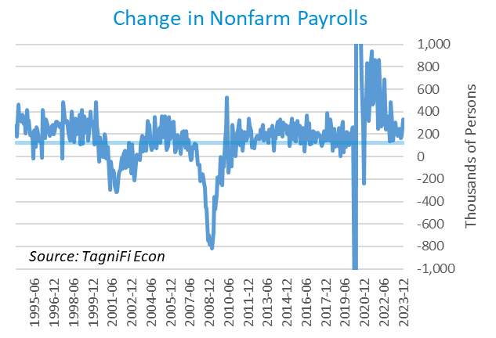

# Inflation

In the 4th quarter of 2023, inflation decelerated, with the Consumer Price Index[24] for all items rising 3.3% for the year ended December 2023, down from its more-than-40-year high of 8.9% in June 2022. Shelter prices accounted for a large portion of December’s annual increase; motor vehicle insurance, recreation, personal care, and education expenses also contributed. Food prices also rose during 2023, both at home and away from home. Energy costs were down for the year ended December 2023 due to lower prices for gasoline, natural gas, and fuel oil. Excluding volatile energy prices[25], the annual increase was 3.7%. The average price of a gallon of gas[26] in the U.S. tumbled 17.5% during the 4th quarter 2023 to $3.29. December’s average price was down 2.0% from one year prior and 35.0% from its record high of $5.06 in June 2022.

In the month of December 2023, higher prices for shelter were primarily responsible for the increase in the consumer price index. Energy prices were also up for the month as gasoline and electricity costs rose; natural gas and fuel oil costs fell in December.

The Federal Reserve has been taking aggressive action to curb inflation with a series of target interest rate hikes totaling 5.25 percentage points since March 2022. The Fed held its target rate steady throughout the 4th quarter of 2023 and indicated that rate cuts may be on the horizon in the coming year.

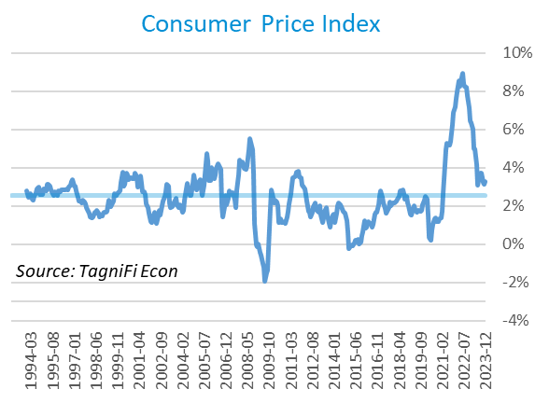

Wholesale inflation has been quicker to regulate than consumer inflation. The Producer Price Index[27] fell 3.6% in the 4th quarter and 3.2% since December 2022. The average annual increase over the last 30 years was 2.8%.

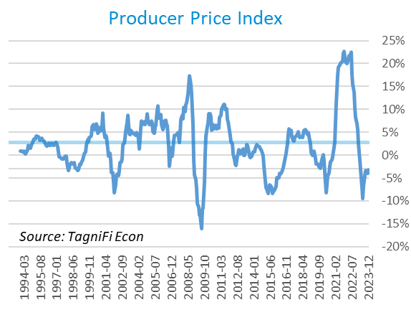

The 5-year breakeven inflation rate[28], an indicator for the market’s inflation expectations for the period, declined to 2.12% at the end of the 4th quarter from 2.22% at the end of the 3rd quarter 2023.

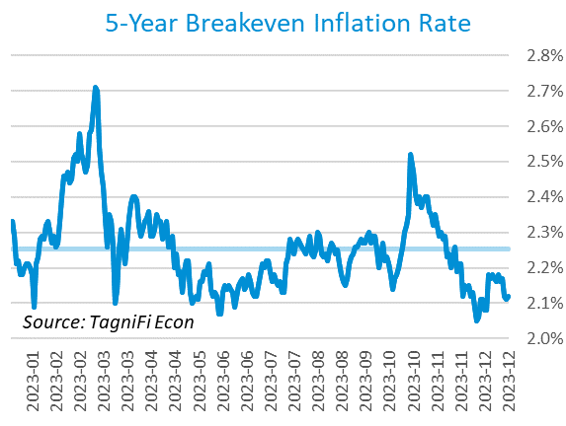

U.S. crude oil[29] prices fell in the 4th quarter, as concerns of overproduction by non-OPEC suppliers dominated the market despite an increase in global risk due to the war unfolding in Gaza. Crude prices ended the 4th quarter at $71.89 per barrel, down 20.8% from the prior quarter and 10.3% over one year.

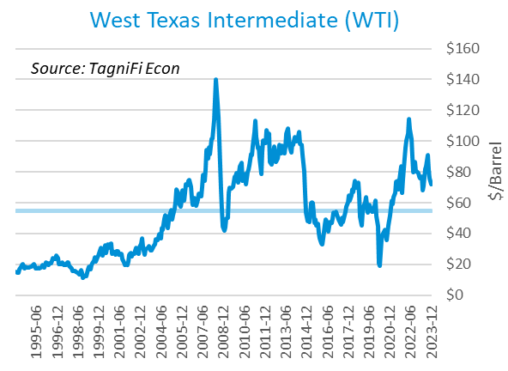

# Housing

Although mortgage rates began to abate from their nearly-23-year high, the elevated cost of financing, combined with high prices and tight housing inventory, continued to constrain the housing market in the 4th quarter of 2023. Home sales, which dwindled throughout 2023, weakened further during the 4th quarter. Home prices in major cities continued to rise, though increases slowed at the end of 2023. New home starts[30] rose 7.7% during the 4th quarter to a level of 1.46 million in December; both single-family and multi-unit homes contributed to the quarterly increase. Total new home starts were up 7.6% year-over-year and above their 30-year average of 1.34 million.

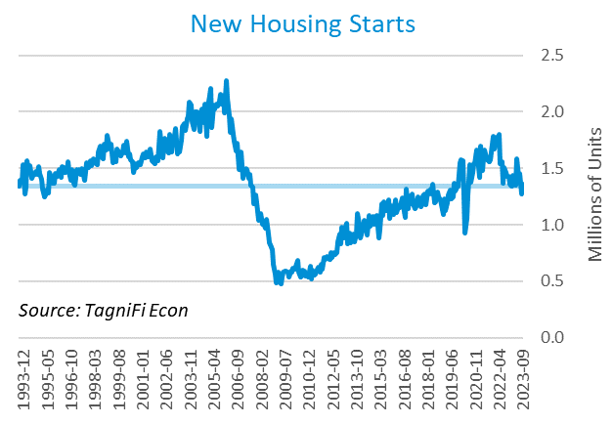

The cost of financing for would-be homebuyers fell during the 4th quarter, with the 30-year fixed-rate mortgage[31] ending December 2023 at an average of 6.61% after peaking at 7.79% in late October.

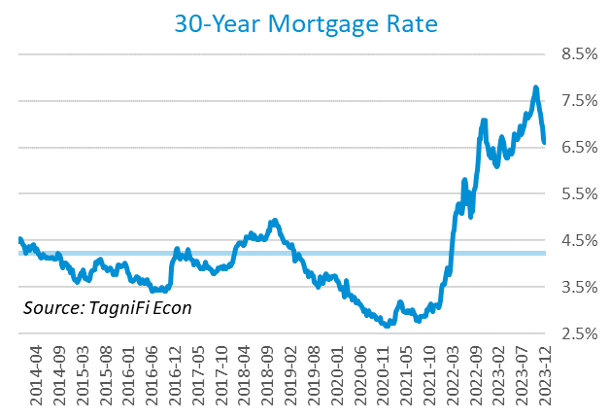

The S&P Case-Shiller Home Price Index (20-city)[32] was 0.1% higher from October to November and 5.4% higher since November 2022. Led by Detroit, San Diego, and Cleveland, 19 of the 20 cities experienced one-year price increases; 1 experienced a decrease.

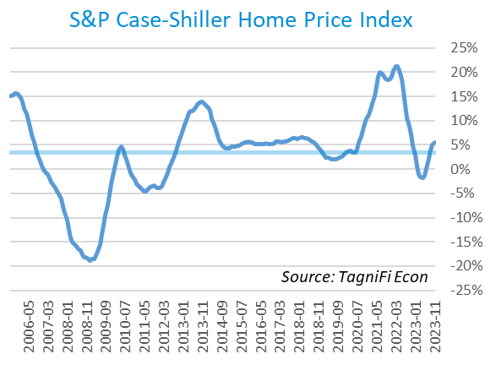

# Consumer Spending

Personal Consumption Expenditures (PCE)[33] rose 1.1% in the 4th quarter to $19.0 trillion. PCE were up 5.9% since the 4th quarter last year. Spending increased in December for services such as financial services and insurance, health care, and recreation services. Goods spending also increased, especially for motor vehicles and parts, other nondurable goods (led by prescription drugs) and gasoline and other energy goods.

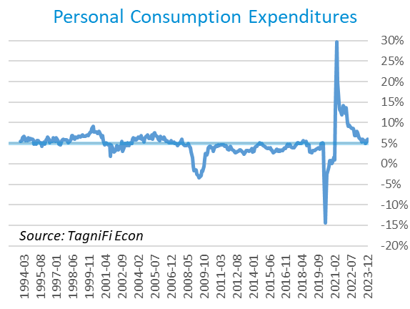

Auto manufacturers reported autos and light trucks sold[34] at an annual rate of 16.1 million in December 2023, up 2.2% from September. New vehicle prices[35] receded from their record high, down 0.8% during the 4th quarter. Used car prices[36], rose 1.3% from September to December.

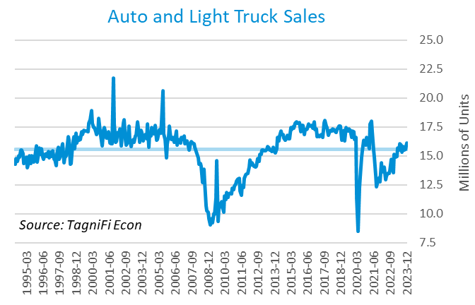

The University of Michigan’s consumer sentiment index[37] stood at 69.7 in December 2023, continuing the rebound from its all-time low of 50.0 in June 2022. The index was up 16.6% in the year ended December 2023 yet still well below its 30-year average of 86.4. Inflation anxieties dropped in December as energy prices declined.

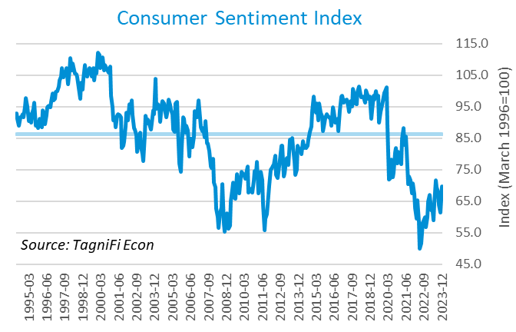

# Capital Markets

The table below shows the quarterly, year-to-date, and 12-month performance of major U.S. equity indices. Capital markets rallied in the 4th quarter of 2023 as inflation cooled while other economic markers remained robust. Tech stocks enjoyed a particularly strong 2023 resulting from developments in the AI market, but the enthusiasm spread through the wider market as investors were encouraged by the Feds’ signals that interest rate reduction could begin next year. The NASDAQ Composite jumped 13.6% during the 4th quarter of 2023, and the Dow Jones Industrial Average rose 12.5%. The Wilshire 5000, S&P 500, and Dow Jones Composite Average indexes increased 11.7%, 11.2%, and 10.2%, respectively, during the quarter. The Dow Jones Transportation Average was up 6.2% over the 4th quarter.



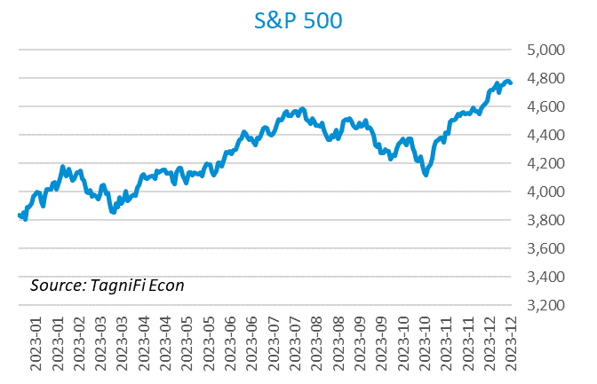

Stock market volatility, as measured by the VIX [38], ended the 4th quarter of 2023 at 12.5, down 28.9% since the prior quarter and 42.5% since the 4th quarter of 2022. The biggest drop of the quarter was in November.

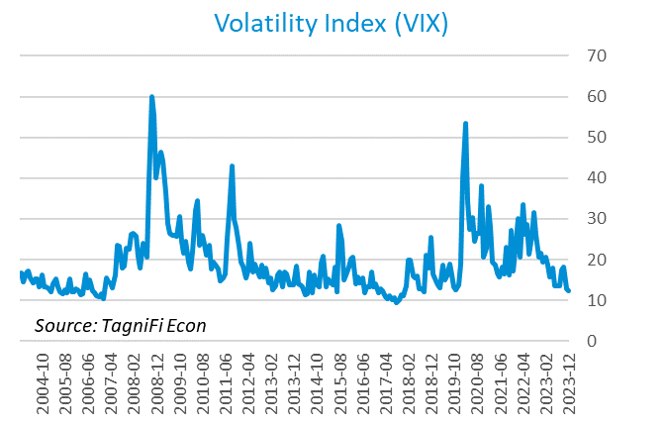

# Outlook

In December 2023, the FOMC revised their near-term real GDP projections upward and unemployment rate projections downward; little change was made to near-term PCE inflation projections. Little to no adjustments were made to longer-run projections for the three indicators.

The FOMC revised their projection for real GDP[39] upward for 2023, to 2.60% growth, while 2024 to 2026 projections remained little changed, at 1.45% in 2024, 1.75% in 2025, and 1.90% in 2026. They forecast Personal Consumption Expenditures (PCE) inflation[40] of 2.80% in 2023, moderating to 2.35% in 2024, 2.10% in 2025, and 2.00% in 2026. They expected that the unemployment rate[41] would be 3.80% in 2023, rising to 4.10% in 2024 and remaining there through 2026. The board lowered shorter-term projections of future target rates[42], revising the median projections to 5.40% in 2023, 4.65% in 2024, 3.50% in 2025, and 2.80% in 2026. The committee has foreshadowed that the campaign of rate hikes may be over, with three potential rate cuts coming in 2024.



Appendix – Selected Interest Rates



# About This Report

The *Quarterly Economic Update* is a free publication sponsored by TagniFi. You are free to share this report and include its contents in the economic outlook section of your valuation reports as required by *Revenue Ruling 59-60*. Please forward this free report to a colleague to help us spread the word about TagniFi.

How TagniFi Helps Business Valuation Teams

TagniFi’s financial data platform empowers business valuation teams to quickly and easily build highly accurate financial models with full transparency—and within seconds.

**Better Public Comps**  
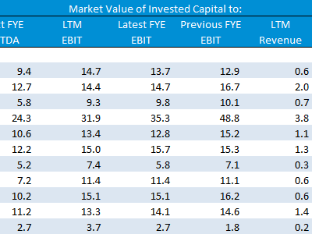Search for public companies with TagniFi Web. Simply enter your valuation date and ticker symbols in Excel to run a guideline public company method. Your Excel model populates instantly with the financial statements, analyst estimates, interest rates and economic data for your valuation date.

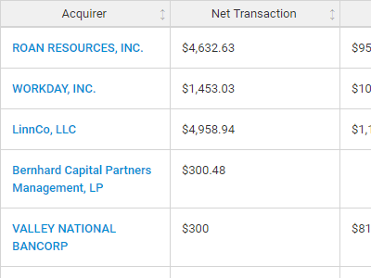

**Better Transaction Comps**  
Search for public and private M&A transactions with TagniFi Web. Run your transaction comps within seconds by pasting the Deal ID into your Excel model. Every deal disclosed in an SEC filing (8-K, 10-K, or 10-Q) is available for your analysis. Choose from over 90 fields of data available for every deal.

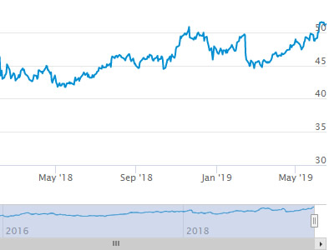

**Historical Beta and Volatility**Calculate historical beta and volatility as of your valuation date automatically. Simply enter the tickers and valuation date in Excel - TagniFi does the rest. In addition to beta and volatility, there are over 40 Excel models available in the Model Library to help with your valuation report.

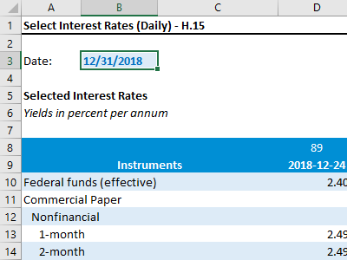**Interest Rates and Economic Data**Automate the interest rates and economic data in your valuation report using the TagniFi Excel plugin. Choose from over 200,000 time series available. All data in this *Quarterly Economic Update* is from the TagniFi platform. Use economic and interest rate data for your own valuation models with the TagniFi Excel plugin.

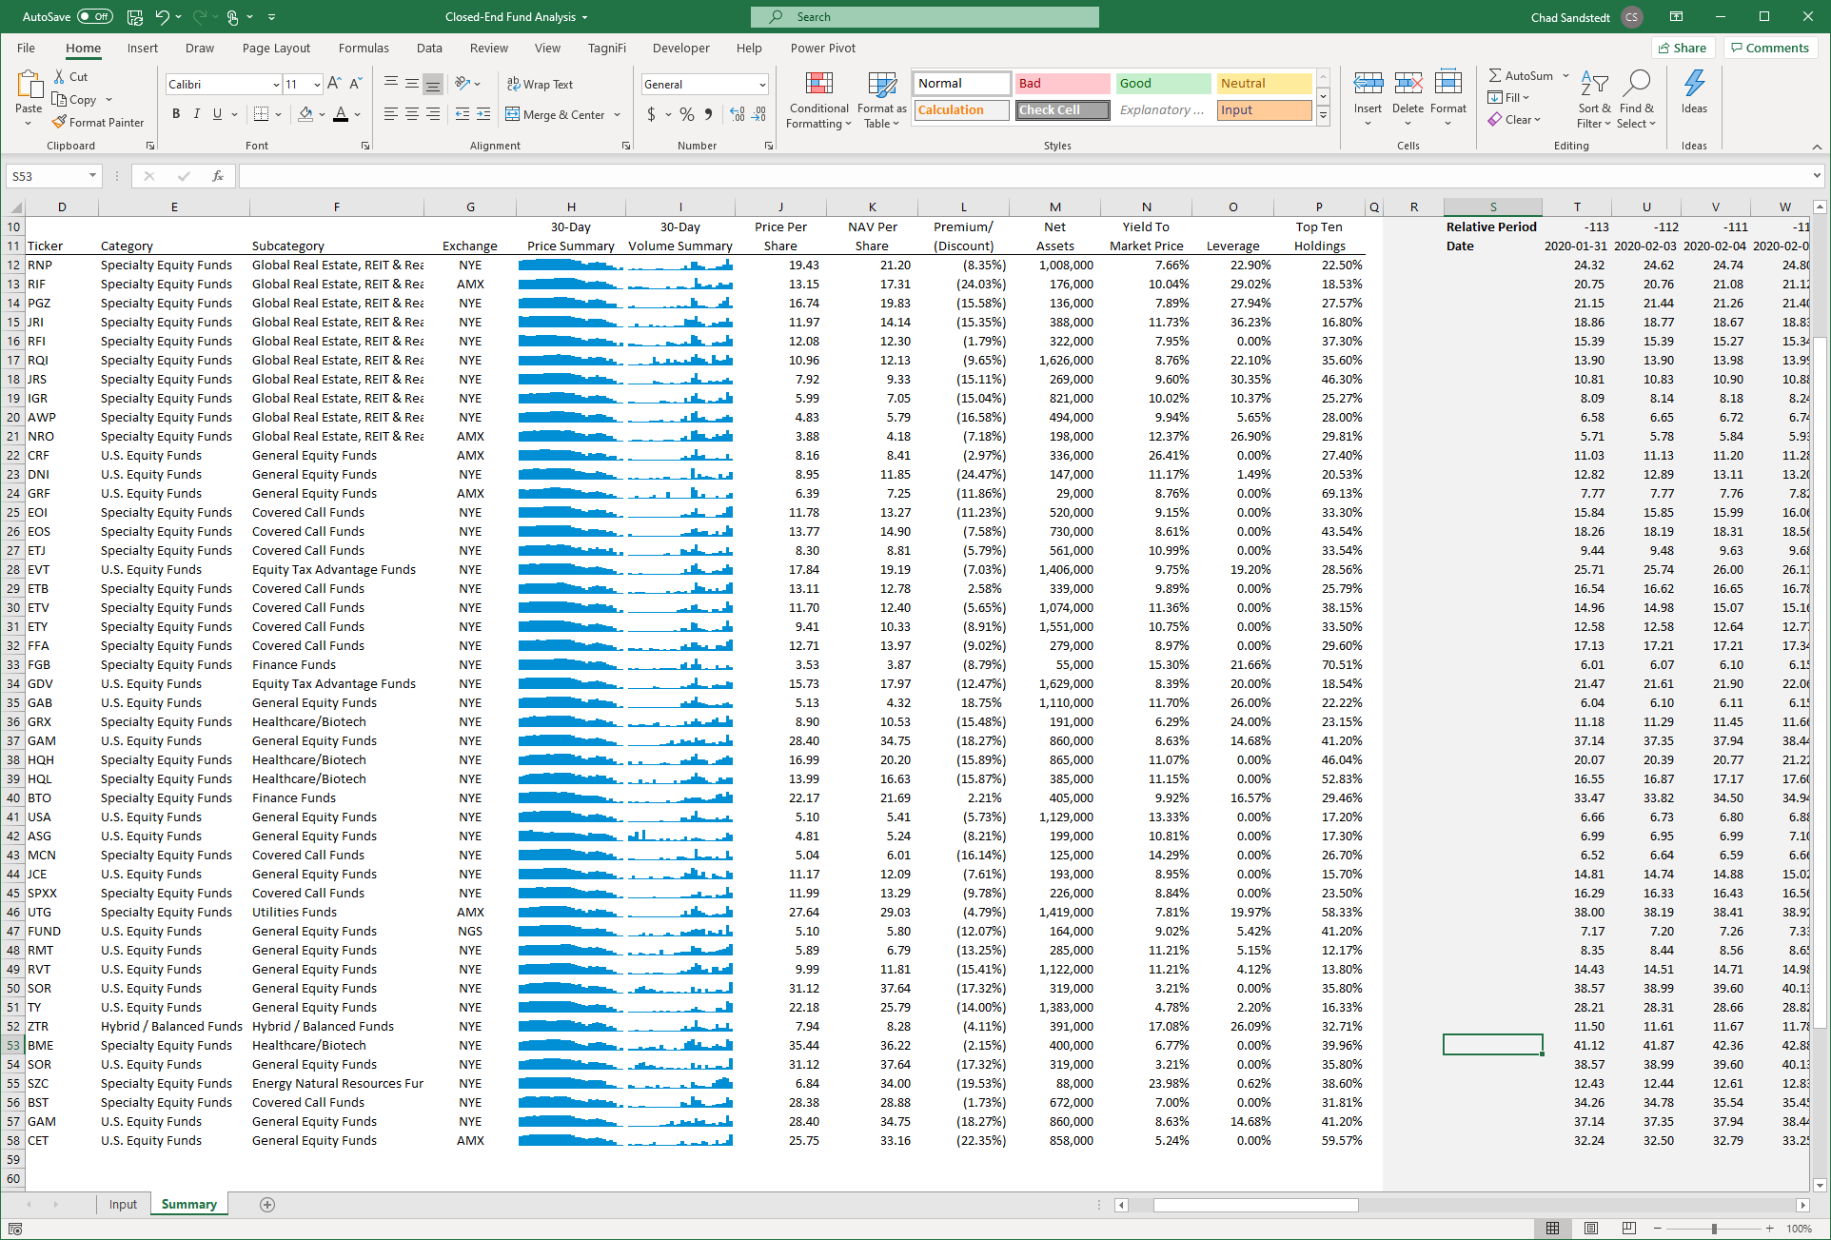

**Closed-End Mutual Fund Data**Search for closed-end mutual funds by keyword, category, subcategory, and more with the TagniFi Console. Use the TagniFi Excel plugin to calculate historical discounts, yields, leverage, as of your valuation date automatically. Simply enter the tickers and valuation date in Excel - TagniFi does the rest.

1. Federal Reserve Bank of Philadelphia, Coincident Economic Activity Index for the United States [USPHCI], *retrieved from FRED, Federal Reserve Bank of St. Louis;* [*https://fred.stlouisfed.org/series/USPHCI*](https://fred.stlouisfed.org/series/USPHCI)*, Feb 2, 2024.*
2. Board of Governors of the Federal Reserve System (US), Trade Weighted U.S. Dollar Index: Broad, Goods and Services [DTWEXBGS], *retrieved from FRED, Federal Reserve Bank of St. Louis;* [*https://fred.stlouisfed.org/series/DTWEXBGS*](https://fred.stlouisfed.org/series/DTWEXBGS)*, Feb 2, 2024.*
3. U.S. Bureau of Economic Analysis, Real Gross Domestic Product [GDPC1], *retrieved from FRED, Federal Reserve Bank of St. Louis;*[*https://fred.stlouisfed.org/series/GDPC1*](https://fred.stlouisfed.org/series/GDPC1)*, Feb 2, 2024.*
4. U.S. Bureau of Economic Analysis, Contributions to percent change in real gross domestic product: Personal consumption expenditures [DPCERY2Q224SBEA], *retrieved from FRED, Federal Reserve Bank of St. Louis;* [*https://fred.stlouisfed.org/series/DPCERY2Q224SBEA*](https://fred.stlouisfed.org/series/DPCERY2Q224SBEA)*, Feb 2, 2024.*
5. U.S. Bureau of Economic Analysis, Contributions to percent change in real gross domestic product: Government consumption expenditures and gross investment [A822RY2Q224SBEA], *retrieved from FRED, Federal Reserve Bank of St. Louis;* [*https://fred.stlouisfed.org/series/A822RY2Q224SBEA*](https://fred.stlouisfed.org/series/A822RY2Q224SBEA)*, Feb 2, 2024.*
6. U.S. Bureau of Economic Analysis, Contributions to percent change in real gross domestic product: Net exports of goods and services [A019RY2Q224SBEA], *retrieved from FRED, Federal Reserve Bank of St. Louis;* [*https://fred.stlouisfed.org/series/A019RY2Q224SBEA*](https://fred.stlouisfed.org/series/A019RY2Q224SBEA)*, Feb 2, 2024.*
7. U.S. Bureau of Economic Analysis, Contributions to percent change in real gross domestic product: Gross private domestic investment [A006RY2Q224SBEA], *retrieved from FRED, Federal Reserve Bank of St. Louis;* [*https://fred.stlouisfed.org/series/A006RY2Q224SBEA*](https://fred.stlouisfed.org/series/A006RY2Q224SBEA)*, Feb 2, 2024.*
8. Federal Reserve Bank of Philadelphia, The Livingston Survey June 2023, [economic release], retrieved from <https://www.philadelphiafed.org/surveys-and-data/real-time-data-research/livingston-survey>, Feb 2, 2024.
9. Board of Governors of the Federal Reserve System (US), Industrial Production Index [INDPRO], *retrieved from FRED, Federal Reserve Bank of St. Louis;*[*https://fred.stlouisfed.org/series/INDPRO*](https://fred.stlouisfed.org/series/INDPRO)*, Feb 2, 2024.*
10. Board of Governors of the Federal Reserve System (US), Capacity Utilization, Manufacturing (NAICS), *retrieved from FRED, Federal Reserve Bank of St. Louis;* [*https://fred.stlouisfed.org/series/MCUMFN*](https://fred.stlouisfed.org/series/MCUMFN)*, Feb 2, 2024.*
11. Board of Governors of the Federal Reserve System (US), Federal Funds Effective Rate [FEDFUNDS], *retrieved from FRED, Federal Reserve Bank of St. Louis;* [*https://fred.stlouisfed.org/series/FEDFUNDS*](https://fred.stlouisfed.org/series/FEDFUNDS)*, Feb 2, 2024.*
12. Selected Interest Rates Instruments, Yields in percent per annum, *retrieved from FRED, Federal Reserve Bank of St. Louis;* [https://fred.stlouisfed.org/release/tables?rid=18&eid=289&od=2023-06-30#](https://fred.stlouisfed.org/release/tables?rid=18&eid=289&od=2023-06-30)*, Feb 2, 2024.*
13. Board of Governors of the Federal Reserve System (US), Federal Funds Target Range - Upper Limit [DFEDTARU], *retrieved from FRED, Federal Reserve Bank of St. Louis;* [*https://fred.stlouisfed.org/series/DFEDTARU*](https://fred.stlouisfed.org/series/DFEDTARU)*, Feb 2, 2024*.
14. Board of Governors of the Federal Reserve System (US), 10-Year Treasury Constant Maturity Rate [DGS10], *retrieved from FRED, Federal Reserve Bank of St. Louis;*[*https://fred.stlouisfed.org/series/DGS10*](https://fred.stlouisfed.org/series/DGS10)*, Feb 2, 2024.*
15. Moody’s, Moody's Seasoned Baa Corporate Bond Yield [DBAA], *retrieved from FRED, Federal Reserve Bank of St. Louis;* [*https://fred.stlouisfed.org/series/DBAA*](https://fred.stlouisfed.org/series/DBAA)*, Feb 2, 2024.*
16. Moody’s, Moody's Seasoned Aaa Corporate Bond Yield [DAAA], *retrieved from FRED, Federal Reserve Bank of St. Louis;* [*https://fred.stlouisfed.org/series/DAAA*](https://fred.stlouisfed.org/series/DAAA)*, Feb 2, 2024.*
17. U.S. Bureau of Labor Statistics, Civilian Unemployment Rate [UNRATE], *retrieved from FRED, Federal Reserve Bank of St. Louis;*[*https://fred.stlouisfed.org/series/UNRATE*](https://fred.stlouisfed.org/series/UNRATE)*, Feb 2, 2024.*
18. U.S. Bureau of Labor Statistics, Civilian Labor Force Level [CLF16OV], *retrieved from FRED, Federal Reserve Bank of St. Louis;* [*https://fred.stlouisfed.org/series/CLF16OV*](https://fred.stlouisfed.org/series/CLF16OV)*, Feb 2, 2024.*
19. U.S. Bureau of Labor Statistics, Labor Force Participation Rate [CIVPART], *retrieved from FRED, Federal Reserve Bank of St. Louis;* [*https://fred.stlouisfed.org/series/CIVPART*](https://fred.stlouisfed.org/series/CIVPART)*, Feb 2, 2024.*
20. U.S. Bureau of Labor Statistics, Quits: Total Nonfarm [JTSQUL], *retrieved from FRED, Federal Reserve Bank of St. Louis;* [*https://fred.stlouisfed.org/series/JTSQUL*](https://fred.stlouisfed.org/series/JTSQUL)*, Feb 2, 2024.*
21. U.S. Bureau of Labor Statistics, Job Openings: Total Nonfarm [JTSJOL], *retrieved from FRED, Federal Reserve Bank of St. Louis;* [*https://fred.stlouisfed.org/series/JTSJOL*](https://fred.stlouisfed.org/series/JTSJOL)*, Feb 2, 2024.*
22. U.S. Bureau of Labor Statistics Total Unemployed, Plus All Persons Marginally Attached to the Labor Force, Plus Total Employed Part Time for Economic Reasons, as a Percent of the Civilian Labor Force Plus All Persons Marginally Attached to the Labor Force (U-6) [U6RATE], *retrieved from FRED, Federal Reserve Bank of St. Louis;*[*https://fred.stlouisfed.org/series/U6RATE*](https://fred.stlouisfed.org/series/U6RATE)*, Feb 2, 2024.*
23. U.S. Bureau of Labor Statistics, All Employees: Total Nonfarm Payrolls [PAYEMS], *retrieved from FRED, Federal Reserve Bank of St. Louis;*[*https://fred.stlouisfed.org/series/PAYEMS*](https://fred.stlouisfed.org/series/PAYEMS)*, Feb 2, 2024.*
24. U.S. Bureau of Labor Statistics, Consumer Price Index for All Urban Consumers: All Items [CPIAUCSL], *retrieved from FRED, Federal Reserve Bank of St. Louis;*[*https://fred.stlouisfed.org/series/CPIAUCSL*](https://fred.stlouisfed.org/series/CPIAUCSL)*, Feb 2, 2024.*
25. U.S. Bureau of Labor Statistics, Consumer Price Index for All Urban Consumers: All Items Less Energy in U.S. City Average [CPILEGSL], *retrieved from FRED, Federal Reserve Bank of St. Louis;* [*https://fred.stlouisfed.org/series/CPILEGSL*](https://fred.stlouisfed.org/series/CPILEGSL)*, Feb 2, 2024*.
26. U.S. Bureau of Labor Statistics, Average Price: Gasoline, Unleaded Regular (Cost per Gallon/3.785 Liters) in U.S. City Average [APU000074714], *retrieved from FRED, Federal Reserve Bank of St. Louis;* [*https://fred.stlouisfed.org/series/APU000074714*](https://fred.stlouisfed.org/series/APU000074714)*, Feb 2, 2024.*
27. U.S. Bureau of Labor Statistics, Producer Price Index for All Commodities [PPIACO], *retrieved from FRED, Federal Reserve Bank of St. Louis;*[*https://fred.stlouisfed.org/series/PPIACO*](https://fred.stlouisfed.org/series/PPIACO)*, Feb 2, 2024.*
28. *Federal Reserve Bank of St. Louis, 5-Year Breakeven Inflation Rate [T5YIE], retrieved from FRED, Federal Reserve Bank of St. Louis;*[*https://fred.stlouisfed.org/series/T5YIE*](https://fred.stlouisfed.org/series/T5YIE)*, Feb 2, 2024.*
29. U.S. Energy Information Administration, Crude Oil Prices: West Texas Intermediate (WTI) - Cushing, Oklahoma [DCOILWTICO], *retrieved from FRED, Federal Reserve Bank of St. Louis;* [*https://fred.stlouisfed.org/series/DCOILWTICO*](https://fred.stlouisfed.org/series/DCOILWTICO)*, Feb 2, 2024.*
30. U.S. Bureau of the Census, Housing Starts: Total: New Privately Owned Housing Units Started [HOUST], *retrieved from FRED, Federal Reserve Bank of St. Louis;*[*https://fred.stlouisfed.org/series/HOUST*](https://fred.stlouisfed.org/series/HOUST)*, Feb 2, 2024.*
31. Freddie Mac, 30-Year Fixed Rate Mortgage Average in the United States [MORTGAGE30US], *retrieved from FRED, Federal Reserve Bank of St. Louis;*[*https://fred.stlouisfed.org/series/MORTGAGE30US*](https://fred.stlouisfed.org/series/MORTGAGE30US)*, Feb 2, 2024.*
32. S&P Dow Jones Indices LLC, S&P/Case-Shiller 20-City Composite Home Price Index [SPCS20RSA], *retrieved from FRED, Federal Reserve Bank of St. Louis;*[*https://fred.stlouisfed.org/series/SPCS20RSA*](https://fred.stlouisfed.org/series/SPCS20RSA)*, Feb 2, 2024.*
33. U.S. Bureau of Economic Analysis, Personal Consumption Expenditures [PCE], *retrieved from FRED, Federal Reserve Bank of St. Louis;*[*https://fred.stlouisfed.org/series/PCE*](https://fred.stlouisfed.org/series/PCE)*, Feb 2, 2024.*
34. U.S. Bureau of Economic Analysis, Light Weight Vehicle Sales: Autos and Light Trucks [ALTSALES], *retrieved from FRED, Federal Reserve Bank of St. Louis; <https://fred.stlouisfed.org/series/ALTSALES>, Feb 2, 2024.*
35. U.S. Bureau of Labor Statistics, Consumer Price Index for All Urban Consumers: New Vehicles in U.S. City Average [CUUR0000SETA01], *retrieved from FRED, Federal Reserve Bank of St. Louis;* [*https://fred.stlouisfed.org/series/CUUR0000SETA01*](https://fred.stlouisfed.org/series/CUUR0000SETA01)*, Feb 2, 2024.*
36. U.S. Bureau of Labor Statistics, Consumer Price Index for All Urban Consumers: Used Cars and Trucks in U.S. City Average [CUSR0000SETA02], *retrieved from FRED, Federal Reserve Bank of St. Louis;* [*https://fred.stlouisfed.org/series/CUSR0000SETA02*](https://fred.stlouisfed.org/series/CUSR0000SETA02), *Feb 2, 2024.*
37. *University of Michigan, University of Michigan: Consumer Sentiment [UMCSENT], retrieved from FRED, Federal Reserve Bank of St. Louis;* [*https://fred.stlouisfed.org/series/UMCSENT*](https://fred.stlouisfed.org/series/UMCSENT)*, Feb 2, 2024.*
38. *Chicago Board Options Exchange, CBOE Volatility Index: VIX [VIXCLS], retrieved from FRED, Federal Reserve Bank of St. Louis;* [*https://fred.stlouisfed.org/series/VIXCLS*](https://fred.stlouisfed.org/series/VIXCLS)*, Feb 2, 2024.*
39. *Federal Reserve Bank of St. Louis, FOMC Summary of Economic Projections for the Growth Rate of Real Gross Domestic Product [GDPC1CTM], retrieved from FRED, Federal Reserve Bank of St. Louis;*[*https://fred.stlouisfed.org/series/GDPC1CTM*](https://fred.stlouisfed.org/series/GDPC1CTM)*, Feb 2, 2024.*
40. *Federal Reserve Bank of St. Louis, FOMC Summary of Economic Projections for the Personal Consumption Expenditures Inflation Rate, Central Tendency, Midpoint [PCECTPICTM], retrieved from FRED, Federal Reserve Bank of St. Louis;*[*https://fred.stlouisfed.org/series/PCECTPICTM*](https://fred.stlouisfed.org/series/PCECTPICTM)*, Feb 2, 2024.*
41. *Federal Reserve Bank of St. Louis, FOMC Summary of Economic Projections for the Civilian Unemployment Rate, Central Tendency, Midpoint [UNRATECTM], retrieved from FRED, Federal Reserve Bank of St. Louis;*[*https://fred.stlouisfed.org/series/UNRATECTM*](https://fred.stlouisfed.org/series/UNRATECTM)*, Feb 2, 2024.*
42. *U.S. Federal Open Market Committee and Federal Reserve Bank of St. Louis, FOMC Summary of Economic Projections for the Fed Funds Rate, Range, Midpoint [FEDTARCTM], retrieved from FRED, Federal Reserve Bank of St. Louis;* [*https://fred.stlouisfed.org/series/FEDTARCTM*](https://fred.stlouisfed.org/series/FEDTARCTM)*, February 2, 2024.*