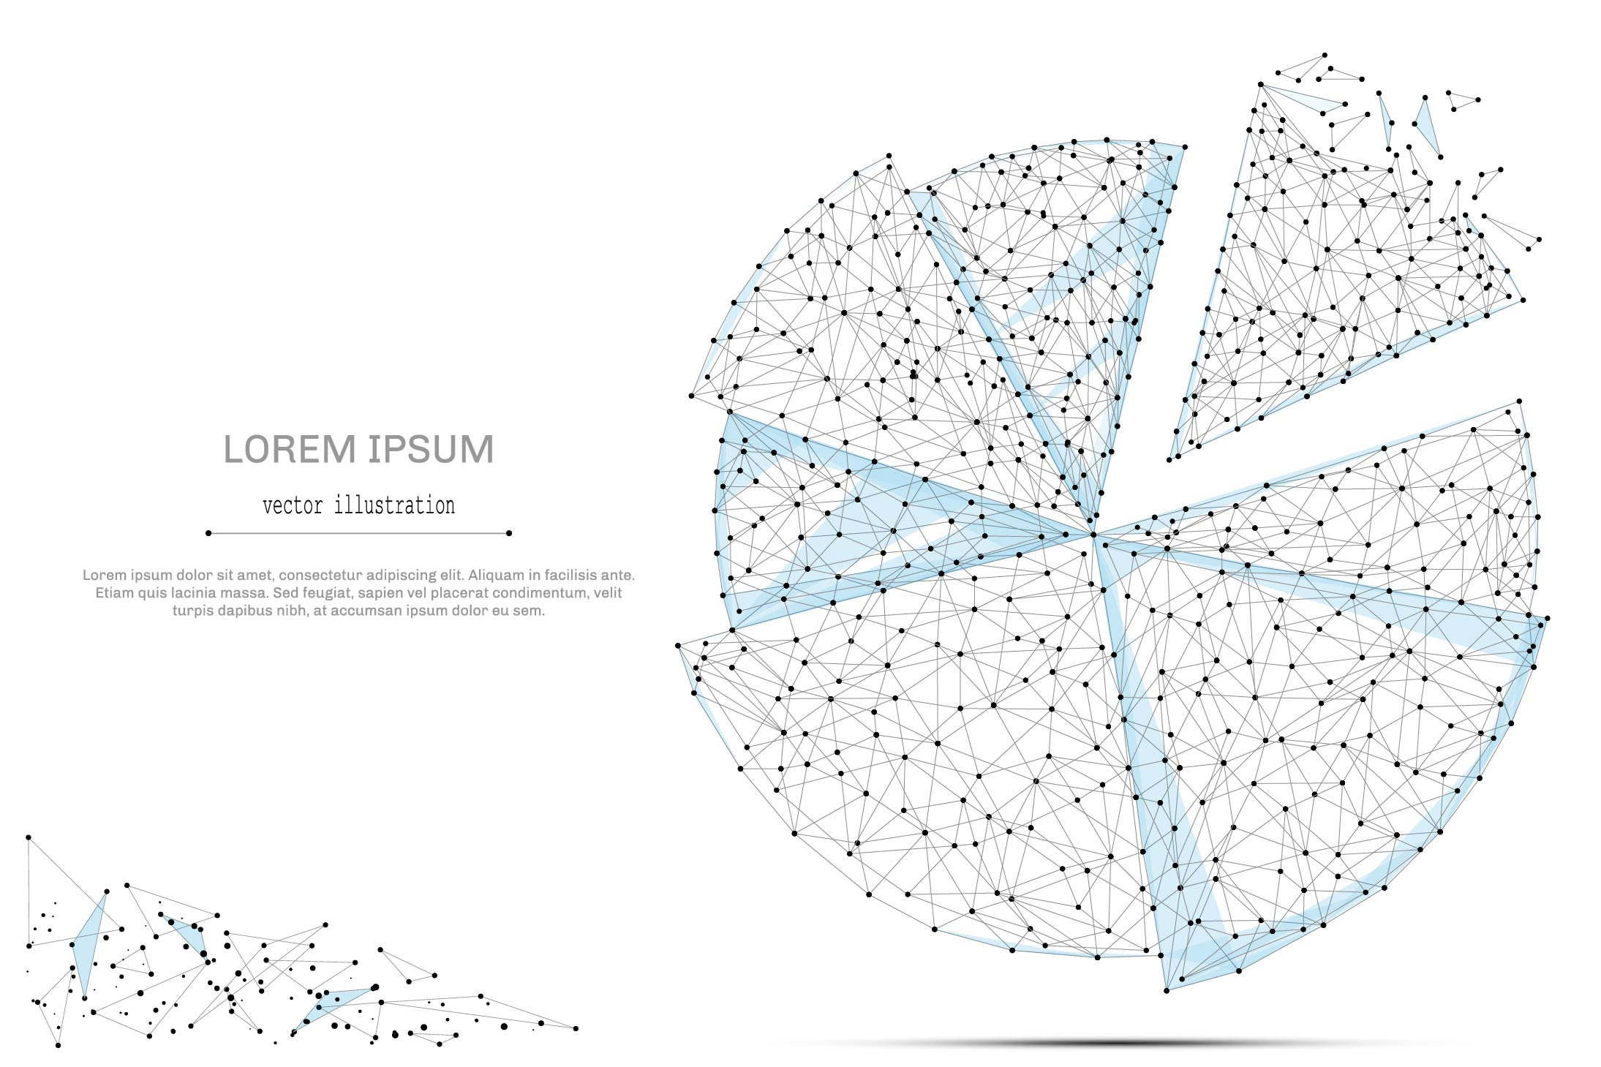

QUARTERLY ECONOMIC UPDATE

For the 1st Quarter of 2024

Abstract

Designed for business valuation professionals, TagniFi’s Quarterly Economic   
Update provides timely economic data to satisfy Revenue Ruling 56-60.

# Summary

With inflation again proving stubborn in the 1st quarter of 2024, the labor market remaining strong, and domestic production continuing to grow, albeit at a slower pace, a soft landing for the US economy is still widely anticipated, though it may prove slower to develop than hoped. In light of the 1st quarter data, the Federal Reserve foreshadowed a wait-and-see plan that may delay the expected reversal of its hawkish interest rate policy.

A frequent bright spot for the economy in recent years, job growth exceeded expectations with broad gains among nonfarm industries. Capital markets posted a strong 1st quarter despite the continued elevation in interest rates, and consumer sentiment continued its rebound from June 2022’s historic low.

Despite increases in personal spending, particularly for services, domestic production growth lagged behind expectations. Housing market data was similarly mixed, constrained by elevated interest rates and limited inventory. Home sales continued to decline, while prices in major cities rose further.

Despite the quarter’s disappointing real GDP and inflation data, FOMC members’ near-term projections of domestic production and unemployment were slightly more optimistic. Projections of longer-term economic performance changed little.

A multifactor indicator of economic strength, the Philadelphia Fed’s coincident index[1] of economic activity in the U.S. rose 0.3% in March 2024 and 0.7% during the 1st quarter. For the quarter, coincident indexes increased in 43 states, decreased in 4 states, and remained unchanged in 3. Coincident indexes reflect unemployment, payroll employment, manufacturing hours, and wages and salaries.



The U.S. dollar index for goods and services[2] rose 2.2% during the 1st quarter of 2024. The dollar was up 1.6% from the prior year on hotter-than-expected inflation data and consequent expectations that the fed would hold interest rates steady for the short term.

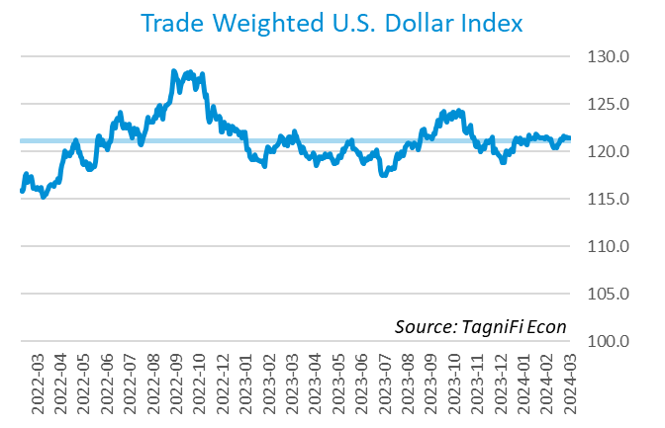

# Q1 Economic Highlights

* The Philadelphia Fed’s coincident index of economic activity in the U.S. rose 0.3% in March 2024 and 0.7% during the 1st quarter.
* The U.S. dollar index rose 2.2% during the 1st quarter of 2024 and was up 1.6% from the prior year.
* Real GDP grew at an annualized rate of 1.6% during the 1st quarter of 2024.
* The effective federal funds rate was unchanged at 5.33% during the 1st quarter, holding at the 23-year high reached in the 3rd quarter of 2023.
* The 1-year and 2-year annual treasury yields ended the 1st quarter at 5.03% and 4.59%, respectively. The benchmark 10-year treasury yielded 4.20% at the end of the quarter, while the 30-year treasury yielded 4.34%.
* The unemployment rate ended the 1st quarter at 3.8%, up slightly from the prior quarter. Nonfarm payrolls grew by 0.8 million jobs in the 1st quarter.
* The Consumer Price Index for all items rose 3.5% for the year ended March 2024. Excluding volatile energy prices, the annual increase was 3.6%.
* Crude oil prices ended the 1st quarter at $83.96 per barrel, up 16.8% from the prior quarter and 10.9% year-over-year.
* New home starts dropped 15.6% during the 1st quarter to a level of 1.32 million in March. Total new home starts were down 4.3% year-over-year.
* The S&P 500 climbed 10.2% during the 1st quarter of 2024, and the Wilshire 5000 rose 9.6%. The NASDAQ Composite index increased 9.1%. The Dow Jones Industrial, Composite, and Transportation Averages were up 5.6%, 4.0%, and 2.0%, respectively, during the quarter.

# Business Activity

Real gross domestic product (GDP)[3] grew at an annualized rate of 1.6% during the 1st quarter of 2024, slowing more than expected from a 3.4% increase in the 4th quarter of 2023. Gains in consumer spending, fixed investment, and government spending were tempered by declining net exports and private inventories. Combined with higher-than-expected inflation data, the underwhelming production report disheartened investors and temporarily softened markets.

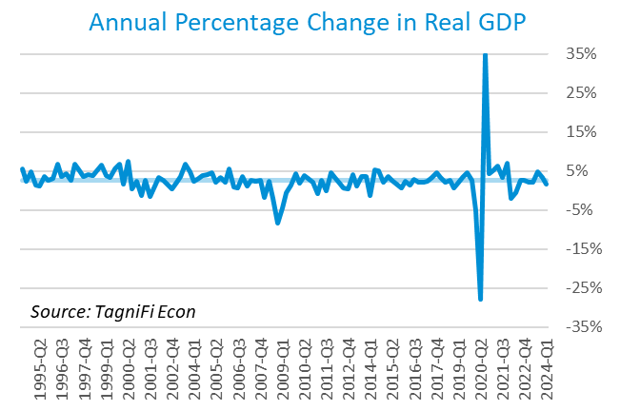

Personal consumption expenditures[4] (PCE) had a positive 1.7% effect on real GDP in the 1st quarter. A rise in spending on services, especially for health care and financial services and insurance, fueled the gains in PCE. Spending on goods was down, led by motor vehicles and parts as well as gasoline and other energy goods.

Gross domestic private investment[5] also contributed 0.6% to the increase in the 1st quarter real GDP estimate. Both residential and nonresidential fixed investment rose, with residential gains reflecting brokers’ commissions, other ownership transfer costs, and new single-family housing construction; nonresidential gains were led by intellectual property, particularly software. Private inventory investment was down, with decreases in wholesale trade and manufacturing.

Government expenditures[6] rose at the state and local level, contributing 0.2% to the 1st quarter GDP gain. Higher state and local government spending was led by compensation of state and local government employees. Federal spending was down slightly, with a decline in national defense spending more than offsetting an uptick in nondefense spending.

Net exports[7] had a negative 0.9% effect on real GDP in the 1st quarter as growth of imports (which have a negative effect on GDP) far outpaced that of exports. Import gains reflected increases in both goods and services.

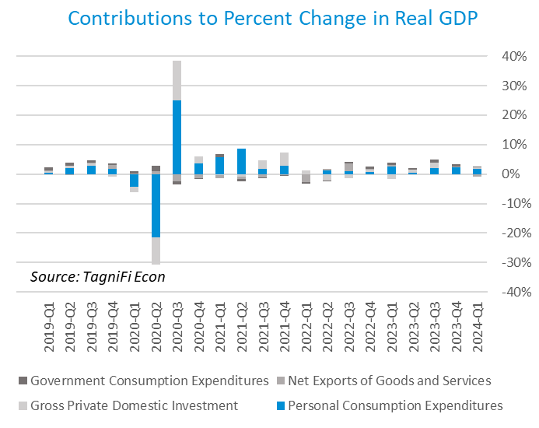

Economists polled by the Livingston Survey[8] in December 2023 projected real GDP to moderate to an annual rate of 1.0% in the 1st half of 2024 and an annual rate of 1.2% in the 2nd half of 2024.

The Industrial Production Index[9] is an economic indicator that measures real output for all facilities located in the United States manufacturing, mining, and electric, and gas utilities. The index stood at 102.7 at the end of the 1st quarter, essentially unchanged from the 4th quarter.

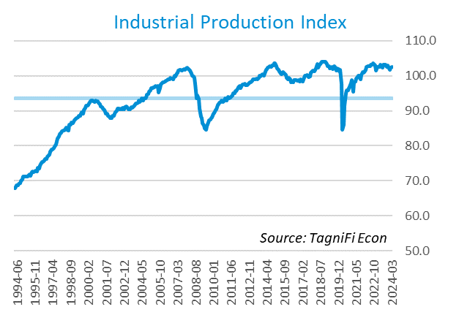

The Capacity Utilization Index[10], which attempts to capture industrial output as a percentage of the economy’s maximum production capacity, ended the 1st quarter of 2024 at 77.3%. March 2024’s level was above the 30-year average of 76.8% for this metric and up 0.1% from the previous quarter.

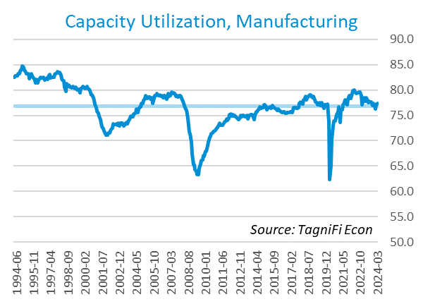

# Interest Rates

The effective federal funds rate[11] was unchanged at 5.33% during the 1st quarter, holding at the 23-year high reached in the 3rd quarter of 2023. Treasury bond yields[12] for periods of one year and up rose during the 1st quarter, with the yield curve remaining inverted. The closely watched two- and ten-year rates have been inverted since July 2022. The 1-year and 2-year annual treasury yields ended the 1st quarter at 5.03% and 4.59%, respectively. The benchmark 10-year treasury yielded 4.20% at the end of the quarter, while the 30-year treasury yielded 4.34%. See *Appendix – Selected Interest Rates* for detailed interest rate data.

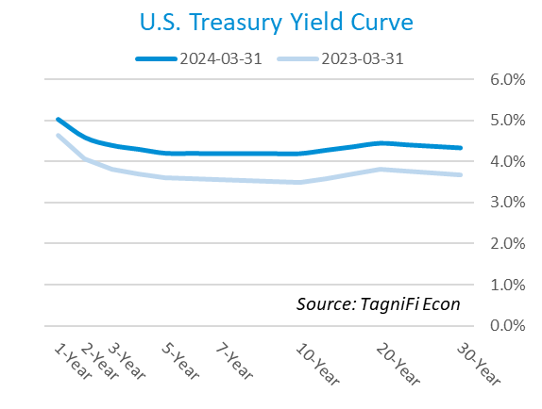

In the 1st quarter of 2024, the Federal Reserve continued to hold the federal funds target rate[13] steady throughout the quarter at a range of 5.25% to 5.50%—the highest in 23 years. With inflation higher than expected in the 1st quarter, unemployment still low, and domestic production still growing, the FOMC foreshadowed a cautious approach to loosening economic policy that may entail holding target rates at their current level for longer.

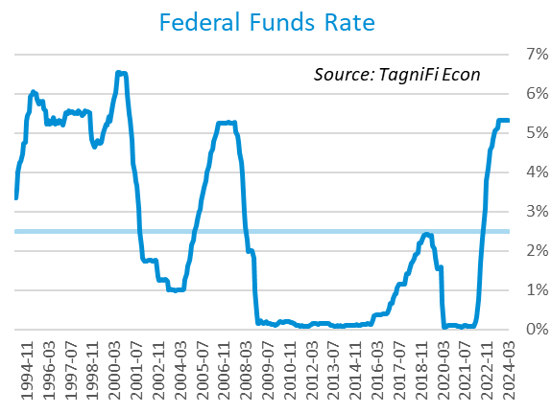

The yield on the benchmark 10-year U.S. treasury[14] ended the 1st quarter at 4.20%, up 0.32 percentage points from the previous quarter and above the average yield of 3.83% over the last 30 years.

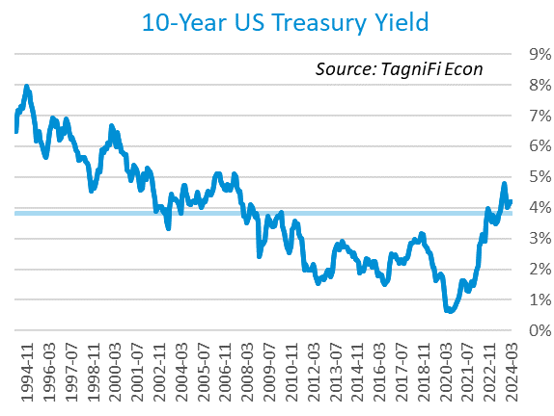

Moody’s Baa Corporate Bond Yield Index[15] ended the 1st quarter of 2024 at 5.70%, up 0.21 percentage points since the previous quarter. Moody’s less-risky Aaa[16] Index rose 0.32 percentage points during the quarter to a level of 4.97%.

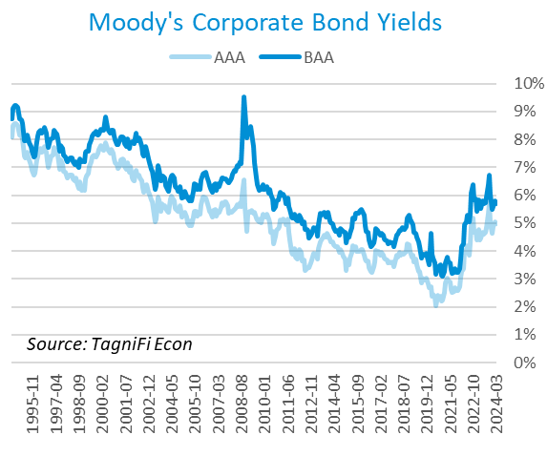

# Employment

The official unemployment rate[17] ended the 1st quarter at 3.8%, up slightly from the prior quarter, but well below the 30-year historical average of 5.6% and below the 4.0% to 5.0% range accepted as an equilibrium level of “full employment.” The labor force[18] rose by 0.4 million workers during the quarter. The labor force participation rate[19] ticked up to 62.7% in March 2024 but was still 0.6 percentage points below its pre-pandemic level. Economists polled by the Livingston Survey in December 2023 projected the unemployment rate to rise to 4.2% in both June and December 2024.

In March 2024, nonfarm worker quits[20] stood at 3.3 million, down 3.2% over the quarter and 12.6% over the year. Job openings[21] totaled 8.5 million in March 2024, 2.5 times the number of resignations. The job openings count was down 4.5% during the 1st quarter and 11.8% from year-ago levels.

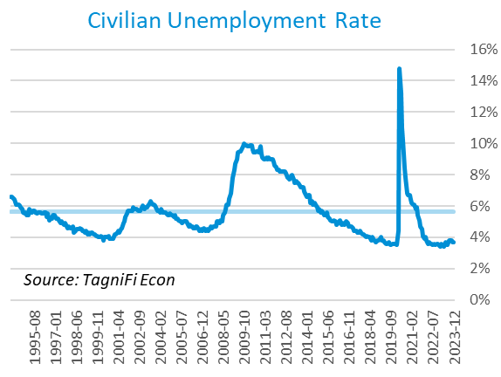

The U-6 unemployment rate[22] is an alternative measure of unemployment with a broader definition, including such groups as discouraged workers who are not actively searching for jobs but want full-time work and part-time workers who want full-time work. The U‑6 unemployment rate has generally followed the same pattern as the official rate and stood at 7.3% in March 2024.

Nonfarm payrolls[23] grew by 0.8 million jobs in the 1st quarter. U.S. nonfarm payrolls in March 2024 totaled 158.1 million jobs, up 2.9 million from the prior March. March’s job market growth exceeded expectations with broad gains led by the health care, government, leisure and hospitality, and construction industries.

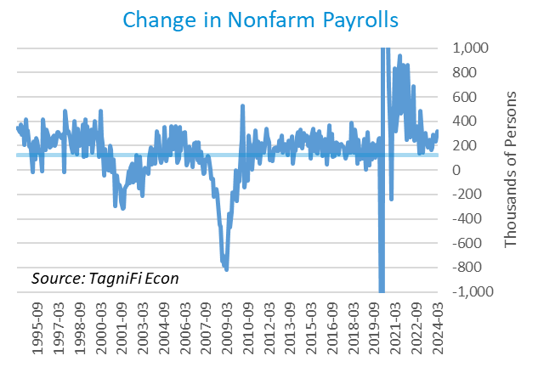

# Inflation

In the 1st quarter of 2024, inflation again accelerated, but continued to rise at a more moderate pace than much of 2021 and 2022. The Consumer Price Index[24] for all items rose 3.5% for the year ended March 2024. Shelter was a main contributor of March’s annual increase; motor vehicle insurance, medical care, recreation, and personal care also contributed. Food prices also rose since last March, both at home and away from home. Higher prices for gasoline and electricity led energy costs up for the year ended March 2024, while lower prices for natural gas and fuel oil moderated the increase. Excluding volatile energy prices[25], the annual increase was 3.6%. The average price of a gallon of gas[26] in the U.S. jumped 8.9% during the 1st quarter 2024 to $3.58. March’s average price was 0.8% higher than one year prior.

In the month of March 2024, higher prices for shelter and gasoline were responsible for more than half of the increase in the consumer price index. Energy service prices and food away from home prices also rose in March.

The Federal Reserve, which had been taking aggressive action to curb inflation with a series of target interest rate hikes totaling 5.25 percentage points from March 2022 to July 2023, continued to hold the target rate steady throughout the 1st quarter of 2024. While multiple rate cuts had been expected in 2024, rising inflation in the 1st quarter prompted the Fed to leave target rates at their current level and forecast caution in future policy.

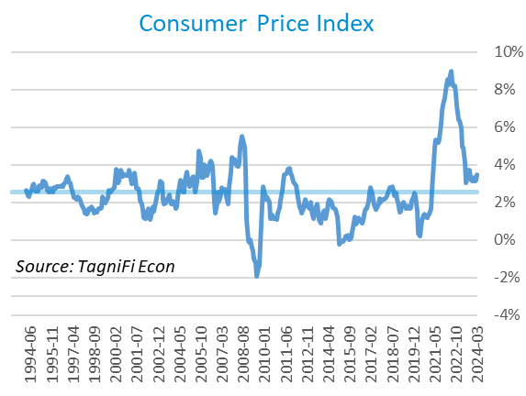

Wholesale inflation has been quicker to regulate than consumer inflation. The Producer Price Index[27] rose 2.1% in the 1st quarter but was 0.7% lower since March 2023. The average annual increase over the last 30 years was 2.8%.

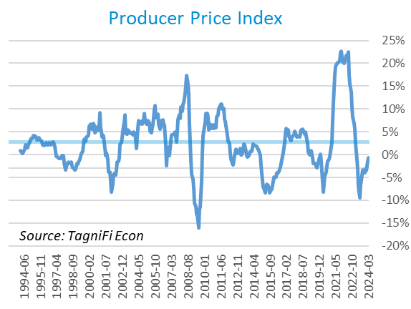

The 5-year breakeven inflation rate[28], an indicator for the market’s inflation expectations for the period, rose to 2.38% at the end of the 1st quarter 2024 from 2.12% at the end of the 4th quarter 2024.

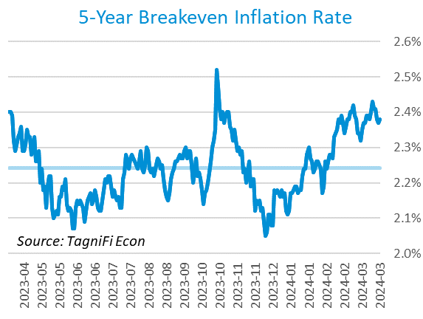

U.S. crude oil[29] prices rose in the 1st quarter, settling at $83.96 per barrel after some turbulence sparked by rising US inventories. The OPEC+ alliance is expected to continue its current production cuts, limiting global supply and supporting prices. Crude prices ended the 1st quarter up 16.8% from the prior quarter and 10.9% year-over-year.

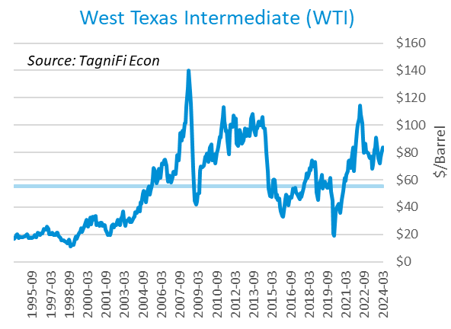

# Housing

Persistently elevated mortgage rates and tight housing inventory continued to constrain sales in the housing market during the 1st quarter of 2024. Home prices in major cities continued to rise. New home starts[30] dropped 15.6% during the 1st quarter to a level of 1.32 million in March, mostly due to a decrease in multi-family home starts; single family home starts also declined slightly. Total new home starts were down 4.3% year-over-year and stood slightly below their 30-year average of 1.34 million.

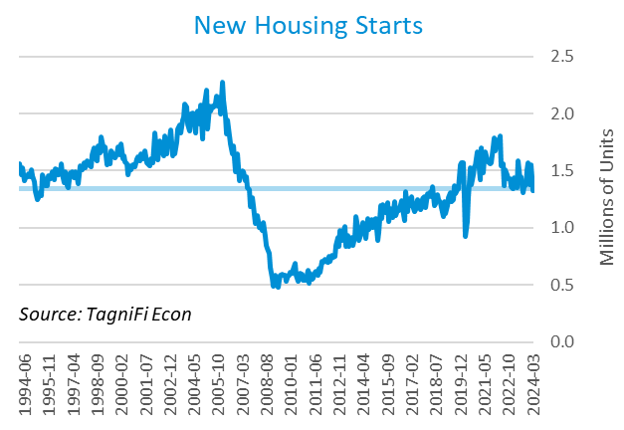

The cost of financing for would-be homebuyers rose during the 1st quarter, with the 30-year fixed-rate mortgage[31] up 0.18 percentage points to an average of 6.79% at the end of March 2024. The average rate was still lower than its peak of 7.79% in late October.

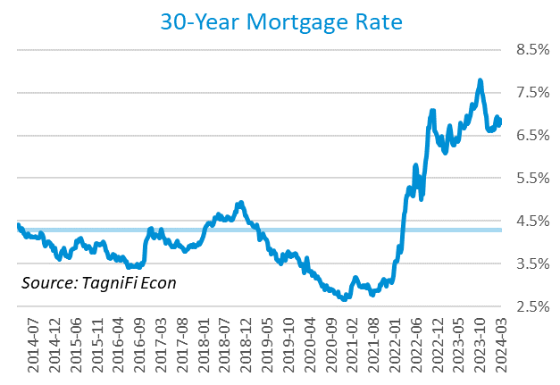

The S&P Case-Shiller Home Price Index (20-city)[32] was 0.6% higher from January to February and 7.3% higher since February 2023. Led by San Diego, Chicago, Detroit, and New York, all of the 20 cities experienced one-year price increases.

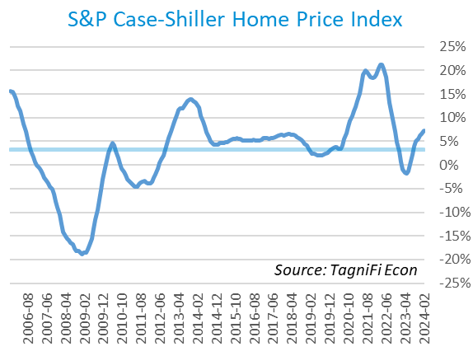

# Consumer Spending

Personal Consumption Expenditures (PCE)[33] rose 1.8% in the 1st quarter to $19.4 trillion. PCE were up 5.8% since the 1st quarter last year. Spending increased in March for services such as health care (both outpatient and hospital services) and housing and utilities (led by housing). Goods spending also increased, especially for motor vehicles and parts, gasoline and other energy goods (led by motor vehicle fuels, lubricants, and fluids), other nondurable goods (led by recreational items), and food and beverages.

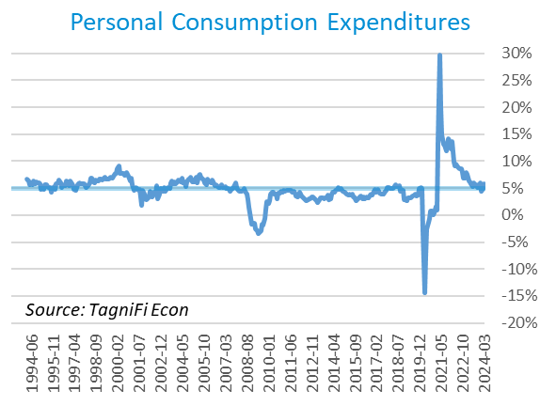

Auto manufacturers reported autos and light trucks sold[34] at an annual rate of 15.6 million in March 2024, down 3.4% from December. New vehicle prices[35] remained near their record high, unchanged during the 1st quarter. Used car prices[36] fell 4.0% from December to March.

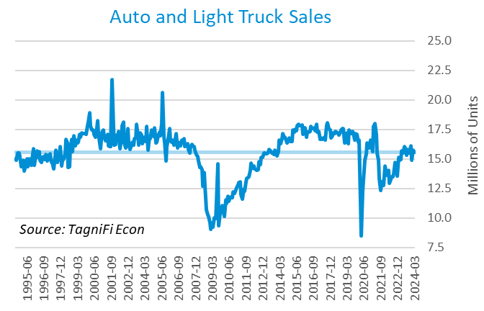

The University of Michigan’s consumer sentiment index[37] stood at 79.4 in March 2024, continuing the rebound from its all-time low of 50.0 in June 2022 despite consumers’ ongoing inflation concerns. The index was up 28.1% year-over-year yet still well below its 30-year average of 86.2.

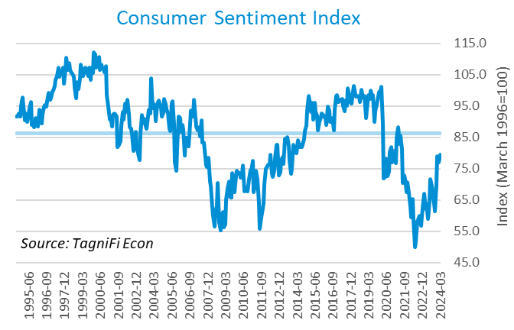

# Capital Markets

The table below shows the quarterly, year-to-date, and 12-month performance of major U.S. equity indices. Capital markets held strong in the 1st quarter of 2024 despite waning expectations of imminent interest rate cuts. Markets continued to look ahead to a soft landing for the economy, with eventual rate cuts, and the opportunities promised by a broader adoption of AI . The S&P 500 climbed 10.2% during the 1st quarter of 2024, and the Wilshire 5000 rose 9.6%. The NASDAQ Composite index increased 9.1%. The Dow Jones Industrial, Composite, and Transportation Averages were up 5.6%, 4.0%, and 2.0%, respectively, during the quarter.



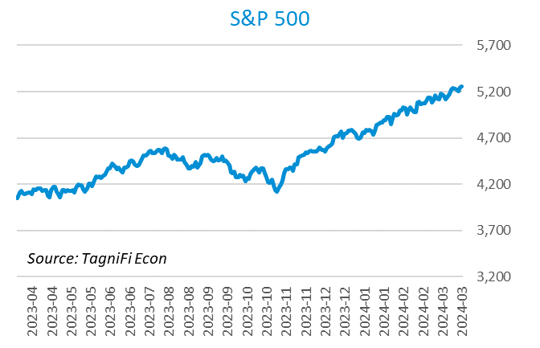

Stock market volatility, as measured by the VIX [38], ended the 1st quarter of 2024 at 13.0, up 4.5% since the prior quarter but down 30.4% since the 1st quarter of 2023. The VIX rose in January before receding in February and March.

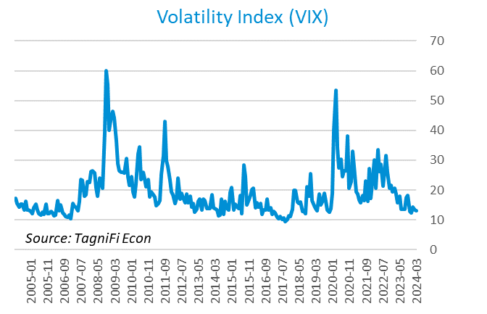

# Outlook

In March 2024, the FOMC revised their near-term real GDP projections upward and unemployment rate projections downward; little change was made to near-term PCE inflation projections. Minimal adjustments were made to longer-run projections for the three indicators.

The FOMC revised their projections for real GDP[39] upward for 2024 and 2025, to 2.20% and 2.10% growth, respectively, while 2026 projections inched up to 1.95% in 2026. They forecast Personal Consumption Expenditures (PCE) inflation[40] of 2.50% in 2024, moderating to 2.15% in 2025 and 2.05% in 2026. They expected that the unemployment rate[41] would be 4.00% in 2024, 4.05% in 2025, and 4.10% in 2026. The board slightly raised projections of future target rates[42] to 4.85% in 2024, 3.75% in 2025, and 3.00% in 2026. The committee forecasted a careful approach to any future rate cuts and indicated willingness to hold rates at their high level as long as is deemed necessary.



Appendix – Selected Interest Rates



# About This Report

The *Quarterly Economic Update* is a free publication sponsored by TagniFi. You are free to share this report and include its contents in the economic outlook section of your valuation reports as required by *Revenue Ruling 59-60*. Please forward this free report to a colleague to help us spread the word about TagniFi.

How TagniFi Helps Business Valuation Teams

TagniFi’s financial data platform empowers business valuation teams to quickly and easily build highly accurate financial models with full transparency—and within seconds.

**Better Public Comps**  
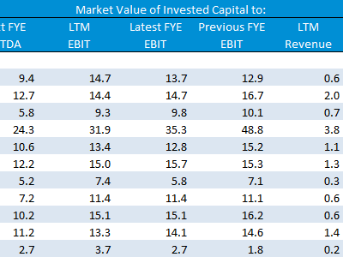Search for public companies with TagniFi Web. Simply enter your valuation date and ticker symbols in Excel to run a guideline public company method. Your Excel model populates instantly with the financial statements, analyst estimates, interest rates and economic data for your valuation date.

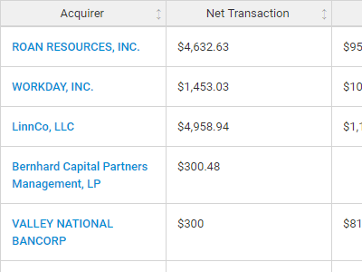

**Better Transaction Comps**  
Search for public and private M&A transactions with TagniFi Web. Run your transaction comps within seconds by pasting the Deal ID into your Excel model. Every deal disclosed in an SEC filing (8-K, 10-K, or 10-Q) is available for your analysis. Choose from over 90 fields of data available for every deal.

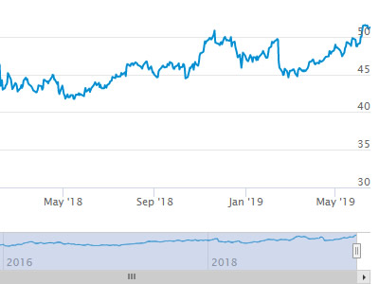

**Historical Beta and Volatility**Calculate historical beta and volatility as of your valuation date automatically. Simply enter the tickers and valuation date in Excel - TagniFi does the rest. In addition to beta and volatility, there are over 40 Excel models available in the Model Library to help with your valuation report.

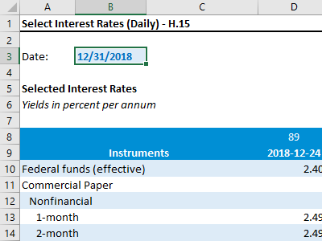**Interest Rates and Economic Data**Automate the interest rates and economic data in your valuation report using the TagniFi Excel plugin. Choose from over 200,000 time series available. All data in this *Quarterly Economic Update* is from the TagniFi platform. Use economic and interest rate data for your own valuation models with the TagniFi Excel plugin.

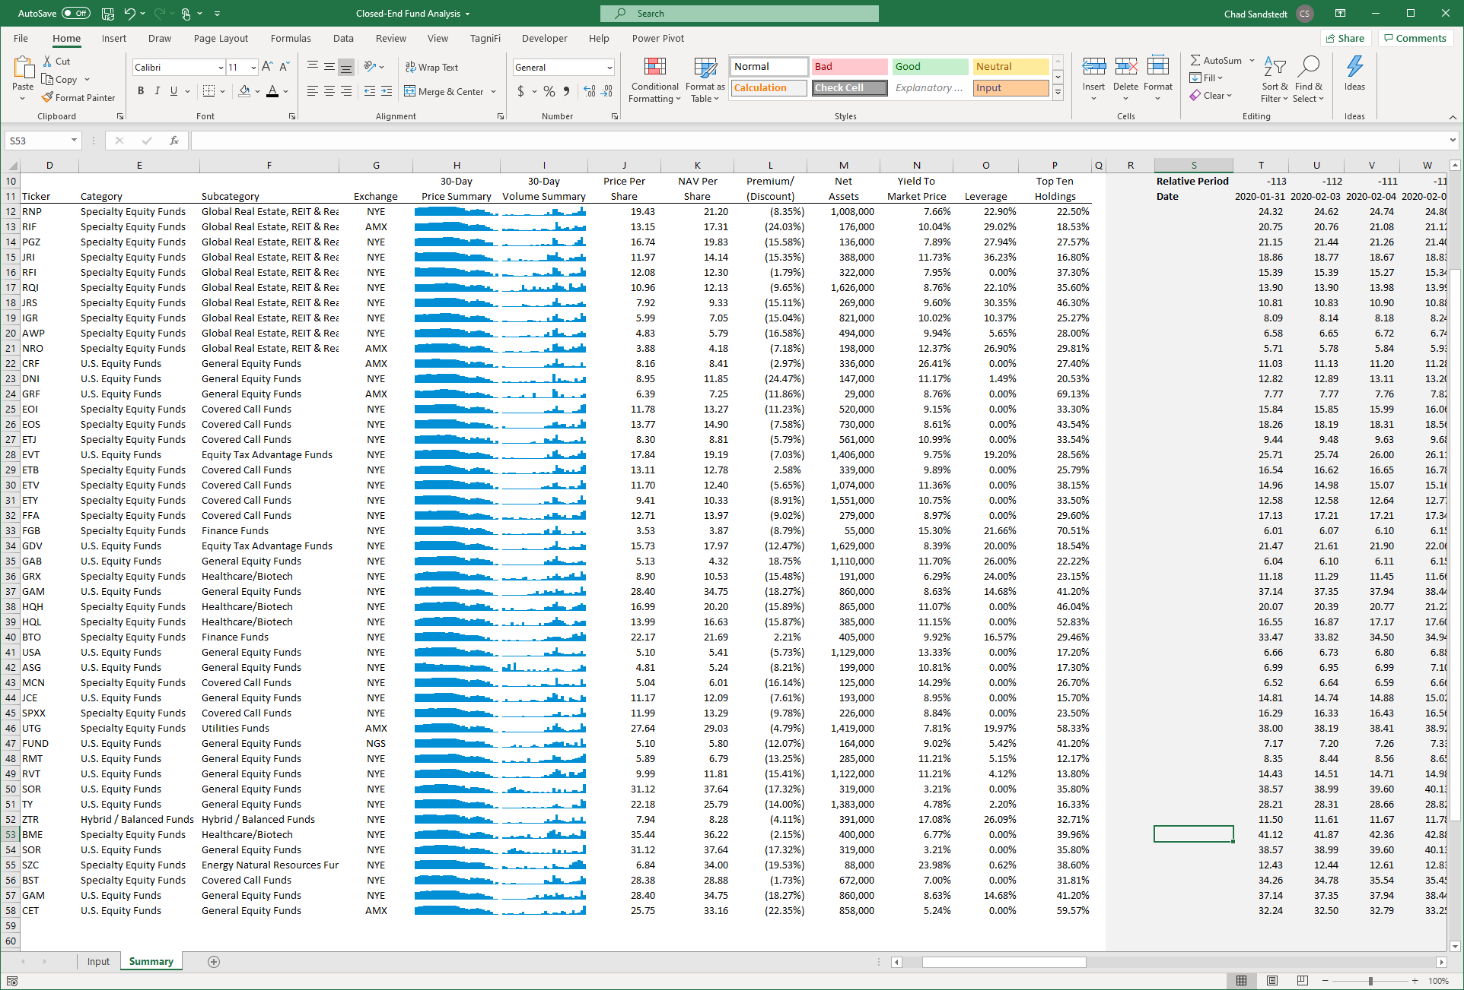

**Closed-End Mutual Fund Data**Search for closed-end mutual funds by keyword, category, subcategory, and more with the TagniFi Console. Use the TagniFi Excel plugin to calculate historical discounts, yields, leverage, as of your valuation date automatically. Simply enter the tickers and valuation date in Excel - TagniFi does the rest.

1. Federal Reserve Bank of Philadelphia, Coincident Economic Activity Index for the United States [USPHCI], *retrieved from FRED, Federal Reserve Bank of St. Louis;* [*https://fred.stlouisfed.org/series/USPHCI*](https://fred.stlouisfed.org/series/USPHCI)*, May 3, 2024.*
2. Board of Governors of the Federal Reserve System (US), Trade Weighted U.S. Dollar Index: Broad, Goods and Services [DTWEXBGS], *retrieved from FRED, Federal Reserve Bank of St. Louis;* [*https://fred.stlouisfed.org/series/DTWEXBGS*](https://fred.stlouisfed.org/series/DTWEXBGS)*, May 3, 2024.*
3. U.S. Bureau of Economic Analysis, Real Gross Domestic Product [GDPC1], *retrieved from FRED, Federal Reserve Bank of St. Louis;*[*https://fred.stlouisfed.org/series/GDPC1*](https://fred.stlouisfed.org/series/GDPC1)*, May 3, 2024.*
4. U.S. Bureau of Economic Analysis, Contributions to percent change in real gross domestic product: Personal consumption expenditures [DPCERY2Q224SBEA], *retrieved from FRED, Federal Reserve Bank of St. Louis;* [*https://fred.stlouisfed.org/series/DPCERY2Q224SBEA*](https://fred.stlouisfed.org/series/DPCERY2Q224SBEA)*, May 3, 2024.*
5. U.S. Bureau of Economic Analysis, Contributions to percent change in real gross domestic product: Gross private domestic investment [A006RY2Q224SBEA], *retrieved from FRED, Federal Reserve Bank of St. Louis;* [*https://fred.stlouisfed.org/series/A006RY2Q224SBEA*](https://fred.stlouisfed.org/series/A006RY2Q224SBEA)*, May 3, 2024.*
6. U.S. Bureau of Economic Analysis, Contributions to percent change in real gross domestic product: Government consumption expenditures and gross investment [A822RY2Q224SBEA], *retrieved from FRED, Federal Reserve Bank of St. Louis;* [*https://fred.stlouisfed.org/series/A822RY2Q224SBEA*](https://fred.stlouisfed.org/series/A822RY2Q224SBEA)*, May 3, 2024.*
7. U.S. Bureau of Economic Analysis, Contributions to percent change in real gross domestic product: Net exports of goods and services [A019RY2Q224SBEA], *retrieved from FRED, Federal Reserve Bank of St. Louis;* [*https://fred.stlouisfed.org/series/A019RY2Q224SBEA*](https://fred.stlouisfed.org/series/A019RY2Q224SBEA)*, May 3, 2024.*
8. Federal Reserve Bank of Philadelphia, The Livingston Survey December 2023, [economic release], retrieved from <https://www.philadelphiafed.org/surveys-and-data/real-time-data-research/livingston-survey>, May 3, 2024.
9. Board of Governors of the Federal Reserve System (US), Industrial Production Index [INDPRO], *retrieved from FRED, Federal Reserve Bank of St. Louis;*[*https://fred.stlouisfed.org/series/INDPRO*](https://fred.stlouisfed.org/series/INDPRO)*, May 3, 2024.*
10. Board of Governors of the Federal Reserve System (US), Capacity Utilization, Manufacturing (NAICS), *retrieved from FRED, Federal Reserve Bank of St. Louis;* [*https://fred.stlouisfed.org/series/MCUMFN*](https://fred.stlouisfed.org/series/MCUMFN)*, May 3, 2024.*
11. Board of Governors of the Federal Reserve System (US), Federal Funds Effective Rate [FEDFUNDS], *retrieved from FRED, Federal Reserve Bank of St. Louis;* [*https://fred.stlouisfed.org/series/FEDFUNDS*](https://fred.stlouisfed.org/series/FEDFUNDS)*, May 3, 2024.*
12. Selected Interest Rates Instruments, Yields in percent per annum, *retrieved from FRED, Federal Reserve Bank of St. Louis;* [https://fred.stlouisfed.org/release/tables?rid=18&eid=289&od=2024-03-28#](https://fred.stlouisfed.org/release/tables?rid=18&eid=289&od=2024-03-28)*, May 3, 2024.*
13. Board of Governors of the Federal Reserve System (US), Federal Funds Target Range - Upper Limit [DFEDTARU], *retrieved from FRED, Federal Reserve Bank of St. Louis;* [*https://fred.stlouisfed.org/series/DFEDTARU*](https://fred.stlouisfed.org/series/DFEDTARU)*, May 3, 2024*.
14. Board of Governors of the Federal Reserve System (US), 10-Year Treasury Constant Maturity Rate [DGS10], *retrieved from FRED, Federal Reserve Bank of St. Louis;*[*https://fred.stlouisfed.org/series/DGS10*](https://fred.stlouisfed.org/series/DGS10)*, May 3, 2024.*
15. Moody’s, Moody's Seasoned Baa Corporate Bond Yield [DBAA], *retrieved from FRED, Federal Reserve Bank of St. Louis;* [*https://fred.stlouisfed.org/series/DBAA*](https://fred.stlouisfed.org/series/DBAA)*, May 3, 2024.*
16. Moody’s, Moody's Seasoned Aaa Corporate Bond Yield [DAAA], *retrieved from FRED, Federal Reserve Bank of St. Louis;* [*https://fred.stlouisfed.org/series/DAAA*](https://fred.stlouisfed.org/series/DAAA)*, May 3, 2024.*
17. U.S. Bureau of Labor Statistics, Civilian Unemployment Rate [UNRATE], *retrieved from FRED, Federal Reserve Bank of St. Louis;*[*https://fred.stlouisfed.org/series/UNRATE*](https://fred.stlouisfed.org/series/UNRATE)*, May 3, 2024.*
18. U.S. Bureau of Labor Statistics, Civilian Labor Force Level [CLF16OV], *retrieved from FRED, Federal Reserve Bank of St. Louis;* [*https://fred.stlouisfed.org/series/CLF16OV*](https://fred.stlouisfed.org/series/CLF16OV)*, May 3, 2024.*
19. U.S. Bureau of Labor Statistics, Labor Force Participation Rate [CIVPART], *retrieved from FRED, Federal Reserve Bank of St. Louis;* [*https://fred.stlouisfed.org/series/CIVPART*](https://fred.stlouisfed.org/series/CIVPART)*, May 3, 2024.*
20. U.S. Bureau of Labor Statistics, Quits: Total Nonfarm [JTSQUL], *retrieved from FRED, Federal Reserve Bank of St. Louis;* [*https://fred.stlouisfed.org/series/JTSQUL*](https://fred.stlouisfed.org/series/JTSQUL)*, May 3, 2024.*
21. U.S. Bureau of Labor Statistics, Job Openings: Total Nonfarm [JTSJOL], *retrieved from FRED, Federal Reserve Bank of St. Louis;* [*https://fred.stlouisfed.org/series/JTSJOL*](https://fred.stlouisfed.org/series/JTSJOL)*, May 3, 2024.*
22. U.S. Bureau of Labor Statistics Total Unemployed, Plus All Persons Marginally Attached to the Labor Force, Plus Total Employed Part Time for Economic Reasons, as a Percent of the Civilian Labor Force Plus All Persons Marginally Attached to the Labor Force (U-6) [U6RATE], *retrieved from FRED, Federal Reserve Bank of St. Louis;*[*https://fred.stlouisfed.org/series/U6RATE*](https://fred.stlouisfed.org/series/U6RATE)*, May 3, 2024.*
23. U.S. Bureau of Labor Statistics, All Employees: Total Nonfarm Payrolls [PAYEMS], *retrieved from FRED, Federal Reserve Bank of St. Louis;*[*https://fred.stlouisfed.org/series/PAYEMS*](https://fred.stlouisfed.org/series/PAYEMS)*, May 3, 2024.*
24. U.S. Bureau of Labor Statistics, Consumer Price Index for All Urban Consumers: All Items [CPIAUCSL], *retrieved from FRED, Federal Reserve Bank of St. Louis;*[*https://fred.stlouisfed.org/series/CPIAUCSL*](https://fred.stlouisfed.org/series/CPIAUCSL)*, May 3, 2024.*
25. U.S. Bureau of Labor Statistics, Consumer Price Index for All Urban Consumers: All Items Less Energy in U.S. City Average [CPILEGSL], *retrieved from FRED, Federal Reserve Bank of St. Louis;* [*https://fred.stlouisfed.org/series/CPILEGSL*](https://fred.stlouisfed.org/series/CPILEGSL)*, May 3, 2024*.
26. U.S. Bureau of Labor Statistics, Average Price: Gasoline, Unleaded Regular (Cost per Gallon/3.785 Liters) in U.S. City Average [APU000074714], *retrieved from FRED, Federal Reserve Bank of St. Louis;* [*https://fred.stlouisfed.org/series/APU000074714*](https://fred.stlouisfed.org/series/APU000074714)*, May 3, 2024.*
27. U.S. Bureau of Labor Statistics, Producer Price Index for All Commodities [PPIACO], *retrieved from FRED, Federal Reserve Bank of St. Louis;*[*https://fred.stlouisfed.org/series/PPIACO*](https://fred.stlouisfed.org/series/PPIACO)*, May 3, 2024.*
28. *Federal Reserve Bank of St. Louis, 5-Year Breakeven Inflation Rate [T5YIE], retrieved from FRED, Federal Reserve Bank of St. Louis;*[*https://fred.stlouisfed.org/series/T5YIE*](https://fred.stlouisfed.org/series/T5YIE)*, May 3, 2024.*
29. U.S. Energy Information Administration, Crude Oil Prices: West Texas Intermediate (WTI) - Cushing, Oklahoma [DCOILWTICO], *retrieved from FRED, Federal Reserve Bank of St. Louis;* [*https://fred.stlouisfed.org/series/DCOILWTICO*](https://fred.stlouisfed.org/series/DCOILWTICO)*, May 3, 2024.*
30. U.S. Bureau of the Census, Housing Starts: Total: New Privately Owned Housing Units Started [HOUST], *retrieved from FRED, Federal Reserve Bank of St. Louis;*[*https://fred.stlouisfed.org/series/HOUST*](https://fred.stlouisfed.org/series/HOUST)*, May 3, 2024.*
31. Freddie Mac, 30-Year Fixed Rate Mortgage Average in the United States [MORTGAGE30US], *retrieved from FRED, Federal Reserve Bank of St. Louis;*[*https://fred.stlouisfed.org/series/MORTGAGE30US*](https://fred.stlouisfed.org/series/MORTGAGE30US)*, May 3, 2024.*
32. S&P Dow Jones Indices LLC, S&P/Case-Shiller 20-City Composite Home Price Index [SPCS20RSA], *retrieved from FRED, Federal Reserve Bank of St. Louis;*[*https://fred.stlouisfed.org/series/SPCS20RSA*](https://fred.stlouisfed.org/series/SPCS20RSA)*, May 3, 2024.*
33. U.S. Bureau of Economic Analysis, Personal Consumption Expenditures [PCE], *retrieved from FRED, Federal Reserve Bank of St. Louis;*[*https://fred.stlouisfed.org/series/PCE*](https://fred.stlouisfed.org/series/PCE)*, May 3, 2024.*
34. U.S. Bureau of Economic Analysis, Light Weight Vehicle Sales: Autos and Light Trucks [ALTSALES], *retrieved from FRED, Federal Reserve Bank of St. Louis; <https://fred.stlouisfed.org/series/ALTSALES>, May 3, 2024.*
35. U.S. Bureau of Labor Statistics, Consumer Price Index for All Urban Consumers: New Vehicles in U.S. City Average [CUUR0000SETA01], *retrieved from FRED, Federal Reserve Bank of St. Louis;* [*https://fred.stlouisfed.org/series/CUUR0000SETA01*](https://fred.stlouisfed.org/series/CUUR0000SETA01)*, May 3, 2024.*
36. U.S. Bureau of Labor Statistics, Consumer Price Index for All Urban Consumers: Used Cars and Trucks in U.S. City Average [CUSR0000SETA02], *retrieved from FRED, Federal Reserve Bank of St. Louis;* [*https://fred.stlouisfed.org/series/CUSR0000SETA02*](https://fred.stlouisfed.org/series/CUSR0000SETA02), *May 3, 2024.*
37. *University of Michigan, University of Michigan: Consumer Sentiment [UMCSENT], retrieved from FRED, Federal Reserve Bank of St. Louis;* [*https://fred.stlouisfed.org/series/UMCSENT*](https://fred.stlouisfed.org/series/UMCSENT)*, May 3, 2024.*
38. *Chicago Board Options Exchange, CBOE Volatility Index: VIX [VIXCLS], retrieved from FRED, Federal Reserve Bank of St. Louis;* [*https://fred.stlouisfed.org/series/VIXCLS*](https://fred.stlouisfed.org/series/VIXCLS)*, May 3, 2024.*
39. *Federal Reserve Bank of St. Louis, FOMC Summary of Economic Projections for the Growth Rate of Real Gross Domestic Product [GDPC1CTM], retrieved from FRED, Federal Reserve Bank of St. Louis;*[*https://fred.stlouisfed.org/series/GDPC1CTM*](https://fred.stlouisfed.org/series/GDPC1CTM)*, May 3, 2024.*
40. *Federal Reserve Bank of St. Louis, FOMC Summary of Economic Projections for the Personal Consumption Expenditures Inflation Rate, Central Tendency, Midpoint [PCECTPICTM], retrieved from FRED, Federal Reserve Bank of St. Louis;*[*https://fred.stlouisfed.org/series/PCECTPICTM*](https://fred.stlouisfed.org/series/PCECTPICTM)*, May 3, 2024.*
41. *Federal Reserve Bank of St. Louis, FOMC Summary of Economic Projections for the Civilian Unemployment Rate, Central Tendency, Midpoint [UNRATECTM], retrieved from FRED, Federal Reserve Bank of St. Louis;*[*https://fred.stlouisfed.org/series/UNRATECTM*](https://fred.stlouisfed.org/series/UNRATECTM)*, May 3, 2024.*
42. *U.S. Federal Open Market Committee and Federal Reserve Bank of St. Louis, FOMC Summary of Economic Projections for the Fed Funds Rate, Range, Midpoint [FEDTARCTM], retrieved from FRED, Federal Reserve Bank of St. Louis;* [*https://fred.stlouisfed.org/series/FEDTARCTM*](https://fred.stlouisfed.org/series/FEDTARCTM)*, May 3, 2024.*