QUARTERLY ECONOMIC UPDATE

For the 2nd Quarter of 2024

Abstract

Designed for business valuation professionals, TagniFi’s Quarterly Economic   
Update provides timely economic data to satisfy Revenue Ruling 56-60.

# Summary

Domestic production exceeded expectations in the 2nd quarter of 2024, signaling a still-strong economy despite slower-than-expected progress on inflation and a slight softening in the labor market. In response, the Federal Reserve forecasted a more moderate approach to loosening its hawkish monetary policy over time, citing ongoing economic strength in the face of high interest rates. Broad increases in personal spending, private investment, and government spending all contributed to robust GDP growth in the 2nd quarter.

Inflation continued to moderate at a glacial pace, due in part to lower gasoline prices. Soft demand for fuels also held crude oil prices lower in the 2nd quarter of 2024.

A frequent bright spot for the economy in recent years, the job market dimmed slightly in the 2nd quarter of 2024, with unemployment rising, labor force participation inching down, and uneven nonfarm employment growth. Still, the labor market remains well within the bounds of full employment. Capital markets posted a mixed 2nd quarter despite the continued tailwind in the tech sector provided by emerging AI tools.

Housing market data indicated some softening. As sales continued to be constrained by elevated interest rates, unsold housing inventory rose in the 2nd quarter of 2024. Prices in major cities continued to rise.

FOMC members’ projections of domestic production and inflation reflected the data, wih both revised upward in the near term. Unemployment expectations changed little, as did projections of longer-term economic performance across all three measures.

A multifactor indicator of economic strength, the Philadelphia Fed’s coincident index[1] of economic activity in the U.S. rose 0.2% in June 2024 and 0.6% during the 2nd quarter. For the quarter, coincident indexes increased in 39 states, decreased in 8 states, and remained unchanged in 3 states. Coincident indexes reflect unemployment, payroll employment, manufacturing hours, and wages and salaries.



The U.S. dollar index for goods and services[2] rose 2.6% during the 2nd quarter of 2024. The dollar was up 4.1% from the prior year, primarily reflecting the Fed’s cautious approach to easing hawkish policy.

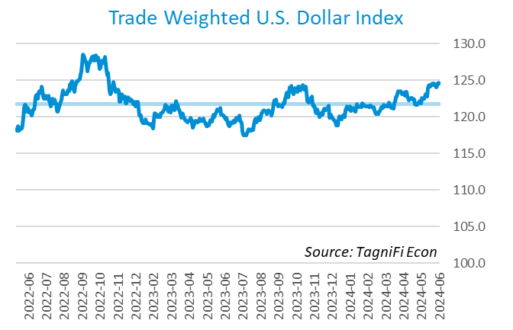

# Q2 Economic Highlights

* The Philadelphia Fed’s coincident index of economic activity in the U.S. rose 0.2% in June 2024 and 0.6% during the 2nd quarter.
* The U.S. dollar index rose 2.6% during the 2nd quarter of 2024 and was up 4.1% from the prior year.
* Real GDP grew at an annualized rate of 2.8% during the 2nd quarter of 2024.
* The effective federal funds rate was unchanged at 5.33% during the 2nd quarter, holding at the 23-year high reached in the 3rd quarter of 2023.
* The 1-year and 2-year annual treasury yields ended the 2nd quarter at 5.09% and 4.71%, respectively. The benchmark 10-year treasury yielded 4.36% at the end of the quarter, while the 30-year treasury yielded 4.51%.
* The unemployment rate ended the 2nd quarter at 4.1%, up from the prior quarter. Nonfarm payrolls grew by 0.5 million jobs in the 2nd quarter.
* The Consumer Price Index for all items rose 3.0% for the year ended June 2024. Excluding volatile energy prices, the annual increase was 3.1%.
* Crude oil prices ended the 2nd quarter at $82.83 per barrel, down 1.3% from the prior quarter but up 17.2% year-over-year.
* New home starts rose 4.2% during the 2nd quarter to a level of 1.35 million in June. Total new home starts were down 4.4% year-over-year.
* The NASDAQ Composite climbed 8.3% during the 2nd quarter. The S&P 500 rose 3.9%, while the Dow Jones Transportation, Composite, and Industrial Averages were down 4.9%, 2.1%, and 1.7%, respectively, during the quarter.

# Business Activity

Real gross domestic product (GDP)[3] grew at an annualized rate of 2.8% during the 2nd quarter of 2024, climbing more than expected from a 1.4% increase in the 1st quarter. Gains in consumer spending, private inventory investment, and nonresidential fixed investment were tempered by declining net exports. Government spending also increased in the 2nd quarter. The scale and makeup of the 2nd quarter GDP growth encouraged economists and investors.

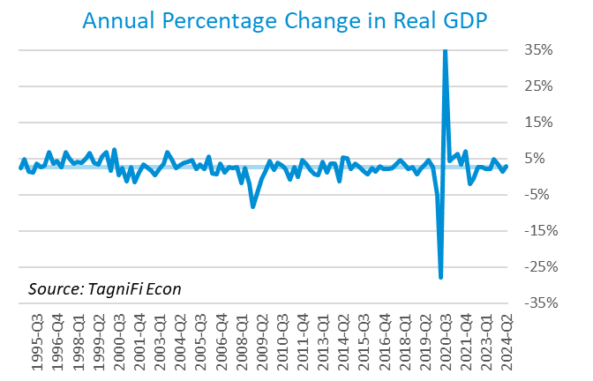

Personal consumption expenditures[4] (PCE) had a positive 1.6% effect on real GDP in the 2nd quarter. A rise in spending on services, especially for health care, housing and utilities, and recreation services, led PCE growth. Spending on goods also rose, led by motor vehicles and parts, recreational goods and vehicles, furnishings and durable household equipment, and gasoline and other energy goods.

Gross domestic private investment[5] contributed 1.5% to the increase in the 2nd quarter real GDP estimate. Private inventory investment rose, particularly in the wholesale trade and retail trade industries. The increase in nonresidential fixed investment reflected increases in equipment and intellectual property products, partly offset by a decrease in structures.

Government expenditures[6] also rose at the state and local level, contributing 0.5% to the 2nd quarter GDP gain. Higher government expenditures were led by state and local government consumption and national defense investment.

Net exports[7] had a negative 0.7% effect on real GDP in the 2nd quarter as growth of imports (which have a negative effect on GDP) far outpaced that of exports. Import gains were seen primarily in capital goods, excluding automotive.

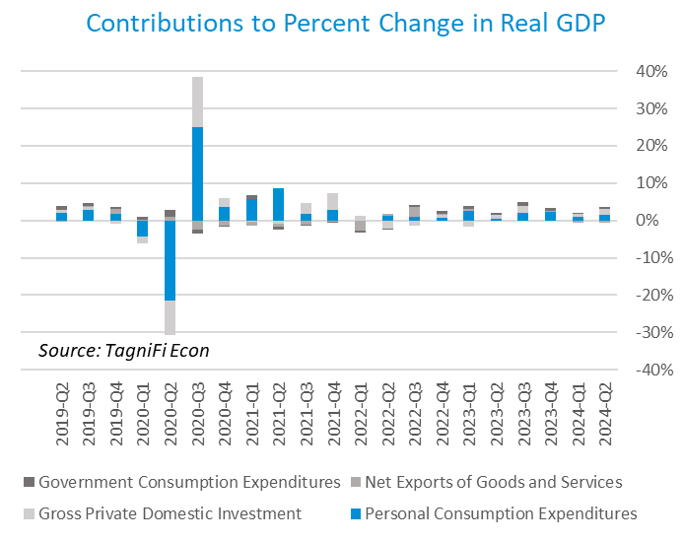

Economists polled by the Livingston Survey[8] in June 2024 projected real GDP to rise to an annual rate of 2.0% in the 1st half of 2024, moderating to an annual rate of 1.7% in the 2nd half of 2024 before rebounding to 2.0% in the 1st half of 2025.

The Industrial Production Index[9] is an economic indicator that measures real output for all facilities located in the United States manufacturing, mining, and electric, and gas utilities. The index stood at 104.0 at the end of the 2nd quarter, up 1.6% from the 2nd quarter.

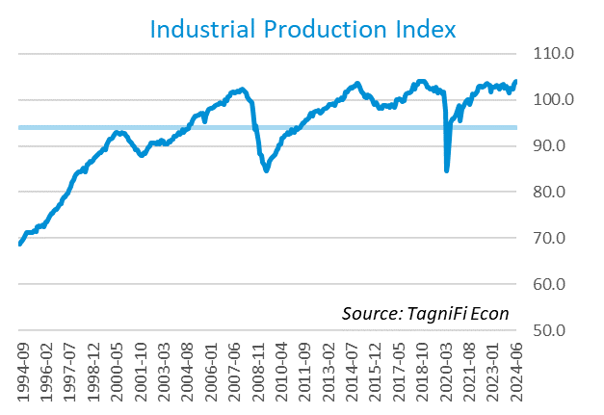

The Capacity Utilization Index[10], which attempts to capture industrial output as a percentage of the economy’s maximum production capacity, ended the 2nd quarter of 2024 at 77.8%. June 2024’s level was above the 30-year average of 76.9% for this metric and up 0.5% from the previous quarter.

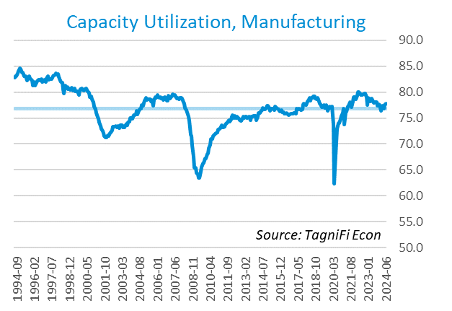

# Interest Rates

The effective federal funds rate[11] was unchanged at 5.33% during the 2nd quarter, holding steady at the 23-year high reached in the 3rd quarter of 2023. Treasury bond yields[12] for periods of one year and up rose slightly during the 2nd quarter, with the yield curve remaining inverted. The closely watched two- and ten-year rates have been inverted since July 2022. The 1-year and 2-year annual treasury yields ended the 2nd quarter at 5.09% and 4.71%, respectively. The benchmark 10-year treasury yielded 4.36% at the end of the quarter, while the 30-year treasury yielded 4.51%. See *Appendix – Selected Interest Rates* for detailed interest rate data.

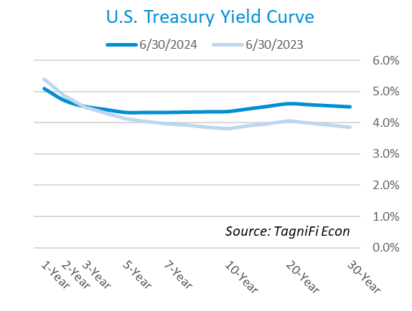

In the 2nd quarter of 2024, the Federal Reserve continued to hold the federal funds target rate[13] steady throughout the quarter at a range of 5.25% to 5.50%—the highest in over 23 years. With inflation still above the Fed’s goal despite making slow progress, and economic conditions remaining strong, the FOMC remains cautious in its approach to monetary policy, signaling just one expected rate cut in 2024 and raising its long-term interest rate projection.

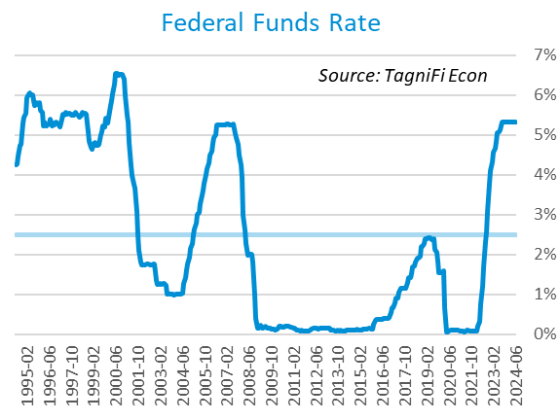

The yield on the benchmark 10-year U.S. treasury[14] ended the 2nd quarter at 4.36%, up 0.16 percentage points from the previous quarter and above the average yield of 3.80% over the last 30 years.

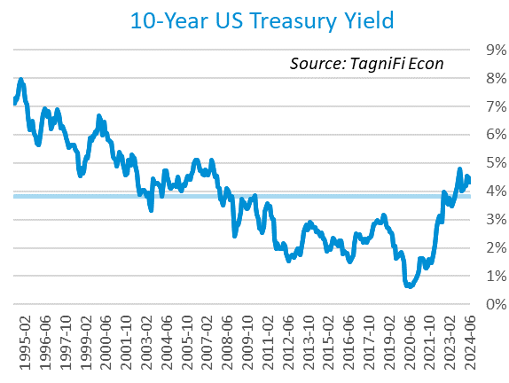

Moody’s Baa Corporate Bond Yield Index[15] ended the 2nd quarter of 2024 at 5.91%, up 0.21 percentage points since the previous quarter. Moody’s less-risky Aaa[16] Index rose 0.22 percentage points during the quarter to a level of 5.19%.

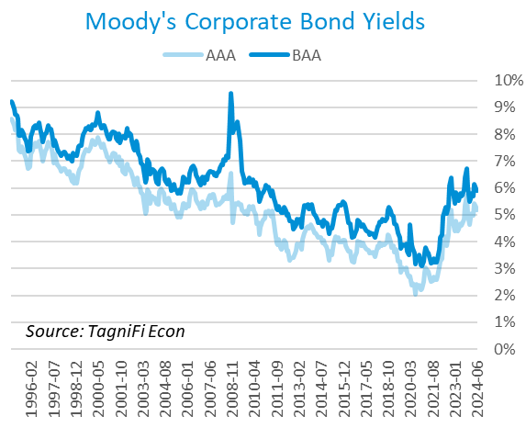

# Employment

The jobs market, which has been a bright spot in the US economy throughout the pandemic recovery, waned slightly in 2nd quarter of 2024. The official unemployment rate[17] ended the 2nd quarter at 4.1%, up from the prior quarter but well below the 30-year historical average of 5.6% and within the 4.0% to 5.0% range accepted as an equilibrium level of “full employment.” The labor force[18] rose by 0.1 million workers during the quarter. The labor force participation rate[19] inched down to 62.6% in June 2024, 0.7 percentage points below its pre-pandemic level. Economists polled by the Livingston Survey in June 2024 projected the unemployment rate to be 3.9% in June, rising slightly to 4.0% in December 2024 and 4.1% in June 2025.

In May 2024, nonfarm worker quits[20] stood at 3.5 million, up 0.2% over the month but down 13.7% over the year. Job openings[21] totaled 8.1 million in May 2024, 2.4 times the number of resignations. The job openings count was up 2.8% from April but down 12.6% from May 2023.

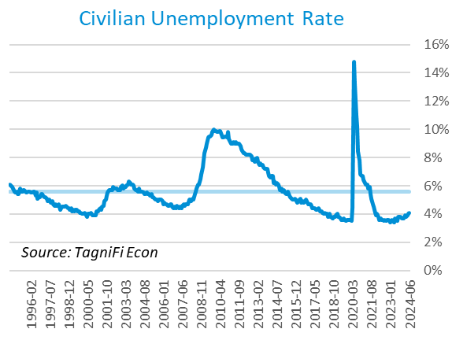

The U-6 unemployment rate[22] is an alternative measure of unemployment with a broader definition, including such groups as discouraged workers who are not actively searching for jobs but want full-time work and part-time workers who want full-time work. The U‑6 unemployment rate has generally followed the same pattern as the official rate and stood at 7.4% in June 2024.

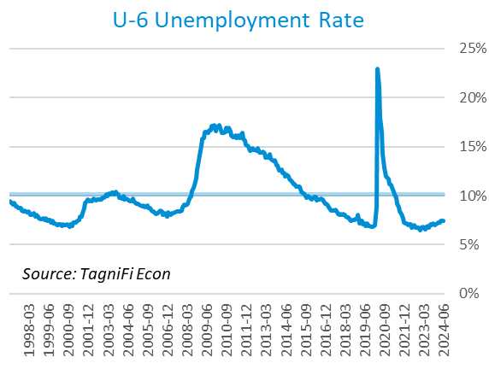

Nonfarm payrolls[23] grew by 0.5 million jobs in the 2nd quarter. U.S. nonfarm payrolls in June 2024 totaled 158.6 million jobs, up 2.6 million from the prior June. June’s job market growth was highly concentrated in healthcare and social assistance and government, especially education. Several other sectors gained jobs, such as construction and wholesale trade, while three sectors lost jobs—professional and business services, retail trade, and manufacturing.

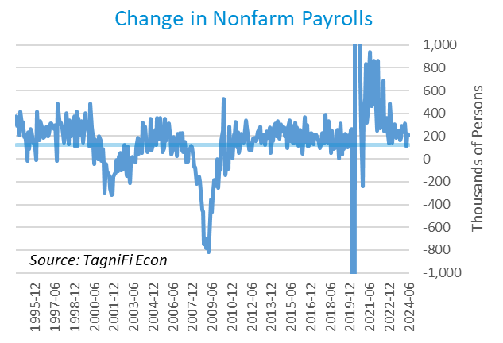

# Inflation

In the 2nd quarter of 2024, inflation kept a more moderate pace than much of 2021 and 2022. The Consumer Price Index[24] for all items rose 3.0% for the year ended June 2024. Since last June, notable price increases included shelter, motor vehicle insurance, medical care, personal care, and recreation, as well as food. Prices for energy goods also rose, except for gasoline. Excluding volatile energy prices[25], the annual increase was 3.1%. The average price of a gallon of gas[26] in the U.S. rose 0.6% during the 2nd quarter 2024 to $3.60. June’s average price was 3.0% lower than one year prior.

In the month of June 2024, prices fell for energy, especially gasoline. Moderating the decline were higher prices for shelter, as well as motor vehicle insurance, household furnishings and operations, medical care, and personal care. Prices also rose for food, both away from home and at home.

The Federal Reserve, which had been taking aggressive action to curb inflation with a series of target interest rate hikes totaling 5.25 percentage points from March 2022 to July 2023, continued to hold the target rate steady throughout the 2nd quarter of 2024. While multiple rate cuts had been expected in 2024, sluggish cooling of inflation data and continued economic strength in the 1st half prompted the Fed to leave target rates at their current level and revise predictions of future target rates upward.

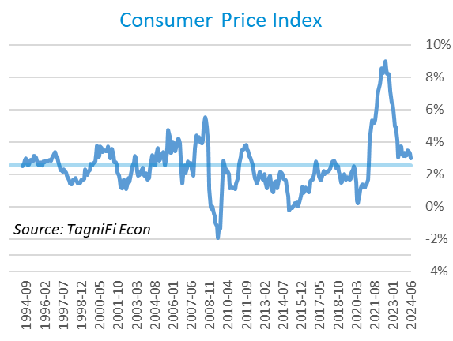

Wholesale inflation has been quicker to regulate than consumer inflation. The Producer Price Index[27] rose 0.2% in the 2nd quarter and 0.6% since June 2023. The average annual increase over the last 30 years was 2.8%.

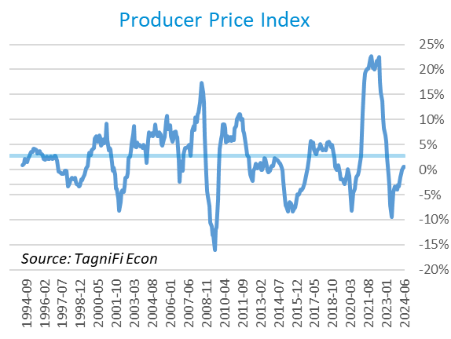

The 5-year breakeven inflation rate[28], an indicator for the market’s inflation expectations for the period, declined to 2.24% at the end of the 2nd quarter 2024 from 2.38% at the end of the 1st quarter.

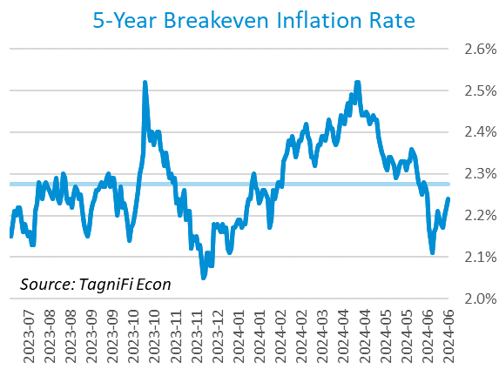

U.S. crude oil[29] prices fell in the 2nd quarter, settling at $82.83 per barrel amid relatively soft US demand, partly attributed to the Fed foreshadowing plans to keep interest rates high for longer than expected. US crude and gasoline inventories climbed in June and demand further softened due to coastal flooding. Hopes for a summer rebound in fuel demand and escalating tensions in the Middle East tempered the price declines. Crude prices ended the 2nd quarter down 1.3% from the prior quarter but up 17.2% year-over-year.

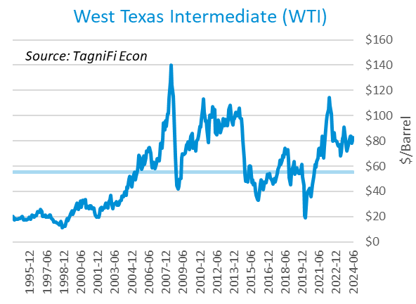

# Housing

Persistently elevated mortgage rates continued to constrain sales in the housing market during the 2nd quarter of 2024, and unsold inventory rose closer to pre-pandemic levels. Home prices in major cities continued to rise. New home starts[30] rose 4.2% during the 2nd quarter to a level of 1.35 million in June due to a jump in multi-family home starts; single family home starts declined. Total new home starts were down 4.4% year-over-year but stood slightly above their 30-year average of 1.34 million.

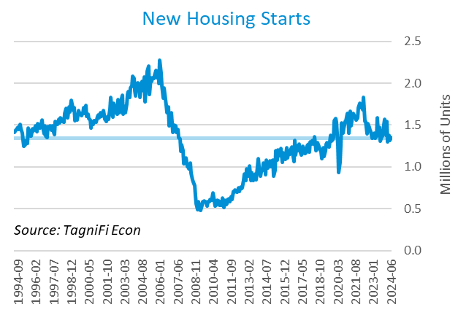

The cost of financing for would-be homebuyers rose during the 2nd quarter, with the 30-year fixed-rate mortgage[31] up 1.00 percentage points to an average of 6.86% at the end of June 2024. The average rate was still lower than its peak of 7.79% in late October.

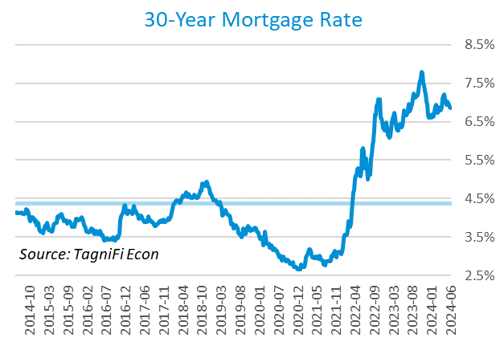

The S&P Case-Shiller Home Price Index (20-city)[32] was 1.1% higher quarter-over-quarter and 6.7% higher since May 2023. Led by New York, San Diego, Las Vegas, and Los Angeles, all of the 20 cities experienced one-year price increases.

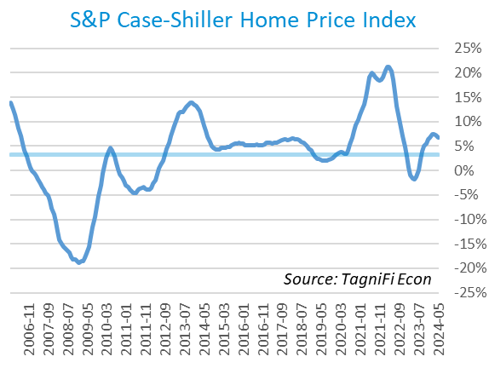

# Consumer Spending

Personal Consumption Expenditures (PCE)[33] rose 0.9% in the 2nd quarter to $19.4 trillion and 5.2% over the same quarter last year. Spending increased in June for services such as other services (led by international travel) and housing and utilities (led by housing). Goods spending also increased, especially for other nondurable goods (led by pharmaceutical and other medical products) and recreational goods and vehicles; however, goods spending was moderated by decreases in motor vehicles and parts (led by new motor vehicles) and gasoline and other energy goods.

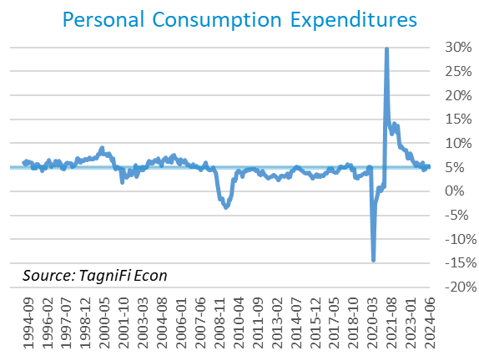

Auto manufacturers reported autos and light trucks sold[34] at an annual rate of 15.3 million in June 2024, down 1.3% from March. New vehicle prices[35] remained near their record high, inching down 0.1% during the 2nd quarter. Used car prices[36] fell 2.3% from March to June.

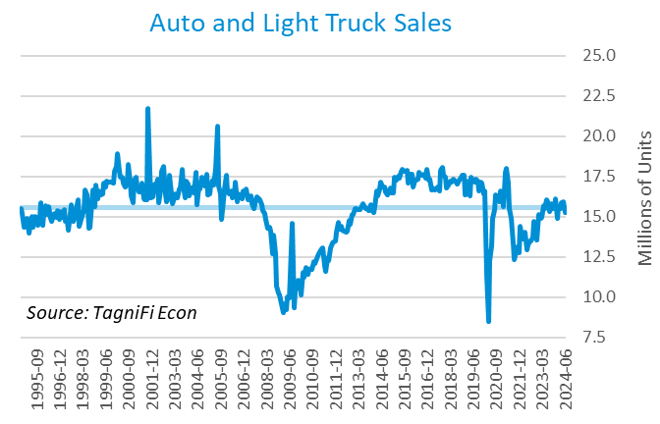

The University of Michigan’s consumer sentiment index[37] stood at 68.2 in June 2024, down from 79.4 in March but still above its all-time low of 50.0 in June 2022. The continued elevation in prices has been an important factor in consumer sentiment in recent months, especially for lower-income Americans. The index was up 6.2% year-over-year yet still well below its 30-year average of 86.1.

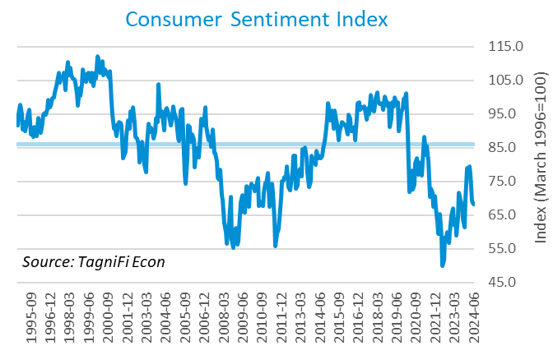

# Capital Markets

The table below shows the quarterly, year-to-date, and 12-month performance of major U.S. equity indices. Capital markets posted mixed results in the 2nd quarter of 2024 as expectations of interest rate cuts were met with Fed caution; still, AI’s boost to technology-sector stocks pushed markets to a positive 1st half. AI’s influence was evident in 2nd-quarter results among major market indices, as the tech-heavy NASDAQ Composite and NASDAQ 100 climbed 8.3% and 7.8%, respectively, during the quarter. The broader S&P 500 rose 3.9%, and the Dow Jones Utility Average rose 2.8%. Other blue-chip focused Dow Jones averages—Transportation, Composite, and Industrial—were down 4.9%, 2.1%, and 1.7%, respectively, during the 2nd quarter.



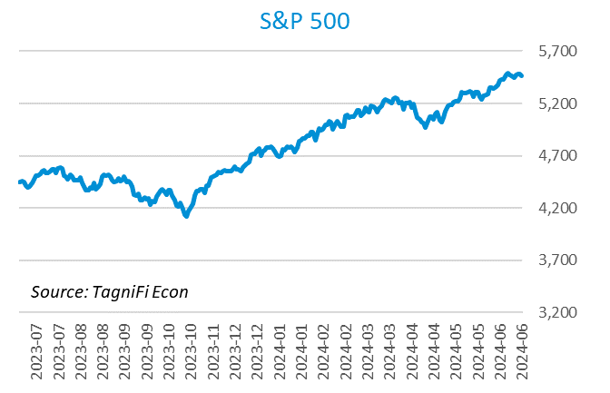

Corporate debt issuances were up in the second quarter, with the ICE BofA US Corporate Index[38] inching up 0.1% and the ICE BofA US High Yield Index[39] increasing 1.1%.



Stock market volatility, as measured by the VIX [40], ended the 2nd quarter of 2024 at 12.4, down 4.4% since the prior quarter and 8.5% since the 2nd quarter of 2023. The VIX rose in April before receding in May and June.

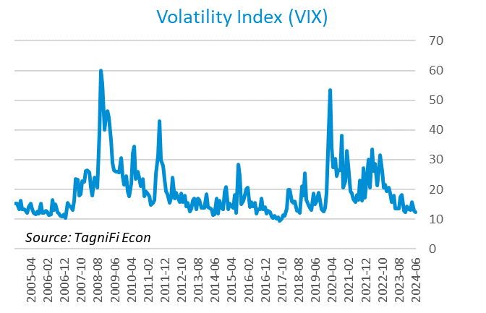

# Outlook

In June 2024, the FOMC revised their near-term PCE inflation projections upward and real GDP projections slightly downward; minimal adjustments were made to unemployment rate projections or to longer-term projections for any of the three indicators.

The FOMC revised their projections for Personal Consumption Expenditures (PCE) inflation[41] upward for 2024 to 2.70%, moderating to 2.30% in 2025; projections for 2026 held steady at 2.05%. They revised real GDP[42] projections downward slightly to 2.1% in 2024 and 2.00% in 2025, while 2026 projections were unchanged at 1.95%. They expected that the unemployment rate[43] would be 4.05% in 2024, 4.05% in 2025, and 4.10% in 2026. The board raised projections of future target rates[44] to 5.15% in 2024, 4.15% in 2025, and 3.25% in 2026. The committee again emphasized a willingness to hold rates steady as long as warranted, and decreased the number of predicted rate cuts in 2024 from three to one.



Appendix – Selected Interest Rates



# About This Report

The *Quarterly Economic Update* is a free publication sponsored by TagniFi. You are free to share this report and include its contents in the economic outlook section of your valuation reports as required by *Revenue Ruling 59-60*. Please forward this free report to a colleague to help us spread the word about TagniFi.

How TagniFi Helps Business Valuation Teams

TagniFi’s financial data platform empowers business valuation teams to quickly and easily build highly accurate financial models with full transparency—and within seconds.

**Better Public Comps**  
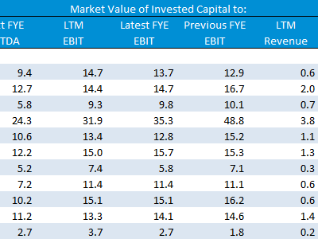Search for public companies with TagniFi Web. Simply enter your valuation date and ticker symbols in Excel to run a guideline public company method. Your Excel model populates instantly with the financial statements, analyst estimates, interest rates and economic data for your valuation date.

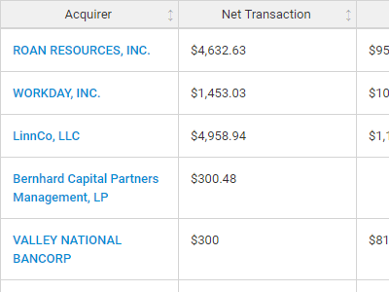

**Better Transaction Comps**  
Search for public and private M&A transactions with TagniFi Web. Run your transaction comps within seconds by pasting the Deal ID into your Excel model. Every deal disclosed in an SEC filing (8-K, 10-K, or 10-Q) is available for your analysis. Choose from over 90 fields of data available for every deal.

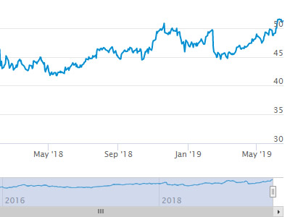

**Historical Beta and Volatility**Calculate historical beta and volatility as of your valuation date automatically. Simply enter the tickers and valuation date in Excel - TagniFi does the rest. In addition to beta and volatility, there are over 40 Excel models available in the Model Library to help with your valuation report.

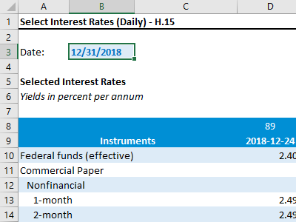**Interest Rates and Economic Data**Automate the interest rates and economic data in your valuation report using the TagniFi Excel plugin. Choose from over 200,000 time series available. All data in this *Quarterly Economic Update* is from the TagniFi platform. Use economic and interest rate data for your own valuation models with the TagniFi Excel plugin.

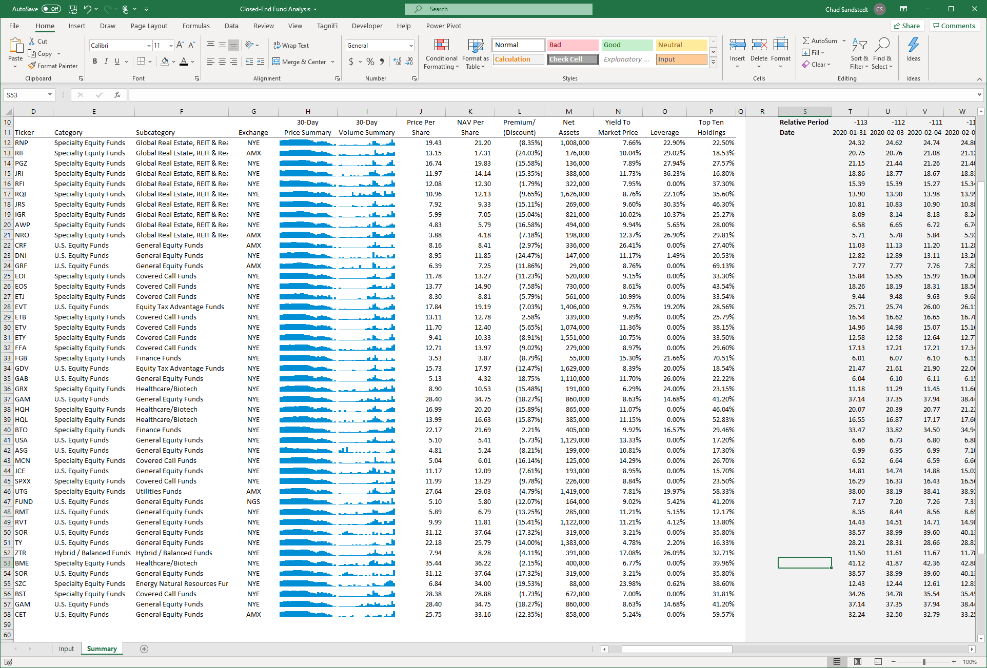

**Closed-End Mutual Fund Data**Search for closed-end mutual funds by keyword, category, subcategory, and more with the TagniFi Console. Use the TagniFi Excel plugin to calculate historical discounts, yields, leverage, as of your valuation date automatically. Simply enter the tickers and valuation date in Excel - TagniFi does the rest.

**Corporate Bond Data**Use interest rates along any point of the yield curve for your debt valuation engagements as of your valuation date. View historical price and yield information for over 80,000 corporate bond along with their characteristics.Search for bonds by rating to find guideline bonds for your analysis.

1. Federal Reserve Bank of Philadelphia, Coincident Economic Activity Index for the United States [USPHCI], *retrieved from FRED, Federal Reserve Bank of St. Louis;* [*https://fred.stlouisfed.org/series/USPHCI*](https://fred.stlouisfed.org/series/USPHCI)*, Jul 26, 2024.*
2. Board of Governors of the Federal Reserve System (US), Trade Weighted U.S. Dollar Index: Broad, Goods and Services [DTWEXBGS], *retrieved from FRED, Federal Reserve Bank of St. Louis;* [*https://fred.stlouisfed.org/series/DTWEXBGS*](https://fred.stlouisfed.org/series/DTWEXBGS)*, Jul 26, 2024.*
3. U.S. Bureau of Economic Analysis, Real Gross Domestic Product [GDPC1], *retrieved from FRED, Federal Reserve Bank of St. Louis;*[*https://fred.stlouisfed.org/series/GDPC1*](https://fred.stlouisfed.org/series/GDPC1)*, July 26, 2024.*
4. U.S. Bureau of Economic Analysis, Contributions to percent change in real gross domestic product: Personal consumption expenditures [DPCERY2Q224SBEA], *retrieved from FRED, Federal Reserve Bank of St. Louis;* [*https://fred.stlouisfed.org/series/DPCERY2Q224SBEA*](https://fred.stlouisfed.org/series/DPCERY2Q224SBEA)*, Jul 26, 2024.*
5. U.S. Bureau of Economic Analysis, Contributions to percent change in real gross domestic product: Gross private domestic investment [A006RY2Q224SBEA], *retrieved from FRED, Federal Reserve Bank of St. Louis;* [*https://fred.stlouisfed.org/series/A006RY2Q224SBEA*](https://fred.stlouisfed.org/series/A006RY2Q224SBEA)*, Jul 26, 2024.*
6. U.S. Bureau of Economic Analysis, Contributions to percent change in real gross domestic product: Government consumption expenditures and gross investment [A822RY2Q224SBEA], *retrieved from FRED, Federal Reserve Bank of St. Louis;* [*https://fred.stlouisfed.org/series/A822RY2Q224SBEA*](https://fred.stlouisfed.org/series/A822RY2Q224SBEA)*, Jul 26, 2024.*
7. U.S. Bureau of Economic Analysis, Contributions to percent change in real gross domestic product: Net exports of goods and services [A019RY2Q224SBEA], *retrieved from FRED, Federal Reserve Bank of St. Louis;* [*https://fred.stlouisfed.org/series/A019RY2Q224SBEA*](https://fred.stlouisfed.org/series/A019RY2Q224SBEA)*, Jul 26, 2024.*
8. Federal Reserve Bank of Philadelphia, The Livingston Survey December 2023, [economic release], retrieved from <https://www.philadelphiafed.org/surveys-and-data/real-time-data-research/livingston-survey>, Jul 26, 2024.
9. Board of Governors of the Federal Reserve System (US), Industrial Production Index [INDPRO], *retrieved from FRED, Federal Reserve Bank of St. Louis;*[*https://fred.stlouisfed.org/series/INDPRO*](https://fred.stlouisfed.org/series/INDPRO)*, Jul 26, 2024.*
10. Board of Governors of the Federal Reserve System (US), Capacity Utilization, Manufacturing (NAICS), *retrieved from FRED, Federal Reserve Bank of St. Louis;* [*https://fred.stlouisfed.org/series/MCUMFN*](https://fred.stlouisfed.org/series/MCUMFN)*, Jul 26, 2024.*
11. Board of Governors of the Federal Reserve System (US), Federal Funds Effective Rate [FEDFUNDS], *retrieved from FRED, Federal Reserve Bank of St. Louis;* [*https://fred.stlouisfed.org/series/FEDFUNDS*](https://fred.stlouisfed.org/series/FEDFUNDS)*, Jul 26, 2024.*
12. Selected Interest Rates Instruments, Yields in percent per annum, *retrieved from FRED, Federal Reserve Bank of St. Louis;* [https://fred.stlouisfed.org/release/tables?rid=18&eid=289&od=2024-06-28#](https://fred.stlouisfed.org/release/tables?rid=18&eid=289&od=2024-06-28)*, Jul 26, 2024.*
13. Board of Governors of the Federal Reserve System (US), Federal Funds Target Range - Upper Limit [DFEDTARU], *retrieved from FRED, Federal Reserve Bank of St. Louis;* [*https://fred.stlouisfed.org/series/DFEDTARU*](https://fred.stlouisfed.org/series/DFEDTARU)*, Jul 26, 2024*.
14. Board of Governors of the Federal Reserve System (US), 10-Year Treasury Constant Maturity Rate [DGS10], *retrieved from FRED, Federal Reserve Bank of St. Louis;*[*https://fred.stlouisfed.org/series/DGS10*](https://fred.stlouisfed.org/series/DGS10)*, Jul 26, 2024.*
15. Moody’s, Moody's Seasoned Baa Corporate Bond Yield [DBAA], *retrieved from FRED, Federal Reserve Bank of St. Louis;* [*https://fred.stlouisfed.org/series/DBAA*](https://fred.stlouisfed.org/series/DBAA)*, Jul 26, 2024.*
16. Moody’s, Moody's Seasoned Aaa Corporate Bond Yield [DAAA], *retrieved from FRED, Federal Reserve Bank of St. Louis;* [*https://fred.stlouisfed.org/series/DAAA*](https://fred.stlouisfed.org/series/DAAA)*, Jul 26, 2024.*
17. U.S. Bureau of Labor Statistics, Civilian Unemployment Rate [UNRATE], *retrieved from FRED, Federal Reserve Bank of St. Louis;*[*https://fred.stlouisfed.org/series/UNRATE*](https://fred.stlouisfed.org/series/UNRATE)*, Jul 26, 2024.*
18. U.S. Bureau of Labor Statistics, Civilian Labor Force Level [CLF16OV], *retrieved from FRED, Federal Reserve Bank of St. Louis;* [*https://fred.stlouisfed.org/series/CLF16OV*](https://fred.stlouisfed.org/series/CLF16OV)*, Jul 26, 2024.*
19. U.S. Bureau of Labor Statistics, Labor Force Participation Rate [CIVPART], *retrieved from FRED, Federal Reserve Bank of St. Louis;* [*https://fred.stlouisfed.org/series/CIVPART*](https://fred.stlouisfed.org/series/CIVPART)*, Jul 26, 2024.*
20. U.S. Bureau of Labor Statistics, Quits: Total Nonfarm [JTSQUL], *retrieved from FRED, Federal Reserve Bank of St. Louis;* [*https://fred.stlouisfed.org/series/JTSQUL*](https://fred.stlouisfed.org/series/JTSQUL)*, Jul 26, 2024.*
21. U.S. Bureau of Labor Statistics, Job Openings: Total Nonfarm [JTSJOL], *retrieved from FRED, Federal Reserve Bank of St. Louis;* [*https://fred.stlouisfed.org/series/JTSJOL*](https://fred.stlouisfed.org/series/JTSJOL)*, Jul 26, 2024.*
22. U.S. Bureau of Labor Statistics Total Unemployed, Plus All Persons Marginally Attached to the Labor Force, Plus Total Employed Part Time for Economic Reasons, as a Percent of the Civilian Labor Force Plus All Persons Marginally Attached to the Labor Force (U-6) [U6RATE], *retrieved from FRED, Federal Reserve Bank of St. Louis;*[*https://fred.stlouisfed.org/series/U6RATE*](https://fred.stlouisfed.org/series/U6RATE)*, Jul 26, 2024.*
23. U.S. Bureau of Labor Statistics, All Employees: Total Nonfarm Payrolls [PAYEMS], *retrieved from FRED, Federal Reserve Bank of St. Louis;*[*https://fred.stlouisfed.org/series/PAYEMS*](https://fred.stlouisfed.org/series/PAYEMS)*, Jul 26, 2024.*
24. U.S. Bureau of Labor Statistics, Consumer Price Index for All Urban Consumers: All Items [CPIAUCSL], *retrieved from FRED, Federal Reserve Bank of St. Louis;*[*https://fred.stlouisfed.org/series/CPIAUCSL*](https://fred.stlouisfed.org/series/CPIAUCSL)*, Jul 26, 2024.*
25. U.S. Bureau of Labor Statistics, Consumer Price Index for All Urban Consumers: All Items Less Energy in U.S. City Average [CPILEGSL], *retrieved from FRED, Federal Reserve Bank of St. Louis;* [*https://fred.stlouisfed.org/series/CPILEGSL*](https://fred.stlouisfed.org/series/CPILEGSL)*, Jul 26, 2024*.
26. U.S. Bureau of Labor Statistics, Average Price: Gasoline, Unleaded Regular (Cost per Gallon/3.785 Liters) in U.S. City Average [APU000074714], *retrieved from FRED, Federal Reserve Bank of St. Louis;* [*https://fred.stlouisfed.org/series/APU000074714*](https://fred.stlouisfed.org/series/APU000074714)*, Jul 26, 2024.*
27. U.S. Bureau of Labor Statistics, Producer Price Index for All Commodities [PPIACO], *retrieved from FRED, Federal Reserve Bank of St. Louis;*[*https://fred.stlouisfed.org/series/PPIACO*](https://fred.stlouisfed.org/series/PPIACO)*, Jul 26, 2024.*
28. *Federal Reserve Bank of St. Louis, 5-Year Breakeven Inflation Rate [T5YIE], retrieved from FRED, Federal Reserve Bank of St. Louis;*[*https://fred.stlouisfed.org/series/T5YIE*](https://fred.stlouisfed.org/series/T5YIE)*, Jul 26, 2024.*
29. U.S. Energy Information Administration, Crude Oil Prices: West Texas Intermediate (WTI) - Cushing, Oklahoma [DCOILWTICO], *retrieved from FRED, Federal Reserve Bank of St. Louis;* [*https://fred.stlouisfed.org/series/DCOILWTICO*](https://fred.stlouisfed.org/series/DCOILWTICO)*, July 26, 2024.*
30. U.S. Bureau of the Census, Housing Starts: Total: New Privately Owned Housing Units Started [HOUST], *retrieved from FRED, Federal Reserve Bank of St. Louis;*[*https://fred.stlouisfed.org/series/HOUST*](https://fred.stlouisfed.org/series/HOUST)*, Jul 26, 2024.*
31. Freddie Mac, 30-Year Fixed Rate Mortgage Average in the United States [MORTGAGE30US], *retrieved from FRED, Federal Reserve Bank of St. Louis;*[*https://fred.stlouisfed.org/series/MORTGAGE30US*](https://fred.stlouisfed.org/series/MORTGAGE30US)*, Jul 26, 2024.*
32. S&P Dow Jones Indices LLC, S&P/Case-Shiller 20-City Composite Home Price Index [SPCS20RSA], *retrieved from FRED, Federal Reserve Bank of St. Louis;*[*https://fred.stlouisfed.org/series/SPCS20RSA*](https://fred.stlouisfed.org/series/SPCS20RSA)*, Jul 26, 2024.*
33. U.S. Bureau of Economic Analysis, Personal Consumption Expenditures [PCE], *retrieved from FRED, Federal Reserve Bank of St. Louis;*[*https://fred.stlouisfed.org/series/PCE*](https://fred.stlouisfed.org/series/PCE)*, Jul 26, 2024.*
34. U.S. Bureau of Economic Analysis, Light Weight Vehicle Sales: Autos and Light Trucks [ALTSALES], *retrieved from FRED, Federal Reserve Bank of St. Louis; <https://fred.stlouisfed.org/series/ALTSALES>, Jul 26, 2024.*
35. U.S. Bureau of Labor Statistics, Consumer Price Index for All Urban Consumers: New Vehicles in U.S. City Average [CUUR0000SETA01], *retrieved from FRED, Federal Reserve Bank of St. Louis;* [*https://fred.stlouisfed.org/series/CUUR0000SETA01*](https://fred.stlouisfed.org/series/CUUR0000SETA01)*, Jul 26, 2024.*
36. U.S. Bureau of Labor Statistics, Consumer Price Index for All Urban Consumers: Used Cars and Trucks in U.S. City Average [CUSR0000SETA02], *retrieved from FRED, Federal Reserve Bank of St. Louis;* [*https://fred.stlouisfed.org/series/CUSR0000SETA02*](https://fred.stlouisfed.org/series/CUSR0000SETA02), *Jul 26, 2024.*
37. *University of Michigan, University of Michigan: Consumer Sentiment [UMCSENT], retrieved from FRED, Federal Reserve Bank of St. Louis;* [*https://fred.stlouisfed.org/series/UMCSENT*](https://fred.stlouisfed.org/series/UMCSENT)*, Jul 26, 2024.*
38. *Ice Data Indices, LLC, ICE BofA US Corporate Index Total Return Index Value [BAMLCC0A0CMTRIV], retrieved from FRED, Federal Reserve Bank of St. Louis;* [*https://fred.stlouisfed.org/series/BAMLCC0A0CMTRIV*](https://fred.stlouisfed.org/series/BAMLCC0A0CMTRIV)*, Jul 31, 2024.*
39. *Ice Data Indices, LLC, ICE BofA US High Yield Index Total Return Index Value [BAMLHYH0A0HYM2TRIV], retrieved from FRED, Federal Reserve Bank of St. Louis;* [*https://fred.stlouisfed.org/series/BAMLHYH0A0HYM2TRIV*](https://fred.stlouisfed.org/series/BAMLHYH0A0HYM2TRIV)*, Jul 31, 2024*
40. *Chicago Board Options Exchange, CBOE Volatility Index: VIX [VIXCLS], retrieved from FRED, Federal Reserve Bank of St. Louis;* [*https://fred.stlouisfed.org/series/VIXCLS*](https://fred.stlouisfed.org/series/VIXCLS)*, Jul 26, 2024.*
41. *Federal Reserve Bank of St. Louis, FOMC Summary of Economic Projections for the Personal Consumption Expenditures Inflation Rate, Central Tendency, Midpoint [PCECTPICTM], retrieved from FRED, Federal Reserve Bank of St. Louis;*[*https://fred.stlouisfed.org/series/PCECTPICTM*](https://fred.stlouisfed.org/series/PCECTPICTM)*, Jul 26, 2024.*
42. *Federal Reserve Bank of St. Louis, FOMC Summary of Economic Projections for the Growth Rate of Real Gross Domestic Product [GDPC1CTM], retrieved from FRED, Federal Reserve Bank of St. Louis;*[*https://fred.stlouisfed.org/series/GDPC1CTM*](https://fred.stlouisfed.org/series/GDPC1CTM)*,* *Jul 26, 2024.*
43. *Federal Reserve Bank of St. Louis, FOMC Summary of Economic Projections for the Civilian Unemployment Rate, Central Tendency, Midpoint [UNRATECTM], retrieved from FRED, Federal Reserve Bank of St. Louis;*[*https://fred.stlouisfed.org/series/UNRATECTM*](https://fred.stlouisfed.org/series/UNRATECTM)*, Jul 26, 2024.*
44. *U.S. Federal Open Market Committee and Federal Reserve Bank of St. Louis, FOMC Summary of Economic Projections for the Fed Funds Rate, Range, Midpoint [FEDTARCTM], retrieved from FRED, Federal Reserve Bank of St. Louis;* [*https://fred.stlouisfed.org/series/FEDTARCTM*](https://fred.stlouisfed.org/series/FEDTARCTM)*, Jul 26, 2024.*