QUARTERLY ECONOMIC UPDATE

For the 3rd Quarter of 2024

Abstract

Designed for business valuation professionals, TagniFi’s Quarterly Economic   
Update provides timely economic data to satisfy Revenue Ruling 56-60.

# Summary

Overall, the U.S. economy experienced solid growth in the 3rd quarter of 2024, but signs of a cooling economy and a softening labor market emerged. While the economic growth remained solid, unemployment data pointed to a cooling economy and a softening labor market.

Domestic production growth was slightly below expectations in the quarter. Broad increases in personal spending, exports, and government spending contributed to GDP growth while a downturn in private inventory investment and rising imports was a drag on GDP.

Inflation continued to moderate due in part to lower gasoline prices. Soft fuel demand and expected OPEC’s increase in production led to lower crude oil prices. In response, the Federal Reserve cut the interest rate by 0.5% and signaled that additional gradual rate cuts are expected.

A frequent bright spot for the economy in recent years, the job market sent mixed signals in the 3rd quarter of 2024, with unemployment unchanged, labor force participation inching up, and uneven nonfarm employment growth. Still, the labor market remains well within the bounds of full employment.

Capital markets posted strong gains in the 3rd quarter, fueled by the Fed’s interest rate cut and easing concerns about inflation. The broader S&P 500 and Dow Jones Industrial indexes outperformed the tech-heavy NASDAQ indexes.

Housing market data indicated some softening. As sales continued to be constrained by elevated interest rates, unsold housing inventory rose in the 3rd quarter of 2024. Prices in major cities continued to rise year-over-year.

FOMC members’ short-term domestic production and inflation projections were revised slightly downward. Unemployment expectations were revised slightly up, while forecasts of longer-term economic performance were minimally changed across all three measures.

A multifactor indicator of economic strength, the Philadelphia Fed’s coincident index[1] of economic activity in the U.S. rose 0.3% in September 2024 and 0.7% during the 3rd quarter. For the quarter, coincident indexes increased in 34 states, decreased in 10 states, and remained unchanged in 6 states. Coincident indexes reflect unemployment, payroll employment, manufacturing hours, and wages and salaries.



The U.S. dollar index for goods and services[2] declined 2.4% during the 3rd quarter of 2024, reflecting the expectation of the Fed’s rate cuts. The dollar index was down 0.9% from the prior year.

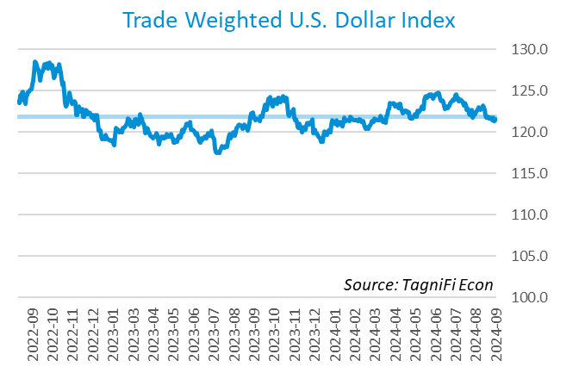

# Q3 Economic Highlights

* The Philadelphia Fed’s coincident index of economic activity in the U.S. rose 0.3% in September 2024 and 0.7% during the 3rd quarter.
* The U.S. dollar index rose 2.4% during the 3rd quarter of 2024 and was down 0.9% from the prior year.
* Real GDP grew at an annualized rate of 2.8% during the 3rd quarter of 2024.
* The effective federal funds rate declined to 5.13% during the 3rd quarter, the first decline since the 23-year high reached in the 3rd quarter of 2023.
* The 1-year and 2-year annual treasury yields ended the 3rd quarter at 3.98% and 3.66%, respectively. The benchmark 10-year treasury yielded 3.81% at the end of the quarter, while the 30-year treasury yielded 4.14%.
* The unemployment rate ended the 3rd quarter at 4.1%, unchanged from the prior quarter. Nonfarm payrolls grew by 0.4 million jobs in the 3rd quarter.
* The Consumer Price Index for all items rose 3.4% for the year ended September 2024. Excluding volatile energy prices, the annual increase was 3.1%.
* Crude oil prices ended the 3rd quarter at $68.75 per barrel, down 17.0% from the prior quarter and down 24.3% year-over-year.
* New home starts rose 1.9% during the 3rd quarter to 1.54 million in September. Total new home starts were down 0.7% year-over-year.
* The NASDAQ Composite climbed 2.6% during the 3rd quarter. The S&P 500 rose 5.5%, while the Dow Jones Transportation, Composite, and Industrial Averages were up 5.7%, 8.6%, and 8.2%, respectively, during the quarter.

# Business Activity

Real gross domestic product (GDP)[3] grew at an annualized rate of 2.8% during the 3rd quarter of 2024, slightly lower than expected, and down from 3.0% in the 2nd quarter. Gains in consumer spending and exports were tempered by the downturn in private inventory investment, a larger decline in residential fixed investment, and increasing imports. Government spending also increased in the 3rd quarter. The scale and makeup of the 3rd quarter GDP growth pointed to continued economic expansion.

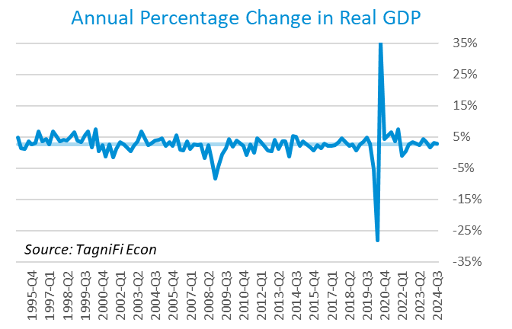

Personal consumption expenditures[4] (PCE) had a positive 2.5% effect on real GDP in the 3rd quarter. A rise in spending on services, especially for health care as well as food services and accommodations, contributed to PCE growth. Spending on goods also rose, led by other nondurable goods (such as prescription drugs) and motor vehicles and parts.

Gross domestic private investment[5] contributed 0.1% to the increase in the 3rd quarter real GDP estimate. Private inventory investment declined, particularly in wholesale and retail industries. The increase in nonresidential fixed investment reflected increases in equipment and intellectual property products, partially offset by a decrease in structures. Residential fixed investment declined in the 3rd quarter.

Government expenditures[6] also rose, contributing 0.9% to the 3rd quarter GDP gain. State and local government consumption and national defense investment contributed to higher government expenditures.

Net exports[7] had a negative 0.6% effect on real GDP in the 3rd quarter as the growth of imports (which have a negative impact on GDP) far outpaced that of exports. Import and export gains were seen primarily in capital goods, excluding automotive.

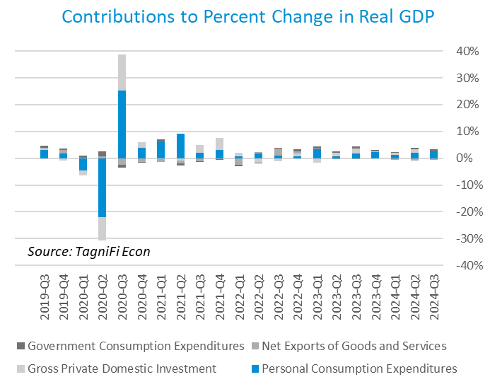

Economists polled by the Livingston Survey[8] in June 2024 projected real GDP to rise to an annual rate of 2.0% in the 1st half of 2024, moderating to an annual rate of 1.7% in the 2nd half of 2024 before rebounding to 2.0% in the 1st half of 2025.

The Industrial Production Index[9] is an economic indicator that measures real output for all facilities located in the United States manufacturing, mining, and electric and gas utility sectors. The index stood at 102.6 at the end of the 3rd quarter, down 0.6% from the 2nd quarter.

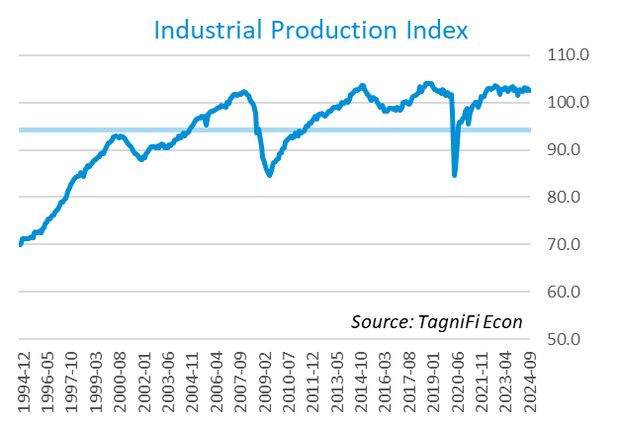

The Capacity Utilization Index[10], which attempts to capture industrial output as a percentage of the economy’s maximum production capacity, ended the 3rd quarter of 2024 at 76.6%. September 2024’s level was slightly below the 30-year average of 76.9% for this metric and down 0.7% from the previous quarter.

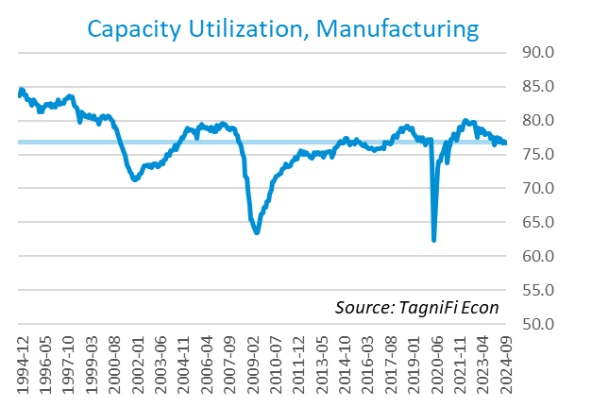

# Interest Rates

The effective federal funds rate[11] stood at 5.13% in the 3rd quarter, down from 5.33% during the 2nd quarter, a first decline since the 23-year high reached in the 3rd quarter of 2023. Treasury bond yields[12] for periods of one year and up declined during the 3rd quarter. The closely watched two-year yield fell below the ten-year rate, signaling the end of the inverted yield curve that was observable since July 2022. The 1-year and 2-year annual treasury yields ended the 3rd quarter at 3.98% and 3.66%, respectively. The benchmark 10-year treasury yielded 3.81% at the end of the quarter, while the 30-year treasury yielded 4.14%. See *Appendix – Selected Interest Rates* for detailed interest rate data.

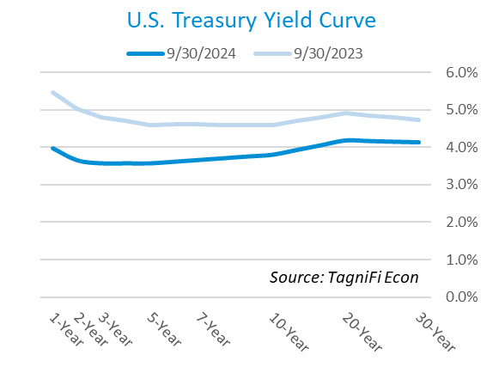

In the 3rd quarter of 2024, the Federal Reserve cut the federal funds target rate[13] to a range of 4.75% to 5.00%, the first cut in four years and a sharp decline from the 23-year high of 5.25% to 5.50%. With the inflation outlook cooling off and the employment market softening, the FOMC signaled that additional rate cuts are likely in the upcoming months.

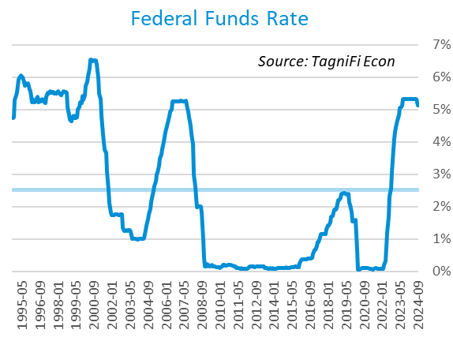

The yield on the benchmark 10-year U.S. treasury[14] ended the 3rd quarter at 3.81%, down 0.55 percentage points from the previous quarter and slightly above the average yield of 3.78% over the last 30 years.

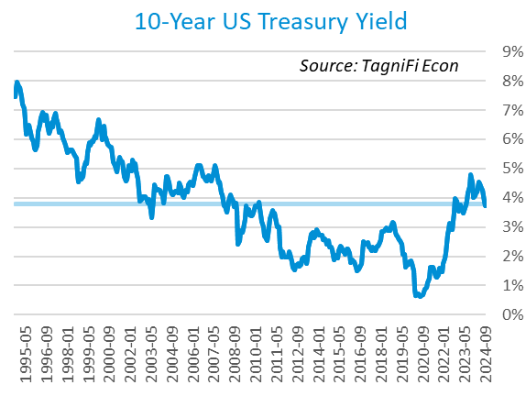

Moody’s Baa Corporate Bond Yield Index[15] ended the 3rd quarter of 2024 at 5.44%, down 0.47 percentage points since the previous quarter. Moody’s less-risky Aaa[16] Index also declined 0.47 percentage points during the quarter to 4.72%.

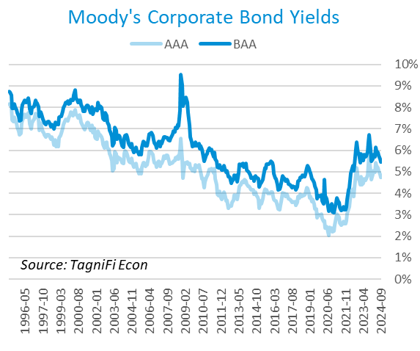

# Employment

The jobs market, a bright spot in the US economy throughout the pandemic recovery, remained steady in the 3rd quarter. The official unemployment rate[17] ended the quarter at 4.1%, unchanged from the prior quarter but well below the 30-year historical average of 5.6% and within the 4.0% to 5.0% range accepted as an equilibrium level of “full employment.” The labor force[18] rose by 0.7 million workers during the quarter while the labor force participation rate[19] inched up to 62.7% in September 2024, 0.6 percentage points below its pre-pandemic level. Economists polled by the Livingston Survey in June 2024 projected the unemployment rate to be 3.9% in June, rising slightly to 4.0% in December 2024 and 4.1% in June 2025.

In September 2024, nonfarm worker quits[20] stood at 3.1 million, down 3.4% over the month and 14.6% over the year. Job openings[21] totaled 7.4 million in September 2024, 2.4 times the number of resignations. The job openings count declined 5.3% from August 2024 and down more than 20% from September 2023.

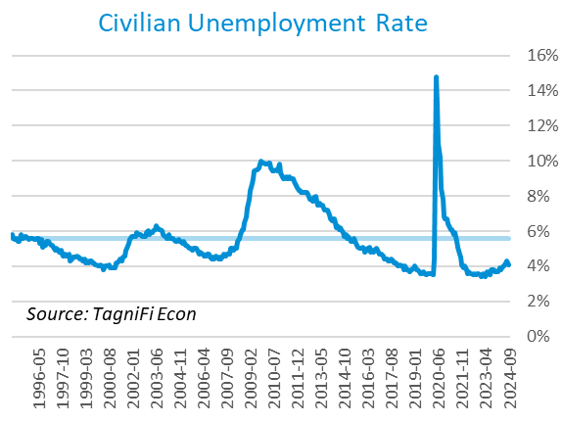

The U-6 unemployment rate[22] is an alternative measure of unemployment with a broader definition, including such groups as discouraged workers who are not actively searching for jobs but want full-time work and part-time workers who want full-time work. The U‑6 unemployment rate has generally followed the same pattern as the official rate and stood at 7.7% in September 2024.

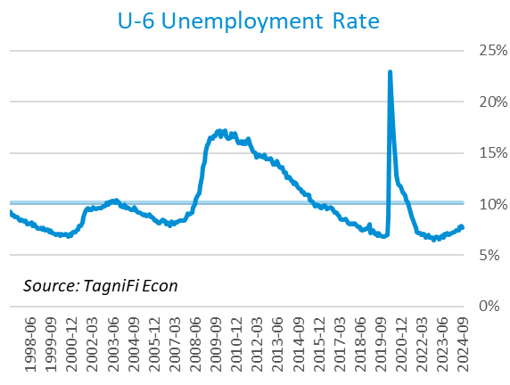

Nonfarm payrolls[23] grew by 0.4 million jobs in the 3rd quarter. U.S. nonfarm payrolls in September 2024 totaled 159.0 million jobs, up 2.3 million from the prior September. September’s job market growth was highly concentrated in healthcare and social assistance government. Several other sectors, such as construction and food services, also gained jobs, while most industries experienced little change.

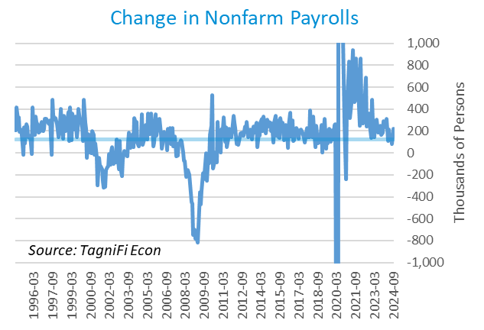

# Inflation

In the 3rd quarter of 2024, inflation kept a more moderate pace than in 2021 and 2022. The Consumer Price Index[24] for all items rose 2.4% for the year ended September 2024. Since last September, notable price increases have included shelter, medical care (including medical care services), motor vehicle insurance, and food. Prices for motor gasoline and fuel declined. Excluding volatile energy prices[25], the annual increase was 3.1%. The average price of a gallon of gas[26] in the U.S. declined 7.14% during the 3rd quarter of 2024 to $3.34. September’s average price was 16.15% lower than one year prior.

In the month of September 2024, prices fell for energy, especially gasoline. Higher prices for shelter, motor vehicle insurance, medical care, apparel, and airline travel moderated the decline in energy prices. Prices also rose for food, both away from home and at home.

The Federal Reserve, which had been taking aggressive action to curb inflation with a series of target interest rate hikes totaling 5.25 percentage points from March 2022 to July 2023, cut the target rate during the 3rd quarter of 2024. While additional rate cuts are expected by the end of 2024, the Fed indicated that the size of the cuts would depend on the inflation and economic data readings.

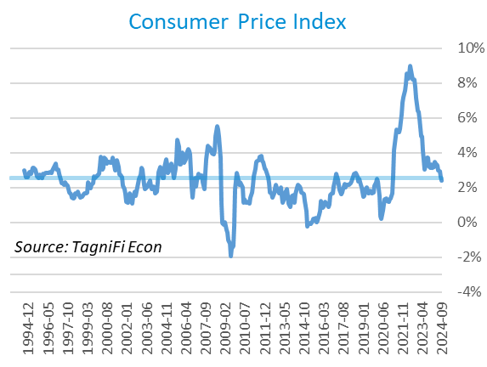

Wholesale inflation has been quicker to regulate than consumer inflation. The Producer Price Index[27] declined 1.3% in the 3rd quarter and 2.5% since September 2023. The average annual increase over the last 30 years was 2.8%.

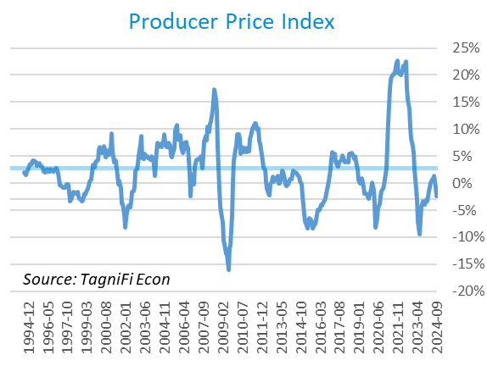

The 5-year breakeven inflation rate[28], an indicator of the market’s inflation expectations for the period, declined to 2.07% at the end of the 3rd quarter from 2.24% at the end of the 2nd quarter.

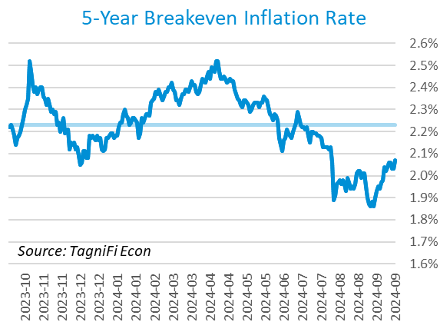

U.S. crude oil[29] prices fell in the 3rd quarter, settling at $68.75 per barrel amid relatively soft US demand, OPEC’s plans to increase production, and softening international demand. Crude prices ended the 3rd quarter down 17.0% from the prior quarter and down 24.3% year-over-year.

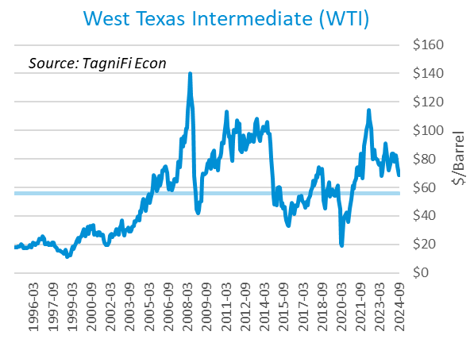

# Housing

The inventory of unsold homes increased by 1.5% in September compared to the previous month and increased by 23.0% from September 2023. The median existing-home sales price was up 3% compared to last year. The median sales price increased year over year in all four US regions.[30] New home starts[31] rose 1.9% during the 3rd quarter to 1.35 million in September, primarily due to an uptick in multifamily home starts during the 3rd quarter. Total new home starts were down 0.7% year-over-year but remained slightly above their 30-year average of 1.34 million.

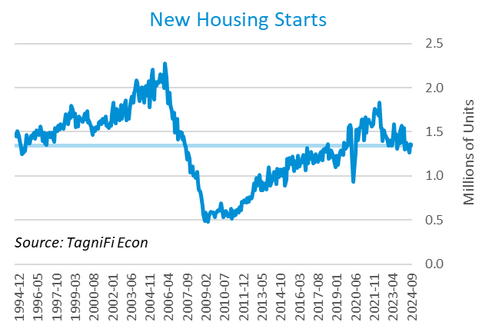

The cost of financing for would-be homebuyers declined during the 3rd quarter, with the 30-year fixed-rate mortgage[32] down 0.78 percentage points to an average of 6.08% at the end of September 2024. The average rate was 1.71% lower than its peak of 7.79% in late October 2023.

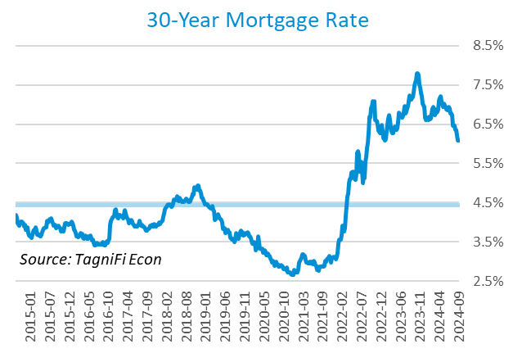

The S&P Case-Shiller Home Price Index (20-city)[33] for August 2024 was 1.1% higher compared to May 2024 and 5.2% higher since August 2023. While all 20 cities recorded a year-over-year increase, only New York, Las Vegas, and Chicago market readings were at an all-time high, signaling that the housing market could be softening. [34]

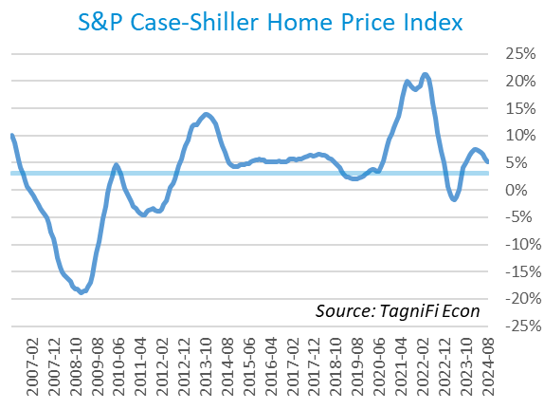

# Consumer Spending

Personal Consumption Expenditures (PCE)[35] rose 1.4% in the 3rd quarter to $20.0 trillion, and 5.3% over the same quarter last year. Spending increased in September for services such as healthcare services and housing and utilities (led by housing).[36] Goods spending also increased, especially for other nondurable goods (led by prescription drugs), food and beverages, and motor vehicles and parts (led by new light trucks); however, goods spending was moderated by gasoline and other energy goods.

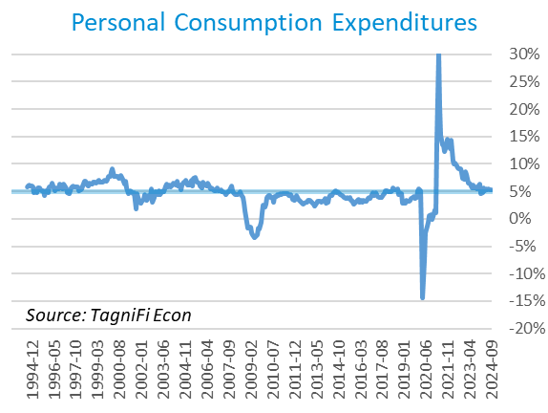

Auto manufacturers reported autos and light trucks sold[37] at an annual rate of 15.8 million in September 2024, up 4.9% from June. New vehicle prices[38], while declining 0.3% during the 3rd quarter, remained near their record high. Used car prices[39] fell 2.9% from June to September.

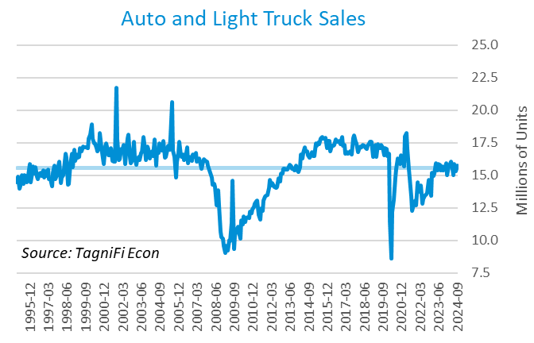

The University of Michigan’s consumer sentiment index[40] stood at 70.1 in September 2024, up from 68.2 in June and above its all-time low of 50.0 in June 2022. The softening inflation likely contributed to a slightly improved sentiment index. The index was up 3.4% year-over-year yet still well below its 30-year average of 85.9.

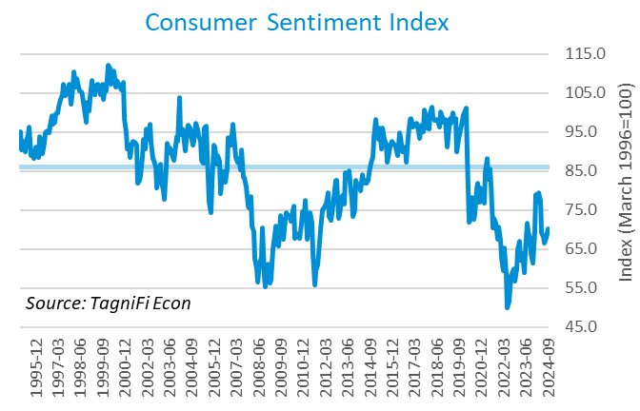

# Capital Markets

The table below shows major U.S. equity indices' quarterly, year-to-date, and 12-month performance. In contrast to the mixed 2nd quarter results, where AI-related stocks led gains, the 3rd quarter rally was broad-based. Fed’s 0.5% rate cut and easing inflation concerns were among the primary factors contributing to market optimism. During the quarter, the tech-heavy NASDAQ Composite and NASDAQ 100 climbed 1.9% and 2.6%, respectively. The broader S&P 500 rose 5.5%, and the Dow Jones Utility Average rose 16.9%. Other blue-chip-focused Dow Jones averages—Transportation, Composite, and Industrial—were up 5.7%, 8.6%, and 8.2%, respectively, during the 3rd quarter.



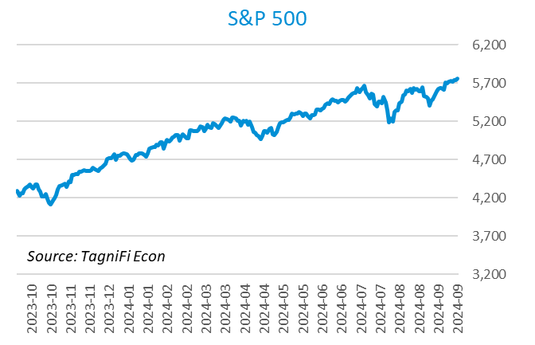

Corporate debt issuances were up in the third quarter, with the ICE BofA US Corporate Index[41] inching up 5.7% and the ICE BofA US High Yield Index[42] increasing 5.3%.



Stock market volatility, as measured by the VIX [43], ended the 3rd quarter of 2024 at 16.7, up 34.5% over the prior quarter and down 5% since the 3rd quarter of 2023. The VIX rose in August before receding in September.

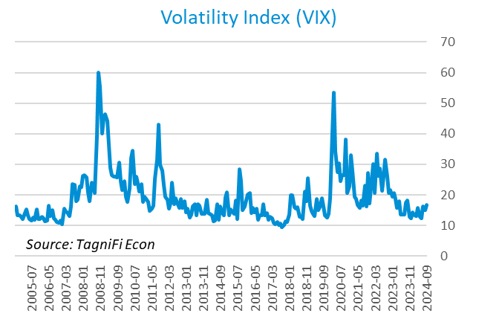

# Outlook

In September 2024, the FOMC cut interest rate by 0.5% and signaled additional gradual adjustments of the interest rate in the upcoming months while cautioning that the interest rate may not go back to the pre-pandemic levels. The Fed revised their near-term PCE inflation projections slightly downward and unemployment rate projections slightly upward. The median projection for real GDP was revised slightly downward. Minimal adjustments were made to longer-term projections for any of the three indicators.

The FOMC revised their projections for Personal Consumption Expenditures (PCE) inflation[44] to 2.30% and 2.15% in 2024 and 2025, respectively. The updated 2026 and 2027 projections stood at 2.00%. The real GDP[45] projections stood at 2.00% for 2024 and 2025, and 2.10% and 1.95% for 2026 and 2027, respectively. The expected unemployment rate[46] stood at 4.35% for 2024 and 2025, and 4.2% for 2026 and 2027. The board updated projections of future target rates[47] to 4.5% in 2024, 3.35% in 2025, and 3.10% in 2026 and 2027. The committee emphasized a willingness to cut rates gradually in the upcoming periods but cautioned that the size of the cuts would depend on the data.



Appendix – Selected Interest Rates



# About This Report

The *Quarterly Economic Update* is a free publication sponsored by TagniFi. You are free to share this report and include its contents in the economic outlook section of your valuation reports as required by *Revenue Ruling 59-60*. Please forward this free report to a colleague to help us spread the word about TagniFi.

How TagniFi Helps Business Valuation Teams

TagniFi’s financial data platform empowers business valuation teams to quickly and easily build highly accurate financial models with full transparency—and within seconds.

**Better Public Comps**  
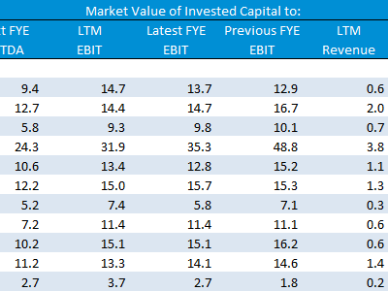Search for public companies with TagniFi Web. Simply enter your valuation date and ticker symbols in Excel to run a guideline public company method. Your Excel model populates instantly with the financial statements, analyst estimates, interest rates and economic data for your valuation date.

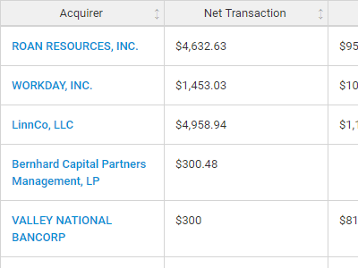

**Better Transaction Comps**  
Search for public and private M&A transactions with TagniFi Web. Run your transaction comps within seconds by pasting the Deal ID into your Excel model. Every deal disclosed in an SEC filing (8-K, 10-K, or 10-Q) is available for your analysis. Choose from over 90 fields of data available for every deal.

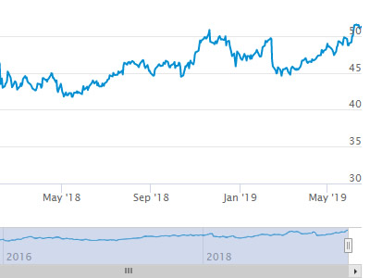

**Historical Beta and Volatility**Calculate historical beta and volatility as of your valuation date automatically. Simply enter the tickers and valuation date in Excel - TagniFi does the rest. In addition to beta and volatility, there are over 40 Excel models available in the Model Library to help with your valuation report.

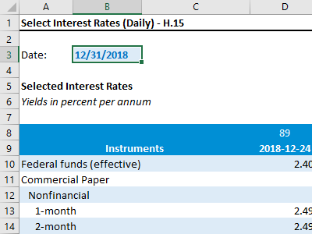**Interest Rates and Economic Data**Automate the interest rates and economic data in your valuation report using the TagniFi Excel plugin. Choose from over 200,000 time series available. All data in this *Quarterly Economic Update* is from the TagniFi platform. Use economic and interest rate data for your own valuation models with the TagniFi Excel plugin.

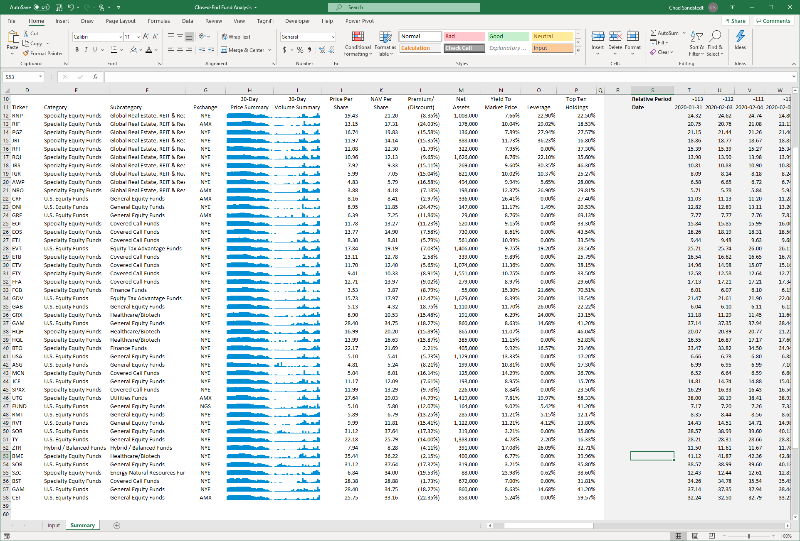

**Closed-End Mutual Fund Data**Search for closed-end mutual funds by keyword, category, subcategory, and more with the TagniFi Console. Use the TagniFi Excel plugin to calculate historical discounts, yields, leverage, as of your valuation date automatically. Simply enter the tickers and valuation date in Excel - TagniFi does the rest.

**Corporate Bond Data**Use interest rates along any point of the yield curve for your debt valuation engagements as of your valuation date. View historical price and yield information for over 80,000 corporate bond along with their characteristics.Search for bonds by rating to find guideline bonds for your analysis.

1. Federal Reserve Bank of Philadelphia, Coincident Economic Activity Index for the United States [USPHCI], *retrieved from FRED, Federal Reserve Bank of St. Louis;* [*https://fred.stlouisfed.org/series/USPHCI*](https://fred.stlouisfed.org/series/USPHCI)*, November 4, 2024.*
2. Board of Governors of the Federal Reserve System (US), Trade Weighted U.S. Dollar Index: Broad, Goods and Services [DTWEXBGS], *retrieved from FRED, Federal Reserve Bank of St. Louis;* [*https://fred.stlouisfed.org/series/DTWEXBGS*](https://fred.stlouisfed.org/series/DTWEXBGS)*, November 4, 2024.*
3. U.S. Bureau of Economic Analysis, Real Gross Domestic Product [GDPC1], *retrieved from FRED, Federal Reserve Bank of St. Louis;*[*https://fred.stlouisfed.org/series/GDPC1*](https://fred.stlouisfed.org/series/GDPC1)*, November 4, 2024.*
4. U.S. Bureau of Economic Analysis, Contributions to percent change in real gross domestic product: Personal consumption expenditures [DPCERY2Q224SBEA], *retrieved from FRED, Federal Reserve Bank of St. Louis;* [*https://fred.stlouisfed.org/series/DPCERY2Q224SBEA*](https://fred.stlouisfed.org/series/DPCERY2Q224SBEA)*, November 4, 2024.*
5. U.S. Bureau of Economic Analysis, Contributions to percent change in real gross domestic product: Gross private domestic investment [A006RY2Q224SBEA], *retrieved from FRED, Federal Reserve Bank of St. Louis;* [*https://fred.stlouisfed.org/series/A006RY2Q224SBEA*](https://fred.stlouisfed.org/series/A006RY2Q224SBEA)*, November 4, 2024.*
6. U.S. Bureau of Economic Analysis, Contributions to percent change in real gross domestic product: Government consumption expenditures and gross investment [A822RY2Q224SBEA], *retrieved from FRED, Federal Reserve Bank of St. Louis;* [*https://fred.stlouisfed.org/series/A822RY2Q224SBEA*](https://fred.stlouisfed.org/series/A822RY2Q224SBEA)*, November 4, 2024.*
7. U.S. Bureau of Economic Analysis, Contributions to percent change in real gross domestic product: Net exports of goods and services [A019RY2Q224SBEA], *retrieved from FRED, Federal Reserve Bank of St. Louis;* [*https://fred.stlouisfed.org/series/A019RY2Q224SBEA*](https://fred.stlouisfed.org/series/A019RY2Q224SBEA)*, November 4, 2024.*
8. Federal Reserve Bank of Philadelphia, The Livingston Survey December 2023, [economic release], retrieved from <https://www.philadelphiafed.org/surveys-and-data/real-time-data-research/livingston-survey>, November 4, 2024.
9. Board of Governors of the Federal Reserve System (US), Industrial Production Index [INDPRO], *retrieved from FRED, Federal Reserve Bank of St. Louis;*[*https://fred.stlouisfed.org/series/INDPRO*](https://fred.stlouisfed.org/series/INDPRO)*, November 4, 2024.*
10. Board of Governors of the Federal Reserve System (US), Capacity Utilization, Manufacturing (NAICS), *retrieved from FRED, Federal Reserve Bank of St. Louis;* [*https://fred.stlouisfed.org/series/MCUMFN*](https://fred.stlouisfed.org/series/MCUMFN)*, November 4, 2024.*
11. Board of Governors of the Federal Reserve System (US), Federal Funds Effective Rate [FEDFUNDS], *retrieved from FRED, Federal Reserve Bank of St. Louis;* [*https://fred.stlouisfed.org/series/FEDFUNDS*](https://fred.stlouisfed.org/series/FEDFUNDS)*, November 4, 2024.*
12. Selected Interest Rates Instruments, Yields in percent per annum, *retrieved from FRED, Federal Reserve Bank of St. Louis;* [https://fred.stlouisfed.org/release/tables?rid=18&eid=289&od=2024-06-28#](https://fred.stlouisfed.org/release/tables?rid=18&eid=289&od=2024-06-28)*, November 4, 2024.*
13. Board of Governors of the Federal Reserve System (US), Federal Funds Target Range - Upper Limit [DFEDTARU], *retrieved from FRED, Federal Reserve Bank of St. Louis;* [*https://fred.stlouisfed.org/series/DFEDTARU*](https://fred.stlouisfed.org/series/DFEDTARU)*, November 4, 2024*.
14. Board of Governors of the Federal Reserve System (US), 10-Year Treasury Constant Maturity Rate [DGS10], *retrieved from FRED, Federal Reserve Bank of St. Louis;*[*https://fred.stlouisfed.org/series/DGS10*](https://fred.stlouisfed.org/series/DGS10)*, November 4, 2024.*
15. Moody’s, Moody's Seasoned Baa Corporate Bond Yield [DBAA], *retrieved from FRED, Federal Reserve Bank of St. Louis;* [*https://fred.stlouisfed.org/series/DBAA*](https://fred.stlouisfed.org/series/DBAA)*, November 4, 2024.*
16. Moody’s, Moody's Seasoned Aaa Corporate Bond Yield [DAAA], *retrieved from FRED, Federal Reserve Bank of St. Louis;* [*https://fred.stlouisfed.org/series/DAAA*](https://fred.stlouisfed.org/series/DAAA)*, November 4, 2024.*
17. U.S. Bureau of Labor Statistics, Civilian Unemployment Rate [UNRATE], *retrieved from FRED, Federal Reserve Bank of St. Louis;*[*https://fred.stlouisfed.org/series/UNRATE*](https://fred.stlouisfed.org/series/UNRATE)*, November 4, 2024.*
18. U.S. Bureau of Labor Statistics, Civilian Labor Force Level [CLF16OV], *retrieved from FRED, Federal Reserve Bank of St. Louis;* [*https://fred.stlouisfed.org/series/CLF16OV*](https://fred.stlouisfed.org/series/CLF16OV)*, November 4, 2024.*
19. U.S. Bureau of Labor Statistics, Labor Force Participation Rate [CIVPART], *retrieved from FRED, Federal Reserve Bank of St. Louis;* [*https://fred.stlouisfed.org/series/CIVPART*](https://fred.stlouisfed.org/series/CIVPART)*, November 4, 2024.*
20. U.S. Bureau of Labor Statistics, Quits: Total Nonfarm [JTSQUL], *retrieved from FRED, Federal Reserve Bank of St. Louis;* [*https://fred.stlouisfed.org/series/JTSQUL*](https://fred.stlouisfed.org/series/JTSQUL)*, November 4, 2024.*
21. U.S. Bureau of Labor Statistics, Job Openings: Total Nonfarm [JTSJOL], *retrieved from FRED, Federal Reserve Bank of St. Louis;* [*https://fred.stlouisfed.org/series/JTSJOL*](https://fred.stlouisfed.org/series/JTSJOL)*, November 4, 2024.*
22. U.S. Bureau of Labor Statistics Total Unemployed, Plus All Persons Marginally Attached to the Labor Force, Plus Total Employed Part Time for Economic Reasons, as a Percent of the Civilian Labor Force Plus All Persons Marginally Attached to the Labor Force (U-6) [U6RATE], *retrieved from FRED, Federal Reserve Bank of St. Louis;*[*https://fred.stlouisfed.org/series/U6RATE*](https://fred.stlouisfed.org/series/U6RATE)*, November 4, 2024.*
23. U.S. Bureau of Labor Statistics, All Employees: Total Nonfarm Payrolls [PAYEMS], *retrieved from FRED, Federal Reserve Bank of St. Louis;*[*https://fred.stlouisfed.org/series/PAYEMS*](https://fred.stlouisfed.org/series/PAYEMS)*, November 4, 2024.*
24. U.S. Bureau of Labor Statistics, Consumer Price Index for All Urban Consumers: All Items [CPIAUCSL], *retrieved from FRED, Federal Reserve Bank of St. Louis;*[*https://fred.stlouisfed.org/series/CPIAUCSL*](https://fred.stlouisfed.org/series/CPIAUCSL)*, November 4, 2024.*
25. U.S. Bureau of Labor Statistics, Consumer Price Index for All Urban Consumers: All Items Less Energy in U.S. City Average [CPILEGSL], *retrieved from FRED, Federal Reserve Bank of St. Louis;* [*https://fred.stlouisfed.org/series/CPILEGSL*](https://fred.stlouisfed.org/series/CPILEGSL)*, November 4, 2024*.
26. U.S. Bureau of Labor Statistics, Average Price: Gasoline, Unleaded Regular (Cost per Gallon/3.785 Liters) in U.S. City Average [APU000074714], *retrieved from FRED, Federal Reserve Bank of St. Louis;* [*https://fred.stlouisfed.org/series/APU000074714*](https://fred.stlouisfed.org/series/APU000074714)*, November 4, 2024.*
27. U.S. Bureau of Labor Statistics, Producer Price Index for All Commodities [PPIACO], *retrieved from FRED, Federal Reserve Bank of St. Louis;*[*https://fred.stlouisfed.org/series/PPIACO*](https://fred.stlouisfed.org/series/PPIACO)*, November 4, 2024.*
28. *Federal Reserve Bank of St. Louis, 5-Year Breakeven Inflation Rate [T5YIE], retrieved from FRED, Federal Reserve Bank of St. Louis;*[*https://fred.stlouisfed.org/series/T5YIE*](https://fred.stlouisfed.org/series/T5YIE)*, November 4, 2024.*
29. U.S. Energy Information Administration, Crude Oil Prices: West Texas Intermediate (WTI) - Cushing, Oklahoma [DCOILWTICO], *retrieved from FRED, Federal Reserve Bank of St. Louis;* [*https://fred.stlouisfed.org/series/DCOILWTICO*](https://fred.stlouisfed.org/series/DCOILWTICO)*, November 4, 2024.*
30. National Association of Realtors (NAR): Existing-Home Sales Slid 1.0% in September*, retrieved from NAR*[*https://www.nar.realtor/newsroom/existing-home-sales-slid-1-0-in-september*](https://www.nar.realtor/newsroom/existing-home-sales-slid-1-0-in-september)*, November 4, 2024.*
31. U.S. Bureau of the Census, Housing Starts: Total: New Privately Owned Housing Units Started [HOUST], *retrieved from FRED, Federal Reserve Bank of St. Louis;*[*https://fred.stlouisfed.org/series/HOUST*](https://fred.stlouisfed.org/series/HOUST)*, November 4, 2024.*
32. Freddie Mac, 30-Year Fixed Rate Mortgage Average in the United States [MORTGAGE30US], *retrieved from FRED, Federal Reserve Bank of St. Louis;*[*https://fred.stlouisfed.org/series/MORTGAGE30US*](https://fred.stlouisfed.org/series/MORTGAGE30US)*, November 4, 2024.*
33. S&P Dow Jones Indices LLC, S&P/Case-Shiller 20-City Composite Home Price Index [SPCS20RSA], *retrieved from FRED, Federal Reserve Bank of St. Louis;*[*https://fred.stlouisfed.org/series/SPCS20RSA*](https://fred.stlouisfed.org/series/SPCS20RSA)*, November 4, 2024.*
34. S&P Global, S&P CORELOGIC CASE-SHILLER INDEX RECORDS 4.2% ANNUAL GAIN IN AUGUST 2024, retrieved from S&P Global: <https://press.spglobal.com/2024-10-30-S-P-CORELOGIC-CASE-SHILLER-INDEX-RECORDS-4-2-ANNUAL-GAIN-IN-AUGUST-2024#:~:text=NEW%20YORK%2C%20Oct.%2030%2C,from%20previous%20levels%20in%202024>., November 4, 2024.
35. U.S. Bureau of Economic Analysis, Personal Consumption Expenditures [PCE], *retrieved from FRED, Federal Reserve Bank of St. Louis;*[*https://fred.stlouisfed.org/series/PCE*](https://fred.stlouisfed.org/series/PCE)*, November 4, 2024.*
36. U.S. Bureau of Economic Analysis, Personal Income and Outlays, September 2024; [*https://www.bea.gov/news/2024/personal-income-and-outlays-september-2024*](https://www.bea.gov/news/2024/personal-income-and-outlays-september-2024)*; November 4, 2024.* 
37. U.S. Bureau of Economic Analysis, Light Weight Vehicle Sales: Autos and Light Trucks [ALTSALES], *retrieved from FRED, Federal Reserve Bank of St. Louis; <https://fred.stlouisfed.org/series/ALTSALES>, November 4, 2024.*
38. U.S. Bureau of Labor Statistics, Consumer Price Index for All Urban Consumers: New Vehicles in U.S. City Average [CUUR0000SETA01], *retrieved from FRED, Federal Reserve Bank of St. Louis;* [*https://fred.stlouisfed.org/series/CUUR0000SETA01*](https://fred.stlouisfed.org/series/CUUR0000SETA01)*, November 4, 2024.*
39. U.S. Bureau of Labor Statistics, Consumer Price Index for All Urban Consumers: Used Cars and Trucks in U.S. City Average [CUSR0000SETA02], *retrieved from FRED, Federal Reserve Bank of St. Louis;* [*https://fred.stlouisfed.org/series/CUSR0000SETA02*](https://fred.stlouisfed.org/series/CUSR0000SETA02), *November 4, 2024.*
40. *University of Michigan, University of Michigan: Consumer Sentiment [UMCSENT], retrieved from FRED, Federal Reserve Bank of St. Louis;* [*https://fred.stlouisfed.org/series/UMCSENT*](https://fred.stlouisfed.org/series/UMCSENT)*, November 4, 2024.*
41. *Ice Data Indices, LLC, ICE BofA US Corporate Index Total Return Index Value [BAMLCC0A0CMTRIV], retrieved from FRED, Federal Reserve Bank of St. Louis;* [*https://fred.stlouisfed.org/series/BAMLCC0A0CMTRIV*](https://fred.stlouisfed.org/series/BAMLCC0A0CMTRIV)*, November 4, 2024.*
42. *Ice Data Indices, LLC, ICE BofA US High Yield Index Total Return Index Value [BAMLHYH0A0HYM2TRIV], retrieved from FRED, Federal Reserve Bank of St. Louis;* [*https://fred.stlouisfed.org/series/BAMLHYH0A0HYM2TRIV*](https://fred.stlouisfed.org/series/BAMLHYH0A0HYM2TRIV)*, November 4, 2024*
43. *Chicago Board Options Exchange, CBOE Volatility Index: VIX [VIXCLS], retrieved from FRED, Federal Reserve Bank of St. Louis;* [*https://fred.stlouisfed.org/series/VIXCLS*](https://fred.stlouisfed.org/series/VIXCLS)*, November 4, 2024.*
44. *Federal Reserve Bank of St. Louis, FOMC Summary of Economic Projections for the Personal Consumption Expenditures Inflation Rate, Central Tendency, Midpoint [PCECTPICTM], retrieved from FRED, Federal Reserve Bank of St. Louis;*[*https://fred.stlouisfed.org/series/PCECTPICTM*](https://fred.stlouisfed.org/series/PCECTPICTM)*, November 4, 2024.*
45. *Federal Reserve Bank of St. Louis, FOMC Summary of Economic Projections for the Growth Rate of Real Gross Domestic Product [GDPC1CTM], retrieved from FRED, Federal Reserve Bank of St. Louis;*[*https://fred.stlouisfed.org/series/GDPC1CTM*](https://fred.stlouisfed.org/series/GDPC1CTM)*, November 4, 2024.*
46. *Federal Reserve Bank of St. Louis, FOMC Summary of Economic Projections for the Civilian Unemployment Rate, Central Tendency, Midpoint [UNRATECTM], retrieved from FRED, Federal Reserve Bank of St. Louis;*[*https://fred.stlouisfed.org/series/UNRATECTM*](https://fred.stlouisfed.org/series/UNRATECTM)*, November 4, 2024.*
47. *U.S. Federal Open Market Committee and Federal Reserve Bank of St. Louis, FOMC Summary of Economic Projections for the Fed Funds Rate, Range, Midpoint [FEDTARCTM], retrieved from FRED, Federal Reserve Bank of St. Louis;* [*https://fred.stlouisfed.org/series/FEDTARCTM*](https://fred.stlouisfed.org/series/FEDTARCTM)*, November 4, 2024.*