QUARTERLY ECONOMIC UPDATE

For the 4th Quarter of 2024

Abstract

Designed for business valuation professionals, TagniFi’s Quarterly Economic   
Update provides timely economic data to satisfy Revenue Ruling 56-60.

# Summary

Overall, the U.S. economy experienced solid growth in the 4th quarter of 2024, with GDP increasing and unemployment remaining low. While the economic growth remained solid, the short-term inflation outlook increased, leading the Federal Reserve Board to take a cautious stance on future interest rate cuts.

Domestic production growth was slightly below expectations in the quarter. Broad increases in personal and government spendings contributed to GDP growth, while a downturn in private investment was a drag on GDP.

Inflation remained moderate despite higher fuel prices compared to the previous quarter. Colder weather and continuing geopolitical tension led to higher crude oil prices. In response, the Federal Reserve cut the target interest rate by 0.5% and signaled that the Board may slow the pace of future cuts.

A frequent bright spot for the economy in recent years, the job market sent mixed signals in the 4th quarter of 2024, with unemployment unchanged, labor force participation decreasing, and uneven nonfarm employment growth. Still, the labor market remains well within the bounds of full employment.

Capital markets posted solid gains in the 4th quarter, fueled by the strong economy, earnings growth, the Fed’s interest rate cut, and expectations of more business-friendly government policy. The tech-heavy NASDAQ indexes outperformed the broader S&P 500 and Dow Jones Industrial indexes.

Housing market data remained mixed, with some encouraging signs of possible recovery. As sales continued to be constrained by elevated interest rates, unsold housing inventory declined in the 4th quarter of 2024. Prices in most major cities continued to rise year-over-year.

FOMC members’ short-term domestic production and inflation projections were revised slightly upward. Unemployment expectations were revised slightly downward, while forecasts of longer-term economic performance were minimally changed across all three measures.

A multifactor indicator of economic strength, the Philadelphia Fed’s coincident index[1] of economic activity in the U.S. rose 0.3% in December 2024 and 0.6% during the 4th quarter. For the quarter, the index increased in thirty-six states, decreased in nine states, and remained unchanged in five. Coincident indexes reflect unemployment, payroll employment, manufacturing hours, and wages and salaries.



The U.S. dollar index for goods and services[2] added a solid 6.7% during the 4th quarter of 2024, reflecting the expectation of stronger growth in the U.S. economy compared to other developed markets and expectations of slower future interest rate cuts. The dollar index was up 8.3% over the prior year.

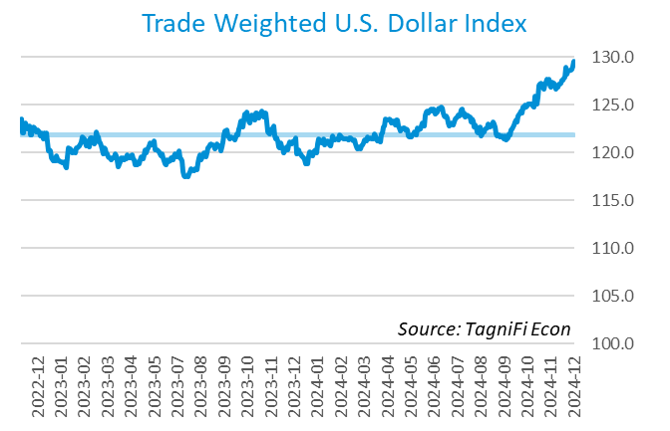

# Q4 Economic Highlights

* The Philadelphia Fed’s coincident index of economic activity in the U.S. rose 0.3% in December 2024 and 0.6% during the 4th quarter.
* The U.S. dollar index rose 6.6% during the 4th quarter of 2024 and was up 8.3% from the prior year.
* Real GDP grew at an annualized rate of 2.3% during the 4th quarter of 2024.
* The effective federal funds rate declined to 4.48% during the 4th quarter following 0.25% cuts by the Fed in November and December.
* The 1-year and 2-year annual treasury yields ended the 4th quarter at 4.16% and 4.25%, respectively. The benchmark 10-year treasury yielded 4.58% at the end of the quarter, while the 30-year treasury yielded 4.78%.
* The unemployment rate ended the 4th quarter at 4.1%, unchanged from the prior quarter. Nonfarm payrolls grew by 0.5 million jobs in the 4th quarter.
* The Consumer Price Index for all items rose 2.9% for the year ended December 2024. Excluding volatile energy prices, the annual increase was 3.1%.
* Crude oil prices ended the 4th quarter at $72.44 per barrel, up 5.4% from the prior quarter and 0.8% year-over-year.
* New home starts rose 10.6% during the 4th quarter to 1.5 million in December. Total new home starts were down 4.4% year-over-year.
* The NASDAQ Composite climbed 6.2% during the 4th quarter. The S&P 500 rose 2.1%, and Dow Jones Industrial Average added 0.5%, while the Dow Jones Transportation and Composite Averages were down 2.4% and 1.1%, respectively, during the quarter.

# Business Activity

Real gross domestic product (GDP)[3] grew at an annualized rate of 2.3% during the 4th quarter of 2024, slightly lower than expected, and down from 3.1% in the 3rd quarter. GDP grew 2.8% for the full year, compared with 2.9% in 2023. Gains in 4th quarter consumer spending were tempered by a downturn in private investment. Both exports and imports decreased during the quarter, with the net exports unchanged from the 3rd quarter. Government spending also increased in the 4th quarter. The scale and makeup of the 4th quarter GDP growth pointed to continued economic expansion.

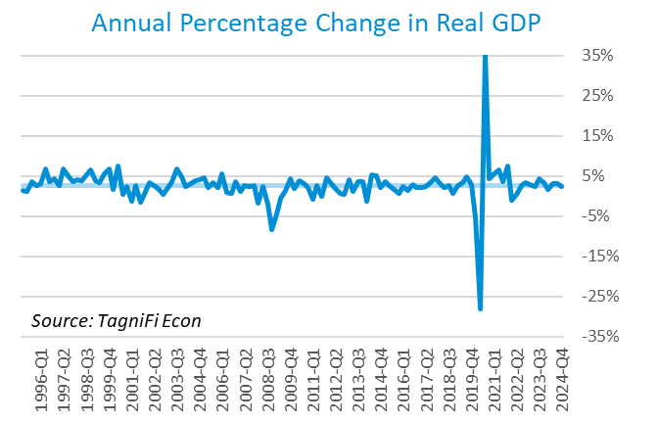

Personal consumption expenditures[4] (PCE) had a positive 2.8% effect on real GDP in the 4th quarter. A rise in spending on services, especially for health care (including hospital and outpatient services), housing and utilities, and financial services and insurance, contributed to PCE growth. Spending on goods also rose, led by recreational goods and vehicles and motor vehicles and parts.

Gross domestic private investment[5] had a negative impact on the GDP, decreasing the 4th quarter real GDP estimate by 1.0%. Both the wholesale and retail sectors experienced negative changes in inventory. The decrease in nonresidential fixed investment reflected decreases in information processing and transportation equipment categories, partially offset by increased intellectual property products. Residential fixed investment increased in the 4th quarter.

Government expenditures[6] rose in the 4th quarter, contributing 0.4% to GDP gain. Increased state and local employee compensation and national defense investment contributed to higher government expenditures.

Net exports[7] were effectively unchanged in the 4th quarter as imports (which have a negative impact on GDP) declined slightly more than exports. The decline in exports was led by decreases in capital and consumer goods, except automotive. The decline in imports was primarily explained by lower imports of capital goods, automotive vehicles, and industrial supplies and materials, partially offset by increased imports of nondurable consumer goods.

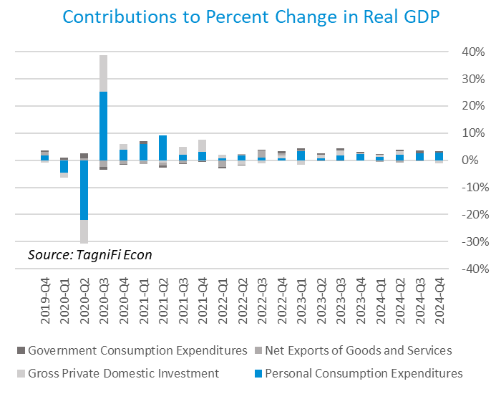

Economists polled by the Livingston Survey[8] in December 2024 projected real GDP to rise to an annual rate of 2.5% in the 2nd half of 2024, moderating to an annual rate of 1.9% in the 1st and 2nd half of 2025.

The Industrial Production Index[9] is an economic indicator that measures real output for all facilities located in the United States manufacturing, mining, and electric and gas utility sectors. The index stood at 103.2 at the end of the 4th quarter, up 0.6% from the 3rd quarter.

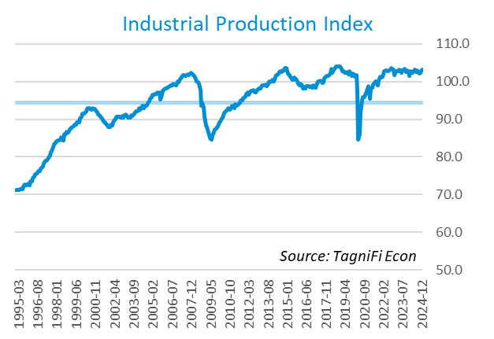

The Capacity Utilization Index[10], which attempts to capture industrial output as a percentage of the economy’s maximum production capacity, ended the 4th quarter of 2024 at 76.5%. December 2024’s level was slightly below the 30-year average of 76.8% for this metric and down slightly from the previous quarter.

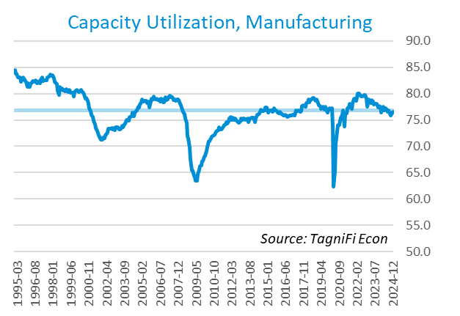

# Interest Rates

Treasury yields[11] for periods of one year and up increased during the 4th quarter. The closely watched two-year yield remained below the ten-year rate for the second consecutive quarter, signaling the end of the inverted yield curve that was observable between July 2022 and the first half of 2024. The 1-year and 2-year annual treasury yields ended the 4th quarter at 4.16% and 4.25%, respectively. The benchmark 10-year treasury yielded 4.58% at the end of the quarter, while the 30-year treasury yielded 4.78%. See *Appendix – Selected Interest Rates* for detailed interest rate data.

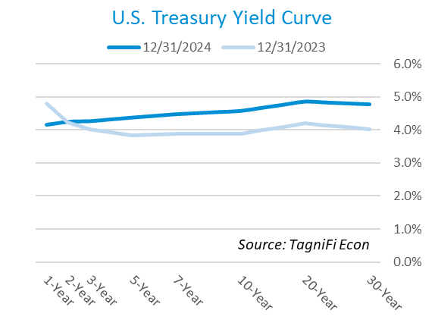

In the 4th quarter of 2024, the Federal Reserve cut the federal funds target rate[12] to a range of 4.25% to 4.50%, the second consecutive quarterly cut in four years, and a sharp decline from the 23-year high of 5.25% to 5.50%. With the inflation outlook remaining above the Fed’s optimal rate of 2% and the employment market strong, the FOMC signaled that it may take a more cautious approach to additional rate cuts in the upcoming months.

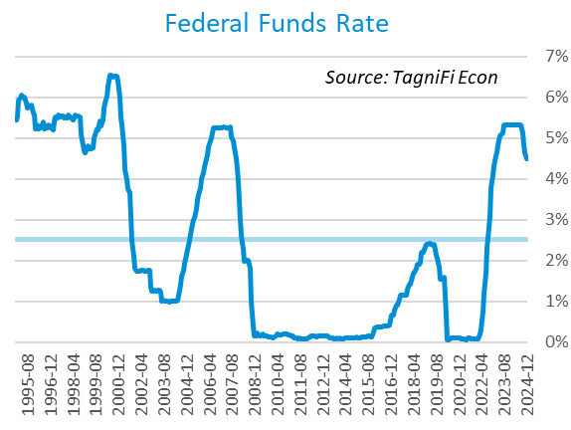

The yield on the benchmark 10-year U.S. treasury[13] ended the 4th quarter at 4.58%, up 0.67% from the previous quarter and above the average yield of 3.76% over the last 30 years.

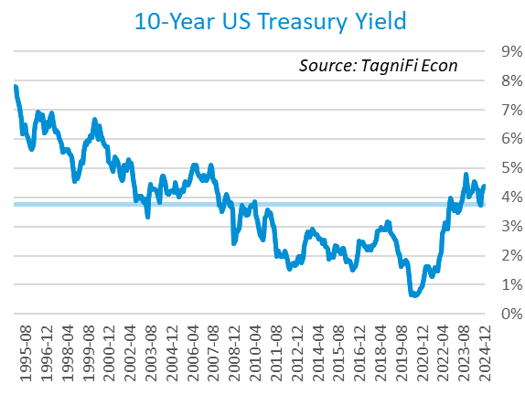

Moody’s Baa Corporate Bond Yield Index[14] ended the 4th quarter of 2024 at 6.00%, up 0.56% compared to the previous quarter. Moody’s less-risky Aaa[15] Bond Yield Index increased by 0.68% during the quarter to 5.40%.

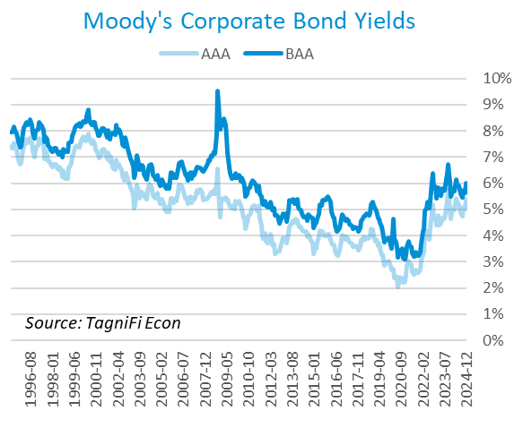

# Employment

The jobs market, a bright spot in the US economy throughout the pandemic recovery, showed mixed results in the 4th quarter. The official unemployment rate[16] ended the quarter at 4.1%, unchanged from the prior quarter but well below the 30-year historical average of 5.6% and within the 4.0% to 5.0% range accepted as an equilibrium level of “full employment.” The labor force[17] declined by 0.16 million workers during the quarter, while the labor force participation rate[18] inched down to 62.5% in December 2024, 0.8 percentage points below its pre-pandemic level. Economists polled by the Livingston Survey in December 2024 projected the unemployment rate to be 4.2% in December, rising slightly to 4.3% in June 2025 and remaining steady at 4.3% in December 2025.

In December 2024, nonfarm worker quits[19] stood at 3.2 million, up 2.1% over the month and down 7.0% over the year. Job openings[20] totaled 7.6 million in December 2024, 2.4 times the number of resignations. The job openings count decreased by 6.8% from November 2024 and down more than 14% from December 2023.

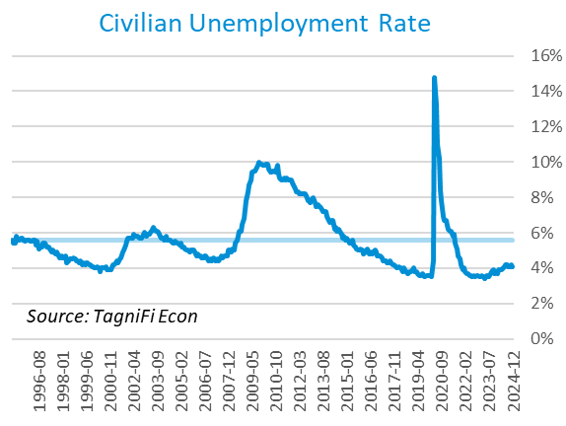

The U-6 unemployment rate[21] is an alternative measure of unemployment with a broader definition, including such groups as discouraged workers who are not actively searching for jobs but want full-time work and part-time workers who want full-time work. The U‑6 unemployment rate has generally followed the same pattern as the official rate and stood at 7.5% in December 2024.

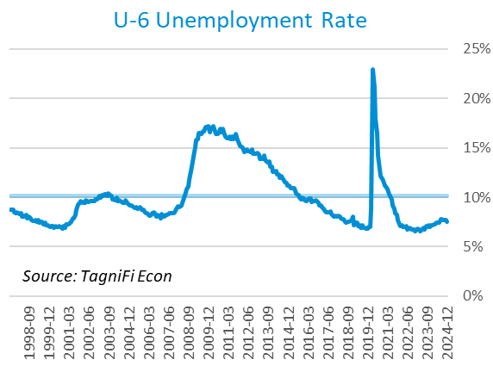

Nonfarm payrolls[22] grew by 0.5 million jobs in the 4th quarter. U.S. nonfarm payrolls in December 2024 totaled 159.5 million jobs, up 2.2 million from the prior December. December’s job market growth was primarily concentrated in health care, government, and social assistance. The retail sector also gained jobs, while most industries experienced little change.

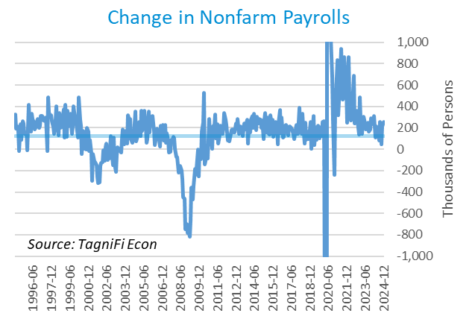

# Inflation

In the 4th quarter of 2024, inflation kept a more moderate pace than in 2021 and 2022. The Consumer Price Index[23] for all items rose 2.9% for the year ended December 2024. Since last December, notable price increases have included shelter, medical care (including medical care services), transportation services, and food. Prices for used cars and trucks, motor gasoline, and fuel declined. Excluding volatile energy prices[24], the annual increase was 3.1%. The average price of a gallon of gas[25] in the U.S. declined 6.0% during the 4th quarter of 2024 to $3.15. December’s average price was 4.4% lower than one year prior.

In the month of December 2024, prices increased for energy (including gasoline and fuel), airline fares, utilities, used cars and trucks, new vehicles, and medical care. Prices also rose for food, both away from home and at home.

The Federal Reserve, which had been taking aggressive action to curb inflation with a series of target interest rate hikes totaling 5.25 percentage points from March 2022 to July 2023, cut the target rate in both November and December, bringing the total rate cut to 1.00% in 2024. While additional rate cuts are expected in 2025, the Fed indicated that the size of the cuts would depend on the inflation and economic data readings.

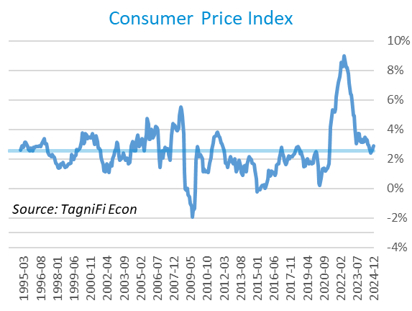

Wholesale inflation has been quicker to regulate than consumer inflation. The Producer Price Index[26] increased 0.3% in the 4th quarter and 1.5% since December 2023. The average annual increase over the last 30 years was 2.8%.

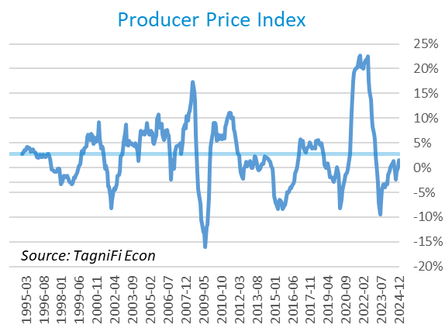

The 5-year breakeven inflation rate[27], an indicator of the market’s inflation expectations for the period, increased to 2.38% at the end of the 4th quarter from 2.07% at the end of the 3rd quarter.

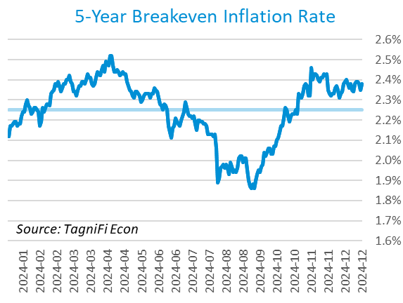

U.S. crude oil[28] prices increased in the 4th quarter, settling at $72.44 per barrel amid a seasonal increase in demand and continued geopolitical tension. Crude prices ended the 4th quarter up 5.4% from the prior quarter and up 0.8% year-over-year.

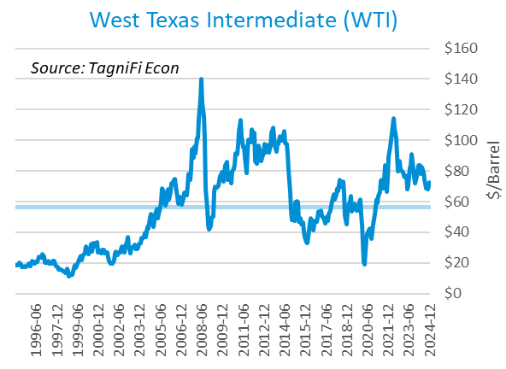

# Housing

The inventory of unsold homes decreased by 13.5% in December compared to the previous month and increased by 16.2% from December 2023. The median existing home sales price was up 6% compared to last year. The median sales price increased year over year in all four US regions.[29] New home starts[30] rose 10.6% during the 4th quarter to 1.5 million in December, primarily due to an uptick in multifamily home starts during the 4th quarter. Total new home starts were down 4.4% year-over-year but remained slightly above their 30-year average of 1.3 million.

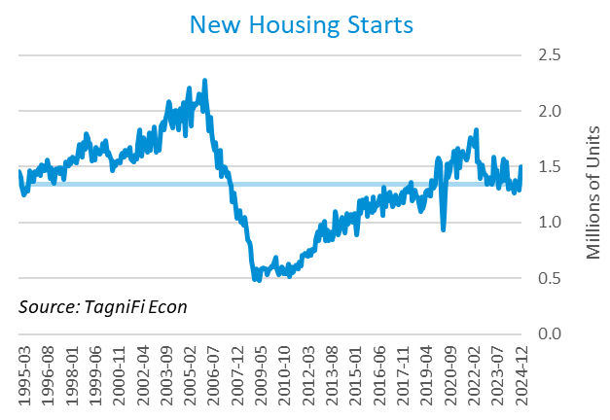

The cost of financing for would-be homebuyers increased during the 4th quarter, with the 30-year fixed-rate mortgage[31] up 0.77 percentage points to an average of 6.85% at the end of December 2024. The average rate was 0.94% lower than its peak of 7.79% in late October 2023.

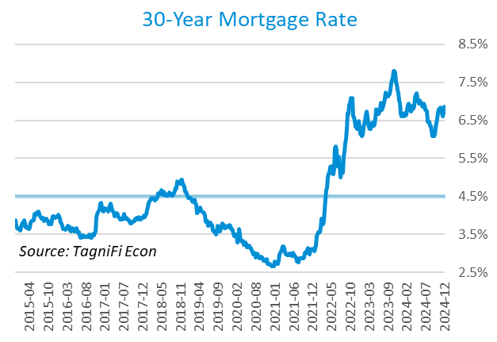

The S&P Case-Shiller Home Price Index (20-city)[32] for November 2024 was 1.0% higher compared to August 2024 and 4.4% higher since November 2023. While 19 of the 20 cities recorded a year-over-year increase, the Tampa index fell 0.4%. According to S&P Dow Jones Indices (S&P DJI), only New York, Washington, D.C., and Chicago are performing above historical norms, signaling that the housing market could be softening. [33]

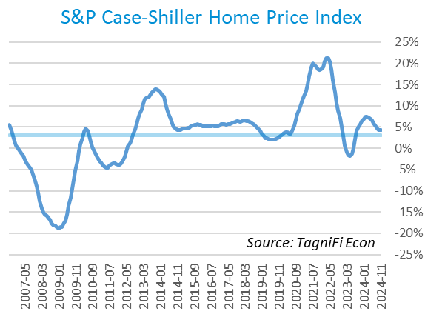

# Consumer Spending

Personal Consumption Expenditures (PCE)[34] rose 1.7% in the 4th quarter to $20.4 trillion and 5.7% over the same quarter last year. Spending increased in December for services such as healthcare services, transportation, and housing and utilities (led by housing).[35] Goods spending also increased, especially for gasoline and other energy goods, food and beverages, and motor vehicles and parts.

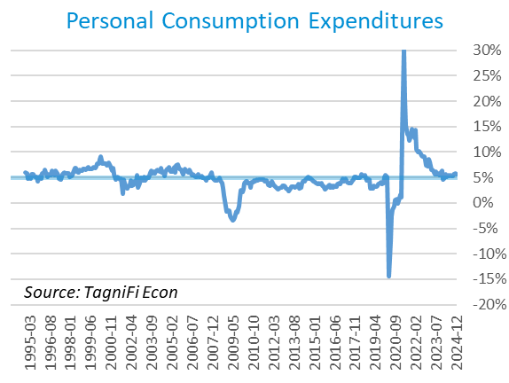

Auto manufacturers reported autos and light trucks sold[36] at an annual rate of 16.8 million in December 2024, up 6.5% from September. New vehicle prices[37] increased 0.1% during the 4th quarter, remaining near their record high. Used car prices[38] increased 6.0% from September to December.

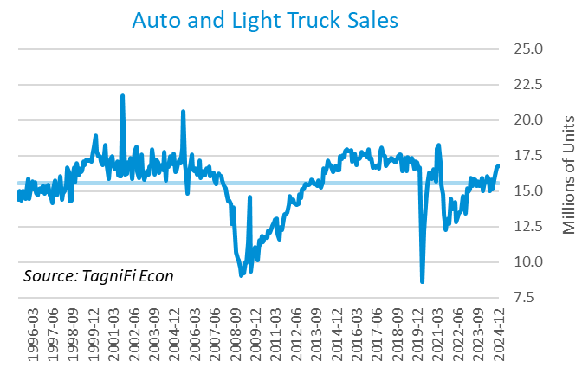

The University of Michigan’s consumer sentiment index[39] stood at 74.0 in December 2024, up from 70.1 in September, marking a fifth consecutive increase in the sentiment index. The index bottomed at its all-time low of 50.0 in June 2022. The softening inflation likely contributed to a slightly improved sentiment index. The index was up 6.2% year-over-year yet still well below its 30-year average of 85.7.

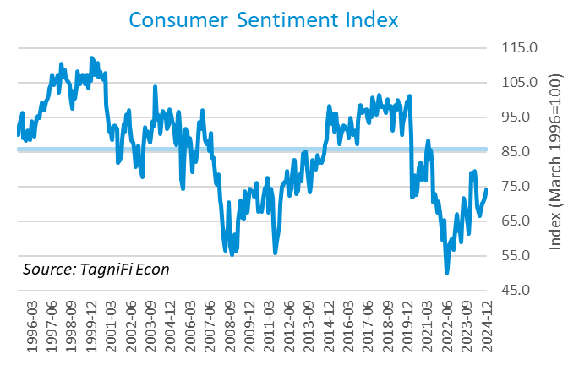

# Capital Markets

The table below shows major U.S. equity indices' quarterly, year-to-date, and 12-month performance. The stock market ended the year on a positive note, with a strong economy, the Fed’s interest rate cuts, and and an expectation of pro-business government policies among the primary factors contributing to market optimism. Increasing inflation expectations and the Fed’s more careful approach to future interest rate cuts likely took some steam off the year-end rally.

In contrast to the broad-based 3rd quarter gains, the technology sector led the market gains in the 4th quarter. During the quarter, the tech-heavy NASDAQ Composite and NASDAQ 100 climbed 6.2% and 4.7%, respectively. The broader S&P 500 rose 2.1%, while the Dow Jones Industrial Average rose a modest 0.5%. Other blue-chip-focused Dow Jones averages—Transportation, Composite, and Utility—were down 2.4%, 1.1%, and 7.3%, respectively, during the 4th quarter.



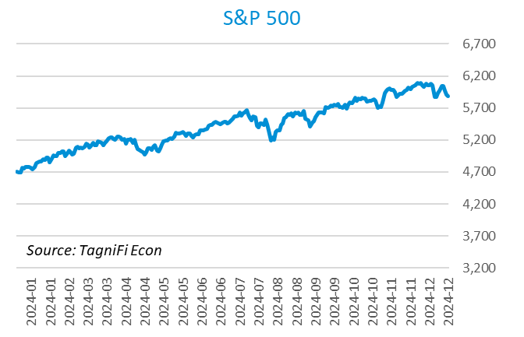

With increasing yields on corporate debt, bond prices struggled in the 4th quarter. The ICE BofA US Corporate Index[40] declined 2.8%, while the ICE BofA US High Yield Index[41] inched higher by 0.2%.



As measured by the VIX [42], stock market volatility ended the 4th quarter of 2024 at 17.3, up 3.7% over the prior quarter and up 39.4% year-over-year. The VIX rose in October before receding after the elections in November.

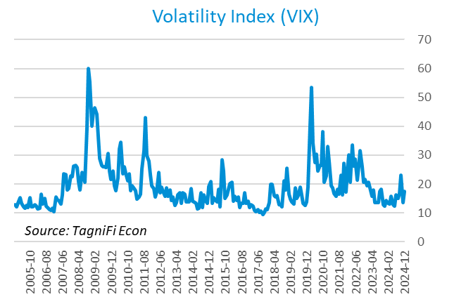

# Outlook

The FOMC cut interest rates by 0.25% in November and December while signaling a more cautious approach to future interest rate cuts and implying that the interest rate may not return to the pre-pandemic level. The Fed revised their near-term PCE inflation projections slightly upward and unemployment rate projections slightly downward. The median projection for real GDP was revised slightly upward. Minimal adjustments were made to longer-term projections for any of the three indicators.

The FOMC revised their projections for Personal Consumption Expenditures (PCE) inflation[43] to 2.45% in 2024 and 2025, respectively. The updated 2026 and 2027 projections stood at 2.10% and 2.00%, respectively. Real GDP[44] projections stood at 2.45% for 2024, 2.00% for 2025, and 2.00% and 1.90% for 2026 and 2027, respectively. The forecast unemployment rate[45] stood at 4.20% for 2024 and 4.35% for 2025, and 4.25% and 4.20% for 2026 and 2027, respectively. The Board updated projections of future target rates[46] to stand at 4.5% in 2024, 3.85% in 2025, and 3.35% and 3.25% in 2026 and 2027, respectively. The committee emphasized its long-term goal of maximal employment and 2% inflation but cautioned that future cuts are contingent on the economic data.



Appendix – Selected Interest Rates



# About This Report

The *Quarterly Economic Update* is a free publication sponsored by TagniFi. You are free to share this report and include its contents in the economic outlook section of your valuation reports as required by *Revenue Ruling 59-60*. Please forward this free report to a colleague to help us spread the word about TagniFi.

How TagniFi Helps Business Valuation Teams

TagniFi’s financial data platform empowers business valuation teams to quickly and easily build highly accurate financial models with full transparency—and within seconds.

**Better Public Comps**  
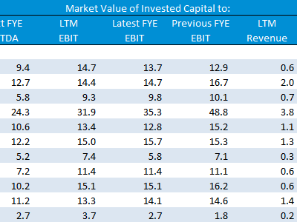Search for public companies with TagniFi Web. Simply enter your valuation date and ticker symbols in Excel to run a guideline public company method. Your Excel model populates instantly with the financial statements, analyst estimates, interest rates and economic data for your valuation date.

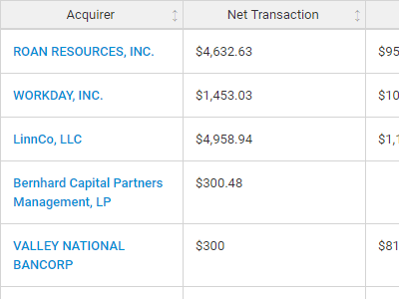

**Better Transaction Comps**  
Search for public and private M&A transactions with TagniFi Web. Run your transaction comps within seconds by pasting the Deal ID into your Excel model. Every deal disclosed in an SEC filing (8-K, 10-K, or 10-Q) is available for your analysis. Choose from over 90 fields of data available for every deal.

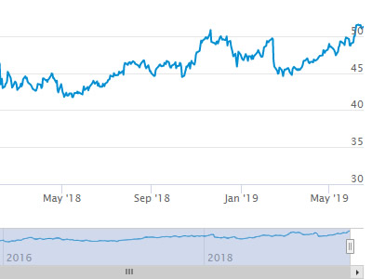

**Historical Beta and Volatility**Calculate historical beta and volatility as of your valuation date automatically. Simply enter the tickers and valuation date in Excel - TagniFi does the rest. In addition to beta and volatility, there are over 40 Excel models available in the Model Library to help with your valuation report.

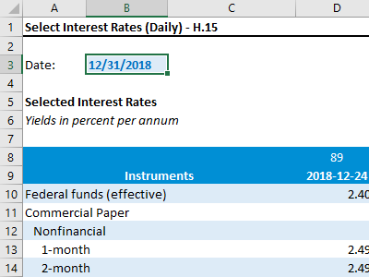**Interest Rates and Economic Data**Automate the interest rates and economic data in your valuation report using the TagniFi Excel plugin. Choose from over 200,000 time series available. All data in this *Quarterly Economic Update* is from the TagniFi platform. Use economic and interest rate data for your own valuation models with the TagniFi Excel plugin.

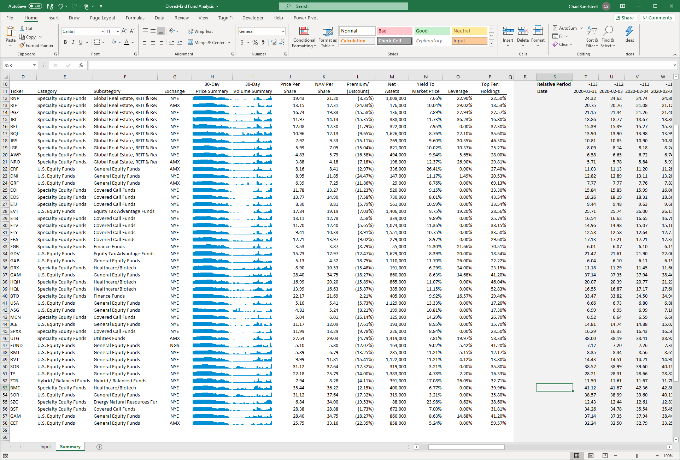

**Closed-End Mutual Fund Data**Search for closed-end mutual funds by keyword, category, subcategory, and more with the TagniFi Console. Use the TagniFi Excel plugin to calculate historical discounts, yields, leverage, as of your valuation date automatically. Simply enter the tickers and valuation date in Excel - TagniFi does the rest.

**Corporate Bond Data**Use interest rates along any point of the yield curve for your debt valuation engagements as of your valuation date. View historical price and yield information for over 80,000 corporate bond along with their characteristics.Search for bonds by rating to find guideline bonds for your analysis.

1. Federal Reserve Bank of Philadelphia, Coincident Economic Activity Index for the United States [USPHCI], *retrieved from FRED, Federal Reserve Bank of St. Louis;* [*https://fred.stlouisfed.org/series/USPHCI*](https://fred.stlouisfed.org/series/USPHCI)*, February 2, 2025.*
2. Board of Governors of the Federal Reserve System (US), Trade Weighted U.S. Dollar Index: Broad, Goods and Services [DTWEXBGS], *retrieved from FRED, Federal Reserve Bank of St. Louis;* [*https://fred.stlouisfed.org/series/DTWEXBGS*](https://fred.stlouisfed.org/series/DTWEXBGS)*, February 2, 2025.*
3. U.S. Bureau of Economic Analysis, Real Gross Domestic Product [GDPC1], *retrieved from FRED, Federal Reserve Bank of St. Louis;*[*https://fred.stlouisfed.org/series/GDPC1*](https://fred.stlouisfed.org/series/GDPC1)*, February 2, 2025.*
4. U.S. Bureau of Economic Analysis, Contributions to percent change in real gross domestic product: Personal consumption expenditures [DPCERY2Q224SBEA], *retrieved from FRED, Federal Reserve Bank of St. Louis;* [*https://fred.stlouisfed.org/series/DPCERY2Q224SBEA*](https://fred.stlouisfed.org/series/DPCERY2Q224SBEA)*,* *February 2, 2025.*
5. U.S. Bureau of Economic Analysis, Contributions to percent change in real gross domestic product: Gross private domestic investment [A006RY2Q224SBEA], *retrieved from FRED, Federal Reserve Bank of St. Louis;* [*https://fred.stlouisfed.org/series/A006RY2Q224SBEA*](https://fred.stlouisfed.org/series/A006RY2Q224SBEA)*, February 2, 2025.*
6. U.S. Bureau of Economic Analysis, Contributions to percent change in real gross domestic product: Government consumption expenditures and gross investment [A822RY2Q224SBEA], *retrieved from FRED, Federal Reserve Bank of St. Louis;* [*https://fred.stlouisfed.org/series/A822RY2Q224SBEA*](https://fred.stlouisfed.org/series/A822RY2Q224SBEA)*, February 2, 2025.*
7. U.S. Bureau of Economic Analysis, Contributions to percent change in real gross domestic product: Net exports of goods and services [A019RY2Q224SBEA], *retrieved from FRED, Federal Reserve Bank of St. Louis;* [*https://fred.stlouisfed.org/series/A019RY2Q224SBEA*](https://fred.stlouisfed.org/series/A019RY2Q224SBEA)*, February 2, 2025.*
8. Federal Reserve Bank of Philadelphia, The Livingston Survey December 2024, [economic release], retrieved from <https://www.philadelphiafed.org/surveys-and-data/real-time-data-research/livingston-survey>, *February 2, 2025*.
9. Board of Governors of the Federal Reserve System (US), Industrial Production Index [INDPRO], *retrieved from FRED, Federal Reserve Bank of St. Louis;*[*https://fred.stlouisfed.org/series/INDPRO*](https://fred.stlouisfed.org/series/INDPRO)*, February 2, 2025.*
10. Board of Governors of the Federal Reserve System (US), Capacity Utilization, Manufacturing (NAICS), *retrieved from FRED, Federal Reserve Bank of St. Louis;* [*https://fred.stlouisfed.org/series/MCUMFN*](https://fred.stlouisfed.org/series/MCUMFN)*, February 2, 2025.*
11. Selected Interest Rates Instruments, Yields in percent per annum, *retrieved from FRED, Federal Reserve Bank of St. Louis;* [https://fred.stlouisfed.org/release/tables?rid=18&eid=289&od=2024-06-28#](https://fred.stlouisfed.org/release/tables?rid=18&eid=289&od=2024-06-28)*, February 2, 2025.*
12. Board of Governors of the Federal Reserve System (US), Federal Funds Target Range - Upper Limit [DFEDTARU], *retrieved from FRED, Federal Reserve Bank of St. Louis;* [*https://fred.stlouisfed.org/series/DFEDTARU*](https://fred.stlouisfed.org/series/DFEDTARU)*, February 2, 2025*.
13. Board of Governors of the Federal Reserve System (US), 10-Year Treasury Constant Maturity Rate [DGS10], *retrieved from FRED, Federal Reserve Bank of St. Louis;*[*https://fred.stlouisfed.org/series/DGS10*](https://fred.stlouisfed.org/series/DGS10)*, February 2, 2025.*
14. Moody’s, Moody's Seasoned Baa Corporate Bond Yield [DBAA], *retrieved from FRED, Federal Reserve Bank of St. Louis;* [*https://fred.stlouisfed.org/series/DBAA*](https://fred.stlouisfed.org/series/DBAA)*, February 2, 2025.*
15. Moody’s, Moody's Seasoned Aaa Corporate Bond Yield [DAAA], *retrieved from FRED, Federal Reserve Bank of St. Louis;* [*https://fred.stlouisfed.org/series/DAAA*](https://fred.stlouisfed.org/series/DAAA)*, February 2, 2025.*
16. U.S. Bureau of Labor Statistics, Civilian Unemployment Rate [UNRATE], *retrieved from FRED, Federal Reserve Bank of St. Louis;*[*https://fred.stlouisfed.org/series/UNRATE*](https://fred.stlouisfed.org/series/UNRATE)*, February 2, 2025.*
17. U.S. Bureau of Labor Statistics, Civilian Labor Force Level [CLF16OV], *retrieved from FRED, Federal Reserve Bank of St. Louis;* [*https://fred.stlouisfed.org/series/CLF16OV*](https://fred.stlouisfed.org/series/CLF16OV)*, February 2, 2025.*
18. U.S. Bureau of Labor Statistics, Labor Force Participation Rate [CIVPART], *retrieved from FRED, Federal Reserve Bank of St. Louis;* [*https://fred.stlouisfed.org/series/CIVPART*](https://fred.stlouisfed.org/series/CIVPART)*, February 2, 2025.*
19. U.S. Bureau of Labor Statistics, Quits: Total Nonfarm [JTSQUL], *retrieved from FRED, Federal Reserve Bank of St. Louis;* [*https://fred.stlouisfed.org/series/JTSQUL*](https://fred.stlouisfed.org/series/JTSQUL)*, February 2, 2025.*
20. U.S. Bureau of Labor Statistics, Job Openings: Total Nonfarm [JTSJOL], *retrieved from FRED, Federal Reserve Bank of St. Louis;* [*https://fred.stlouisfed.org/series/JTSJOL*](https://fred.stlouisfed.org/series/JTSJOL)*, February 2, 2025.*
21. U.S. Bureau of Labor Statistics Total Unemployed, Plus All Persons Marginally Attached to the Labor Force, Plus Total Employed Part Time for Economic Reasons, as a Percent of the Civilian Labor Force Plus All Persons Marginally Attached to the Labor Force (U-6) [U6RATE], *retrieved from FRED, Federal Reserve Bank of St. Louis;*[*https://fred.stlouisfed.org/series/U6RATE*](https://fred.stlouisfed.org/series/U6RATE)*, February 2, 2025.*
22. U.S. Bureau of Labor Statistics, All Employees: Total Nonfarm Payrolls [PAYEMS], *retrieved from FRED, Federal Reserve Bank of St. Louis;*[*https://fred.stlouisfed.org/series/PAYEMS*](https://fred.stlouisfed.org/series/PAYEMS)*, February 2, 2025.*
23. U.S. Bureau of Labor Statistics, Consumer Price Index for All Urban Consumers: All Items [CPIAUCSL], *retrieved from FRED, Federal Reserve Bank of St. Louis;*[*https://fred.stlouisfed.org/series/CPIAUCSL*](https://fred.stlouisfed.org/series/CPIAUCSL)*, February 2, 2025.*
24. U.S. Bureau of Labor Statistics, Consumer Price Index for All Urban Consumers: All Items Less Energy in U.S. City Average [CPILEGSL], *retrieved from FRED, Federal Reserve Bank of St. Louis;* [*https://fred.stlouisfed.org/series/CPILEGSL*](https://fred.stlouisfed.org/series/CPILEGSL)*, February 2, 2025*.
25. U.S. Bureau of Labor Statistics, Average Price: Gasoline, Unleaded Regular (Cost per Gallon/3.785 Liters) in U.S. City Average [APU000074714], *retrieved from FRED, Federal Reserve Bank of St. Louis;* [*https://fred.stlouisfed.org/series/APU000074714*](https://fred.stlouisfed.org/series/APU000074714)*, February 2, 2025.*
26. U.S. Bureau of Labor Statistics, Producer Price Index for All Commodities [PPIACO], *retrieved from FRED, Federal Reserve Bank of St. Louis;*[*https://fred.stlouisfed.org/series/PPIACO*](https://fred.stlouisfed.org/series/PPIACO)*, February 2, 2025.*
27. *Federal Reserve Bank of St. Louis, 5-Year Breakeven Inflation Rate [T5YIE], retrieved from FRED, Federal Reserve Bank of St. Louis;*[*https://fred.stlouisfed.org/series/T5YIE*](https://fred.stlouisfed.org/series/T5YIE)*, February 2, 2025.*
28. U.S. Energy Information Administration, Crude Oil Prices: West Texas Intermediate (WTI) - Cushing, Oklahoma [DCOILWTICO], *retrieved from FRED, Federal Reserve Bank of St. Louis;* [*https://fred.stlouisfed.org/series/DCOILWTICO*](https://fred.stlouisfed.org/series/DCOILWTICO)*, February 2, 2025*
29. National Association of Realtors (NAR): Existing-Home Sales Slid 1.0% in September*, retrieved from NAR*[*hhttps://www.nar.realtor/newsroom/existing-home-sales-ascended-2-2-in-december*](hhttps://www.nar.realtor/newsroom/existing-home-sales-ascended-2-2-in-december), *February 2, 2025*.
30. U.S. Bureau of the Census, Housing Starts: Total: New Privately Owned Housing Units Started [HOUST], *retrieved from FRED, Federal Reserve Bank of St. Louis;*[*https://fred.stlouisfed.org/series/HOUST*](https://fred.stlouisfed.org/series/HOUST)*, February 2, 2025.*
31. Freddie Mac, 30-Year Fixed Rate Mortgage Average in the United States [MORTGAGE30US], *retrieved from FRED, Federal Reserve Bank of St. Louis;*[*https://fred.stlouisfed.org/series/MORTGAGE30US*](https://fred.stlouisfed.org/series/MORTGAGE30US)*, February 2, 2025.*
32. S&P Dow Jones Indices LLC, S&P/Case-Shiller 20-City Composite Home Price Index [SPCS20RSA], *retrieved from FRED, Federal Reserve Bank of St. Louis;*[*https://fred.stlouisfed.org/series/SPCS20RSA*](https://fred.stlouisfed.org/series/SPCS20RSA)*, February 2, 2025.*
33. S&P Global, S&P CORELOGIC CASE-SHILLER INDEX RECORDS 4.2% ANNUAL GAIN IN AUGUST 2024, retrieved from S&P Global: <https://press.spglobal.com/2025-01-29-S-P-CORELOGIC-CASE-SHILLER-INDEX-RECORDS-3-8-ANNUAL-GAIN-IN-NOVEMBER-2024>, *February 2, 2025*.
34. U.S. Bureau of Economic Analysis, Personal Consumption Expenditures [PCE], *retrieved from FRED, Federal Reserve Bank of St. Louis;*[*https://fred.stlouisfed.org/series/PCE*](https://fred.stlouisfed.org/series/PCE)*, February 2, 2025.*
35. U.S. Bureau of Economic Analysis, Personal Income and Outlays, September 2024; <https://www.bea.gov/news/2025/personal-income-and-outlays-december-2024>*, February 2, 2025.* 
36. U.S. Bureau of Economic Analysis, Light Weight Vehicle Sales: Autos and Light Trucks [ALTSALES], *retrieved from FRED, Federal Reserve Bank of St. Louis; <https://fred.stlouisfed.org/series/ALTSALES>, February 2, 2025.*
37. U.S. Bureau of Labor Statistics, Consumer Price Index for All Urban Consumers: New Vehicles in U.S. City Average [CUUR0000SETA01], *retrieved from FRED, Federal Reserve Bank of St. Louis;* [*https://fred.stlouisfed.org/series/CUUR0000SETA01*](https://fred.stlouisfed.org/series/CUUR0000SETA01)*, February 2, 2025.*
38. U.S. Bureau of Labor Statistics, Consumer Price Index for All Urban Consumers: Used Cars and Trucks in U.S. City Average [CUSR0000SETA02], *retrieved from FRED, Federal Reserve Bank of St. Louis;* [*https://fred.stlouisfed.org/series/CUSR0000SETA02*](https://fred.stlouisfed.org/series/CUSR0000SETA02), *February 2, 2025.*
39. *University of Michigan, University of Michigan: Consumer Sentiment [UMCSENT], retrieved from FRED, Federal Reserve Bank of St. Louis;* [*https://fred.stlouisfed.org/series/UMCSENT*](https://fred.stlouisfed.org/series/UMCSENT)*, February 2, 2025.*
40. *Ice Data Indices, LLC, ICE BofA US Corporate Index Total Return Index Value [BAMLCC0A0CMTRIV], retrieved from FRED, Federal Reserve Bank of St. Louis;* [*https://fred.stlouisfed.org/series/BAMLCC0A0CMTRIV*](https://fred.stlouisfed.org/series/BAMLCC0A0CMTRIV)*, February 2, 2025.*
41. *Ice Data Indices, LLC, ICE BofA US High Yield Index Total Return Index Value [BAMLHYH0A0HYM2TRIV], retrieved from FRED, Federal Reserve Bank of St. Louis;* [*https://fred.stlouisfed.org/series/BAMLHYH0A0HYM2TRIV*](https://fred.stlouisfed.org/series/BAMLHYH0A0HYM2TRIV)*,* *February 2, 2025.*
42. *Chicago Board Options Exchange, CBOE Volatility Index: VIX [VIXCLS], retrieved from FRED, Federal Reserve Bank of St. Louis;* [*https://fred.stlouisfed.org/series/VIXCLS*](https://fred.stlouisfed.org/series/VIXCLS)*, February 2, 2025.*
43. *Federal Reserve Bank of St. Louis, FOMC Summary of Economic Projections for the Personal Consumption Expenditures Inflation Rate, Central Tendency, Midpoint [PCECTPICTM], retrieved from FRED, Federal Reserve Bank of St. Louis;*[*https://fred.stlouisfed.org/series/PCECTPICTM*](https://fred.stlouisfed.org/series/PCECTPICTM)*, February 2, 2025.*
44. *Federal Reserve Bank of St. Louis, FOMC Summary of Economic Projections for the Growth Rate of Real Gross Domestic Product [GDPC1CTM], retrieved from FRED, Federal Reserve Bank of St. Louis;*[*https://fred.stlouisfed.org/series/GDPC1CTM*](https://fred.stlouisfed.org/series/GDPC1CTM)*, February 2, 2025.*
45. *Federal Reserve Bank of St. Louis, FOMC Summary of Economic Projections for the Civilian Unemployment Rate, Central Tendency, Midpoint [UNRATECTM], retrieved from FRED, Federal Reserve Bank of St. Louis;*[*https://fred.stlouisfed.org/series/UNRATECTM*](https://fred.stlouisfed.org/series/UNRATECTM)*, February 2, 2025.*
46. *U.S. Federal Open Market Committee and Federal Reserve Bank of St. Louis, FOMC Summary of Economic Projections for the Fed Funds Rate, Range, Midpoint [FEDTARCTM], retrieved from FRED, Federal Reserve Bank of St. Louis;* [*https://fred.stlouisfed.org/series/FEDTARCTM*](https://fred.stlouisfed.org/series/FEDTARCTM)*, February 2, 2025.*