QUARTERLY ECONOMIC UPDATE

For the 1st Quarter of 2025

Abstract

Designed for business valuation professionals, TagniFi’s Quarterly Economic   
Update provides timely economic data to satisfy Revenue Ruling 56-60.

# Summary

Overall, the U.S. economy sent softening signals in the 1st quarter of 2025, with GDP decreasing, the outlook for inflation increasing, and unemployment inching up. However, while the economy contracted in the 1st quarter, the negative GDP growth was primarily attributed to rising imports (which have a negative impact on GDP) as consumers pulled the demand for imported goods forward amid concerns about increasing prices following higher tariffs. Although GDP growth lost momentum, the short-term inflation outlook increased, leading the Federal Reserve Board to leave the interest rate unchanged and take a cautious stance on future interest rate cuts.

Domestic production growth was negative in the quarter. An increase in imports and a decrease in government spending were a drag on the GDP, partially offset by solid consumer spending and private investments.

Inflation was slightly higher than expected despite lower fuel prices compared to the previous quarter. Trade wars and concerns about softening U.S. and global economies led to lower crude oil prices. In response, the Federal Reserve left the target interest rate unchanged and signaled that future cuts would depend on the economic data.

A frequent bright spot for the economy in recent years, the job market sent mixed signals in the 1st quarter of 2025, with unemployment inching up, labor force participation unchanged, and uneven nonfarm employment growth. Still, the labor market remains well within the bounds of full employment.

Capital markets posted sharp losses in the 1st quarter, fueled by economic uncertainty, a rising inflationary outlook, expectations of higher imports tariffs, and the Fed’s cautionary approach to interest rate cuts. The tech-heavy NASDAQ indexes underperformed the broader S&P 500 and Dow Jones Industrial indexes.

Housing market data remained mixed, with some encouraging signs of possible recovery. As sales continued to be constrained by elevated interest rates, unsold housing inventory increased compared to the previous year. Prices in most major cities continued to rise year-over-year.

FOMC members’ short-term domestic production outlook was revised slightly downward. Unemployment expectations and inflation projections were revised slightly upward, while forecasts of longer-term economic performance were minimally changed.

A multifactor indicator of economic strength, the Philadelphia Fed’s coincident index[1] of economic activity in the U.S. rose 0.2% in March 2025 and 0.6% during the 1st quarter. For the quarter, the index increased in forty-two states, decreased in four, and remained unchanged in four. Coincident indexes reflect unemployment, payroll employment, manufacturing hours, and wages and salaries.



The U.S. dollar index for goods and services[2] declined 2.0% during the 1st quarter of 2025, reflecting the expectation of slower growth in the U.S. economy compared to other developed markets amid concerns about the economic slowdown caused by the trading wars. The dollar index was up 4.6% over the prior year.

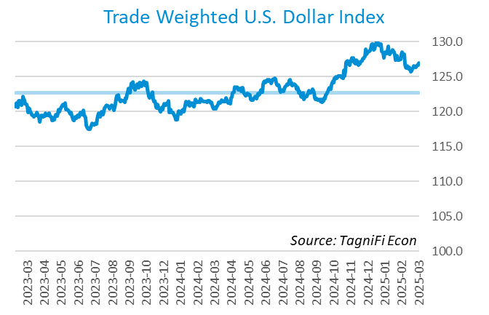

# Q1 Economic Highlights

* The Philadelphia Fed’s coincident index of economic activity in the U.S. rose 0.2% in March 2025 and 0.6% during the 1st quarter.
* The U.S. dollar index declined 2.0% during the 1st quarter of 2025 and was up 4.6% from the prior year.
* Real GDP contracted at an annualized rate of 0.3% during the 1st quarter of 2025.
* The effective federal funds rate declined to 4.33% in the 1st quarter.
* The 1-year and 2-year annual treasury yields ended the 1st quarter at 4.03% and 3.89%, respectively. The benchmark 10-year treasury yielded 4.23% at the end of the quarter, while the 30-year treasury yielded 4.59%.
* The unemployment rate ended the 1st quarter at 4.2%, slightly up from the prior quarter. Nonfarm payrolls grew by 0.4 million jobs in the 1st quarter.
* The Consumer Price Index for all items rose 2.4% for the year ended March 2025. Excluding volatile energy prices, the annual increase was 2.8%.
* Crude oil prices ended the 1st quarter at $71.87 per barrel, down 0.8% from the prior quarter and down 14% year-over-year.
* New home starts decreased 13.2% during the 1st quarter to 1.3 million in March. Total new home starts were up 1.9% year-over-year.
* The NASDAQ Composite declined 10.4% during the 1st quarter. The S&P 500 dropped 4.6%, and the Dow Jones Industrial Average reported a more moderate loss of 1.3%, while the Dow Jones Transportation and Composite Averages were down 7.2% and 2.0%, respectively, during the quarter. The Dow Jones Utility Average was up 4.2% during the quarter.

# Business Activity

Real gross domestic product (GDP)[3] declined at an annualized rate of 0.3% during the 1st quarter of 2025, the first contraction since Q1 2022. Q1 2025 GDP was slightly lower than expected and down from 2.4% growth in the 4th quarter of 2024. GDP grew 2.1% year over year. The decline in the 1st quarter GDP reflects surging imports and declining government spending, partially offset by increasing investment, consumer spending, and exports. The increase in imports likely reflects the pulled-forward demand amid concerns about higher tariffs expected to take effect in Q2 2025. The negative 1st quarter GDP growth pointed to an economic slowdown or reversal of the economic expansion.

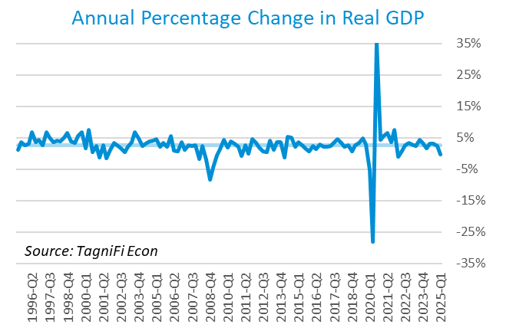

Personal consumption expenditures[4] (PCE) had a positive 1.2% effect on real GDP in the 1st quarter. A rise in spending on services, especially health care (including hospital and outpatient services) and housing and utilities, contributed to PCE growth. While spending on nondurable goods also rose, spending on durable goods declined.

Gross domestic private investment[5] had a positive impact on the GDP, increasing the 1st quarter real GDP estimate by 3.6%. While both the wholesale and retail sectors experienced positive changes in inventory, the retail inventory of motor vehicles and parts declined for the second consecutive quarter. The increase in nonresidential fixed investment reflected robust growth in the information processing equipment, computers and peripheral equipment, and intellectual property categories. Residential fixed investment remained effectively unchanged in the 1st quarter.

Government expenditures[6] declined in the 1st quarter, subtracting 0.3% from real GDP. The decline in government expenditures reflects a decrease in federal defense investment, partially offset by higher state and local employee compensation.

Net exports[7] declined by 4.8% in the 1st quarter as imports (which have a negative impact on GDP) surged, partially offset by an increase in exports. The increase in exports was led by increase in capital and consumer goods, except automotive. The increase in imports was primarily explained by higher imports of consumer goods, except food and automotive (such as medicinal, dental, and pharmaceutical preparations, including vitamins). Imports of capital goods, except automotive (such as computers, peripherals, and parts) also increased during Q1.

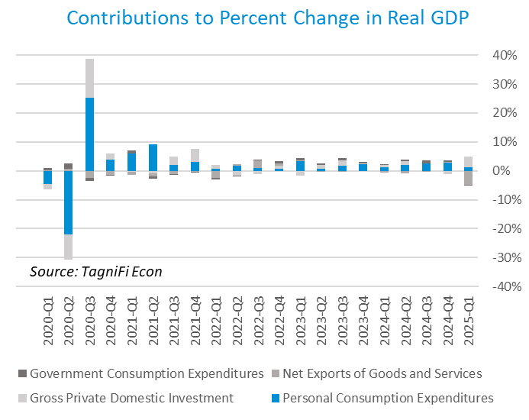

Economists polled by the Livingston Survey[8] in December 2024 projected real GDP to rise to an annual rate of 2.5% in the 2nd half of 2024, moderating to an annual rate of 1.9% in the 1st and 2nd half of 2025.

The Industrial Production Index[9] is an economic indicator that measures real output for all facilities located in the United States manufacturing, mining, and electric and gas utility sectors. The index stood at 103.9 at the end of the 1st quarter, up 0.75% from the 4th quarter.

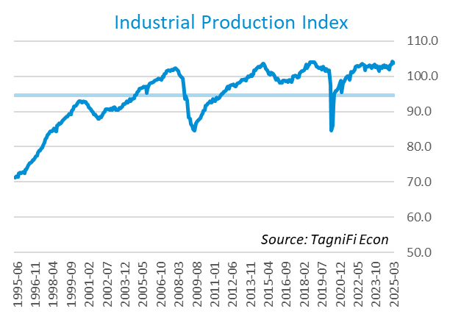

The Capacity Utilization Index[10], which attempts to capture industrial output as a percentage of the economy’s maximum production capacity, ended the 1st quarter of 2025 at 77.2%. March 2025’s level was slightly above the 30-year average of 76.7% for this metric and up slightly from the previous quarter.

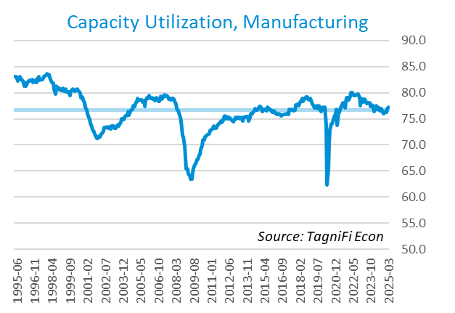

# Interest Rates

Treasury yields[11] for periods of one year and up declined during the 1st quarter. The closely watched two-year yield remained below the ten-year rate for the third consecutive quarter, signaling the end of the inverted yield curve that was observable between July 2022 and the first half of 2024. The 1-year and 2-year annual treasury yields ended the 1st quarter at 4.03% and 3.89%, respectively. The benchmark 10-year treasury yielded 4.23% at the end of the quarter, while the 30-year treasury yielded 4.59%. See *Appendix – Selected Interest Rates* for detailed interest rate data.

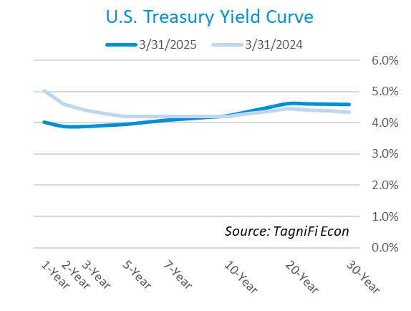

In the 1st quarter of 2025, the Federal Reserve held the federal funds target rate[12] steady at a range of 4.25% to 4.50%, pausing the emerging trend of the interest rate cuts of the second half of 2024. Still, the Q1 2025 interest rate range reflects a moderate decline from the 23-year high of 5.25% to 5.50%. With the economy outlook softening amid economic uncertainty and the inflation outlook remaining above the Fed’s optimal rate of 2%, the FOMC signaled that it may take a more cautious approach to additional rate cuts in the upcoming months compared to the second half of 2024. The effective federal funds rate declined to 4.33% in the 1st quarter.

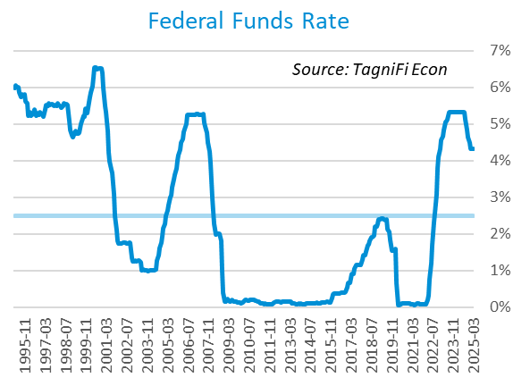

The yield on the benchmark 10-year U.S. treasury[13] ended the 1st quarter at 4.23%, down 0.35% from the previous quarter and above the average yield of 3.73% over the last 30 years.

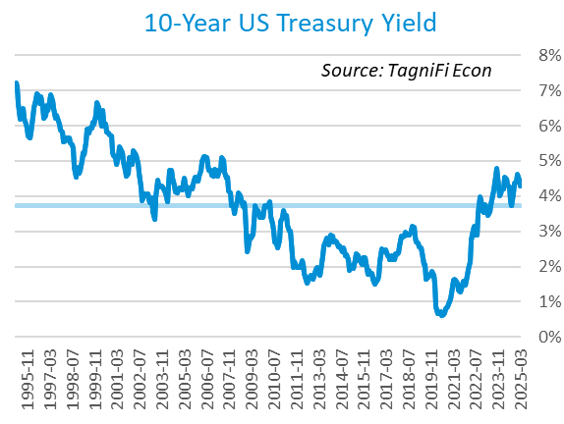

Moody’s Baa Corporate Bond Yield Index[14] ended the 1st quarter of 2025 at 5.99%, effectively unchanged from the previous quarter. Moody’s less-risky Aaa[15] Bond Yield Index decreased slightly by 0.1% during the quarter to 5.31%.

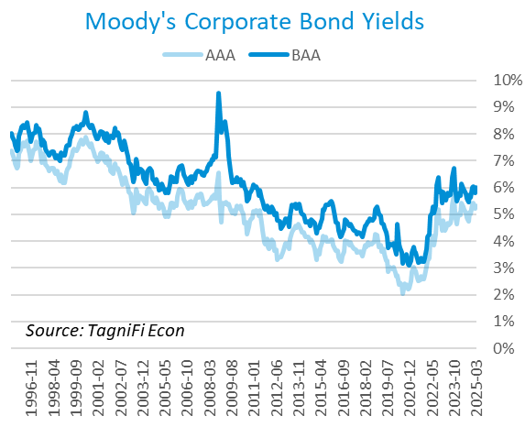

# Employment

The jobs market, a bright spot in the US economy throughout the pandemic recovery, showed mixed results in the 1st quarter. The official unemployment rate[16] ended the quarter at 4.2%, slightly up from the prior quarter’s unemployment rate of 4.1% but well below the 30-year historical average of 5.6% and within the 4.0% to 5.0% range accepted as an equilibrium level of “full employment.” The labor force[17] increased by 2.0 million workers during the quarter, while the labor force participation rate[18] remained unchanged at 62.5% in March 2025, 0.8 percentage points below its pre-pandemic level. Economists polled by the Livingston Survey in December 2024 projected the unemployment rate to be 4.2% in December, rising slightly to 4.3% in June 2025 and remaining steady at 4.3% in December 2025.

In March 2025, nonfarm worker quits[19] stood at 3.3 million, up 2.5% over the month and slightly up over the year. Job openings[20] totaled 7.2 million in March 2025, 2.2 times the number of resignations. The job openings count decreased by 3.9% from February 2025 and down more than 11% from March 2024.

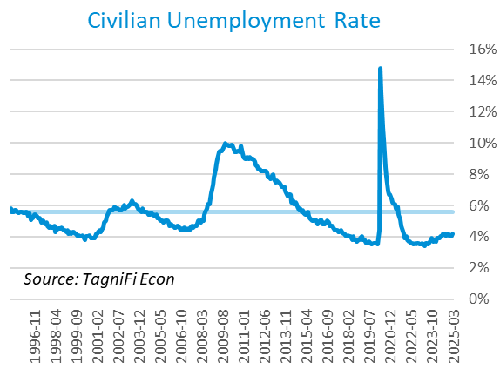

The U-6 unemployment rate[21] is an alternative measure of unemployment with a broader definition, including such groups as discouraged workers who are not actively searching for jobs but want full-time work and part-time workers who want full-time work. The U‑6 unemployment rate has generally followed the same pattern as the official rate and stood at 7.9% in March 2025.

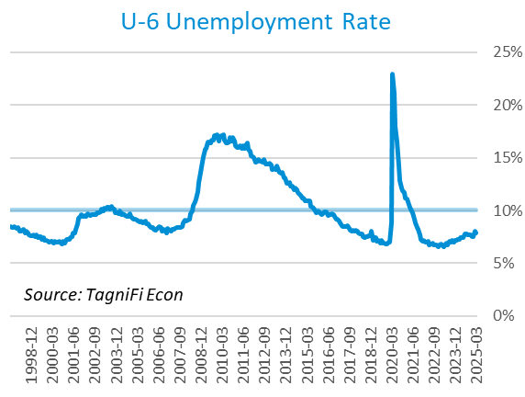

Nonfarm payrolls[22] grew by 0.4 million jobs in the 1st quarter. U.S. nonfarm payrolls in March 2025 totaled 159.3 million jobs, up 1.8 million from the prior March. March’s job market growth was primarily concentrated in health care, social assistance, and retail sectors. Federal government jobs declined during the quarter, reflecting the Department of Government Efficiency (DOGE) initiatives to reduce the federal government workforce. Other industries mostly experienced little change.

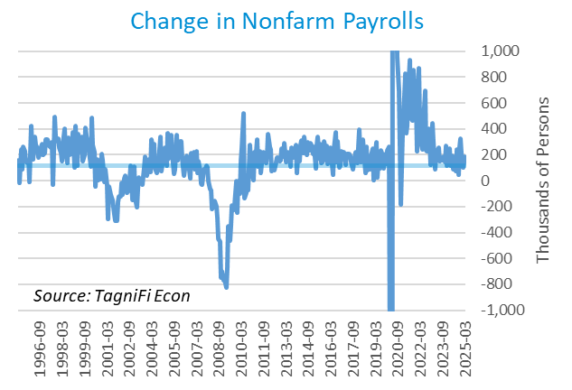

# Inflation

In the 1st quarter of 2025, inflation kept a more moderate pace than previous years with significant inflationary pressures. The Consumer Price Index[23] for all items rose 2.4% for the year ended March 2025. Since last March, notable price increases have included shelter, medical care (including medical care services), transportation services, utilities, and food. Prices for motor gasoline and fuel declined, and prices for new vehicles remained unchanged year-over-year. Excluding volatile energy prices[24], the annual increase was 2.8%. The average price of a gallon of gas[25] in the U.S. increased 2.8% during the 1st quarter of 2025 to $3.23. March’s average price was 9.8% lower than one year prior.

The Consumer Price Index decreased by 0.1% in March 2025 compared to February 2025. In the month of March 2025, energy prices (including gasoline and fuel) declined, partially offset by rising utility prices. Prices for transportation services and used cars and trucks declined during the month, while food (both away from home and at home) and medical care services prices rose.

The Federal Reserve, which had been taking aggressive action to curb inflation with a series of target interest rate hikes totaling 5.25 percentage points from March 2022 to July 2023, cut the target rate in both November and December, bringing the total rate cut to 1.00% in 2024. However, the Fed left the interest rate unchanged in the first quarter of 2025, signaling that the size of the future cuts would depend on the inflation and economic data readings.

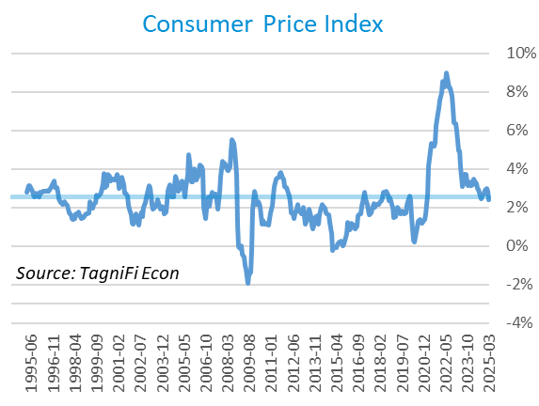

Wholesale inflation has been quicker to regulate than consumer inflation. The Producer Price Index[26] increased 2.1% in the 1st quarter and 1.5% since March 2024. The average annual increase over the last 30 years was 2.7%.

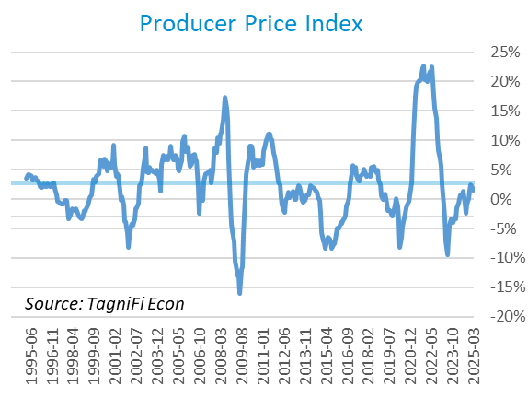

The 5-year breakeven inflation rate[27], an indicator of the market’s inflation expectations for the period, increased to 2.6% at the end of the 1st quarter of 2025 from 2.4% at the end of the 4th quarter of 2024.

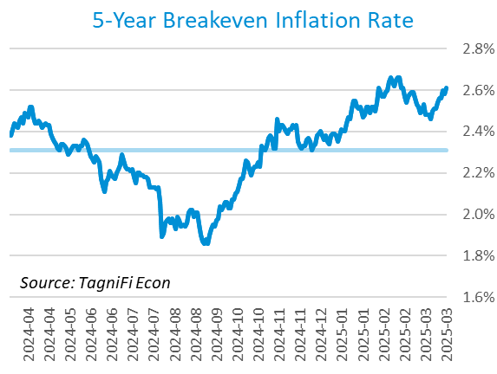

U.S. crude oil[28] prices decreased slightly in the 1st quarter, settling at $71.87 per barrel at the end of the volatile quarter amid trade wars and concerns about softening U.S. and global economies. Crude prices ended the 1st quarter down 0.8% from the prior quarter and down 14% year-over-year.

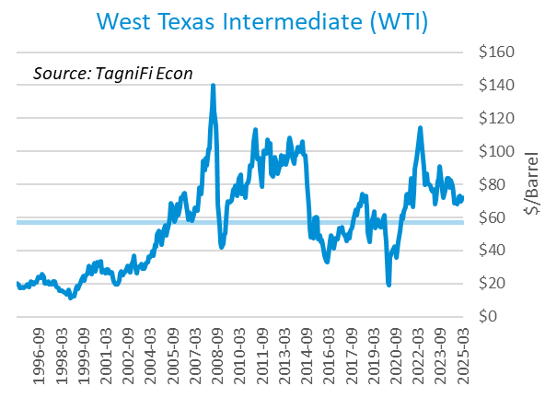

# Housing

The inventory of unsold homes increased by 8.1% in March compared to the previous month and increased by 19.8% from March 2024. The median existing home sales price was up 2.7% compared to last year. The median sales price increased year-over-year in all four US regions.[29] New home starts[30] declined 13.2% during the 1st quarter to 1.3 million in March, reflecting a decrease in both multifamily and single family home starts during the 1st quarter. Total new home starts were up 1.9% year-over-year and remained on par with their 30-year average of 1.3 million.

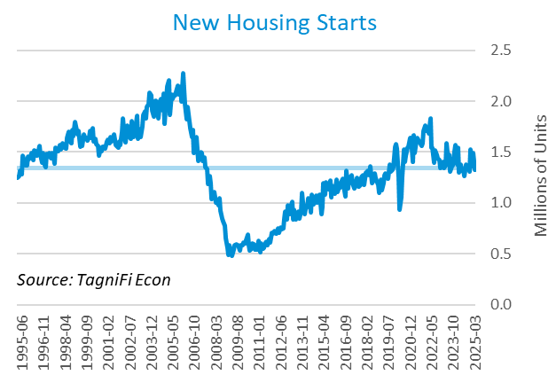

The cost of financing for would-be homebuyers decreased during the 1st quarter, with the 30-year fixed-rate mortgage[31] down 0.2 percentage points to an average of 6.65% at the end of March 2025. The average rate was 1.1% lower than its peak of 7.79% in late October 2023.

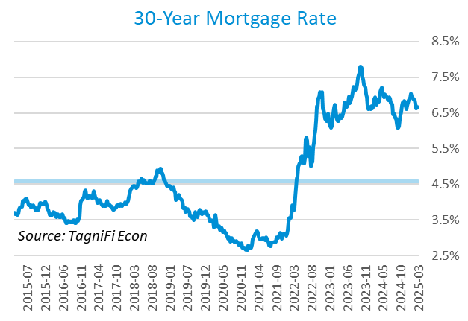

The S&P Case-Shiller Home Price Index (20-city)[32] for February 2025 was 1.3% higher compared to November 2024 and 4.5% higher since February 2024. While 19 of the 20 cities recorded a year-over-year increase, the Tampa index fell 1.46% year-over-year. New York, Chicago, and Cleveland reported the highest annual gains of 7.7%, 7.0%, and 6.6%, respectively. According to S&P Dow Jones Indices (S&P DJI), while buyers demand is still subdued due to high interest rates and low affordability, the February 2025 readings suggest a slow, sustainable pace of growth. [33]

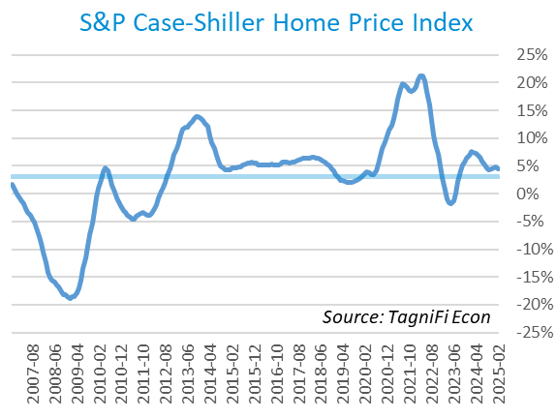

# Consumer Spending

Personal Consumption Expenditures (PCE)[34] rose 1.2% in the 1st quarter to $20.7 trillion and 5.6% over the same quarter last year. Spending increased in March for services such as healthcare services, financial services and insurance, and housing and utilities.[35] Goods spending also increased, especially for motor vehicles and parts, partially offset by a decline in gasoline and other energy goods spending.

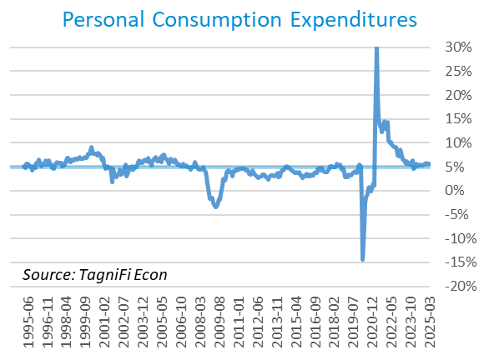

Auto manufacturers reported autos and light trucks sold[36] at an annual rate of 17.8 million in March 2025, up 5.7% from December 2024. New vehicle prices[37] increased 0.3% during the 1st quarter, remaining near their record high. Used car prices[38] increased 2.4% from December 2024 to March 2025.

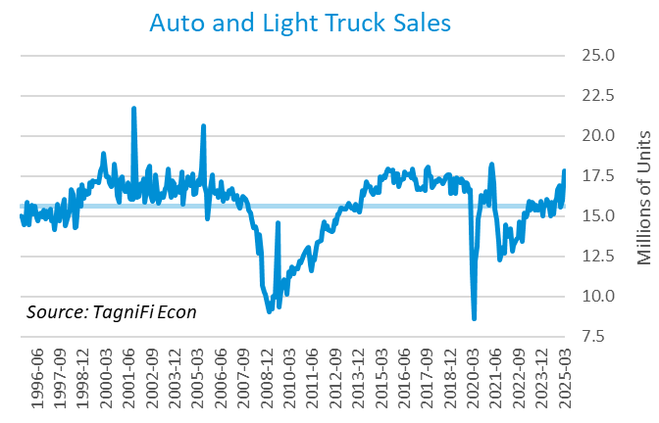

The University of Michigan’s consumer sentiment index[39] stood at 57.0 in March 2025, a steep decline from 74.0 in December 2024 and the lowest reading since July 2022. The index bottomed at its all-time low of 50.0 in June 2022. The economic uncertainty amid trade wars and inflation concerns related to higher tariffs likely weighed on consumer sentiment and contributed to a sharp downturn in the sentiment index. The index was down 23% year-over-year and well below its 30-year average of 85.5.

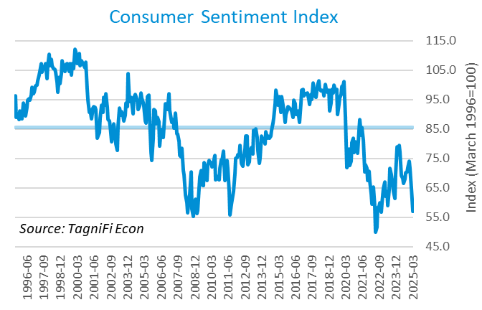

# Capital Markets

The table below shows major U.S. equity indices' quarterly, year-to-date, and 12-month performance. The stock market ended the quarter on a sharply negative note, with economic uncertainty caused by trade wars, tariffs, and inflation concerns among the primary factors contributing to market pessimism. Weakening economic data and the Fed’s more careful approach to future interest rate cuts are also likely weighed on the market sentiment.

The first quarter market losses were broad-based, with most major indexes experiencing a sharp decline compared to the 4th quarter of 2024. During the quarter, the tech-heavy NASDAQ Composite and NASDAQ 100 dropped 10.4% and 8.3%, respectively. The broader S&P 500 lost 4.6%, while the Dow Jones Industrial Average lost a more moderate 1.3%. Other blue-chip-focused Dow Jones averages—Transportation and Composite—were down 7.2% and 2.0%, respectively, during the 1st quarter. Dow Jones Utility, the notable exception among the major indexes, rose 4.2% during the quarter. Generally, while the utility sector is not recession-proof, it is more resilient during the economic downturn than a more volatile tech sector.



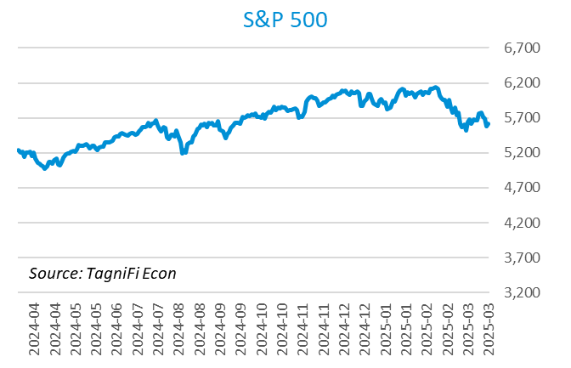

The corporate bond indexes gained during the 1st quarter, with the ICE BofA US Corporate Index[40] gaining 2.4% and the ICE BofA US High Yield Index[41] adding 0.9%.



As measured by the VIX [42], stock market volatility ended the 1st quarter of 2025 at 22.3, up 28.4% over the prior quarter and up 71% year-over-year. The VIX Index climbed steadily since the second half of February before reaching its peak of 27.9 in mid-March and receding to 22.3 at the end of the quarter.

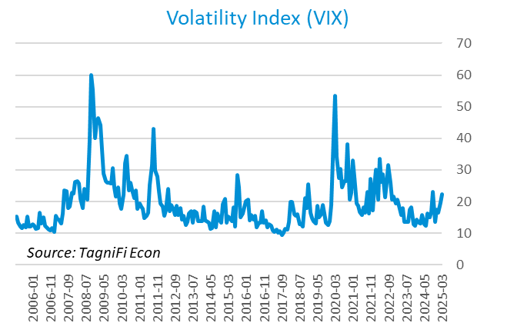

# Outlook

The FOMC left the interest rate unchanged in the 1st quarter while signaling a more cautious, data-driven approach to future interest rate cuts. The Fed revised their near-term PCE inflation and unemployment projections slightly upward. The median projection for real GDP was revised slightly downward. Minimal adjustments were made to longer-term projections for any of the three indicators.

The FOMC revised their projections for Personal Consumption Expenditures (PCE) inflation[43] to 2.75% in 2025. The updated 2026 and 2027 projections stood at 2.20% and 2.05%, respectively. Real GDP[44] projections stood at 1.70% for 2025 and 1.75% and 1.80% for 2026 and 2027, respectively. The forecast unemployment rate[45] stood at 4.35% for 2025 and 2026 and 4.25% for 2027. The Board updated projections of future target rates[46] to stand at 4.15% in 2025 and 3.5% and 3.25% in 2026 and 2027, respectively. The committee emphasized its long-term goal of maximal employment and 2% inflation but cautioned that future cuts are contingent on the economic data.



Appendix – Selected Interest Rates



# About This Report

The *Quarterly Economic Update* is a free publication sponsored by TagniFi. You are free to share this report and include its contents in the economic outlook section of your valuation reports as required by *Revenue Ruling 59-60*. Please forward this free report to a colleague to help us spread the word about TagniFi.

How TagniFi Helps Business Valuation Teams

TagniFi’s financial data platform empowers business valuation teams to quickly and easily build highly accurate financial models with full transparency—and within seconds.

**Better Public Comps**  
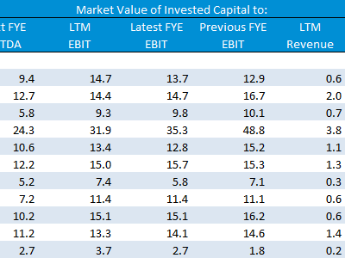Search for public companies with TagniFi Web. Simply enter your valuation date and ticker symbols in Excel to run a guideline public company method. Your Excel model populates instantly with the financial statements, analyst estimates, interest rates and economic data for your valuation date.

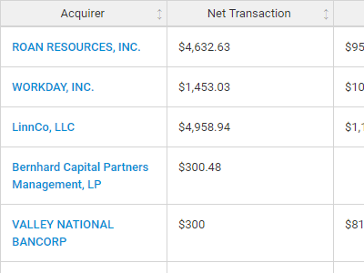

**Better Transaction Comps**  
Search for public and private M&A transactions with TagniFi Web. Run your transaction comps within seconds by pasting the Deal ID into your Excel model. Every deal disclosed in an SEC filing (8-K, 10-K, or 10-Q) is available for your analysis. Choose from over 90 fields of data available for every deal.

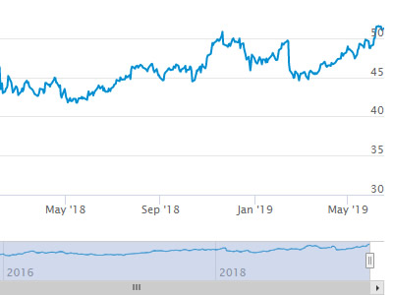

**Historical Beta and Volatility**Calculate historical beta and volatility as of your valuation date automatically. Simply enter the tickers and valuation date in Excel - TagniFi does the rest. In addition to beta and volatility, there are over 40 Excel models available in the Model Library to help with your valuation report.

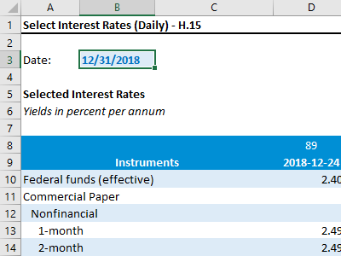**Interest Rates and Economic Data**Automate the interest rates and economic data in your valuation report using the TagniFi Excel plugin. Choose from over 200,000 time series available. All data in this *Quarterly Economic Update* is from the TagniFi platform. Use economic and interest rate data for your own valuation models with the TagniFi Excel plugin.

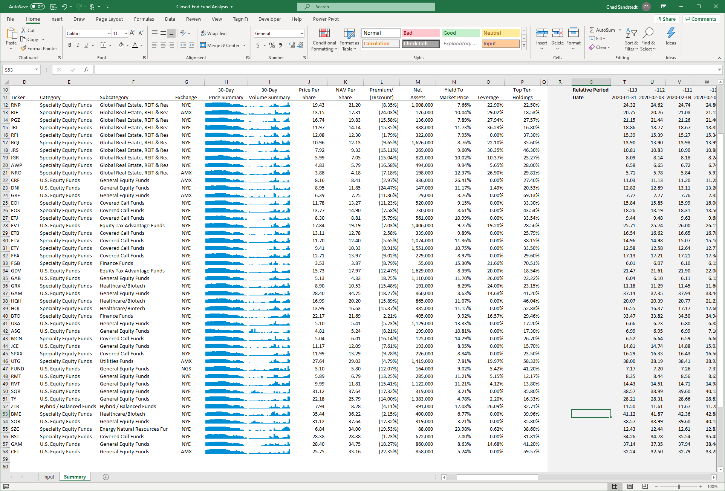

**Closed-End Mutual Fund Data**Search for closed-end mutual funds by keyword, category, subcategory, and more with the TagniFi Console. Use the TagniFi Excel plugin to calculate historical discounts, yields, leverage, as of your valuation date automatically. Simply enter the tickers and valuation date in Excel - TagniFi does the rest.

**Corporate Bond Data**Use interest rates along any point of the yield curve for your debt valuation engagements as of your valuation date. View historical price and yield information for over 80,000 corporate bond along with their characteristics.Search for bonds by rating to find guideline bonds for your analysis.

1. Federal Reserve Bank of Philadelphia, Coincident Economic Activity Index for the United States [USPHCI], *retrieved from FRED, Federal Reserve Bank of St. Louis;* [*https://fred.stlouisfed.org/series/USPHCI*](https://fred.stlouisfed.org/series/USPHCI)*, May 2, 2025.*
2. Board of Governors of the Federal Reserve System (US), Trade Weighted U.S. Dollar Index: Broad, Goods and Services [DTWEXBGS], *retrieved from FRED, Federal Reserve Bank of St. Louis;* [*https://fred.stlouisfed.org/series/DTWEXBGS*](https://fred.stlouisfed.org/series/DTWEXBGS)*, May 2, 2025.*
3. U.S. Bureau of Economic Analysis, Real Gross Domestic Product [GDPC1], *retrieved from FRED, Federal Reserve Bank of St. Louis;*[*https://fred.stlouisfed.org/series/GDPC1*](https://fred.stlouisfed.org/series/GDPC1)*, May 2, 2025.*
4. U.S. Bureau of Economic Analysis, Contributions to percent change in real gross domestic product: Personal consumption expenditures [DPCERY2Q224SBEA], *retrieved from FRED, Federal Reserve Bank of St. Louis;* [*https://fred.stlouisfed.org/series/DPCERY2Q224SBEA*](https://fred.stlouisfed.org/series/DPCERY2Q224SBEA)*,* *May 2, 2025.*
5. U.S. Bureau of Economic Analysis, Contributions to percent change in real gross domestic product: Gross private domestic investment [A006RY2Q224SBEA], *retrieved from FRED, Federal Reserve Bank of St. Louis;* [*https://fred.stlouisfed.org/series/A006RY2Q224SBEA*](https://fred.stlouisfed.org/series/A006RY2Q224SBEA)*, May 2, 2025.*
6. U.S. Bureau of Economic Analysis, Contributions to percent change in real gross domestic product: Government consumption expenditures and gross investment [A822RY2Q224SBEA], *retrieved from FRED, Federal Reserve Bank of St. Louis;* [*https://fred.stlouisfed.org/series/A822RY2Q224SBEA*](https://fred.stlouisfed.org/series/A822RY2Q224SBEA)*, May 2, 2025.*
7. U.S. Bureau of Economic Analysis, Contributions to percent change in real gross domestic product: Net exports of goods and services [A019RY2Q224SBEA], *retrieved from FRED, Federal Reserve Bank of St. Louis;* [*https://fred.stlouisfed.org/series/A019RY2Q224SBEA*](https://fred.stlouisfed.org/series/A019RY2Q224SBEA)*, May 2, 2025.*
8. Federal Reserve Bank of Philadelphia, The Livingston Survey December 2024, [economic release], retrieved from <https://www.philadelphiafed.org/surveys-and-data/real-time-data-research/livingston-survey>, *May 2, 2025*.
9. Board of Governors of the Federal Reserve System (US), Industrial Production Index [INDPRO], *retrieved from FRED, Federal Reserve Bank of St. Louis;*[*https://fred.stlouisfed.org/series/INDPRO*](https://fred.stlouisfed.org/series/INDPRO)*, May 2, 2025.*
10. Board of Governors of the Federal Reserve System (US), Capacity Utilization, Manufacturing (NAICS), *retrieved from FRED, Federal Reserve Bank of St. Louis;* [*https://fred.stlouisfed.org/series/MCUMFN*](https://fred.stlouisfed.org/series/MCUMFN)*, May 2, 2025.*
11. Selected Interest Rates Instruments, Yields in percent per annum, *retrieved from FRED, Federal Reserve Bank of St. Louis; https://fred.stlouisfed.org/release/tables?rid=18&eid=289&od=2025-03-31#, May 2, 2025.*
12. Board of Governors of the Federal Reserve System (US), Federal Funds Target Range - Upper Limit [DFEDTARU], *retrieved from FRED, Federal Reserve Bank of St. Louis;* [*https://fred.stlouisfed.org/series/DFEDTARU*](https://fred.stlouisfed.org/series/DFEDTARU)*, May 2, 2025*.
13. Board of Governors of the Federal Reserve System (US), 10-Year Treasury Constant Maturity Rate [DGS10], *retrieved from FRED, Federal Reserve Bank of St. Louis;*[*https://fred.stlouisfed.org/series/DGS10*](https://fred.stlouisfed.org/series/DGS10)*, May 2, 2025.*
14. Moody’s, Moody's Seasoned Baa Corporate Bond Yield [DBAA], *retrieved from FRED, Federal Reserve Bank of St. Louis;* [*https://fred.stlouisfed.org/series/DBAA*](https://fred.stlouisfed.org/series/DBAA)*, May 2, 2025.*
15. Moody’s, Moody's Seasoned Aaa Corporate Bond Yield [DAAA], *retrieved from FRED, Federal Reserve Bank of St. Louis;* [*https://fred.stlouisfed.org/series/DAAA*](https://fred.stlouisfed.org/series/DAAA)*, May 2, 2025.*
16. U.S. Bureau of Labor Statistics, Civilian Unemployment Rate [UNRATE], *retrieved from FRED, Federal Reserve Bank of St. Louis;*[*https://fred.stlouisfed.org/series/UNRATE*](https://fred.stlouisfed.org/series/UNRATE)*, May 2, 2025.*
17. U.S. Bureau of Labor Statistics, Civilian Labor Force Level [CLF16OV], *retrieved from FRED, Federal Reserve Bank of St. Louis;* [*https://fred.stlouisfed.org/series/CLF16OV*](https://fred.stlouisfed.org/series/CLF16OV)*, May 2, 2025.*
18. U.S. Bureau of Labor Statistics, Labor Force Participation Rate [CIVPART], *retrieved from FRED, Federal Reserve Bank of St. Louis;* [*https://fred.stlouisfed.org/series/CIVPART*](https://fred.stlouisfed.org/series/CIVPART)*, May 2, 2025.*
19. U.S. Bureau of Labor Statistics, Quits: Total Nonfarm [JTSQUL], *retrieved from FRED, Federal Reserve Bank of St. Louis;* [*https://fred.stlouisfed.org/series/JTSQUL*](https://fred.stlouisfed.org/series/JTSQUL)*, May 2, 2025.*
20. U.S. Bureau of Labor Statistics, Job Openings: Total Nonfarm [JTSJOL], *retrieved from FRED, Federal Reserve Bank of St. Louis;* [*https://fred.stlouisfed.org/series/JTSJOL*](https://fred.stlouisfed.org/series/JTSJOL)*, May 2, 2025.*
21. U.S. Bureau of Labor Statistics Total Unemployed, Plus All Persons Marginally Attached to the Labor Force, Plus Total Employed Part Time for Economic Reasons, as a Percent of the Civilian Labor Force Plus All Persons Marginally Attached to the Labor Force (U-6) [U6RATE], *retrieved from FRED, Federal Reserve Bank of St. Louis;*[*https://fred.stlouisfed.org/series/U6RATE*](https://fred.stlouisfed.org/series/U6RATE)*, May 2, 2025.*
22. U.S. Bureau of Labor Statistics, All Employees: Total Nonfarm Payrolls [PAYEMS], *retrieved from FRED, Federal Reserve Bank of St. Louis;*[*https://fred.stlouisfed.org/series/PAYEMS*](https://fred.stlouisfed.org/series/PAYEMS)*, May 2, 2025.*
23. U.S. Bureau of Labor Statistics, Consumer Price Index for All Urban Consumers: All Items [CPIAUCSL], *retrieved from FRED, Federal Reserve Bank of St. Louis;*[*https://fred.stlouisfed.org/series/CPIAUCSL*](https://fred.stlouisfed.org/series/CPIAUCSL)*, May 2, 2025.*
24. U.S. Bureau of Labor Statistics, Consumer Price Index for All Urban Consumers: All Items Less Energy in U.S. City Average [CPILEGSL], *retrieved from FRED, Federal Reserve Bank of St. Louis;* [*https://fred.stlouisfed.org/series/CPILEGSL*](https://fred.stlouisfed.org/series/CPILEGSL)*, May 2, 2025*.
25. U.S. Bureau of Labor Statistics, Average Price: Gasoline, Unleaded Regular (Cost per Gallon/3.785 Liters) in U.S. City Average [APU000074714], *retrieved from FRED, Federal Reserve Bank of St. Louis;* [*https://fred.stlouisfed.org/series/APU000074714*](https://fred.stlouisfed.org/series/APU000074714)*, May 2, 2025.*
26. U.S. Bureau of Labor Statistics, Producer Price Index for All Commodities [PPIACO], *retrieved from FRED, Federal Reserve Bank of St. Louis;*[*https://fred.stlouisfed.org/series/PPIACO*](https://fred.stlouisfed.org/series/PPIACO)*, May 2, 2025.*
27. *Federal Reserve Bank of St. Louis, 5-Year Breakeven Inflation Rate [T5YIE], retrieved from FRED, Federal Reserve Bank of St. Louis;*[*https://fred.stlouisfed.org/series/T5YIE*](https://fred.stlouisfed.org/series/T5YIE)*, May 2, 2025.*
28. U.S. Energy Information Administration, Crude Oil Prices: West Texas Intermediate (WTI) - Cushing, Oklahoma [DCOILWTICO], *retrieved from FRED, Federal Reserve Bank of St. Louis;* [*https://fred.stlouisfed.org/series/DCOILWTICO*](https://fred.stlouisfed.org/series/DCOILWTICO)*, May 2, 2025*
29. National Association of Realtors (NAR): Existing-Home Sales Receded 5.9% in March*, retrieved from NAR**https://www.nar.realtor/newsroom/existing-home-sales-receded-5-9-in-march*, *May 2, 2025*.
30. U.S. Bureau of the Census, Housing Starts: Total: New Privately Owned Housing Units Started [HOUST], *retrieved from FRED, Federal Reserve Bank of St. Louis;*[*https://fred.stlouisfed.org/series/HOUST*](https://fred.stlouisfed.org/series/HOUST)*, May 2, 2025.*
31. Freddie Mac, 30-Year Fixed Rate Mortgage Average in the United States [MORTGAGE30US], *retrieved from FRED, Federal Reserve Bank of St. Louis;*[*https://fred.stlouisfed.org/series/MORTGAGE30US*](https://fred.stlouisfed.org/series/MORTGAGE30US)*, May 2, 2025.*
32. S&P Dow Jones Indices LLC, S&P/Case-Shiller 20-City Composite Home Price Index [SPCS20RSA], *retrieved from FRED, Federal Reserve Bank of St. Louis;*[*https://fred.stlouisfed.org/series/SPCS20RSA*](https://fred.stlouisfed.org/series/SPCS20RSA)*, May 2, 2025.*
33. S&P Global, S&P CORELOGIC CASE-SHILLER INDEX RECORDS 3.9% ANNUAL GAIN IN FEBRUAEY 2025, retrieved from S&P Global: *https://press.spglobal.com/2025-04-29-S-P-CORELOGIC-CASE-SHILLER-INDEX-RECORDS-3-9-ANNUAL-GAIN-IN-FEBRUARY-2025#:~:text=NEW%20YORK%2C%20April%2029%2C%202025,previous%20reading%20in%20January%202025.*, *May 2, 2025*.
34. U.S. Bureau of Economic Analysis, Personal Consumption Expenditures [PCE], *retrieved from FRED, Federal Reserve Bank of St. Louis;*[*https://fred.stlouisfed.org/series/PCE*](https://fred.stlouisfed.org/series/PCE)*, May 2, 2025.*
35. U.S. Bureau of Economic Analysis, Personal Income and Outlays, March 2025; https://www.bea.gov/news/2025/personal-income-and-outlays-march-2025*, May 2, 2025.* 
36. U.S. Bureau of Economic Analysis, Light Weight Vehicle Sales: Autos and Light Trucks [ALTSALES], *retrieved from FRED, Federal Reserve Bank of St. Louis; <https://fred.stlouisfed.org/series/ALTSALES>, May 2, 2025.*
37. U.S. Bureau of Labor Statistics, Consumer Price Index for All Urban Consumers: New Vehicles in U.S. City Average [CUUR0000SETA01], *retrieved from FRED, Federal Reserve Bank of St. Louis;* [*https://fred.stlouisfed.org/series/CUUR0000SETA01*](https://fred.stlouisfed.org/series/CUUR0000SETA01)*, May 2, 2025.*
38. U.S. Bureau of Labor Statistics, Consumer Price Index for All Urban Consumers: Used Cars and Trucks in U.S. City Average [CUSR0000SETA02], *retrieved from FRED, Federal Reserve Bank of St. Louis;* [*https://fred.stlouisfed.org/series/CUSR0000SETA02*](https://fred.stlouisfed.org/series/CUSR0000SETA02), *May 2, 2025.*
39. *University of Michigan, University of Michigan: Consumer Sentiment [UMCSENT], retrieved from FRED, Federal Reserve Bank of St. Louis;* [*https://fred.stlouisfed.org/series/UMCSENT*](https://fred.stlouisfed.org/series/UMCSENT)*, May 2, 2025.*
40. *Ice Data Indices, LLC, ICE BofA US Corporate Index Total Return Index Value [BAMLCC0A0CMTRIV], retrieved from FRED, Federal Reserve Bank of St. Louis;* [*https://fred.stlouisfed.org/series/BAMLCC0A0CMTRIV*](https://fred.stlouisfed.org/series/BAMLCC0A0CMTRIV)*, May 2, 2025.*
41. *Ice Data Indices, LLC, ICE BofA US High Yield Index Total Return Index Value [BAMLHYH0A0HYM2TRIV], retrieved from FRED, Federal Reserve Bank of St. Louis;* [*https://fred.stlouisfed.org/series/BAMLHYH0A0HYM2TRIV*](https://fred.stlouisfed.org/series/BAMLHYH0A0HYM2TRIV)*,* *May 2, 2025.*
42. *Chicago Board Options Exchange, CBOE Volatility Index: VIX [VIXCLS], retrieved from FRED, Federal Reserve Bank of St. Louis;* [*https://fred.stlouisfed.org/series/VIXCLS*](https://fred.stlouisfed.org/series/VIXCLS)*, May 2, 2025.*
43. *Federal Reserve Bank of St. Louis, FOMC Summary of Economic Projections for the Personal Consumption Expenditures Inflation Rate, Central Tendency, Midpoint [PCECTPICTM], retrieved from FRED, Federal Reserve Bank of St. Louis;*[*https://fred.stlouisfed.org/series/PCECTPICTM*](https://fred.stlouisfed.org/series/PCECTPICTM)*, May 2, 2025.*
44. *Federal Reserve Bank of St. Louis, FOMC Summary of Economic Projections for the Growth Rate of Real Gross Domestic Product [GDPC1CTM], retrieved from FRED, Federal Reserve Bank of St. Louis;*[*https://fred.stlouisfed.org/series/GDPC1CTM*](https://fred.stlouisfed.org/series/GDPC1CTM)*, May 2, 2025.*
45. *Federal Reserve Bank of St. Louis, FOMC Summary of Economic Projections for the Civilian Unemployment Rate, Central Tendency, Midpoint [UNRATECTM], retrieved from FRED, Federal Reserve Bank of St. Louis;*[*https://fred.stlouisfed.org/series/UNRATECTM*](https://fred.stlouisfed.org/series/UNRATECTM)*, May 2, 2025.*
46. *U.S. Federal Open Market Committee and Federal Reserve Bank of St. Louis, FOMC Summary of Economic Projections for the Fed Funds Rate, Range, Midpoint [FEDTARCTM], retrieved from FRED, Federal Reserve Bank of St. Louis;* [*https://fred.stlouisfed.org/series/FEDTARCTM*](https://fred.stlouisfed.org/series/FEDTARCTM)*, May 2, 2025.*